Collaborative To-Do List Application:
Core Functionality Implementation
Xhon Pelushi and Sikun Peng
University of the Cumberlands
MSCS-632-M30: Advanced Programming Languages
Dr. Jay Thom
June 2026

Implementation Overview
This report documents the Day 2 core functionality implementation of the Collaborative To-Do List Application, completed as part of the MSCS-632 Residency Weekend Group Project. Both language implementations — Java and JavaScript (Node.js) — are fully operational as interactive terminal applications. All core requirements have been met: multi-user support, task creation and management, task categorization and status tracking, concurrent access control, and user-specific task views.
The GitHub repository is available at https://github.com/xhon-pelushi/MSCS632-Group-Project. The repository contains separate directories for each implementation: java/ for the Java application built with Maven, and javascript/ for the Node.js application. Instructions for building and running each application are provided in the repository README and in the language-specific README files.

Implemented Features
The following core features have been implemented in both the Java and JavaScript implementations:
- Multi-user support: Users can be created and selected at startup. The application tracks an active user session throughout the interaction. Both implementations pre-load two team members (or allow dynamic user creation) and support switching between users at any time.
- Task management: Users can add tasks with a title, description, category, and user assignment. Tasks can be edited to update any field, marked as complete, or deleted. All operations are confirmed with on-screen feedback.
- Task categorization and status tracking: Tasks are assigned one of four categories (WORK, PERSONAL, SHOPPING, OTHER) and one of three statuses (PENDING, IN_PROGRESS, COMPLETED). Both fields can be filtered independently to show a subset of tasks.
- User-specific task views: Option 2 in the main menu filters the task list to show only tasks assigned to the currently active user, providing a personal to-do view within the shared task pool.
- Concurrent access control: Java uses a ReentrantLock inside TaskManager to serialize all writes across threads, with a built-in concurrency demo that launches two threads simultaneously. JavaScript implements an AsyncMutex class using Promises that queues overlapping async write operations, demonstrated via Promise.all with overlapping async callers.

Build and Run Instructions
Both applications run entirely in the terminal with no external dependencies beyond their respective runtimes. The following instructions apply to any system with Java 21 and Maven (Java), or Node.js 18 or later (JavaScript) installed.

Java (Maven)
cd java
mvn clean package
mvn exec:java

JavaScript (Node.js)
cd javascript
node index.js

JavaScript Implementation Screenshots
The following screenshots demonstrate the JavaScript implementation running in the terminal. The application uses Node.js readline for interactive input and an AsyncMutex class to serialize concurrent async writes.

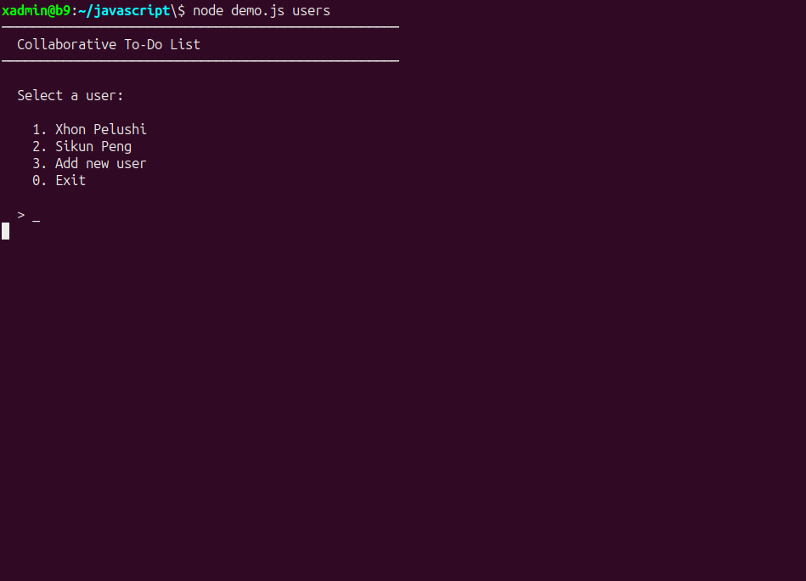
Figure 1. JavaScript — User selection screen on startup.
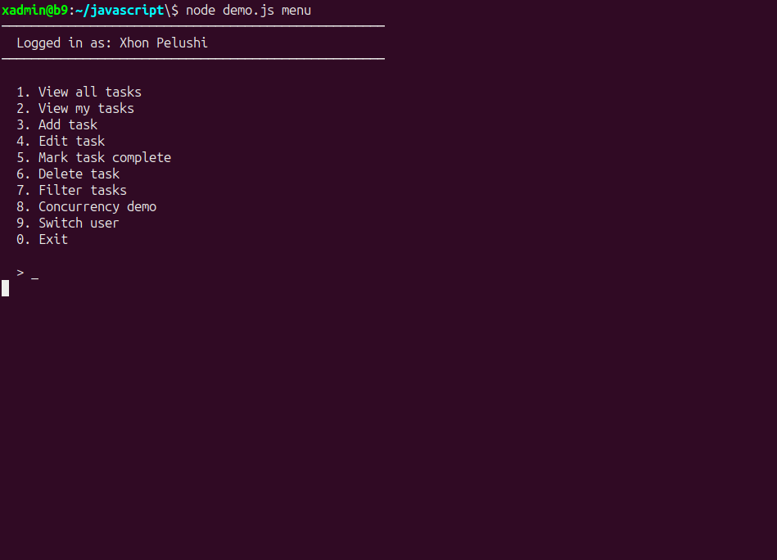
Figure 2. JavaScript — Main menu after logging in as Xhon Pelushi.
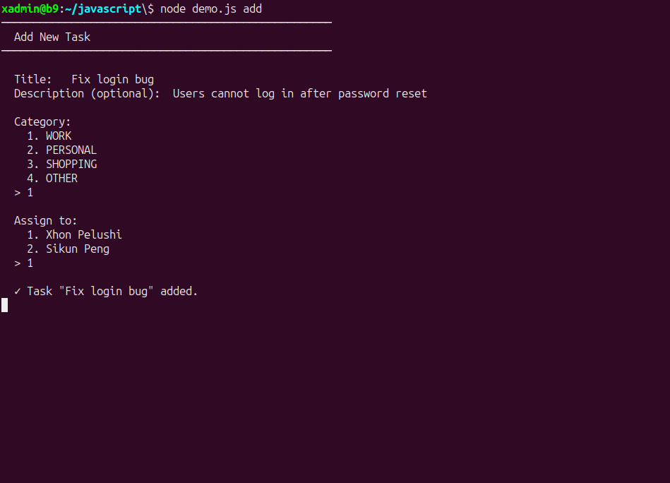
Figure 3. JavaScript — Adding a new task with title, category, and assignment.
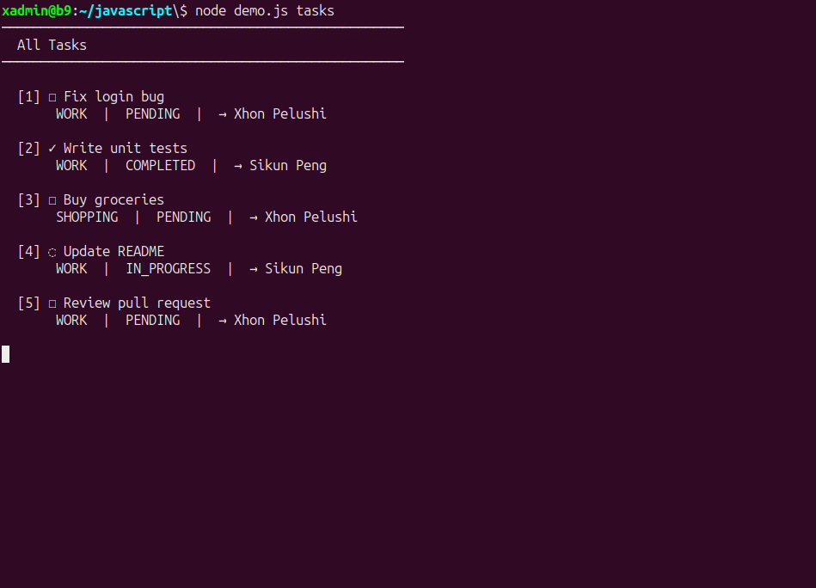
Figure 4. JavaScript — Task list showing multiple tasks with mixed statuses.
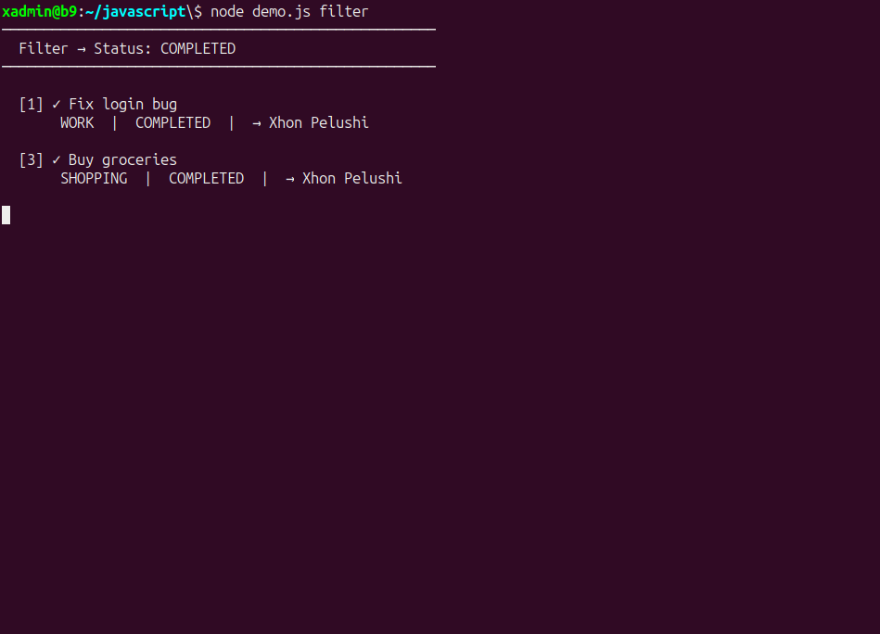
Figure 5. JavaScript — Task list filtered to show only COMPLETED tasks.
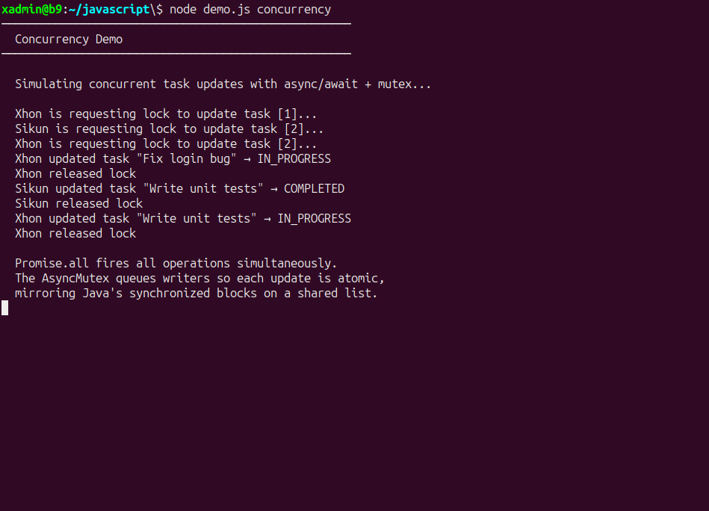
Figure 6. JavaScript — Concurrency demo showing AsyncMutex serializing concurrent async writes.

Java Implementation Screenshots
The following screenshots demonstrate the Java implementation running in the terminal. The application uses Scanner for interactive input and a ReentrantLock inside TaskManager to guard all concurrent writes.

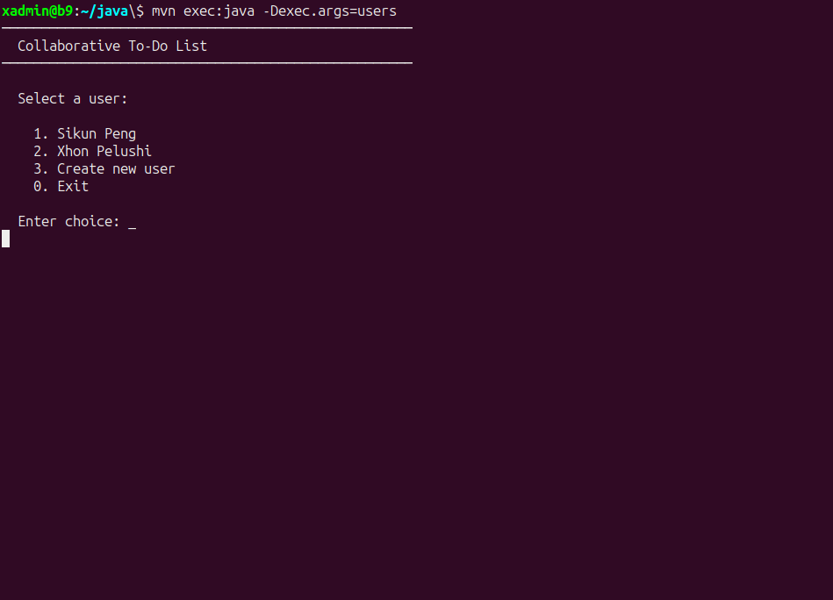
Figure 7. Java — User selection screen on startup.
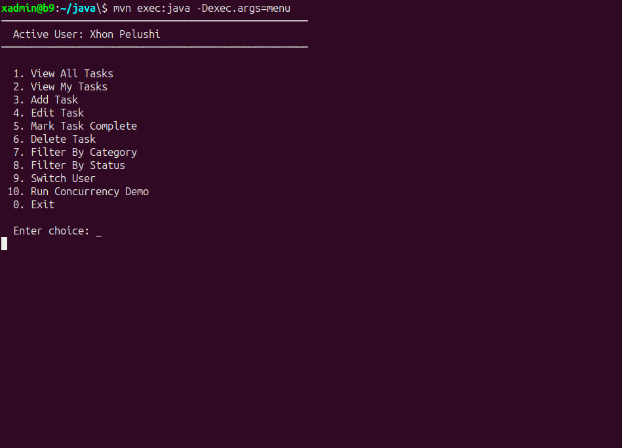
Figure 8. Java — Main menu after logging in as Xhon Pelushi.
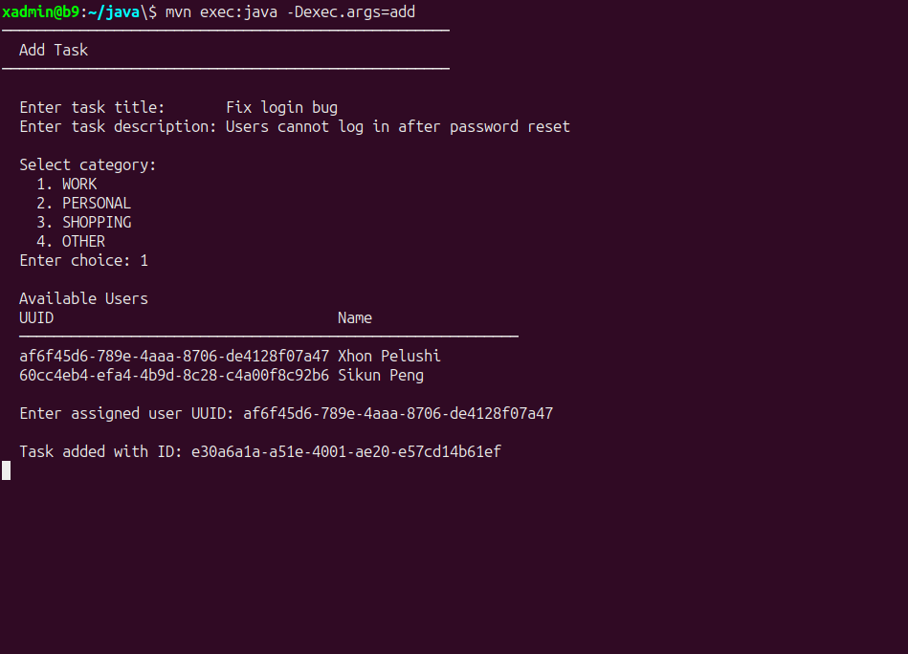
Figure 9. Java — Adding a new task with UUID-based user assignment.
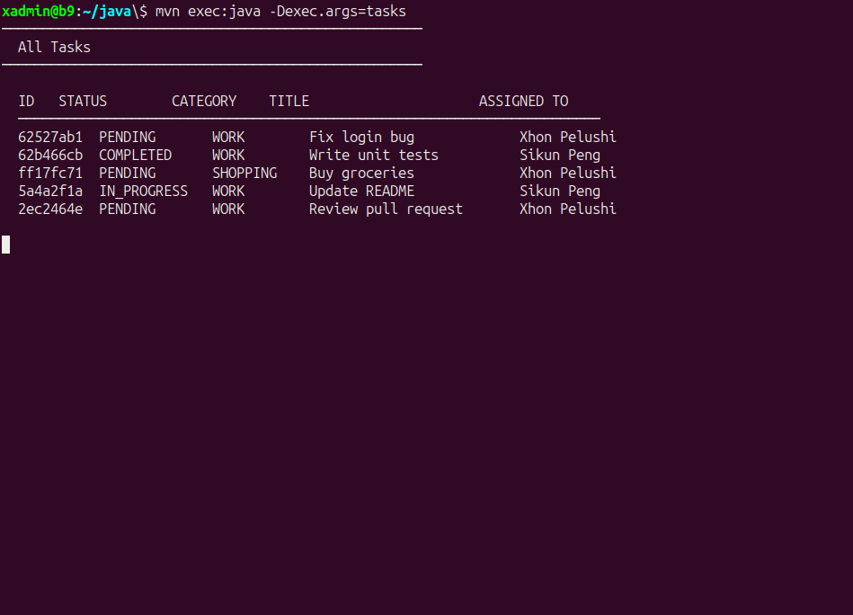
Figure 10. Java — Task list showing all tasks with status and category.
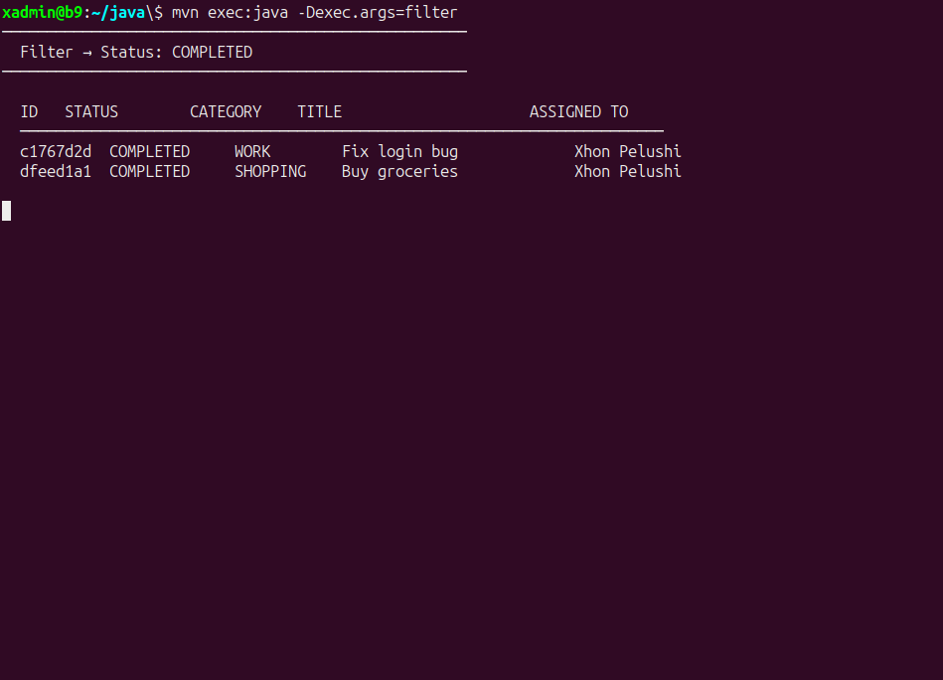
Figure 11. Java — Task list filtered to show only COMPLETED tasks.
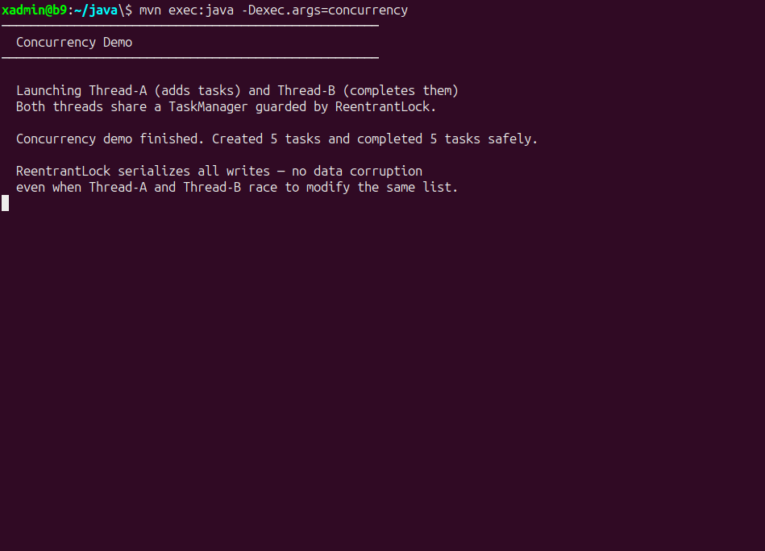
Figure 12. Java — Concurrency demo showing Thread-A and Thread-B sharing a ReentrantLock-guarded TaskManager.

GitHub Repository
All source code, screenshots, and documentation are stored in the team's shared GitHub repository at https://github.com/xhon-pelushi/MSCS632-Group-Project. The repository is organized with a java/ directory containing the Maven project and a javascript/ directory containing the Node.js application. A README.md at the repository root provides the project overview, feature list, language comparison table, team roles, and build and run instructions for both implementations.

References
Bloch, J. (2018). Effective Java (3rd ed.). Addison-Wesley.
Flanagan, D. (2020). JavaScript: The definitive guide (7th ed.). O'Reilly Media.
Node.js Foundation. (2024). readline: Readline module. Node.js Documentation. https://nodejs.org/api/readline.html
Oracle. (2024). Class ReentrantLock. Java SE 21 API Documentation. https://docs.oracle.com/en/java/docs/api/java.base/java/util/concurrent/locks/ReentrantLock.html

