Collaborative To-Do List Application:
A Comparative Analysis of Java and JavaScript
Xhon Pelushi and Sikun Peng
University of the Cumberlands
MSCS-632-M30: Advanced Programming Languages
Dr. Jay Thom
June 2026

Introduction
This report compares two complete implementations of the same Collaborative To-Do List application, one written in Java and one in JavaScript running on Node.js. Both programs deliver an identical feature set, including multi-user support, task creation and editing, categorization, status tracking, filtering, user-specific views, and a concurrency demonstration. Because the requirements were held constant, the two code bases form a controlled experiment that isolates how each language's design shaped our solution. The full source code is available in the team repository at https://github.com/xhon-pelushi/MSCS632-Group-Project. The sections that follow examine programming paradigms, type systems, concurrency models, syntax, error handling, ease of use, and performance, and reflect on how these characteristics influenced our approach.

Programming Paradigms
Java is a class-based, statically typed, object-oriented language, and it pushed us toward an explicit object model. We organized the application into model classes (Task, User, TaskStatus, TaskCategory), service classes (TaskManager, UserManager), and a separate user-interface layer (Menu), each encapsulating its own data and behavior. JavaScript is multi-paradigm and prototype-based; it allowed a lighter, more functional style built on plain object literals, module functions, and array methods such as map and filter. The Java version expresses structure through types and classes, whereas the JavaScript version expresses it through modules and functions. Neither approach is inherently superior, but each is the path of least resistance in its respective language, and the resulting designs reflect that.

Type Systems and Data Modeling
The most visible difference is the type system. In Java, a task is a class with fixed, compiler-checked field types, and the constructor rejects null values at the point of construction. In JavaScript, a task is a flexible object literal whose shape is a convention rather than a guarantee.
Java — Task is a typed class
public final class Task {
private final UUID id;
private String title;
private TaskStatus status; // must be a TaskStatus
private TaskCategory category; // must be a TaskCategory
}
JavaScript — Task is a plain object literal
const task = {
id: String(_nextId++),
title: title.trim(),
status: STATUS.PENDING, // just a string; nothing enforces it
category,
};
The same contrast appears in how each language represents a fixed set of values. Java provides first-class enums, so an invalid status is impossible to construct and is caught at compile time. JavaScript has no traditional enum, so we approximated one with a frozen object of string constants and relied on runtime validation and developer discipline to keep values consistent.
Java enum vs. JavaScript frozen object
// Java
public enum TaskStatus { PENDING, IN_PROGRESS, COMPLETED }
// JavaScript
const STATUS = Object.freeze({
PENDING: 'PENDING',
IN_PROGRESS: 'IN_PROGRESS',
COMPLETED: 'COMPLETED',
});
In practice, Java's static typing caught several mistakes before the program ran, such as passing an argument of the wrong type or misspelling an enum constant. JavaScript never raised those errors on its own, so we added explicit checks, for example confirming that a selected category existed in the allowed list before assigning it. The trade-off was clear: Java required more declarations upfront but removed an entire class of runtime bugs, while JavaScript moved faster initially but shifted the burden of correctness onto our own validation code.

Concurrency Models
Concurrency revealed the deepest design difference. Java supports true multithreading, so two threads can modify shared memory at the same instant, creating real data races. We therefore guarded every write to the shared task store with a ReentrantLock. JavaScript executes on a single-threaded event loop, so two callbacks never run in parallel; however, asynchronous operations can still interleave, allowing one async caller to read stale state before another finishes writing. To make the demonstration parallel-safe in spirit, we implemented a small AsyncMutex backed by Promises that serializes overlapping writes the way a synchronized block would.
Java — ReentrantLock guards a shared map
private final ReentrantLock lock = new ReentrantLock();
public Task addTask(...) {
lock.lock();
try {
tasks.put(task.getId(), task);
return task;
} finally {
lock.unlock();
}
}
JavaScript — AsyncMutex guards a shared array
async function addTask(...) {
await mutex.lock();
try {
tasks.push(task);
return task;
} finally {
mutex.unlock();
}
}
The way concurrent work is launched also differs. Java spawns and joins operating-system threads, while JavaScript fires several asynchronous operations at once with Promise.all and lets the event loop coordinate them. Both demonstrations produce a consistent final state, but they reach it through fundamentally different machinery.
Launching concurrent work: threads vs. Promise.all
// Java
adderThread.start();
completerThread.start();
adderThread.join();
// JavaScript
await Promise.all([
userAction('Xhon', tasks[0].id, IN_PROGRESS, 0),
userAction('Sikun', tasks[1].id, COMPLETED, 10),
]);
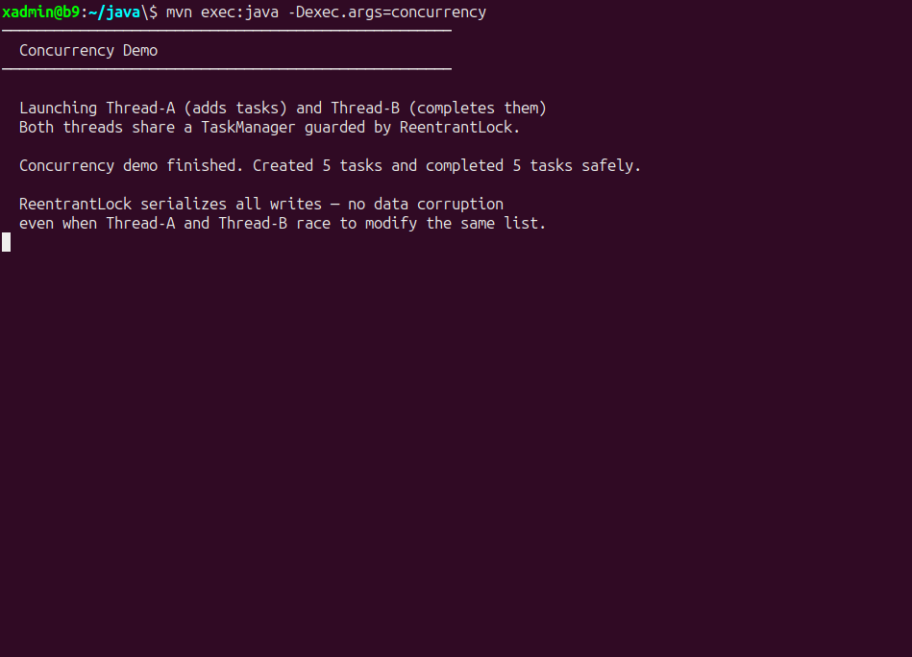
Figure 1. Java — two threads sharing a ReentrantLock-guarded TaskManager.
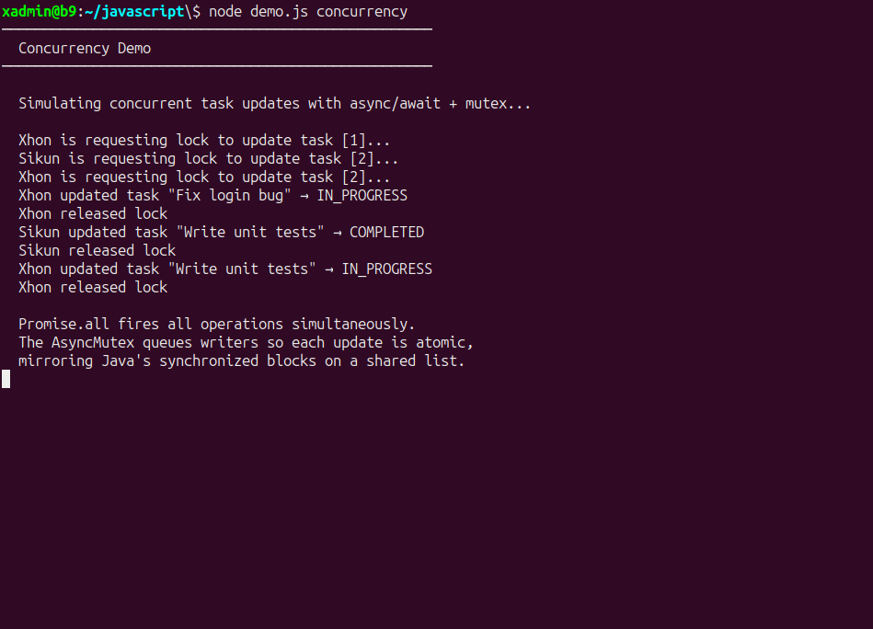
Figure 2. JavaScript — AsyncMutex serializing overlapping async writes.

Syntax Differences and Input Handling
Beyond types and threads, everyday syntax shaped how the two programs read input. Java's Scanner is blocking and synchronous: the calling thread simply waits until the user presses Enter, which makes a menu loop read like a straightforward sequence of statements. Node.js input through readline is event-driven and asynchronous, so we used async and await to make the menu feel sequential while still yielding to the event loop between prompts. JavaScript also favored more concise expressions, such as arrow functions, object destructuring, the spread operator, and template literals, whereas Java favored explicit declarations and method signatures.
Reading a menu choice: blocking vs. asynchronous
// Java — blocks the thread until Enter is pressed
System.out.print("Enter choice: ");
String input = scanner.nextLine().trim();
// JavaScript — awaits a Promise, yielding to the event loop
const choice = (await ask(' > ')).trim();

Error Handling
Both languages offer try/catch, but the kinds of errors they surface differ. Java's combination of static types, enums, and Objects.requireNonNull let the compiler and runtime reject many invalid states automatically, and our menu wrapped each action in a loop that caught IllegalArgumentException and NoSuchElementException and re-prompted the user. JavaScript's flexibility meant that bad data usually failed silently rather than throwing, so we wrote explicit guards that validated input against the allowed set of values before acting on it. Java tended to fail fast and loudly; JavaScript required us to decide deliberately where failure should occur.

Ease of Use and Performance
In terms of developer experience, JavaScript was faster to start: objects and arrays needed no class definitions, the runtime required no compilation step, and the program could be run immediately with node index.js. Java demanded more ceremony, including class declarations, types, a package structure, and a Maven build, but that same structure made the larger program easier to navigate, refactor, and reason about as it grew. On performance, Java's compiled bytecode and JVM just-in-time optimization, together with genuine multithreading, make it the stronger choice for CPU-bound work that can be parallelized across cores. Node.js, with its non-blocking event loop, excels at input/output-bound and highly concurrent workloads such as network services, even though it executes user code on a single thread. For a small terminal application neither difference was noticeable, but each language's strengths point clearly toward different production use cases.
Dimension | Java | JavaScript (Node.js)
Paradigm | Class-based, object-oriented | Multi-paradigm, prototype-based
Typing | Static, strongly typed | Dynamic, weakly typed
Fixed values | Native enums | Frozen object of constants
Concurrency | OS threads + ReentrantLock | Event loop + async/await + mutex
Parallel launch | Thread.start / join | Promise.all
Console input | Scanner (blocking) | readline (asynchronous)
Build / run | Maven compile, then run | Run directly with Node.js
Best fit | CPU-bound, large systems | I/O-bound, concurrent services

How Language Characteristics Influenced Our Approach
Holding the requirements fixed made it clear that the language, not the problem, drove most of our design decisions. Java's static typing and class model led us to invest in an explicit, layered architecture with strong compile-time guarantees, which paid off in safety and maintainability at the cost of more upfront code. JavaScript's dynamic typing and asynchronous model led us to a lighter, faster-to-write design that depended on careful runtime validation and an event-loop view of concurrency. The same feature, such as protecting concurrent writes, became a ReentrantLock in one language and a Promise-based mutex in the other. Working in both languages side by side made the trade-offs between safety and flexibility, and between structure and speed, concrete rather than theoretical, and it reinforced that choosing a language is really choosing a set of defaults that will shape the entire solution.

References
Bloch, J. (2018). Effective Java (3rd ed.). Addison-Wesley.
Flanagan, D. (2020). JavaScript: The definitive guide (7th ed.). O'Reilly Media.
Mozilla. (2024). JavaScript guide. MDN Web Docs. https://developer.mozilla.org/en-US/docs/Web/JavaScript/Guide
Node.js Foundation. (2024). The Node.js event loop. Node.js Documentation. https://nodejs.org/en/docs/guides/event-loop-timers-and-nexttick
Oracle. (2024). Class ReentrantLock. Java SE 21 API Documentation. https://docs.oracle.com/en/java/javase/21/docs/api/java.base/java/util/concurrent/locks/ReentrantLock.html

