For-Hire Angler Travel and Targeting Report 2024: Monroe County

A data report for the Monroe County Government and Tourist Development Council prepared by:

Ed Camp, Assistant Professor of Fisheries and Aquaculture Governance, University of Florida, [edvcamp@ufl.edu](mailto:edvcamp@ufl.edu)

Shelly Krueger, Florida Sea Grant Agent Monroe County, [shellykrueger@ufl.edu](mailto:shellykrueger@ufl.edu)

Table of Contents

### Abbreviations and Definitions

**NMFS**: National Marine Fisheries Service.  
**MRIP**: Marine Recreational Information Program, which is operated by NMFS to survey coastal anglers.  
**APAIS**: Access Point Angler Intercept Survey, the survey implemented by MRIP to collect information about angling.  
**Keys and South Florida region**: refers to the areas of and marine waters adjacent to Monroe and Miami-Dade counties.

### Overview Summary

*Why this report might be important*  
Recreational fishing is one of the dominant recreational uses of marine ecosystems globally, and marine recreational fisheries (recreational fisheries occurring in saltwater) are particularly important to Florida. Florida has more saltwater anglers than any other state—2.4 million (USFWS 2011), with over a million saltwater fishing licenses sold annually. The total economic output (market activity) of saltwater fishing in Florida was estimated at around $8b annually (NOAA 2017), making fishing a vital part of Florida’s overall economy, and especially critical for coastal counties. Because of their importance, marine recreational fisheries in Florida are carefully managed by state (Florida Fish and Wildlife Conservation Commission; FWC) and by federal (NOAA’s National Marine Fisheries Service, NMFS) agencies. These two agencies partner to collect information about recreational fishing that is freely available to the public in the form of large databases. Extracting and visualizing these data can be challenging. We have queried these databases and summarized information we think may be helpful to the for-hire fishing industry and related tourism industry of Monroe County. **Specifically this information can be used to inform advertisements of the for-hire fishing and related tourism in Monroe County.**

*What this report can be used for*  
This report is designed to provide information about marine recreational for-hire fishing dynamics in Monroe County. The for-hire fishing sector includes private charters where a small group of anglers (usually 1-6 people) hire a guide to take them fishing, as well as “party” or “head” boats, where usually 20 or more anglers pay per person to fish from a larger, captained boat. The for-hire fishing industry is important for several reasons. First, it represents employment and livelihoods for the guides, captains, and crew offering for-hire fishing services. Second, the for-hire sector allows people who do not own or rent their own boats access to recreational fishing. Finally, the for-hire sector can play a role in tourist decisions, as the availability of for-hire fishing can attract angler from out of county, state, or even country to travel to local areas to stay and fish.

The for-hire fishing dynamics described here include information about what species of fish for-hire recreational fishers (here called “angler clients”) are most often trying to catch and where angler clients come from when they make a for-hire trip to marine waters from Monroe County. Angler targeting and travel information may have several uses. Understanding what fish species are commonly targeted may help inform:

* Which species are most popular with local or non-local angler clients.
* How to best advertise fishing in this area–e.g. what fish species should be pictured in advertisements.
* Which fishery management rule changes **might** most affect the local for-hire industry and their angler clients.
* How changes in fish populations (like from a habitat change or fish kill) may affect the amoung of for-hire fishing trips, angler travel, and eventually, local economies.

Information on where anglers come from when they fish local waters has multiple potential uses as well, and we think it can inform:

* Locations to place advertisements for local for-hire fishing. For example, does it make more sense to advertise Monroe County recreational fishing in New York, or in Georgia?.
* Which people might want to be involved in local for-hire fisheries decision-making. For example, if many angler clients who commonly fish Monroe County reside in other counties, these anglers may be interested in Monroe County rule changes.

Together, this information is intended to help the local for-hire fishing industry and related tourism industry of Monroe County. It may also be useful to the the Monroe County Government and Tourist Development Council, especially if they work with or on behalf of the for-hire fishing industry to promote marine for-hire fishing-based tourism in Monroe County.

*Where the information from this report comes from*  
All of the data in this report come from the NOAA’s National Marine Fisheries Program (NMFS) Marine Recreational Information Program (MRIP). These data are publicly available for download at <https://www.fisheries.noaa.gov/recreational-fishing-data/data-downloads>. The MRIP program contains information voluntarily provided by anglers at fishing locations surveyed according to a scientifically designed sampling program. Data are continuously collected, but data in this report are for years 2013-2023. Future reports will show updated data as they are available.

### NMFS MRIP background

*What is MRIP–the Marine Recreational Information Program?*  
While commercial fishers have a separate reporting system with specific requirements for commercial fishers to report fishing locations and catches to state and federal agencies, no such requirements exist for recreational fishers The MRIP is NMFS’s way of gathering information needed to sustainably manage recreational fisheries. The MRIP allows state and federal researchers and managers to understand things like:

* How many recreational fishing trips are being taken in a region and time period?
* Are these trips for-hire, private-recreational (fishing out of a personal or rented vessel) or shore-based? These separate categories are called the fishing “mode” in MRIP.
* How many of these trips target a certain species?
* What state and county do anglers come from when they fish a certain area?
* Additional information about angler catch rates adn sizes of fish.

These things (especially information about total fishing effort, catch rates, and fish size) can be important for developing stock assessments that inform fisheries management decisions. The MRIP system includes two main surveys. One is an “access point” or “intercept” survey designed to understand aspects of fishing trips like length of trip, origin, target species, etc. The other, **which this report does not use**, is designed to understand what proportion of the human population in an area is engaging in these types of fishing trips. Information from the two surveys is combined to allow researchers to estimate some of the information described in the bullet points above, as well as important things like the total amount of a certain fish species that recreational fishers harvest or remove in a region and time.

*What MRIP information does this report use?*  
It is important to understand that this report does not use the estimates from MRIP. This report only uses the actual data provided by the angler intercept survey, and specifically this report only includes anglers indicating they were on for-hire trips. This means all the data here are exactly what anglers are telling surveyors when they are interviewed. This distinction is important for a couple reasons. The data used here are simply descriptive. We do not show “error” or “uncertainty” around them, because we are reporting the metrics from the database, and not extrapolating the data by any statistical weighting factors or subjecting them to statistical estimation processes. What this means, is that the data here should describe general trends like what people fish for and where they come from, as long as anglers are correctly reporting to surveyors what they did when they went fishing. These data also depend on the MRIP statistical process for determining how to survey which intercept sites (boat ramps, access points). There are a lot of statistical details on this last point, but in short, as long as the MRIP sites are sampled roughly in proportion to their use (so that more frequently used sites are sampled more), these trends shown here should be correct. However, please understand that MRIP was designed mostly for tracking “big picture” changes (such as state-wide trends in effort). Thus the information here is for informational purposes, and the authors cannot guarantee the statistical accuracy or precision of what is presented.

*Additional information about MRIP*  
A lot of additional information is available about the NMFS MRIP data and how these data are used. We have described the parts of this information that are important to know to understand and best use the data provided in this report. Additional information directly through NOAA Fisheries at <https://www.fisheries.noaa.gov/topic/recreational-fishing-data>, as well as through the Marine Resource Education Program, MREP (different from MRIP), for which more information is available at: <https://www.gmri.org/our-work/fisheries-convening/mrep-southeast>. Finally, many Florida Sea Grant agents and county faculty, FWC personnel, and University of Florida researchers know about MRIP and may be able to answer additional questions.

### Fishing Trip Origins: Where do your anglers come from?

*Background on data used*  
Every for-hire recreational fishing trip made has an origin and a destination. In MRIP, the origin is described as the angler’s residence, and the destination is defined as where the angler was surveyed (e.g., boat ramp, fishing pier, etc.). For specifically the maps in this report, the **origin** is considered to be the population centroid of the angler’s county-of-residence. The population centroid is the spatial location in a county that “balances” the counties population. This means the centroid is the most likely “average” location for a person to come from, given we know they live in a certain county. For example, in Collier County, the population centroid would be closer to Naples in the east, than it would be to the middle of the county, which is sparsely populated. The fishing site destinations that are surveyed include those in the MRIP Access Point Angler Intercept Survey (APAIS) and are selected as part of a statistically designed survey. Further information about APAIS and the specific destinations is available at: <https://www.fisheries.noaa.gov/recreational-fishing-data/public-access-fishing-site-register>

*Fishing Trip Origins: Background on methods used*  
For the for-hire recreational fishing trip origin information, we use data available in the MRIP “trips” databases that describe the results of the MRIP APAIS survey—this is the information that anglers tell surveyors when they are interviewed about their trips. We designed queries that let us look at the for-hire angler clients that were interviewed in specifically Monroe County—i.e. the trips where anglers’ fishing destination was in marine waters adjacent to Monroe County, regardless of where the origin was. Once we have isolated the trips occurring in Monroe County, we can analyze where most of these trips came from. Specifically, we can look at things like:

* The proportion of for-hire trips sampled in Monroe County that come from out-of-state origins.
* The proportion of for-hire trips sampled in Monroe County with in-state origins.
* Both the above, but for trips in a multi-county region that includes Monroe County.

One thing that is important to note is that we report the proportion of the sampled for-hire trips. This is not the same as reporting the total number of for-hire trips. Enumerating the total number of trips would require estimation tools that are not described here. However, because of the statistical design that the MRIP APAIS survey is implemented, the proportions we use (of sampled for-hire trips) should generally correspond to the total numbers of for-hire trips. What this means is that the information in this report can be very useful for understanding where people come from when they make for-hire marine fishing trips in Monroe County. Additional information on angler trip analyses is provided in (Camp et al. 2018).

We provide two types of information about angler origins:

* Tables describing where for-hire angler clients come from.
* Figures of maps graphically illustrating for-hire angler clients travel.

### Fishing Trip Origins Results: Tables

We provide two tables summarizing where for-hire angler clients come from when they fish various parts of Florida and specifically the Keys and South Florida region and Monroe County.  
**Table 1** compares the states that out-of-state angler clients come from when they fish either anywhere in Florida, the Keys and South Florida region, or specifically Monroe County.  
**Table 2** shows the county-origins of for-hire trips made by Florida residents. It compares the proportion of sampled trips coming from counties by angler clients (*i*) living outside of the Keys and South Florida region, (*ii*) living outside of Monroe County, and (*iii*) living anywhere in Florida, including Monroe County.

We anticipate these tables may be useful in several ways, including:

* Understanding where for-hire angler clients fishing in Monroe County come from, which may inform placement of fishing and tourism advertisements.
* Understanding how for-hire angler client origins may differ between Monroe County and surrounding areas. This can potentially be used to further fine tune efficient advertisement placement by identifying locations where for-hire fishing captains in Monroe County may compete more or less with nearby counties for angling visitors.
* Understanding what proportion of angler clients fishing Monroe County are local vs. visitors, which may be useful for deciding where to have meetings about Monroe County for-hire fishing.

#### Table 1

Out-of-state for-hire angler client origins comparison

| Orig.(FL) | Prop. | Orig.(Keys and South Florida) | Prop. | Orig.(Monroe) | Prop. |
| --- | --- | --- | --- | --- | --- |
| Georgia | 0.103 | Not Available | 0.095 | Texas | 0.083 |
| Texas | 0.078 | Texas | 0.086 | New Jersey | 0.064 |
| Not Available | 0.055 | New York | 0.060 | New York | 0.057 |
| Tennessee | 0.054 | New Jersey | 0.057 | Georgia | 0.056 |
| Illinois | 0.048 | Georgia | 0.051 | Not Available | 0.055 |
| Ohio | 0.048 | North Carolina | 0.049 | North Carolina | 0.051 |
| Michigan | 0.043 | Illinois | 0.046 | Pennsylvania | 0.050 |
| Alabama | 0.042 | Pennsylvania | 0.046 | Michigan | 0.046 |
| New York | 0.041 | Michigan | 0.042 | Illinois | 0.045 |
| Indiana | 0.035 | Ohio | 0.039 | Ohio | 0.043 |

**Table 1. State origins of for-hire angler clients fishing Florida, the Keys and South Florida region, and Monroe County, for 2013-2023.**  
This table compares which states out-of-state for-hire angler clients come from when they fish either Florida as a whole, the Keys and South Florida region (here defined as including Monroe and Miami-Dade counties), or Monroe County.

* Columns 1 & 2 show the state origins of non-Florida residents when they make a for-hire trip to Florida.
* Columns 3 & 4 show the state origins of non-Florida residents when they make a for-hire trip to the Keys and South Florida region.
* Columns 5 & 6 show the state origins of non-Florida residents when they make a for-hire trip to Monroe County.

This comparison allows understanding where (*i*) out of state for-hire angler clients fishing Monroe County come from, and (*ii*) how that compares to the local region and broader state of Florida. This may be helpful for understanding if Monroe County is attracting for-hire angler clients from specific origins differently than the surrounding region of the Keys and South Florida, or Florida as a whole.  
The “Not Available” is returned either when for-hire angler clients refuse to give state of origin, or more often when they do not reside in the US-i.e. international visitors.

#### Table 2

In-state for-hire angler client origin comparison

| Out-of-region Orig. | Prop. | Out-of-county Orig. | Prop. | Any Orig. | Prop. |
| --- | --- | --- | --- | --- | --- |
| Broward | 0.191 | Miami-Dade | 0.130 | Miami-Dade | 0.118 |
| Palm Beach | 0.142 | Broward | 0.128 | Broward | 0.117 |
| Hillsborough | 0.064 | Palm Beach | 0.128 | Palm Beach | 0.116 |
| Lee | 0.059 | Hillsborough | 0.056 | Monroe | 0.090 |
| Pinellas | 0.056 | Pinellas | 0.055 | Hillsborough | 0.051 |
| Orange | 0.052 | Lee | 0.053 | Pinellas | 0.050 |
| Duval | 0.037 | Orange | 0.047 | Lee | 0.049 |
| Brevard | 0.036 | Brevard | 0.034 | Orange | 0.043 |
| Collier | 0.032 | Duval | 0.034 | Brevard | 0.031 |
| St Johns | 0.030 | Collier | 0.029 | Duval | 0.031 |

**Table 2. County origins of Florida residents making for-hire trips to the Keys and South Florida region and Monroe County, for 2013-2023.**  
This table compares which counties Florida resident angler clients come from when they make for-hire trips to the Keys and South Florida region (Monroe and Miami-Dade counties) or specifically Monroe County.

* Columns 1 & 2 show origins of Florida resident angler clients fishing the Keys and South Florida region who live outside of the Keys and South Florida region.
* Columns 3 & 4 show origins of Florida resident angler clients fishing Monroe County but living outside of Monroe County.
* Columns 5 & 6 show origins of Florida resident angler clients fishing Monroe County, regardless of where in Florida they live.

This comparison allows understanding (*i*) where Florida resident angler who make for-hire fishing trips to the Keys and South Florida region and Monroe County come from, and (*ii*) the Florida counties from which the greatest proportion of out-of-county for-hire trips come from.

### Fishing Trip Origin Results: Maps

We provide several maps to graphically illustrate where sampled for-hire angler clients come from when they fish the Keys and South Florida region and Monroe County. The maps show the “direct line” paths between the population centroids of angler clients’ county of residence and the location where they were sampled by the MRIP APAIS survey-i.e. their fishing destinations. For all maps, thicker and warmer colored lines indicate more trips from a given county to a given destination, and thinner and cooler colors suggests fewer trips. Here, different maps are created for different species, including the top five species targeted in the Keys and South Florida region.  
**Figure 1** maps trips to Monroe County regardless of species targeted.  
**Figure 2** maps trips to the Keys and South Florida region when anglers targeted Dolphin.  
**Figure 3** maps trips to the Keys and South Florida region when anglers targeted Atlantic tarpon.  
**Figure 4** maps trips to the Keys and South Florida region when anglers targeted Yellowtail snapper.  
**Figure 5** maps trips to the Keys and South Florida region when anglers targeted Sailfish.  
**Figure 6** maps trips to the Keys and South Florida region when anglers targeted Snapper family.

The primary purpose of these figures is to serve as a visual aid to augment the use of the previous tables.

#### Figure 1.

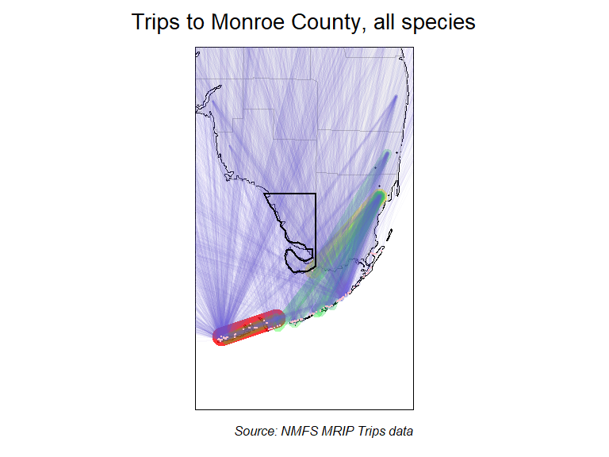

**Figure 1. Map showing where for-hire trips fishing Monroe County originated in, regardless of species targeted, for 2013-2023.** Thicker and warmer colored lines show relatively more trips taken, and thinner, cooler colored lines show that relatively fewer trips were taken.

#### Figure 2.

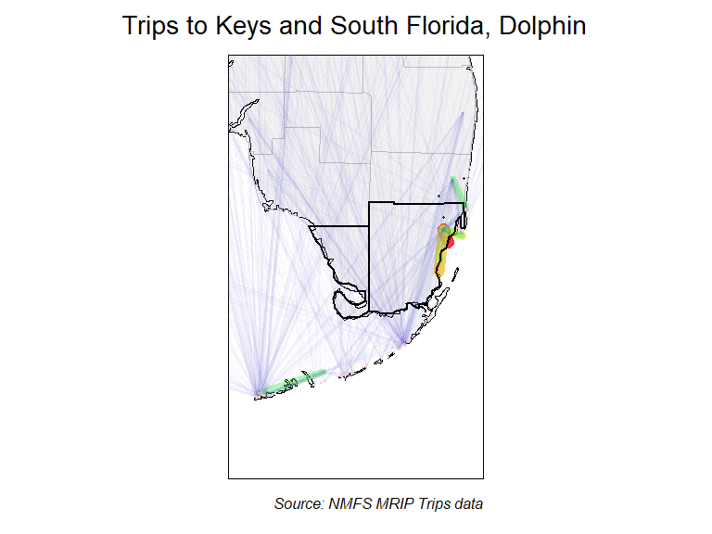

**Figure 2. Map showing where for-hire trips fishing the Keys and South Florida region originated in, when targeted Dolphin, for 2013-2023.** Thicker and warmer colored lines show relatively more trips taken, and thinner, cooler colored lines show that relatively fewer trips were taken.

#### Figure 3.

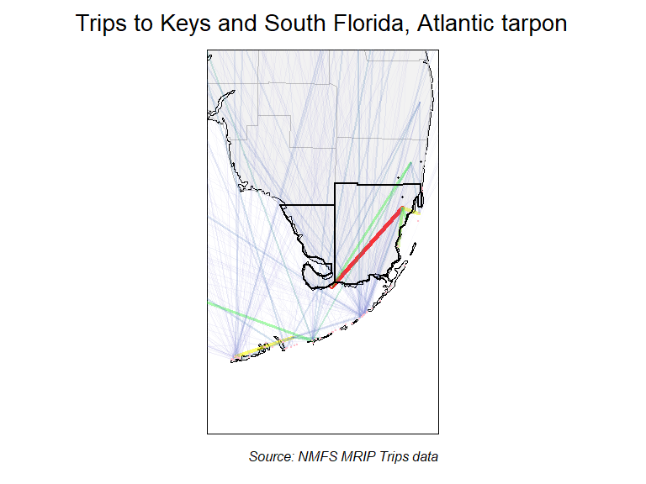

**Figure 3. Map showing where for-hire trips fishing the Keys and South Florida region originated in, when targeted Atlantic tarpon, for 2013-2023.** Thicker and warmer colored lines show relatively more trips taken, and thinner, cooler colored lines show that relatively fewer trips were taken.

#### Figure 4.

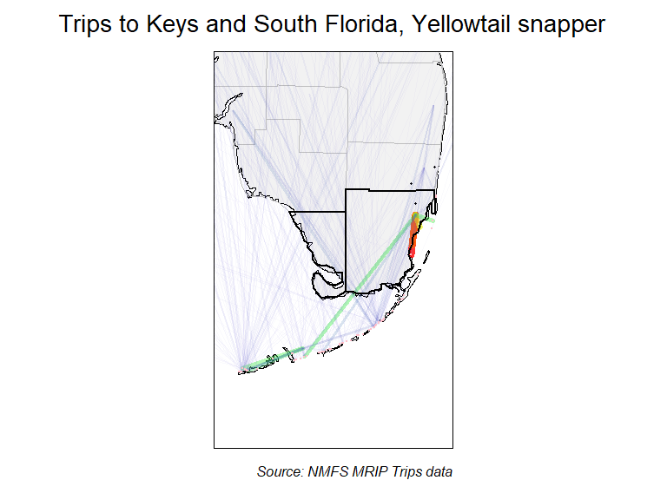

**Figure 4. Map showing where for-hire trips fishing the Keys and South Florida region originated in, when targeted Yellowtail snapper, for 2013-2023.** Thicker and warmer colored lines show relatively more trips taken, and thinner, cooler colored lines show that relatively fewer trips were taken.

#### Figure 5.

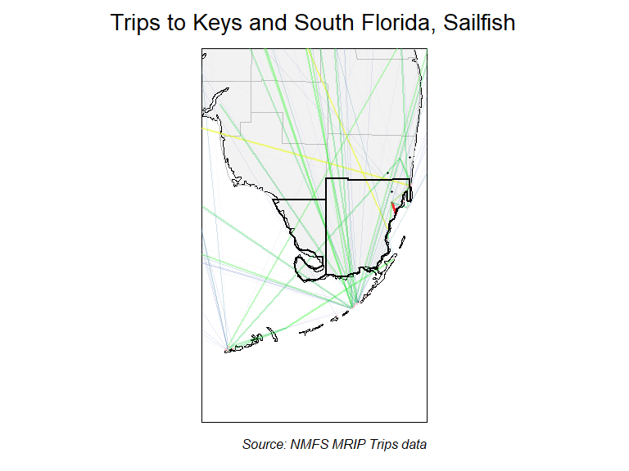

**Figure 5. Map showing where for-hire trips fishing the Keys and South Florida region originated in, when targeted Sailfish, for 2013-2023.** Thicker and warmer colored lines show relatively more trips taken, and thinner, cooler colored lines show that relatively fewer trips were taken.

#### Figure 6.

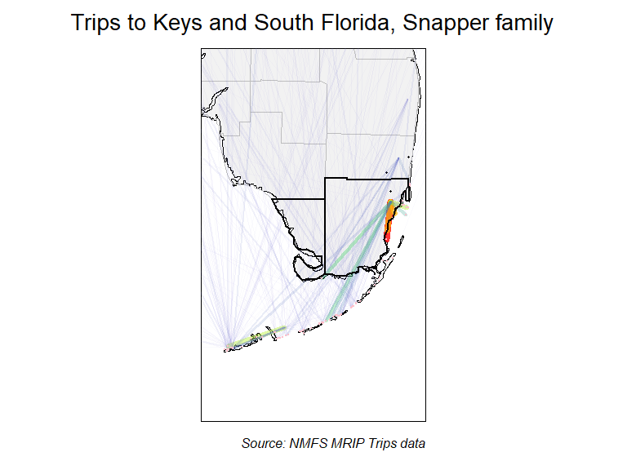

**Figure 6. Map showing where for-hire trips fishing the Keys and South Florida region originated in, when targeted Snapper family, for 2013-2023.** Thicker and warmer colored lines show relatively more trips taken, and thinner, cooler colored lines show that relatively fewer trips were taken.

### Species targeted: What do your anglers fish for?

*Background on data used*  
The MRIP APIAS includes questions about the species that interviewed anglers were targeting on their recently completed fishing trips. Specifically, anglers are asked what their “primary” and “secondary” targeted species were. Not all anglers provide a specific species, though often more for-hire angler clients do. The species targeted information can be used here to understand what species are most commonly targeted on for-hire trips. Further information about APAIS and the specific destinations is available at: <https://www.fisheries.noaa.gov/recreational-fishing-data/public-access-fishing-site-register>.

*Species targeted: Background on methods used*  
To understand what fish species for-hire angler clients most commonly targeted, we use data available in the MRIP “trips” databases from specifically for-hire trips. These data contain the information that anglers tell surveyors when they are interviewed about their recreational fishing for-hire trips. We designed a series of queries to calculate the proportions of trips targeting specific fish species. Queries represented different scenarios regarding where anglers were intercepted (their destinations) and where they listed their home residence (their origin). This information was summarized by pooling trips over time—i.e. looking at the last 10 years (2013-2023) together. To assess potential changes in the fish that anglers target, we also analyzed time series for species most commonly targeted by for-hire angler clients. Time series were constructed by assessing the proportions of trips intercepted in the Keys and South Florida region that targeted a specific species for each of the last 10 years.

*Species targeted: Information provided*  
Two types of information products were developed:

* Tables describing the proportions of for-hire trips targeting different fish species at various combinations of fishing locations and residences.
* Figures showing the time series of proportion of for-hire trips taken in the Keys and South Florida region targeting the most popular fish species.

One thing that is important to note is that we report the proportion of the sampled for-hire trips targeting a certain species. This is not the same as reporting the total number of for-hire trips. Enumerating the total number of trips would require estimation tools that are not described here. However, because of the statistical design used to implement the MRIP APAIS survey, the proportions we use (of sampled for-hire trips) should correspond to the total numbers of trips. What this means is that the information in this report can be very useful for things like understanding where people, on average, are coming from when then make for-hire trips to Monroe County.

### Species Targeted Results: Tables

Tables describing the proportions of trips targeting different fish species at various combinations of fishing locations and residences, including:

* For-hire trips in all of Florida, regardless of origin.
* For-hire trips in Florida’s 7 coast, regardless of origin.
* For-hire trips in the Keys and South Florida region, regardless of origin.
* For-hire trips taken in Monroe County, regardless of origin.
* For-hire trips taken in Monroe County by Monroe County residents.
* For-hire trips taken in Monroe County by non-residents of Monroe County.
* For-hire trips taken in Monroe County by out-of-state anglers.

These results are summarized in two separate tables that promote comparison of Monroe County to surrounding areas. All results represent data pooled over the last 10 years (2013-2023).

We anticipate these tables may be useful in several ways, including:

* Understanding what species angler clients are targeting when they make for-hire trips in Monroe County, which may help inform advertising or business decisions by local for-hire captains.
* Understanding what species visiting (non Monroe-County residents) angler clients target, which may inform the media outlets and visuals (e.g., fish photos) of future advertisements or information produced by the Manatee County Tourism Development Council in support of the for-hire fishing sector.

#### Table 3

Proportion of species targeted in for-hire trips, comparing county to state

| FL trips | Prop. | FL 7 trips | Prop. | Keys and South Florida trips | Prop. | Monroe trips | Prop. |
| --- | --- | --- | --- | --- | --- | --- | --- |
| No Target | 0.510 | No Target | 0.455 | No Target | 0.562 | No Target | 0.513 |
| Red snapper | 0.056 | Red snapper | 0.071 | Dolphin | 0.138 | Dolphin | 0.148 |
| King mackerel | 0.045 | Red grouper | 0.051 | Atlantic tarpon | 0.060 | Atlantic tarpon | 0.072 |
| Red drum | 0.041 | King mackerel | 0.043 | Yellowtail snapper | 0.046 | Yellowtail snapper | 0.057 |
| Dolphin | 0.040 | Red drum | 0.041 | Sailfish | 0.037 | Snapper family | 0.039 |
| Red grouper | 0.038 | Dolphin | 0.034 | Snapper family | 0.033 | Sailfish | 0.038 |
| Common snook | 0.025 | Spanish mackerel | 0.033 | Bonefish | 0.010 | Gray snapper | 0.013 |
| Spanish mackerel | 0.025 | Spotted seatrout | 0.032 | Gray snapper | 0.010 | Sea bass family | 0.011 |
| Spotted seatrout | 0.025 | Atlantic tarpon | 0.028 | Blackfin tuna | 0.009 | Blackfin tuna | 0.010 |
| Atlantic tarpon | 0.022 | Common snook | 0.028 | Requiem shark family | 0.009 | Bonefish | 0.008 |

**Table 3. Comparison of species targeted in for-hire trips to Monroe County to other regions of Florida, for 2013-2023.**

* Columns 1 & 2 show species targeted by for-hire trips made throughout Florida.
* Columns 3 & 4 show species targeted by for-hire trips made to the 7 coast of Florida.
* Columns 5 & 6 show species targeted by for-hire trips made in the Keys and South Florida region.
* Columns 7 & 8 show species targeted by for-hire trips made in Monroe County.

#### Table 4

Proportion of species targeted in for-hire trips, comparing county to state

| All Monroe trips | Prop. | In county trips | Prop. | Out of county trips | Prop. | Out of state trips | Prop. |
| --- | --- | --- | --- | --- | --- | --- | --- |
| No Target | 0.513 | No Target | 0.448 | No Target | 0.515 | No Target | 0.548 |
| Dolphin | 0.148 | Dolphin | 0.090 | Dolphin | 0.149 | Dolphin | 0.116 |
| Atlantic tarpon | 0.072 | Atlantic tarpon | 0.075 | Atlantic tarpon | 0.072 | Atlantic tarpon | 0.082 |
| Yellowtail snapper | 0.057 | Sailfish | 0.071 | Yellowtail snapper | 0.057 | Yellowtail snapper | 0.046 |
| Snapper family | 0.039 | Yellowtail snapper | 0.067 | Snapper family | 0.039 | Sailfish | 0.043 |
| Sailfish | 0.038 | Snapper family | 0.056 | Sailfish | 0.038 | Snapper family | 0.038 |
| Gray snapper | 0.013 | Sea bass family | 0.041 | Gray snapper | 0.013 | Gray snapper | 0.012 |
| Sea bass family | 0.011 | Bonefish | 0.022 | Blackfin tuna | 0.010 | Requiem shark family | 0.010 |
| Blackfin tuna | 0.010 | Lane snapper | 0.019 | Sea bass family | 0.010 | Bonefish | 0.009 |
| Bonefish | 0.008 | Blackfin tuna | 0.015 | Wahoo | 0.009 | Wahoo | 0.009 |

**Table 4. Proportions of species targeted by for-hire fishing trips made in Monroe County by anglers from various origins, for 2013-2023.**

* Columns 1 & 2 show the species targeted by all for-hire trips made in Monroe County.
* Columns 3 & 4 show the species targeted in Monroe County by Monroe residents making for-hire trips.
* Columns 5 & 6 show the species targeted in Monroe County by Florida residents not living in Monroe County making for-hire trips.
* Columns 7 & 8 shows the species targeted in Monroe County by non-residents of Florida making for-hire trips.

### Species Targeted Results: Time series figures

We provide time series of the proportion of sampled for-hire trips that targeted each of the top nine species targeted in for-hire trips in the Keys and South Florida region. Data are available for each year from 2013-2023, and represent the raw proportions of surveyed trips, which means that no uncertainty estimates (e.g. “error” bars) are relevant to these data.

The multi-panel figure below should primarily be useful for understanding how the species of fish for-hire angler clients target when they fish has changed in recent years. These changes may be related to changes in for-hire angler or captain preferences, but can have other causes as well, such as:

* Changes in costs of for-hire fishing (e.g., fuel or other variable costs).
* Changes in fishing regulations for specific species.
* Changes in fish populations, which can be the result of changing fishing, climate, fisheries management, or habitat, as well as perturbations like red tide or cold kills.

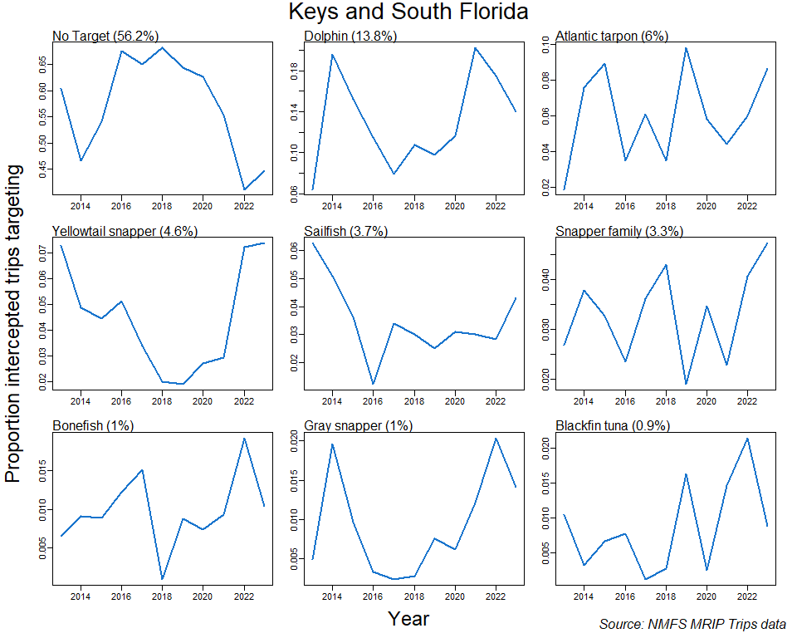

**Figure 6. Time series of the proportion of sampled for-hire trips targeting each of the top 9 fish species targets in the Keys and South Florida region, for 2013-2023.**  
Each panel describes the time series for one of the top-targeted fish species (including no species targeted, “No Target”). Proportion of total for-hire trips targeting each species over the entire span of years (2013-2023) shown is provided in parentheses following each species’ name.

### Sample Sizes of data for this report

Some counties do not have a large for-hire fishing industry, and it is important to understand if the data in this report come from relatively small samples. Here we provide the sample sizes for some of the types of trips referenced here. Please note these sample sizes describe the number of trips **surveyed**, not the total number of trips taken.

#### Table 5

Proportion of species targeted in for-hire trips, comparing county to state

| Type of for-hire trips | Number of trips sampled |
| --- | --- |
| All Keys and South Florida Region | 12282 |
| All Monroe County | 9679 |
| Monroe trips by Monroe County residents | 268 |
| Monroe trips by FL but not Monroe County residents | 2725 |
| Monroe trips by non-Monroe County residents | 9411 |
| Monroe trips by non-FL residents | 6686 |

**Table 5. The number of for-hire fishing trips intercepted and surveyed that were used for this report.** Note the table specifies sample sizes of for-hire trips taken to the broader Keys and South Florida region as well as those taken to Monroe County. Samples sizes of for-hire trips to Monroe County are further described by origin.

### References

Camp, E. V., Ahrens R. N. M., C. Crandall, and K. Lorenzen. 2018. “Angler travel distances: Implications for spatial approaches to marine recreational fisheries governance.” *Marine Policy* 87: 263–74.

NOAA, National Marine Fisheries Service. 2017. “Fisheries Economics of the United States, 2015.” NOAA Tech. Memo. NMFS-F/SPO-170. U.S. Depart. of Commerce.

USFWS, U. S. Fish Wildlife Service. 2011. “National Survey of Fishing, Hunting, and Wildlife-Associated Recreation.” U.S. Depart. of Commerce.