Angler Travel and Targeting Report 2024: Levy County

A data report for the Cedar Key Chamber of Commerce and the Levy County Visitors Bureau prepared by:

Ed Camp, Assistant Professor of Fisheries and Aquaculture Governance, University of Florida, [edvcamp@ufl.edu](mailto:edvcamp@ufl.edu)

Savanna Barry, Florida Sea Grant Regional Specialized Extension Agent Nature Coast, [savanna.barry@ufl.edu](mailto:savanna.barry@ufl.edu)

Table of Contents

### Abbreviations and Definitions

**NMFS**: National Marine Fisheries Service.  
**MRIP**: Marine Recreational Information Program, which is operated by NMFS to survey coastal anglers.  
**APAIS**: Access Point Angler Intercept Survey, the survey implemented by MRIP to collect information about angling.  
**Big Bend region**: refers to the areas of and marine waters adjacent to Dixie, Levy, Citrus, Hernando, and Pasco counties.

### Overview Summary

*Why this report might be important*  
Recreational fishing is one of the dominant recreational uses of marine ecosystems globally, and marine recreational fisheries (recreational fisheries occurring in saltwater) are particularly important to Florida. Florida has more saltwater anglers than any other state—2.4 million (USFWS 2011), with over a million saltwater fishing licenses sold annually. The total economic output (market activity) of saltwater fishing in Florida was estimated at around $8b annually (NOAA 2017), making fishing a vital part of Florida’s overall economy, and especially critical for coastal counties. Because of their importance, marine recreational fisheries in Florida are carefully managed by state (Florida Fish and Wildlife Conservation Commission; FWC) and by federal (NOAA’s National Marine Fisheries Service, NMFS) agencies. These two agencies partner to collect information about recreational fishing that is freely available to the public in the form of large databases. Extracting and visualizing these data can be challenging. We have queried these databases and summarized information we think may be helpful to the Cedar Key Chamber of Commerce and the Levy County Visitors Bureau. **Specifically this information can be used to inform advertisements of fishing-related tourism in Levy County.**

*What this report can be used for*  
This report is designed to provide information about marine recreational fishing dynamics in Levy County. Fishing dynamics include information about what species of fish recreational fishers (commonly called “anglers”) are most often trying to catch and where anglers come from when they fish marine waters from Levy County. Angler targeting and travel information may have several uses. Understanding what fish species are commonly targeted may help inform:

* Which species are most popular with local or non-local anglers.
* How to best advertise fishing in this area–e.g. what fish species should be pictured in advertisements.
* Which rule changes local anglers will care the most about.
* How changes in fish populations (like from a habitat change or fish kill) may affect fishing effort, angler travel, and eventually, local economies.

Information on where anglers come from when they fish local waters has multiple potential uses as well, and we think it can inform:

* Locations to place advertisements for local fishing. For example, does it make more sense to advertise Levy County recreational fishing in New York, or in Georgia?.
* Which people might want to be involved in local fisheries decision-making. For example, if many Levy County anglers reside in other counties, these anglers should perhaps be surveyed prior to any rule changes.

Together, this information is intended to help local governance entities, like the Cedar Key Chamber of Commerce and the Levy County Visitors Bureau, access and use data that can help them better serve their constituents and sustain or improve the economic effects of marine recreational fishing in Levy County.

*Where the information from this report comes from*  
All of the data in this report come from the NOAA’s National Marine Fisheries Program (NMFS) Marine Recreational Information Program (MRIP). These data are publicly available for download at <https://www.fisheries.noaa.gov/recreational-fishing-data/data-downloads>. The MRIP program contains information voluntarily provided by anglers at fishing locations surveyed according to a scientifically designed sampling program. Data are continuously collected, but data in this report are for years 2013-2023. Future reports will show updated data as they are available.

### NMFS MRIP background

*What is MRIP?*  
While commercial fishers have a separate reporting system with specific requirements for commercial fishers to report fishing locations and catches to state and federal agencies, no such requirements exist for recreational fishers The MRIP is NMFS’s way of gathering information needed to sustainably manage recreational fisheries. The MRIP allows state and federal researchers and managers to understand things like:

* How many recreational fishing trips are being taken in a region and time period?
* How many of these trips target a certain species?
* What are angling catch rates and how are they changing?
* What are the sizes of fish that are harvested?

These things can be important for developing stock assessments that inform fisheries management decisions. The MRIP system includes two main surveys. One is an “access point” or “intercept” survey designed to understand aspects of fishing trips like length of trip, origin, target species, etc. The other, which this report does not use, is designed to understand what proportion of the human population in an area is engaging in these types of fishing trips. Information from the two surveys is combined to allow researchers to estimate some of the information described in the bullet points above, as well as important things like the total amount of a certain fish species that recreational fishers harvest or remove in a region and time.

*What MRIP information does this report use?*  
It is important to understand that this report does not use the estimates from MRIP. This report only uses the actual data provided by the angler intercept survey. This means all the data here are exactly what anglers are telling surveyors when they are interviewed. This distinction is important for a couple reasons. The data used here are simply descriptive. We do not show “error” or “uncertainty” around them, because we are reporting the metrics from the database, and not extrapolating the data by any factors or subjecting them to statistical estimation processes. What this means, is that the data here will be correct as long as anglers are correctly reporting to surveyors what they did when they went fishing.

*Additional information about MRIP*  
A lot of additional information is available about the NMFS MRIP data and how these data are used. We have described the parts of this information that are important to know to understand and best use the data provided in this report. Additional information directly through NOAA Fisheries at <https://www.fisheries.noaa.gov/topic/recreational-fishing-data>, as well as through the Marine Resource Education Program, MREP (different from MRIP), for which more information is available at: <https://www.gmri.org/our-work/fisheries-convening/mrep-southeast>. Finally, many Florida Sea Grant agents and county faculty, FWC personnel, and University of Florida researchers know about MRIP and may be able to answer additional questions.

### Fishing Trip Origins: Where do your anglers come from?

*Background on data used*  
Every recreational fishing trip made has an origin and a destination. In the MRIP data system, the origin is described as the angler’s residence, and the destination is defined as where the angler was intercepted (e.g., boat ramp, fishing pier, etc.). For this report, the residence is considered to be the population centroid of the angler’s county-of-residence. The population centroid is the spatial location in a county that “balances” the counties population. This means the centroid isn’t the geographical center of the county, but it is the most likely “average” location for a person to come from, given we know they live in a certain county. The fishing site destinations that are surveyed include those in the MRIP Access Point Angler Intercept Survey (APAIS). What is important is that these destination sites are selected as part of a statistically designed survey. Further information about APAIS and the specific destinations is available at: <https://www.fisheries.noaa.gov/recreational-fishing-data/public-access-fishing-site-register>

*Fishing Trip Origins: Background on methods used*  
For the recreational fishing trip origin information, we use data available in the MRIP “trips” databases that describe the results of the MRIP APAIS survey—this is the information that anglers tell surveyors when they are interviewed about their trips. We designed queries that let us look at the anglers that were interviewed in specifically Levy County—i.e. the trips where anglers’ fishing destination was in marine waters adjacent to Levy County, regardless of where the origin was. Once we have isolated the trips occurring in Levy County, we can analyze where most of these trips came from. Specifically, we can look at things like:

* The proportion of trips sampled in Levy County that come from out-of-state origins.
* The proportion of trips sampled in Levy County with in-state origins.
* Both the above, but for trips in a multi-county region that includes Levy County.

One thing that is important to note is that we report the proportion of the sampled trips. This is not the same as reporting the total number of trips. Enumerating the total number of trips would require estimation tools that are not described here. However, because of the statistical design that the MRIP APAIS survey is implemented, the proportions we use (of sampled trips) should correspond to the total numbers of trips. What this means is that the information in this report can be very useful for things like understanding where people, on average, are coming from when then fish Levy County. Additional information on angler trip analyses is provided in (Camp et al. 2018).

We provide two types of information about angler origins:

* Tables describing where anglers come from.
* Figures of maps graphically illustrating anglers travel.

### Fishing Trip Origins Results: Tables

We provide two tables summarizing where anglers come from when they fish various parts of Florida and specifically the Big Bend region and Levy County.  
**Table 1** compares the states that out-of-state anglers come from when they fish either anywhere in Florida, the Big Bend region, or specifically Levy County.  
**Table 2** shows the county-origins of trips made by Florida residents. It compares the proportion of sampled trips coming from counties by anglers (*i*) living outside of the Big Bend region, (*ii*) living outside of Levy County, and (*iii*) living anywhere in Florida, including Levy County.

We anticipate these tables may be useful in several ways, including:

* Understanding where anglers fishing in Levy County come from, which may inform placement of fishing and tourism advertisements.
* Understanding how angler origins may differ between Levy County and surrounding areas. This can potentially be used to further fine tune efficient advertisement placement by identifying locations where Levy County may compete more or less with nearby counties for angling visitors.
* Understanding what proportion of anglers fishing Levy County are local vs. visitors, which may be useful for deciding where to have meetings about Levy County fishing.

#### Table 1

Out-of-state angler origins comparison

| Origin when fishing FL | Percent(%) | Origin when fishing Big Bend | Percent(%) | Origin when fishing Levy | Percent(%) |
| --- | --- | --- | --- | --- | --- |
| Georgia | 14.8 | Georgia | 15.3 | Georgia | 19.0 |
| Alabama | 6.3 | Michigan | 8.0 | Illinois | 8.6 |
| Texas | 5.7 | Illinois | 7.9 | Michigan | 8.0 |
| Not Available | 5.7 | New York | 5.9 | North Carolina | 6.6 |
| Tennessee | 4.9 | Pennsylvania | 5.7 | Ohio | 6.0 |
| Ohio | 4.8 | Ohio | 4.4 | Pennsylvania | 5.2 |
| Michigan | 4.7 | Not Available | 4.2 | Kentucky | 4.0 |
| Illinois | 4.5 | Tennessee | 4.1 | West Virginia | 3.4 |
| New York | 4.1 | North Carolina | 3.6 | Indiana | 3.2 |
| Pennsylvania | 3.5 | Indiana | 2.8 | Texas | 3.2 |

**Table 1. State origins of anglers fishing Florida, the Big Bend region, and Levy County, for 2013-2023.**  
This table compares which states out-of-state anglers come from when they fish either Florida as a whole, the Big Bend region (here defined as including Dixie, Levy, Citrus, Hernando, and Pasco counties), or Levy County.

* Columns 1 & 2 show what states non-Florida residents come from when they fish in **Florida**.
* Columns 3 & 4 show what states non-Florida residents come from when they fish the **** region.
* Columns 5 & 6 show what states non-Florida residents come from when they fish **Levy** County.

This comparison allows understanding where (*i*) out of state anglers fishing Levy County come from, and (*ii*) how that compares to the local region and broader state of Florida. This may be helpful for understanding if Levy County is attracting anglers from specific origins differently than the surrounding region of the Big Bend, or Florida as a whole. The “Not Available” is returned either when anglers refuse to give state of origin, or do not reside in the US-i.e. international visitors.

#### Table 2

In-state angler origin comparison

| Out-of-region Orig. | Percent(%) | Out-of-county Orig. | Percent(%) | Any Orig. | Percent(%) |
| --- | --- | --- | --- | --- | --- |
| Marion | 21.7 | Alachua | 32.5 | Alachua | 24.6 |
| Alachua | 15.6 | Marion | 30.1 | Levy | 24.2 |
| Hillsborough | 12.0 | Citrus | 7.4 | Marion | 22.8 |
| Pinellas | 10.0 | Lake | 3.1 | Citrus | 5.6 |
| Sumter | 7.5 | Columbia | 2.6 | Lake | 2.3 |
| Lake | 7.2 | Gilchrist | 2.6 | Columbia | 2.0 |
| Polk | 3.1 | Sumter | 2.3 | Gilchrist | 2.0 |
| Columbia | 2.9 | Suwannee | 1.4 | Sumter | 1.7 |
| Gilchrist | 2.2 | Duval | 1.3 | Suwannee | 1.1 |
| Orange | 2.2 | Clay | 1.2 | Duval | 1.0 |

**Table 2. County origins of Florida anglers fishing the Big Bend region and Levy county, for 2013-2023.**  
This table compares which counties Florida resident anglers come from when they fish the Big Bend region (Dixie, Levy, Citrus, Hernando, and Pasco counties) or specifically Levy County.

* Columns 1 & 2 show where Florida residents who live outside of the Big Bend region come from when they fish the Big Bend region.
* Columns 3 & 4 show where Florida residents who live outside of Levy County come from when they fish Levy County.
* Columns 5 & 6 show where Florida residents come from, regardless of where they live, when they fish Levy County.

This comparison allows understanding (*i*) where Florida resident anglers fishing the Big Bend region and Levy County come from, and (*ii*) the Florida counties from which the greatest proportion of out-of-county trips come from. It also may be useful to understand the approximate percent of trips that are made by county residents vs. all county non-residents. For Levy County, 22% of trips intercepted were made by residents, and 78% were made by non-county residents.

### Fishing Trip Origin Results: Maps

We provide several maps to graphically illustrate where sampled anglers come from when they fish the Big Bend region and Levy County. The maps show the “direct line” paths between the population centroids of anglers’ county of residence and the location where they were sampled by the MRIP APAIS survey-i.e. their fishing destinations. For all maps, thicker and warmer colored lines indicate more trips from a given county to a given destination, and thinner and cooler colors suggests fewer trips. Here, different maps are created for different species, including the top five species targeted in the Big Bend region.  
**Figure 1** maps trips to Levy County regardless of species targeted.  
**Figure 2** maps trips to the Big Bend region when anglers targeted Red drum.  
**Figure 3** maps trips to the Big Bend region when anglers targeted Spotted seatrout.  
**Figure 4** maps trips to the Big Bend region when anglers targeted Gag.  
**Figure 5** maps trips to the Big Bend region when anglers targeted Common snook.  
**Figure 6** maps trips to the Big Bend region when anglers targeted Gray snapper.

The primary purpose of these figures is to serve as a visual aid to augment the use of the previous tables.

#### Figure 1.

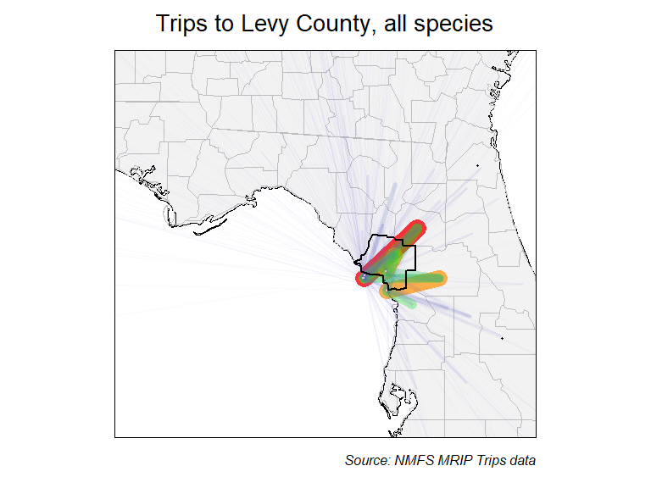

**Figure 1. Map showing where trips fishing Levy County originated in, regardless of species targeted, for 2013-2023.** Thicker and warmer colored lines show relatively more trips taken, and thinner, cooler colored lines show that relatively fewer trips were taken.

#### Figure 2.

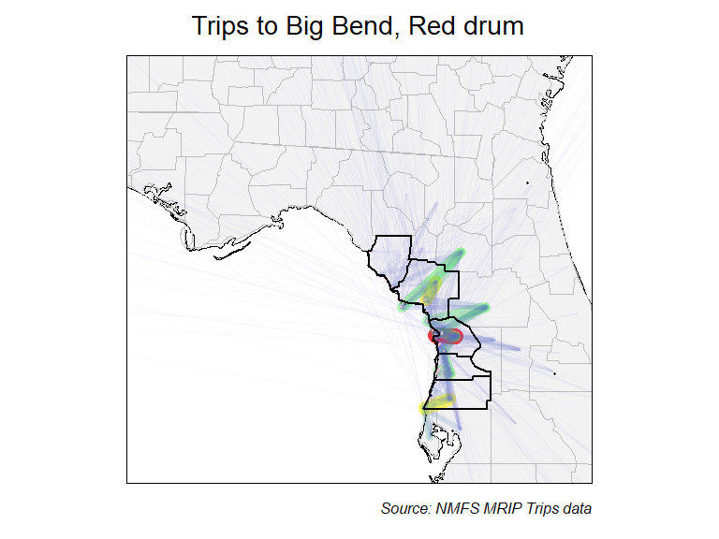

**Figure 2. Map showing where trips fishing the Big Bend region originated in, when targeted Red drum, for 2013-2023.** Thicker and warmer colored lines show relatively more trips taken, and thinner, cooler colored lines show that relatively fewer trips were taken.

#### Figure 3.

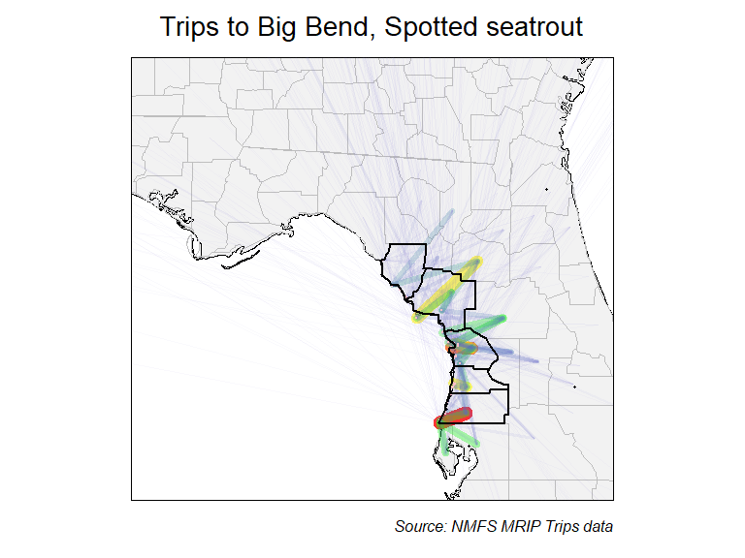

**Figure 3. Map showing where trips fishing the Big Bend region originated in, when targeted Spotted seatrout, for 2013-2023.** Thicker and warmer colored lines show relatively more trips taken, and thinner, cooler colored lines show that relatively fewer trips were taken.

#### Figure 4.

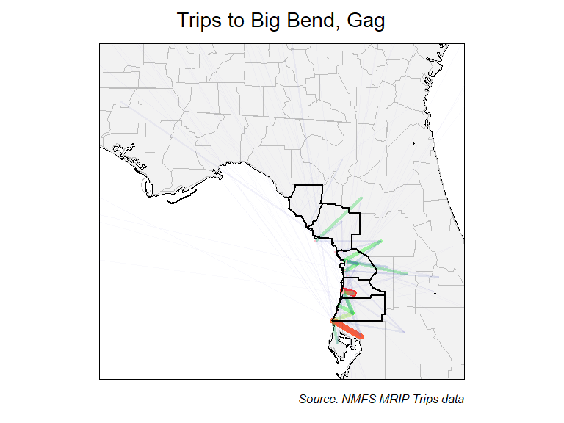

**Figure 4. Map showing where trips fishing the Big Bend region originated in, when targeted Gag, for 2013-2023.** Thicker and warmer colored lines show relatively more trips taken, and thinner, cooler colored lines show that relatively fewer trips were taken.

#### Figure 5.

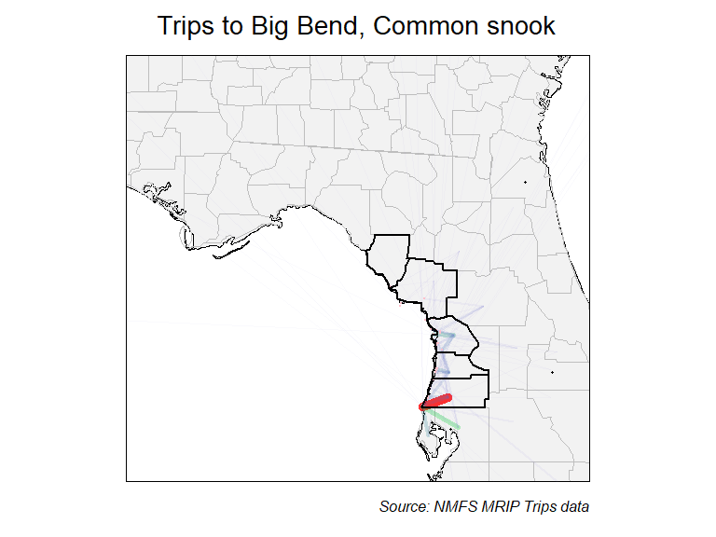

**Figure 5. Map showing where trips fishing the Big Bend region originated in, when targeted Common snook, for 2013-2023.** Thicker and warmer colored lines show relatively more trips taken, and thinner, cooler colored lines show that relatively fewer trips were taken.

#### Figure 6.

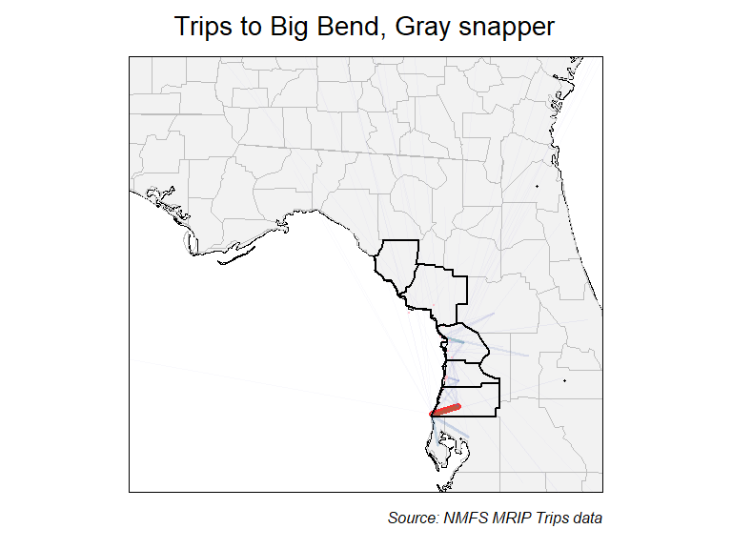

**Figure 6. Map showing where trips fishing the Big Bend region originated in, when targeted Gray snapper, for 2013-2023.** Thicker and warmer colored lines show relatively more trips taken, and thinner, cooler colored lines show that relatively fewer trips were taken.

### Species targeted: What do your anglers fish for?

*Background on data used*  
The MRIP APIAS includes questions about the species that interviewed anglers were targeting on their recently completed fishing trips. Specifically, anglers are asked what their “primary” and “secondary” targeted species were. Not all anglers provide a specific species. Statewide, nearly 50% of trips do not have a listed target, though certain regions have much greater proportions trips targeting specific fish. The species targeted information is used by MRIP to estimate fishing effort, but can be used here to understand what species are most commonly fished for. Further information about APAIS and the specific destinations is available at: <https://www.fisheries.noaa.gov/recreational-fishing-data/public-access-fishing-site-register>.

*Species targeted: Background on methods used*  
To understand what fish species anglers most commonly fished for, we use data available in the MRIP “trips” databases that describe the results of the MRIP APAIS survey. The “trips” database contains the information that anglers tell surveyors when they are interviewed about their recreational fishing trips. We designed a series of queries to calculate the proportions of trips targeting specific fish species. Queries represented different scenarios regarding where anglers were intercepted (their destinations) and where they listed their home residence (their origin). This information was summarized by pooling trips over time—i.e. looking at the last 10 years (2013-2023) together. To assess potential changes in the fish that anglers target, we also analyzed time series for some of the most commonly targeted species. Time series were constructed by assessing the proportions of trips intercepted in the Big Bend region that targeted a specific species for each of the last 10 years.

*Species targeted: Information provided*  
Two types of information products were developed:

* Tables describing the proportions of trips targeting different fish species at various combinations of fishing locations and residences.
* Figures showing the time series of proportion of trips taken in the Big Bend region targeting the most popular fish species.

One thing that is important to note is that we report the proportion of the sampled trips targeting a certain species. This is not the same as reporting the total number of trips. Enumerating the total number of trips would require estimation tools that are not described here. However, because of the statistical design used to implement the MRIP APAIS survey, the proportions we use (of sampled trips) should correspond to the total numbers of trips. What this means is that the information in this report can be very useful for things like understanding where people, on average, are coming from when then fish Levy County.

### Species Targeted Results: Tables

Tables describing the proportions of trips targeting different fish species at various combinations of fishing locations and residences, including:

* Trips in all of Florida, regardless of origin.
* Trips in Florida’s 7 coast, regardless of origin.
* Trips in the Big Bend region, regardless of origin.
* Trips taken in Levy County, regardless of origin.
* Trips taken in Levy County by Levy County residents.
* Trips taken in Levy County by non-residents of Levy County.
* Trips taken in Levy County by out-of-state anglers.

These results are summarized in two separate tables that promote comparison of Levy County to surrounding areas. All results represent data pooled over the last 10 years (2013-2023).

We anticipate these tables may be useful in several ways, including:

* Understanding what species anglers are targeting when they fish in Levy County, which may help inform local government interest in state and regional fisheries management issues.
* Understanding what species visiting (non Levy-County residents) anglers target, which may inform the media outlets and visuals (e.g., fish photos) of future advertisements).

#### Table 3

Proportion of species targeted, comparing county to state

| FL trips | Prop. | FL 7 trips | Prop. | Big Bend trips | Prop. | Levy trips | Prop. |
| --- | --- | --- | --- | --- | --- | --- | --- |
| No Target | 0.460 | No Target | 0.448 | No Target | 0.345 | No Target | 0.344 |
| Red drum | 0.103 | Red drum | 0.103 | Red drum | 0.236 | Red drum | 0.317 |
| Spotted seatrout | 0.064 | Spotted seatrout | 0.083 | Spotted seatrout | 0.197 | Spotted seatrout | 0.217 |
| Common snook | 0.047 | Common snook | 0.049 | Gag | 0.057 | Sheepshead | 0.021 |
| Dolphin | 0.037 | Red snapper | 0.034 | Common snook | 0.033 | Gag | 0.018 |
| King mackerel | 0.026 | Gray snapper | 0.030 | Gray snapper | 0.017 | Black drum | 0.011 |
| Red snapper | 0.026 | Spanish mackerel | 0.030 | Red grouper | 0.011 | Common snook | 0.009 |
| Gray snapper | 0.025 | King mackerel | 0.023 | Sheepshead | 0.011 | Cobia | 0.007 |
| Spanish mackerel | 0.023 | Gag | 0.022 | Cobia | 0.010 | Spanish mackerel | 0.007 |
| Sheepshead | 0.020 | Atlantic tarpon | 0.021 | Red snapper | 0.010 | Red snapper | 0.006 |

**Table 3. Comparison of species targeted in Levy county to other regions of Florida, for 2013-2023.**

* Columns 1 & 2 show species targeted for trips made throughout Florida.
* Columns 3 & 4 show species targeted for trips made to the 7 coast of Florida.
* Columns 5 & 6 show species targeted for trips made in the Big Bend region.
* Columns 7 & 8 show species targeted for trips made in Levy County.

#### Table 4

Proportion of species targeted, comparing county to state

| All Levy trips | Prop. | In county trips | Prop. | Out of county trips | Prop. | Out of state trips | Prop. |
| --- | --- | --- | --- | --- | --- | --- | --- |
| No Target | 0.344 | Red drum | 0.421 | No Target | 0.351 | No Target | 0.382 |
| Red drum | 0.317 | No Target | 0.318 | Red drum | 0.288 | Red drum | 0.264 |
| Spotted seatrout | 0.217 | Spotted seatrout | 0.182 | Spotted seatrout | 0.227 | Spotted seatrout | 0.247 |
| Sheepshead | 0.021 | Gag | 0.011 | Sheepshead | 0.025 | Gag | 0.023 |
| Gag | 0.018 | Sheepshead | 0.009 | Gag | 0.021 | White grunt | 0.020 |
| Black drum | 0.011 | Striped mullet | 0.008 | Black drum | 0.014 | Atlantic tarpon | 0.009 |
| Common snook | 0.009 | Tripletail | 0.008 | Common snook | 0.010 | Common snook | 0.009 |
| Cobia | 0.007 | Cobia | 0.007 | Spanish mackerel | 0.008 | Red snapper | 0.009 |
| Spanish mackerel | 0.007 | Common snook | 0.007 | Cobia | 0.007 | Sheepshead | 0.009 |
| Red snapper | 0.006 | Red snapper | 0.006 | Red grouper | 0.006 | Black drum | 0.006 |

**Table 4. Proportions of species targeted by fishing trips made in Levy county by anglers from various origins, for 2013-2023.**

* Columns 1 & 2 show the species targeted by all trips made in Levy County.
* Columns 3 & 4 show the species targeted in Levy County by Levy residents.
* Columns 5 & 6 show the species targeted in Levy County by Florida residents not living in Levy County.
* Columns 7 & 8 shows the species targeted in Levy County by non-residents of Florida.

### Species Targeted Results: Time series figures

We provide time series of the proportion of intercepted trips that targeted each of the top nine species fished for in the Big Bend region. Data are available for each year from 2013-2023, and represent the raw proportions of surveyed trips, which means that no uncertainty estimates (e.g. “error” bars) are relevant to these data.

The multi-panel figure below should primarily be useful for understanding how the species of fish anglers target when they fish has changed in recent years. These changes may be related to changes in angler’s preferences, but can have other causes as well, such as:

* Changes in costs of fishing (e.g., fuel), since some species require larger boats or longer travel times to target.
* Changes in fishing regulations for specific species.
* Changes in knowledge of how to successfully target specific species.
* Changes in fish populations, which can be the result of changing fishing, fisheries management, or habitat, as well as perturbations like red tide or cold kills.

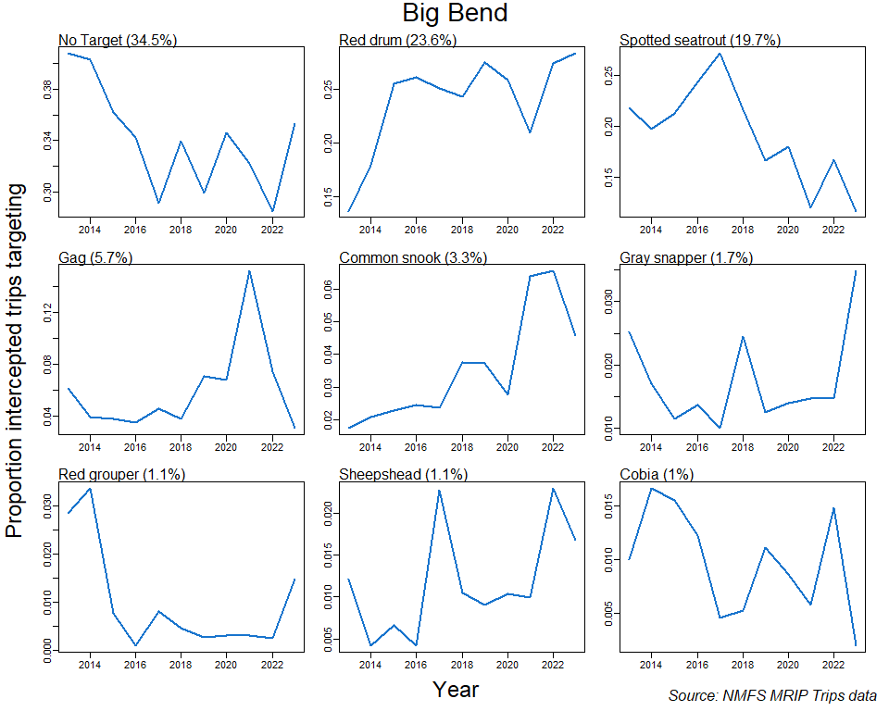

**Figure 6. Time series of the proportion of intercepted trips targeting each of the top 9 fish species targets in the Big Bend region, for 2013-2023.**  
Each panel describes the time series for one of the top-targeted fish species (including no species targeted, “No Target”). Proportion of total trips targeting each species over the entire span of years (2013-2023) shown is provided in parentheses following each species’ name.

### References

Camp, E. V., Ahrens R. N. M., C. Crandall, and K. Lorenzen. 2018. “Angler travel distances: Implications for spatial approaches to marine recreational fisheries governance.” *Marine Policy* 87: 263–74.

NOAA, National Marine Fisheries Service. 2017. “Fisheries Economics of the United States, 2015.” NOAA Tech. Memo. NMFS-F/SPO-170. U.S. Depart. of Commerce.

USFWS, U. S. Fish Wildlife Service. 2011. “National Survey of Fishing, Hunting, and Wildlife-Associated Recreation.” U.S. Depart. of Commerce.