For-Hire Angler Travel and Targeting Report 2025: Brevard County
A data report for the Space Coast Office of Tourism prepared by:
Edward Camp, Associate Professor of Fisheries and Aquaculture Governance, University of Florida, edvcamp@ufl.edu
Holly Abeels, Florida Sea Grant Extension Agent Brevard County, habeels@ufl.edu
Table of Contents

Abbreviations and Definitions
NMFS: National Marine Fisheries Service, sometimes called NOAA Fisheries MRIP: Marine Recreational Information Program, which is operated by NOAA Fisheries to survey coastal anglers.
APAIS: Access Point Angler Intercept Survey, the survey implemented by MRIP to collect information about angling.
East Central FL region: refers to the areas of and marine waters adjacent to Volusia and Brevard counties. For-hire: Refers to fishing trips and anglers who pay to fish with someone else, such as with a guide, a charter captian, or on a head- or party boat.

Overview Summary
Why this report might be important
Recreational fishing is one of the dominant recreational uses of marine ecosystems globally, and marine recreational fisheries (recreational fisheries occurring in saltwater) are particularly important to Florida. The fore-hire fishing sector–in which anglers pay to fish with a guide or captiain, in of particular importance because they (1) provide access to fisheries to those who often may not have thier own vessel, and (2) provide a livelihood for those guides, captain’s, and deckhands in the fore-hire business. Information about for-hire fisheries is collected by state () and by federal (NOAA Fisheries) agencies. This information is available in large databases such as the NOAA Marine Recreational Information Program (MRIP), but requires expertise to query, extract, and visualize. We have queried these databases and summarized for-hire information we think may be helpful to the Space Coast Office of Tourism. Specifically this information can be used to inform for-hire fishing-related tourism in Brevard County.
What this report can be used for
This report is designed to provide information about marine recreational for-hire fishing dynamics in Brevard County. The for-hire fishing sector includes private charters where a small group of anglers (usually 1-6 people) hire a guide to take them fishing, as well as “party” or “head” boats, where usually 20 or more anglers pay per person to fish from a larger, captained boat. The for-hire fishing industry is important for several reasons. First, it represents employment and livelihoods for the guides, captains, and crew offering for-hire fishing services. Second, the for-hire sector allows people who do not own or rent their own boats access to recreational fishing. Finally, the for-hire sector can play a role in tourist decisions, as the availability of for-hire fishing can attract angler from out of county, state, or even country to travel to local areas to stay and fish.
The for-hire fishing dynamics described here include information about what species of fish for-hire recreational fishers (here called “angler clients”) are most often trying to catch and where angler clients come from when they make a for-hire trip to marine waters from Brevard County. Angler targeting and travel information may have several uses. Understanding what fish species are commonly targeted may help inform:
- Which species are most popular with local or non-local angler clients.
- How to best advertise fishing in this area–e.g. what fish species should be pictured in advertisements.
- Which fishery management rule changes might most affect the local for-hire industry and their angler clients.
- How changes in fish populations (like from a habitat change or fish kill) may affect the amount of for-hire fishing trips, angler travel, and eventually, local economies.
Information on where anglers come from when they fish local waters has multiple potential uses as well, and we think it can inform:
- Locations to place advertisements for local for-hire fishing. For example, does it make more sense to advertise Brevard County recreational fishing in New York, or in Georgia?
- Which people might want to be involved in local for-hire fisheries decision-making. For example, if many angler clients who commonly fish Brevard County reside in other counties, these anglers may be interested in Brevard County rule changes.
Together, this information is intended to help the local for-hire fishing industry and related tourism industry of Brevard County. It may also be useful to the the Space Coast Office of Tourism, especially if they work with or on behalf of the for-hire fishing industry to promote marine for-hire fishing-based tourism in Brevard County.
Where the information from this report comes from
All of the data in this report come from the NOAA’s National Marine Fisheries Program (NMFS) Marine Recreational Information Program (MRIP). These data are publicly available for download at https://www.fisheries.noaa.gov/recreational-fishing-data/data-downloads. The MRIP program contains information voluntarily provided by anglers at fishing locations surveyed according to a scientifically designed sampling program. Data are continuously collected, but data in this report are for years 2014-2024. Future reports will show updated data as they are available.

NMFS MRIP background
What is MRIP?
The MRIP is NOAA Fisheries’ data program to inform sustainable management of recreational fisheries, and helps decision-makers understand things like:
- How many recreational fishing trips are being taken in a region and time period?
- How many of these trips target a certain species?
- What are angling catch rates and how are they changing?
- What are the sizes of fish that are harvested?
- Are these trips for-hire, private-recreational (fishing out of a personal or rented vessel) or shore-based? These separate categories are called the fishing “mode” in MRIP.
The MRIP system includes two main surveys. One is an “access point” or “intercept” survey designed to understand aspects of fishing trips like length of trip, origin, target species, etc. The other survey, which this report does not use, is designed to understand what proportion of the human population in an area is engaging in these types of fishing trips. Information from the two surveys is combined to allow researchers to estimate some of the information described in the bullet points above, as well as important things like the total amount of a certain fish species that recreational fishers harvest or remove in a region and time.
What MRIP information does this report use?
This report only uses the actual data provided by the angler intercept survey–i.e. from interviews with anglers returning from fishing. Specifically this report only includes information from anglers who were on for-hire trips. This means all the data shown here are what anglers are saying when they are interviewed. We do not show “error” or “uncertainty” around the data presented because we are reporting the metrics from the database, and not extrapolating the data by any factors or subjecting them to statistical estimation processes. The data in this report are what for-hire anglers said, may not always describe the overall for-hire angler population, especially in places or times when few for-hire anglers were interviewed.
Additional information about MRIP
Additional information is available about the NMFS MRIP data and their use. Additional information directly through NOAA Fisheries at https://www.fisheries.noaa.gov/topic/recreational-fishing-data, as well as through the Marine Resource Education Program, MREP, for which more information is available at: https://www.gmri.org/our-work/fisheries-convening/mrep-southeast. Finally, many Sea Grant agents and county faculty, personnel, and researchers know about MRIP and may be able to answer additional questions.

Fishing Trip Origins: Where do your for-hire anglers come from?
Background on data used
Recreational fishing trips all have an origin and a destination. In the MRIP data system, the origin is described as the angler’s county of residence, and this report uses the population centroid of that county as the origin location. The MRIP data defines the destination as the specific place where the angler was intercepted by the MRIP survey (e.g., boat ramp, fishing pier, etc.). The fishing site destinations that are surveyed include those in the MRIP Access Point Angler Intercept Survey (APAIS). What is important is that these destination sites are selected as part of a statistically designed survey. Further information about APAIS and the specific destinations is available at: https://www.fisheries.noaa.gov/recreational-fishing-data/public-access-fishing-site-register
Fishing Trip Origins: Background on methods used
For the recreational fishing trip origin information, we use data available in the MRIP “trips” databases that describe the results of the MRIP APAIS survey—this is the information that anglers tell surveyors when they are interviewed about their trips. We designed queries that let us look at the anglers that were interviewed in specifically Brevard County—i.e. the trips where anglers’ fishing destination was in marine waters adjacent to Brevard County, regardless of where the origin was. Once we have isolated the trips occurring in Brevard County, we can analyze where most of these trips came from. Specifically, we can look at things like:
- The percent of for-hire trips sampled in Brevard County that come from out-of-state origins.
- The percent of for-hire trips sampled in Brevard County with in-state origins.
- The percent of for-hire trips sampled in Brevard County with in-state but out-of-county origins.
The above are important for understanding how people and dollars move from out of the county to in to the county becuase of the for-hire fishery. However, this report does not calculate those dollars, or provide the estimates of the total numbers of trips. Some of this information is provided in other reports available upon request of the authors, and additional information on angler trip analyses is provided in (Camp et al. 2018).
We provide two types of information about for-hire angler origins:
- Tables describing where for-hire anglers come from.
- Figures of maps graphically illustrating for-hire anglers’ travel.

Fishing Trip Origins Results: Tables
We provide two tables summarizing where for-hire anglers come from when they fish various parts of Florida and specifically the East Central FL region and Brevard County.
Table 1 compares the states that out-of-state for-hire anglers come from when they fish either anywhere in Florida, the East Central FL region, or specifically Brevard County.
Table 2 shows the county-origins of trips made by Florida residents. It compares the proportion of sampled trips coming from counties by for-hire anglers (i) living outside of the East Central FL region, (ii) living outside of Brevard County, and (iii) living anywhere in Florida, including Brevard County.
We anticipate these tables may be useful in several ways, including:
- Understanding where for-hire anglers fishing in Brevard County come from, which may inform placement of fishing and tourism advertisements.
- Understanding how for-hire angler origins may differ between Brevard County and surrounding areas. This can potentially be used to further fine tune efficient advertisement placement by identifying locations where Brevard County may compete more or less with nearby counties for angling visitors.
- Understanding what proportion of for-hire anglers fishing Brevard County are local vs. visitors, which may be useful for deciding where to have meetings about Brevard County fishing.

Table 1
Out-of-state angler origins comparison
Origin when fishing FL | Per. (%) | Origin when fishing East Central FL | Per. (%) | Origin when fishing Brevard | Per. (%)
Georgia | 10.1 | Georgia | 10.5 | Texas | 8.0
Texas | 7.8 | Texas | 6.9 | Michigan | 6.6
Tennessee | 5.3 | Michigan | 5.9 | Not Available | 6.0
Not Available | 5.1 | Minnesota | 4.9 | Minnesota | 5.6
Ohio | 4.9 | Not Available | 4.8 | Georgia | 5.4
Illinois | 4.7 | Ohio | 4.5 | Missouri | 4.5
Michigan | 4.5 | Missouri | 4.4 | Ohio | 4.3
New York | 4.1 | Tennessee | 4.2 | Indiana | 4.1
Alabama | 3.9 | Indiana | 4.1 | Kentucky | 3.6
Indiana | 3.4 | Pennsylvania | 3.5 | Tennessee | 3.6
Table 1. Where out-of-state for-hire anglers came from when they fished Florida, the East Central FL region, and Brevard County, for 2014-2024.
This table shows the top ten states that out-of-state for-hire anglers come from when they fish in Florida. It allows comparisons of out-of-state origins for Florida as a whole, the East Central FL region (here defined as including Volusia and Brevard counties), and Brevard County.
- Columns 1 & 2 show where non-Florida residents come from when they for-hire fish in Florida.
- Columns 3 & 4 show where non-Florida residents come from when they for-hire fish the East Central FL region.
- Columns 5 & 6 show where non-Florida residents come from when they for-hire fish Brevard County.
This comparison allows understanding where (i) out of state for-hire anglers fishing Brevard County come from, and (ii) how that compares to the local region and broader state of Florida. This may be helpful for understanding if Brevard County is attracting anglers from specific origins differently than the surrounding region of the East Central FL, or Florida as a whole. The “Not Available” is returned either when anglers refuse to give state of origin, or do not reside in the US-i.e. international visitors.

Table 2
In-state angler origin comparison
Out-of-region Orig. | Per. (%) | Out-of-county Orig. | Per. (%) | Any Orig. | Per. (%)
Orange | 32.3 | Orange | 34.2 | Brevard | 29.6
Seminole | 19.0 | Seminole | 17.0 | Orange | 24.1
Lake | 10.8 | Lake | 9.7 | Seminole | 12.0
Osceola | 5.8 | Osceola | 6.2 | Lake | 6.8
Polk | 4.4 | Volusia | 6.1 | Osceola | 4.4
Marion | 2.9 | Polk | 5.0 | Volusia | 4.3
Alachua | 2.2 | Hillsborough | 1.8 | Polk | 3.5
Duval | 2.1 | Marion | 1.7 | Hillsborough | 1.3
Hillsborough | 2.1 | Duval | 1.5 | Marion | 1.2
Flagler | 1.8 | Pinellas | 1.5 | Duval | 1.1
Table 2. County origins of Florida for-hire anglers fishing the East Central FL region and Brevard county, for 2014-2024.
This table compares which counties Florida resident anglers come from when they fish the East Central FL region (Volusia and Brevard counties) or specifically Brevard County.
- Columns 1 & 2 show where Florida residents who live outside of the East Central FL region come from when they for-hire fish the East Central FL region.
- Columns 3 & 4 show where Florida residents who live outside of Brevard County come from when they for-hire fish Brevard County.
- Columns 5 & 6 show where Florida residents come from, regardless of what county they live in, when they for-hire fish Brevard County.
This comparison allows understanding (i) where Florida resident for-hire anglers fishing the East Central FL region and Brevard County come from, and (ii) the Florida counties from which the greatest proportion of out-of-county trips come from. It also may be useful to understand the approximate percent of trips that are made by county residents vs. all county non-residents. For Brevard County, 14% of trips intercepted were made by residents, and 86% were made by non-county residents.

Fishing Trip Origin Results: Maps
We provide several maps to graphically illustrate where sampled for-hire anglers come from when they fish the East Central FL region and Brevard County. The maps show the “direct line” paths between the population centroids of the for-hire anglers’ county of residence and the location where they were sampled by the MRIP APAIS survey-i.e. their fishing destinations. For all maps, thicker and warmer colored lines indicate more trips from a given county to a given destination, and thinner and cooler colors suggests fewer trips. Here, different maps are created for different species, including the top five species targeted in the East Central FL region.
Figure 1 maps trips to Brevard County regardless of species targeted.
Figure 2 maps trips to the East Central FL region when anglers targeted King mackerel.
Figure 3 maps trips to the East Central FL region when anglers targeted Red drum.
Figure 4 maps trips to the East Central FL region when anglers targeted Requiem shark family.
Figure 5 maps trips to the East Central FL region when anglers targeted Dolphin.
Figure 6 maps trips to the East Central FL region when anglers targeted Red snapper.
The primary purpose of these figures is to serve as a visual aid to augment the use of the previous tables.

Figure 1.
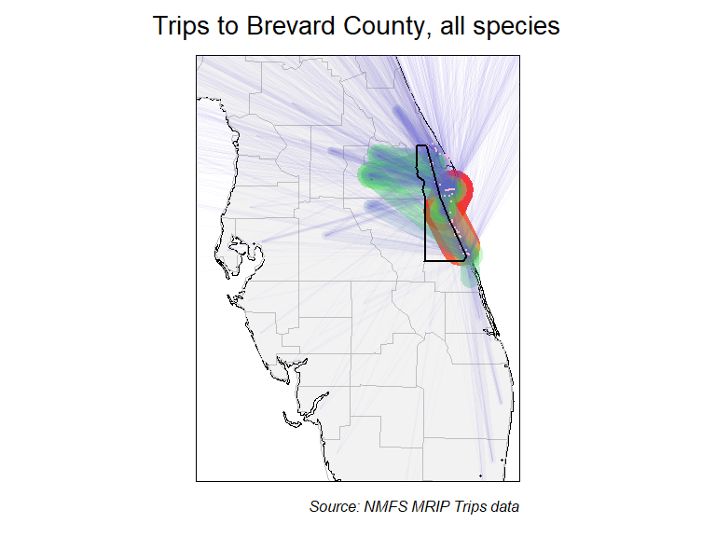
Figure 1. Map showing where for-hire trips fishing Brevard County originated in, regardless of species targeted, for 2014-2024. Thicker and warmer colored lines show relatively more trips taken, and thinner, cooler colored lines show that relatively fewer trips were taken.

Figure 2.
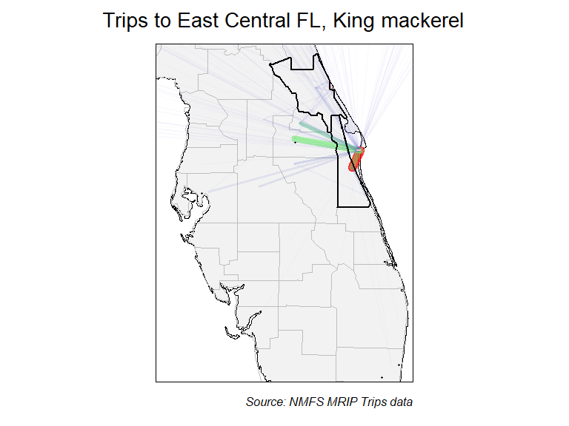
Figure 2. Map showing where for-hire trips fishing the East Central FL region originated in, when targeted King mackerel, for 2014-2024. Thicker and warmer colored lines show relatively more trips taken, and thinner, cooler colored lines show that relatively fewer trips were taken.

Figure 3.
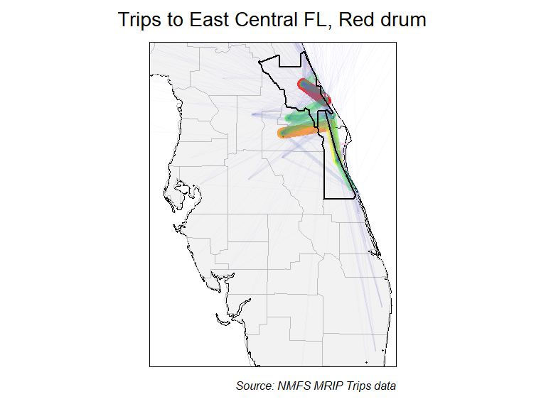
Figure 3. Map showing where for-hire trips fishing the East Central FL region originated in, when targeted Red drum, for 2014-2024. Thicker and warmer colored lines show relatively more trips taken, and thinner, cooler colored lines show that relatively fewer trips were taken.

Figure 4.
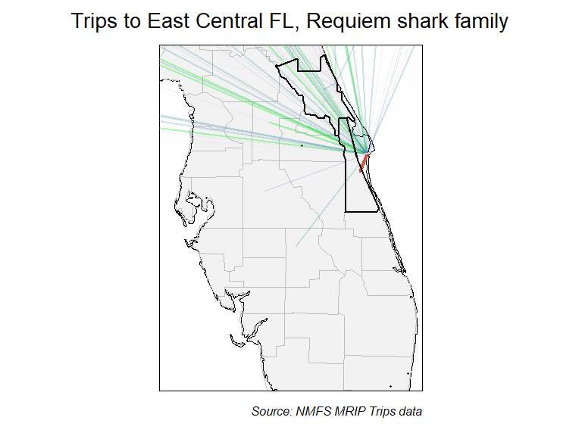
Figure 4. Map showing where for-hire trips fishing the East Central FL region originated in, when targeted Requiem shark family, for 2014-2024. Thicker and warmer colored lines show relatively more trips taken, and thinner, cooler colored lines show that relatively fewer trips were taken.

Figure 5.
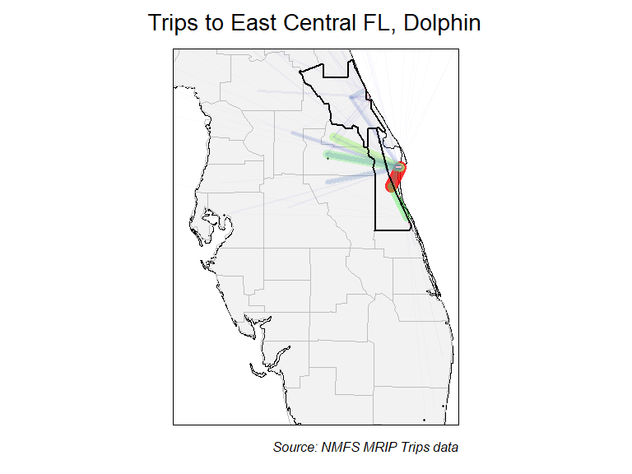
Figure 5. Map showing where for-hire trips fishing the East Central FL region originated in, when targeted Dolphin, for 2014-2024. Thicker and warmer colored lines show relatively more trips taken, and thinner, cooler colored lines show that relatively fewer trips were taken.

Figure 6.
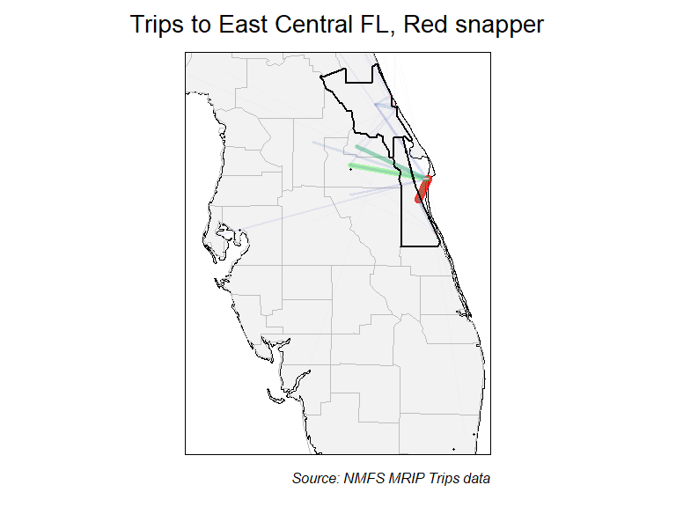
Figure 6. Map showing where for-hire trips fishing the East Central FL region originated in, when targeted Red snapper, for 2014-2024. Thicker and warmer colored lines show relatively more trips taken, and thinner, cooler colored lines show that relatively fewer trips were taken.

Species targeted: What do your for-hire anglers fish for?
Background on data used
The MRIP APIAS includes questions about the species that interviewed for-hire anglers were targeting on their recently completed fishing trips. Specifically, for-hire anglers are asked what their “primary” and “secondary” targeted species were. Not all anglers provide a specific species. Though many anglers do not specify a target (e.g., “fishing for whatever is biting”), this information is also useful. Further information about APAIS and the specific destinations is available at: https://www.fisheries.noaa.gov/recreational-fishing-data/public-access-fishing-site-register.
Species targeted: Background on methods used
We used MRIP “trips” data that contain information from intercepted for-hire angler interviews to understand what fish species anglers most commonly fished for. Essentially surveyors visit fishing access sites and ask anglers about their fishing trips. Data from these interviews are shown for different “queries”. Queries represented different scenarios regarding where anglers were intercepted (their destinations) and where they listed their home residence (their origin). This information was summarized by pooling trips over time—i.e. looking at the last 10 years (2014-2024) together. To assess potential changes in the fish that anglers target, we also analyzed time series for some of the most commonly targeted species. Time series were constructed by assessing the proportions of trips intercepted in the East Central FL region that targeted a specific species for each of the last 10 years.
Species targeted: Information provided
Two types of information products were developed:
- Tables describing the proportions of for-hire trips targeting different fish species at various combinations of fishing locations and residences.
- Figures showing the time series of proportion of for-hire trips taken in the East Central FL region targeting the most popular fish species.
It is important to note is that we report the percent of the sampled trips targeting a certain species, not the actual total estimates of trips targeting a species. The percentages we use here should closely match estimates because of the statistical design used to implement the MRIP APAIS survey. This means is that the information in this report can be very useful for things like understanding what people, on average, are fishing for when then fish Brevard County, but it wouldn’t be appropriate to try to use these percentages to understand the total amount of fishing effort.

Species Targeted Results: Tables
Tables describing the proportions of trips targeting different fish species at various combinations of fishing locations and residences, including:
- For-hire trips in all of Florida, regardless of origin.
- For-hire trips in the East Central FL region, regardless of origin.
- For-hire trips taken in Brevard County, regardless of origin.
- For-hire trips taken in Brevard County by Brevard County residents.
- For-hire trips taken in Brevard County by non-residents of Brevard County.
- For-hire trips taken in Brevard County by out-of-state anglers.
These results are summarized in two separate tables that promote comparison of Brevard County to surrounding areas. All results represent data pooled over the last 10 years (2014-2024).
We anticipate these tables may be useful in several ways, including:
- Understanding what species anglers are targeting when they fish in Brevard County, which may help inform local government interest in state and regional fisheries management issues.
- Understanding what species visiting (non Brevard-County residents) anglers target, which may inform the media outlets and visuals (e.g., fish photos) of future advertisements).

Table 3
Species targeted by for-hire trips, comparing county to state
FL trips | Per. (%) | East Central FL trips | Per. (%) | Brevard trips | Per. (%)
No Target | 49.0 | No Target | 59.4 | No Target | 59.1
Red snapper | 5.7 | King mackerel | 9.9 | King mackerel | 11.9
King mackerel | 4.6 | Red drum | 5.4 | Requiem shark family | 5.9
Red drum | 4.4 | Requiem shark family | 4.7 | Dolphin | 3.5
Dolphin | 4.1 | Dolphin | 3.8 | Red drum | 3.1
Red grouper | 3.5 | Red snapper | 3.2 | Red snapper | 3.0
Common snook | 2.8 | Greater amberjack | 1.6 | Greater amberjack | 1.7
Spanish mackerel | 2.6 | Amberjack genus | 1.3 | Sea bass family | 1.7
Spotted seatrout | 2.6 | Common snook | 1.2 | Amberjack genus | 1.6
Atlantic tarpon | 2.4 | Sea bass family | 1.2 | Requiem shark genus | 1.5
Table 3. Comparison of species targeted by for-hire anglers in Brevard county to other areas of Florida, for 2014-2024.
- Columns 1 & 2 show species targeted by for-hire trips made throughout Florida.
- Columns 3 & 4 show species targeted by for-hire trips made in the East Central FL region.
- Columns 5 & 6 show species targeted by for-hire trips made in Brevard County.

Table 4
Species targeted by for-hire trips, comparing county to state
In county trips | Per. (%) | Out of county trips | Per. (%) | Out of state trips | Per. (%)
No Target | 58.2 | No Target | 59.2 | No Target | 64.0
King mackerel | 10.7 | King mackerel | 12.1 | King mackerel | 11.5
Dolphin | 6.8 | Requiem shark family | 6.3 | Requiem shark family | 8.5
Amberjack genus | 5.5 | Red drum | 3.4 | Red drum | 2.8
Requiem shark family | 3.6 | Dolphin | 3.0 | Requiem shark genus | 2.6
Red snapper | 3.2 | Red snapper | 3.0 | Dolphin | 1.6
Common snook | 2.1 | Greater amberjack | 1.8 | Greater amberjack | 1.5
Sea bass family | 2.0 | Requiem shark genus | 1.7 | Common snook | 1.2
Atlantic tarpon | 1.4 | Sea bass family | 1.6 | Cobia | 0.7
Red drum | 1.2 | Common snook | 1.1 | Red snapper | 0.7
Table 4. Proportions of species targeted by fishing trips made in Brevard county by anglers from various origins, for 2014-2024.
- Columns 1 & 2 show the species targeted in Brevard County by Brevard County residents.
- Columns 3 & 4 show the species targeted in Brevard County by Florida residents not living in Brevard County.
- Columns 5 & 6 shows the species targeted in Brevard County by non-residents of Florida.

Species Targeted by For-Hire Trips: Time series figures
We provide time series of the proportion of intercepted for-hire trips that targeted each of the top nine species fished for in the East Central FL region. Data are available for each year from 2014-2024, and represent the raw proportions of surveyed trips, which means that no uncertainty estimates (e.g. “error” bars) are relevant to these data.
The multi-panel figure below should primarily be useful for understanding how the species of fish anglers target when they fish has changed in recent years. These changes may be related to changes in angler’s preferences, but can have other causes as well, such as:
- Changes in costs of fishing (e.g., fuel), since some species require larger boats or longer travel times to target.
- Changes in fishing regulations for specific species.
- Changes in knowledge of how to successfully target specific species.
- Changes in fish populations, which can be the result of changing fishing, fisheries management, or habitat, as well as perturbations like red tide or cold kills.

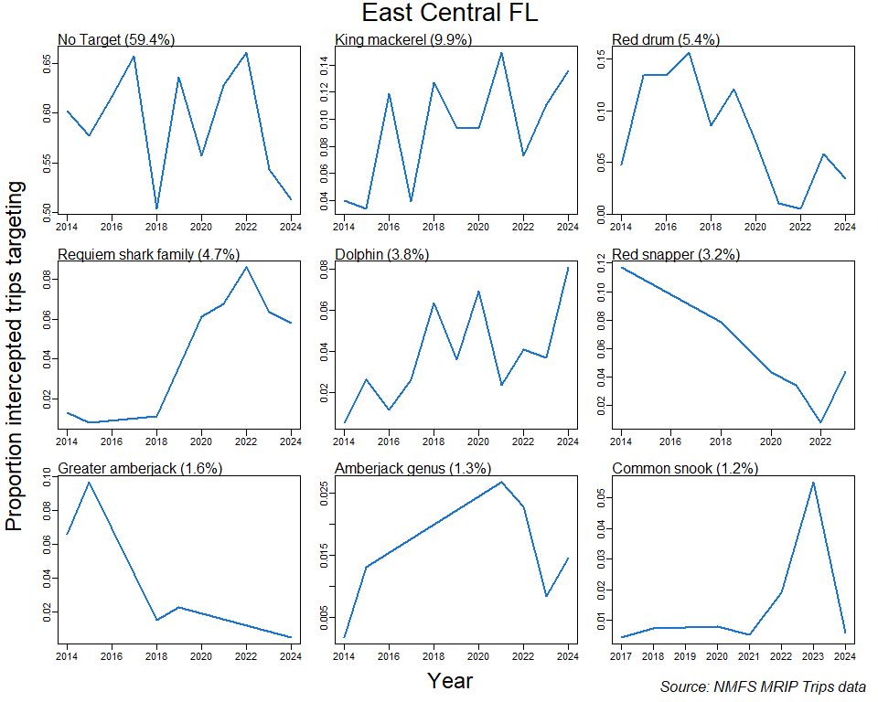
Figure 6. Time series of the proportion of intercepted for-hire trips targeting each of the top 9 fish species targets in the East Central FL region, for 2014-2024.
Each panel describes the time series for one of the top-targeted fish species (including no species targeted, “No Target”). Proportion of total trips targeting each species over the entire span of years (2014-2024) shown is provided in parentheses following each species’ name.

References
Camp, E. V., Ahrens R. N. M., C. Crandall, and K. Lorenzen. 2018. “Angler travel distances: Implications for spatial approaches to marine recreational fisheries governance.” Marine Policy 87: 263–74.

