Angler Travel and Targeting Report 2025: Lee County
A data report for the Lee County Government and Tourist Development Council prepared by:
Edward Camp, Associate Professor of Fisheries and Aquaculture Governance, University of Florida, edvcamp@ufl.edu
Michael Sipos, Florida Sea Grant Extension Agent Collier County, sipos624@ufl.edu
Table of Contents

Abbreviations and Definitions
NMFS: National Marine Fisheries Service.
MRIP: Marine Recreational Information Program, which is operated by NMFS to survey coastal anglers.
APAIS: Access Point Angler Intercept Survey, the survey implemented by MRIP to collect information about angling.
Charlotte Harbor region: refers to the areas of and marine waters adjacent to Charlotte and Lee counties.

Overview Summary
Why this report might be important
Recreational fishing is one of the dominant recreational uses of marine ecosystems globally, and marine recreational fisheries (recreational fisheries occurring in saltwater) are particularly important to Florida. Because of their importance, marine recreational fisheries in Florida are carefully managed by state () and by federal (NOAA’s National Marine Fisheries Service, NMFS) agencies. These two agencies partner to collect information about recreational fishing that is freely available to the public in the form of large databases. Extracting and visualizing these data can be challenging. We have queried these databases and summarized information we think may be helpful to the Lee County Government and Tourist Development Council. Specifically this information can be used to inform advertisements of fishing-related tourism in Lee County.
What this report can be used for
This report is designed to provide information about marine recreational fishing dynamics in Lee County. Fishing dynamics include information about what species of fish recreational fishers (commonly called “anglers”) are most often trying to catch and where anglers come from when they fish marine waters from Lee County. Angler targeting and travel information may have several uses. Understanding what fish species are commonly targeted may help inform:
- Which species are most popular with local or non-local anglers.
- How to best advertise fishing in this area–e.g. what fish species should be pictured in advertisements.
- Which rule changes local anglers will care the most about.
- How changes in fish populations (like from a habitat change or fish kill) may affect fishing effort, angler travel, and eventually, local economies.
Information on where anglers come from when they fish local waters has multiple potential uses as well, and we think it can inform:
- Locations to place advertisements for local fishing. For example, does it make more sense to advertise Lee County recreational fishing in New York, or in Georgia?.
- Which people might want to be involved in local fisheries decision-making. For example, if many Lee County anglers reside in other counties, these anglers should perhaps be surveyed prior to any rule changes.
Together, this information is intended to help local governance entities, like the Lee County Government and Tourist Development Council, access and use data that can help them better serve their constituents and sustain or improve the economic effects of marine recreational fishing in Lee County.
Where the information from this report comes from
All of the data in this report come from the NOAA’s National Marine Fisheries Program (NMFS) Marine Recreational Information Program (MRIP). These data are publicly available for download at https://www.fisheries.noaa.gov/recreational-fishing-data/data-downloads. The MRIP program contains information voluntarily provided by anglers at fishing locations surveyed according to a scientifically designed sampling program. Data are continuously collected, but data in this report are for years 2013-2023. Future reports will show updated data as they are available.

NMFS MRIP background
What is MRIP?
The Marine Recreational Information Program (MRIP) is NMFS’s way of gathering information needed to sustainably manage recreational fisheries. The MRIP allows state and federal researchers and managers to understand things like:
- How many recreational fishing trips are being taken in a region and time period?
- How many of these trips target a certain species?
- What are angling catch rates and how are they changing?
- What are the sizes of fish that are harvested?
These things can be important for developing stock assessments that inform fisheries management decisions. The MRIP system includes two main surveys. One is an “access point” or “intercept” survey designed to understand aspects of fishing trips like length of trip, origin, target species, etc. The other, which this report does not use, is designed to understand what proportion of the human population in an area is engaging in these types of fishing trips. Information from the two surveys is combined to allow researchers to estimate some of the information described in the bullet points above, as well as important things like the total amount of a certain fish species that recreational fishers harvest or remove in a region and time.
What MRIP information does this report use?
This report only uses the actual data provided by the angler intercept survey, and does not use any of the MRIP estimates. This means all the data shown here are what anglers are saying when they are interviewed. We do not show “error” or “uncertainty” around the data presented because we are reporting the metrics from the database, and not extrapolating the data by any factors or subjecting them to statistical estimation processes. The data we report should be “correct” in that they are what is reported, but if few anglers are intercepted, these may not always describe the overall angler population.
Additional information about MRIP
Additional information is available about the NMFS MRIP data and their use. Additional information directly through NOAA Fisheries at https://www.fisheries.noaa.gov/topic/recreational-fishing-data, as well as through the Marine Resource Education Program, MREP, for which more information is available at: https://www.gmri.org/our-work/fisheries-convening/mrep-southeast. Finally, many Sea Grant agents and county faculty, personnel, and researchers know about MRIP and may be able to answer additional questions.

Fishing Trip Origins: Where do your anglers come from?
Background on data used
Recreational fishing trips all have an origin and a destination. In the MRIP data system, the origin is described as the angler’s county of residence, and this report uses the population centroid of that county as the origin location. The MRIP data defines the destination as the specific place where the angler was intercepted by the MRIP survey (e.g., boat ramp, fishing pier, etc.). The fishing site destinations that are surveyed include those in the MRIP Access Point Angler Intercept Survey (APAIS). What is important is that these destination sites are selected as part of a statistically designed survey. Further information about APAIS and the specific destinations is available at: https://www.fisheries.noaa.gov/recreational-fishing-data/public-access-fishing-site-register
Fishing Trip Origins: Background on methods used
For the recreational fishing trip origin information, we use data available in the MRIP “trips” databases that describe the results of the MRIP APAIS survey—this is the information that anglers tell surveyors when they are interviewed about their trips. We designed queries that let us look at the anglers that were interviewed in specifically Lee County—i.e. the trips where anglers’ fishing destination was in marine waters adjacent to Lee County, regardless of where the origin was. Once we have isolated the trips occurring in Lee County, we can analyze where most of these trips came from. Specifically, we can look at things like:
- The proportion of trips sampled in Lee County that come from out-of-state origins.
- The proportion of trips sampled in Lee County with in-state origins.
- Both the above, but for trips in a multi-county region that includes Lee County.
One thing that is important to note is that we report the proportion of the sampled trips. This is not the same as reporting the total number of trips. Enumerating the total number of trips would require estimation tools that are not described here. However, because of the statistical design that the MRIP APAIS survey is implemented, the proportions we use (of sampled trips) should correspond to the total numbers of trips. What this means is that the information in this report can be very useful for things like understanding where people, on average, are coming from when then fish Lee County. Additional information on angler trip analyses is provided in (Camp et al. 2018).
We provide two types of information about angler origins:
- Tables describing where anglers come from.
- Figures of maps graphically illustrating anglers travel.

Fishing Trip Origins Results: Tables
We provide two tables summarizing where anglers come from when they fish various parts of Florida and specifically the Charlotte Harbor region and Lee County.
Table 1 compares the states that out-of-state anglers come from when they fish either anywhere in Florida, the Charlotte Harbor region, or specifically Lee County.
Table 2 shows the county-origins of trips made by Florida residents. It compares the proportion of sampled trips coming from counties by anglers (i) living outside of the Charlotte Harbor region, (ii) living outside of Lee County, and (iii) living anywhere in Florida, including Lee County.
We anticipate these tables may be useful in several ways, including:
- Understanding where anglers fishing in Lee County come from, which may inform placement of fishing and tourism advertisements.
- Understanding how angler origins may differ between Lee County and surrounding areas. This can potentially be used to further fine tune efficient advertisement placement by identifying locations where Lee County may compete more or less with nearby counties for angling visitors.
- Understanding what proportion of anglers fishing Lee County are local vs. visitors, which may be useful for deciding where to have meetings about Lee County fishing.

Table 1
Out-of-state angler origins comparison
Origin when fishing FL | Per. (%) | Origin when fishing Charlotte Harbor | Per. (%) | Origin when fishing Lee | Per. (%)
Georgia | 14.8 | Michigan | 9.9 | Ohio | 9.6
Alabama | 6.3 | Ohio | 9.0 | Illinois | 8.1
Texas | 5.7 | Not Available | 8.1 | Michigan | 7.9
Not Available | 5.7 | Illinois | 7.4 | Not Available | 7.8
Tennessee | 4.9 | Pennsylvania | 5.7 | Pennsylvania | 6.1
Ohio | 4.8 | Indiana | 5.3 | Minnesota | 5.4
Michigan | 4.7 | New York | 5.3 | New York | 5.2
Illinois | 4.5 | Minnesota | 4.5 | Wisconsin | 5.0
New York | 4.1 | Wisconsin | 4.3 | Indiana | 4.3
Pennsylvania | 3.5 | Georgia | 3.3 | Georgia | 3.3
Table 1. Where out-of-state anglers came from when they fished Florida, the Charlotte Harbor region, and Lee County, for 2013-2023.
This table shows the top ten states that out-of-state come from when they fish in Florida. It allows comparisons of out-of-state origins for Florida as a whole, the Charlotte Harbor region (here defined as including Charlotte and Lee counties), and Lee County.
- Columns 1 & 2 show what states non-Florida residents come from when they fish in Florida.
- Columns 3 & 4 show what states non-Florida residents come from when they fish the Charlotte Harbor region.
- Columns 5 & 6 show what states non-Florida residents come from when they fish Lee County.
This comparison allows understanding where (i) out of state anglers fishing Lee County come from, and (ii) how that compares to the local region and broader state of Florida. This may be helpful for understanding if Lee County is attracting anglers from specific origins differently than the surrounding region of the Charlotte Harbor, or Florida as a whole. The “Not Available” is returned either when anglers refuse to give state of origin, or do not reside in the US-i.e. international visitors.

Table 2
In-state angler origin comparison
Out-of-region Orig. | Per. (%) | Out-of-county Orig. | Per. (%) | Any Orig. | Per. (%)
Sarasota | 40.3 | Collier | 22.9 | Lee | 83.9
Collier | 9.1 | Charlotte | 10.5 | Collier | 3.7
De Soto | 8.4 | Broward | 6.7 | Charlotte | 1.7
Polk | 6.3 | Polk | 6.7 | Broward | 1.1
Highlands | 3.5 | Sarasota | 5.9 | Polk | 1.1
Hillsborough | 3.2 | Hillsborough | 5.1 | Sarasota | 0.9
Broward | 2.8 | Palm Beach | 4.9 | Hillsborough | 0.8
Hardee | 2.7 | Hendry | 4.6 | Palm Beach | 0.8
Orange | 2.7 | Orange | 4.2 | Hendry | 0.7
Palm Beach | 2.4 | Miami-Dade | 4.0 | Orange | 0.7
Table 2. County origins of Florida anglers fishing the Charlotte Harbor region and Lee county, for 2013-2023.
This table compares which counties Florida resident anglers come from when they fish the Charlotte Harbor region (Charlotte and Lee counties) or specifically Lee County.
- Columns 1 & 2 show where Florida residents who live outside of the Charlotte Harbor region come from when they fish the Charlotte Harbor region.
- Columns 3 & 4 show where Florida residents who live outside of Lee County come from when they fish Lee County.
- Columns 5 & 6 show where Florida residents come from, regardless of where they live, when they fish Lee County.
This comparison allows understanding (i) where Florida resident anglers fishing the Charlotte Harbor region and Lee County come from, and (ii) the Florida counties from which the greatest proportion of out-of-county trips come from. It also may be useful to understand the approximate percent of trips that are made by county residents vs. all county non-residents. For Lee County, 64% of trips intercepted were made by residents, and 36% were made by non-county residents.

Fishing Trip Origin Results: Maps
We provide several maps to graphically illustrate where sampled anglers come from when they fish the Charlotte Harbor region and Lee County. The maps show the “direct line” paths between the population centroids of anglers’ county of residence and the location where they were sampled by the MRIP APAIS survey-i.e. their fishing destinations. For all maps, thicker and warmer colored lines indicate more trips from a given county to a given destination, and thinner and cooler colors suggests fewer trips. Here, different maps are created for different species, including the top five species targeted in the Charlotte Harbor region.
Figure 1 maps trips to Lee County regardless of species targeted.
Figure 2 maps trips to the Charlotte Harbor region when anglers targeted Red drum.
Figure 3 maps trips to the Charlotte Harbor region when anglers targeted Common snook.
Figure 4 maps trips to the Charlotte Harbor region when anglers targeted Spotted seatrout.
Figure 5 maps trips to the Charlotte Harbor region when anglers targeted Gray snapper.
Figure 6 maps trips to the Charlotte Harbor region when anglers targeted Atlantic tarpon.
The primary purpose of these figures is to serve as a visual aid to augment the use of the previous tables.

Figure 1.
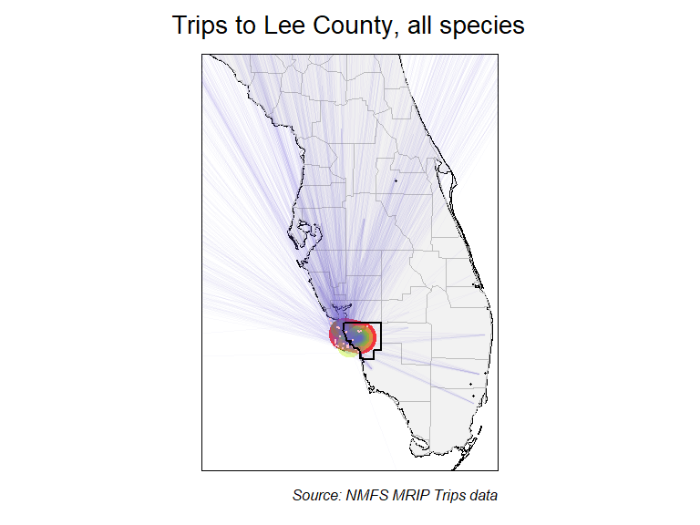
Figure 1. Map showing where trips fishing Lee County originated in, regardless of species targeted, for 2013-2023. Thicker and warmer colored lines show relatively more trips taken, and thinner, cooler colored lines show that relatively fewer trips were taken.

Figure 2.
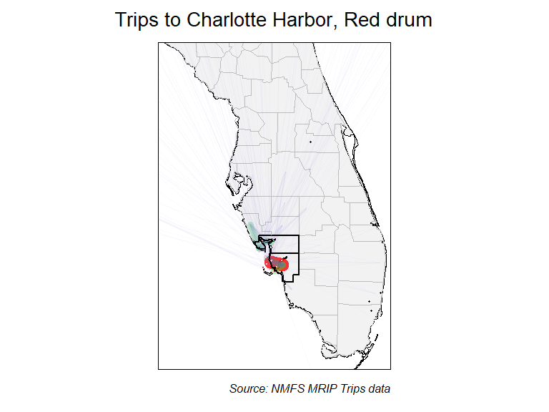
Figure 2. Map showing where trips fishing the Charlotte Harbor region originated in, when targeted Red drum, for 2013-2023. Thicker and warmer colored lines show relatively more trips taken, and thinner, cooler colored lines show that relatively fewer trips were taken.

Figure 3.
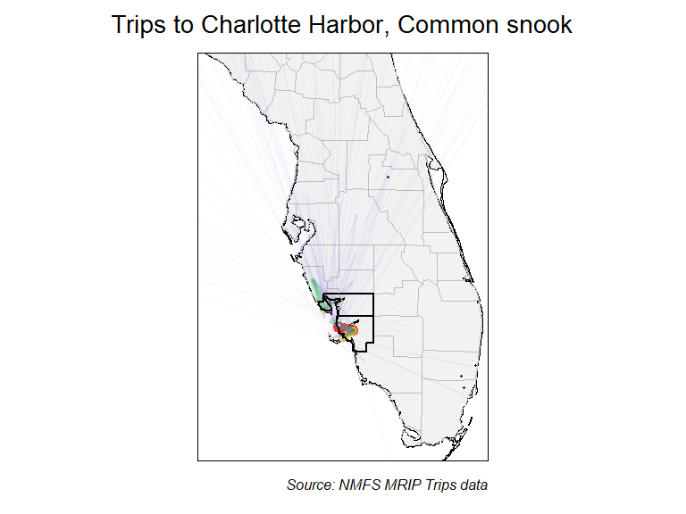
Figure 3. Map showing where trips fishing the Charlotte Harbor region originated in, when targeted Common snook, for 2013-2023. Thicker and warmer colored lines show relatively more trips taken, and thinner, cooler colored lines show that relatively fewer trips were taken.

Figure 4.
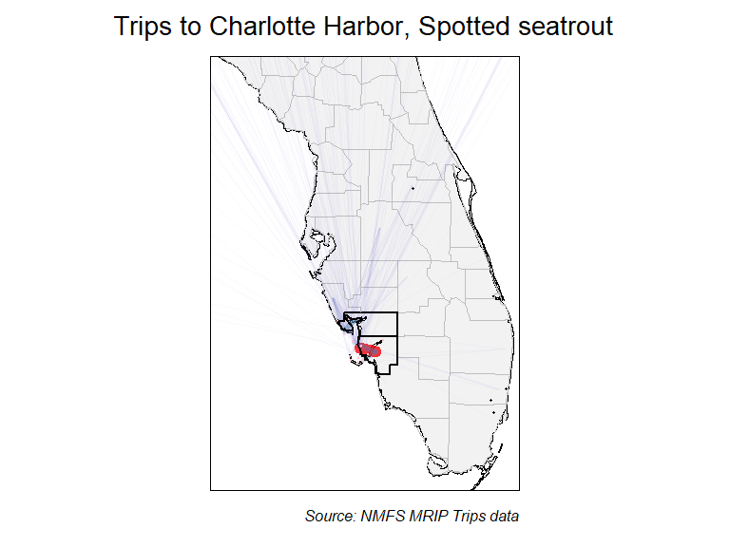
Figure 4. Map showing where trips fishing the Charlotte Harbor region originated in, when targeted Spotted seatrout, for 2013-2023. Thicker and warmer colored lines show relatively more trips taken, and thinner, cooler colored lines show that relatively fewer trips were taken.

Figure 5.
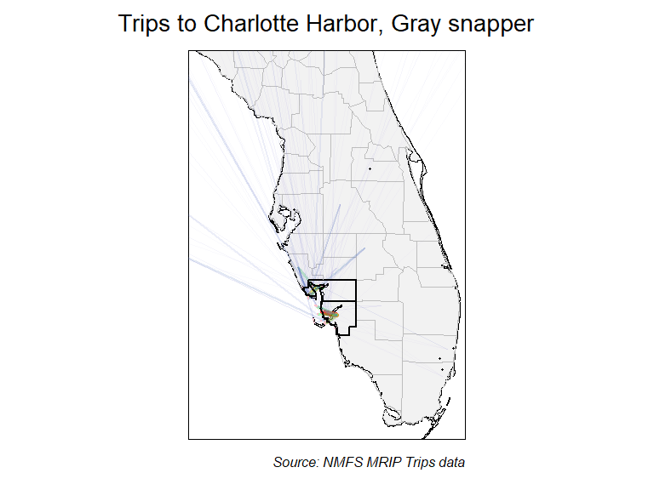
Figure 5. Map showing where trips fishing the Charlotte Harbor region originated in, when targeted Gray snapper, for 2013-2023. Thicker and warmer colored lines show relatively more trips taken, and thinner, cooler colored lines show that relatively fewer trips were taken.

Figure 6.
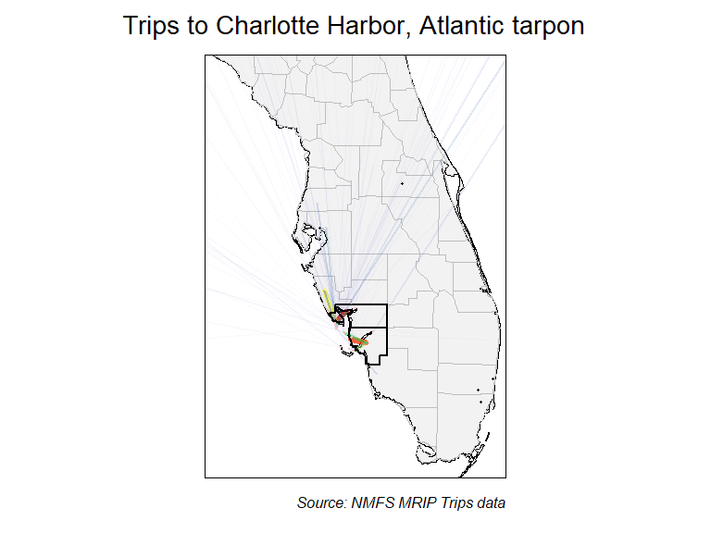
Figure 6. Map showing where trips fishing the Charlotte Harbor region originated in, when targeted Atlantic tarpon, for 2013-2023. Thicker and warmer colored lines show relatively more trips taken, and thinner, cooler colored lines show that relatively fewer trips were taken.

Species targeted: What do your anglers fish for?
Background on data used
The MRIP APIAS includes questions about the species that interviewed anglers were targeting on their recently completed fishing trips. Specifically, anglers are asked what their “primary” and “secondary” targeted species were. Not all anglers provide a specific species. Though many anglers do not specify a target (e.g., “fishing for whatever is biting”), this information is also useful. Further information about APAIS and the specific destinations is available at: https://www.fisheries.noaa.gov/recreational-fishing-data/public-access-fishing-site-register.
Species targeted: Background on methods used
We used MRIP “trips” data that contain information from intercepted angler interviews to understand what fish species anglers most commonly fished for. Essentially surveyors visit fishing access sites and ask anglers about their fishing trips. Data from these interviews are shown for different “queries”. Queries represented different scenarios regarding where anglers were intercepted (their destinations) and where they listed their home residence (their origin). This information was summarized by pooling trips over time—i.e. looking at the last 10 years (2013-2023) together. To assess potential changes in the fish that anglers target, we also analyzed time series for some of the most commonly targeted species. Time series were constructed by assessing the proportions of trips intercepted in the Charlotte Harbor region that targeted a specific species for each of the last 10 years.
Species targeted: Information provided
Two types of information products were developed:
- Tables describing the proportions of trips targeting different fish species at various combinations of fishing locations and residences.
- Figures showing the time series of proportion of trips taken in the Charlotte Harbor region targeting the most popular fish species.
It is important to note is that we report the percent of the sampled trips targeting a certain species, not the actual total estimates of trips targeting a species. The percentages we use here should closely match estimates because of the statistical design used to implement the MRIP APAIS survey. This means is that the information in this report can be very useful for things like understanding what people, on average, are fishing for when then fish Lee County, but it woudln’t be appropriate to try to use these percentages to understand the total amount of fishing effort.

Species Targeted Results: Tables
Tables describing the proportions of trips targeting different fish species at various combinations of fishing locations and residences, including:
- Trips in all of Florida, regardless of origin.
- Trips in the Charlotte Harbor region, regardless of origin.
- Trips taken in Lee County, regardless of origin.
- Trips taken in Lee County by Lee County residents.
- Trips taken in Lee County by non-residents of Lee County.
- Trips taken in Lee County by out-of-state anglers.
These results are summarized in two separate tables that promote comparison of Lee County to surrounding areas. All results represent data pooled over the last 10 years (2013-2023).
We anticipate these tables may be useful in several ways, including:
- Understanding what species anglers are targeting when they fish in Lee County, which may help inform local government interest in state and regional fisheries management issues.
- Understanding what species visiting (non Lee-County residents) anglers target, which may inform the media outlets and visuals (e.g., fish photos) of future advertisements).

Table 3
Proportion of species targeted, comparing county to state
FL trips | Per. (%) | Charlotte Harbor trips | Per. (%) | Lee trips | Per. (%)
No Target | 46.0 | No Target | 51.1 | No Target | 49.1
Red drum | 10.3 | Red drum | 12.6 | Red drum | 14.5
Spotted seatrout | 6.4 | Common snook | 10.0 | Common snook | 10.6
Common snook | 4.7 | Spotted seatrout | 6.5 | Spotted seatrout | 7.7
Dolphin | 3.7 | Gray snapper | 3.9 | Gray snapper | 3.6
King mackerel | 2.6 | Atlantic tarpon | 3.6 | Atlantic tarpon | 3.1
Red snapper | 2.6 | Sheepshead | 3.3 | Sheepshead | 2.6
Gray snapper | 2.5 | Red grouper | 1.8 | Red grouper | 2.3
Spanish mackerel | 2.3 | Requiem shark genus | 0.8 | Requiem shark genus | 0.8
Sheepshead | 2.0 | Florida pompano | 0.6 | Spanish mackerel | 0.6
Table 3. Comparison of species targeted in Lee county to other areas of Florida, for 2013-2023.
- Columns 1 & 2 show species targeted for trips made throughout Florida.
- Columns 3 & 4 show species targeted for trips made in the Charlotte Harbor region.
- Columns 5 & 6 show species targeted for trips made in Lee County.

Table 4
Proportion of species targeted, comparing county to state
In county trips | Per. (%) | Out of county trips | Per. (%) | Out of state trips | Per. (%)
No Target | 48.8 | No Target | 49.5 | No Target | 52.5
Red drum | 16.6 | Red drum | 10.8 | Spotted seatrout | 9.3
Common snook | 11.0 | Common snook | 9.9 | Common snook | 7.7
Spotted seatrout | 6.7 | Spotted seatrout | 9.3 | Red drum | 6.8
Gray snapper | 3.7 | Atlantic tarpon | 4.5 | Sheepshead | 5.2
Atlantic tarpon | 2.3 | Sheepshead | 3.7 | Atlantic tarpon | 4.3
Red grouper | 2.2 | Gray snapper | 3.5 | Gray snapper | 3.7
Sheepshead | 2.0 | Red grouper | 2.5 | Red grouper | 3.2
Florida pompano | 0.6 | Requiem shark genus | 1.1 | Requiem shark genus | 1.5
Requiem shark genus | 0.6 | Lane snapper | 0.8 | Lane snapper | 1.0
Table 4. Proportions of species targeted by fishing trips made in Lee county by anglers from various origins, for 2013-2023.
- Columns 1 & 2 show the species targeted in Lee County by Lee County residents.
- Columns 3 & 4 show the species targeted in Lee County by Florida residents not living in Lee County.
- Columns 5 & 6 shows the species targeted in Lee County by non-residents of Florida.

Species Targeted Results: Time series figures
We provide time series of the proportion of intercepted trips that targeted each of the top nine species fished for in the Charlotte Harbor region. Data are available for each year from 2013-2023, and represent the raw proportions of surveyed trips, which means that no uncertainty estimates (e.g. “error” bars) are relevant to these data.
The multi-panel figure below should primarily be useful for understanding how the species of fish anglers target when they fish has changed in recent years. These changes may be related to changes in angler’s preferences, but can have other causes as well, such as:
- Changes in costs of fishing (e.g., fuel), since some species require larger boats or longer travel times to target.
- Changes in fishing regulations for specific species.
- Changes in knowledge of how to successfully target specific species.
- Changes in fish populations, which can be the result of changing fishing, fisheries management, or habitat, as well as perturbations like red tide or cold kills.

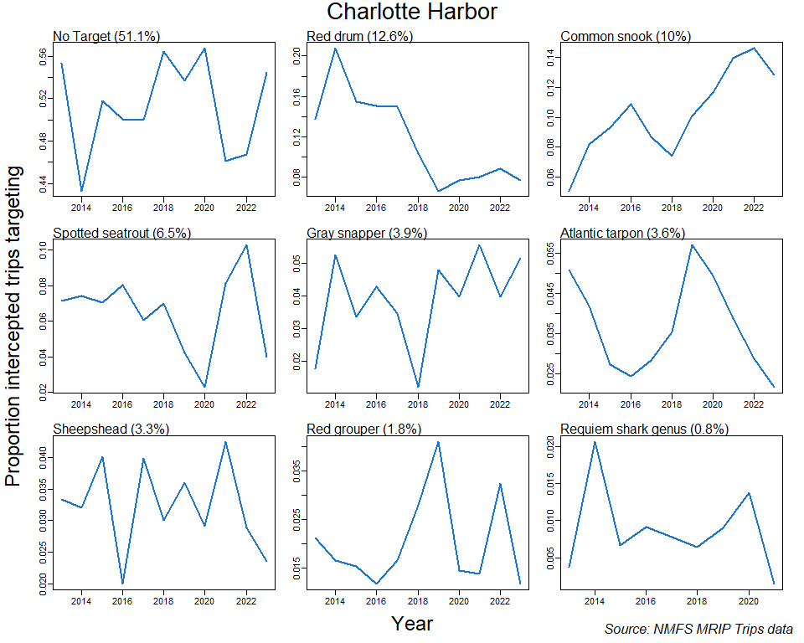
Figure 6. Time series of the proportion of intercepted trips targeting each of the top 9 fish species targets in the Charlotte Harbor region, for 2013-2023.
Each panel describes the time series for one of the top-targeted fish species (including no species targeted, “No Target”). Proportion of total trips targeting each species over the entire span of years (2013-2023) shown is provided in parentheses following each species’ name.

References
Camp, E. V., Ahrens R. N. M., C. Crandall, and K. Lorenzen. 2018. “Angler travel distances: Implications for spatial approaches to marine recreational fisheries governance.” Marine Policy 87: 263–74.

