1. log in page
   1. When users first run the chess game, they should see the name input box

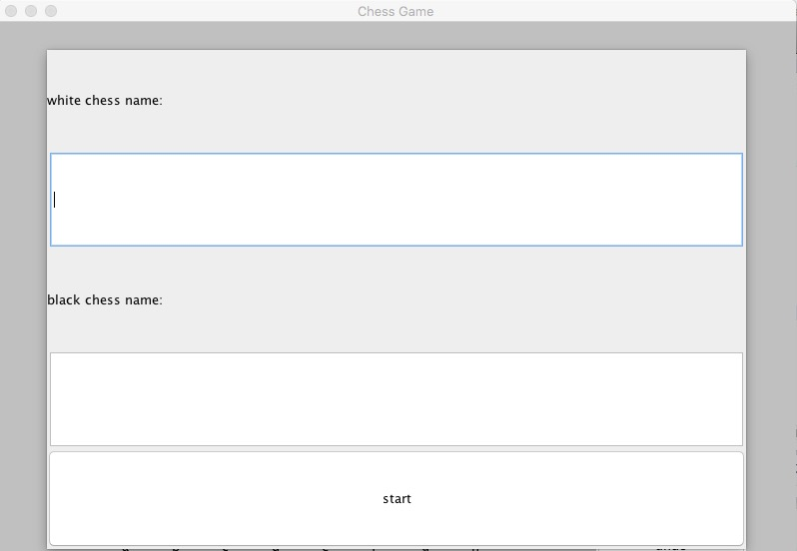

* 1. If users hit the button without typing in name for both users, nothing will happen
  2. After users typing in names and hit start, names should be displayed in the user info panel in 2(a)

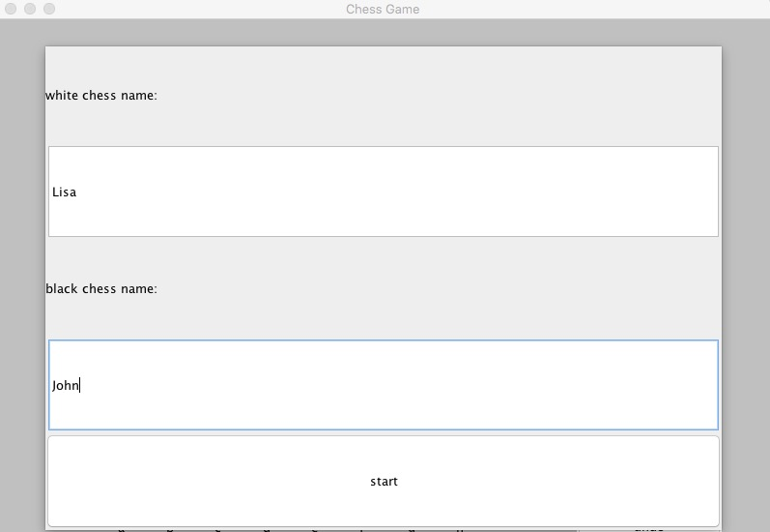

1. user info panel
   1. After first login, there should be two panel, white and black, with scores 0

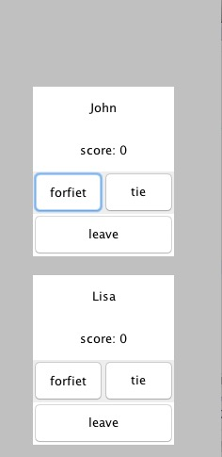

* 1. if one user forfeit, the score for the other user will increase

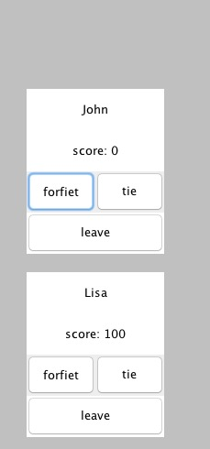

* 1. if two user both agrees tie, the score will be added for both user

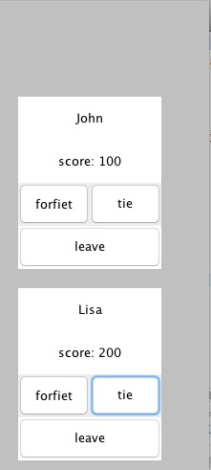

* 1. if one user choose to leave, it will go back to the log in page in 1(c)
  2. if one side checkmate, the score for the other user will increase
  3. if both side stalemate, the score will be added for both user

1. chess board
   1. when first launch the chess game
      1. the chessboard should be 8\*8 by default
      2. the chessboard should be marked from 1 to 8 from bottom to top on both left side and right part of the board
      3. the chessboard should be marked from a to h from left to right on both top and bottom part of the board
      4. the white chess should be placed at the bottom two rows and the black chess should be placed at the top two rows
      5. all the white chesses and black chesses should be placed in correct position

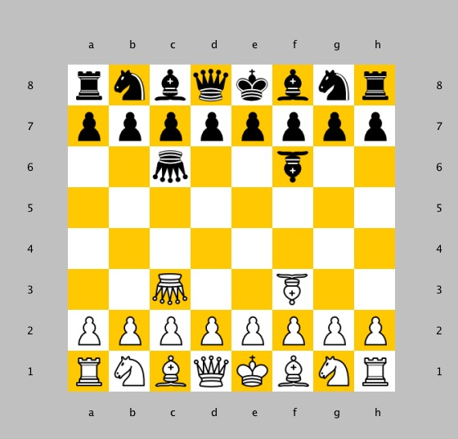

* 1. if one user forfeit or both user tie, the chessboard will be set back to initial position in (a)
  2. if user played with wrong turn, popup window will notifying with “wrong turn”

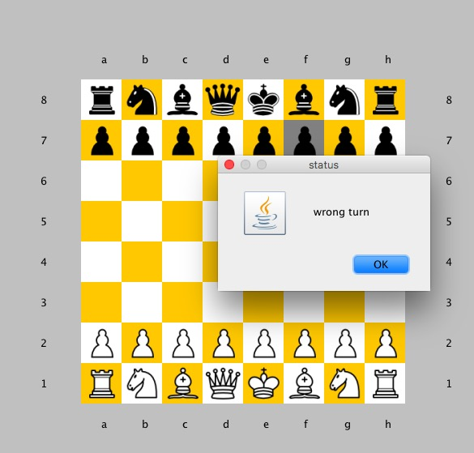

* 1. if user play an illegal move, popup window will notifying with “illegal move”

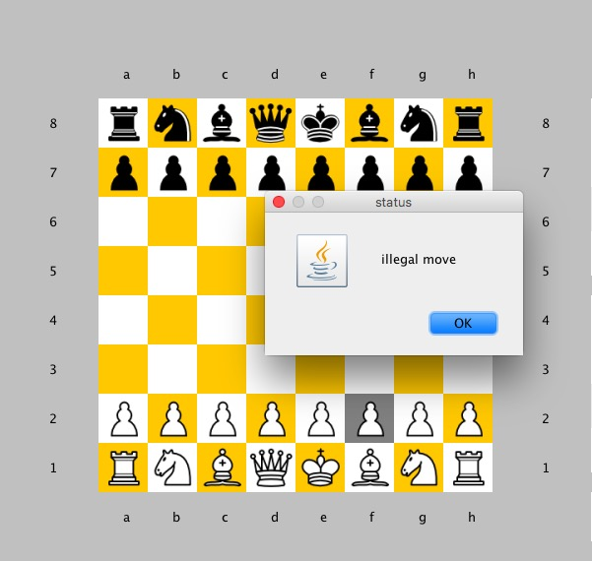

* 1. if checkmate, popup window will notifying with checkmate and the winner side

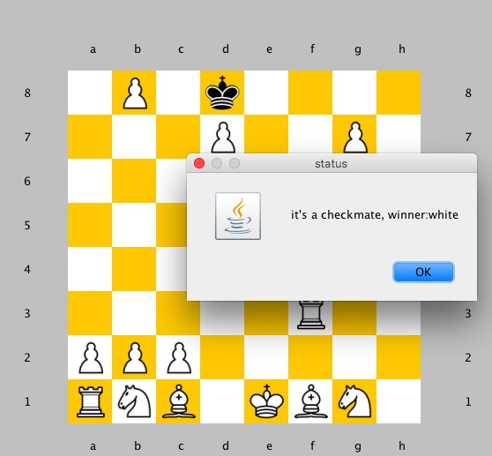

* 1. if stalemate, popup window will notifying with “stalemate”

1. undo
   1. user should be able to undo until no undo is available
   2. when no undo is available, pop up window will notify with “can’t undo now”

