6.1

import numpy as np

import matplotlib.pyplot as plt

import sys

import math

def read_and_plot_file(fileName):

x = []

y = []

with open(fileName, "r") as f:

for line in f:

if line.startswith(("#")):

continue

data = line.split()

x.append(float(data[0].strip()))

y.append(float(data[1].strip()))

plt.plot(x, y)

plt.xlabel = 'x'

plt.ylabel = 'f'

plt.show()

return x, y

x, y = read_and_plot_file("./files/xy.dat")

print(max(y))

print(min(y))

console:

0.9482

-0.9482

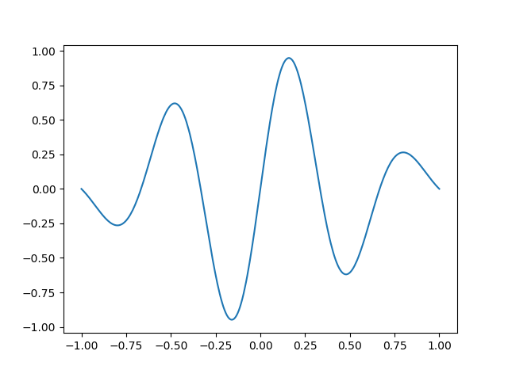

#6.2

import numpy as np

import matplotlib.pyplot as plt

import sys

import math

def read_and_plot_file(fileName):

x = []

y = []

with open(fileName, "r") as f:

for line in f:

print line

if line.startswith(("#")):

continue

data = line.split()

if len(data) != 2:

continue

x.append(float(data[0].strip()))

y.append(float(data[1].strip()))

plt.plot(x, y)

plt.xlabel = 'x'

plt.ylabel = 'f'

plt.show()

return x, y

read_and_plot_file(sys.argv[1])

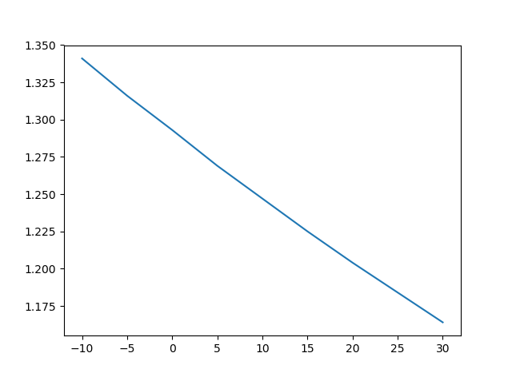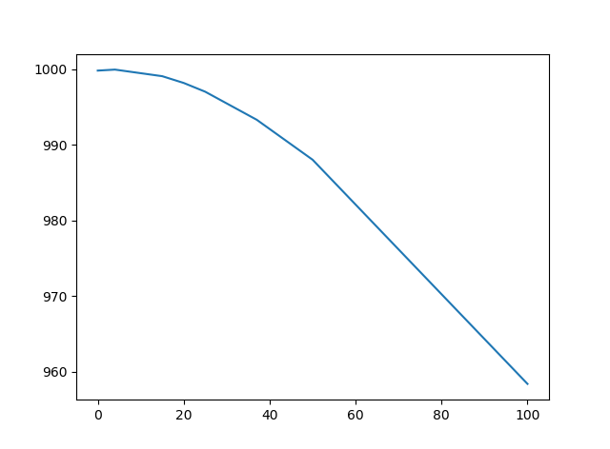

6.8

def read_file(fileName):

d = {}

with open(fileName, "r") as f:

for line in f:

print line

if line.startswith(("#")):

continue

data = line.split()

name = []

v = None

for t in data:

try:

v = float(t)

break

except:

name.append(t)

if v is not None:

d[" ".join(name)] = v

print(d)

return d

read_file("./files/constants.txt")

console output:

{'Planck constant': 6.6260755e-34, 'elementary charge': 1.60217733e-19, 'speed of light': 299792458.0, 'electron mass': 9.1093897e-31, 'Avogadro number': 6.0221367e+23, 'proton mass': 1.6726231e-27, 'gravitational constant': 6.67259e-11, 'Boltzmann constant': 1.380658e-23}

6.9

t1 is a dict which support square bracket to add/access any key

t2 is a list which only support square bracket to access valid index

to fix second part, preset the length of t1 to 2

t2 = [None] * 2

t2[0] = 0

t2[1] = 1

6.10

def read_densities(filename):

infile = open(filename, "r")

densities1 = {}

densities2 = {}

for line in infile:

words = line.split()

density1 = float(words[-1])

substance1 = " ".join(words[:-1])

densities1[substance1] = density1

density2 = float(line[12:])

substance2 = line[0:12].strip()

densities2[substance2] = density2

infile.close()

print(densities1 == densities2)

densities = read_densities("files/densities.dat")

console output :

True

6.12

d = {}

for star in data:

d[star[0]] = star[3]

print(d)

console:

{'Wolf 359': 2e-05, 'Alpha Centauri C': 6e-05, 'Alpha Centauri B': 0.45, 'Alpha Centauri A': 1.56, 'Luyten 726-8 A': 6e-05, 'Sirius B': 0.003, 'Sirius A': 23.6, 'Luyten 726-8 B': 4e-05, 'BD +36 degrees 2147': 0.006, "Barnard's Star": 0.0005, 'Ross 154': 0.0005}

6.13

data = [

('Alpha Centauri A', 4.3, 0.26, 1.56),

('Alpha Centauri B', 4.3, 0.077, 0.45),

('Alpha Centauri C', 4.2, 0.00001, 0.00006),

('Barnard\'s Star', 6.0, 0.00004, 0.0005),

('Wolf 359', 7.7, 0.000001, 0.00002),

('BD +36 degrees 2147', 8.2, 0.0003, 0.006),

('Luyten 726-8 A', 8.4, 0.000003, 0.00006),

('Luyten 726-8 B', 8.4, 0.000002, 0.00004),

('Sirius A', 8.6, 1.00, 23.6),

('Sirius B', 8.6, 0.001, 0.003),

('Ross 154', 9.4, 0.00002, 0.0005),

]

d = {}

for star in data:

sd = {}

sd["distance"] = star[1]

sd["apparent brightness"] = star[2]

sd["luminosity"] = star[3]

d[star[0]] = sd

print(d)

console:

{'Wolf 359': {'distance': 7.7, 'apparent brightness': 1e-06, 'luminosity': 2e-05}, 'Alpha Centauri C': {'distance': 4.2, 'apparent brightness': 1e-05, 'luminosity': 6e-05}, 'Alpha Centauri B': {'distance': 4.3, 'apparent brightness': 0.077, 'luminosity':

0.45}, 'Alpha Centauri A': {'distance': 4.3, 'apparent brightness': 0.26, 'luminosity': 1.56}, 'Luyten 726-8 A': {'distance': 8.4, 'apparent brightness': 3e-06, 'luminosity': 6e-05}, 'Sirius B': {'distance': 8.6, 'apparent brightness': 0.001, 'luminosity': 0.003}, 'Sirius A': {'distance': 8.6, 'apparent brightness': 1.0, 'luminosity': 23.6}, 'Luyten 726-8 B': {'distance': 8.4, 'apparent brightness': 2e-06, 'luminosity': 4e-05}, 'BD +36 degrees 2147': {'distance': 8.2, 'apparent brightness': 0.0003, 'luminosity': 0.006}, "Barnard's Star": {'distance': 6.0, 'apparent brightness': 4e-05, 'luminosity': 0.0005}, 'Ross 154': {'distance': 9.4, 'apparent brightness': 2e-05, 'luminosity': 0.0005}}

6.18

def read_file(filename):

infile = open(filename, "r")

infile.readline() # read column headings

dates = []; prices = []

for line in infile:

columns = line.split(",")

date = columns[0]

date = date[:-3] # skip day of month

price = columns[-1]

dates.append(date)

prices.append(float(price))

infile.close()

dates.reverse()

prices.reverse()

for p in prices:

p / prices[0]

return dates, prices

d = {}

def multiComp(companyName):

fileName = companyName + ".csv"

dates, prices = read_file(fileName)

d[companyName] = (dates, prices)

for val in d.values():

plt.plot(range(len(val[2])), val[2])

6.22

import numpy as np

import matplotlib.pyplot as plt

import sys

import math

def buildCityMap(fileName):

d = {}

with open(fileName, "r") as f:

for line in f:

if line.strip().startswith("<li class=MsoNormal"):

line = next(f)

i = line.find("<b>")

j = line.find("</b>")

cityName = line[i + 3 : j].strip()

if cityName[-1] == "(":

cityName = cityName[:-2]

next(f)

line = next(f)

print line

i = line.find(">")

j = line.find("<")

tempFile = line[i + 1:j].strip()

d[cityName] = "./files/city_temp/" + tempFile

return d

cityMap = buildCityMap("./files/city_temp/citylistWorld.htm")

def buildTempDict(city, cityMap):

date = []

temp = []

with open(cityMap[city], "r") as f:

for line in f:

t = line.split()

date.append("-".join(t[0:3]))

if float(t[3]) < 0:

print t[3]

temp.append(float(t[3]))

return date, temp

d = buildTempDict("Beijing", cityMap)

def plotTemp(cities, cityMap):

d = {}

for city in cities:

_, temp = buildTempDict(city, cityMap)

plt.plot(range(len(temp)), temp)

plt.show()

plotTemp(["Beijing", "Paris"], cityMap)

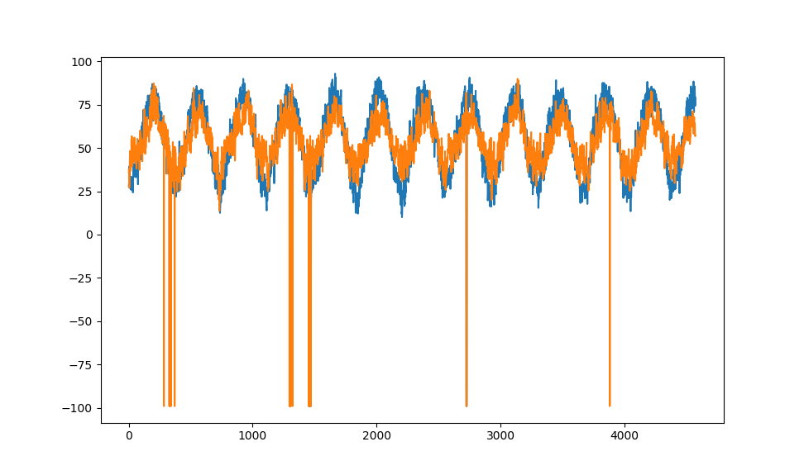

6.29

def getHtml1():

url1 = "https://weather.com/weather/today/l/USNY0996:1:US"

local_file, header = urllib.urlretrieve(url1)

with open(local_file, "r") as f:

for line in f:

i = line.find("<span class=\"styles-xz0ANuUJ__temperature__3Ph8k\">")

j = line.find("<!---->", i)

if i > 0 and j > 0:

print("weather.com", float(line[i + 50:j]))

def getHtml2():

url2 = "https://forecast.weather.gov/MapClick.php?lat=40.71455000000003&lon=-74.00713999999994#.WnYnpq6nH3g"

local_file, header = urllib.urlretrieve(url2)

with open(local_file, "r") as f:

for line in f:

i = line.find("<p class=\"myforecast-current-lrg\">")

j = line.find("&", i)

if i > 0 and j > 0:

print("weather.gov", float(line[i + 34:j]))

getHtml1()

getHtml2()

console:

('weather.com', 31.0)

('weather.gov', 30.0)