深圳大学考试答题纸

(以论文、报告等形式考核专用)  
二○ 二○一 ～二○ 二 二 学年度第 二 学期

|  |  |  |  |  |  |  |  |  |  |  |  |  |  |  |  |
| --- | --- | --- | --- | --- | --- | --- | --- | --- | --- | --- | --- | --- | --- | --- | --- |
| 课程编号 | 1503260001 | | 课序号 | |  | | 课程名称 | | 专业研究英语 | | 主讲教师 | 刘凌 | 评分 |  | |
| 学 号 | 2020151036 | | | 姓名 | | 谢弘烨 | | 专业年级 | | 2020级 软件工程 | | | | | |
|  | | | | | | | | | | | | | | | |
| 教师评语： | | | | | | | | | | | | | | | |
| 题目： | | Application prospects for physical engines | | | | | | | | | | | | |  |

**Application prospects for physical engines**

**Abstract**

Today, virtual environments are used in a variety of applications to produce highly dynamic virtual worlds, none more difficult than the simulation of the laws of physics. And such a program that simulates the physical world is called a physics engine. This technical report will briefly introduce a few simple physics engines and the application scenarios of physics engines in various industries.

**Keywords**

Physics engine; simulation

1. **Introduction**

Physics plays a vital role in our every day life. It allows us to understand how and why everything work, to learn about the laws of motion, space and time and to anticipate what will happen in the real world. Sometimes to help design better, to educate and to recreate what will happen in real world in virtual world, we need to first find a way to simulate the laws of physics in virtual world, which means in our computer. And such a program in our computer which can simulate the laws of physics is called a physics engine. For example, rocket engineers can simulate the process of rocket launch before actual launch in order to avoid the potential risk of failure launch. In class where students are struggling to learn science, they can now see the orbit of the solar system, the structure of an organic molecule or the movement of a single-celled organism with their own eyes with the assistance of a physics engine. If a game includes the interaction of a variety of objects as one of its features, a physics engine is indispensable.

For a long time, a large number of industries have face their need for physical simulation, therefore many physics engine with different emphases have emerged. In Section 2, we will introduce three simple physics engines. Section 3 will show the current use of physics engines in different industries and the future of physics engines.

1. **Three simple physics engines**
   1. **A Real-time Physics Engine Based on MPM and PBD**

Real-time physics simulation has always been a hot topic in industry and academia. Although the commonly used methods have been able to give simulation results robustly and quickly, authenticity and controllability are still a tricky and urgent problem to be solved. Therefore, Mr. Wu Yilong and Mr. Chang Yu from University of Electronic Science and Technology of China completed a real-time level physics engine based on the Taichi programming language, using the commonly used PDB algorithm and the latest MLS-MPM algorithm [1].

The PDB part of this engine is based on an untraditional programming language, Taichi. Due to the automatic parallelization feature of Taichi, this engine, using parallel nonlinear Gauss-Seidle, can automatically and iteratively solve the constraint equations. This makes it possible to get a perfect result on hardware with average performance.

In the framework of MLS-MPM, this engine can simulate the coupling of 10,000 water and sand particles on two 256 $×$ 256 resolution grids with average-performance hardwares.

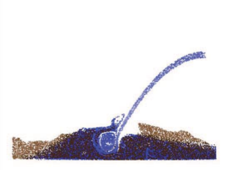

Figure 1:Sand-water coupling

* 1. **A Physics Engine for Simulating Liquids and Gases**

In order to meet the requirements of research tasks and the needs of the teachers, Dr. Chernousenko, Dr. Ivanova, Dr. Baranov and Dr. Kvasov from National Research Nuclear University MEPHI develop this physics engine [2].

This engine is mainly based on C++, using a variety of libraries like GLEW, GLAD, GLM and so on. Since this engine is more oriented to research and teaching, it is more examining of the intermolecular forces of liquids and gases, and the properties in molecular motion, in addition to the general characteristics of a physics engine.

As a result, this team develop a optimal software which applies for a small number of 103 molecules and can simulate and visualize the movement of gas and liquid lolecules in 3D. And it allows users to set the number of molecules needed.

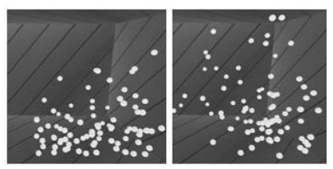

Figure 2:Gas model

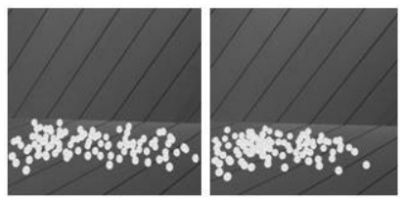

Figure 3:Liquid model

However, due to the fact that the gas and liquid physics simulation of this engine is as close as possible to the conditions of real physics, the engine requires hardware with high performance to get acceptable performance. For example, on Intel i5 8th Gen, 20ms per 100particles is spent per frame.

* 1. **A physics Engine for Modeling Autonomous Motion(Soda Loader)**

SodaConstructor is a physics kit that allows users to creart 2D physical motions, which has been attracted a lot of attention in the past decades. Students around the world have been using it to model classical physics, for it allows users to create autonomous models whose autonomous motions can be displayed to visually demonstrate the underlying physics concepts.

This engine was built aiming to recreate a SodaConstructor-like system. Therefore it is reverse engineered from a closed-source application and loads some of the physics models from SodaConstructor [3].

Since a physics model is stored as a XML file by SodaConstructor, the main module of this engine is a loader, which is why it is called Soda Loader. A XML file contails a number of global variables which holds constants such as gravity and friction other then variables for masses, springs and muscles. After loading a XML file, Soda Loader create its own physics model and then process it.

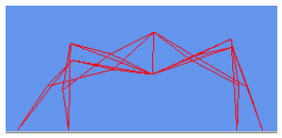

Figure 4:Simulation example: walker

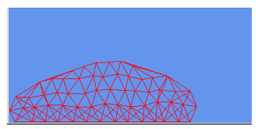

Figure 5:Simulation example: slug

1. **current and future of physics engines**

Nowadays, physics engines can be seen in a lot of places, but mainly in game industry and engineering.

The physics engine in games due to system latency, memory, CPU and GPU limitations, generally will simplify the original, rigorous mathematical model, so that you can quickly get a good-looking result to deceive your eyes. In engineering, because of the higher accuracy required for the calculation results, we can tolerate longer calculation time, using such as small servers, supercomputing clusters to run for days or even weeks to get a more accurate result.

In fact, their underlying mathematical models are more or less the same, only the actual application of the trade-off approximation is different.

In the future, more and more industries will apply physical engines. The rapidly developing computer hardware and the software optimization of the physics engine itself will make it easier and easier to apply the physics engine. Hopefully that one day, we will not only see the use of physics engines in colleges and universities, in laboratories, but also in classrooms where students use physics engines to learn intuitively, and in fields where farmers use physics engines to foresee harvests.

1. **Conclusions**

Physics engine is the topic of this paper. Firstly, we have learnt about three simple physics engines with different emphases, which are A Real-time Physics Engine Based on MPM and PBD, A Physics Engine for Simulating Liquids and Gases and A physics Engine for Modeling Autonomous Motion(Soda Loader). Secondly, we learn about the current usage scenarios of physics engines and foresee the possible ones in the future.

1. **Acknowledgements**

This survey paper has been written under the instructions of Professor Ling Liu. Most of the reference papers were got from ACM/IEEE by the Digital Library of Shenzhen University.

**啊啊啊啊啊啊啊啊啊啊啊啊啊啊啊啊啊啊啊啊啊啊啊啊啊啊啊啊啊啊啊啊啊啊啊**

**啊啊啊啊啊啊啊啊啊啊啊啊啊啊啊啊啊啊啊啊啊啊啊啊啊啊啊啊啊啊啊啊啊啊啊啊啊**

**啊啊啊啊啊啊啊啊啊啊啊啊啊啊啊啊啊啊啊啊啊啊啊啊啊啊啊啊啊啊啊啊啊啊啊啊啊**

**啊啊啊啊啊啊啊啊啊啊啊啊啊啊啊啊啊啊啊啊啊啊啊啊啊啊啊啊啊啊啊啊啊啊啊啊啊**

**啊啊啊啊啊啊啊啊啊啊啊啊啊啊啊啊啊啊啊啊啊啊啊啊啊啊啊啊啊啊啊啊啊啊啊啊啊**

**References**

1. Y. Wu and C. Yu, "Real-time Physics Engine Based on MPM and PBD," 2020 International Conference on Virtual Reality and Visualization (ICVRV), 2020, pp. 308-309, doi: 10.1109/ICVRV51359.2020.00078.
2. V. V. Chernousenko, A. V. Ivanova, I. S. Baranov and I. Y. Kvasov, "The Development of a Physics Engine for Simulating Liquids and Gases," 2021 IEEE Conference of Russian Young Researchers in Electrical and Electronic Engineering (ElConRus), 2021, pp. 266-269, doi: 10.1109/ElConRus51938.2021.9396385.
3. J. Yang and G. Hu, "A physics simulation engine for modeling autonomous motion through reverse engineering of sodaconstructor," 2009 IEEE/ACS International Conference on Computer Systems and Applications, 2009, pp. 287-292, doi: 10.1109/AICCSA.2009.5069338.