**深 圳 大 学**

**实 验 报 告**

**课程名称： 数据库系统**

**实验序号： 实验1**

**实验名称：**  **SQL的DDL语言和单表查询**

**学 号： 2020151036**

**姓 名： 谢弘烨**

**实验完成日期： 2022年 月 日**

**一、实验目的：**

1. 了解DBMS系统的功能、软件组成；

2、掌握利用SQL语句定义、和简单操纵数据库的方法。

**二、实验要求：**

1、在课外安装相关软件并浏览软件自带的帮助文件和功能菜单，了解DBMS的功能、结构；  
 2、创建一个有两个关系表的数据库；（建议采用ORACLE ISQLPLUS）

3、数据库、关系表定义；

4、学习定义关系表的约束(主键、外键、自定义)；

5、了解SQL的数据定义功能；

6、了解SQL的操纵基本功能；

8、了解视图的概念；

**三、实验设备：**

计算机、数据库管理系统如DB2，Oracle 等软件。

**四、实验内容**

1、使用SQL DDL语句**建立关系数据库模式，并用DML数据**如下；

|  |  |  |  |  |  |  |  |
| --- | --- | --- | --- | --- | --- | --- | --- |
| EMPNO | ENAME | JOB | MGR | HIREDATE | SAL | COMM | DEPTNO |
| 7369 | SMITH | CLERK | 7902 | 17-Dec-90 | 13750 |  | 20 |
| 7499 | ALLEN | SALESMAN | 7698 | 20-FEB-89 | 19000 | 6400 | 30 |
| 7521 | WARD | SALESMAN | 7698 | 22-FEB-93 | 18500 | 4250 | 30 |
| 7566 | JONES | MANAGER | 7839 | 02-APR-89 | 26850 |  | 20 |
| 7654 | MARTIN | SALESMAN | 7698 | 28-SEP-97 | 15675 | 3500 | 30 |
| 7698 | BLAKE | MANAGER | 7839 | 01-MAY-90 | 24000 |  | 30 |
| 7782 | CLARK | MANAGER | 7839 | 09-JUN-88 | 27500 |  | 10 |
| 7788 | SCOTT | ANALYST | 7566 | 19-APR-87 | 19500 |  | 20 |
| 7839 | KING | PRESIDENT |  | 17-NOV-83 | 82500 |  | 10 |
| 7844 | TURNER | SALESMAN | 7698 | 08-SEP-92 | 18500 | 6250 | 30 |
| 7876 | ADAMS | CLERK | 7788 | 23-MAY-96 | 11900 |  | 20 |
| 7900 | JAMES | CLERK | 7698 | 03-DEC-95 | 12500 |  | 30 |
| 7902 | FORD | ANALYST | 7566 | 03-DEC-91 | 21500 |  | 20 |
| 7934 | MILLER | CLERK | 7782 | 23-JAN-95 | 13250 |  | 10 |
| 3258 | GREEN | SALESMAN | 4422 | 24-Jul-95 | 18500 | 2750 | 50 |
| 4422 | STEVENS | MANAGER | 7839 | 14-Jan-94 | 24750 |  | 50 |
| 6548 | BARNES | CLERK | 4422 | 16-Jan-95 | 11950 |  | 50 |

**DEPT+(学生自己的学号)**:

|  |  |  |
| --- | --- | --- |
| DEPTNO | DNAME | LOC |
| 10 | ACCOUNTING | LONDON |
| 20 | RESEARCH | PRESTON |
| 30 | SALES | LIVERPOOL |
| 40 | OPERATIONS | STAFFORD |
| 50 | MARKETING | LUTON |

**以下为学生实验填写部分：**

1. **参考课件约束方式，创建emp和dept的DDL语句 （****要有语句和运行结果截屏）**

创建dept表：

依照实验要求在表中添加属性，同时声明主码为deptno

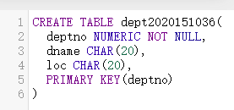

运行结果：

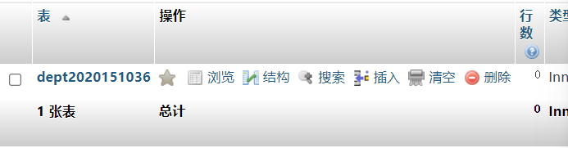

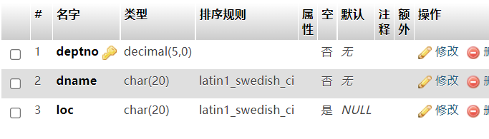

创建emp关系表：

依照实验要求在表中添加属性，同时声明主码为empno。此外以dept表中的dept为参照声明外码dept，以自身主码empno为参照声明外码mgr

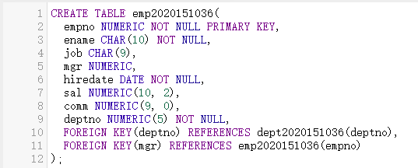

运行结果：

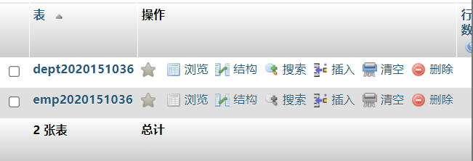

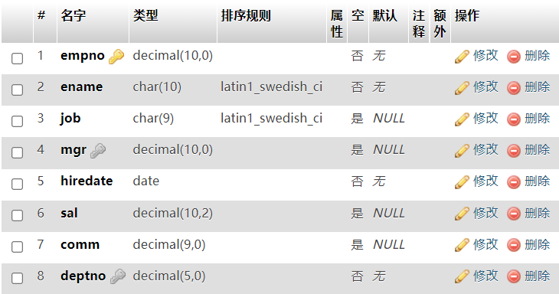

1. **插入emp和dept数据的DML语句 （要有语句和运行结果截屏）**

依照实验要求插入dept表中的数据：

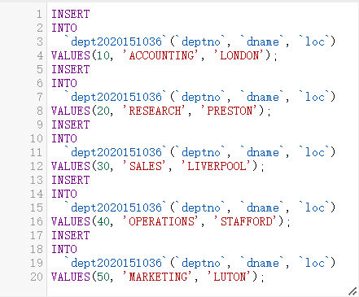

结果如下：

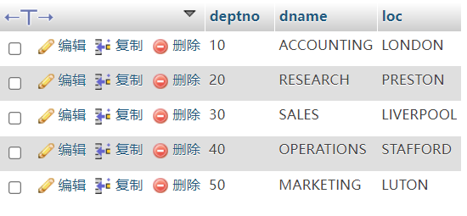

插入emp表中数据：

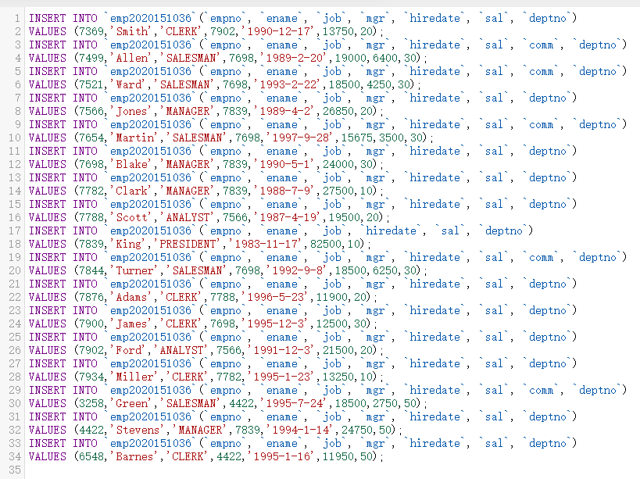

出现以下错误提示：

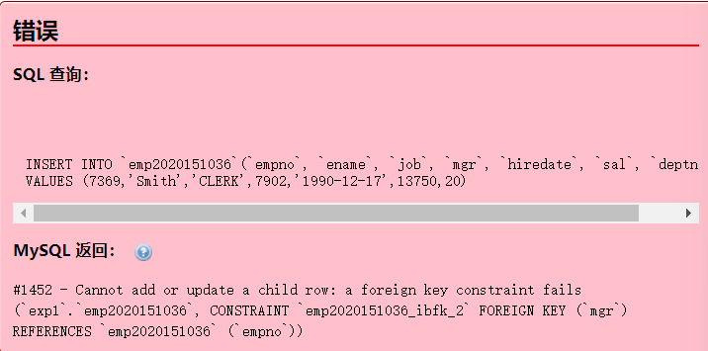

错误原因为在创建表时声明表内的外码约束，该约束的存在使得插入的每行数据地empno和mgr值必须相同。

解决办法：先删除掉在mgr上添加的外码约束，插入所有数据后再另行添加

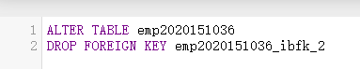

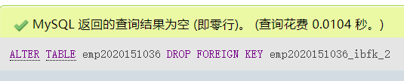

结果如下：

删除外码约束后成功插入所有数据

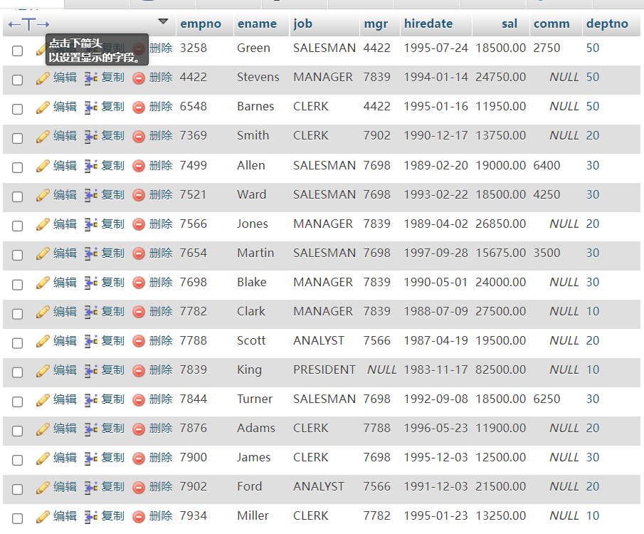

最后再加上外码约束



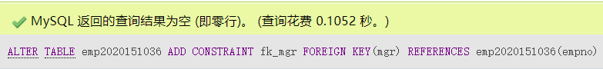

**3．完成实验指导书的EX1 and EX2.（要有题目语句和运行结果截屏）**

EX1：

1. List all information about the employees.

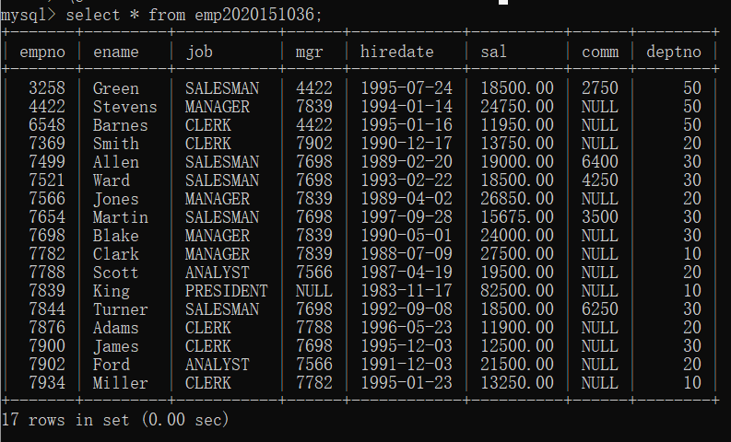

1. List all information about the departments

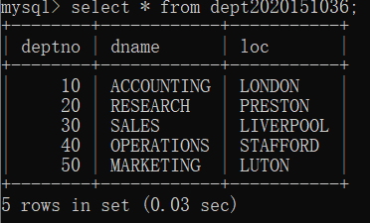

3 List only the following information from the EMP table ( Employee name, employee number, salary, department number)

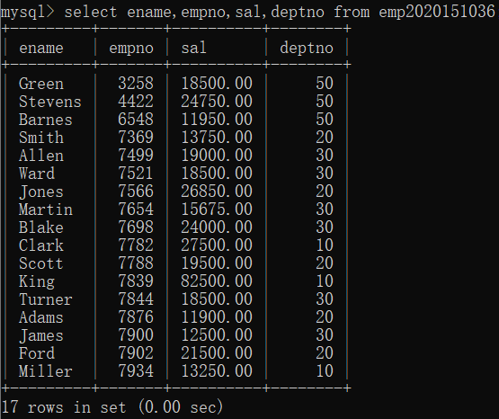

4 List details of employees in departments 10 and 30.

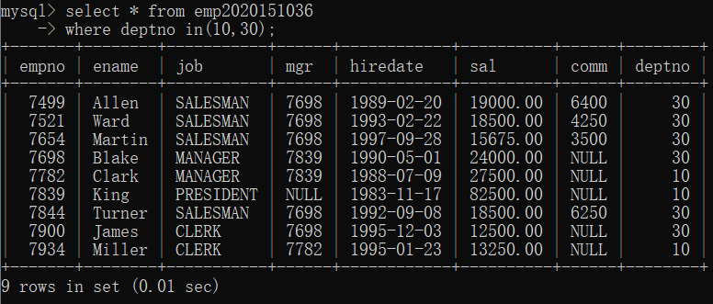

5 List all the jobs in the EMP table eliminating duplicates.

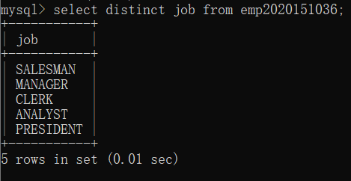

6. What are the names of the employees who earn less than £20,000?

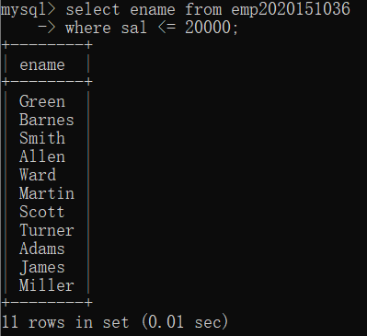

7. What is the name, job title and employee number of the person in department 20 who earns more than £25000?

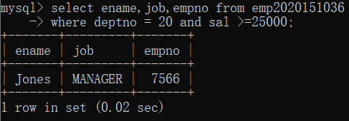

8. Find all employees whose job is either Clerk or Salesman.

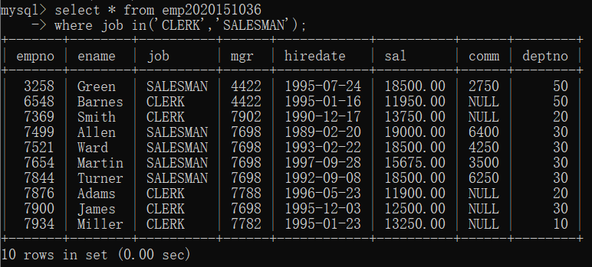

9. Find any Clerk who is not in department 10.

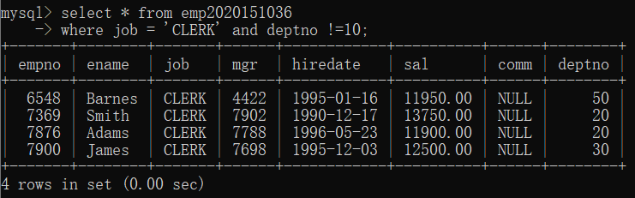

10. Find everyone whose job is Salesman and all the Analysts in department 20.

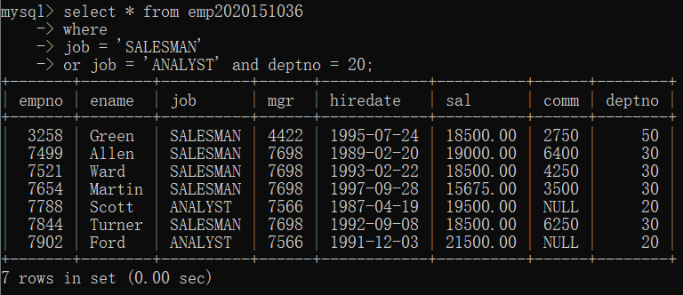

11. Find all the employees who earn between £15,000 and £20,000.

Show the employee name, department and salary.

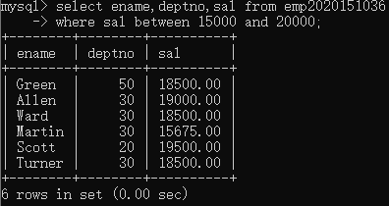

12 Find the name of the President.

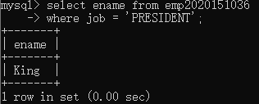

13 Find all the employees whose last names end with S

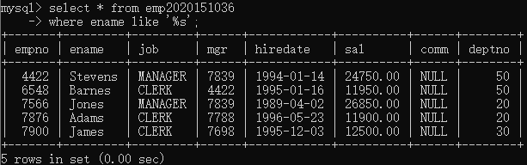

14 List the employees whose names have TH or LL in them

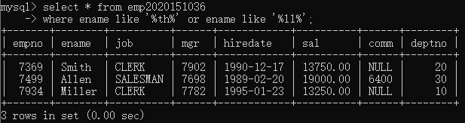

15 List only those employees who receive commission.

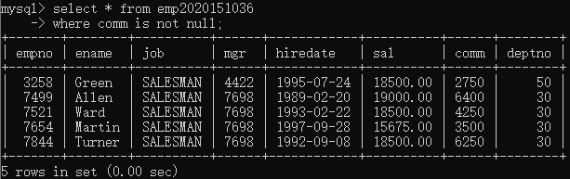

16 Find the name, job, salary, hiredate, and department number of all employees by alphabetical order of name.

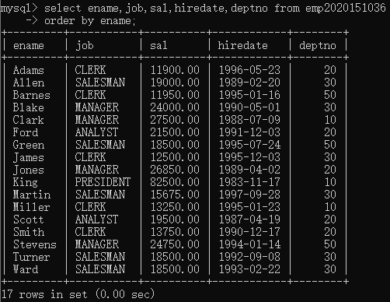

17. Find the name, job, salary, hiredate and department number of all employees in ascending order by their salaries.

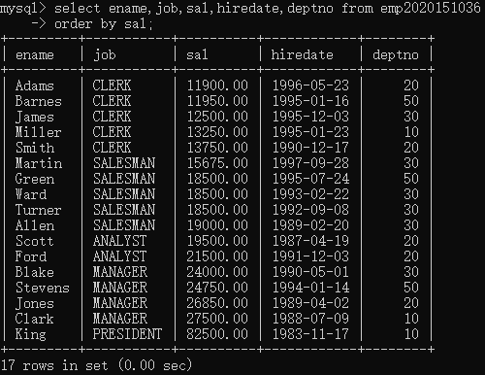

18. List all salesmen in descending order by commission divided by their salary.

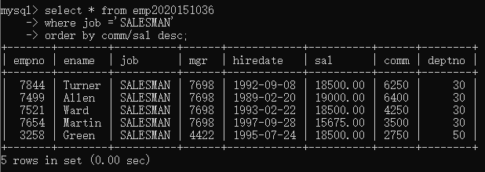

19. Order employees in department 30 who receive commision, in ascending order by commission

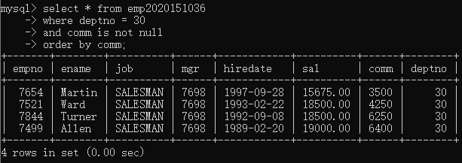

20 Find the names, jobs, salaries and commissions of all employees who do not have managers.

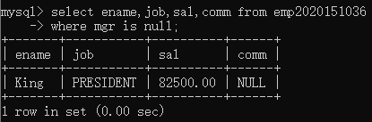

21 Find all the salesmen in department 30 who have a salary greater than or equal to £18000.

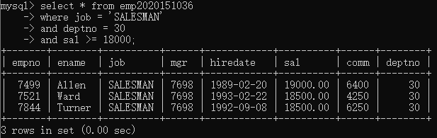

EX2：

1. Find the name and salary of employees in Luton.

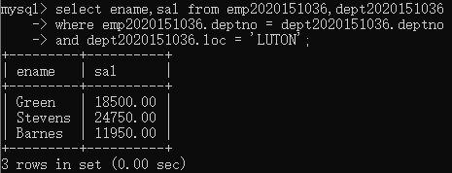

2. Join the DEPT table to the EMP table and show in department number order.

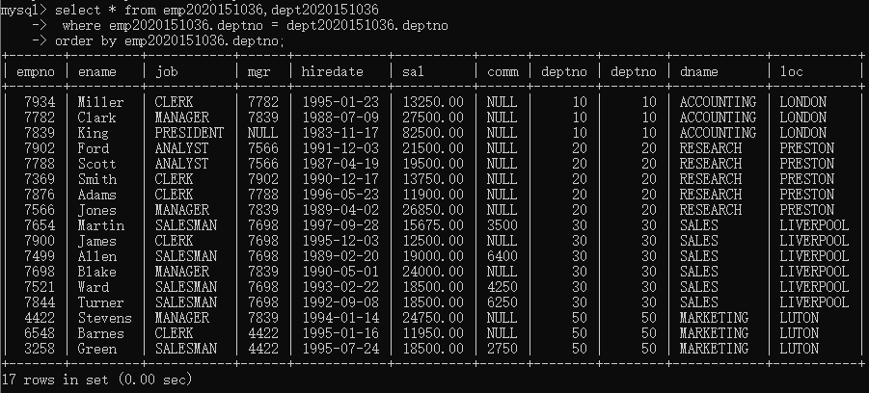

3. List the names of all salesmen who work in SALES

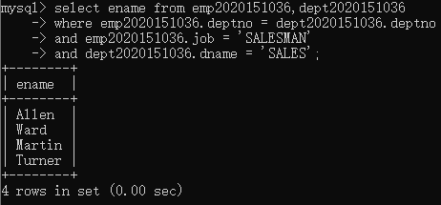

4. List all departments that do not have any employees.

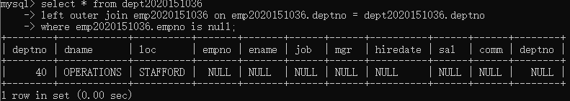

5 For each employee whose salary exceeds his manager's salary, list the employee's name and salary and the manager's name and salary.

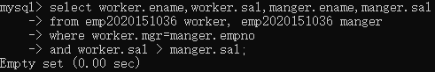

6. List the employees who have BLAKE as their manager.

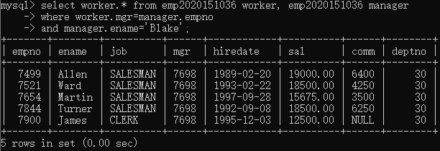

**五.实验心得**

通过此次实验，学会了MySql的基本操作（建表，增删数据，查询数据），进一步理解数据库系统的作用，并加深理解关系型数据库的主键、外键。要学好数据库这门课，最重要的还是多动手，多写sql语句，正所谓“熟能生巧”。

**签名**（手签，不得打印）：

|  |
| --- |
| 指导教师批阅意见：  成绩评定：  指导教师签字：  年 月 日 |
| 备注： |