**深 圳 大 学**

**实 验 报 告**

**课程名称： 数据库系统**

**实验序号： 实验2**

**实验名称： SQL的多表连接查询以及视图**

**学 号： 2020151036**

**姓 名： 谢弘烨**

**实验完成日期： 2022 年 10月 11 日**

**一、实验目的：**

1. 了解DBMS系统的功能、软件组成；

2、掌握利用SQL语句定义、和简单操纵数据库的方法。

**二、实验要求：**

1、在课外安装相关软件并浏览软件自带的帮助文件和功能菜单，了解DBMS的功能、结构；  
 2、创建一个有两个关系表的数据库；

3、数据库、关系表定义；

4、学习定义关系表的约束(主键、外键、自定义)；

5、了解SQL的数据定义功能；

6、了解SQL的操纵基本功能；

8、了解视图的概念；

**三、实验设备：**

计算机、数据库管理系统如MYSQL 等软件。

**四、实验内容**

1、

**EMP+(学生自己的学号) :**

|  |  |  |  |  |  |  |  |
| --- | --- | --- | --- | --- | --- | --- | --- |
| EMPNO | ENAME | JOB | MGR | HIREDATE | SAL | COMM | DEPTNO |
| 7369 | SMITH | CLERK | 7902 | 17-Dec-90 | 13750 |  | 20 |
| 7499 | ALLEN | SALESMAN | 7698 | 20-FEB-89 | 19000 | 6400 | 30 |
| 7521 | WARD | SALESMAN | 7698 | 22-FEB-93 | 18500 | 4250 | 30 |
| 7566 | JONES | MANAGER | 7839 | 02-APR-89 | 26850 |  | 20 |
| 7654 | MARTIN | SALESMAN | 7698 | 28-SEP-97 | 15675 | 3500 | 30 |
| 7698 | BLAKE | MANAGER | 7839 | 01-MAY-90 | 24000 |  | 30 |
| 7782 | CLARK | MANAGER | 7839 | 09-JUN-88 | 27500 |  | 10 |
| 7788 | SCOTT | ANALYST | 7566 | 19-APR-87 | 19500 |  | 20 |
| 7839 | KING | PRESIDENT |  | 17-NOV-83 | 82500 |  | 10 |
| 7844 | TURNER | SALESMAN | 7698 | 08-SEP-92 | 18500 | 6250 | 30 |
| 7876 | ADAMS | CLERK | 7788 | 23-MAY-96 | 11900 |  | 20 |
| 7900 | JAMES | CLERK | 7698 | 03-DEC-95 | 12500 |  | 30 |
| 7902 | FORD | ANALYST | 7566 | 03-DEC-91 | 21500 |  | 20 |
| 7934 | MILLER | CLERK | 7782 | 23-JAN-95 | 13250 |  | 10 |
| 3258 | GREEN | SALESMAN | 4422 | 24-Jul-95 | 18500 | 2750 | 50 |
| 4422 | STEVENS | MANAGER | 7839 | 14-Jan-94 | 24750 |  | 50 |
| 6548 | BARNES | CLERK | 4422 | 16-Jan-95 | 11950 |  | 50 |

**DEPT+(学生自己的学号)**:

|  |  |  |
| --- | --- | --- |
| DEPTNO | DNAME | LOC |
| 10 | ACCOUNTING | LONDON |
| 20 | RESEARCH | PRESTON |
| 30 | SALES | LIVERPOOL |
| 40 | OPERATIONS | STAFFORD |
| 50 | MARKETING | LUTON |

**以下为学生实验填写部分，完成实验指导书Exercises3,4,5,6,7 全部题目，要有题目语句和运行结果截屏：**

EXE3：

1 Find how many employees have a title of manager without listing them.

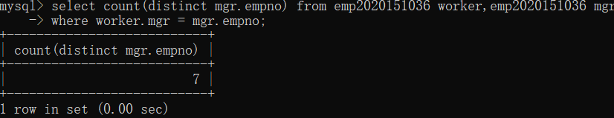

2 Compute the average annual salary plus commission for all salesmen

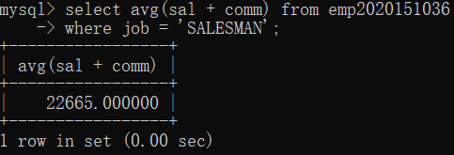

3 Find the highest and lowest salaries and the difference between them (single SELECT statement)

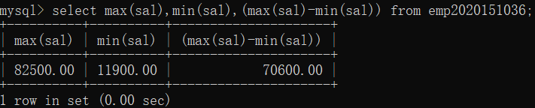

4 Find the number of characters in the longest department name

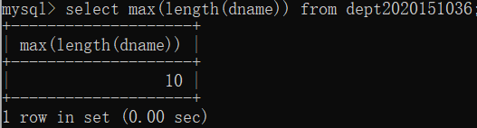

5 Count the number of people in department 30 who receive a salary and the number of people who receive a commission (single statement).

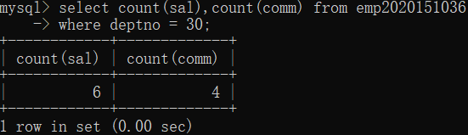

6 List the average commission of employees who receive a commission, and the average commission of all employees (assume employees who do not receive a commission attract zero commission)

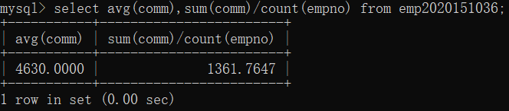

7 List the average salary of employees that receive a salary, the average commission of employees that receive a commission, the average salary plus commission of only those employees that receive a commission and the average salary plus commission of all employees including those that do not receive a commission. (single statement)

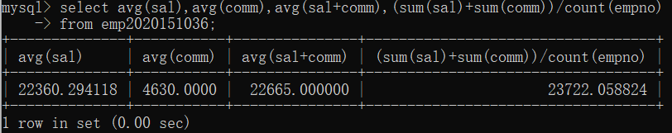

8 Compute the daily and hourly salary for employees in department 30, round to the nearest penny. Assume there are 22 working days in a month and 8 working hours in a day.

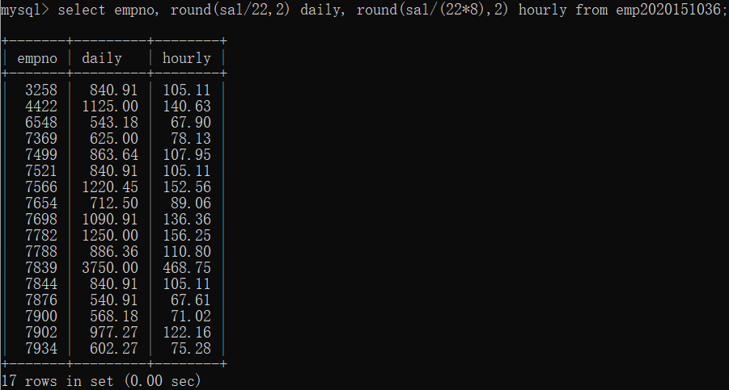

9 Issue the same query as the previous one except that this time truncate (TRUNC) to the nearest penny rather than round.

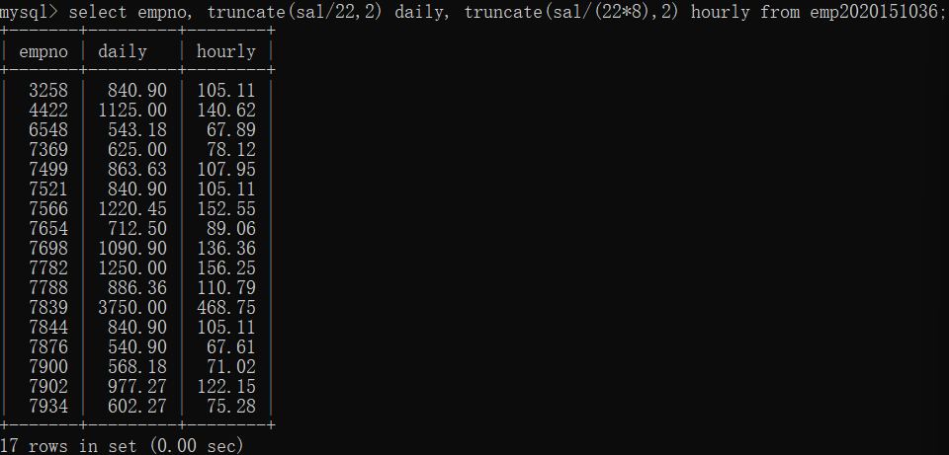

EXE4：

1 Select the name, job, and date of hire of the employees in department 20. (Format the HIREDATE column to MM/DD/YY)

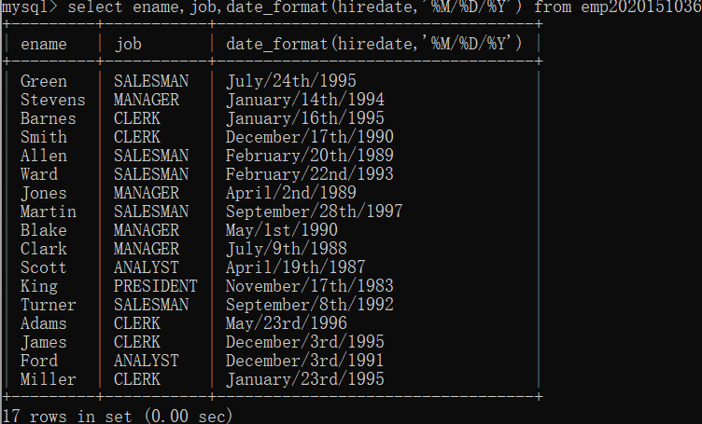

2 Then format the HIREDATE column into DoW (day of the week), Day (day of the month), MONTH (name of the month) and YYYY(year)

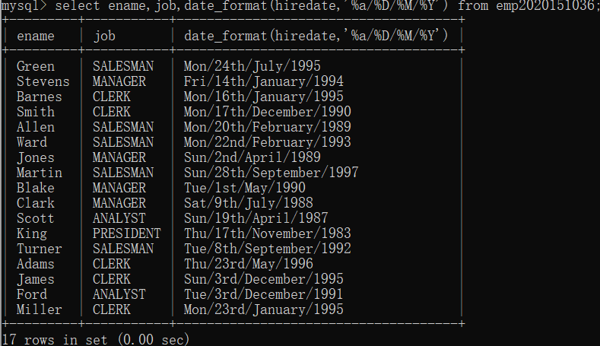

1. Which employees were hired in April?

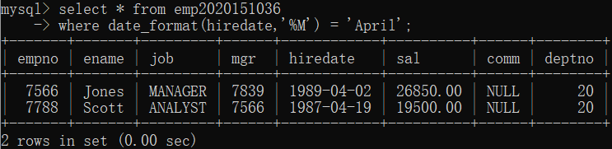

4 Which employees were hired on a Tuesday?

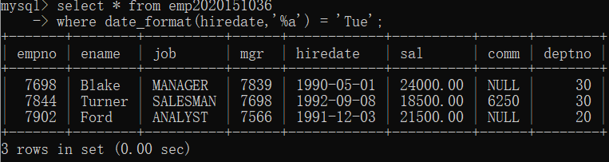

5 Are there any employees who have worked more than 30 years for the company?

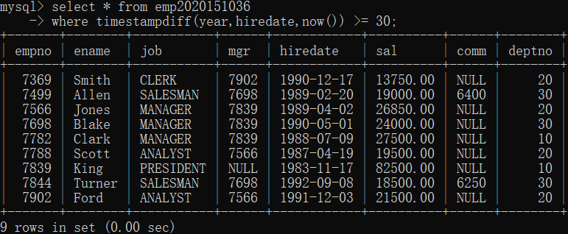

6 Show the weekday of the first day of the month in which each employee was hired. (plus their names)//被雇佣当月第一天星期几

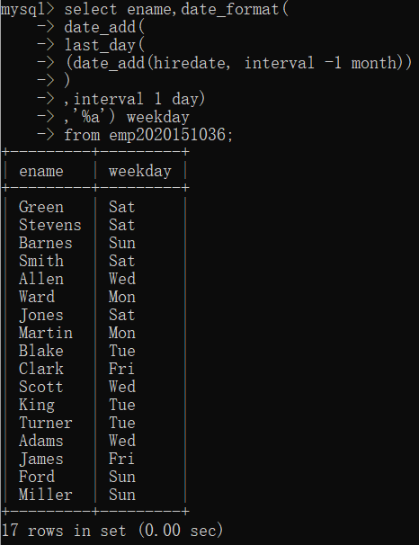

7 Show details of employee hiredates and the date of their first payday.

(Paydays occur on the last Friday of each month) (plus their names)

此处忽略了入职日在当月最后一个周五之后的情况。

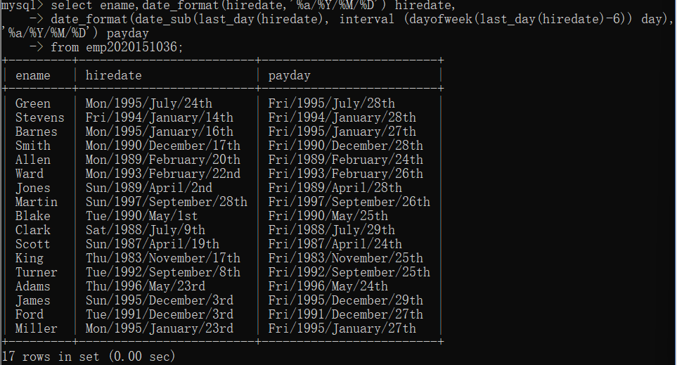

8 Refine your answer to 7 such that it works even if an employee is hired after the last Friday of the month (cf Martin)

入职时已经错过发薪日，利用上一题中的做法无法解决。因此加入条件判断，如此处Martin，当入职日在当月最后一个周五之后时，求入职日下个月的最后一个周五。

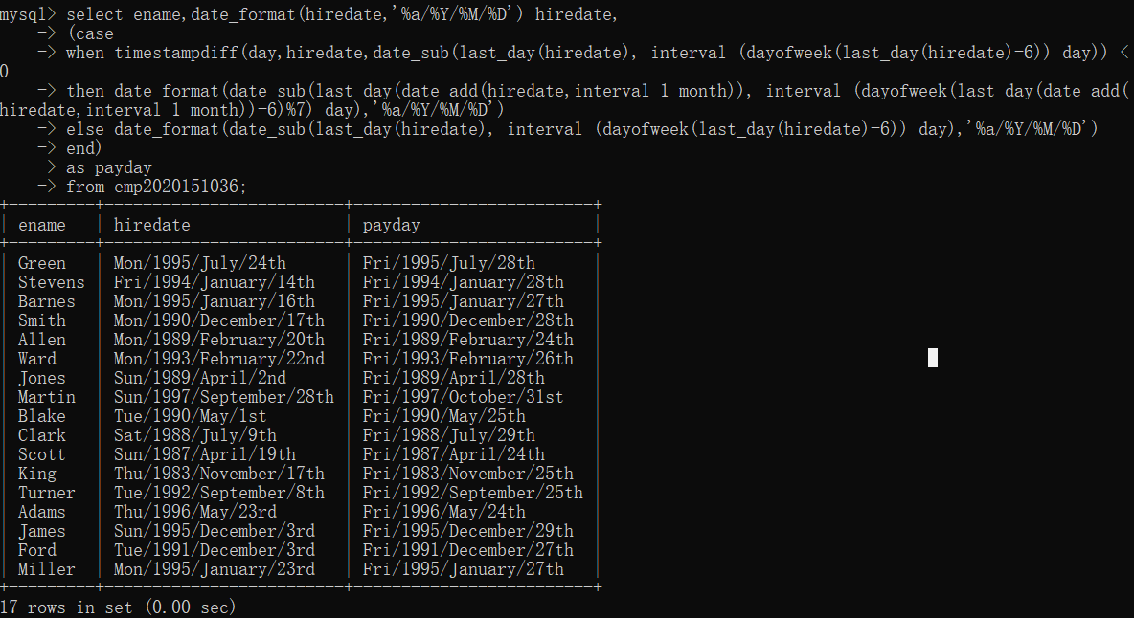

EXE5：

1 List the department number and average salary of each department.

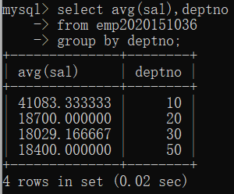

2 Divide all employees into groups by department and by job within department. Count the employees in each group and compute each group's average annual salary.

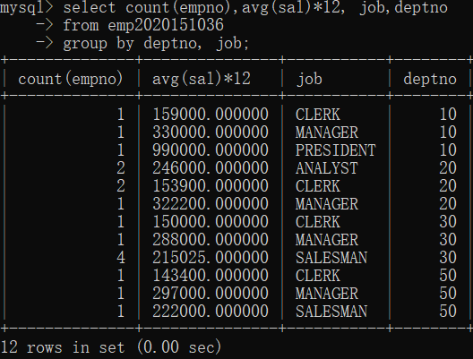

3 Issue the same query as above except list the department name rather than the department number.

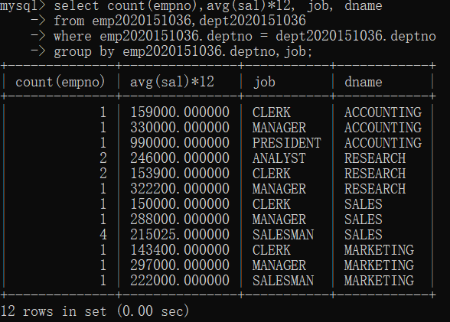

4 List the average annual salary for all job groups having more than 2 employees in the group.

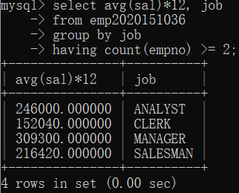

5 Find all departments with an average commission greater than 25% of average salary.

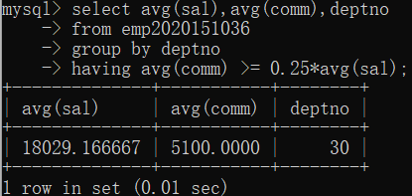

6 Find each department's average annual salary for all its employees except the managers and the president.

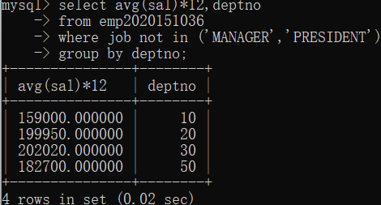

EXE6：

1 List the name and job of employees who have the same job as Jones.

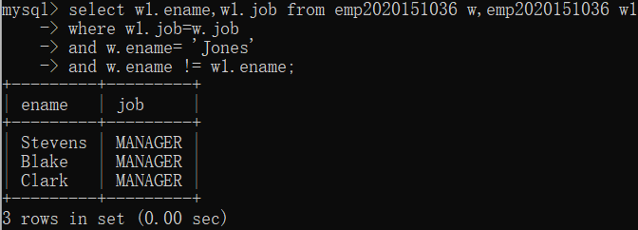

2 Find all the employees in Department 10 that have a job that is the same as anyone in department 30.

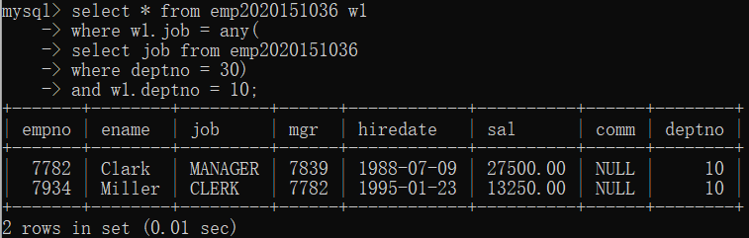

3 List the name, job, and department of employees who have the same job as Jones or a salary greater than or equal to Ford.

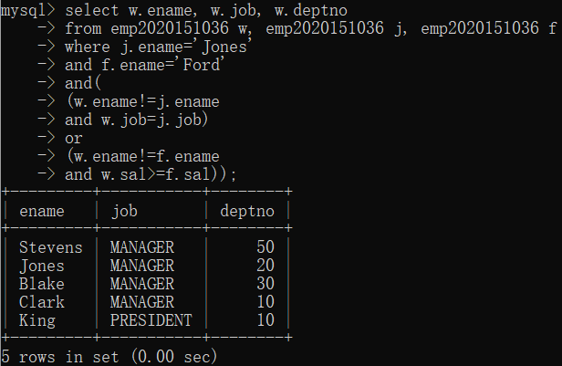

4 Find all employees in department 10 that have a job that is the same as anyone in the Sales department

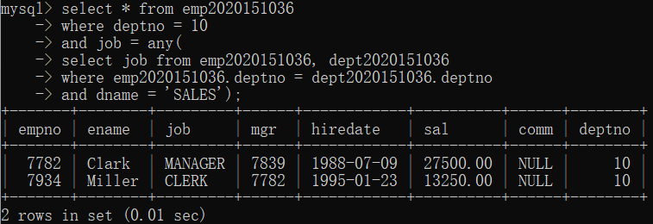

5 Find the employees located in Liverpool who have the same job as Allen. Return the results in alphabetical order by employee name.

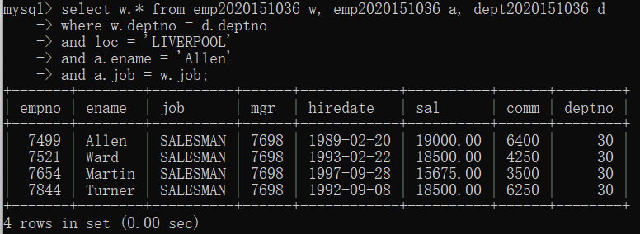

6 Find all the employees that earn more than the average salary of employees in their department.

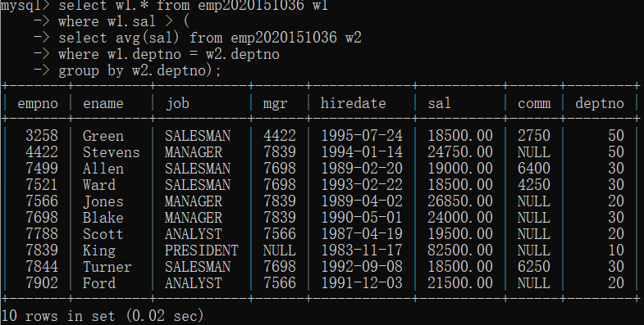

7 Find all the employees that earn more than JONES, using temporary labels to abbreviate table names.

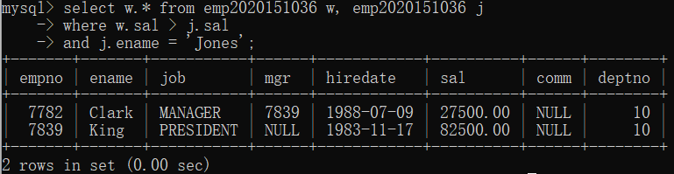

EXE7：

1 Create a new table called loans with columns named LNO NUMERIC (3), EMPNO NUMERIC (4), TYPE CHAR(1), AMNT NUMERIC (8,2)

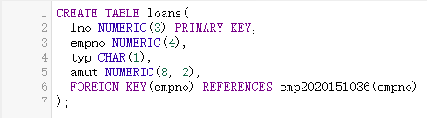

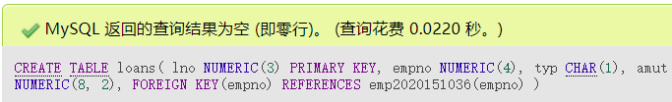

2 Insert the following data

LNO EMPNO TYPE AMNT

23 7499 M 20000.00

42 7499 C 2000.00

65 7844 M 3564.00

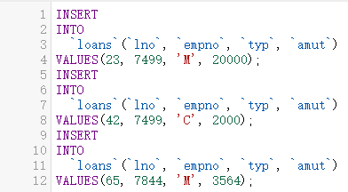

3 Check that you have created 3 new records in Loans

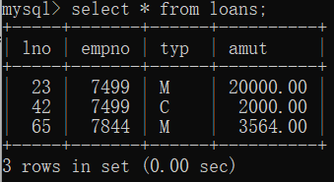

4 The Loans table must be altered to include another column OUTST NUMERIC(8,2)

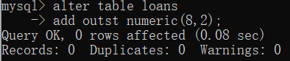

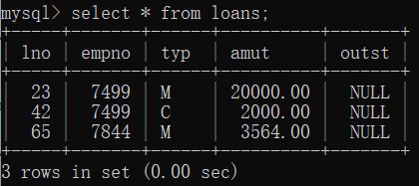

5 Add 10% interest to all M type loans

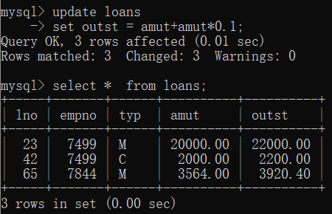

6 Remove all loans less than £3000.00

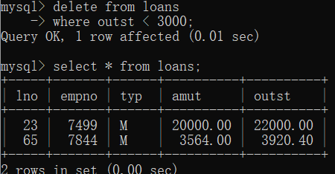

7 Change the name of loans table to accounts

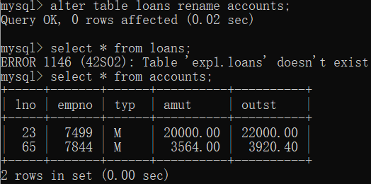

8 Change the name of column LNO to LOANNO

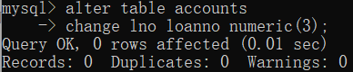

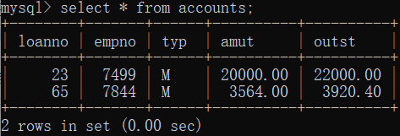

9 Create a view for use by personnel in department 30 showing employee name, number, job and hiredate

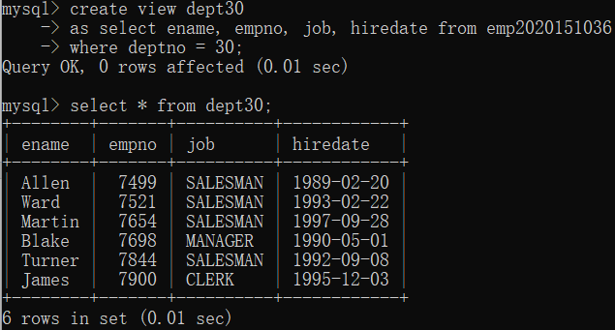

10 Use the view to show employees in department 30 having jobs which are not salesman

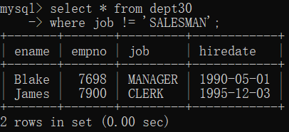

11 Create a view which shows summary information for each department.

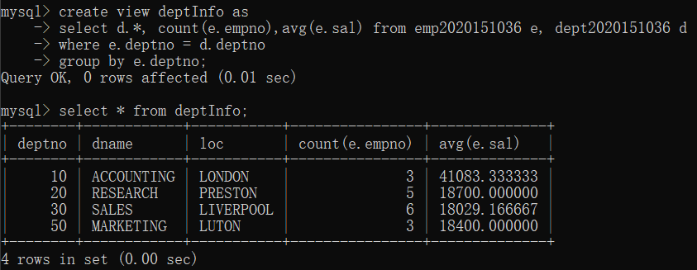

**五.实验心得**

在本次实验中，我掌握了如何从数据库中读取不同的数据以及如何对其进行编辑。此外，我还掌握了“JOIN”，“GROUP BY”，“HAVING”等语句的用法。

|  |
| --- |
| 指导教师批阅意见：  成绩评定：  指导教师签字：  年 月 日 |
| 备注： |