第五套
Time — 35 minutes per Section
Section 1 Easy
1.
n > 1
Quantity A: 125n
Quantity B: 215(n-1)

A. Quantity A is greater.
B. Quantity B is greater.
C. The two quantities are equal
D. The relationship cannot be determined from the information given.

2.
Quantity A: The area of an isosceles triangle that has one right angle and two sides of length 2
Quantity B: The area of an equilateral triangle that has sides of length 2

A. Quantity A is greater.
B. Quantity B is greater.
C. The two quantities are equal
D. The relationship cannot be determined from the information given.

3.
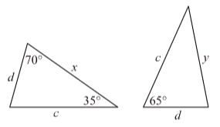

Quantity A: x
Quantity B: y

A. Quantity A is greater.
B. Quantity B is greater.
C. The two quantities are equal
D. The relationship cannot be determined from the information given.

4.
Quantity A: The number of integers from 1 to 300 that are divisible by both 5 and 9
Quantity B: 6

A. Quantity A is greater.
B. Quantity B is greater.
C. The two quantities are equal
D. The relationship cannot be determined from the information given.

5.
Quantity A: The time taken by the car to travel the d miles at r miles per hour
Quantity B: d/s hours

A. Quantity A is greater.
B. Quantity B is greater.
C. The two quantities are equal
D. The relationship cannot be determined from the information given.

6.
-10<x+y< 20
5<x<10

Quantity A: y
Quantity B: -15

A. Quantity A is greater.
B. Quantity B is greater.
C. The two quantities are equal
D. The relationship cannot be determined from the information given.

7.
R=(2¹⁶)(5³⁴)(N⁵⁰),where N is a positive integer.

Quantity A:
Quantity B: R/10

A. Quantity A is greater.
B. Quantity B is greater.
C. The two quantities are equal
D. The relationship cannot be determined from the information given.

8.
2s=r+t

Quantity A: The median of r, s, and t
Quantity B: s

A. Quantity A is greater.
B. Quantity B is greater.
C. The two quantities are equal
D. The relationship cannot be determined from the information given.

9.
A copy machine was used to produce two smaller versions of a rectangular picture. Each dimension of the original picture was reduced by 20 percent to produce the first smaller version, and then each dimension of the first smaller version was reduced by 15 percent to produce the second smaller version. Each dimension of the second smaller version was what percent of the corresponding dimension of the original picture?

A. 35%
B. 38%
C. 65%
D. 68%
E. 70%

10.
A metal right circular cylinder is 20 centimeters tall, has a base with diameter 8 centimeters, and is open at both ends. Which of the following is closest to the outside surface area of the cylinder, in square centimeters?

A. 450
B. 475
C. 500
D. 525
E. 550

11.
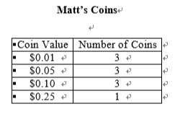
Matt has 10 coins, and their values are shown in the table. If Matt randomly selects 4 of the coins, which of the following could be the total value of the 4 coins?

Indicate all such values.

A. $0.25
B. $0.26
C. $0.27
D. $0.28

12.
If 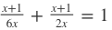,
what is the value of x?
x=

13.
x,12,11
If the standard deviation of the three numbers in the list above is 4, what is the standard deviation of x+9, 21, and 20?

A. 4
B. 13
C. 31
D. 36
E. 108

14.
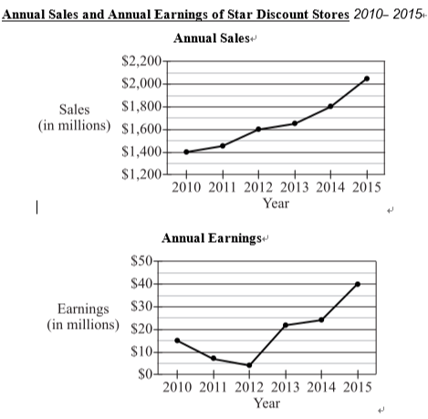

According to a projection made in January 2016, for each of the three years following 2015, annual sales would increase by an amount equal to 12 of the increase in annual sales from 2014 to 2015. According to this projection, approximately what would annual sales be for the year 2018?

A. $2,200 million
B. $2,425 million
C. $3,450 million
D. $4,050 million
E. $4,875 million

15.

Based on the information given, which of the following statements are true?

Indicate all such statements.

A. For the years shown, the range of the annual earnings was greater than $30 million.
B. From 2010 to 2015, both annual sales and annual earnings more than doubled.
C. For each of the years shown, annual earnings were more than 1 percent of annual sales.

16.

The number of stores owned by Star Discount in 2015 was twice the number owned by Star Discount in 2010. By approximately what percent did the average annual earnings per store increase from 2010 to 2015?

A. 5%
B. 12%
C. 25%
D. 33%
E. 40%

17.
In a certain list of positive integers, the ratio of the number of odd integers to the number of even integers is 7 to 4. One-fourth of the number of odd integers is what fraction of the total number of integers in the list?

A. 7/44
B. 3/16
C. 11/28
D. 7/16
E. 9/16

18.
If the circumference of a circle is 6, what is the area of the circle?

A. 6/π²
B. 9/π
C. 6 π
D. 9π
E. 36 π

19.
In the xy-plane, the graph of the equation
passes through the point (c,-c). What is the value of c?

A. -6
B. -3
C. 2
D. 3
E. 6

20.
On a final exam, 75 percent of a class had scores that were greater than 70, and 60 percent of the class had scores that were less than 85. What percent of the class had scores that were greater than 70 but less than 85?
%



Section 1

1-5: D,A,A,C,B
6-10: D,B,C,D,C
11-15: ABD,2,A,B,A
16-20: D,A,B,A,35

Time — 35 minutes per Section
Section 2 Medium
1.
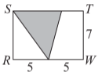
The area of the shaded region inside rectangle RSTW is 28.

Quantity A: The sum of the areas of the unshaded regions inside rectangle RSTW
Quantity B: 42

A. Quantity A is greater.
B. Quantity B is greater.
C. The two quantities are equal
D. The relationship cannot be determined from the information given.

2.
List K consists of 10 numbers whose standard deviation is 7.
List M is formed by adding 3 to each number in list K.

Quantity A: The standard deviation of the numbers in list M
Quantity B: 7

A. Quantity A is greater.
B. Quantity B is greater.
C. The two quantities are equal
D. The relationship cannot be determined from the information given.

3.
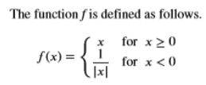
Quantity A: f(2)
Quantity B: f(-1/4)

A. Quantity A is greater.
B. Quantity B is greater.
C. The two quantities are equal
D. The relationship cannot be determined from the information given.

4.
At a community college, 36 students are enrolled in a psychology class and 28 students are enrolled in a statistics class. Of the students enrolled in the psychology class, 17 are also enrolled in the statistics class.

Quantity A: The number of students at the college who are enrolled in only one of the two classes
Quantity B: 30

A. Quantity A is greater.
B. Quantity B is greater.
C. The two quantities are equal
D. The relationship cannot be determined from the information given.

5.
x<8

Quantity A: |x|
Quantity B: 9

A. Quantity A is greater.
B. Quantity B is greater.
C. The two quantities are equal
D. The relationship cannot be determined from the information given

6.
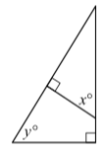
Quantity A: x
Quantity B: y

A. Quantity A is greater.
B. Quantity B is greater.
C. The two quantities are equal
D. The relationship cannot be determined from the information given

7.
0 < p < 1
n is a positive integer.

Quantity A: p^{n}
Quantity B: p^{-n}

A. Quantity A is greater.
B. Quantity B is greater.
C. The two quantities are equal
D. The relationship cannot be determined from the information given

8.
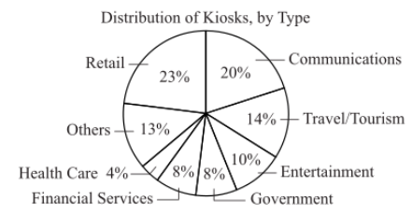

According to the graph, the kiosks of which of the following two types combined account for 6/25 of all the kiosks?

A. Entertainment and retail
B. Entertainment and financial services
C. Entertainment and travel/tourism
D. Communications and government
E. Retail and financial services

9.
0.4, 0.8, 1.2, 2.0, y
If the average (arithmetic mean) of the 5 numbers in the list above is 1.0, what is the value of y?

A. 0.2
B. 0.4
C. 0.6
D. 0.8
E. 1.0

10.
In a certain sequence of numbers, each term after the first term is found by multiplying the preceding term by 3 and then subtracting 2 from the product. If the third term of the sequence is 55, what is the first term of the sequence?

A. 5
B. 6
C. 7
D. 8
E. 9

11.
Points P, Q, and R lie on a line, and point Q is between point P and point R. The length of line segment PQ is 5. Which of the following could be the length of line segment PR?

Indicate all such lengths.

A. 2
B. 4
C. 6
D. 8

12.
If c, d, and e are integers greater than 1 and cde=66, what is the value of c+d+e ?

A. 16
B. 19
C. 20
D. 33
E. 35

13.
An initial amount of 600 grams of a saltwater solution that was 5 percent salt, by mass, was reduced to 300 grams of solution by evaporating some of the water. If the amount of salt remained the same, then the resulting solution was what percent salt?

A. 60%
B. 30%
C. 20%
D. 10%
E. 6%

14.
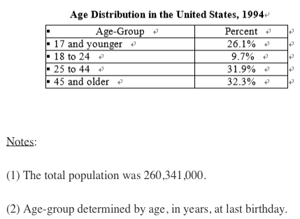

Approximately how many people were age 24 years or younger?

A. 25 million
B. 36 million
C. 68 million
D. 87 million
E. 93 million

15.

The median age of the population is in which of the four age-groups shown?

A. 17 and younger
B. 18 to 24
C. 25 to 44
D. 45 and older
E. It cannot be determined from the information given.

16.

Which of the following information, if any, together with the information given, is sufficient to determine the average (arithmetic mean) age for the population?

A. The number of people in each age-group
B. The average age for each age-group
C. The median age for each age-group
D. The median age for the population
E. No additional information is needed; the information given is sufficient.

17.
John and Paul begin work at 8:00 in the morning and finish at 4:30 in the afternoon. John begins his first break of the day at 8:45 and his second break at 9:30, and he continues to take a break every 45 minutes throughout the day. Paul begins his first break at 9:00 and his second break at 10:00, and he continues to take a break every 60 minutes throughout the day. At which of the following times do John and Paul begin a break at the same time?

Indicate all such times.

A. 10:00 in the morning
B. 11:00 in the morning
C. 12:00 noon
D. 1:00 in the afternoon
E. 2:00 in the afternoon.
F. 3:00 in the afternoon
G. 4:00 in the afternoon

18.
In the xy-plane, a quadrilateral has vertices at (-9,-2), (-1,-2) ,(-1,-4) , and (-9,-4). What is the perimeter of the quadrilateral?

A. 4
B. 10
C. 20
D. 24
E. 32

19.
The total charge for a 4-week dance class is $55.00. The class has 3 sessions per week, and each session lasts 45 minutes. Approximately what is the charge per hour for the class?

A. $18.30
B. $13.75
C. $6.10
D. $5.35
E. $4.60

20.
If4^{x}=256, what is the value of 2^{2x-1} ?
2^{2x-1} =



Section 2

1-5: C,C,B,C,D
6-10: C,B,C,C,C
11-15: CD,A,D,E,C
16-20: B,BE,C,C,128

第六套
Time — 35 minutes per Section
Section 1 medium

1.
S={2,7,9,10,11,15}
A number r is to be selected at random from set S.

Quantity A: The probability that the value of will be 1
Quantity B: 1/2

A. Quantity A is greater.
B. Quantity B is greater.
C. The two quantities are equal
D. The relationship cannot be determined from the information given.

2.
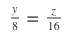
Quantity A: (y+1)/4
Quantity B: (z+1)/8

A. Quantity A is greater.
B. Quantity B is greater.
C. The two quantities are equal
D. The relationship cannot be determined from the information given.

3.
Quantity A: 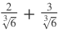
Quantity B: 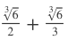

A. Quantity A is greater.
B. Quantity B is greater.
C. The two quantities are equal
D. The relationship cannot be determined from the information given.

4.
The length of each side of square PQRS is greater than 3. The radius of circle C is 3.

Quantity A: The area of square PQRS
Quantity B: The area of circle C

A. Quantity A is greater.
B. Quantity B is greater.
C. The two quantities are equal
D. The relationship cannot be determined from the information given.

5.
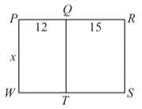
The ratio of PW to PR in rectangle PRSW is equal to the ratio of PQ to QT in rectangle PQTW.

Quantity A: x
Quantity B: 20

A. Quantity A is greater.
B. Quantity B is greater.
C. The two quantities are equal
D. The relationship cannot be determined from the information given.

6.
For 1 year, Maria invested $10,000 at a simple annual interest rate of x percent and $8,000 at a simple annual interest rate of y percent, where x=3y/4 and y>0.

Quantity A: The amount of interest earned on the $10,000 investment
Quantity B: The amount of interest earned on the $8,000 investment

A. Quantity A is greater.
B. Quantity B is greater.
C. The two quantities are equal
D. The relationship cannot be determined from the information given.

7.
The points (r,s) and (t,u) are in the xy-plane, where r, s, t, and u are all less than 0 and r≠t.

Quantity A: The slope of the line that passes through (r,s) and (t,u)
Quantity B: 0

A. Quantity A is greater.
B. Quantity B is greater.
C. The two quantities are equal
D. The relationship cannot be determined from the information given.

8.
14.6, 12.6, 16.3, 16.2, 16.2, 17.8, 17.7, 16.0, 14.6, 12.6

The readings of the electric meter for a certain business for each of 10 months are listed above. What is the median of the readings?

A. 16.0
B. 16.1
C. 16.2
D. 16.25
E. 16.3

9.
When measured from sea level, the height of Mountain C is 40 percent of the height of Mountain D. If the height of Mountain C is greater than 800 meters, which of the following values could be the height, in meters, of Mountain D?

Indicate all such values.

A. 1200
B. 1500
C. 1600
D. 1800
E. 2500
F. 3000

10.
An empty box weighs 50 ounces. The box is to be packed with at least 98 units of a certain product but not more than 102 units. If each unit weighs 0.82 ounce and the packed box weighs w ounces, then w must satisfy which of the following inequalities?

A. 80.36≤w≤83.64
B. 88.56≤w≤112.2
C. 119.50≤w≤132.64
D. 130.36≤w≤133.64
E. 131.55≤w≤137.56

11.
The integers s and t are divisible by 5. Which of the following is NOT necessarily true?

A. s-t is divisible by 5.
B. s+t is divisible by 10.
C. st is divisible by 25.
D. s² -t² is divisible by 5.
E. s² +t² is divisible by 25.

12.
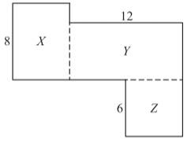

The figure shows some of the dimensions, in meters, of a building with eight sides. The perimeters of rectangular regions X, Y, and Z are 28, 34, and 22 meters, respectively. What is the perimeter of the building, in meters?

A. 60
B. 64
C. 70
D. 74
E. 84

13.
If x=3 is a solution of the equation x²+bx-18=0, where b is a constant, then the other solution is

A. x=15
B. x=9
C. x=6
D. x=-3
E. x=-6

14.
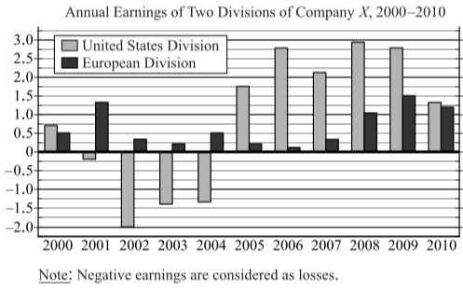

For 2008 the annual earnings of the European division were approximately what percent of the combined annual earnings of the two divisions?

A. 25%
B. 40%
C. 50%
D. 60%
E. 75%

15.

If the annual earnings of the European division for 2009 represented 7 percent of the division`s annual revenues, approximately how much were its annual revenues?

A. $11 billion
B. $21 billion
C. $37 billion
D. $105 billion
E. $214 billion

16.

For the years shown, the range of the annual earnings of the United States division was approximately how much greater than the range of the annual earnings of the European division?

A. $1.5 billion
B. $2.7 billion
C. $3.6 billion
D. $4.3 billion
E. $5.0 billion

17.
The average (arithmetic mean) of w, x, y, and z is equal to the average of x, y, and z. Which of the following expressions represents w in terms of x, y, and z?

A. (x+y+z)/4
B. (x+y+z)/3
C. 3(x+y+z)/4
D. 4(x+y+z)/3
E. 12(x+y+z)

18.
How many integers between 115 and 969 are cubes of integers?



19.
The width of rectangle T is 25 percent greater than the width of rectangle R, and the length of T is 10 percent greater than the length of R. The area of T is what percent greater than the area of R ?

A. 2.5%
B. 15%
C. 27.3%
D. 35%
E. 37.5%

20.
If -1 < x < 1 and x≠0, which of the following statements must be true?
Indicate all such statements.

A.
B. x²<x
C. x³<x²

Section 1

1-5: B,A,A,D,B
6-10: B,D,B,EF,D
11-15: B,B,E,A,B
16-20: C,B,5,E,C

Time — 35 minutes per Section
Section 2 Hard
1.
Each of the 120 people in a group donated one of three different amounts to charity. Of the people in the group,2/3 donated $10.00 each,1/4 donated $15.00 each, and the rest donated $25.00 each.

Quantity A: The average (arithmetic mean) amount donated per person in the group
Quantity B: $12.50

A. Quantity A is greater.
B. Quantity B is greater.
C. The two quantities are equal
D. The relationship cannot be determined from the information given.

2.
-|x|=|x|

Quantity A: x
Quantity B: 0

A. Quantity A is greater.
B. Quantity B is greater.
C. The two quantities are equal
D. The relationship cannot be determined from the information given.

3.
Quantity A: The greatest possible value of 2/(x-y), where 6≤x≤8 and 2≤y≤5
Quantity B: 2/3

A. Quantity A is greater.
B. Quantity B is greater.
C. The two quantities are equal
D. The relationship cannot be determined from the information given.

4.
The function f is defined by f(x)=x(x²−4) for all numbers x.

Quantity A: The number of points at which the graph of y=f(x) intersects the x-axis in the xy-plane
Quantity B: 3

A. Quantity A is greater.
B. Quantity B is greater.
C. The two quantities are equal
D. The relationship cannot be determined from the information given.

5.
0 < r < v < x < y < z

Quantity A: The average (arithmetic mean) of the 4 numbers r, v, y, and z
Quantity B: The average (arithmetic mean) of the 5 numbers r, v, x, y, and z

A. Quantity A is greater.
B. Quantity B is greater.
C. The two quantities are equal
D. The relationship cannot be determined from the information given.

6.
The volume of a right circular cylinder is 2,000π, and its height is 16 times its radius.

Quantity A: The radius of the cylinder
Quantity B: 5

A. Quantity A is greater.
B. Quantity B is greater.
C. The two quantities are equal
D. The relationship cannot be determined from the information given.

7.
C1,C2,C3,...Cj...
The sequence shown is defined by C1=5 and Cj+1=(1/5)Cj for each positive integer j.

Quantity A: C10
Quantity B: 5¹⁵C25

A. Quantity A is greater.
B. Quantity B is greater.
C. The two quantities are equal
D. The relationship cannot be determined from the information given.

8.
An investor placed a total of $6,400 in two accounts for one year. One of the accounts earned simple annual interest at a rate of 5 percent, and the other earned simple annual interest at a rate of 3 percent. The investor made no deposits or withdrawals from the accounts. If each account earned the same amount of interest after one year, what was the total amount of interest earned from both accounts?

A. $128
B. $144
C. $240
D. $256
E. $512

9.
A flat rectangular tile has a length that is between 4 inches and 6 inches and a width that is between 3 inches and 6 inches. Which of the following could be the value of the area, in square feet, of the top surface of the tile? (1 foot = 12 inches)

Indicate all such values.

A. 1/8
B. 1/6
C. 1/2
D. 4/3

10.
If 2, 4, 6, and 9 are the digits of two 2-digit integers, what is the least possible positive difference between the integers?

A. 28
B. 27
C. 17
D. 13
E. 9

11.
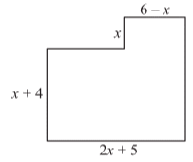

In the figure, all intersecting line segments meet at right angles. Which of the following represents the perimeter of the figure in terms of x?

A. 3x+15
B. 4x+9
C. 5x+19
D. 6x+16
E. 8x+18

12.
A certain experiment has only three possible outcomes. The probabilities of the outcomes are p, r, and s. If r=1-3p, what is s in terms of p?

A. p
B. 2p
C. 3p
D. 1-p
E. 1-2p

13.
When the positive integer d is divided by 12, the remainder is 5. What is the remainder when d² is divided by 8?

A. 1
B. 3
C. 5
D. 6
E. 7

14.
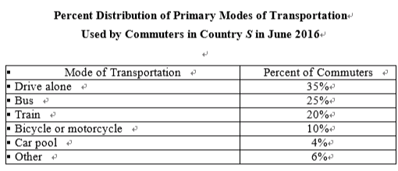

If 75 percent of the commuters were local commuters and if 20 percent of the local commuters used buses as their primary mode of transportation, what percent of all commuters who used buses as their primary mode of transportation were local commuters?

A. 6%
B. 15%
C. 30%
D. 60%
E. 75%

15.

For commuters who used car pools as their primary mode of transportation, the average (arithmetic mean) number of commuters per car pool vehicle was 2.5. Which of the following is closest to the total number of car pool vehicles for these commuters?

A. 0.02 million
B. 0.13 million
C. 0.32 million
D. 0.80 million
E. 1.20 million

16.

From June 2016 to December 2016, the total number of commuters increased by x percent while the percent of commuters who used trains as their primary mode of transportation remained the same. If the number of commuters who used trains as their primary mode of transportation increased by 16,000 from June to December, what is the value of x?

A. 1
B. 2
C. 3
D. 4
E. 5

17.
The sale price of a certain radio is 25 percent less than the list price and 40 percent greater than the wholesale price of the radio. If the wholesale price of the radio is $30, what is the list price of the radio?

A. $52
B. $53
C. $54
D. $55
E. $56

18.
A list consists of three different positive integers whose sum is 10.

Which of the following statements individually provide(s) sufficient additional information to determine the value of the greatest integer in the list?

Indicate all such statements.

A. The median of the integers in the list is 3.
B. The range of the integers in the list is 5.
C. The sum of the greatest integer and the least integer in the list is 7.

19.
A group of n college students bought three identical round cakes to share. They divided the first cake into equal-sized pieces, one piece for each of them. They did the same with the second cake. After 3 of the students decided they did not want any more cake, the remaining students divided the third cake into equal-sized pieces, one piece for each of them. If Silvia received 1 piece from each of the three cakes, then, in terms of n, the amount of cake that she received was the same as what fraction of 1 cake?

- 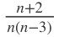
B. 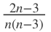
C. 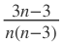
D. 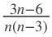
E. 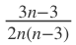

20.
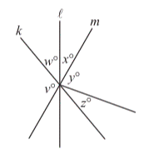

In the figure, lines k, l, and m intersect at a single point, which is the vertex of all the angles shown. If x=z, y=2w, and v=110, what is the ratio of x to w?

Give your answer as a fraction.



Section 2

1-5: C,C,A,C,D
6-10: C,C,C,AB,D
11-15: E,B,A,D,B
16-20: A,E,B,D,3/4

第七套
Time — 35 minutes per Section
Section 1 Easy
1.
0< x< y< 1

Quantity A: y-x
Quantity B: (x-y)²

A. Quantity A is greater.
B. Quantity B is greater.
C. The two quantities are equal
D. The relationship cannot be determined from the information given.

2.
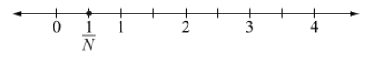

Quantity A: N
Quantity B: 1/2

A. Quantity A is greater.
B. Quantity B is greater.
C. The two quantities are equal
D. The relationship cannot be determined from the information given.

3.
Last Monday, James paid $8.00 per share for 180 shares of Stock X, paid $10.00 per share for 160 shares of Stock Y, paid $12.00 per share for 200 shares of Stock Z, and bought no other shares of stock.

Quantity A: The average (arithmetic mean) price per share that James paid for all of the shares of stock he bought last Monday
Quantity B: $10.00

A. Quantity A is greater.
B. Quantity B is greater.
C. The two quantities are equal
D. The relationship cannot be determined from the information given.

4.
2x+cy=10
6x+2cy=40
The system of equations shown has a solution, where c is a constant.

Quantity A: c
Quantity B: 1

A. Quantity A is greater.
B. Quantity B is greater.
C. The two quantities are equal
D. The relationship cannot be determined from the information given.

5.
The average (arithmetic mean) of the 6 numbers q, r, s, t, u, and v is 36.

Quantity A: 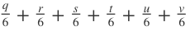
Quantity B: 6

A. Quantity A is greater.
B. Quantity B is greater.
C. The two quantities are equal
D. The relationship cannot be determined from the information given

6.
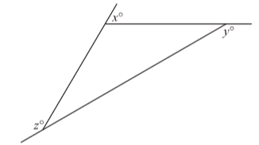

Quantity A: x+y+z
Quantity B: 360

A. Quantity A is greater.
B. Quantity B is greater.
C. The two quantities are equal
D. The relationship cannot be determined from the information given.

7.


In the figure shown, two rectangular regions overlap to form a triangular region, which is shaded. The perimeters of the rectangles are 15 and 21, and the perimeter of the triangle is 6.

Quantity A: The sum of the lengths of the thick line segments
Quantity B: 30

A. Quantity A is greater.
B. Quantity B is greater.
C. The two quantities are equal
D. The relationship cannot be determined from the information given.

8.
x and y are integers.
2^{x}-3y=20

Quantity A: y
Quantity B: 0

A. Quantity A is greater.
B. Quantity B is greater.
C. The two quantities are equal
D. The relationship cannot be determined from the information given.

9.
If x is 50 percent of y and if z is 30 percent of y, where y>0 , then z is what percent of x ? %



10.
A total of $36,000 was invested for one month in a new money market account that paid simple annual interest at the rate of r percent. If the investment earned $360 in interest for the month, what is the value of r ?

A. 10.0
B. 10.5
C. 11.0
D. 12.0
E. 12.5

11.
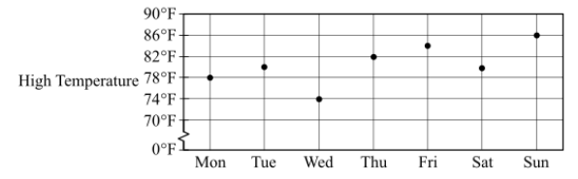

The equation C=(5/9)(F−32) represents the relationship between temperature C in degrees Celsius and the corresponding temperature F in degrees Fahrenheit. The graph shows the high temperature, in degrees Fahrenheit, on each day of a certain week. Which of the following is closest to the range of the high temperatures for the week, in degrees Celsius?

A. 4℃
B. 7℃
C. 8℃
D. 12℃
E. 14℃

12.
The circular bases of a right circular cylinder are inscribed in two opposite faces of a cube. If the volume of the cube is 64, which of the following is closest to the volume of the cylinder?

A. 46
B. 50
C. 54
D. 58
E. 62

13.
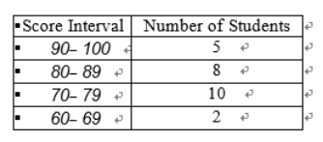

All of the students in an English class took a test, and each student received a test score that was a whole number between 60 and 100, inclusive. The table shows the number of students who received a test score in each of four score intervals. Which of the following numbers could be the median test score for all of the students?

Indicate all such numbers.

A. 85
B. 80
C. 75
D. 70
E. 65
F. 60

14.
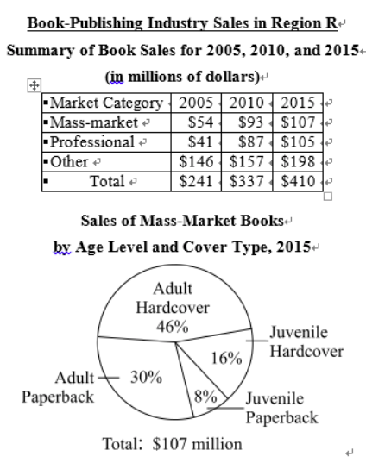

For mass-market books in 2015, which of the following is closest to the ratio of the dollar amount of sales of adult hardcover books to the dollar amount of sales of juvenile hardcover books?

A. 7 to 2
B. 5 to 2
C. 4 to 1
D. 3 to 1
E. 2 to 1

15.

For 2005, if sales of law books accounted for 39 percent of the dollar amount of sales of professional books, then sales of law books accounted for what percent of the dollar amount of all book sales for 2005?

Give your answer to the nearest whole percent.
%



16.

If the sales of mass-market adult hardcover books accounted for 33 percent of mass-market book sales in 2010, by approximately what percent did the dollar amount of sales of this type of book increase from 2010 to 2015 ?

A. 20%
B. 30%
C. 40%
D. 50%
E. 60%

17.
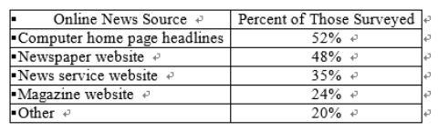

In a study of online news sources, computer users were surveyed to determine what computer sources they used for online news. The responses of those surveyed are summarized in the table shown. If 15 percent of those surveyed responded that they used both newspaper and magazine websites, what percent of those surveyed used newspaper websites but not magazine websites?
%



18.
The circumference of circle X is 24π. If the radius of circle Y is equal to 1/12 of the circumference of circle X, what is the circumference of circle Y?

A. π
B. 2π
C. 2π²
D. 4π²
E. 2π³

19.
If t≠0, which of the following is equivalent to 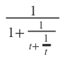?

A.
B. 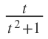
C. 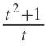
D. 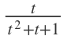
E. 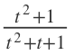

20.
6≤|x|≤8
1≤|y|≤2
3≤|z|≤4

If x, y, and z satisfy the inequalities shown, what is the least possible value of |x+y+z| ?

A. 0
B. 1
C. 2
D. 3
E. 4

Section 1

1-5: A,A,A,D,A
6-10: C,C,D,60,D
11-15: B,B,AB,D,7
16-20: E,33,D,E,A

Time — 35 minutes per Section
Section 2 Medium
1.
|x|+|y|=3

Quantity A: x+y
Quantity B: -2

A. Quantity A is greater.
B. Quantity B is greater.
C. The two quantities are equal
D. The relationship cannot be determined from the information given.

2.
The sum of 11 consecutive integers is 22.

Quantity A: The median of the 11 integers
Quantity B: 3

A. Quantity A is greater.
B. Quantity B is greater.
C. The two quantities are equal
D. The relationship cannot be determined from the information given.

3.
When the positive integer q is divided by 2, the remainder is 0.

Quantity A: The remainder when q is divided by 8
Quantity B: 4

A. Quantity A is greater.
B. Quantity B is greater.
C. The two quantities are equal
D. The relationship cannot be determined from the information given.

4.
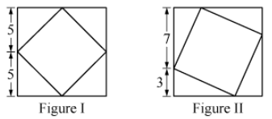
Figure I and Figure II each show a small square inscribed in a large square that has sides of length 10.

Quantity A: The perimeter of the small square in Figure I
Quantity B: The perimeter of the small square in Figure II

A. Quantity A is greater.
B. Quantity B is greater.
C. The two quantities are equal
D. The relationship cannot be determined from the information given.

5.
Quantity A: The area of a circle with circumference 8πx
Quantity B: The area of a circle with radius 4x

A. Quantity A is greater.
B. Quantity B is greater.
C. The two quantities are equal
D. The relationship cannot be determined from the information given.

6.
A certain car travels 120 miles in t hours at a constant rate of r miles per hour.

Quantity A: The number of hours required for the car to travel 240 miles at a constant rate of 3r miles per hour
Quantity B: t

A. Quantity A is greater.
B. Quantity B is greater.
C. The two quantities are equal
D. The relationship cannot be determined from the information given.

7.
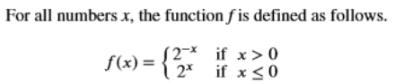

Quantity A: f(-4)+f(0)-f(4)
Quantity B: 1

A. Quantity A is greater.
B. Quantity B is greater.
C. The two quantities are equal
D. The relationship cannot be determined from the information given.

8.
If x=-3, which of the following is greatest?

A. 1+x
B. x-5
C. 1/x
D. 3x
E. x³

9.
A class contains 120 students, each of whom is either a part-time student or a full-time student. If a student is to be selected at random from the class, then the probability that the student will be a part-time student is 2/5. How many of the students in the class are full-time students?

A. 24
B. 48
C. 60
D. 72
E. 96

10.
The least positive integer that is divisible by 2, 3, 15, and 28 is

A. 210
B. 420
C. 840
D. 1260
E. 2520

11.
In a certain city, 15 percent of the total population is more than 60 years old. If 60 percent of the people older than 60 voted in a recent election, then these voters comprised what percent of the total population?

A. 6%
B. 8%
C. 9%
D. 15%
E. 60%

12.
According to the scale given on a certain map, 1 inch is equivalent to 20 miles. Which of the following scales are the same as the scale given on the map?

Indicate all such scales.

A. 1/4 inch is equivalent to 5 miles.
B. 1/2 inch is equivalent to 10 miles.
C. 5/2 inches are equivalent to 50 miles.
D. 4 inches are equivalent to 80 miles.

13.
If x is an odd integer, which of the following must be an odd integer?

A. x⁴+1
B. x⁴-1
C. (x+1)⁵-2
D. (x+1)⁵+1
E. (x+1)⁶+2

14.
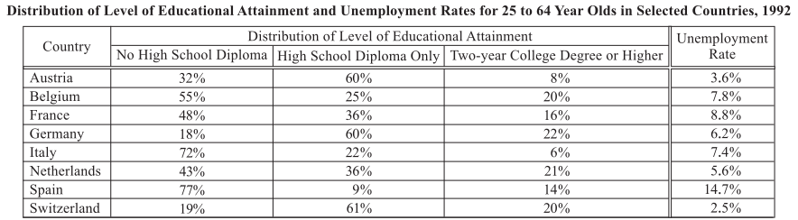

For the countries shown, what is the range of the percents of 25 to 64 year olds with no high school diploma?

A. 52%
B. 59%
C. 63%
D. 68%
E. 69%

15.

For how many of the countries was the percent of 25 to 64 year olds with no high school diploma greater than the percent with a two-year college degree or higher?

A. Three
B. Four
C. Five
D. Six
E. Seven

16.

What is the median unemployment rate for 25 to 64 year olds in those countries for which more than 15 percent of 25 to 64 year olds had a level of educational attainment of a two-year college degree or higher?

A. 5.6%
B. 6.2%
C. 6.8%
D. 7.8%
E. 8.8%

17.
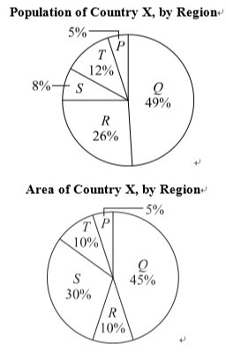
Country X consists of five regions-P, Q, R, S, and T. The circle graphs show the percent distributions of the population and the area of Country X, by region. Which region of Country X has the greatest population per unit of area?

A. P
B. Q
C. R
D. S
E. T

18.
Which two of the following points in the -plane lie on the same horizontal line?

Indicate both of the points.

A. (3,4)
B. (6,8)
C. (4,5)
D. (5,4)
E. (6,2)

19.
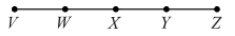

In the figure shown, X is the midpoint of line segment VZ, and W and Y are the midpoints of line segments VX and XZ, respectively. What is the ratio of the length of VY to the length of WY?

A. 2 to 1
B. 2 to 3
C. 3 to 2
D. 3 to 4
E. 4 to 3

20.
The sum of the squares of three consecutive positive integers is 149. What is the sum of the three integers?



Section 2

1-5: D,B,D,B,C
6-10: B,C,C,D,B
11-15: C,ABCD,D,B,D
16-20: B,C,AD,C,21

第八套
Time — 35 minutes per Section
Section 1 Medium
1.
x and y are integers and xy<0.

Quantity A: x^{y}
Quantity B: 0

A. Quantity A is greater.
B. Quantity B is greater.
C. The two quantities are equal
D. The relationship cannot be determined from the information given.

2.
A certain ship traveled 40 miles at an average speed of 18 knots.
(Note: 1 knot = 1.15 miles per hour, rounded to the nearest 0.01 mile.)

Quantity A: The time it took the ship to travel the 40 miles
Quantity B: 2 hours

A. Quantity A is greater.
B. Quantity B is greater.
C. The two quantities are equal
D. The relationship cannot be determined from the information given.

3.
In RST, the measure of angle S is 52°, and the measure of angle T is 58°.

Quantity A: The length of side RS
Quantity B: The length of side ST

A. Quantity A is greater.
B. Quantity B is greater.
C. The two quantities are equal
D. The relationship cannot be determined from the information given.

4.
15 < x < 30
15 < y < 30
15 < z < 30

Quantity A: The range of the three numbers x, y, and z
Quantity B: 15

A. Quantity A is greater.
B. Quantity B is greater.
C. The two quantities are equal
D. The relationship cannot be determined from the information given.

5.
0 < x < y < 1

Quantity A: 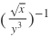
Quantity B: 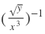

A. Quantity A is greater.
B. Quantity B is greater.
C. The two quantities are equal
D. The relationship cannot be determined from the information given.

6.
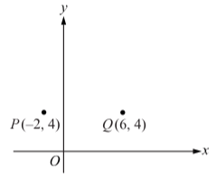

In the xy-plane shown, point R (not shown) has coordinates (c,d), where c>0. The area of triangle PQR is 24.

Quantity A: c
Quantity B: 2

A. Quantity A is greater.
B. Quantity B is greater.
C. The two quantities are equal
D. The relationship cannot be determined from the information given.

7.
x²y³<0

Quantity A: xy²
Quantity B: 0

A. Quantity A is greater.
B. Quantity B is greater.
C. The two quantities are equal
D. The relationship cannot be determined from the information given.

8.
Consider dates represented by three numbers in the form day-month-year. For example, 21-3-2000 represents March 21, 2000. A date in which the day, month, and year are each divisible by 5 is called a "triple-five date." How many triple-five dates were there in the year 2010 ?

A. 6
B. 9
C. 10
D. 11
E. 12

9.
If the average (arithmetic mean) of three consecutive integers is 2 more than the average of 18, 27, and 30, what is the greatest of the three consecutive integers?

A. 26
B. 27
C. 28
D. 30
E. 75

10.
Each of the marbles in a bag is either blue, red, or green, and there is at least one marble of each color in the bag. If the bag contains twice as many blue marbles as red marbles, then the number of red marbles in the bag divided by the total number of marbles in the bag is

A. less than 1/3
B. equal to 1/3
C. between 1/3 and 1/2
D. between 1/2 and 2
E. greater than 2

11.
The circumference of circle C1 is 12π and the circumference of circle C2 is 24π. What is the ratio of the area of C2 to the area of C1?

A. 2 to 1
B. 3 to 1
C. 4 to 1
D. 6 to 1
E. 8 to 1

12.
In the rectangular coordinate system, line k has slope 1/2 and y-intercept 4. What is the x-intercept of k?

A. -8
B. -2
C. 1/2
D. 2
E. 8

13.
Each of two generators produces energy at a constant rate, but the two rates are different. One of the generators produces n units of energy in 4 hours, and the other generator produces the same amount of energy in half the time. What fraction of n units of energy will be produced by both generators if they work simultaneously for 40 minutes?

A. 3/8
B. 1/2
C. 5/8
D. 3/4
E. 7/8

14.
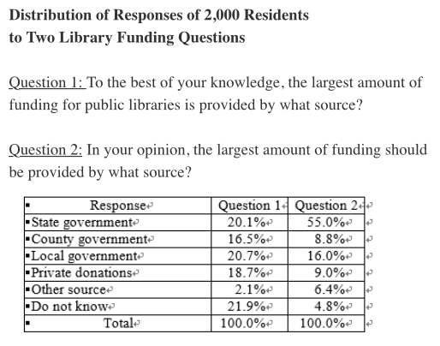

The number of residents who chose "Private donations" as a response to question 1 was how many more than the number who chose "Private donations" as a response to question 2?

A. 232
B. 218
C. 194
D. 168
E. 128

15.

If one resident is to be randomly selected from among the 2,000 residents, what is the probability that the selected resident`s response to question 2 was either "Local government" or "Private donations"?

A. 1/4
B. 2/7
C. 1/3
D. 2/5
E. 1/2

16.

What is the greatest possible number of residents who chose the response "Local government" to both questions?

A. 94
B. 320
C. 414
D. 640
E. 740

17.
Marcel purchased a television at a price that was less than its list price. The total amount that he paid for the television consisted of the purchase price and a sales tax of $7.20, which was p percent of the purchase price. Which of the following statements individually provide(s) sufficient additional information to determine the value of p ?

Indicate all such statements.

A. The total amount that Marcel paid for the television was $127.20.
B. The purchase price of the television was $40.00 less than the list price.
C. The purchase price of the television was 25 percent less than the list price.

18.
How many integers between 1 and 100 are multiples of 7 but are not multiples of 6?



19.
A. 1/7
B. 2/7
C. 3/7
D. 4/7
E. 5/7

20.
The function g is defined for all numbers x by g(x)=rx⁵-sx³+t, where r, s, and t are constants. If g(1)=0, which of the following could be the values of the three constants?

Indicate all such values.

A. r=3, s=2 and t=-1
B. r=-4, s=3 and t=1
C. r=-2, s=-1 and t=1
D. r=4, s=3 and t=-7
E. r=4, s=-3 and t=-7

Section 1

1-5: D,B,B,B,A
6-10: D,D,E,C,A
11-15: C,A,B,C,A
16-20: B,A,12,B,ACE

Time — 35 minutes per Section
Section 2 Hard
1.
List K consists of the four numbers w, x, y, and z. List M consists of the four numbers w+5, x+5, y+5, and z+5.

Quantity A: The standard deviation of the numbers in list K
Quantity B: The standard deviation of the numbers in list M

A. Quantity A is greater.
B. Quantity B is greater.
C. The two quantities are equal
D. The relationship cannot be determined from the information given.

2.
A car traveled at a constant speed of 48 kilometers per hour for 3 kilometers.

Quantity A: The time, in minutes, it took for the car to travel the 3 kilometers
Quantity B: 3.75 minutes

A. Quantity A is greater.
B. Quantity B is greater.
C. The two quantities are equal
D. The relationship cannot be determined from the information given.

3.
n is a positive integer.

Quantity A:
Quantity B: 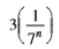

A. Quantity A is greater.
B. Quantity B is greater.
C. The two quantities are equal
D. The relationship cannot be determined from the information given.

4.
x=1/2

Quantity A: 5x⁽⁻³⁾-9x⁽⁻²⁾
Quantity B: 4

A. Quantity A is greater.
B. Quantity B is greater.
C. The two quantities are equal
D. The relationship cannot be determined from the information given.

5.
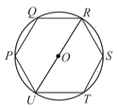
In the figure shown, hexagon PQRSTU is equilateral and is inscribed in the circle with center O.

Quantity A: The length of diameter UOR
Quantity B: The length of arc RST

A. Quantity A is greater.
B. Quantity B is greater.
C. The two quantities are equal
D. The relationship cannot be determined from the information given.

6.
Quantity A: (r+s)²
Quantity B: r²+s²

A. Quantity A is greater.
B. Quantity B is greater.
C. The two quantities are equal
D. The relationship cannot be determined from the information given.

7.
x>2 and y<0

Quantity A: |xy|-x
Quantity B: xy

A. Quantity A is greater.
B. Quantity B is greater.
C. The two quantities are equal
D. The relationship cannot be determined from the information given.

8.
Ben has 30 pencils in a box. Each of the pencils is one of 5 different colors, and there are 6 pencils of each color. If Ben selects pencils one at a time from the box without being able to see the pencils, what is the minimum number of pencils that he must select in order to ensure that he selects at least 2 pencils of each color?

A. 24
B. 25
C. 26
D. 27
E. 28

9.
The price of a package of notebooks is 1/3 more at Store A than at Store B. If the difference in these prices is $0.35, what is the price at Store A?

A. $0.70
B. $1.05
C. $1.40
D. $1.75
E. $2.45

10.
The circumference of circle C is equal to the perimeter of square S. If the area of the circle is z, which of the following represents the area of the square, in terms of z ?

A. π/4z
B. 4/zπ
C. zπ/4
D. 4π/z
E. 4z/π

11.
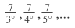

The first term of the infinite sequence shown is , and each term thereafter has a numerator of 7 and a denominator that is 1 greater than the denominator of the preceding term. Which of the following terms of the sequence is equal to the 6th term of the sequence minus the 7th term of the sequence?

A. 40th
B. 42nd
C. 44th
D. 70th
E. 72nd

12.
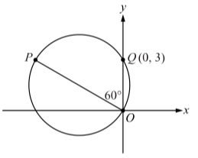

In the figure shown, OP is a diameter of the circle. What is the x-coordinate of point P?

A. -3
B. -6
C.
D.
E.

13.
The odds in favor of the occurrence of event A are defined to be the ratio of the probability of A occurring to the probability of A not occurring. Past records indicate that the odds in favor of a shipment from Company Z arriving on the specified date are 3 to 7. On the basis of this record, what is the probability that a shipment from Company Z will not arrive on the specified date?

A. 3/10
B. 4/10
C. 7/10
D. 3/7
E. 4/7

14.
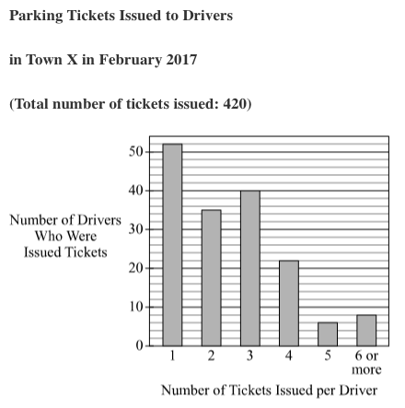

To the nearest whole percent, the number of drivers who were issued 3 parking tickets is what percent greater than the number who were issued 4 or more tickets?

A. 4%
B. 9%
C. 10%
D. 11%
E. 16%

15.

What is the average (arithmetic mean) number of parking tickets issued to the drivers who were issued 6 or more tickets?

A. 7.0
B. 7.5
C. 8.0
D. 8.5
E. 9.0

16.

What is the average (arithmetic mean) number of parking tickets issued to the drivers who were issued 6 or more tickets?

A. 2.0
B. 2.5
C. 3.0
D. 3.5
E. 4.0

17.
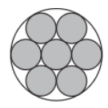

In the figure shown, seven small circles of equal diameter are located inside a large circle. Each of the six outer small circles is tangent to the small circle in the center, to two other adjacent small circles, and to the large circle. If the diameter of the large circle is D, then the sum of the areas of the unshaded regions inside the large circle is equal to which of the following?

A. 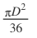
B. 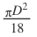
C. 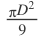
D. 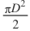
E. 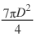

18.
Of the students enrolled at University U in the fall of 2008, 3/8 were sophomores and 1/50 were biology majors. Which of the following could be the number of students enrolled at University U in the fall of 2008?

Indicate all such numbers.

A. 7000
B. 7040
C. 7050
D. 7100
E. 7125
F. 7200

19.
If 3x+y=2, 3x+2y=0, and x-2z=1, what is the value of z?

Give your answer as a fraction.

Z=



20.
When the positive integer N is divided by 16, the remainder is 3. Which of the following integers could be the remainder when N is divided by 6 ?

Indicate all such integers.

A. 0
B. 1
C. 2
D. 3
E. 4
F. 5

Section 2

1-5: C,C,D,C,B
6-10: D,D,C,C,C
11-15: D,E,C,D,B
16-20: A,B,AF,1/6,BDF

