第五套
Time — 35 minutes per Section
Section 1 Easy
1.
Quantity A: 2^{x+2}
Quantity B: (4)(2^{x})
A. Quantity A is greater.
B. Quantity B is greater.
C. The two quantities are equal
D. The relationship cannot be determined from the information given.

2.
x is a negative integer.
Quantity A: x^{2x}
Quantity B: 0
A. Quantity A is greater.
B. Quantity B is greater.
C. The two quantities are equal
D. The relationship cannot be determined from the information given.

3.
t > 0, x < 2t, y > 5t
Quantity A: (y-x)/3
Quantity B: t
A. Quantity A is greater.
B. Quantity B is greater.
C. The two quantities are equal
D. The relationship cannot be determined from the information given.

4.
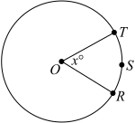
Point O is the center of the circle. Line segment OT and arc RST both have length 4.
Quantity A: x
Quantity B: 60
A. Quantity A is greater.
B. Quantity B is greater.
C. The two quantities are equal
D. The relationship cannot be determined from the information given.

5.
y = 2x² + 3
Quantity A: In the equation, the number of y-values that correspond to each x-value
Quantity B: 2
A. Quantity A is greater.
B. Quantity B is greater.
C. The two quantities are equal
D. The relationship cannot be determined from the information given.

x≠1
Quantity A: (x²-2)/(x-1)
Quantity B: x+2
A. Quantity A is greater.
B. Quantity B is greater.
C. The two quantities are equal
D. The relationship cannot be determined from the information given.

(x + y)² = 25
Quantity A: The average (arithmetic mean) of x and y
Quantity B: 0
A. Quantity A is greater.
B. Quantity B is greater.
C. The two quantities are equal
D. The relationship cannot be determined from the information given.

8.
Quantity A: The standard deviation of the heights of 12 people whose heights range from 62 inches to 74 inches, inclusive
Quantity B: The standard deviation of the heights of 12 people whose heights range from 60 inches to 72 inches, inclusive
A. Quantity A is greater.
B. Quantity B is greater.
C. The two quantities are equal
D. The relationship cannot be determined from the information given.

9.
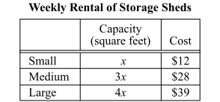
If a company required a total storage capacity equal to the combined storage capacity of 16 small sheds, which of the following rentals would cost the least per week for the company’s storage capacity requirements?
A. 4 medium sheds and 4 small sheds
B. 5 medium sheds and 1 small shed
C. 1 large shed and 4 medium sheds
D. 2 large sheds, 2 medium sheds, and 2 small sheds
E. 3 large sheds, 1 medium shed, and 1 small shed

10.
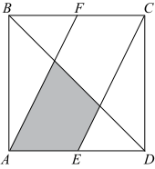
In the figure, ABCD is a square, E is the midpoint of side AD, and F is the midpoint of side BC. The area of the shaded region is what fraction of the area of square region ABCD?
A. 1/8
B. 1/6
C. 1/5
D. 1/4
E. 1/3

11.
When the integer n is divided by 20, the remainder is 15. Which of the following must be a divisor of n?
A. 3 B. 5 C. 6 D. 7 E. 10
12.
Twenty-three cards are numbered consecutively from 1 through 23. If one card is to be randomly selected from the 23 cards, what is the probability that the number on the selected card will be a multiple of 3 or a multiple of 4 or a multiple of both 3 and 4?
A. 7/23
B. 9/23
C. 11/23
D. 12/23
E. 13/23

13.
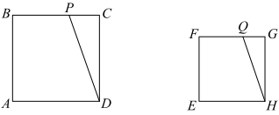
In the figures shown, ABCD is a square with sides of length 12, and EFGH is a square with sides of length 9. If the ratio of the area of square ABCD to the area of square EFGH is equal to the ratio of the area of triangle PCD to the area of triangle QGH, what is the ratio of the length of PC to the length of QG?
Give your answer as a fraction.

14. Questions 14-16 are based on the graph below 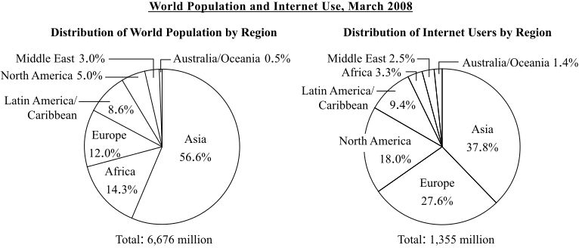
Which of the following is closest to the fraction of the world population who were Internet users?
A. 1/20
B. 1/10
C. 1/5
D. 1/3
E. 1/2

15.
For which of the following regions was the number of Internet users greater than the population of the Middle East?
Indicate all such regions.
- Africa
- Asia
- Europe
- Latin America/Caribbean
- North America

16.
The number of Internet users in Europe and Asia was closest to what percent of the world population?
A. 13.3%
B. 44.6%
C. 65.4%
D. 68.6%
E. 70.9%

17.
At 12:00 noon a hose began draining water from a pool at a constant rate of 120 ounces per minute. At 2:00 that afternoon, an additional hose began draining water from the pool, increasing the constant rate at which the water was being drained to 240 ounces per minute. The pool was empty before 4:30 that afternoon. Which of the following could have been the amount of water, in ounces, in the pool at 12:00 noon that day?
Indicate all such amounts.
A. 42640
B. 46080
C. 50250
D. 52540
E. 55320

18.
The sequence of numbers C₁, C₂, C₃, ...C_{n}... is defined by C₁=2, C₂=4 and C_{n}=C_{n−1}+n for each integer n greater than 2. What is the value of C₆?
A. 12
B. 17
C. 18
D. 22
E. 24

19.
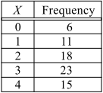
The table shows the frequency distribution of the random variable X. What is the median of the distribution of the values of X?
A. 1.0
B. 1.8
C. 2.0
D. 2.5
E. 3.0

20.
A product is on sale for a discounted price that is 20 percent less than its regular price. The regular price is what percent greater than the discounted price?

Section 2 Medium
1.
Of all the students in a classroom, 13 have brown eyes and 14 of the rest of the students have green eyes.
Quantity A: The fraction of the students in the classroom who have green eyes
Quantity B: 1/12
A. Quantity A is greater.
B. Quantity B is greater.
C. The two quantities are equal
D. The relationship cannot be determined from the information given.

2.
Quantity A: The average (arithmetic mean) of the 5 consecutive integers between 5 and 11
Quantity B: The median of the 5 consecutive integers between 5 and 11
A. Quantity A is greater.
B. Quantity B is greater.
C. The two quantities are equal
D. The relationship cannot be determined from the information given.

3.
The length of each side of square S is 10. The length of each edge of cube T is 4.
Quantity A: The area of square S
Quantity B: The surface area of cube T
A. Quantity A is greater.
B. Quantity B is greater.
C. The two quantities are equal
D. The relationship cannot be determined from the information given.

4.
n is a positive integer. n²+2n is even.
Quantity A: (−1)^{n}
Quantity B: (−1)^{n−1}
A. Quantity A is greater.
B. Quantity B is greater.
C. The two quantities are equal
D. The relationship cannot be determined from the information given.

5.
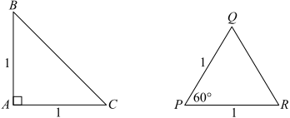
Quantity A: The perimeter of ABC
Quantity B: The perimeter of PQR
A. Quantity A is greater.
B. Quantity B is greater.
C. The two quantities are equal
D. The relationship cannot be determined from the information given.

Quantity A: In the xy-plane, the distance from the point (-5, -3) to the point (-2, -5)
Quantity B: In the xy-plane, the distance from the point (3, 4) to the point(6, 2)
A. Quantity A is greater.
B. Quantity B is greater.
C. The two quantities are equal
D. The relationship cannot be determined from the information given.

x is a number greater than 0.
Quantity A: x/x
Quantity B: x/1
A. Quantity A is greater.
B. Quantity B is greater.
C. The two quantities are equal
D. The relationship cannot be determined from the information given.

8.
A certain saleswoman earns $4 for each hour worked plus a 10 percent commission on her total sales. In June she worked 240 hours and had total sales of $40,400. What percent of the money she earned in June was commission?
A. 78.0%
B. 79.2%
C. 80.0%
D. 80.8%
E. 88.0%

9.
If the speed of a vehicle was reduced from 65 miles per hour to 35 miles per hour, by approximately how many kilometers per hour was the speed reduced? (1 kilometer = 0.62 mile, rounded to the nearest 0.01 mile)
A. 16 B. 22 C. 40 D. 48 E. 56

10.
a < 8 < a+8 < 2a+4 < a²−20
If a is an integer that satisfies the inequalities shown, what is the value of a?

11.
A total of $72,000 was invested for one month in a new money market account that paid simple annual interest at the rate of r percent. If the investment earned $360 in interest for the month, what is the value of r?
A. 3 B. 6 C. 9 D. 10 E. 12
12.
Set A consists of four consecutive integers. Set B consists of all integers that result from adding 2 to each of the integers in set A together with all integers that result from subtracting 2 from each of the integers in set A. How many more integers are in set B than in set A?
A. 1 B. 2 C. 3 D. 4 E. 8

13.
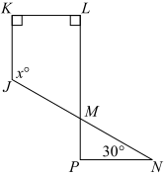
In the figure above, if line KL is parallel to line PN, what is the value of x?
A. 105 B. 120 C. 135 D. 150 E. it cannot be determined

14. Questions 14-16 are based on the graph below
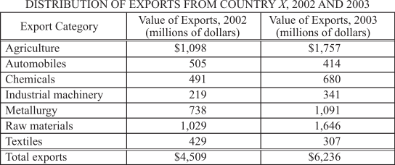
For how many of the seven categories did the value of exports increase by more than 50 percent from 2002 to 2003?
A. two B. three C. four D. five E. six

15.
Approximately what was the percent increase in the value of the total exports from 2002 to 2003?
A. 10% B. 20% C. 30% D. 40% E. 50%

16.
The range of the value of exports for the seven export categories shown was how much greater in 2003 than in 2002?
$_____million

17.
m=(n²-25)/100
If n is a 2-digit integer with units digit 5 in the equation shown, which of the following could be the units digit of m?
A. 1 B. 3 C. 5 D. 6 E. 8

18.
List K: a, b, c, d, e
List K consists of five numbers such that 0 < a < b < c < d < e.
Which of the following statements must be true?
Indicate all such statements.
A. The range of the numbers in list K is e.
B. The median of the numbers in list K is c.
C. The average (arithmetic mean) of the numbers in list K is c.

19.
Which of the following lists has the greatest standard deviation?
A. 10, 20, 30, 40, 50
B. 10, 30, 30, 30, 50
C. 10, 25, 30, 35, 50
D. 10, 10, 30, 50, 50
E. 20, 20, 30, 40, 40

20.
An item was on sale for a discounted price that was p percent less than the regular price of $50. A customer purchased the item at the discounted price and used a coupon valued at k dollars to pay for part of the item. If the discounted price was equal to the value of the coupon plus $20, which of the following could be the values of p and k?
Indicate all such values.
A. p=10 and k=20
B. p=10 and k=25
C. p=20 and k=10
D. p=20 and k=20
E. p=30 and k=15

Section 3 Medium
1.
The price of a certain coat is discounted by x percent, and the new price is then discounted by y percent, resulting in price p.
Quantity A: Price p if x=10 and y=30
Quantity B: Price p if x=20 and y=20
A. Quantity A is greater.
B. Quantity B is greater.
C. The two quantities are equal
D. The relationship cannot be determined from the information given.

2.
s, t, and u are integers, and 10 ≤ s
Quantity A: s + t/u
Quantity B: 11
A. Quantity A is greater.
B. Quantity B is greater.
C. The two quantities are equal
D. The relationship cannot be determined from the information given.

3.
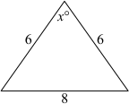
Quantity A: x
Quantity B: 60
A. Quantity A is greater.
B. Quantity B is greater.
C. The two quantities are equal
D. The relationship cannot be determined from the information given.

4.
The function f is defined by f(x)=x⁻¹⁰⁰ for all nonzero numbers x.
Quantity A: f(2)
Quantity B: f(-2)
A. Quantity A is greater.
B. Quantity B is greater.
C. The two quantities are equal
D. The relationship cannot be determined from the information given.

5.
m is the least positive integer for which 18m can be expressed as the square of an integer. n is the least positive integer for which 9n can be expressed as the cube of an integer.
Quantity A: m
Quantity B: n
A. Quantity A is greater.
B. Quantity B is greater.
C. The two quantities are equal
D. The relationship cannot be determined from the information given.

Quantity A: 50!/(25!*25!)
Quantity B: 50!/(24!*26!)
A. Quantity A is greater.
B. Quantity B is greater.
C. The two quantities are equal
D. The relationship cannot be determined from the information given.

3x+4y=2, 6x+8y=4
Quantity A: x
Quantity B: y
A. Quantity A is greater.
B. Quantity B is greater.
C. The two quantities are equal
D. The relationship cannot be determined from the information given.

8.
Which of the following discounts on a certain computer, when applied to the regular price of $1,200, are equivalent to a 30 percent discount off the regular price of that computer?
Indicate all such discounts.
A. A $360 discount
B. A 20 percent discount followed by a $10 discount
C. A 25 percent discount followed by a $60 discount

9.
At a local election there were two propositions on the ballot, R and S. Twice as many voters voted "yes" for R as for S. If the number who voted "yes" for R but "no" for S was 750 and the number who voted "yes" for S but "no" for R was 310, how many voted "yes" for both propositions?
A. 122 B. 127 C. 130 D. 135 E. 140

10.
Of the x members of a certain club, 3/8 are men and 2/9 of the men are over 50 years old. If 4 men in the club are over 50 years old, what is the value of x?
A. 48 B. 68 C. 72 D. 96 E. 136

11.
A storage trunk contains 6 identical blankets and 3 identical pillows. The weight of each blanket is 3 times the weight of each pillow. What is the ratio of the total weight of the 6 blankets to the total weight of the 3 pillows?
- 2 to 1 B. 3 to 1 C. 6 to 1 D. 9 to 1 E. 18 to 1

12.
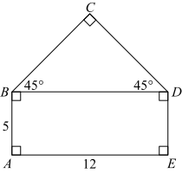
What is the perimeter of polygon ABCDE above?
A. 34 B. 12$\sqrt{2}$+17 C. 12$\sqrt{2}$+22 D. 12$\sqrt{3}$+17 E. 12$\sqrt{3}$+22

13.
Which of the following is equivalent to (a-b)-(c-d)?
A. (a-b)+(-c-d)
B. (a-c)+(b-d)
C. (a+c)-(b+d)
D. (a-d)+(b-c)
E. (a+d)-(b+c)

14. Questions 14-16 are based on the graph below
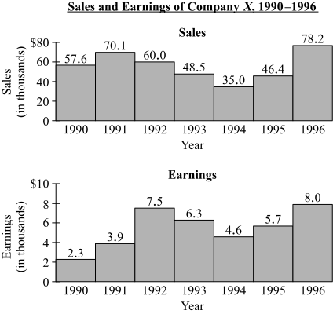
For the years shown, what was the median of the company`s sales, in thousands of dollars?
A. $46.4 B. $48.5 C. $52.0 D. $57.6 E. $58.8

15.
Which of the following is closest to the average (arithmetic mean) sales of the company for the 3 years that the company experienced its greatest earnings?
A. $59000 B. $60000 C. $62000 D. $65000 E. $67000

16.
The company`s sales in 1996 were approximately what percent greater than its sales in 1995?
A. 10% B. 30% C. 50% D. 70% E. 90%

17.
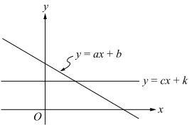
The figure shows the graphs, in the xy-plane, of the equations y=ax+b and y=cx+k, where a, b, c, and k are constants. Which of the following statements must be true?
Indicate all such statements.
A. c < a B. c > a C. k < b D. k > b

18.
A list of 42 numbers has an average (arithmetic mean) of 110.0. A second list of 58 numbers has an average of 150.0. What is the average of the 100 numbers in the two lists combined?

19.
The volume of a large cube is twice the volume of a small cube. If the length of an edge of the small cube is 2, what is the length of an edge of the large cube?
A. 4 B. 8 C. 2$\sqrt[3]{2}$ D. 4$\sqrt[3]{2}$ E. 8$\sqrt[3]{2}$

20.
The average (arithmetic mean) of x, x+2, x+4, and x+6 is 6. What is the average of x², (x+2)², (x+4)², and (x+6)²?
A. 30 B. 36 C. 41 D. 49 E. 52
Section 4 Hard
1.
y≥0
Quantity A: ($\sqrt{y+5}$ - $\sqrt{y}$) ($\sqrt{y+5}$ + $\sqrt{y}$)
Quantity B: 5
A. Quantity A is greater.
B. Quantity B is greater.
C. The two quantities are equal
D. The relationship cannot be determined from the information given.

2.
In the xy-plane, the graph of y=g(x) intersects the x-axis at 3 points.
Quantity A: The number of points at which the graph of y=g(x−5) intersects the x-axis
Quantity B: 3
A. Quantity A is greater.
B. Quantity B is greater.
C. The two quantities are equal
D. The relationship cannot be determined from the information given.

3.
m and n are positive integers. n and n+2 are factors of m.
Quantity A: m/n
Quantity B: n+2
A. Quantity A is greater.
B. Quantity B is greater.
C. The two quantities are equal
D. The relationship cannot be determined from the information given.

4.
x > 7999
Quantity A: The digit in the thousands place of x
Quantity B: 6
A. Quantity A is greater.
B. Quantity B is greater.
C. The two quantities are equal
D. The relationship cannot be determined from the information given.
5.
n is a negative integer, and p is a positive integer.
Quantity A: The product of the integers from n to p, inclusive
Quantity B: 0
A. Quantity A is greater.
B. Quantity B is greater.
C. The two quantities are equal
D. The relationship cannot be determined from the information given.

x percent of y is 3/4 of z, where xyz ≠ 0.
Quantity A: xy/z
Quantity B: 75
A. Quantity A is greater.
B. Quantity B is greater.
C. The two quantities are equal
D. The relationship cannot be determined from the information given.

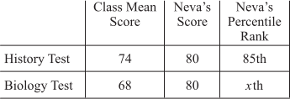
Quantity A: x
Quantity B: 85
A. Quantity A is greater.
B. Quantity B is greater.
C. The two quantities are equal
D. The relationship cannot be determined from the information given.

8.
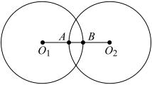
In the figure above, the circles centered at O₁ and O₂ have radius of equal length. If O₁O₂=9 and AB=3, what is the circumference of the circle centered at O₁?
A. 6π B. 9π C. 12π D. 18π E. 36π

9.
If n is an integer, what is the least value of n for which 4^{−n}<1/512?
A. 4 B. 5 C. 6 D. 7 E. 8

10.
On the outside, a closed rectangular packing box, made out of cardboard, is 12 inches long, 18 inches wide, and 24 inches high. If the cardboard is 1/4 inch thick, which of the following is closest to the volume inside the box, in cubic inches?
A. 3700 B. 3900 C. 4300 D. 4700 E. 5200

11.
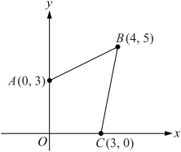
In the xy-plane above, what is the area of quadrilateral OABC?
- 15 B. 27/2 C. 45/4 D. 21/2 E. 7

12.
The average (arithmetic mean) ages, in years, of the people in group A and group B are 41 and 36, respectively. The average age, in years, of the people in the two groups combined is 38. If there are no people in both group A and group B, what fraction of the people in the two groups combined are in group B?
A. 2/5 B. 1/2 C. 3/5 D. 2/3 E. 3/4

13.
How many integers n between 100 and 299 are there such that the hundreds digit of n is less than the tens digit of n and the tens digit of n is less than the units digit of n?
A. 48 B. 49 C. 50 D. 51 E. 52

14. Questions 14-16 are based on the graph below
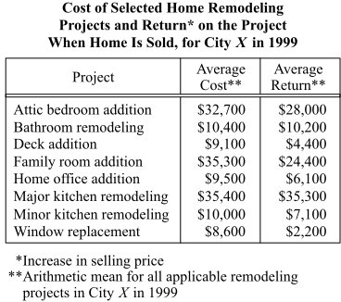
What is the range of the average costs for the eight home remodeling projects listed?
A. $24100 B. $24700 C. $25400 D. $26100 E. $26800

15.
In City X, the percent increase from 1997 to 1999 in the average cost of a deck addition was 45 percent, and the percent increase from 1994 to 1997 in the average cost of a deck addition was 26 percent. Which of the following expressions represents the average cost, in dollars, of a deck addition in City X in 1994?
A. (1.45)(1.26)(9100)
B. (0.45)(0.26)(9100)
C. (1.26)(9100)/1.45
D. 9100/(1.45*1.26)
E. 9100/(0.45*0.26)

16.
For how many of the remodeling projects listed is the average return on the project when the home is sold less than 75 percent of the average cost of the project?
A. three B. four C. five D. six E. seven

17.
A grocery store had 105 pieces of fruit for sale consisting of apples, mangoes, and peaches.
Which of the following statements individually provide(s) sufficient additional information to determine the number of apples for sale at the grocery store?
Indicate all such statements.
- The total number of apples and peaches was 62.
- The ratio of the number of apples to the total number of mangoes and peaches was 1 to 6.
- The ratio of the number of mangoes to the number of peaches was 43 to 47.

18.
Of the 36 students in a certain class, 10 are in the chess club and 13 are in the bridge club. If 20 of the students are not in either club, how many of the students are in only one of the two clubs?
A. 7 B. 9 C. 14 D. 16 E. 23

19.
x(x+3)(x-5)>0
Which of the following inequalities specify values of x that satisfy the inequality above?
Indicate all such inequalities.
A. x < -3 B. -3 < x < 0 C. 0 < x < 5 D. x > 5

20.
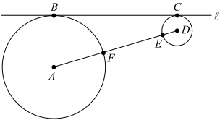
The figure shows a circle with center A and radius 10, and a circle with center D and radius 3. AD intersects the two circles at points F and E, respectively. Line is tangent to the two circles at points B and C, respectively. If the length of FE is 12, what is the length of BC?

第六套
Time — 35 minutes per Section
Section 1 Easy
1.
x is a positive two-digit integer with units digit 6, and y is a positive two-digit integer with tens digit 8.
Quantity A: The least possible value of x+y
Quantity B: 96
A. Quantity A is greater.
B. Quantity B is greater.
C. The two quantities are equal
D. The relationship cannot be determined from the information given.

2.
Each of six consecutive positive integers is divided by 6.
Quantity A: The average (arithmetic mean) of the 6 resulting remainders
Quantity B: 3.5
A. Quantity A is greater.
B. Quantity B is greater.
C. The two quantities are equal
D. The relationship cannot be determined from the information given.

3.
x, y, and z are positive integers. 3x+2y+z=42
Quantity A: x+y+z
Quantity B: 18
A. Quantity A is greater.
B. Quantity B is greater.
C. The two quantities are equal
D. The relationship cannot be determined from the information given.

4.
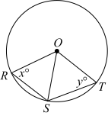
The center of the circle is O and RS > ST.
Quantity A: x
Quantity B: y
A. Quantity A is greater.
B. Quantity B is greater.
C. The two quantities are equal
D. The relationship cannot be determined from the information given.

5.
m + t = 1, m < t
Quantity A: mt
Quantity B: m²
A. Quantity A is greater.
B. Quantity B is greater.
C. The two quantities are equal
D. The relationship cannot be determined from the information given.

6.
x is an integer.
Quantity A: 10^{3x+1}/10^{x+3}
Quantity B: 10^{x+1}/10^{1-x}
A. Quantity A is greater.
B. Quantity B is greater.
C. The two quantities are equal
D. The relationship cannot be determined from the information given.

7.
Quantity A: The number of possible values of the product pt, where p and t are even positive integers and 30 < pt < 34
Quantity B: 1
A. Quantity A is greater.
B. Quantity B is greater.
C. The two quantities are equal
D. The relationship cannot be determined from the information given.

8.
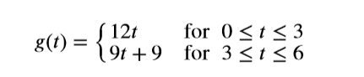
A submarine`s depth, in meters below sea level, at a time t minutes after it began to dive below the sea surface is equal to g(x) for 0 ≤ t ≤ 6. Its diving speed, measured in meters per minute, is the rate of change in depth.
Quantity A: The average diving speed of the submarine for 0 ≤ t ≤ 3
Quantity B: The average diving speed of the submarine for 3 ≤ t ≤ 6
A. Quantity A is greater.
B. Quantity B is greater.
C. The two quantities are equal
D. The relationship cannot be determined from the information given.

9.
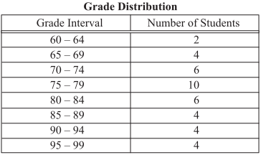
The table shows the distribution of the grades on a chemistry exam taken by a class of 40 students. If one of the students is to be chosen at random, what is the probability that the student chosen will be one whose grade on the exam is greater than or equal to 90?
Give your answer as a fraction.

10.
In a certain store, notebooks that normally sell for 59 cents each are on sale for 2 for 99 cents. If a person buys 2x of these notebooks at the sale price, what is the value of x if the total amount saved compared to buying at the normal price is 95 cents?
A. 9 B. 8 C. 7 D. 6 E. 5

11.
List J: 5, 7, 9 List K: 4, 6, 8, 10
Set M will be created by choosing 2 different numbers from list J and 1 number from list K. How many different combinations of numbers are possible for set M?

12.
If x is an integer, which of the following must be an even integer?
A. (x+1)²
B. (x+1)(x+2)
C. (x+1)(x+3)
D. (x+2)²
E. (x+2)(x+4)

13.
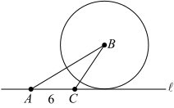
Point B is the center of the circle, the circle is tangent to line, and the area of triangular region ABC is 18. What is the circumference of the circle?
- 3π B. 6π C. 8π D. 9π E. 12π

14. Questions 14-16 are based on the graph below
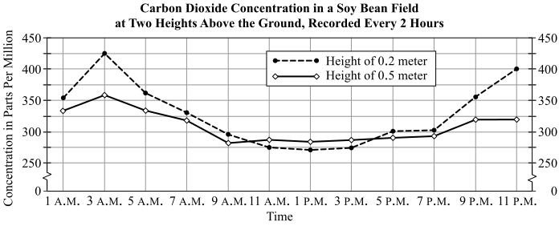
For how many of the times at which readings were taken was the difference between the concentrations at the two heights greater than 50 parts per million?
A. one
B. two
C. three
D. four
E. five

15.
For approximately how many hours was the concentration of carbon dioxide at 0.5 meter greater than or equal to the concentration at 0.2 meter?
A. 3 B. 6 C. 9 D. 12 E. 15

16.
The median of the 12 recorded concentrations at 0.2 meter is approximately how many parts per million?
A. 275 B. 295 C. 315 D. 335 E. 355

17.
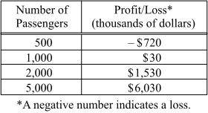
The table shows the profit or loss that a travel company makes for rendering services to different numbers of passengers. If each additional passenger increases the profit, or decreases the loss, by the same dollar amount, what is the number of passengers for which the travel company will have neither a profit nor a loss?
A. 900 B. 950 C. 975 D. 980 E. 998

18.
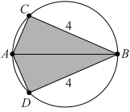
Line segment AB is a diameter of the circle and has length 5. Points C and D are on the circle as shown. What is the area of the shaded region?
A. 24 B. 16 C. 14 D. 12 E. 6

19.
The volume of the interior of a rectangular storage bin is 240 cubic meters. If the perimeter of the interior base of the bin is 40 meters, which of the following could be the dimensions of the interior of the bin, in meters?
Indicate all such dimensions.
- 6 by 8 by 5
- 8 by 12 by 2.5
- 9 by 11 by 2.4
- 10 by 10 by 2.4

20.
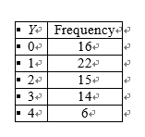
The table shows the frequency distribution of the random variable Y. What is the median of the distribution of the values of Y?
A. 1.0 B. 1.3 C. 1.5 D. 1.7 E. 2.0

Section 2 Medium
1.
r>0, p is 75 percent of r.
Quantity A: 50 percent of p
Quantity B: 25 percent of r
A. Quantity A is greater.
B. Quantity B is greater.
C. The two quantities are equal
D. The relationship cannot be determined from the information given.

2.
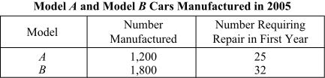
From the cars manufactured in 2005 indicated in the table, one car is to be selected at random from the model A cars and one car is to be selected at random from the model B cars.
Quantity A: The probability that the model A car selected will be one that required repairs in its first year
Quantity B: The probability that the model B car selected will be one that required repairs in its first year
A. Quantity A is greater.
B. Quantity B is greater.
C. The two quantities are equal
D. The relationship cannot be determined from the information given.

3.
x > 0
Quantity A: x/(x+1)
Quantity B: (x+1)/(x+2)
A. Quantity A is greater.
B. Quantity B is greater.
C. The two quantities are equal
D. The relationship cannot be determined from the information given.

4.
In the xy-plane, P and Q are two points on the line with equation y=2x+1. The x-coordinates of P and Q are 2 and 6, respectively.
Quantity A: The length of line segment PQ
Quantity B: 9
A. Quantity A is greater.
B. Quantity B is greater.
C. The two quantities are equal
D. The relationship cannot be determined from the information given.

5.
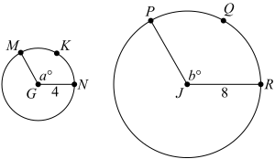
In the circle with center G, arc MKN has length 8/3π.
In the circle with center J, arc PQR has length 16/3π.
Quantity A: a
Quantity B: b
A. Quantity A is greater.
B. Quantity B is greater.
C. The two quantities are equal
D. The relationship cannot be determined from the information given.

6.
y + 2 < 0
Quantity A: |y|/y
Quantity B: -2
A. Quantity A is greater.
B. Quantity B is greater.
C. The two quantities are equal
D. The relationship cannot be determined from the information given.

On the number line shown, a and b are the coordinates of two points.
Quantity A: ab
Quantity B: -ab
A. Quantity A is greater.
B. Quantity B is greater.
C. The two quantities are equal
D. The relationship cannot be determined from the information given.

8.
A small company made a profit of $9,000 last quarter. The dollar amount of the profit was distributed equally among the 4 divisions of the company. If each division distributed its dollar amount of the profit equally among the people in the division, how much more money did a person in a division of 6 people receive than a person in a division of 10 people?

9.
In a social group 62 members enjoy dancing and 28 members enjoy hiking. If each of the 75 members in the group enjoys dancing or hiking, how many members enjoy both dancing and hiking?
A. 13 B. 15 C. 28 D. 34 E. 47

10.
On each of the first 15 days of April, Aaron spent 5 percent of his monthly income for April. If at the end of the 15th day of April, he had $1,250 of his monthly income remaining, what was his monthly income for April?
A. $5,000 B. $6,250 C. $7,500 D. $10,000 E. $25,000

11.
A school stadium contains 2,000 seats. For a certain game, student tickets cost $3 each and nonstudent tickets cost $6 each. What is the least number of nonstudent tickets that must be sold so that the total ticket sales will be at least $8,400?
A. 400 B. 800 C. 900 D. 1200 E. 1600
12.
If r, s, and t are consecutive positive integers and r < s < t, which of the following statements must be true?
Indicate all such statements.
- s is a multiple of 2.
- s is the average (arithmetic mean) of r and t.
- s is the average (arithmetic mean) of r, s, and t.

13.
26, 29, 32, 33, 36, 37, 41, 42, 48, 50
The 10 numbers in list M (not shown) are determined by multiplying each of the 10 numbers in the list above by 5 and then subtracting 20 from each product. How many times greater is the range of the numbers in list M than the range of the numbers in the list above?
_____times greater

14. Questions 14-16 are based on the graph below
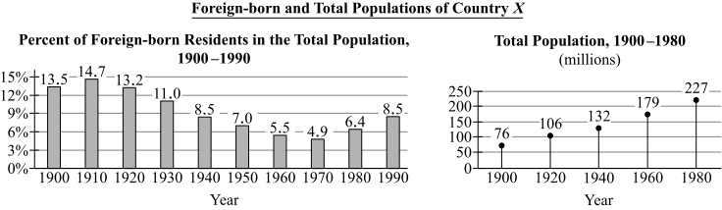
In which of the following years was the number of foreign-born residents greatest?
A. 1900 B. 1920 C. 1940 D. 1960 E. 1980

15.
From 1960 to 1980, the total population increased by approximately what percent?
A. 5% B. 15% C. 25% D. 35% E. 45%

16.
The ratio of the number of foreign-born residents in 1900 to the number of foreign-born residents in 1980 is closest to which of the following?
A. 1 to 2 B. 1 to 3 C. 2 to 3 D. 2 to 5 E. 3 to 2

17.
The sides of a triangle have lengths 7.5, 11, and x. If x is an integer, what is the least possible value of x?
A. 1 B. 2 C. 3 D. 4 E. 5

18.
When the integer n is divided by 24, the remainder is 21. Which of the following must be a divisor of n?
A. 3 B. 4 C. 5 D. 6 E. 9

19.
What is the value of the smallest positive integer n for which 6^{n} is a multiple of 24?
A. 1 B. 2 C. 3 D. 4 E. 5

20.
If 5^{x2 −2x}=1/5, what is the value of x?
A. -1 B. 1 C. 1 + $\sqrt{2}$ D. 1 - $\sqrt{2}$ E. 1 + 2$\sqrt{2}$

Section 3 Medium
1.
The price x of an item is increased 20 percent.
Quantity A: 80 percent of the price of the item after the increase
Quantity B: x
A. Quantity A is greater.
B. Quantity B is greater.
C. The two quantities are equal
D. The relationship cannot be determined from the information given.

2.
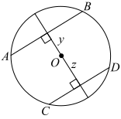
AB and CD are line segments with endpoints on the circle with center O, and z > y.
Quantity A: 1/2 the length of AB
Quantity B: 1/2 the length of CD
A. Quantity A is greater.
B. Quantity B is greater.
C. The two quantities are equal
D. The relationship cannot be determined from the information given.

3.
n is a positive integer and 0 < s < 10.
Quantity A: 1/n + 1/(n+s) + 1/(n+10)
Quantity B: 3/(n+10)
A. Quantity A is greater.
B. Quantity B is greater.
C. The two quantities are equal
D. The relationship cannot be determined from the information given.

4.
In a list consisting of 10 numbers, 5 numbers are greater than 20 and 5 numbers are less than 20.
Quantity A: The median of the numbers in the list
Quantity B: 20
A. Quantity A is greater.
B. Quantity B is greater.
C. The two quantities are equal
D. The relationship cannot be determined from the information given.

5.
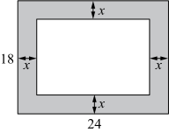
The figure consists of two rectangles whose longer sides are all parallel to each other, and x=3.
Quantity A: The area of the shaded region
Quantity B: The area of the smaller rectangle
A. Quantity A is greater.
B. Quantity B is greater.
C. The two quantities are equal
D. The relationship cannot be determined from the information given.

6.
x < 0 < y
Quantity A: |x|/|y|
Quantity B: -x/y
A. Quantity A is greater.
B. Quantity B is greater.
C. The two quantities are equal
D. The relationship cannot be determined from the information given.

7.
Points R, S, and T are on the number line, and the distance between R and S is greater than the distance between S and T.
Quantity A: RT
Quantity B: RS
A. Quantity A is greater.
B. Quantity B is greater.
C. The two quantities are equal
D. The relationship cannot be determined from the information given.

8.
Jake, Mary, and Ito took a test in their history class. Jake`s score of 68 was the lowest score in the class. Ito`s score of 85 was 5 less than Mary`s score. Mary had the highest score in the class. What was the range of all of the scores in the class?

9.
The driver of a car traveling at a speed of 40 miles per hour had to stop the car quickly. If the driver`s reaction time was 3/4 of a second, approximately how many feet did the car travel during the driver`s reaction time? (1 mile = 5,280 feet)
A. 30 B. 45 C. 60 D. 75 E. 90

10.
Of the integers 2, 7, and 49, which, if any, are divisors of 7⁴⁹+1?
A. none B. 2 only C. 7 only D. 7 and 49 only E. 2, 7, and 49

11.
a₁, a₂, ..., a_{n}, ... In the sequence shown, the terms are defined by a_{n}=(2n−3)² for all positive integers n. If the sum of the first k terms is 11, what is the value of k?
A. 1 B. 2 C. 3 D. 4 E. 5

12.
A new car was sold with new brake linings that were each 0.250 inch thick. After the car had been driven 50,000 miles without replacing any brake linings, the thinnest brake lining was 0.085 inch thick. What was the percent decrease in the thickness of the thinnest brake lining?
A. 34% B. 52% C. 66% D. 74% E. 94%

13.
Jena has a jar that contains 8 nickels and 12 dimes and no other coins. If she adds nickels to the jar one at a time until the ratio of the number of nickels to the total number of coins in the jar is 4 to 5, how many nickels must she add?
A. 20 B. 24 C. 32 D. 40 E. 56

14. Questions 14-16 are based on the graph below
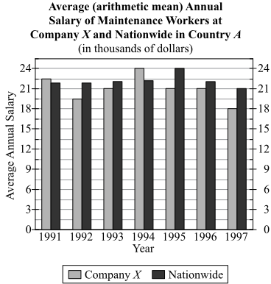
In 1994 the average annual salary of maintenance workers at Company X was approximately what percent of the average annual salary of maintenance workers nationwide in Country A?
A. 25% B. 75% C. 90% D. 110% E. 120%

15.
If Company X employed a total of 200 maintenance workers annually for the years 1991 through 1993 and a total of 150 maintenance workers annually for the years 1994 through 1997, what was the average amount of money spent annually by Company X on the salaries of its maintenance workers for the years 1991 through 1997?
A. $1800000 B. $2400000 C. $3600000 D. $4000000 E. $4800000

16.
For the years 1991 through 1997, what was the ratio of the range of the average annual salaries of maintenance workers at Company X to the range of those nationwide in Country A?
A. 1 to 4 B. 1 to 2 C. 3 to 4 D. 2 to 1 E. 4 to 1

17.
In the xy-plane, the graph of y=(2x+3)(x-5) crosses the y-axis at the point (0, k). What is the value of k?

18.
A, F, M, P, Y If the 5 letters listed above were randomly ordered, what is the probability that the resulting list would be either in alphabetical order (as shown) or in reverse alphabetical order?
A. 1/60 B. 1/20 C. 1/10 D. 1/5 E. 2/5

19.
When positive integer n is divided by 4, the remainder is 2. When n is divided by 3, the remainder is 1. Which of the following statements must be true?
Indicate all such statements.
A. n ≥ 10
B. n is even.
C. n is divisible by 6.

20.
In the xy-plane, line k and line p intersect at 90-degree angles. If the slope of line k is 1/2, what is the slope of line p?
A. -2 B. -1/2 C. 0 D. 1/2 E. 2
Section 4 Hard
1.
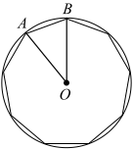
The figure shows a regular 9-sided polygon inscribed in a circle with center O.
Quantity A: The perimeter of the regular polygon
Quantity B: 3 times the perimeter of triangle OAB
A. Quantity A is greater.
B. Quantity B is greater.
C. The two quantities are equal
D. The relationship cannot be determined from the information given.

2.
x > y
Quantity A: xy
Quantity B: x²
A. Quantity A is greater.
B. Quantity B is greater.
C. The two quantities are equal
D. The relationship cannot be determined from the information given.

3.
Set S consists of all possible values of the product ab, where a and b are integers such that 0 < a < b < 10.
Quantity A: The number of odd integers in S
Quantity B: The number of even integers in S
A. Quantity A is greater.
B. Quantity B is greater.
C. The two quantities are equal
D. The relationship cannot be determined from the information given.

4.
n is a positive integer.
Quantity A: The remainder when (n+7)²−49 is divided by n
Quantity B: 1
A. Quantity A is greater.
B. Quantity B is greater.
C. The two quantities are equal
D. The relationship cannot be determined from the information given.

5.
$450, $760, $900, $1,000, $1,250, $1,400, $1,750, $2,000
The eight amounts listed are the reported bonuses earned by eight employees during July. Two of the reported amounts are in error: one is $250 greater than the actual amount and one is $250 less than the actual amount.
Quantity A: The standard deviation of the amounts of the eight reported bonuses
Quantity B: The standard deviation of the amounts of the eight actual bonuses
A. Quantity A is greater.
B. Quantity B is greater.
C. The two quantities are equal
D. The relationship cannot be determined from the information given.

6.
The median of 5 different positive integers is 12.
Quantity A: The least possible sum of the 5 integers
Quantity B: 42
A. Quantity A is greater.
B. Quantity B is greater.
C. The two quantities are equal
D. The relationship cannot be determined from the information given.

0 < w < x < y < z The average (arithmetic mean) of w, x, y, and z is less than the median of w, x, y, and z.
Quantity A: z - y
Quantity B: x - w
A. Quantity A is greater.
B. Quantity B is greater.
C. The two quantities are equal
D. The relationship cannot be determined from the information given.

8.
If the average (arithmetic mean) price of 3 items is $20 and the average price of 2 other items is $10, what is the average price of all 5 items?

9.
Sixty percent of the people who originally auditioned for parts in a musical were excused, and the rest were asked to audition again. Of those who were asked to audition again, 30 percent, or 18 people, were hired. How many people originally auditioned for parts?
A. 150 B. 120 C. 100 D. 60 E. 30

10.
r and n are integers such that r ≥ 4 and n ≥ 4. If (r-3)(n-3) < 5, what is the greatest possible value of n ?
A. 4 B. 5 C. 6 D. 7 E. 8

11.
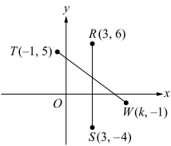
In the xy-plane shown, RS = TW. What is the value of k?
A. 6.0 B. 6.5 C. 7.0 D. 7.5 E. 8.0

12.
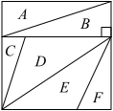
The square region above has area 64 and is divided into six nonoverlapping triangular regions. If the area of triangular region A is 8, then the area of which of the following regions CANNOT be found?
A. B B. C C. A and B combined D. C and D combined E. B, E, and F combined

13.
S is the set of all positive 3-digit integers. How many integers in S are multiples of both 7 and 13?
A. 6 B. 9 C. 12 D. 15 E. 18

14. Questions 14-16 are based on the graph below
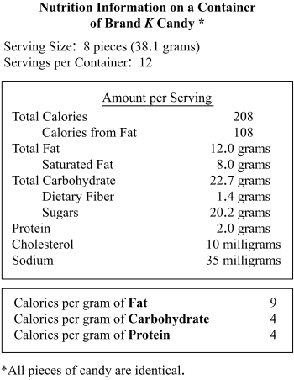
What is the number of Calories from protein in 1 serving of Brand K candy?
A. 0.5 B. 1.0 C. 2.0 D. 4.0 E. 8.0

15.
In 1 serving of Brand K candy, the ratio of the number of Calories from carbohydrates to the total number of Calories in the serving is closest to which of the following fractions?
A. 1/10 B. 1/5 C. 3/10 D. 2/5 E. 3/5

16.
A certain package of 4 brownies has 18 milligrams of cholesterol per brownie. The number of milligrams of cholesterol in the package of brownies is what percent less than the number of milligrams of cholesterol in 1 container of Brand K candy?
A. 40% B. 50% C. 67% D. 75% E. 80%

17.
The manager of a small business took out two one-year loans, each for the same principal amount, to be repaid with interest at the end of the year. Loan S had a simple annual interest rate of 5 percent, and loan R had a simple annual interest rate of 6 percent. If the amount owed for loan S at the end of 9 months was $26,145, what was the amount owed for loan R at the end of 10 months?
A. $26394 B. $26460 C. $29050 D. $29255 E. $31374

18.
A hardware store purchased x identical standard flashlights at $5 each and y identical deluxe flashlights at $7 each. The total cost to the store for both types of flashlights was $92. What is the ratio of x to y?
A. 5 to 7 B. 7 to 5 C. 5 to 1 D. 17 to 1 E. cannot be determined

19.
S: -3, 3, -3, 3, -3, 3, ...
S is a sequence of integers in which -3 and 3 alternate, as shown. If the average (arithmetic mean) of the first n terms of S is −1/5, what is the value of n ?

20.
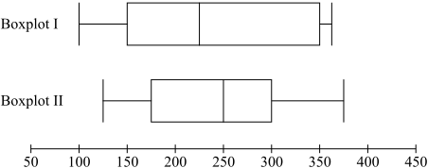
Data list I and data list II are summarized by boxplot I and boxplot II, respectively, as shown above. Which of the following statements must be true?
Indicate all such statements.
A. The median of data list II is greater than the median of data list I.
B. The range of data list I is greater than the range of data list II.
C. The interquartile range of data list I is greater than the interquartile range of data list II.

