# Gerrit Code Review - /groups/ REST API

1:列出调用者可访问的组

curl --digest --user 'banan:1ALAlyH1Wj5ROGQCww8N8Ars79QdVnQA21/36hoPCQ' <http://192.168.0.88/a/groups/>

curl --digest --user 'banan:1ALAlyH1Wj5ROGQCww8N8Ars79QdVnQA21/36hoPCQ' <http://192.168.0.88/a/groups/?owned&q=MyProject-Commiters>

查询组列表中的前1个组

curl --digest --user 'banan:1ALAlyH1Wj5ROGQCww8N8Ars79QdVnQA21/36hoPCQ' <http://192.168.0.88/a/groups/?n=1>

得到一个组的信息

curl --digest --user 'banan:1ALAlyH1Wj5ROGQCww8N8Ars79QdVnQA21/36hoPCQ' <http://192.168.0.88/a/groups/1>

2：创建组

curl -X PUT --digest --user 'banan:1ALAlyH1Wj5ROGQCww8N8Ars79QdVnQA21/36hoPCQ' <http://192.168.0.88/a/groups/dev>（创建一个dev组)

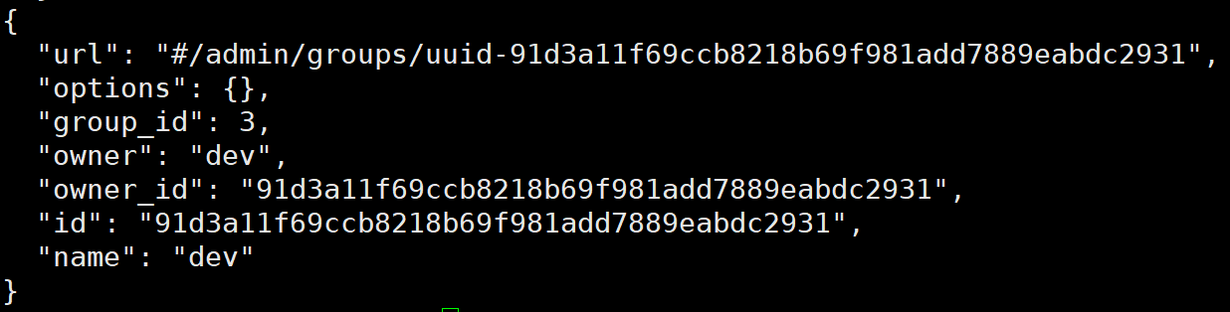

3：获取组的详细信息

curl --digest --user banan:swldNIY63Nxp9ZlPFKc7OY0hky/r5Z0BjXKTlBjdEQ <http://192.168.0.88/a/groups/5b9e107e18656bb9abaac0990bc251292f46a32a/detail>

4：获取组的名称

curl --digest --user banan:swldNIY63Nxp9ZlPFKc7OY0hky/r5Z0BjXKTlBjdEQ <http://192.168.0.88/a/groups/5b9e107e18656bb9abaac0990bc251292f46a32a/name>

5：重命名组'PUT / groups / [{group-id}](http://192.168.0.88/Documentation/rest-api-groups.html" \l "group-id) / name'

curl -X PUT -d@data.txt --header 'Content-Type:application/json;charset=UTF-8' --digest --user banan:swldNIY63Nxp9ZlPFKc7OY0hky/r5Z0BjXKTlBjdEQ <http://192.168.0.88/a/groups/5b9e107e18656bb9abaac0990bc251292f46a32a/name>

5：获取组的描述

curl --digest --user 'banan:rFLz1yzBRy8o4l0KLM87KjhyBmT4BSoSK588MGE9YQ' <http://192.168.0.88/a/groups/2efe5ac318455b62664c42e4c666dda0222eb91f/description>

6：设置组的描述

curl -X PUT -d@data.txt --header 'Content-Type:application/json;charset=UTF-8' --digest --user 'banan:rFLz1yzBRy8o4l0KLM87KjhyBmT4BSoSK588MGE9YQ' <http://192.168.0.88/a/groups/2efe5ac318455b62664c42e4c666dda0222eb91f/description>（设置一个组的描述信息）

7：删除组的描述

curl -X DELETE --digest --user 'banan:rFLz1yzBRy8o4l0KLM87KjhyBmT4BSoSK588MGE9YQ' <http://192.168.0.88/a/groups/2efe5ac318455b62664c42e4c666dda0222eb91f/description>

8：获取组的选项

curl -X PUT -d@data.txt --header 'Content-Type:application/json;charset=UTF-8' --digest --user 'banan:rFLz1yzBRy8o4l0KLM87KjhyBmT4BSoSK588MGE9YQ' <http://192.168.0.88/a/groups/2efe5ac318455b62664c42e4c666dda0222eb91f/options>

{

"visible_to_all": true

}

9:获取组的所有者

curl --digest --user 'banan:rFLz1yzBRy8o4l0KLM87KjhyBmT4BSoSK588MGE9YQ' <http://192.168.0.88/a/groups/2efe5ac318455b62664c42e4c666dda0222eb91f/owner>

10:设置组所有者

curl -X PUT -d@data.txt --header 'Content-Type:application/json;charset=UTF-8' --digest --user 'banan:rFLz1yzBRy8o4l0KLM87KjhyBmT4BSoSK588MGE9YQ' <http://192.168.0.88/a/groups/2efe5ac318455b62664c42e4c666dda0222eb91f/owner>

11：列出组的成员

curl --digest --user 'banan:rFLz1yzBRy8o4l0KLM87KjhyBmT4BSoSK588MGE9YQ' <http://192.168.0.88/a/groups/2efe5ac318455b62664c42e4c666dda0222eb91f/member>

12：获取组员

curl --digest --user 'banan:rFLz1yzBRy8o4l0KLM87KjhyBmT4BSoSK588MGE9YQ' <http://192.168.0.88/a/groups/1/members/>（获取组ID为1的组员）

13：添加组员

curl -X PUT --digest --user 'banan:rFLz1yzBRy8o4l0KLM87KjhyBmT4BSoSK588MGE9YQ' <http://192.168.0.88/a/groups/2/members/gaoyuxia>（添加组ID为2的成员gaoyuxia）

14：删除组员

curl -X POST -d@data.txt --header 'Content-Type:application/json;charset=UTF-8' --digest --user 'banan:VT2b7ndADbjNlYrRpeB0RlRT8nhHm3baIP+Cn8BV3w' <http://192.168.0.88/a/groups/2efe5ac318455b62664c42e4c666dda0222eb91f/members.delete>

15:列出组中直接包含的组

curl --digest --user 'banan:VT2b7ndADbjNlYrRpeB0RlRT8nhHm3baIP+Cn8BV3w' <http://192.168.0.88/a/groups/2efe5ac318455b62664c42e4c666dda0222eb91f/groups/>

curl --digest --user 'banan:VT2b7ndADbjNlYrRpeB0RlRT8nhHm3baIP+Cn8BV3w' [http://192.168.0.88/a/groups/2/groups/](http://192.168.0.88/a/groups/2efe5ac318455b62664c42e4c666dda0222eb91f/groups/)（2为组的ID）

16:删除包含的组

curl -X POST --digest --user 'banan:VT2b7ndADbjNlYrRpeB0RlRT8nhHm3baIP+Cn8BV3w' <http://192.168.0.88/a/groups/2efe5ac318455b62664c42e4c666dda0222eb91f/groups/groups.delete>