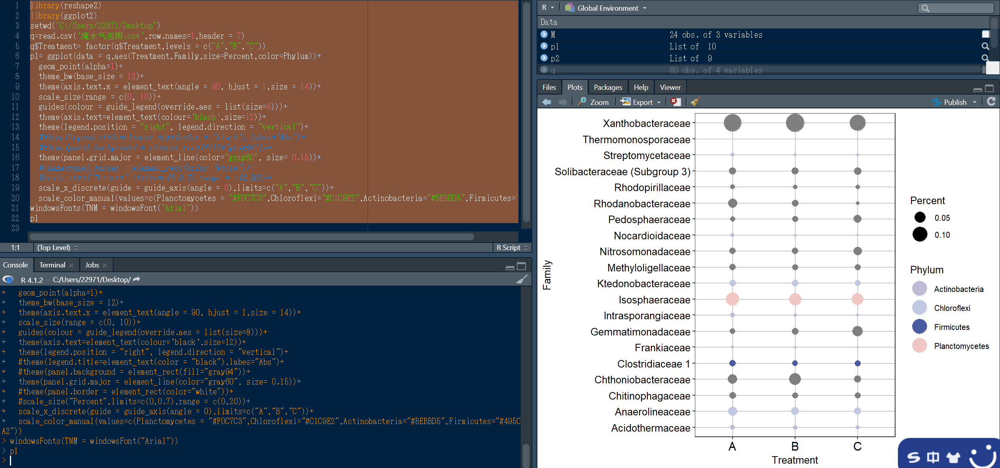

代码

library(reshape2)

library(ggplot2)

setwd("C:/Users/22971/Desktop")

q=read.csv('淹水气泡图.csv',row.names=1,header = T)

q$Treatment= factor(q$Treatment,levels = c("A","B","C"))

p1= ggplot(data = q,aes(Treatment,Family,size=Percent,color=Phylum))+

geom_point(alpha=1)+

theme_bw(base_size = 12)+

theme(axis.text.x = element_text(angle = 90, hjust = 1,size = 14))+

scale_size(range = c(0, 10))+

guides(colour = guide_legend(override.aes = list(size=8)))+

theme(axis.text=element_text(colour='black',size=12))+

theme(legend.position = "right", legend.direction = "vertical")+

#theme(legend.title=element_text(color = "black"),labes="Abs")+

#theme(panel.background = element_rect(fill="gray94"))+

theme(panel.grid.major = element_line(color="gray60", size= 0.15))+

#theme(panel.border = element_rect(color="white"))+

#scale_size("Percent",limits=c(0,0.7),range = c(0,20))+

scale_x_discrete(guide = guide_axis(angle = 0),limits=c("A","B","C"))+

scale_color_manual(values=c(Planctomycetes = "#F0C7C3",Chloroflexi="#C1C9E2",Actinobacteria="#BEBBD5",Firmicutes="#495CA2"))

windowsFonts(TNM = windowsFont("Arial"))

p1