True/False（判断题） (10 points)
Directions: In the answer sheet, write T or F to indicate whether the statement is true or false.（说明：在答题纸上填写 T 或 F 对所陈述的内容进行判断。）

- Mainframe computers are usually less powerful than minicomputers.F
2. Output devices translate the processed information from the computer into a form that humans can understand.T
3. AGP bus is usually faster than system bus.F

Multiple choice（单选题）(10points)
Directions: Circle the letter of the correct answer in the answer sheet.（说明：在答题纸上填写代表正确答案的字母。）

1．In Windows, where is “Recycle Bin” located?
a. memory
b. hard disk
c. floppy disk
d. cache
2．In the following, which one can be used to represent Chinese characters?
a. ASCII
b. EBCDIC
c. Unicode
d. Two's complement notation

Completion（填空题）(10points)
Directions: Write the answers in the answer sheet. Maybe more than one word is needed. You can answer either in English or in Chinese.（说明：将答案写在答题纸上。答案可能不止一个单词。既可用英文答，也可用中文答。）

1．For many Email systems, a POP3 or POP server handles incoming mail, and a(n)
smtp server handles outgoing mail.
2．The cu in the CPU directs and coordinates in the operation of the entire computer system.

Problems solving（问题解答）(20points)
Directions: Answering the questions briefly in the answer sheet. Both English and Chinese can be used.（说明：在答题纸上简要回答问题，既可用英文答，也可用中文答。）

1、Suppose we are performing addtion in CPU, the following figure shows the memory and CPU before execution of the program（假定CPU需要执行加法运算，下图列出了程序执行前CPU和内存的状态）:
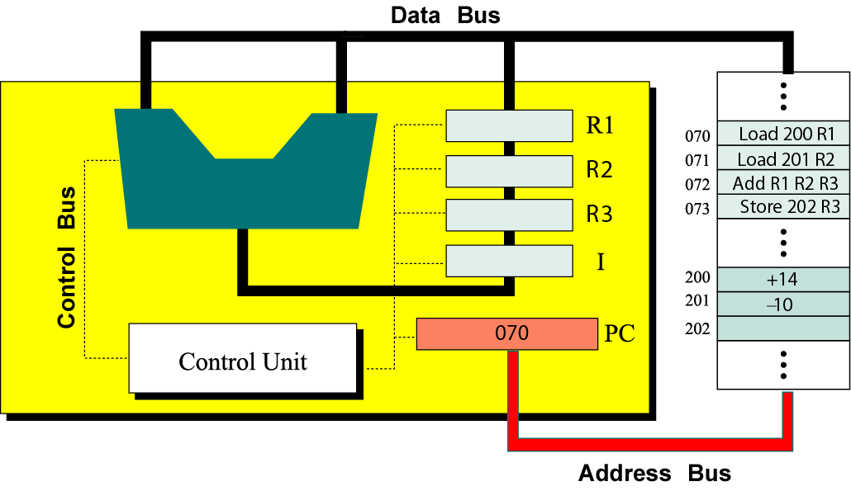
Explain briefly what happens when the CPU executes the instruction stored in memory location 071（简要说明当CPU执行内存地址071中的指令时CPU的具体操作）（6points）。

