Operational manual

of the Level 2 system

Heat treatment line for plates

Version 1.0

February 13th, 2013

List of contents

List of contents 2
Dataflow chart 3
Operation manual for Application / HMI 4
Introduction to this document 4
Introduction to the HMI 4
Header message frame 5
Bottom info frame 5
Main window frame 6
Password protection level 9
List of functions 10
Function 0 : Login - Password input 11
Function 1 : Tabular overview over plate data 12
Function 2 : Tabular overview over plate temperatures in furnace 14
Function 3 : Tabular overview over furnace temperatures 15
Function 10 : Graphical overview over plates in heat treatment plant 16
Function 11 : Graphical overview over furnace temperatures 17
Function 20 : Selection of temperature control – furnace model start/stop 18
Function 21 : Heating Up charts 20
Function 22 : Plate Input Mask 21
Function 23 : Plate report 22
Function 24 : Message report 23
Modification of parameters 24
Function 30 : Parameter Furnace Definition 25
Function 31 : Parameter Furnace Environment 26
Function 32 : Parameter Furnace Setpoints 27
Function 40 : System administration utility 28
Function 41 : Administration - Password Preset 29

Dataflow chart

In the following picture above criteria are represented in simple way:

PROCESS AUTOMATION
Level 1 system
Level 2 system
TCP/IP Server
Level 3
link
Furnace
mathematical model
HMI
visualization
TCP/IP
Graphical views / charts
Tabular views
Change of model parameter
Operation masks
Administration masks
Report / messages
Hardcopy and print function
Online help
Plate tracking system
Plate temperature calculation
Control system
- Setpoint management
- Setpoint calculation
- Soak control
Database
Primary data
Quality
Furnace parameter
Environment
Setpoints
Logbook
Alarm messages
Data archiving
Historical trend data
Password settings
TCP/IP
TCP/IP
SQL-Net
TCP/IP
PROCESS
SIMULATION
TCP/IP
TCP/IP
ODBC
TCP/IP
Level 3 system

and/or

Cooling Bed
Level 2 system
or

LOI Level 2 components

HMI visualization
FurnaceMathModel
TCP/IP-Server (to PLC)
Level-3-Link
Simulate PLC
Oracle™database

LOI Level 1 process automation

PLC TC (tracking system)
PLC BC (burner control)

Level 3

Quality Database

Operation manual for Application / HMI

Introduction to this document

This document shows the different functions of the LOI Level – 2 Computer for the Heat Treatment Plant from the operator’s point of view. It contains a list of the functions of the Level – 2 HMI together with the possible interactions of the operator with the system.

Introduction to the HMI

As the HMI is realized with the Microsoft Visual C++ .NET compiler, it becomes clear that it’s look and feel is very convenient to a user of Microsoft operating systems and utilities.

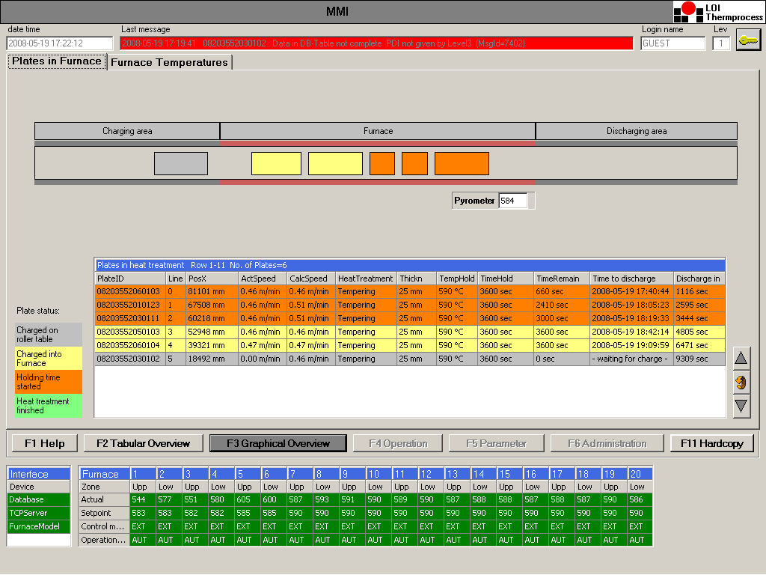

The HMI is subdivided in three frames:

- Header message frame
- Main window frame
- Bottom info frame

Header message frame

The permanent visible message line displays the last occurred system message including Time and date of occurrence. The name of the current operator logged in is displayed.

For login refer to function 0: Login – Password input.

Bottom info frame

From the main menu in the bottom info frame all functions in the main window can be selected by pushbutton (function keys) or mouse-click.

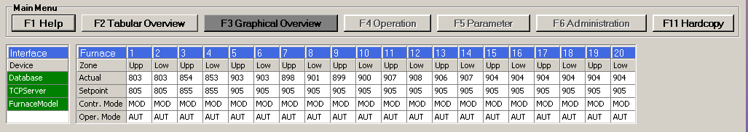

Important information of the furnace will be displayed and permament actualized, which includes

the communication state between HMI and other partners like
- Database
- TCP server which communicates with the level 1 automation
- Furnace mathematical model

furnace upper and lower zone values like
- actual temperature
- temperature set point
- PLC control mode
- PLC operational mode

Main window frame

The main window is designed like card files. This permits the easy access to submenus by the operator.

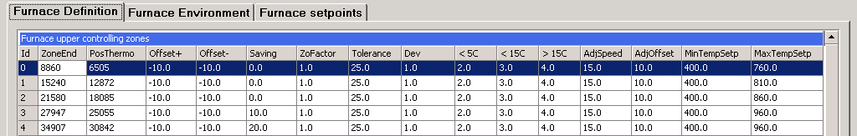

For the interaction of the operators with the system, the following well – known features are used:

- Buttons
- Sliders
- Textlabels
- Panels
- Numeric and alphanumeric edit-fields
- Radio buttons
- Check boxes
- Numeric Up/Down fields
- Data grids
- Charts
In case of pure numeric inputs, a range check with an upper and a lower limit will be proceeded.

Often used buttons:


Scroll backwards in data grid

Refresh data grid, chart or other function

Scroll backwards in data grid

Delete data set

Save data set into database

Chart window:

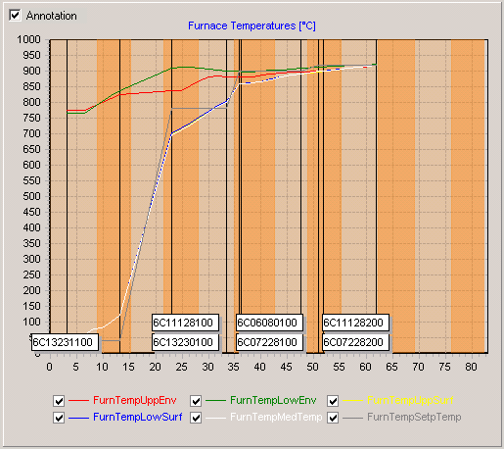

The chart window delivers a easy overview about actual or historic process conditions. The chart contains also some useful tools like annotation (like plate no.) and to fade in/out the trend charts.

Numeric Up/Down fields:

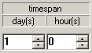
The Numeric-Up-and-down-feature allows to switch fast between senseful numeric values.

Check boxes:

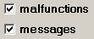
The check box for example allows to visible or unvisible selected data in data grids.

Data grids:

The data grid is used to visualize easy and fast data from the actual process or out of the database. Sometimes it is useful to color data grid rows to make attentive to important values

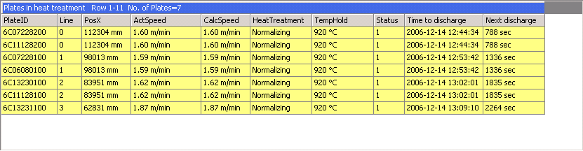

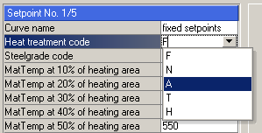
There are data grids which can be edited manually by using the mouse to activate a edit field or a drop-down edit field inside the data grid.

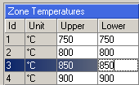
The values typed in will be range checked automatically after leaving the edit field.

Password protection level

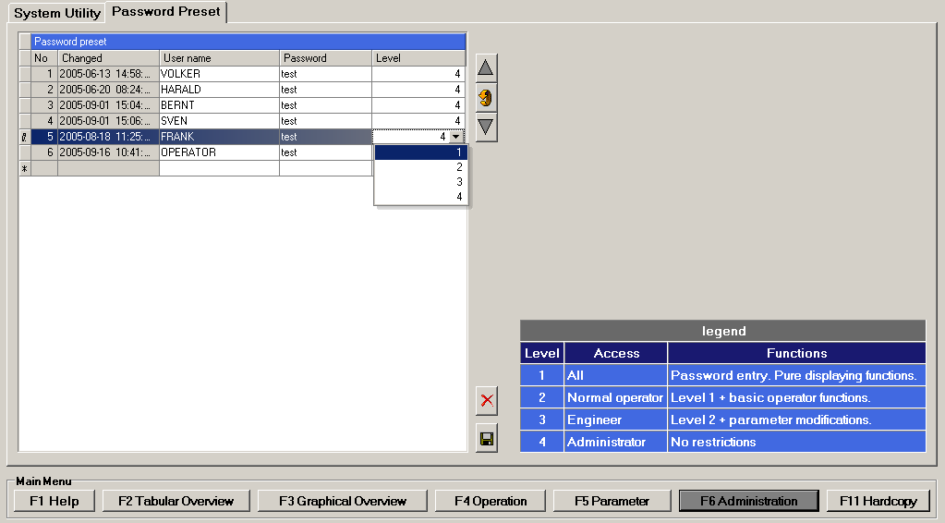

The password mechanism is based on a function specific password protection level (PPL). This parameter decides weather or not an operator (who has to identify himself by his personal password) is allowed to enter a selected function. The following password protection levels are used:

PPL Access Functions

1 All Password entry, pure displaying functions
2 Normal operator Level 1 + basic operator functions
3 Engineer Level 2 + parameter setting functions
4 Administrator No restrictions

To create or edit user and password refer to function 41: Administration – Password preset.

List of functions

The following table list all available functions together with their hot key and their password protection level:

Number | Hot key | PPL | Name
 | F1 | 1 | Main menu – Help overview
 | F2 | 1 | Main menu – Tabular overview
 | F3 | 1 | Main menu – Graphical overview
 | F4 | 1 | Main menu – Operation
 | F5 | 1 | Main menu – Parameter
 | F6 | 1 | Main menu – Administration
 | F7 | 1 | Main menu – Hardcopy
0 |  | 1 | Login – Password input
1 | <Sh>F1 | 1 | Tabular overview – Plates in heat treatment
2 | <Sh>F2 | 1 | Tabular overview – Furnace temperatures
3 | <Sh>F3 | 1 | Tabular overview – Plate temperatures in furnace
10 | <Sh>F5 | 1 | Graphical overview – Plates in Furnace
11 | <Sh>F6 | 1 | Graphical overview – Furnace temperatures
20 | <Ctr>F1 | 2 | Operation – Temperature control
21 | <Ctr>F2 | 2 | Operation – HeatingUp curves
22 | <Ctr>F3 | 2 | Operation – Plate Input
23 | <Ctr>F4 | 2 | Operation – Plate report
24 | <Ctr>F5 | 2 | Operation – Message report
30 | <Ctr>F6 | 3 | Parameter – Furnace definition
31 | <Ctr>F7 | 3 | Parameter – Furnace environment
32 | <Ctr>F8 | 3 | Parameter – Furnace setpoints
40 | <Alt>F1 | 4 | Administration – System utility
41 | <Alt>F2 | 4 | Administration – Password Preset

Function 0 : Login - Password input

The login function is realized in the header window of the MMI.
Press this button to switch to user login.

Then the login name and password can be written in.

After pressing the check button the login will be compared with the password preset.

The dialogue allows the input of user specific passwords.

For example : Name : Operator
Password : ABC123

Every user name is combined with one valid password. This password may be numerical or alphanumerical. It is limited to 10 characters. After successful password input, the password protection level of the MMI is shifted to the value which is given to the operator by the administrator. Entering an invalid password or an unknown user name resets the PPL to the basic value 1. For means of safety, every operator should reset the PPL after finishing his interactions.

A successful login - procedure remains valid until the next login procedure occurs !

For further information of user/password configuration and the PPL Password protection level refer to function 41: Administration - Password Preset.

Function 1 : Tabular overview over plate data

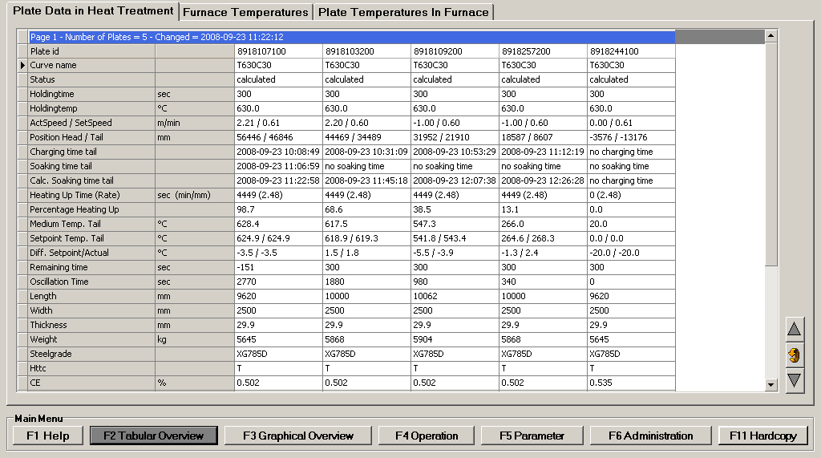

This function presents a tabular overview over all actual plates starting at furnace entrance and ending on the discharging roller table. Vertical scroll buttons allow to focus the display on the most interesting figures. Each line of the tabular overview contains the information of a single plate including the following items:

Dynamic data of plates in progress
- Plate id
- Curve name according to the key values find in Parameter Furnace Setpoint
- Plate status by model (non calculated, calculated, data lost)
- Holding time set point
- Holding temperature set point
- Actual / Setpoint tracking speed
- Position of plate head / tail
- Charging time of plate tail
- Soaking time of plate tail
- Estimated soaking time of plate tail
- Heating up time in sec. and the Heating Up Rate in min/mm
- Percentage of heating up
- Medium temperature of the tail (coldest point)
- Setpoint temperature of the tail according heating up curve
- Difference between Medium and Setpoint temperature
- Remaining holding time until discharge
- Oscillation time of the plate
Static (primary) data of all available plates
- Plate geometry (Length, Width, Thickness and Weight)
- Steel grade
- Heat treatment type (Hardening, Tempering)
- Material analysis (C, Si, Mn, Cr, Ni, Mo, V)
- Database time of last update

The content of the table will be refreshed in regular cycles or by corresponding pushbutton.

Function 2 : Tabular overview over plate temperatures in furnace

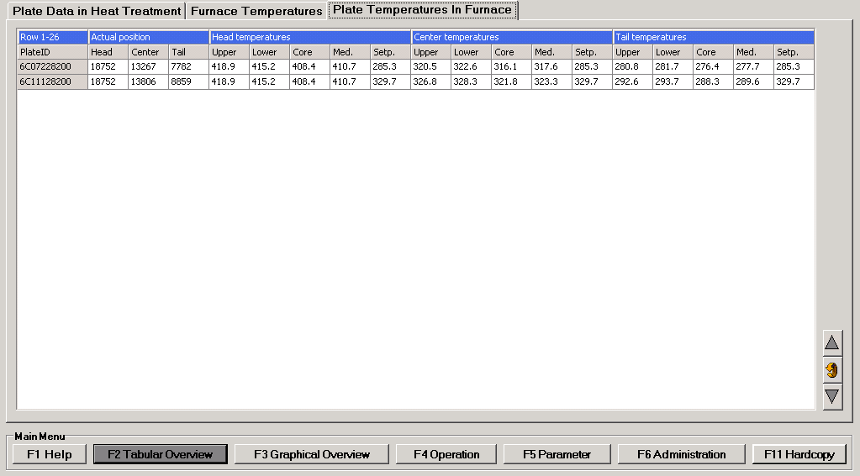

This function presents a tabular overview over all plates inside the furnace. The presentation of the thermal data is similar to the description in the prior section. Each line of the tabular overview contains the following plate specific items:

- Plate id
- Position of plate head
- Position of plate center
- Position of plate tail
- Plate head : Upper surface temperature
- Plate head : Lower surface temperature
- Plate head : Core temperature
- Plate head : Medium temperature
- Plate head : Set point temperature
- Plate center : Upper surface temperature
- Plate center : Lower surface temperature
- Plate center : Core temperature
- Plate center : Medium temperature
- Plate center : Set point temperature
- Plate tail : Upper surface temperature
- Plate tail : Lower surface temperature
- Plate tail : Core temperature
- Plate tail : Medium temperature
- Plate tail : Set point temperature

The content of the table will be refreshed in regular cycles or by corresponding pushbutton.

Function 3 : Tabular overview over furnace temperatures

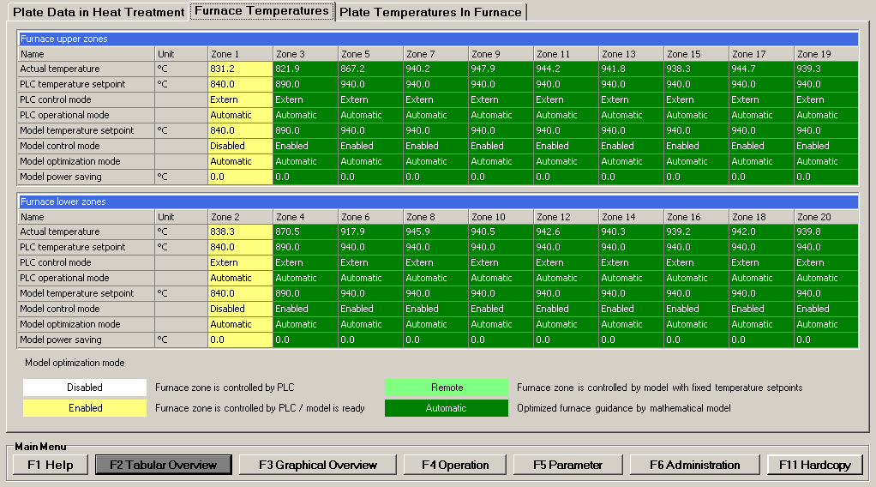

This function visualizes the most important figures of the furnace. This comprises the following zone specific data (10 upper furnace zones, 10 lower furnace zones):

- Actual measured furnace zone temperature
- Temperature set point of PLC (level 1)
- Control mode of PLC (Internal/External)
- Operational mode of PLC (Manual/Automatic)
- Temperature set point by model (level 2)
- Control mode of model (Enabled/Disabled)
- Optimization mode of model (Automatic/Remote/Internal)
- Actual value of temperature saving

The content of the table will be refreshed in regular cycles or by corresponding pushbutton.

Function 10 : Graphical overview over plates in heat treatment plant

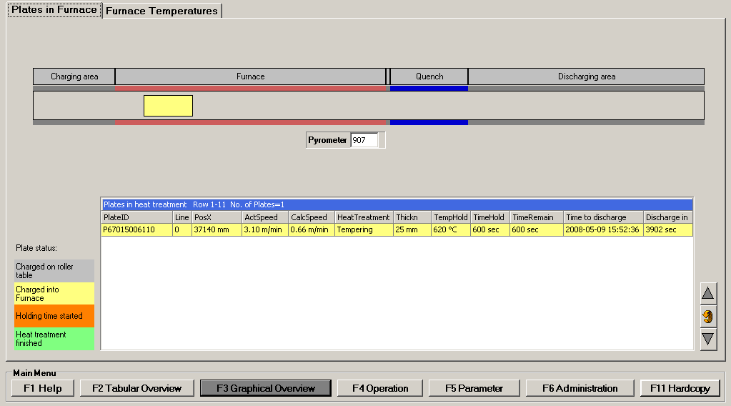

This function presents in a graphical overview all plates inside the heat treatment plant from the beginning of the charging table (Pos. 0) to the end of the discharging roller table. The plates are visualized in different colors as a function of their actual state. A plate might have one of the following state:

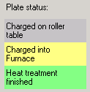

plate is available in the tracking automation system

plate head has reached the furnace entrance

plate tail has reached the holding temperature and time and moves out

In the data grid actual process values of the visualized plates will shown like
- Plate id
- Group id if plates to be added together
- Head pos in x/y-coordinates
- Actual and calculated transport speed of the plate in the furnace or in the quench
- Heat treatment type
- Target holding temperature
- Plate state (see above)
- Estimated discharging date/time stamp the plate will leave the furnace
- time until the plate will leave the furnace in minutes

The content of the table will be refreshed in regular cycles or by corresponding pushbutton.

Function 11 : Graphical overview over furnace temperatures

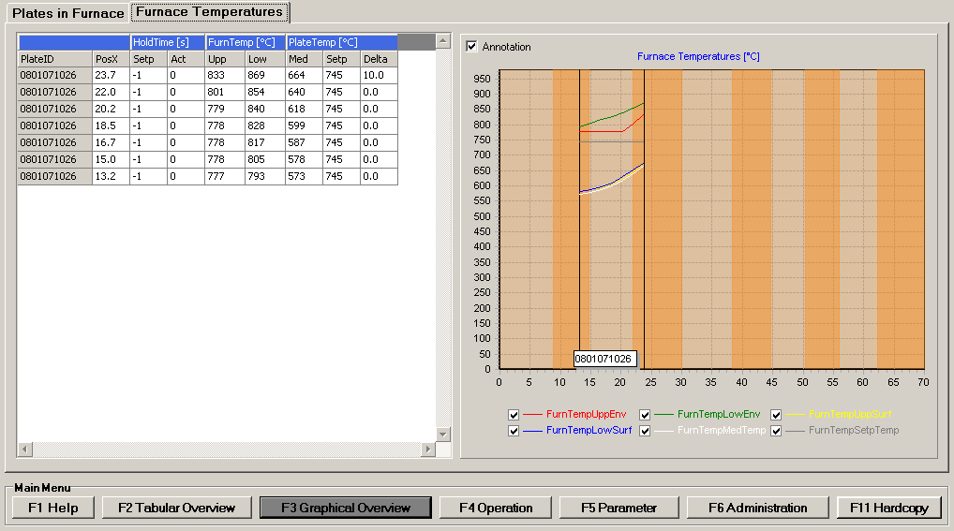

This function presents a graphical overview over the thermal situation of the furnace section of the heat treatment plant. For this aim, up to six temperature curves can be displayed simultaneously. All curves show the slope of a thermal figure of the plates over the length of the complete furnace. The plate is divided in 7 observation points.

The operator can select or deselect the following curves by pushbutton :

- Temperature curve of upper furnace temperature over the furnace length ¹
- Temperature curve of lower furnace temperature over the furnace length ¹
- Temperature curve of medium plate temperature over the furnace length ²
- Temperature curve of upper surface plate temperature over the furnace length ²
- Temperature curve of lower surface temperature over the furnace length ²
- Temperature curve of plate set point temperature over the furnace length ²

¹ : This curve is built with process data
² : This curve is built with data calculated by the mathematical model

In the data grid also the actual position, the holding time target setpoint and the actual holding time of each observation point is shown.
The content of the table will be refreshed in regular cycles.

Function 20 : Selection of temperature control – furnace model start/stop

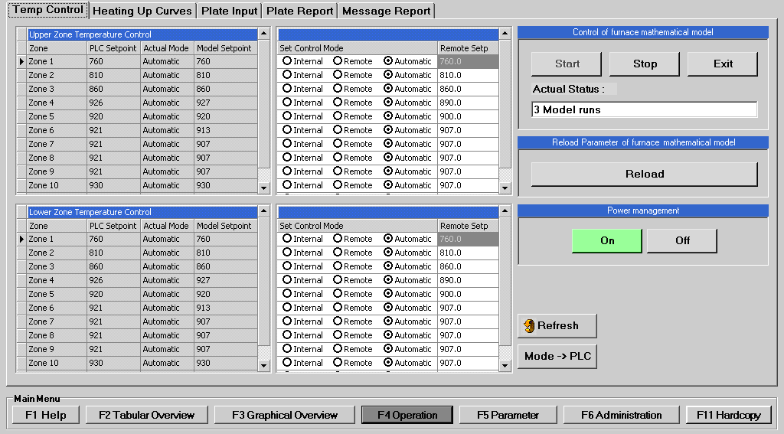

The mathematical model for the furnace is designed to control the Roller Hearth Furnace by a cyclic transmission of optimized temperature set points for each controller zone of the upper and the lower furnace. Beside this automatic control mode, two other working modes are implemented : Internal control mode and Remote control mode.

This screen mask let the operator select between the different possibilities of furnace guidance implemented in the Level – 2 system:

- Fixed temperature set points defined by Level - 1 (Internal control mode)
- Fixed temperature set points defined by Level – 2 (Remote control mode)
- Optimized furnace guidance by the mathematical model of Level – 2 (Automatic control mode)

The operator can start and stop the model functionality. Under normal circumstances, stopping and restarting is not necessary. The Level – 2 – system is designed for continuous operation.

If parameter are changed or basic model configurations in the table MODEL_DATA of the database, the model needs an event to reload these data. This is triggered by the button RELOAD.

If the furnace model needs to update, the model can be shutdown by the EXIT button, which creates a snapshot of the actual furnace condition and plate image. After restart of the model the snapshot will be reimported into the kernel of the model to continue the heat treatment calculation.

In case of long lasting production interrupts like periods of maintenance or power shut downs, it might be necessary to stop the Level – 2 –System.

This means that the internal material tracking system as well as the mathematical models for furnace and quench stop working and the database operations of this processes are finished.

Starting up the Level – 2 – system after a prior shut – down means

- Reset of internal material tracking system
- Starting up of internal material tracking system
- Starting up of the mathematical models for furnace
- Starting up of the database operations

For safety reason, every user interaction must be acknowledged by a confirmation button. In this case a corresponding message including the operator’s login – name will be displayed and archived. If the operator leaves the function without prior confirmation, no changes/modifications will take place.

Function 21 : Heating Up charts

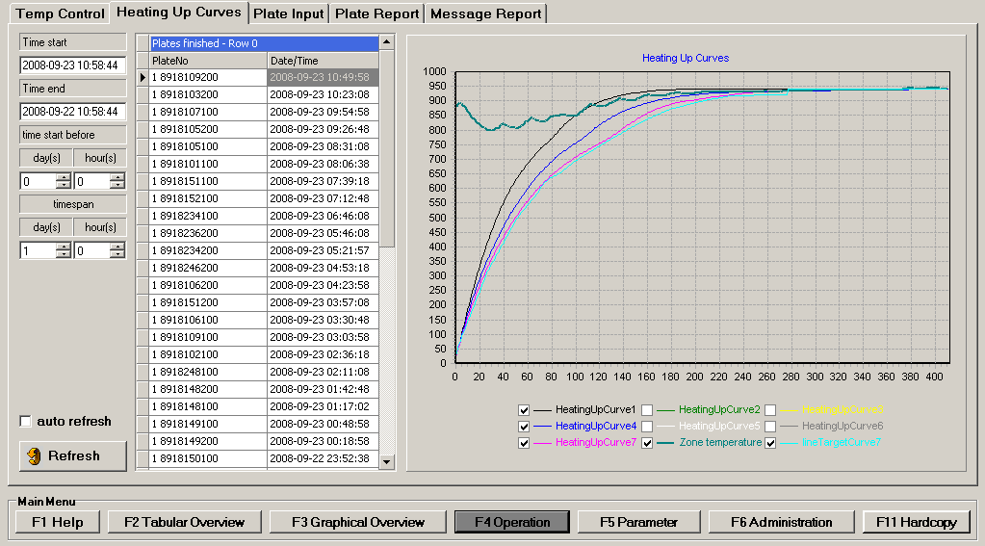

This screen mask is designed to display the heating up curves of heat treated plates. Use the time selection at the left side to filter plates by time of discharge.

Up to 7 curves for the 7 observation points of a plate can be displayed. Each curve can be enabled or disabled with the check box in the chart.

One further curve represents the target temperature of the tail point.

The 9th curve represents the furnace temperature.

The content of the chart will be refreshed automatically if enabled.

Function 22 : Plate Input Mask

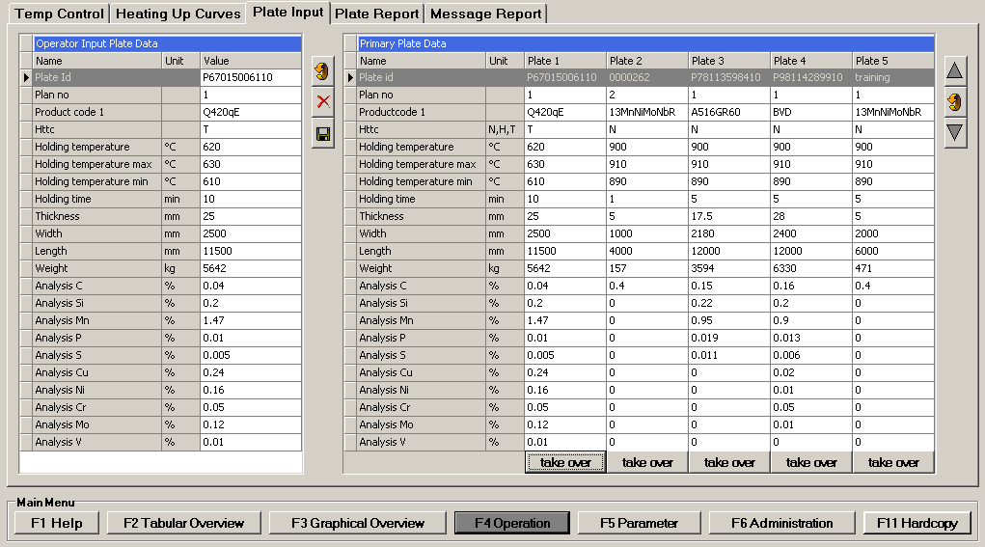

This operator dialogue is designed to let the operator create primary plate data in case of a Level-3-system shutdown. This function is to be regarded with highest caution because original level-3 data could be changed or deleted.

Primary data of five plates are shown on the right side and can be selected with the “take over” button below of the column. To get other plates the operator can use the UpDown function.

On the left side the operator can change the taken over data either or put on a new data record. After pushing the “Save” button the dataset will be stored in the database. With the “Delete” button the dataset will be deleted.

Function 23 : Plate report

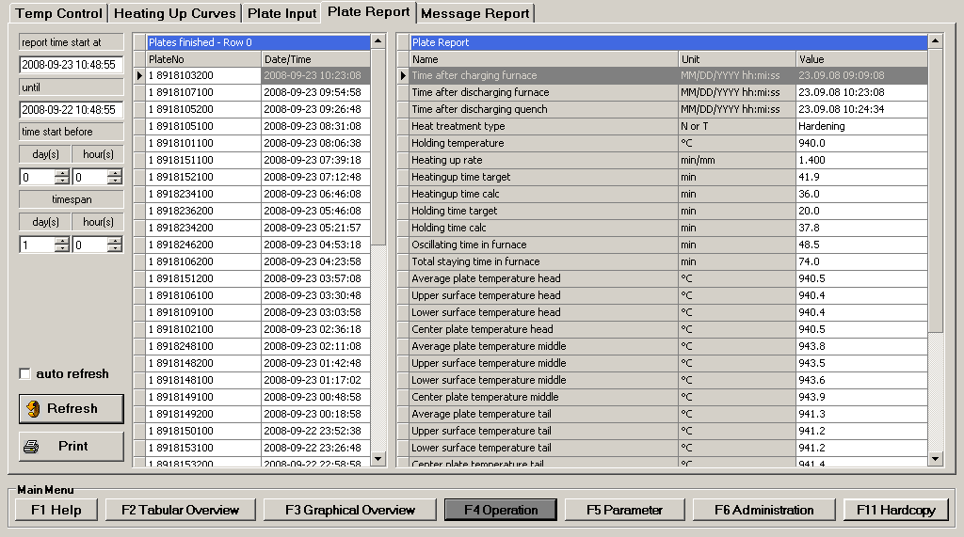

This screen mask is designed to display the report of heat treated plates. Use the time selection at the left side to filter plates by time of discharge.

Following results will be shown:
- Plate identification
- Time of furnace charge and discharge
- Heat treatment type, normalizing or tempering
- Holding temperature calculated and target
- Holding time calculated and target
- Heating up rate
- Oscillation time
- Total time in furnace
- Average plate temperature after furnace discharging by model
- Upper- and lower surface plate temperature after furnace discharging by model
- Center plate temperature after furnace discharging by model
- Measured plate temperature at pyrometer
- Speed of plate at charging and discharging
- Steelgrade
- CE
- Dimensions

The content of the chart will be refreshed automatically if enabled.

Function 24 : Message report

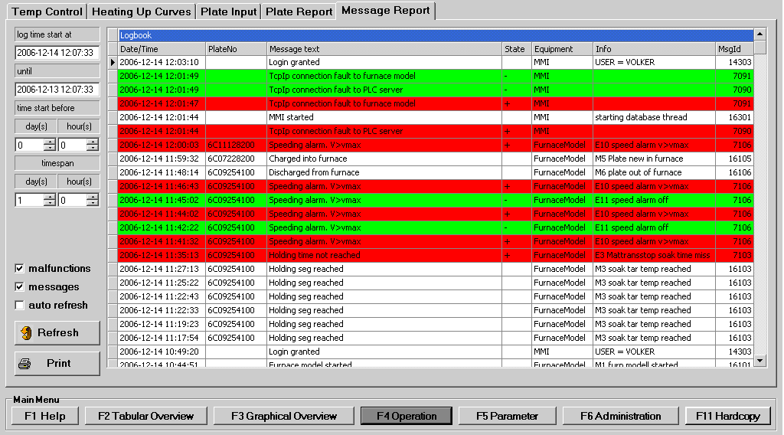

Messages generated by the level 2 processes are collected together in a logbook in the database.

The data grid contains following coloumns:

- Date/Time stamp when message occurred
- Plate ID if the message is plate specific
- Message text
- Malfunction state (active/gone)
- Equipment (MMI, furnace model or level-3-link)
- Additional Info field to specify the message
- Unique message ID

Active malfunctions are colored red, gone entries are colored green. The logbook entries in the database will be cleared in regular cycle to save memory space on disk. The time span of the visualized entries can be adjusted by NumericUp-fields. The report can be printed out manually or cyclically automatic if the corresponding check box is checked. If the operator want to scroll inside the report grid the automatic refresh should be switched off.
By check boxes the operator can separate the logged entries in

- Malfunctions (active or gone)
- Standard messages
- Entries by MMI
- Entries by furnace model

Modification of parameters

The following sections describe the functions and operator dialogues which are designed for the modification of the different parameter sets of the Level – 2 system. As a modification of these parameters typically has a serious influence on the functionality and accuracy of the Level – 2 system, it is obvious, that only skilled engineers shall have access to this part of the HMI.

For all numerical inputs a range check against a maximum and a minimum value is proceeded, but it is obvious that even “allowed” values might have serious consequences if they doesn’t match at all.

Therefore it is recommended that modifications of the parameters described in the following sections shall be done in cooperation with LOI Thermprocess.

Function 30 : Parameter Furnace Definition

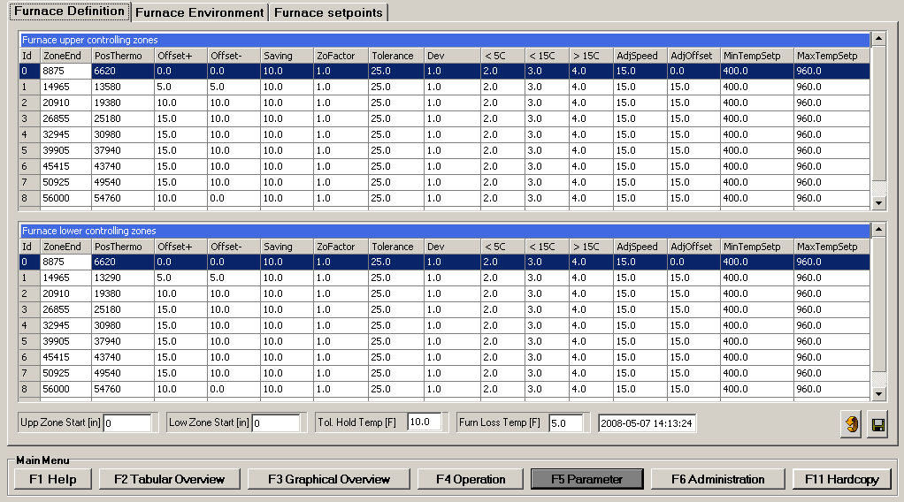

The calculation of the zone set point temperatures depends on several parameters that set limits to the change of the zone temperatures and govern the way the driving temperature differences get valued. This operator dialogue is designed to define the following parameters describing the furnace geometry of each upper and lower zone and corresponding figures like
- location [mm] of furnace controlling zones
- location [mm] of controlling thermocouples
- Offset+ [°C]: higher limit of temperature deviation allowed between target and calculated temperature. This is the max. value which the model increases the setpoint.
- Offset- [°C]: lower limit of temperature deviation allowed between target and calculated temperature. This is the max. value which the model decreases the setpoint.
- Saving [°C]: Maximum value to power down the zone temperature from target holding temperature of a plate existing in the tracking system in front of the zone. Also if a plate is already on charging table and checked in.
- Adj.Steps [°C]: Size of effective zone temperature set point
- Adj.Speed [°C]: Limit of difference between zone setpoints between two calculation runs
- Adj.Offset [°C]: Fixed limit from recipe zone temperature
- Min/max temperature set point value [°C]: Fixed absolute limits

Function 31 : Parameter Furnace Environment

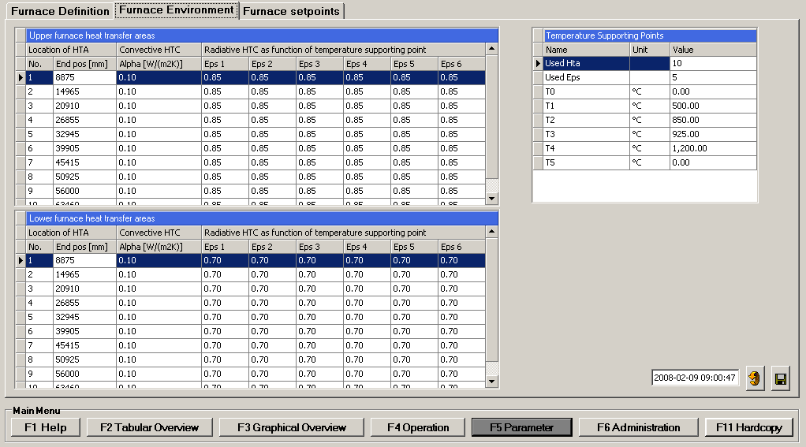

This operator dialogue allows the definition of the heat transfer coefficients of the upper and the lower furnace like :

- Definition of temperature supporting points for radiative heat transfer coefficients
- Number and location of zones with different heat transfer coefficients
- Zone specific convective heat transfer coefficient
- Zone specific radiative heat transfer coefficient as function of temperature

Function 32 : Parameter Furnace Setpoints

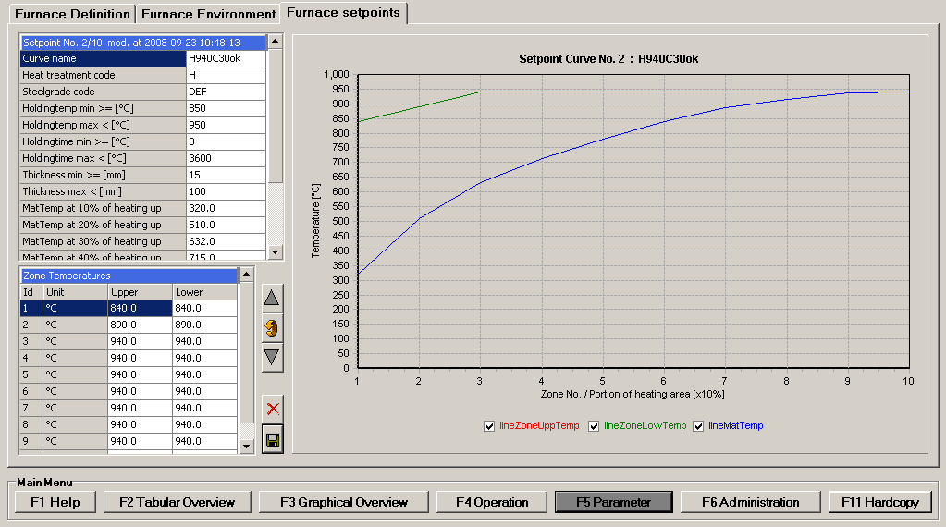

This screen mask allows the definition of the set point curves which are essential for the optimized definition of temperature set points.

A plate set point curve consists of

- Curve Name
- Heat treatment Type code (given by Level 3)
- Steelgrade code (given by Level 3, default = DEF)
- Holding temperature min and max, between this curve is valid
- Plate thickness min and max, between this curve is valid
- Material temperature depended on given plate speed by the tracking automation system
- Furnace temperatures without holding time.

For automatic control mode the model selects a setpoint curve depended on the heat treatment code. Therefore default curves for each code (N, T), holding temperature and thickness must be set by Level 3.

For remote control mode the model selects a fixed setpoint curve which must be defined under the heat treatment code F.

Function 40 : System administration utility

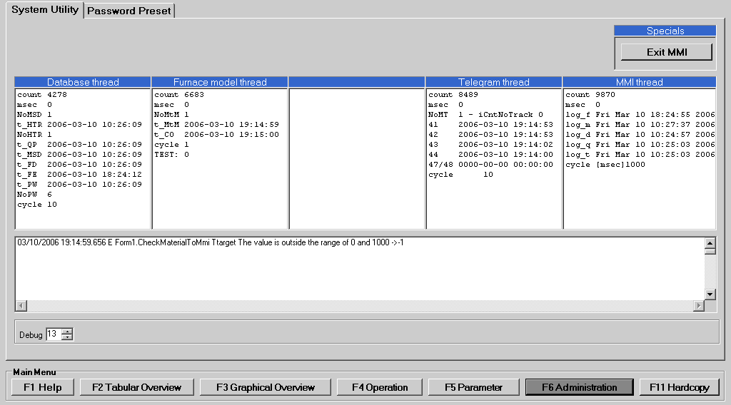

The access to this function is strictly reserved for the system administrator. It is designed to define the following items and to execute the following functions :

- Status of MMI threads
- Logging window
- Exiting the application

Function 41 : Administration - Password Preset

The password mechanism is based on a function specific password protection level (PPL). This parameter decides weather or not an operator (who has to identify himself by his personal password) is allowed to enter a selected function. The following password protection levels are used:

PPL Access Functions

1 All Password entry, pure displaying functions
2 Normal operator Level 1 + basic operator functions
3 Engineer Level 2 + parameter setting functions
4 Administrator No restrictions

A valid password shall have a length of 6 characters. It can be pure numeric or alphanumeric. The password mechanism is case sensitive

