Description

TCPIP telegrams Level 2 and PLC

Plate heat treatment line

Version 1.0 L

May 12th, 2010

Introduction to the content

This document describes the communication concept and structure of the Level 2 of the Heat Treatment Line. Detailed telegram description and contents are listed which belongs to Level 2, tracking and furnace control system. Further telegrams belonging to quench control system and recipe computer are listed in the document

RecipeStation.doc

The Level 2 datebase description incl. installation, configuration, data transfer and maintainance is part of the document

DatabaseManual.doc

History

V1.0 2010-05-12 STR : Taken over by version X1.6 from Oct. 29th, 2008
Communication overview and data flow chart

List of contents

Introduction to the content 2
History 2
List of contents 3
Communication overview 4
Items of communication 5
Data flow chart 5
Definition of telegrams 6
Structure of telegram 6
Types of telegram 6
Overview of all telegrams 7
Telegram number : 301 Tracking Image TC -> L2 9
Telegram number : 302 Plate data before charging TC -> L2 10
Telegram number : 303 Stop Discharging L2 -> TC 12
Telegram number : 401 Actual furnace process values BC -> L2 13
Telegram number : 402 Optimized furnace set values L2 -> BC 14
Telegram number : 601 Tracking telegram TC -> BC 15
Telegram number : 602 Furnace telegram BC -> TC 16
Telegram number: 701 Watchdog QC -> L2 17
Telegram number: 702 Watchdog L2 -> QC 17
Telegram number: 703 Furnace result L2-> QC 18
Telegram number: 704 Acknowledge Furnace result QC -> L2 19
PLC net config 20

Communication overview

Level 2
Furnace model
Graphical views / charts
Tabular views
Change of model parameter
Operation masks
Administration masks
Report / messages
Hardcopy and print function
Online help
Plate tracking system
Plate temperature calculation
Setpoint management
Online controlling
- Zone setpoint calculation
- Plate speed control
- Heat treatment result
Primary data
Quality
Model parameter
Model environmet
Model setpoint
Logbook
Alarm messaging
Data archiving
Historical trend data
Password management

TCP/IP
SQL-Net
TCP/IP
ODBC
Charging telegram
Tracking telegram
Furnace telegram
Process Automation
WinCC
Plate Checkin
TCP/IP Server
DB
HMI

Level 2 tasks

TCP/IP Server
Furnace model
Visualization
Oracle™database

LOI Level 1 process automation

PLC TC (tracking system)
PLC BC (furnace control)
PLC QC (quench control)

Items of communication

Communication is differentiated in line with existing communication partners into different kinds of telegrams or database access.

Telegrams: Data transfer between LOI equipment
Database access: Read/Write operations to the Oracle™database between Level 2 and
- Level 1 WinCC visualization
- Level 3 customer database

Data flow chart

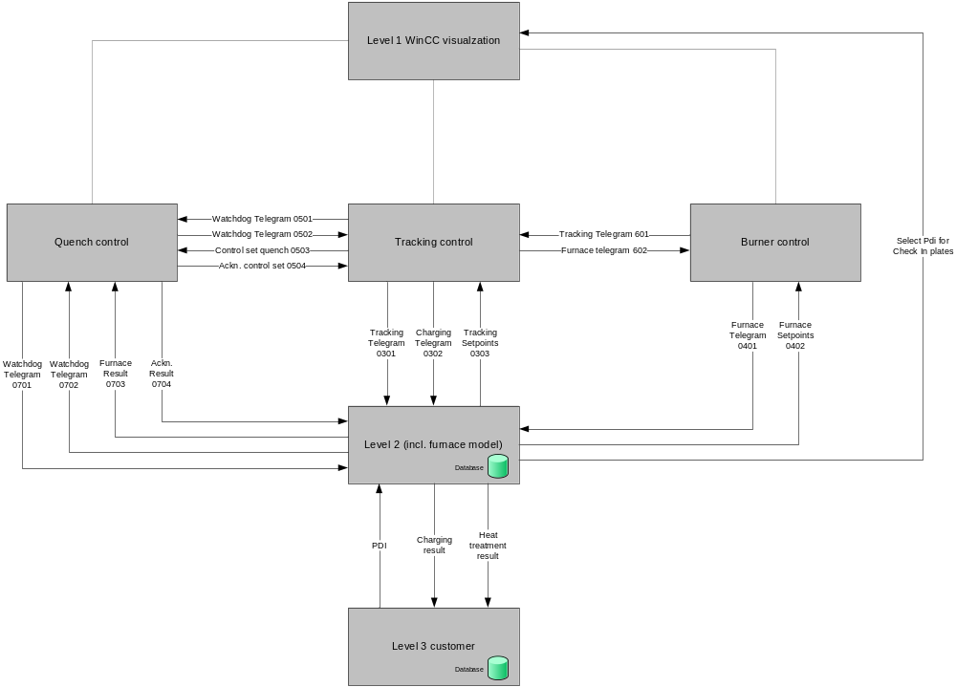

Definition of telegrams

On Level 2 computer site the program “TCPIP-Server.exe” provides the communication to each PLC:

- PLC-AC (automation control) for material tracking
- PLC-BC (burner control) for furnace
- PLC-QC (quench control) for quench

The transport protocol of the telegrams between Level 2 computer and each PLC is TCP/IP. All data exchange between two partners is ensured over one connection means PLC is SERVER and Level 2 is CLIENT. The telegram is coded in binary format and has a fixed length.

Structure of telegram

According to the telegram type, the telegram can be divided into different parts as follows:

- Message Header
- Utilizable Data Header (*)
- Utilizable Data Body

Message Header | 20 Bytes | Binary
Data Header (*) | 86 Bytes | Binary
Data Body | n Bytes | Binary

(*) Only if needed.

Types of telegram

The system uses 2 types of telegrams:

- Watchdog telegram
- Data telegram

Overview of all telegrams

ID | Sender | Receiver | Telegram Length | Timing | Aim | Document
101 | TC | RS | 20 | Cyclically | Watchdog | RecipeStation.doc
102 | RS | TC | 20 | Cyclically | Watchdog | RecipeStation.doc
103 | TC | RS | 114 | Event | Recipe Request by tracking plc | RecipeStation.doc
104 | RS | TC | 474 | Event | Answer with recipe | RecipeStation.doc
201 | QC | RS | 20 | Cyclically | Watchdog | RecipeStation.doc
202 | RS | QC | 20 | Cyclically | Watchdog | RecipeStation.doc
203 | QC | RS | 1708 | Event | Quench result (discharging) | RecipeStation.doc
204 | RS | QC | 108 | Event | Acknowledge quench result | RecipeStation.doc
205 | QC | RS | 114 | Event | Recipe Request (optional) | RecipeStation.doc
206 | RS | QC | 474 (*) | Event | Answer with recipe (optional) | RecipeStation.doc
207 | QC | RS | 620 | Cyclically (*) | Cyclic quench result | RecipeStation.doc
208 | QC | RS | 3120 | Event | Position and flow | RecipeStation.doc
209 | RS | QC | 22 | Event | Acknowledge position and flow | RecipeStation.doc
210 | RS | QC | 3120 | Event | Restore position and flow | RecipeStation.doc
211 | QC | RS | 22 | Event | Ackn. restore position and flow | RecipeStation.doc
301 | TC | L2 | 20 | Cyclically | Tracking image | 0000.doc
302 | TC | L2 | 20 | Cyclically (**) | Plate data before charging | 0000.doc
303 | L2 | TC | 114 | Cyclically | Stop discharging | 0000.doc
401 | BC | L2 | 474 | Cyclically | Actual furnace process values | 0000.doc
402 | L2 | BC | 20 | Cyclically | Optimized furnace set values | 0000.doc
501 | TC | BC | 420 | Cyclically | Watchdog | RecipeStation.doc
502 | BC | TC | 420 | Cyclically | Watchdog | RecipeStation.doc
503 | TC | BC | 420 | Event | Control set quench | RecipeStation.doc
504 | BC | TC | 420 | Event | Acknowledge control set quench | RecipeStation.doc
601 | TC | BC | 420 | Cyclically | Tracking telegram | 0000.doc
602 | BC | TC | 420 | Cyclically | Furnace telegram | 0000.doc
701 | QC | L2 | 20 | Cyclically | Watchdog | 0000.doc
702 | L2 | QC | 20 | Cyclically | Watchdog | 0000.doc
703 | L2 | QC | 140 | Event | Furnace result | 0000.doc
704 | QC | L2 | 22 | Event | Acknowledge Furnace result | 0000.doc

(*) Only if a plate is being quenched and located inside quench area.
(**) Only if a plate is on the charging area or just charging into furnace.

Partner communication with cyclically telegrams in both direction doesn’t need watchdog.

Message Header

A telegram begins always with the Message Header and has a fixed length of 20 Bytes.

Message  Header | Message Id | Indicates the identification of the message | 2 Bytes | Integer
Message  Header | Message Length | Indicates the whole length of the message | 2 Bytes | Integer
Message  Header | Sender | Indicates the sending device | 2 Bytes | Character
Message  Header | Receiver | Indicates the receiver device | 2 Bytes | Character
Message  Header | Timestamp | Indicates the year, month, day, hour, minute, second when sending the message | 8 Bytes | S7-Format
Message  Header | Life counter | -32.768...32.767 | 2 Bytes | Integer
Message  Header | SPARE |  | 2 Bytes | Integer

Telegram number : 301 Tracking Image TC -> L2

Sender : PLC Tracking control TC
Receiver : Level 2 model computer L2
Additional spare:
Total length: 6860 Bytes

Timing and general description : 5 sec
The telegram is sent cyclically by PLC-TC to send all plate tracking data as long as these plates are tracked by the PLC. Even there is no plate in the tracking system, the telegram will be sent as part of alive functionality.

Message  Header |  |  |  |  |  | 20 Bytes
30x | Group data header | num_plates |  | Number of plates in group (1 or 2) |  | 2 Bytes | Integer
30x | Group data header | group_type |  | Type of group:  1. Single Plate  2. One beside one (parallel) |  | 2 Bytes | Integer
30x | Group data header | act_speed |  | Actual speed of plate |  | 4 Bytes | Real | m/min
30x | Group data header | calc_speed |  | Calculated speed of plate |  | 4 Bytes | Real | m/min
30x | Group data header | spare |  | spare data header |  | 32 Bytes | Bytes
30x | Group data body | 2x | plate_id | primary plate identification | 32 Bytes | 92 Bytes | Character
30x | Group data body | 2x | plan_no | secondary plate identificaton | 32 Bytes | 92 Bytes | Character
30x | Group data body | 2x | head_pos | tracked head pos of plate | 4 Bytes | 92 Bytes | Double integer | mm
30x | Group data body | 2x | tail_pos | tracked tail pos of plate | 4 Bytes | 92 Bytes | Double integer | mm
30x | Group data body | 2x | plateid_int | internal plate identification | 4 Bytes | 92 Bytes | Double integer
30x | Group data body | 2x | spare | spare group data | 16 Bytes | 92 Bytes | Bytes

Summary |  | 6860 Bytes

Telegram number : 302 Plate data before charging TC -> L2

Sender : PLC Tracking control TC
Receiver : Level 2 model computer L2
Additional spare:
Total length: 486 Bytes

Timing and general description : 10 sec
The telegram is sent cyclically by PLC-TC, as long as the plate is on the charging table, after it is checked-in. Before charging into furnace, values can be changed.

Message  Header |  |  | 20 Bytes
Data  Body 1 | num_plates | Number of plates in group (1 or 2) | 2 Bytes | Integer
Data  Body 1 | group_type | Type of group:  1. Single Plate  2. One beside one (parallel) | 2 Bytes | Integer
Data  Body 1 | httc | Heat treatment type code (H, N, T) | 2 Bytes | Integer | 1 = H  2 = N  3 = T
Data  Body 1 | holding_temp | Target holding temperature | 4 Bytes | Real | °C
Data  Body 1 | holding_time | Target holding time | 4 Bytes | Double Integer | sec
Data  Body 1 | plate_thickness | Thickness of plate group | 4 Bytes | Real | mm
Data  Body 1 | calc_speed | calculated speed (in furnace) | 4 Bytes | Real | m/min
Data  Body 1 | CE | Carbon Equivalent of plate group | 4 Bytes | Real | %
Data  Body 1 | productcode_2  (optional) | Customer production code to identify a plate specific recipe, e.g. steel grade, material class, | 32 Bytes | Character
Data  Body 1 | handlingcode_quench | Extends the identification for plate specific recipe, if product code is not unique to handle the plate, e.g.  1. Quenching  2. Quenching and oscillating  3. Cooling  4. ... | 2 Bytes | Integer
Data  Body 1 | alloy_C | Carbon | 4 Bytes | Real | %
Data  Body 1 | alloy_Si |  | 4 Bytes | Real | %
Data  Body 1 | alloy_Mn |  | 4 Bytes | Real | %
Data  Body 1 | alloy_P |  | 4 Bytes | Real | %
Data  Body 1 | alloy_S |  | 4 Bytes | Real | %
Data  Body 1 | alloy_Cu |  | 4 Bytes | Real | %
Data  Body 1 | alloy_Ni |  | 4 Bytes | Real | %
Data  Body 1 | alloy_Cr |  | 4 Bytes | Real | %
Data  Body 1 | alloy_Mo |  | 4 Bytes | Real | %
Data  Body 1 | alloy_V |  | 4 Bytes | Real | %
Data  Body 1 | specific.heatrate | Specific heatrate given by HMI of Level1 | 4 Bytes | Real | min/mm
Data  Body 1 | specific.heatrate_on | HMI heatrate ON | 2 Bytes | Integer | 0: OFF  1: ON
Data  Body 1 | spare | Spare data body 1 | 32 Bytes | Bytes

Data  Body 2 | 2x | Pos_head | Head X position of plate | 4 Bytes | 164 Bytes | Double Int
Data  Body 2 | 2x | Pos_tail | Tail X position of plate | 4 Bytes | 164 Bytes | Double Int
Data  Body 2 | 2x | plate_id | primary plate identification | 32 Bytes | 164 Bytes | Character
Data  Body 2 | 2x | plan_no | secondary plate identificaton | 32 Bytes | 164 Bytes | Character
Data  Body 2 | 2x | productcode_1 | Customer production code to identify a plate specific recipe, e.g. steel grade code, material class, | 32 Bytes | 164 Bytes | Character
Data  Body 2 | 2x | plate_length | Total length of plate | 2 Bytes | 164 Bytes | Integer | mm
Data  Body 2 | 2x | plate_width | Width of plate | 2 Bytes | 164 Bytes | Integer | mm
Data  Body 2 | 2x | Plate_int_id |  | 4 Bytes | 164 Bytes | Double Int
Data  Body 2 | 2x | LP_length_1 |  | 2 Bytes | 164 Bytes | Integer | mm
Data  Body 2 | 2x | LP_length_2 |  | 2 Bytes | 164 Bytes | Integer | mm
Data  Body 2 | 2x | LP_length_3 |  | 2 Bytes | 164 Bytes | Integer | mm
Data  Body 2 | 2x | LP_length_4 |  | 2 Bytes | 164 Bytes | Integer | mm
Data  Body 2 | 2x | Spare_length_1 |  | 2 Bytes | 164 Bytes | Integer | mm
Data  Body 2 | 2x | Spare_length_2 |  | 2 Bytes | 164 Bytes | Integer | mm
Data  Body 2 | 2x | Spare_length_3 |  | 2 Bytes | 164 Bytes | Integer | mm
Data  Body 2 | 2x | Spare_length_4 |  | 2 Bytes | 164 Bytes | Integer | mm
Data  Body 2 | 2x | Spare_length_5 |  | 2 Bytes | 164 Bytes | Integer | mm
Data  Body 2 | 2x | LP_thickness_1 |  | 4 Bytes | 164 Bytes | Real | mm
Data  Body 2 | 2x | LP_thickness_2 |  | 4 Bytes | 164 Bytes | Real | mm
Data  Body 2 | 2x | LP_thickness_3 |  | 4 Bytes | 164 Bytes | Real | mm
Data  Body 2 | 2x | Spare_thickn_1 |  | 4 Bytes | 164 Bytes | Real | mm
Data  Body 2 | 2x | Spare_thickn_2 |  | 4 Bytes | 164 Bytes | Real | mm
Data  Body 2 | 2x | Spare_thickn_3 |  | 4 Bytes | 164 Bytes | Real | mm
Data  Body 2 | 2x | LP_shape_code |  | 2 Bytes | 164 Bytes | Integer | 0..10
Data  Body 2 | 2x | Max_Diff_Thickn |  | 4 Bytes | 164 Bytes | Real | mm
Data  Body 2 | 2x | Rate_Lengthwise |  | 4 Bytes | 164 Bytes | Real

Summary |  | 486  Bytes

Telegram number : 303 Stop Discharging L2 -> TC

Sender : Level 2 model computer L2
Receiver : PLC Tracking control TC
Additional spare:
Total length: 536 Bytes

Timing and general description :
The telegram is sent cyclically by Level 2.

Message  Header |  |  |  |  | 20 Bytes
Data  Body | stop_discharging |  | 1 = Stop discharging |  | 2 Bytes | Integer
Data  Body | force_discharging |  | 1 = Force to discharge |  | 2 Bytes | Integer
Data  Body | 30x | plateid_int | Internal plate identification | 4 Bytes | 480 Bytes | Double Integer
Data  Body | 30x | set_speed | Setpoint speed for plate calculated by model | 4 Bytes | 480 Bytes | Real | m/min
Data  Body | 30x | remain_time | Remaining time for heat treatment calculated by model | 4 Bytes | 480 Bytes | Double Integer | millisec
Data  Body | 30x | spare | spare for further values in array | 4 Bytes | 480 Bytes | Byte
Data  Body | spare |  |  |  | 32 Bytes | Byte

Summary |  | 536 Bytes

Telegram number : 401 Actual furnace process values BC -> L2

Sender : PLC Burner control BC
Receiver : Level 2 model computer L2
Additional spare:
Total length: 648 Bytes

Timing and general description :
The telegram is sent cyclically by PLC-BC.

Message  Header |  |  |  | 20 Bytes
Data  Body | furnace_ready |  | 1.32 furnace zones ready for control (binary decoded) | 4 Bytes | Double Integer
Data  Body | furnace_selected |  | 1.32 furnace zones control is selected by HMI (WinCC) (binary decoded) | 4 Bytes | Double Integer
Data  Body | furnace_activated |  | 1.32 furnace zones activatedLevel 2 (binary decoded) | 4 Bytes | Double Integer
Data  Body | furnace_spare |  | for future use | 4 Bytes | Double Integer
Data  Body | furnace_spare |  | for future use | 4 Bytes | Double Integer
Data  Body | 32x | furnace_temp | Actual furnace zone temperatures | 128 Bytes | Real | °C
Data  Body | 32x | furnace_temp_setpoint | Actual furnace zone temperature setpoints | 128 Bytes | Real | °C
Data  Body | 32x | furnace_gradient | Actual furnace zone temperature gradient | 128 Bytes | Real | °C/h
Data  Body | 3x | furnace_pyrometer | Actual pyrometer value | 12 Bytes | Real | °C
Data  Body | 3x | furnace_gas_flow | Actual gas flow value | 12 Bytes | Real | m3/h
Data  Body | 3x | furnace_gas_cons_total | Gas consumption total | 24 Bytes | Real | m3
Data  Body | 3x | furnace_gas_cons_reseted | Gas consumption to be reseted individually | 24 Bytes | Real | m3
Data  Body | 3x | furnace_nitrogen_flow | Actual gas flow value | 12 Bytes | Real | m3/h
Data  Body | 3x | furnace_nitrogen_total | Gas consumption total | 24 Bytes | Real | m3
Data  Body | 3x | furnace_nitrogen_reseted | Gas consumption to be reseted individually | 24 Bytes | Real | m3
Data  Body | 32x | furnace_control_output | Controller output | 128 Bytes | Real | %
Data  Body | 3x | Furnace_pressure | Furnace pressure value | 12 Bytes | Real | bar

Summary |  | 648 Bytes

Telegram number : 402 Optimized furnace set values L2 -> BC

Sender : Level 2 model computer L2
Receiver : PLC Burner control BC
Additional spare:
Total length: 284 Bytes

Timing and general description :
The telegram is sent cyclically by Level 2.

Message  Header |  |  |  | 20 Bytes
Data  Body | furnace_opt_enabled |  | Level 2 enabled to control 32x furnace zones (binary decoded) | 4 Bytes | Double Integer
Data  Body | furnace_opt_spare |  | for future use | 4 Bytes | Double Integer
Data  Body | 32x | furnace_temp_setpoint | Calculated furnace zone temperature setpoints | 128 Bytes | Real | °C
Data  Body | 32x | furnace_opt_spare | for future use | 128 Bytes | Double Integer

Summary |  | 284 Bytes

Telegram number : 601 Tracking telegram TC -> BC

Sender : PLC Tracking control TC
Receiver : PLC Burner control BC
Additional spare:
Total length: 420 Bytes

Timing and general description : The telegram is sent cyclically by TC.

Message  Header |  |  |  | 20 Bytes
Data  Body | 20.0 | Lifebit b0 | Lifebit TC to BC | 1 bit | Byte
Data  Body | 20.1...7 | Spare b1…b7 | for future use | 7 bits | Byte
Data  Body | 21.0 | ChargeDoorOpened |  | 1 bit | Byte
Data  Body | 21.1 | ChargeDoorClosed |  | 1 bit | Byte
Data  Body | 21.2 | DischargeDoorOpened |  | 1 bit | Byte
Data  Body | 21.3 | DischargeDoorClosed |  | 1 bit | Byte
Data  Body | 21.4…6 | Spare b4…b6 |  | 3 bits | Byte
Data  Body | 21.7 | RollStandStill |  | 1 bit | Byte
Data  Body | 22.0…7 | Spare |  | 8 bits | Byte
Data  Body | 23.0…7 | Spare |  | 8 bits | Byte
Data  Body | … |  |  |  | Byte
Data  Body | 35.0…7 | Spare |  | 8 bits | Byte
Data  Body | 36.0 | Z_Target_Temp[1] |  | 8 Bytes | Real | °C
Data  Body | 40.0 | Z_Target_Temp[2] |  | 8 Bytes | Real | °C
Data  Body | … |  |  |  | Real
Data  Body | 160.0 | Z_Target_Temp[32] |  | 8 Bytes | Real | °C
Data  Body | 164.0 | Spare |  | 8 Bytes | Real
Data  Body | 168.0 | Spare |  | 8 Bytes | Real
Data  Body | 288.0 | Spare |  | 8 Bytes | Real
Data  Body | 292.0 | Z01_Plate_At.Brn25 |  | 1 bit | Bool
Data  Body | 292.1 | Z01_Plate_At.Brn26 |  | 1 bit | Bool
Data  Body | 292.2 | Z01_Plate_At.Brn27 |  | 1 bit | Bool
Data  Body | …
Data  Body | 419.7 | Z32_Plate_At.Brn08 |  | 1 bit | Bool
Summary |  |  |  | 420 Bytes

Details see DB670_ID601.pdf

Telegram number : 602 Furnace telegram BC -> TC

Sender : PLC Burner control BC
Receiver : PLC Tracking control TC
Additional spare:
Total length: 420 Bytes

Timing and general description : The telegram is sent cyclically by BC.

Message  Header |  |  |  | 20 Bytes
Data  Body | 20.0 | Lifebit b0 | Lifebit BC to TC | 1 bit | Byte
Data  Body | 20.1...7 | Spare b1…b7 | for future use | 7 bits | Byte
Data  Body | 21.0 | Cmd_OpenChargeDoor |  | 1 bit | Byte
Data  Body | 21.1 | Cmd_CloseChargeDoor |  | 1 bit | Byte
Data  Body | 21.2 | Cmd_OpenDischargeDoor |  | 1 bit | Byte
Data  Body | 21.3 | Cmd_CloseDischargeDoor |  | 1 bit | Byte
Data  Body | 21.4…6 | Spare b4…b6 |  | 3 bits | Byte
Data  Body | 21.7 | Pyrometer_OK |  | 1 bit | Byte
Data  Body | 22.0…7 | Spare |  | 8 bits | Byte
Data  Body | 23.0…7 | Spare |  | 8 bits | Byte
Data  Body | 24.0 | Z01_Temp_OK |  | 1 bit | 4 x Byte | °C
Data  Body | 24.1 | Z02_Temp_OK |  | 1 bit | 4 x Byte | °C
Data  Body | … |  |  |  | 4 x Byte | °C
Data  Body | 27.7 | Z32_Temp_OK |  | 1 bit | 4 x Byte | °C
Data  Body | 28.0…7 | Spare |  | 8 bits | 20 x Byte
Data  Body | 29.0…7 | Spare |  | 8 bits | 20 x Byte
Data  Body | … |  |  |  | 20 x Byte
Data  Body | 47.0…7 | Spare |  | 8 bits | 20 x Byte
Data  Body | 48.0 | Z01_Mode |  | 1 Byte | 32 x Byte
Data  Body | 49.0 | Z02_Mode |  | 1 Byte | 32 x Byte
Data  Body | … |  |  |  | 32 x Byte
Data  Body | 79.0 | Z32_Mode |  | 1 Byte | 32 x Byte
Data  Body | 80.0 | Z01_Act_Temp |  | 4 Bytes | Real | °C
Data  Body | 84.0 | Z02_Act_Temp |  | 4 Bytes | Real | °C
Data  Body | … |  |  |  |  | °C
Data  Body | 204.0 | Z32_Act_Temp |  | 4 Bytes | Real | °C
Data  Body | 208.0 | Pyrometer_01 |  | 4 Bytes | Real | °C
Data  Body | 212.0 | Pyrometer_02 |  | 4 Bytes | Real | °C
Data  Body | 216.0 | Pyrometer_03 |  | 4 Bytes | Real | °C
Data  Body | 220.0 | Spare |  |  | Real
Data  Body | 224.0 | Spare |  |  | Real
Data  Body | …
Data  Body | 416.0 | Spare |  |  | Real
Summary |  |  |  | 420 Bytes

Telegram number: 701 Watchdog QC -> L2

Sender: PLC Quench Control QC
Receiver: Level 2 model computer L2
Additional spare: 0 Bytes
Total length: 20 Bytes

Timing and general description:
The telegram is triggered cyclically by PLC-QC to ensure the alive functionality, where are 2 reasons to disconnect and reestablish the connection:

- The Watchdog telegram is not received after a fixed time
- The Life Counter is not changed between two Watchdog telegrams

Message  Header | Message_Id | 701 | 2 Bytes | Integer
Message  Header | Message_length | 20 | 2 Bytes | Integer
Message  Header | Sender | QC | 2 Bytes | Character
Message  Header | Receiver | L2 | 2 Bytes | Character
Message  Header | Timestamp | Indicates the year, month, day, hour, minute, second when sending the message | 8 Bytes | S7- Format
Message  Header | Life_counter | No limitation, but each telegram gets a new number | 2 Bytes | Integer
Message  Header | SPARE |  | 2 Bytes | Integer
Additional spare |  |  | X Bytes | byte

Telegram number: 702 Watchdog L2 -> QC

Sender: Level 2 model computer L2
Receiver: PLC Quench Control QC
Additional spare:
Total length: 20 Bytes

Telegram number: 703 Furnace result L2-> QC

Sender: Level 2 model computer L2
Receiver: PLC Quench Control QC
Additional spare:
Total length: 152 Bytes

Timing and general description:
The telegram is triggered by Level 2 after heat treatment and discharging of a plate from furnace.

Message  Header |  |  | 20 Bytes
Data  Body | Plate_id | 1. Plate id of group | 32 Bytes | Char
Data  Body | alloy_C | Carbon | 4 Bytes | Real | %
Data  Body | alloy_Si |  | 4 Bytes | Real | %
Data  Body | alloy_Mn |  | 4 Bytes | Real | %
Data  Body | alloy_P |  | 4 Bytes | Real | %
Data  Body | alloy_S |  | 4 Bytes | Real | %
Data  Body | alloy_Cu |  | 4 Bytes | Real | %
Data  Body | alloy_Ni |  | 4 Bytes | Real | %
Data  Body | alloy_Cr |  | 4 Bytes | Real | %
Data  Body | alloy_Mo |  | 4 Bytes | Real | %
Data  Body | alloy_V |  | 4 Bytes | Real | %
Data  Body | Time_charge_furnace | Indicates the year, month, day, hour, minute, second when head entered the furnace | 32 Bytes | Char
Data  Body | Heatrate_PLC | Specific heatrate given by PLC formula | 4 Bytes | Real | min/mm
Data  Body | Heatrate_HMI | Specific heatrate given by HMI of Level1 | 4 Bytes | Real | min/mm
Data  Body | Heatrate_HMI_on | HMI heatrate ON | 2 Bytes | Integer | 0: OFF  1: ON
Data  Body | Platetemp_head | Calculated plate core temperature of the head during discharging | 4 Bytes | Real | °C
Data  Body | Platetemp_center | Calculated plate core temperature of the center during discharging | 4 Bytes | Real | °C
Data  Body | Platetemp_tail | Calculated plate core temperature of the tail during discharging | 4 Bytes | Real | °C
Data  Body | Holdingtime_head | Calculated holding time of the plate head | 2 Bytes | Integer | sec
Data  Body | Holdingtime_center | Calculated holding time of the plate center | 2 Bytes | Integer | sec
Data  Body | Holdingtime_tail | Calculated holding time of the plate tail | 2 Bytes | Integer | sec

Telegram number: 704 Acknowledge Furnace result QC -> L2

Sender: PLC Quench control QC
Receiver: Level 2 model computer L2
Additional spare:
Total length: 22 Bytes

Timing and general description:
The telegram is triggered by event after receiving telegram furnace result (703).

Message  Header |  |  | 20 Bytes
Data  Body | Life_counter_QC | Match the life counter from furnace result | 2 Bytes | Integer

PLC net config

The PLC is SERVER. The TCP connection is “unspecified” and “passive”. Take care of the Block Parameters (ID and LADDR), which need to be compared with the parameter in the PLC function blocks for SEND/RECEIVE to Level2.

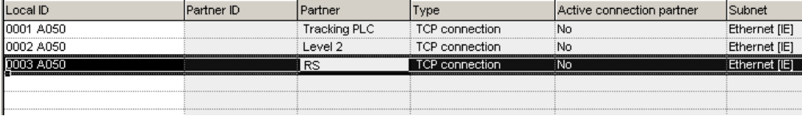
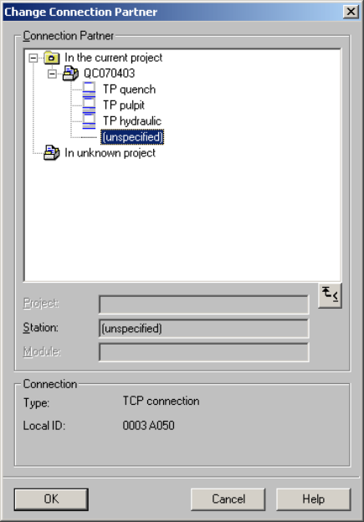
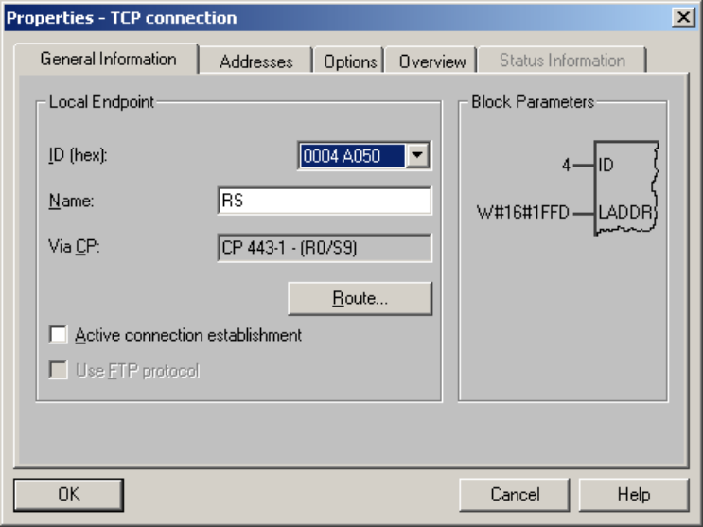
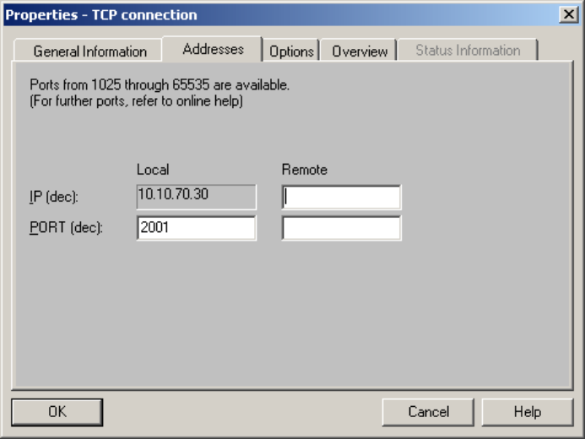
The IP address can be different according customer definition.

