

Pixie-Net
User Manual

Version 2.05
August 30, 2018
Hardware Revisions: A, B

Software Revision: 2.05
Firmware Revision and Variants:
0x0201 (standard)
0x1204 (PSA)
0x2202 (PTP)

XIA LLC
31057 Genstar Rd
Hayward, CA 94544 USA
Email: support@xia.com
Tel: (510) 401-5760; Fax: (510) 401-5761
http://www.xia.com/

Information furnished by XIA LLC is believed to be accurate and reliable. However, no responsibility is assumed by XIA for its use, or for any infringements of patents or other rights of third parties which may result from its use. No license is granted by implication or otherwise under any patent or patent rights of XIA. XIA reserves the right to change hardware or software specifications at any time without notice.

Contents
Safety 5
Specific Precautions 5
Power Source 5
User Adjustments/Disassembly 5
Detector and Preamplifier Damage 5
Voltage Ratings 5
Servicing and Cleaning 5
Linux Passwords 5
Linux Backup 5
Warranty Statement 6
Contact Information: 6
Manual Conventions 7
1 Introduction 8
1.1 Pixie-4 Net Features 8
1.2 Specifications (4 channel 12/250) 9
1.3 System Requirements 10
1.3.1 Drivers and Software 11
1.3.2 Detector Signals 11
1.3.3 Power Requirements 11
1.3.4 Connectors and Cabling 11
1.4 Software and Firmware Overview 11
1.5 Support 12
2 Setup 13
2.1 Power 13
2.2 Serial Port (USB-UART) 13
2.3 SSH login 14
2.4 Web Interface 14
2.5 SMB (Samba) 14
2.6 Required Initial Linux Commands 15
2.7 Useful Linux Commands 15
2.8 Direct Network Connection between Pixie-Net and a Windows PC 16
3 Pixie-Net Operation 17
3.1 Adjust Settings 17
3.2 Data Acquisition 18
3.3 User Interface Options 18
3.3.1 Terminal 18
3.3.2 Terminal and Webpages 19
3.3.3 Terminal, SMB and Windows programs 19
3.3.4 Graphical User Interface on Host PC 20
3.3.5 Webpage-Only Operation 21
3.3.6 On-board ROOT Graphical User Interface 21
3.4 Optimizing Parameters 23
3.4.1 Energy Filter Parameters 23
3.4.2 Threshold and Trigger Filter Parameters 23
3.4.3 Decay Time 23
3.4.4 Baselines and ADC calibration 24
4 API functions 25
4.1 progfippi 25
4.2 gettraces, cgitraces 25
4.3 findsettings 26
4.4 runstats, cgistats 26
4.5 startdaq 27
4.6 acquire 27
4.7 coincdaq 28
4.8 clockprog 29
4.9 pollcsr 29
5 Web Pages 30
5.1 index.html 30
5.2 adcpage.html, cgitraces.cgi 32
5.3 mcapage.html 32
5.4 rspage.html, cgistats.cgi 33
5.5 psahistpage.html 34
5.6 psahistprojpage.html 35
5.7 psasurfacepage.html 36
5.8 lmtablepage.html 37
5.9 cgiwaveforms.cgi 38
5.10 Web Operations (webops/webopsindex.html) 39
6 Parameters in the Settings Files 40
6.1 System Parameters 40
6.2 Module Parameters 41
6.3 Channel Parameters 43
7 Data Formats 47
7.1 List Mode Data Files 47
7.1.1 List mode files with waveforms (Run Type 0x500) 47
7.1.2 List mode files without waveforms (Run Type 0x501) 48
7.1.3 List mode files with PSA (Run Type 0x502) 49
7.1.4 Coincidence list mode files without waveforms (Run Type 0x503) 49
7.1.5 Binary list mode files with waveforms (Run Type 0x400) 49
7.1.6 Binary coincidence list mode files with waveforms (Run Type 0x402) 50
7.2 Run Statistics Files 51
7.3 MCA Files 52
7.4 PSA Files 52
8 Module Registers Visible to Linux 53
8.1 Input Registers 53
8.2 Event Registers 54
8.3 Run Statistics Registers 55
9 Channel Registers Visible to Linux 56
9.1 Input Registers 56
9.2 Event Registers 57
9.3 Run Statistics Registers 58
10 Linux Configuration 60
11 Theory of Operation 63
11.1 Digital Filters for γ-ray Detectors 63
11.2 Trapezoidal Filtering in a Pixie Module 65
11.3 Baselines and Preamplifier Decay Times 66
11.4 Thresholds and Pile-up Inspection 67
11.5 Filter Range 69
11.6 Data Capture Process 69
11.7 Dead Time and Run Statistics 70
11.7.1 Definitions 70
11.7.2 Count time and dead time counters 73
11.7.3 Count Rates 74
11.7.4 Dead time correction in the Pixie-Net 75
12 Hardware and Firmware Variants 77
12.1 Pulse Shape Analysis and Constant Fraction Timing 77
12.1.1 Overview 77
12.1.2 PSA Input Parameters 79
12.1.3 PSA Return Values 79
12.1.4 Reduced General Purpose Functionality 80
12.2 IEEE 1588 Precision Timing Protocol 81
12.2.1 Overview 81
12.2.2 PTP Stack Software: LinuxPTP 82
12.2.3 PTP PHY Control Software: ptp-mii-tool 82
12.2.4 PTP Clock PLL Control Software: clockprog 83
12.2.5 PTP parameter settings 83
12.2.6 Linux Shell Scripts for PTP operation 84
12.2.7 List Mode Data Analysis 85
12.2.8 Reduced General Purpose Functionality 86
13 Hardware Information 87
13.1 Jumpers 87
13.1.1 Revision A Modules 87
13.1.2 Revision B Modules 87
13.2 Connector Pinout 87

Safety
Please take a moment to review these safety precautions. They are provided both for your protection and to prevent damage to the Pixie module and connected equipment. This safety information applies to all operators and service personnel.

Specific Precautions

Power Source
The Pixie-Net module is powered through an AC/DC wall adapter. The default adapter has a variety of AC plug attachments for different localities. Please remember to shut down the Linux OS before removing the power plug

User Adjustments/Disassembly
To avoid personal injury, and/or damage, always disconnect power before accessing the Pixie module’s interior. There are no switches for user configuration inside the box, however, there are debug push button and headers experienced users may want to use.

Detector and Preamplifier Damage
The Pixie module can provide +5V power and a 0..5V control voltage, intended for active PMT bases. The +5V power comes up immediately when the Pixie is connected to power, the control voltage is undefined until the Linux system is booted and basic configuration has been applied.
Please review all instructions and safety precautions provided with these components before powering a connected system.

Voltage Ratings
Signals on the analog inputs (gold SMA connectors) must not exceed ± 3.5V. Exceptions apply for certain attenuation and termination settings, see Appendix.
Signals on the digital inputs (gold MMCX connector and HDMI GPIO connector) must not exceed 3.3V. Please review the pinout in the appendix before making any connections.

Servicing and Cleaning
To avoid personal injury, and/or damage to the Pixie module or connected equipment, do not attempt to repair or clean the inside of these units.

Linux Passwords
The Pixie-Net Linux OS comes with default user IDs and passwords for 1) SSH login, 2) SMB file sharing, and 3) Web Operations as described below. Users should immediately change these passwords, especially when the Pixie-Net is connected to external networks. Don’t let hackers take over your Pixie-Net!

Linux Backup
The Pixie-Net Linux OS is stored on a removable SD card. SD cards’ file systems can become corrupted, which would crash the Linux system and make the Pixie-Net unable to operate. Therefore periodic backup of the SD card is recommended, for example using Win32DiskImager. (Byte for byte copy is required).
Note that all Linux passwords are stored on the SD card

Warranty Statement
XIA LLC warrants that this product will be free from defects in materials and workmanship for a period of one (1) year from the date of shipment. If any such product proves defective during this warranty period, XIA LLC, at its option, will either repair the defective products without charge for parts and labor, or will provide a replacement in exchange for the defective product.
In order to obtain service under this warranty, Customer must notify XIA LLC of the defect before the expiration of the warranty period and make suitable arrangements for the performance of the service.
This warranty shall not apply to any defect, failure or damage caused by improper uses or inadequate care. XIA LLC shall not be obligated to furnish service under this warranty a) to repair damage resulting from attempts by personnel other than XIA LLC representatives to repair or service the product; or b) to repair damage resulting from improper use or connection to incompatible equipment.
THIS WARRANTY IS GIVEN BY XIA LLC WITH RESPECT TO THIS PRODUCT IN LIEU OF ANY OTHER WARRANTIES, EXPRESSED OR IMPLIED. XIA LLC AND ITS VENDORS DISCLAIM ANY IMPLIED WARRANTIES OF MERCHANTABILITYOR FITNESS FOR A PARTICULAR PURPOSE. XIA’S RESPONSIBILITY TO REPAIR OR REPLACE DEFECTIVE PRODUCTS IS THE SOLE AND EXCLUSIVE REMEDY PROVIDED TO THE CUSTOMER FOR BREACH OF THIS WARRANTY. XIA LLC AND ITS VENDORS WILL NOT BE LIABLE FOR ANY INDIRECT, SPECIAL, INCIDENTAL, OR CONSEQUENTIAL DAMAGES IRRESPECTIVE OF WHETHER XIA LLC OR THE VENDOR HAS ADVANCE NOTICE OF THE POSSIBILITY OF SUCH DAMAGES.

Contact Information:

XIA LLC
31057 Genstar Rd.
Hayward, CA 94544 USA

Telephone: (510) 401-5760
Downloads: http://support.xia.com
Hardware Support: support@xia.com
Software Support: support@xia.com

Manual Conventions
Convention | Description | Example
» | The » symbol leads you through nested menu items and dialog box options. | The sequence  File»Page Setup»Options directs you to pull down the File menu, select the Page Setup item, and choose Options from the sub menu.
Bold | Bold text denotes items that you must select or click on in the software, such as menu items, and dialog box options. | ...click on the MCA tab.
[Bold] | Bold text within [ ] denotes a command button. | [Start Run] indicates the command button labeled Start Run.
Monospace | Items in this font denote text or characters that you enter from the keyboard, sections of code, file contents, and syntax examples. | Setup.exe refers to a file called “setup.exe” on the host computer.
“window” | Text in quotation refers to window titles, and quotations from other sources | “Options” indicates the window accessed via Tools»Options.
Italics | Italic text denotes a new term being introduced , or simply emphasis | peaking time refers to the length of the slow filter.  ...it is important first to set the energy filter Gap so that SLOWGAP to at least one unit greater than the preamplifier risetime...
<Key>  <Shift-Alt-Delete> or <Ctrl+D> | Angle brackets denote a key on the keybord (not case sensitive).  A hyphen or plus between two or more key names denotes that the keys should be pressed simultaneously (not case sensitive). | <W> indicates the W key  <Ctrl+W> represents holding the control key while pressing the W key on the keyboard
Bold italic | Warnings and cautionary text. | CAUTION: Improper connections or settings can result in damage to system components.
CAPITALS | CAPITALS denote DSP parameter names | SLOWLEN is the length of the slow energy filter
Small Caps | Small Caps are used for panels/windows/graphs in the GUI. | …go to the mcadisplay panel and you see…
The following conventions are used throughout this manual

Introduction
The Pixie-Net is a Zynq System on Module (SoM) combined with an ADC input board. The Zynq is a combination of an FPGA (Programmable Logic, PL) with an ARM processor (Processing System, PS). The PL captures the ADC data and applies digital pulse processing. The PS runs a basic Linux OS with gcc, webserver, etc; it has USB and Ethernet peripherals and 1GB of memory.

Pixie-4 Net Features
- Designed for
  - high precision γ-ray spectroscopy with HPGe detectors,
  - timing with fast scintillators (NaI, LaBr₃, etc),
  - pulse shape analysis to extract time, position, and/or particle type in segmented or strip detectors, phoswich detectors, or neutron detectors
  - coincidence acquisition
- 12-14 bit, 250 MSPS ADC, 4 channels
- Programmable gain and input offset.
- Programmable pulse height and pileup inspection parameters include trigger filter length, energy filter length, decay time, threshold, and rejection criteria.
- Triggered synchronous waveform acquisition across channels and modules.
- Simultaneous amplitude measurement, waveform capture, and pulse shape analysis.
- On-board MCA memory
- Configurable digital inputs and outputs
- Embedded Linux environment, acting as a standalone PC with built-in SD card drive, USB host, 10/100/1000 Ethernet, webserver, GPIO
- Open source DAQ software

Specifications (4 channel 12/250)

Front Panel I/O
Signal Input (4x) | 4 analog SMA inputs.  Programmable input impedance: 50Ω and 5kΩ.  Input range:  After termination and attenuation, up to ±1.25V DC can be added to compensate signal DC offsets.  After DC offset compensation, signals in the range from  0V to (2V/analog gain)  are accepted by the ADC. (See below for analog gain values)
Pulser Output | 1 MMCX coaxial connector “PULSE”  Periodic, exponentially decaying reference pulser.  Programmable on/off
Control Voltage Output | 1 MMCX coaxial connector “CTRL”  0..5V programmable via DAC
Rear Panel I/O
Logic Input/Output | General Purpose I/O connected to programmable logic:  1 MMCX coaxial connector “VETO”  input only  default use: Veto signal to suppress event triggering  2.5V logic, 5V compatible  1 micro HDMI connector with 13 GPIO signals (not video)  single ended or differential  can be used as clock input  factory set to 5V (default) or 2.5V logic.  PTP variant: PTP and syncE compatible Ethernet (with adapter)
Power | 12V DC in.  AC adapter requirements: 12V, 18W,  Barrel Plug 2.1mm I.D. x 5.5mm O.D., center positive  5V DC out  MMCX coaxial connector “5V”  Usage: typical ~10W, peak ~14W
PMOD | 12-pin 0.1” connector for 8 I/O signals, 3.3V power, GND  Compatible with PMOD I/O modules (I2C, GPIO, serial, wifi, GPS, …)
Clocks | 1 MMCX coaxial connector “CLK”,  programmable PTP clock out (PTP variant only, 3.3V )  or external clock in (any variant, internal jumpers, 2.5V)  1 MMCX coaxial connector “PPS”  programmable PTP trigger (PTP variant only), 3.3V, output only
Processor | 1 USB 2.0  1 USB-UART  1 RJ45 Ethernet  1 SD card slot  3 LEDs
Embedded Processing
Processor | Xilinx Zynq
Data Interfaces | 10/100/1000 Ethernet  USB 2.0 (host)  USB-UART
Memory | 1 GB of DDR3 SDRAM  128 Mb of QSPI Flash  16 GB micro SD card (removable)
Operating System | Linux (Xillinux – based on Ubuntu LTS 12.04, or Ubuntu 15)  Operates from Linux partition on SD card
Digital Controls
Gain | Coarse gain:  250 MSPS variant: 2 gain settings: 2 and 5  Other variants: please contact XIA  Digital gain:  Arbitrary gain factor for channel matching
Offset | DC offset adjustment from –1.25V to +1.25V, in 65535 steps.
Shaping | Trapezoidal filter with peaking times 0.048 to 63.4 µs  Adjustable flat top to eliminate ballistic deficit effects
Trigger | Digital trapezoidal trigger filter with adjustable threshold. Rise time and flat top set independently.
Coincidence | Programmable coincidence window: 40 to 1016 ns  Reject unwanted hit patterns of the 4 channels
Data collection | MCA number of bins 1Ki to 32Ki  Waveform lengths and pre-trigger delay  List mode data format (text, binary, content)
Data Outputs
Spectrum | 1024-32768 bins per channel, 32 bit deep (4.2 billion counts/bin).  Additional memory for sum spectrum for clover detectors.
Statistics | Real time, counting time, filter dead time, input and throughput counts.
List mode event data | Pulse height (energy), time stamps, pulse shape analysis results,  waveform data (up to 4Ki samples) and ancillary data like hit patterns.
Table 1-1. Specifications for the Pixie-Net

System Requirements
The digital spectroscopy system considered here consists of a Pixie-Net and a gamma ray detector with appropriate power supplies. A PC, smartphone or tablet is required to communicate with the Pixie-Net, but data acquisition is fully contained in the Pixie-Net itself.

Drivers and Software
The Pixie-Net operates with an embedded Linux system that includes all software and drivers to communicate with external devices via Ethernet or USB. It can
- Make DAQ results available via webserver
- Read and write USB drives for data exchanges
- Share files over a Windows network
For higher convenience of communication and data analysis, we provide the Pixie Viewer, based on Wavemetrics’ Igor Pro. (Igor version 6.22 or higher is required). Alternative interfaces are under development (LabView, ROOT (under Linux), MATLAB, etc).

Detector Signals
The Pixie-4 Express is designed for fast rising, exponentially decaying signals. Step pulses and short non-exponential pulses can be accommodated with specific parameter settings. Staircase type signals from reset preamplifiers generally need to be AC coupled.
Detector signals must not exceed ± 3.5V.

Power Requirements
The Pixie-4 Express consumes roughly 14 W, requiring the following currents from the AC adapter:
12V up to 1.5 A

Connectors and Cabling
The Pixie-Net uses SMA connectors for the analog inputs from the detectors. SMA to BNC adapter cables are provided with the module.
MMCX connectors are used for power, analog outputs, and digital input/outputs. MMCX to BNC adapter cables are provided with the module.
A micro HDMI connector is used for 13 additional digital inputs and outputs, but not video. HDMI cables are widely available and not provided with the module. For the PTP variant, the micro HDMI connector carries the Ethernet connection, which requires cabling adapters.

Software and Firmware Overview
The DAQ software of the Pixie-Net consists of a small set of C programs (API functions) applying settings to the PL, reading data from the PL, and storing it on the SD card (or network drives). The API functions are called from the Linux command line or as CGI scripts from a web page. DAQ results can be viewed or downloaded via the web page, or copied over the network. Acquisition parameters are stored in an .ini file that can be edited by the user to adjust parameter settings.
Firmware code for the PL on-board pulse processing functions is loaded to the PL as part of the powerup boot sequence.
Users may modify the API functions (source code and gcc compiler is included in the Linux environment on the SD card). Applications can be executed from the SD card or a mounted USB drive.
More sophisticated graphical user interfaces can be developed, providing control buttons and data analysis functions. One such interface is based on Igor Pro, contact XIA for details and demo code for other implementations.

Support
A unique benefit of dealing with a small company like XIA is that the technical support for our sophisticated instruments is often provided by the same people who designed them. Our customers are thus able to get in-depth technical advice on how to fully utilize our products within the context of their particular applications.
Please read through the following sections before contacting us. Contact information is listed in the first few pages of this manual.

Setup
When powered up, the Pixie-Net automatically boots the FPGA configuration and starts the Linux OS. There are several ways for a user to connect to the Pixie-Net Linux OS:
- Serial port via USB-UART
- Network SSH terminal
- Web server
- SMB (Samba) file sharing
The typical procedure for setup would be to first to power up the Pixie-Net (2.1), then install and configure drivers for the serial port on a USB master PC (2.2). Log on via serial port terminal, find the Pixie-Net’s IP address, and execute a few setup programs (2.5). After that, the Pixie-Net can be operated through terminal, web interface and/or SMB.

Power
To power up the Pixie-Net, simply connect the 12V DC power plug from the AC adapter. The center pin must be positive and the adapter must be rated for 18W or more. Several outputs and internal settings are undefined after powerup, so it is recommended to log in quickly via serial port or SSH and apply the settings.
To power down the Pixie-Net, first shut down the Linux OS (type halt), then remove the 12V DC power plug (and UART cable).

Serial Port (USB-UART)
The serial port connection requires a driver to map the UART to a serial port and a terminal running on the USB master PC. Windows installation consists of the following steps:
- Download and extract/install the Silicon Labs CP210x USB-to-UART driver from
www.silabs.com/products/development-tools/software/usb-to-uart-bridge-vcp-drivers. For more information, see microzed.org/sites/default/files/documentations/CP210x_Setup_Guide_1_2.pdf
- Download and install Tera Term (or other suitable terminal program). See http://ttssh2.osdn.jp/
- Connect USB cable between Pixie-Net and PC and power up the Pixie-Net (see 2.1)
(PC: any USB port, Pixie-Net: port labeled UART)
- From the Silicon Labs installation, run CP210xVCPInstaller_x64.exe to create a COM port
- Find the new COM port’s number in the Windows device manager
- The COM port assignment is device specific, so this has to be repeated
every time switching to a different Pixie-Net unit. For the same Pixie-Net,
this is a one-time operation.
- Open Tera Term.
- Connect via the serial port showing the COM number above
- Select Setup > Serial port. Defaults are ok, except baud rate must be 115200
- Adjust the font and size if desired
- Currently, no login credentials are required for Linux login via serial port
On a Linux system, it is possible to use the Minicom utility as for serial port I/O. Usually no installation or drivers are required. It can be configured via
sudo minicom –s
and by specifying ttyUSB0 as the port, with no HW flow control. See also https://help.ubuntu.com/community/Minicom .

SSH login
Tera Term or another suitable program can be used to log in via the network once the Pixie-Net is powered, connected to a network, and its IP address is known. The IP address can be found by
- connecting via serial port terminal as described above, and typing ifconfig
- log on to router, see list of connected devices
- just try the one it had before, IP addresses seem fairly persistent through power cycles
To connect, open a terminal and make connection to the Pixie-Net’s IP address. Default ID/PW is root/xia17pxn (please change).
Two possible free SSH terminal program for Android are “SSH Client” and “JuiceSSH”, allowing login from a tablet or smartphone.

Web Interface
Any web browser can be used to log in via the network once the Pixie-Net is powered, connected to a network, and its IP address is known. The IP address can be found by
- connecting via serial port terminal as described above, and typing ifconfig
- log on to router, see list of connected devices
- just try the one it had before, they seem fairly persistent through power cycles
To connect, enter Pixie-Net’s IP address as the web address in your browser. Any browser should work; XIA uses Firefox and does not test for compatibility with other browsers. No password is required for the Pixie-Net home page, however, login is required for web operations duplicating terminal access. The default ID/PW is webops/xia17pxn (please change).
For proper operation of most links in the home page, prior execution of a function in the Linux terminal is required. See below for details.

SMB (Samba)
The Pixie-Net Linux OS is running Samba, a “Windows interoperability suite of programs for Linux and Unix”. It allows the files in the Linux partition of the Pixie-Net SD card to be shared with Windows networking. By default, only one folder is shared (/var/www) which is the location of the API functions.
To connect, type \\192.168.1.xxx\PNvarwww in the Windows Explorer location bar, where 192.168.1.xxx is the IP Address of the Pixie-Net found as above and PNvarwww is the name given to /var/www for file sharing purposes in Samba. Windows will prompt for login; the default ID/PW is root/xia17pxn (please change).
The settings file settings.ini, output data files, and all (source and executable) files of the API functions can now easily be copied or edited with Windows tools and programs. However, to execute the API functions, serial port or SSH login is required (or in some cases, API functions are executed from the web interface)

Required Initial Linux Commands
Once logged on via the Linux terminal or the web operations page, the following steps must be performed:
- Change directory: cd /var/www
This is the directory visible via the web server. Data created by execution of XIA API functions can be read via the web browser from this directory. For convenience, it contains a “release” of all XIA SW functions and is used as the default working directory. (Not required for web operations page)
- Adjust permissions: chmod 777 /dev/uio0
This allows cgi functions called via the web interface to access the FPGA register space. Only required in OS version older than release 1.2
- Apply settings to FPGA: ./progfippi
- Automatically set a few basic parameters (and resolve random channel swapping): ./findsettings
This should be performed with the detector connected, with the correct polarity and termination setting.

Useful Linux Commands
The following commands may be helpful
- Type ifconfig to find the IP address
The network does not come up by itself occasionally. This appears to coincide with the webpage being open in a browser during (re)boot. For a change of restart, type sudo /etc/init.d/networking restart else power cycle
- Type more /sys/devices/amba.0/f8007100.ps7-xadc/temp
to get the temperature of the Zynq chip. In SW 1.2 and higher using Ubuntu 15, the temperature is reported only as a raw number in /sys/devices/soc0/amba/f8007100.adc/iio:device0/in_temp0_raw; the actual temperature can be computed by subtracting 2219 and multiplying with 0.12304. ADC and Zynq temperatures are also reported in the run statistics and by ./progfippi
- To change a parameter value in the settings file without opening/editing/closing the file, a sed command as follows can be used:
sed –i ‘/RUN_TYPE/c RUN_TYPE 1281’ settings.ini
This replaces (-i = in the file) the line containing the string “RUN_TYPE” with the text “RUN_TYPE 1281”.
- To mount a USB drive (e.g. to copy data or SW updates), type
mount /dev/sda1 /mnt/usb
/var is not a suitable directory to mount the USB stick, as it confuses the web server
- Type date to verify Linux time automagically updated to UTC
- Use the mount command to mount external network drives. For example, to mount NASdrive/data from a PC with IP address 192.168.1.123, type
mount //192.168.1.123/data /mnt/data –o “username=[user],password=[passwd]”
with the appropriate values filled in for [user] and [passwd]
- To mount the SD card boot partition to a folder /mnt/sd, execute
mount /dev/mmcblk0p1 /mnt/sd
this is useful to update the boot files without removing the SD card. The Pixie-Net has to be rebooted before the new boot files become effective.
- To clear the command line history, type
history –c
history –w

Direct Network Connection between Pixie-Net and a Windows PC
The above description of setup and operation of the Pixie-Net assumes both Pixie-Net and the user device (PC, tablet, smartphone) are connected to a local network with DHCP server and gateway. Instead, it is possible to directly connect the Pixie-Net to a laptop or desktop with a standard Ethernet cable (no crossover cable required). However, a number of configurations have to be set manually:
- On the Pixie-Net terminal, type ifconfig eth1 up 192.168.1.86 to bring up the Ethernet connection and assign the IP number. In some cases, eth0 or eth2 has to be used instead of eth1.
- On the Windows PC (here Windows 7), go to Start > Control Panel > Network and Sharing Center > Change Adapter Settings > Local Area Connection
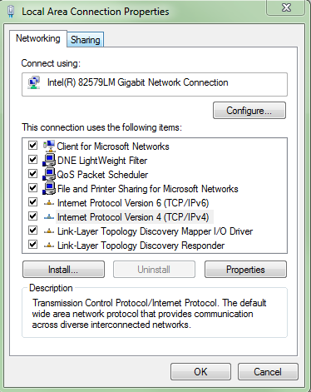 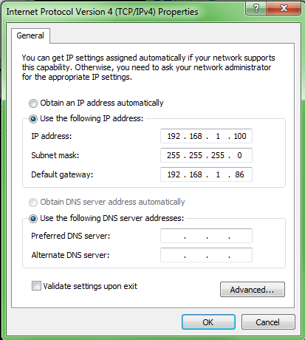
In the Local Area Connection “Properties” dialog, select “Internet Protocol Version 4 (TCP/IPv4)” and click “Properties”.
In the properties dialog, set IP address, subnet mask, and gateway as shown above. (The gateway is equal to Pixie-Net’s IP address.)
Note: The network will not be able to connect to the internet. The date/time of the Pixie-Net will likely be initialized to 1970.

Pixie-Net Operation
Basic operation of the Pixie-Net uses a combination of terminal commands and web interface. The former controls all data taking and requires login to the system. The latter displays data and is accessible to anyone. This provides a measure of security in instrument control while making it convenient to view data.

Adjust Settings
The FPGA settings and processing parameters must be adjusted (once) to match the detector characteristics. This includes analog settings such as gain and offset, and pulse processing parameters such as decay time and trigger threshold.
All settings are stored in an .ini file. The default settings file is configured for the Pixie-Net internal pulser. This file, defaults.ini, contains all the parameter settings as described in section 6. Settings are grouped into system (e.g. requested run time), module (e.g. coincidence patterns), and channel (e.g. offset). A condensed settings file, settings.ini, contains the most important parameters and will override the defaults. The default method to change settings is to edit settings.ini and then execute ./progfippi to apply them to the FPGA. If necessary, lines with additional parameters can be copied from defaults.ini into settings.ini; also lines can be deleted from settings.ini if there is no need to vary specific parameters. The file defaults.ini should be considered a read-only file. Editing can be accomplished with a built-in Linux editor through the terminal (for example VI) or by opening the file in a Windows editor through the SMB file sharing.
The most important parameters for initial setup are
REQ_RUNTIME Requested runtime of the data acquisition
MCSRB_TERM01_01 If 1, channel 0 and 1 inputs are terminated with 50 Ohm, else high-Z
MCSRB_TERM23_02 If 1, channel 2 and 3 inputs are terminated with 50 Ohm, else high-Z
RUN_TYPE 0x301 for MCA only, 0x400-0x503 for various list mode runs
CCSRA_INVERT_05 If 1, invert incoming signal
ANALOG_GAIN Currently limited to 2 or 5
DIG_GAIN Arbitrary gain factor for energies in MCA spectra and list mode events
VOFFSET DC offset
TAU Exponential decay time of the input signal
(See also section 3.4 for optimizing trigger and energy filter settings)
When set up correctly, the signal baseline should be at approximately 400 ADC steps. The polarity and gain should be set such that pulses start with a fast rise and decay back down to baseline, and do not go out of the ADC range (max 4096 steps for a 12 bit ADC). The decay time must be measured and specified as the parameter TAU. This is best verified by opening/refreshing the Pixie-Net ADC page in the web browser, or executing ./gettraces and viewing the resulting ADC.csv file. You can also open/refresh the Run Statistics page in the web browser of execute ./runstats and read the output parameters in the resulting RS.csv file. The current input count rate, out of range fraction, temperatures, and FPGA system time will update even when no run is in progress. The function ./findsettings can assist in finding parameters such as DC offset. It also resolves random channel swapping between channels 0/1 and 2/3.

Data Acquisition

- In the terminal, type ./startdaq or ./acquire to start run with current settings.
The screen will be updated with print statements of the runtime
- In the browser, navigate to the MCA page (“view spectra”) or the Run Statistics page (“view run statistics”) under DAQ Monitoring.
Refresh these pages with browser button to see updates during DAQ
- < wait > Currently the only way to stop is ctrl-c
- When the DAQ finishes in the terminal, the final MCA, the run statistics, and the list mode data files have been created. The filenames are fixed to MCA.csv, RS.csv and LMdata.dat/.txt for ./startdaq while ./acquire allows arbitrary list mode file names.
- In the browser, the data files can be viewed or downloaded (under “DAQ Results”)
- In the terminal, the data files can be copied to local USB drive or network drive
- In a Windows Explorer window pointing to \\<Pixie_Net IP>\PNvarwww, the data files can be copied or opened by Windows tools and programs.

User Interface Options
There are a variety of interface options to operate the Pixie-Net. They range from basic terminal and file I/O to plug-ins for data acquisition or data analysis software. Fundamentally, the Pixie-Net communicates through generic interfaces such as serial port and Ethernet, so that any program emulating a serial port and reading files from a network drive can be used to operate the system. A few examples are listed in the following sections

Terminal

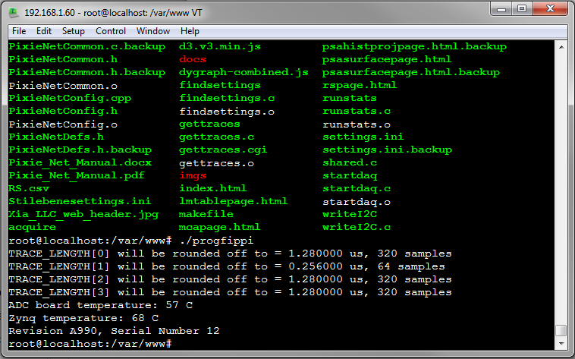
At the most basic level, users can log in to the Pixie-Net with a terminal program and execute the C programs to set up and perform data acquisition (e.g. ./progfippi and ./startdaq). Settings are modified by editing the settings file settings.ini with a basic text editor like VI. Results are files on the Pixie-Net’s SD card, which can be viewed with a text editor or copied to mounted network drives.
This environment may appeal most to users familiar with Linux, and also allows modification and recompilation of the C programs with the built-in gcc compiler.

Terminal and Webpages

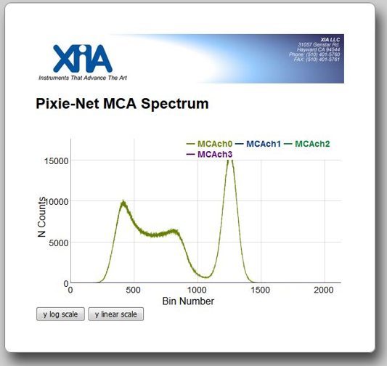
For direct graphical feedback, users can log in via terminal as in the preceding section, but view results as a webpage. The Pixie-Net is running a web server, and the output files are plotted on webpages with a variety of java scripts.
While still requiring familiarity with Linux, the graphical feedback makes for an easier setup and a better presentation of the results.

Terminal, SMB and Windows programs
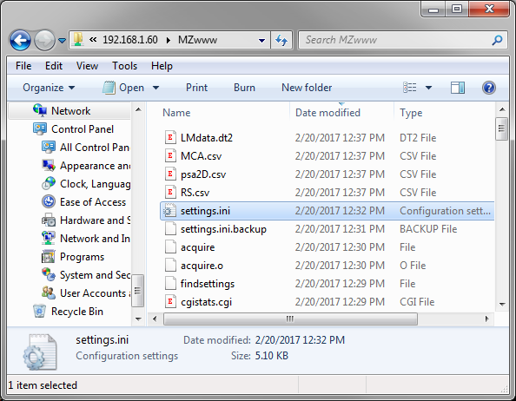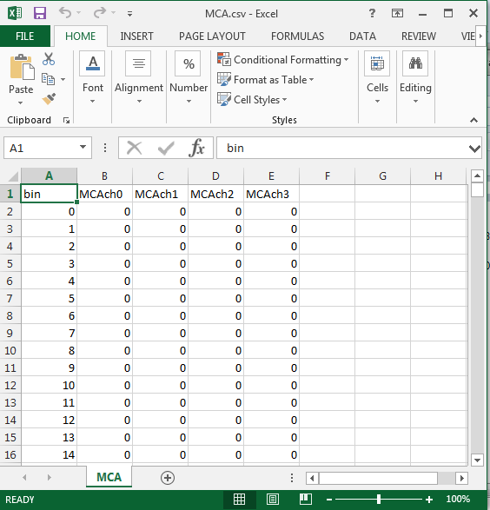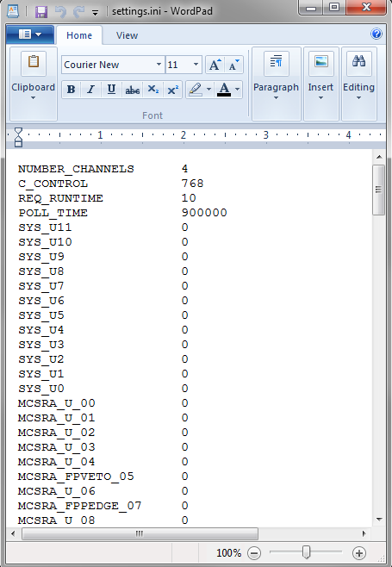
With SMB file sharing, Windows programs can be used to directly view, edit, and analyze settings and results. For example, the workflow could be
- Using WordPad, open, modify, and save settings.ini
- Execute ./progfippi and ./startdaq in the terminal
- Open MCA.csv in Excel or other program to view, analyze, and plot results

Graphical User Interface on Host PC

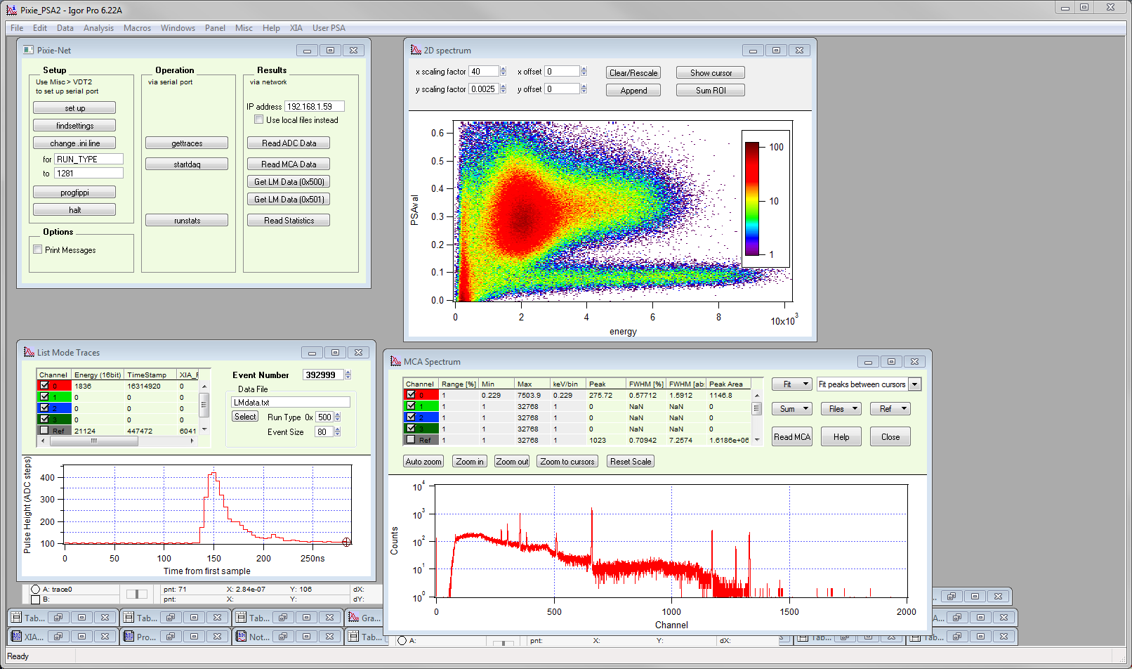
Many data acquisition and analysis program can communicate with serial ports, external files and web servers. Examples include Igor Pro, MATLAB, LabVIEW, and so on. It is therefore possible to develop graphical user interfaces with buttons and plots in such a program. In the picture above, Igor Pro’s “very dumb terminal” function is used to send the commands normally typed into the terminal with the click of a button. After sending the command, Igor reads the Pixie-Net webpage and extracts and displays the data. For example, a “refresh” button in the Igor Pro “oscilloscope” display issues the command ./gettraces and reads/displays ADC.csv. A “start run” button issues ./startdaq, and so on. The data can then be further processed with user specific functions, for example the offline pulse shape analysis 2D histogram visible in the upper right of the plot.
A demo MATLAB implementation is shown in the screenshot below. It uses serial port communication similar to the Igor Pro example described above, then reads and displays the data from files. (While in principle the Pixie-Net's Zynq firmware can be developed with MATLAB tools as well, this is currently not supported by XIA.)
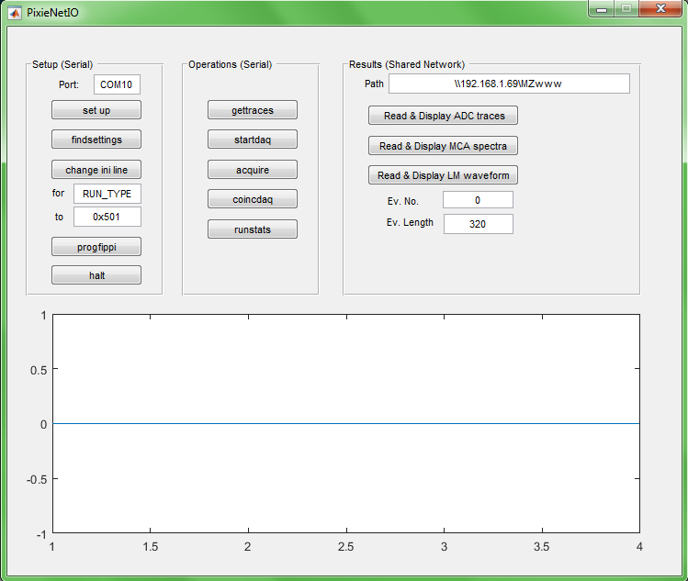
Our current policy is to provide demo code for free, but to charge for software and support for more sophisticated user interfaces, in particular if customized for specific applications. Please contact XIA for more information.

Webpage-Only Operation
As an alternative to the terminal entry and execution of the C programs to set up and perform data acquisition (e.g. ./progfippi and ./startdaq), there is a [moderately] secure web page that allows execution of the C programs as a cgi script through a browser. The Web Operation page can be reached via a link in the “CGI Current Data” section of the Pixie-Net Home page. It essentially lists the C functions that would normally be called by typing in the terminal; clicking on the function name executes the function. Data is created in a separate subdirectory with Linux permissions for data write access for the webserver (/var/www/webops). The Web Operation page shows the equivalent links from the Pixie-Net home page to download and display the data.
Settings files can currently not be modified through the Web Operation page.
As this webpage allows generation and execution of files from any remote user, the webserver has been set up to require authentication to access this webpage. Details of the setup are described in section 10. The default user ID/password is webops/xia17pxn, currently specified as plain text in the file /var/www/webopspasswords. Obviously, this is only moderately secure and should be a) changed by the user as soon as possible and b) upgraded to encrypted password storage for sensitive environments.

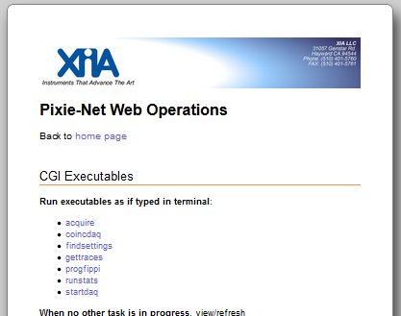

On-board ROOT Graphical User Interface
A further alternative to the terminal entry and execution of the C programs is available on Pixie-Net systems with the Ubuntu 15 operating system, which comes with the ROOT software package installed. A demo ROOT GUI is available that can configure the Pixie-Net (./progfippi etc), view ADC traces, start data acquisitions (./startdaq), and display the resulting spectra.

To use this option, two steps are required:
- Graphical log on
The Pixie-Net processor is capable of generating a graphical desktop, but since there is no video output, direct connection of a monitor is not possible. Instead, users can log on remotely with either
  - Windows Remote Desktop: Start Remote Desktop on a remote Windows PC and enter the Pixie-Net’s IP address, then log on (default user/password root/xia17pxn)
  - Linux SSH X11 forwarding: ssh -Y and -X let you run an X11 program on a remote machine, with its windows appearing on the local X monitor. For example, in a terminal window of the remote Linux PC, type
ssh -Y root@192.168.1.74 (with appropriate IP address)
- Start ROOT and Pixie-Net application
  - Open a terminal on the graphical desktop
  - Type cd /var/www to change to the main DAQ directory
  - Type root to start ROOT
  - Type .x pixieNet.C to start the Pixie-Net ROOT application

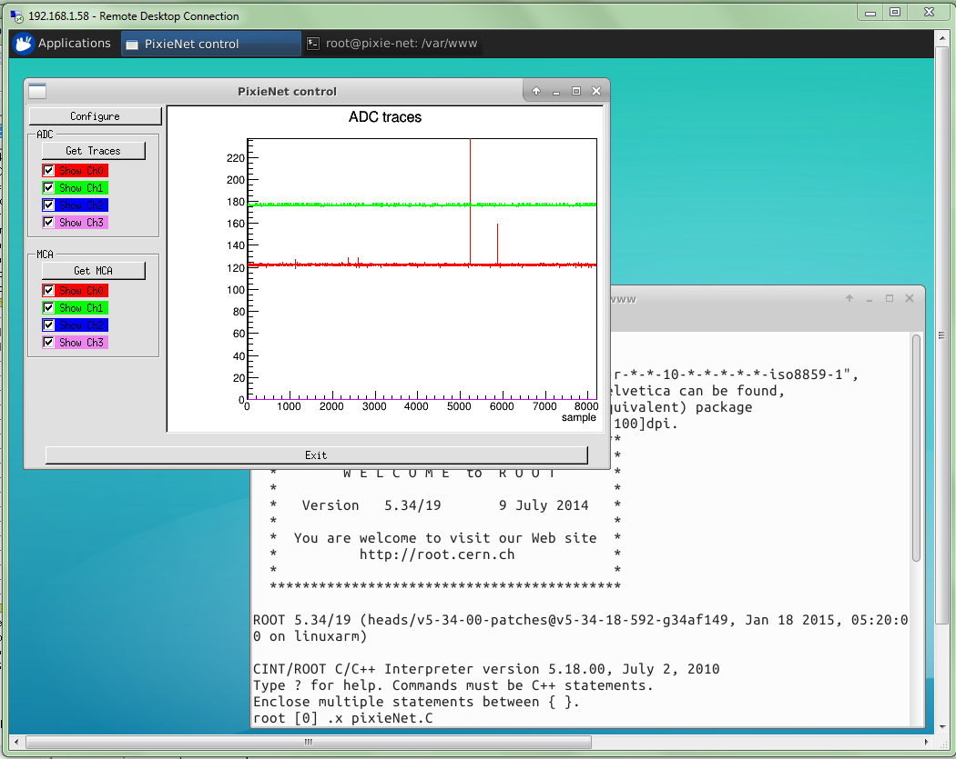

Optimizing Parameters
Optimization of the Pixie-Net’s run parameters for best resolution depends on the individual systems and usually requires some degree of experimentation. Rough guidelines for setting parameters are described below.

Energy Filter Parameters
The main parameter to optimize energy resolution is the energy filter rise time (ENERGY_RISETIME). Generally, longer rise times result in better resolution, but reduce the throughput. Optimization should begin with scanning the rise time through the available range. Try 2µs, 4µs, 8µs, 11.2µs, take a run of 60s or so for each and note changes in energy resolution. Then fine tune the rise time.
The flat top (ENERGY_FLATTOP) usually needs only small adjustments. For a typical coaxial Ge-detector we suggest to use a flat top of 1.2µs. For a small detector (20% efficiency) a flat top of 0.8µs is a good choice. For larger detectors flat tops of 1.2µs and 1.6µs will be more appropriate. In general the flat top needs to be wide enough to accommodate the longest typical signal rise time from the detector. It then needs to be wider by one filter clock cycle than that minimum, but at least 3 filter clock cycles. Note that a filter clock cycle ranges from 0.026 to 0.853µs, depending on the filter range (FILTER_RANGE), so that it is not possible to have a very short flat top together with a very long filter rise time.

Threshold and Trigger Filter Parameters
In general, the trigger threshold (TRIGGER_THRESHOLD) should be set as low as possible for best resolution. If too low, the input count rate will go up dramatically and “noise peaks” will appear at the low energy end of the spectrum. If the threshold is too high, especially at high count rates, low energy events below the threshold can pass the pile-up inspector and pile up with larger events. This increases the measured energy and thus leads to exponential tails on the (ideally Gaussian) peaks in the spectrum. Ideally, the threshold should be set such that the noise peaks just disappear.
The settings of the trigger filter have only minor effect on the resolution. However, changing the trigger conditions might have some effect on certain undesirable peak shapes. A longer trigger filter rise time (TRIGGER_RISETIME) allows the threshold to be lowered more, since the noise is averaged over longer periods. This can help to remove tails on the peaks. A long trigger filter flat top (TRIGGER_FLATTOP) will help to trigger better on slow rising pulses and thus result in a sharper cut off at the threshold in the spectrum.

Decay Time
The preamplifier decay time τ (TAU) is used to correct the energy of a pulse sitting on the falling slope of a previous pulse. The calculations assume a simple exponential decay with one decay constant. A precise value of τ is especially important at high count rates where pulses overlap more frequently. If τ is off the optimum, peaks in the spectrum will broaden, and if τ is very wrong, the spectrum will be significantly blurred.
A first rough estimate of τ can be obtained from the ADC traces. Fine tuning of τ can be achieved by exploring small variations around the estimated value (± 1-2 µs). This is best done at high count rates, as the effect on the resolution is more pronounced. The value of τ found through this way is also valid for low count rates. Manually enter τ, take a short run, and note the value of τ that gives the best resolution.

Baselines and ADC calibration
Between detector pulses, the Pixie module continuously measures baselines, which is ultimately used to correct for the DC offset. Multiple baseline measurements can be averaged to reduce noise (BLAVG), and a threshold (BLCUT) can be set to exclude the occasional bad measurement from the average.

API functions

progfippi
Functions performed
- Parse .ini file, extract FPGA parameters
- Convert into “FPGA units”, e.g. number of samples instead of us
- Apply limits and dependencies, if not ok, give feedback and abort
- Read data from PROM and verify the current version of the Pixie-Net hardware is supported by the software
- Write to FPGA registers to apply settings
- Toggle I2C lines (0x002) to set gain etc. [May be moved to FPAG at some point]
- Issue DSP_CLR and RTC_CLR to PL resets
Arguments: fixed to “settings.ini”
Output: Errors for bad settings, prints hardware info from PROM and temperatures
Restrictions: Do not execute during a data acquisition

gettraces, cgitraces
Read untriggered ADC data: 2K samples, 4 channels. Gettraces writes to a local file ADC.csv, cgitraces prints a webpage with the ADC data to std out, which can be piped into the webserver.
Functions performed
- (TODO Possibly read/apply xdt setting from .ini file for sampling period)
- Read ADC register in PL, write to file or print
Arguments: (possibly ini file name)
Output: ADC.csv
Restrictions: Do not execute during a data acquisition
Notes: For the cgi program to access the PL, its device space must be set to r+w permission to all(?) users: chmod 777 /dev/uio0. The cgi program requires presence of the web page template adcpage.html in the same folder.

findsettings
Perform a series of tasks assisting in the optimization of gain, offset, tau, etc
Functions performed
- Resolve random channel swapping between channels 0/1 and 2/3.
- Ramp DACs and determine DAC setting for a baseline at 10% of the full ADC range
(Note: Pulse polarity has to be set correctly for this function to work properly)
- TODO Acquire baselines and determine Tau
- TODO more?
Arguments: (possibly ini file name)
Output: prints found values for offset, tau, etc
Restrictions: Do not execute during a data acquisition

runstats, cgistats
These functions are used to read and output the run statistics registers. runstats writes them to a local file RS.csv. cgistats prints them as a webpage to std out, which can be piped into the webserver; this is displayed as the “Run statistics” webpage. These functions can be used for development, setup, and diagnostics, for example the run statistics include module revision and serial number, temperature, ICR and OOR.
Run statistics registers are also read and written to the file RS.csv by the data acquisition routines (acquire, startdaq, etc). During a data acquisition, do not execute runstats and cgistats (i.e. do not load webpage “Run statistics” = cgistats.cgi) to avoid conflicting access to the run statistics registers and possible delays and dead times. Instead monitor the file RS.csv (i.e. load webpage “Run status”= rspage.html)
Functions performed
- Read Runstats registers in PL
- Read I2C info from PROM
- write to file
Arguments: none
Output: RS.csv
Restrictions: Do not execute during a data acquisition
Notes: For the cgi program to access the PL, its device space must be set to r+w permission to all(?) users: chmod 777 /dev/uio0. The cgi program requires presence of the web page template rspage.html in the same folder.

startdaq
Start list mode run with or without waveforms (0x400, 0x500, 0x501, 0x502) or MCA run (0x301). Pulse shape analysis data is acquired in run types 0x400 and 0x502 for modules licensed for that function.
This functions is relatively simple and limited in throughput. It serves as an introductory example to users that may want to customize data acquisition. The function acquire is more sophisticated and has higher throughput.
Functions performed
- Parse .ini file, extract parameters
- Compute coefficients for E reconstruction etc
- Set bits in reg 0x000 to start run
  - RunEnable -> 1 (an overall enable of the run)
  - nLive -> 0 (can be used to temporarily pause acquisition (rarely used))
- Monitor DAQ
  - Poll EVSTATS, if data ready:
read event data from PL,
compute E,
read waveforms from PL,
write to LM file (if LM run),
increment MCA
  - Periodically save MCA to file (4Ki bins)
  - Periodically read runstats from PL and write to file
  - Periodically save PSA 2D histogram data to file
  - Periodically read BL data from PL, compute BLavg
- Stop when time is up
- Save final run statistics, PSA, and MCA to file (32Ki bins)
Arguments: none (file names are fixed)
Output: MCA.csv, RS.csv, PSA.csv, LM file (text only)

acquire
Start list mode run with or without waveforms (0x400), coincidence list mode run (0x402), or MCA run (0x301). A more sophisticated and faster version of startdaq. Saves binary list mode data compatible with Pixie-4e.
Functions performed
- Parse .ini file, extract parameters
- Compute coefficients for E reconstruction etc
- Set bits in reg 0x000 to start run
  - RunEnable -> 1 (an overall enable of the run)
  - nLive -> 0 (can be used to temporarily pause acquisition (rarely used))
- Monitor DAQ
  - Poll EVSTATS, if data ready:
read event data from PL,
compute E,
read waveforms from PL,
write to LM file (if LM run),
increment MCA
  - Periodically save MCA to file (4 Ki bins)
  - Periodically read runstats from PL and write to file
  - Periodically read BL data from PL, compute BLavg
- Stop when time is up
- Save final run statistics and MCA to file (32 Ki bins)
Arguments: optional filename for LM file, optional filename for .ini file with parameters, other file names fixed
Output: MCA.csv, RS.csv, LM file (binary)

coincdaq
Start list mode run in coincidence mode without waveforms (0x503). Coincidence mode runs build 4-channel event records that reduce or eliminate the need to parse through list mode data and find records close in time. This functions is relatively simple and limited in throughput. It serves as an introductory example to users that may want to customize data acquisition. The function acquire is more sophisticated and has higher throughput.
Functions performed
- Parse .ini file, extract parameters
- Compute coefficients for E reconstruction etc
- Set bits in reg 0x000 to start run
  - RunEnable -> 1 (an overall enable of the run)
  - nLive -> 0 (can be used to temporarily pause acquisition (rarely used))
- Monitor DAQ
  - Poll EVSTATS, if data ready from ALL channels:
read event data from PL,
compute E,
read waveforms from PL,
write to LM file,
increment MCA
  - Periodically save MCA to file (4Ki bins)
  - Periodically read runstats from PL and write to file
  - Periodically read BL data from PL, compute BLavg
- Stop when time is up
- Save final run statistics, and MCA to file (32Ki bins)
Arguments: none (file names are fixed)
Output: MCA.csv, RS.csv, LM file (text only)

clockprog
Programs the clock PLL that buffers PTP or external clocks for FPGA and ADCs. A number of modes are hardcoded in the program; others can be added with the CDCE813-Q1 data sheet and TI’s ClockPro utility as a reference. This allows for example using an external clock of arbitrary frequency. See also description of PTP variant.
Functions performed
- Program PLL for PTP and external clock
Arguments: mode (read and display, write to EEPROM, program PLL registers)
Output: display current register settings
Restrictions: Do not execute during a data acquisition

pollcsr
reports the 16bit Control and Status Register value, which can be used to check if a run is in progress.
Functions performed
- Read CSR register, print and return value
Arguments: none
Output: print and return CSR value
Restrictions:

Web Pages
The Pixie-Net web pages are located in /var/www; this is the default directory for the installed lighttpd webserver. Browsing to the Pixie-Net’s IP address will bring up index.html, from which all other pages can be accessed.

index.html
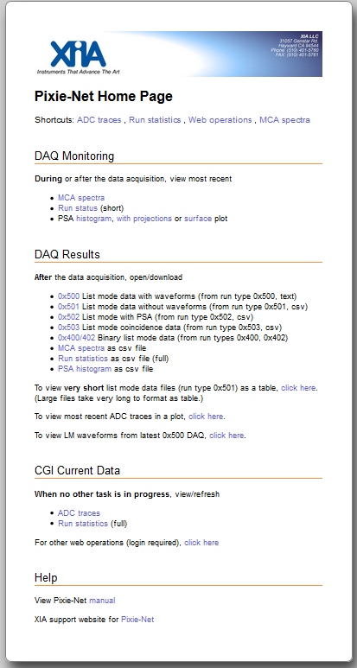
This is the home page for the Pixie-Net.

At the top of the page, there are a few shortcuts to common tasks or pages. Do not use the Run Statistics link during a data acquisition, instead use the Run Status link in the next section.
Under DAQ Monitoring, there are links to view (as plots or tables in the browser) the csv files from the most recent data acquisition for MCA spectra and run status.
Under DAQ Results, the final data files from the most recent tasks can be downloaded or viewed in the browser. This requires that a task in the Linux terminal, such startdaq, runstats, acquire or gettraces has been executed and completed. The screenshot below shows opening/downloading the MCA file. The file can then be opened, and its data displayed and analyzed, in any suitable program.
A further link runs a CGI script to extract and display a list mode waveform from the most recent 0x500 data acquisition (see below).

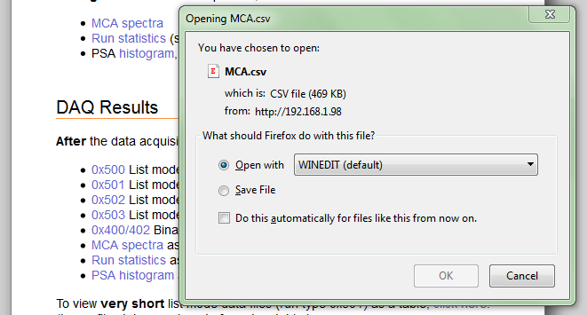

Under CGI Current Data, procedures are executed directly on the Pixie-Net, their output generating webpages for ADC traces and other results instead of files. This combines the two steps of i) executing a function on the Pixie-Net terminal to create data and ii) refreshing the appropriate webpage to view the results. Do not execute these links during a data acquisition.
A further link opens the web operations page (see below) which allows execution of the terminal functions from the web browser. Login is required to prevent unauthorized access.

adcpage.html, cgitraces.cgi

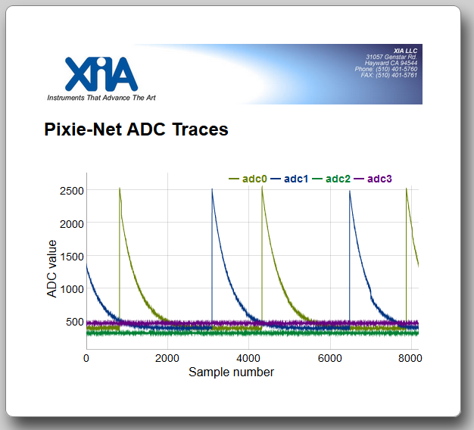
The adcpage contains a chart showing untriggered wavefroms read from the Pixie-Net’s ADCs. Internally, this is a dygraph javascript that links to the file ADC.csv. The csv file has to be generated or refreshed by executing gettraces on the Pixie-Net terminal.
Mouse click and drag operations allow to zoom in and pan. See notes under the plot for details. Use the browser Refresh button to update for new data.
An equivalent page reading and displaying the data can be generated by a cgi script from the web browser when no data acquisition is in progress.

mcapage.html

The mcapage contains a chart showing MCA spectra from the current or most recent data acquisition. Internally, this is a dygraph javascript that links to the file MCA.csv. The file is generated and periodically refreshed by executing startdaq or acquire on the Pixie-Net terminal.

rspage.html, cgistats.cgi

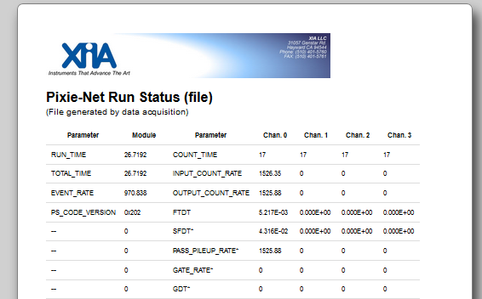
The rspage contains a table showing the Run Status information: the run statistics from the most recent data acquisition (which can be the one in progress). Internally, this is a d3 javascript that links to the file RS.csv. The file is generated and periodically refreshed by executing ./startdaq or ./acquire on the Pixie-Net terminal. It can also be generated outside a data acquisition by executing ./runstats on the Pixie-Net terminal (actual run statistics will not change, but a real time counter increments and some hardware and status information may be of interest).
A similar page reading and displaying the data can be generated by the script cgistats.cgi from the web browser. This should only be used when no data acquisition is in progress This page is named Run Statistics to differentiate for the Run Status page described in the previous paragraph.
Units in the pages (and the underlying csv file) are in seconds or counts/s for the first ~8 lines, then raw internal units (counts and ns).

psahistpage.html

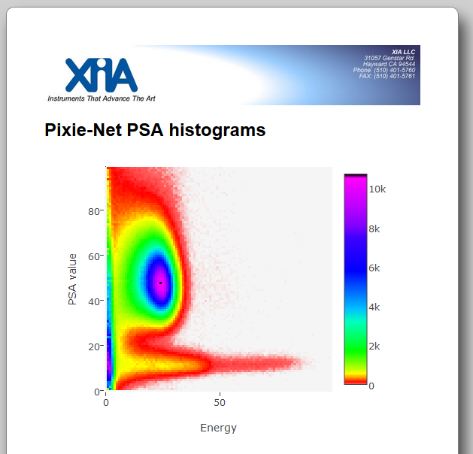

The psahistpage shows results of the pulse shape analysis (PSA) as a 2D histogram. The PSA, as described in section 12.1, computes two sums over characteristic regions of the detector pulse, and calculates the ratio (PSA value) of the two sums. The PSA value is a condensed characteristic of the pulse shape, and can be used with suitable detectors to distinguish event or particle types, for example gammas and neutrons or gammas and alphas.
In the psahistpage, the PSA value (y) is plotted against the pulse energy E (x), and each pixel is colored by intensity. Typically neutrons and gammas fall into two separate branches in the plot.
Internally, this is a plotly javascript that links to the file PSA.csv. The file is generated and periodically refreshed by executing startdaq on the Pixie-Net terminal. Hovering over the plot makes visible options to zoom and save. The histogram has 100 bins in each direction.

psahistprojpage.html

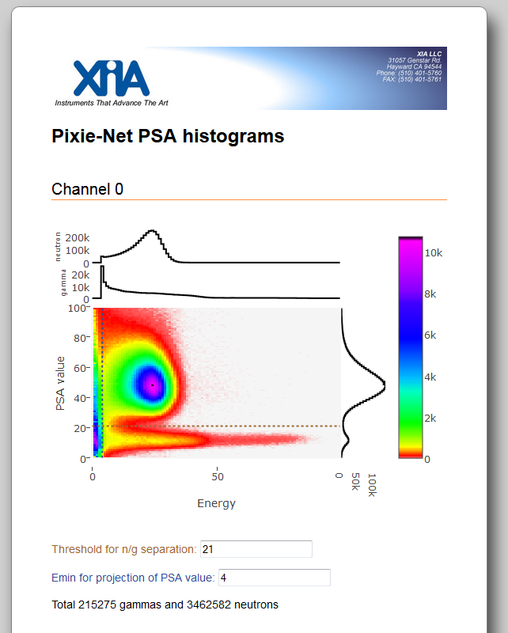

The psahistprojpage shows the same data as the psahistpage, but additionally computes
- a projections to the y axis for all bins > Emin
- a projection to the x axis for all bins > n/g threshold
- a projection to the x axis for all bins < n/g threshold
- the number of gammas and neutrons (E >Emin, PSA value >/< n/g threshold)
Emin and n/g threshold can be entered below the plot. Clicking the browser’s refresh button will recalculate the projections.

psasurfacepage.html

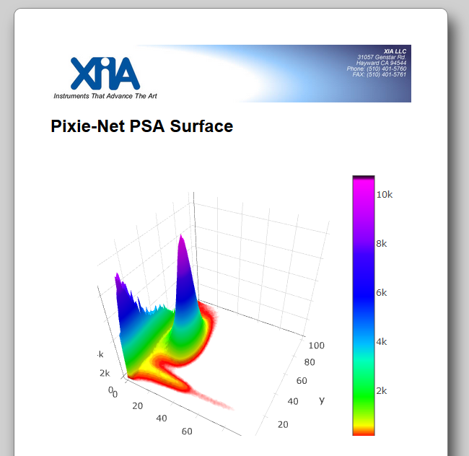
The psasurfacepage shows the same data as the psahistpage, but as a 3D surface plot instead of a 2D histogram. Hovering over the plot makes visible options to rotate and pan the plot.

lmtablepage.html

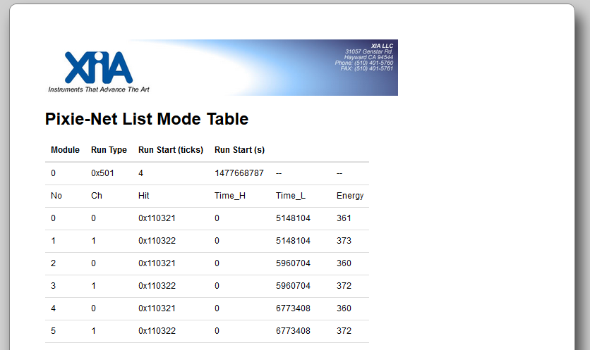
The lmtablepage contains a table showing the results from a list mode run of run type 0x501, which generates a csv table with hit pattern, time stamps, and energy (but no waveforms). The first two lines of the table list run type and start time.
The time stamps units are nanoseconds. The energies reported are in internal units, calibration to keV is required.
Note: This page will load very slowly for large data files. Download of the data file and analysis in a text editor or spreadsheet program is recommended.

cgiwaveforms.cgi
Through a link from the Pixie-Net home page (under DAQ results), the Pixie-Net can execute a cgi script to extract the numbered waveform from the LMdata.txt file created in run type 0x500. When called from the home page, the event number defaults to zero; once the waveform page is displayed, a new event number can be entered which reloads the page with that event’s waveform.

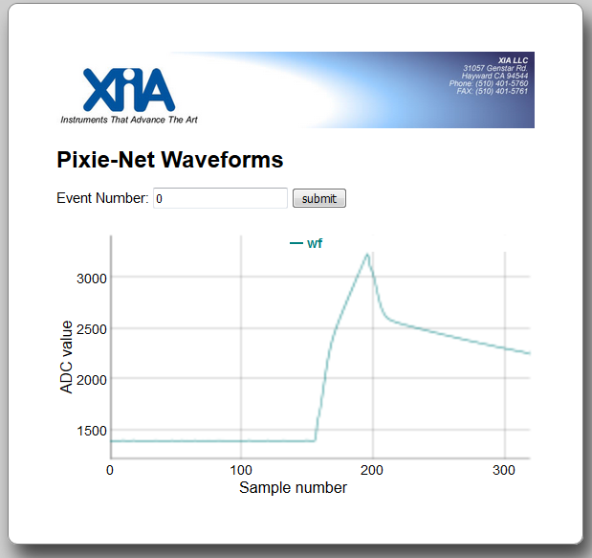

Web Operations (webops/webopsindex.html)
The web operations page allows execution of the terminal functions from the web browser. Login is required to prevent unauthorized access. Default ID/password are webops/xia17pxn (please change). Most of the links and functions from the home page are duplicated, with the following additions and differences:
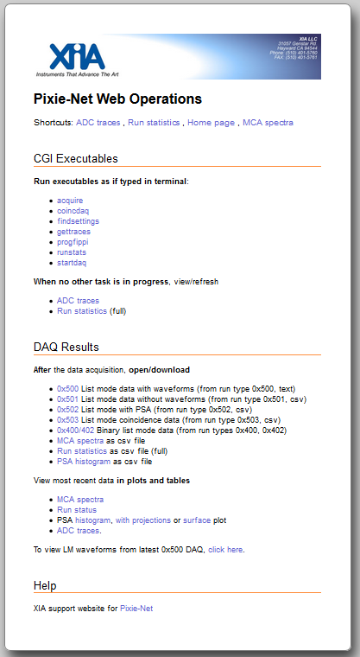

- New list of API functions to be executed as CGI scripts.
Clicking on one of these links executes the API function as if typed into the terminal.
- Data files are created in a new subfolder: /var/www/webops
- API function output (e.g. error messages) are reported as a “plain text” web page; which is empty if no message. Use the browser back button to return to the webops page.
- The API functions use the settings files from /var/www. Currently editing of the file is not possible through the webpage.

Parameters in the Settings Files
The ini files contain the parameter settings for the data acquisition. There are two files, defaults.ini and settings.ini. The file defaults.ini should be considered read-only; it contains defaults for all parameters. The file settings.ini contains a subset of most relevant parameters, which will overwrite the defaults. Parameter lines can be added or removed from settings.ini to focus better on parameters relevant for a certain application. The .ini files are ASCII text files, one line per parameter. Parameter name spelling must be maintained, but the order is not essential. (Users customizing code can add parameters at the end of the file.) The parameter values are in physical units, and will be translated by the progfippi routine into values and bit patterns and then written into PL input registers.
Several control bit patterns are broken out as one bit per line. For other, less commonly used bit patterns, their value can be written as decimals or hexadecimals, for example 65536 or 0xFFFF.
The following sections describe the parameters. Unused parameters are shown in gray. Key parameters for settings.ini are shown in bold. NYI = not yet implemented.

System Parameters

Parameter Name | Units  Limits | Description
NUMBER_CHANNELS | 4 | Number of channels
C_CONTROL | Bits,  0x0-FFFF | unused
REQ_RUNTIME | Seconds,  5..2^32 | Requested run time in (full) seconds
POLL_TIME | Tbd,  100..2^32 | Number of internal polling loops between updates of csv output files. In the order of microseconds
SYS_U11 |  | unused
SYS_U10 |  | unused
SYS_U9 |  | unused
SYS_U8 |  | unused
SYS_U7 |  | unused
SYS_U6 |  | unused
SYS_U5 |  | unused
SYS_U4 |  | unused
SYS_U3 |  | unused
SYS_U2 |  | unused
SYS_U1 |  | unused
SYS_U0 |  | unused

Module Parameters

Parameter Name | Units  Limits | Description
MCSRA_CWGROUP_00 | 0 or 1 | In coinc mode runs (0x503 or 0x402), save only one record per coincidence window
MCSRA_U_01 | 0 or 1 | Module control bit A.1, unused
MCSRA_U_02 | 0 or 1 | Module control bit A.2, unused
MCSRA_U_03 | 0 or 1 | Module control bit A.3, unused
MCSRA_U_04 | 0 or 1 | Module control bit A.4, unused
MCSRA_FPVETO_05 | 0 or 1 | Module control bit A.5,  if 1, enables MMCX input as global Veto,  NYI (always enabled)
MCSRA_U_06 | 0 or 1 | Module control bit A.6, unused
MCSRA_FPPEDGE_07 | 0 or 1 | Module control bit A.7, toggles active edge for front panel pulse counter, NYI
MCSRA_U_08 | 0 or 1 | Module control bit A.8, unused
MCSRA_U_09 | 0 or 1 | Module control bit A.9, unused
MCSRA_U_10 | 0 or 1 | Module control bit A.10, unused
MCSRA_U_11 | 0 or 1 | Module control bit A.11, unused
MCSRA_U_12 | 0 or 1 | Module control bit A.12, unused
MCSRA_U_13 | 0 or 1 | Module control bit A.13, unused
MCSRA_U_14 | 0 or 1 | Module control bit A.14, unused
MCSRA_U_15 | 0 or 1 | Module control bit A.15, unused
MCSRB_U_00 | 0 or 1 | Module control bit B.0, unused
MCSRB_TERM01_01 | 0 or 1 | Module control bit B.1,  if 1, termination for ch.0 and 1 is 50 Ohm, else “high impedance”
MCSRB_TERM23_02 | 0 or 1 | Module control bit B.2,  if 1, termination for ch.2 and 3 is 50 Ohm, else “high impedance”
MCSRB_U_03 | 0 or 1 | Module control bit B.3, unused
MCSRB_PDCH0_04 | 0 or 1 | Module control bit B.4, power down ADC driver for ch.0, NYI
MCSRB_PDCH1_05 | 0 or 1 | Module control bit B.5, power down ADC driver for ch.0, NYI
MCSRB_PDCH2_06 | 0 or 1 | Module control bit B.6, power down ADC driver for ch.0, NYI
MCSRB_PDCH3_07 | 0 or 1 | Module control bit B.7, power down ADC driver for ch.0, NYI
MCSRB_U_08 | 0 or 1 | Module control bit B.8, unused
MCSRB_U_09 | 0 or 1 | Module control bit B.9, unused
MCSRB_U_10 | 0 or 1 | Module control bit B.10, unused
MCSRB_U_11 | 0 or 1 | Module control bit B.11, unused
MCSRB_U_12 | 0 or 1 | Module control bit B.12, unused
MCSRB_U_13 | 0 or 1 | Module control bit B.13, unused
MCSRB_U_14 | 0 or 1 | Module control bit B.14, unused
MCSRB_U_15 | 0 or 1 | Module control bit B.15, unused
COINC_PATTERN_0000 | 0 or 1 | If 1, record events with no channel hit. Useful only for external triggers
COINC_PATTERN_0001 | 0 or 1 | If 1, record events with hitpattern  ch 3210 = ####  (#### are the last 4 digits of the parameter name)  For example, if COINC_PATTERN_0011=1, events with pulses in both channel 0 and 1 will be recorded (if rising edges occur within coincidence window length)  If multiple COINC_PATTERN_#### are 1, events matching any of the patterns are recorded. For example if  COINC_PATTERN_0111=1 and COINC_PATTERN_1011=1 and  COINC_PATTERN_1101=1 and COINC_PATTERN_1110=1,  pulses are recorded if exactly 3 channels have a pulse, but no matter which.
COINC_PATTERN_0010 | 0 or 1
COINC_PATTERN_0011 | 0 or 1
COINC_PATTERN_0100 | 0 or 1
COINC_PATTERN_0101 | 0 or 1
COINC_PATTERN_0110 | 0 or 1
COINC_PATTERN_0111 | 0 or 1
COINC_PATTERN_1000 | 0 or 1
COINC_PATTERN_1001 | 0 or 1
COINC_PATTERN_1010 | 0 or 1
COINC_PATTERN_1011 | 0 or 1
COINC_PATTERN_1100 | 0 or 1
COINC_PATTERN_1101 | 0 or 1
COINC_PATTERN_1110 | 0 or 1
COINC_PATTERN_1111 | 0 or 1
COINCIDENCE_WINDOW | µs,  0.040-4.088 | Coincidence window length
RUN_TYPE | 0x301,  0x400,  0x402,  0x500,  0x501,  0x502,  0x503 | MCA only run  List mode run with waveforms (binary .b00)  Coincidence list mode run (binary .b00)  List mode run with waveforms (text .txt)  List mode run without waveforms (text .dat)  List mode run with PSA, no waveforms (text dt2)  Coincidence list mode run (text .dt3)
FILTER_RANGE | 1..6 | Decimation/averaging for energy filter  See note 1
ACCEPT_PATTERN | Bits,  0x0020 | Controls what type of event to accept (MODULEPATTERN)
SYNC_AT_START | 0..1 | Reset timers at runstart
HV_DAC | 0..5V | Voltage on HV control output
SERIAL_IO | Bits,  0x0-FFFF | Bit pattern for offboard serial data
AUX_CTRL | Bits,  0x0-FFFF | Bit pattern for pulser, LED, etc  Bit0: pulser enabled  Bit1: reserved for LED control  Bit2: reserved  Bit3: if set, require PTP trigger to begin DAQ
MOD_U7 |  | Unused
MOD_U6 |  | Unused
MOD_U5 |  | Unused
MOD_U4 |  | Unused
MOD_U3 |  | Unused
MOD_U2 |  | Unused
MOD_U1 |  | Unused
MOD_U0 |  | Unused

Channel Parameters

Parameter Name | Units  Limits | Description
CCSRA_GROUP_00 | 0 or 1 | Channel control bit A.0,  if 1, respond to distributed group triggers, not local triggers.  Ignored (always 1) in Run Types 0x403, 0x503
CCSRA_U_01 | 0 or 1 | Channel control bit A.1, unused
CCSRA_GOOD_02 | 0 or 1 | Channel control bit A.2,  if 0, channel will not be processed
CCSRA_U_03 | 0 or 1 | Channel control bit A.3, unused
CCSRA_TRIGENA_04 | 0 or 1 | Channel control bit A.4,  if 1, enable trigger (local and distributed)
CCSRA_INVERT_05 | 0 or 1 | Channel control bit A.5,  if 1, ADC data is inverted before processing (for falling edge pulses)
CCSRA_VETO_REJLO_06 | 0 or 1 | Channel control bit A.6,  if 1, reject events when global Veto is low
CCSRA_U_07 | 0 or 1 | Channel control bit A.7, unused
CCSRA_U_08 | 0 or 1 | Channel control bit A.8, unused
CCSRA_NEGE_09 | 0 or 1 | Channel control bit A.9,  if 1, allow negative numbers as result of energy computation, NYI
CCSRA_U_10 | 0 or 1 | Channel control bit A.10, unused
CCSRA_U_11 | 0 or 1 | Channel control bit A.11, unused
CCSRA_GATE_REJLO_12 | 0 or 1 | Channel control bit A.12,  if 1, reject events when channel-specific GATE signal is low
CCSRA_U_13 | 0 or 1 | Channel control bit A.13, unused
CCSRA_U_14 | 0 or 1 | Channel control bit A.14, unused
CCSRA_U_15 | 0 or 1 | Channel control bit A.15, unused
CCSRB_U_00 | 0 or 1 | Channel control bit B.0,unused
CCSRB_U_01 | 0 or 1 | Channel control bit B.1,unused
CCSRB_U_02 | 0 or 1 | Channel control bit B.2,unused
CCSRB_U_03 | 0 or 1 | Channel control bit B.3,unused
CCSRB_U_04 | 0 or 1 | Channel control bit B.4,unused
CCSRB_U_05 | 0 or 1 | Channel control bit B.5,unused
CCSRB_U_06 | 0 or 1 | Channel control bit B.6,unused
CCSRB_U_07 | 0 or 1 | Channel control bit B.7,unused
CCSRB_U_08 | 0 or 1 | Channel control bit B.8,unused
CCSRB_U_09 | 0 or 1 | Channel control bit B.9,unused
CCSRB_U_10 | 0 or 1 | Channel control bit B.10,unused
CCSRB_U_11 | 0 or 1 | Channel control bit B.11,unused
CCSRB_U_12 | 0 or 1 | Channel control bit B.12,unused
CCSRB_U_13 | 0 or 1 | Channel control bit B.13,unused
CCSRB_U_14 | 0 or 1 | Channel control bit B.14,unused
CCSRB_U_15 | 0 or 1 | Channel control bit B.15,unused
CCSRC_VETO_REJHI_00 | 0 or 1 | Channel control bit C.0,  if 1, reject events when global Veto is high
CCSRC_GATE_REJHI _01 | 0 or 1 | Channel control bit C.1,  if 1, reject events when channel-specific Gate signal is high
CCSRC_GATE_FROMVETO_02 | 0 or 1 | Channel control bit C.2,  if 1, use global Veto as the input for this channel’s Gate logic
CCSRC_PILEUP_DISABLE_03 | 0 or 1 | Channel control bit C.3,  if 1, disable pileup rejection
CCSRC_RBAD_DISABLE_04 | 0 or 1 | Channel control bit C.4,  if 1, disable rejection of out-of-range events
CCSRC_PILEUP_INVERT_05 | 0 or 1 | Channel control bit C.5,  if 1, accept only pulses that are piled up
CCSRC_PILEUP_PAUSE_06 | 0 or 1 | Channel control bit C.6,  if 1, disable pileup inspection for 32 clock cycles after trigger. For ringing input signals.
CCSRC_GATE_FEDGE_07 | 0 or 1 | Channel control bit C.7,  if 1, count Gate pulses on falling edge
CCSRC_GATE_STATS_08 | 0 or 1 | Channel control bit C.8,  if 1, run statistics are in GATE mode, only counting while GATE in on
CCSRC_VETO_FEDGE_09 | 0 or 1 | Channel control bit C.9,  if 1, count Veto pulses on falling edge
CCSRC_GATE_ISPULSE_10 | 0 or 1 | Channel control bit C.10,  if 1, logic to re-pulse incoming Gate signal with specified GATE_WINDOW is enabled
CCSRC_U_11 | 0 or 1 | Channel control bit C.11, unused
CCSRC_U_12 | 0 or 1 | Channel control bit C.12, unused
CCSRC_U_13 | 0 or 1 | Channel control bit C.13, unused
CCSRC_CPC2PSA_14 | 0 or 1 | Channel control bit C.14, |  if 1, report gate pulse count as PSA value of list mode record
CCSRC_GATE_PULSEFEDGE_15 | 0 or 1 | Channel control bit C.15,  if 1, start pulse GATE_WINDOW at falling edge of Gate input signal
ENERGY_RISETIME | µs,  0.032 .. 62.976 | Energy filter rise time  See Note 1) and section 3.4.1
ENERGY_FLATTOP | µs,  0.048 .. 62.976 | Energy filter flat top  See Note 1) and section 3.4.1
TRIGGER_RISETIME | µs,  0.016 .. 0.480 | Trigger filter rise time  See note 2) and section 3.4.2
TRIGGER_FLATTOP | µs,  0.048 .. 0.0488 | Trigger filter flat top  See note 2) and section 3.4.2
TRIGGER_THRESHOLD | (ADC steps)  0..4096 | Trigger threshold  See note 3) and section 3.4.2
ANALOG_GAIN | 2 or 5 | Gain with switches/relays/VGAs  Values may vary for different HW variants
DIG_GAIN | Positive float | Digital gain adjustment factor.  Measured ADC amplitude is multiplied with this factor before histogramming and reporting in list mode file.  Binning artefacts can appear with very small or very large numbers
VOFFSET | V  -1.25..1.25 | Analog offset  Used to compensate detector baseline offsets
TRACE_LENGTH | µs,  0..16 | Captured waveform length
TRACE_DELAY | µs,  0..16 | Pre-trigger delay
PSA_START | µs,  0..16 | Start for PSA in waveform, reserved
PSA_END | µs,  0..16 | End for PSA in waveform, reserved
BINFACTOR | 1-16 | MCA binning factor: divide measured pulse height by by 2^N before binning
TAU | µs  positive float | Preamplifier decay time  See section 3.4.3
BLCUT | Positive int | Threshold for bad baseline measurements  See section 3.4.4
XDT | µs | Sampling interval in untriggered traces, NYI
BASELINE_PERCENT | 0-99 | Target offset for baseline, nominally in percent, NYI
PSA_THRESHOLD | ADC steps,  0..2044 | Threshold in CFD and PSA,
INTEGRATOR | 0..2 | Filter mode:  0-trapezoidal,  1-gap sum integral, NYI  2-ignore gap sum, NYI
GATE_WINDOW | µs,  0..2.04 | Coincidence window with gate
GATE_DELAY | µs,  0..2.04 | Delay of external gate signal
COINC_DELAY | µs,  0..1.02 | Delay of ADC signal before coincidence test, equivalent to a cable delay
BLAVG | 65535..  65528 and 0 | Baseline averaging  See section 3.4.4
QDC0_LENGTH | samples  2..60 | Length of PSA sum  See section 12.1
QDC1_LENGTH | samples  2..60 | Length of PSA sum  See section 12.1
QDC0_DELAY | samples  0..250 | Delay of PSA sum relative to trigger point  See section 12.1
QDC1_DELAY | Samples  0..250 | Delay of PSA sum relative to trigger point  See section 12.1
QDC_DIV8 | 0..1 | If 1, divide PSA sums by an extra factor 8 (to avoid overflow for long sums)  See section 12.1
MCA2D_SCALEX | Positive float <655 | The energy (max 64Ki) is divided by this factor before binning into the 2D PSA histogram (max 100 bins)
MCA2D_SCALEY | Positive float <655 | The PSA value (max 64Ki) is divided by this factor before binning into the 2D PSA histogram (max 100 bins)
PSA_NG_THRESHOLD | Positive float | Threshold for PSA value to distinguish neutrons and gammas, NYI
CHAN_U3 |  | Unused
CHAN_U2 |  | Unused
CHAN_U1 |  | Unused
CHAN_U0 |  | Unused

Notes
- Energy filter rise time and flat top depend on FILTER_RANGE (FR). Higher filter ranges have allow longer filter times but with increased coarseness. Maximum combined length is 126 x 0.008μs* 2^FR
FILTER_ RANGE | Filter granularity | max. T_{rise}+T_{flat} | min. T_{rise} | min. T_{flat}
1 | 0.016μs | 2.032μs | 0.032μs | 0.048μs
2 | 0.032μs | 4.064μs | 0.064μs | 0.096μs
3 | 0.064μs | 8.128μs | 0.128μs | 0.192μs
4 | 0.128μs | 16.256μs | 0.256μs | 0.384μs
5 | 0.256μs | 32.512μs | 0.512μs | 0.768μs
6 | 0.512μs | 65.024μs | 1.024μs | 1.536μs
Table 6-1: Filter clock decimations and filter time granularity
- Trigger filter rise time and flat top maximum combined length is 63 x 0.008μs
- The internal triggering compares the output of the trigger filter (technically an area) with (TRIGGER_THRESHOLD * TRIGGER_RISETIME / 8), which must be <1024. The maximum for TRIGGER_THRESHOLD thus depends on TRIGGER_RISETIME. Fractional values for TRIGGER_THRESHOLD are acceptable. TRIGGER_THRESHOLD=0 turns off triggering for this channel.

Data Formats

List Mode Data Files
There are currently six types of list mode data acquisition, with waveforms and without, binary or text, and for special purposes. The following table gives an overview of their differences. It is quite straightforward to modify the code in e.g. startdaq to generate application specific output files.
Run Type | File format | Wave-forms | Function | File extension | Notes
0x400 | binary | Yes | startdaq, acquire | .b00 | General purpose, fast, compatible with Pixie-4e
0x402 | binary | Yes | acquire | .b00 | Coincidences,  compatible with Pixie-4e
0x500 | text | Yes | startdaq | .txt | General purpose, slow
0x501 | text | No | startdaq | .dat | General purpose
0x502 | text | No | startdaq | .dt2 | PSA
0x503 | text | No | coincdaq | .dt3 | Coincidences

As a general rule, times and time stamps are in units of 1ns unless explicitly stated otherwise. Note that time counters are incremented at a rate of 125 MHz, i.e. by 8 ticks every 8 ns.

List mode files with waveforms (Run Type 0x500)
The default filename for list mode files with waveforms is LMdata.txt. Data is in text format and organized as one value per line. The first 4 lines report run type and run start time information. After that, for each event there are 8 header lines and N waveform sample lines. (N can be computed from the TRACE LENGTH in µs specified in the ini file.)
Line | Value | Example
0 | File header: module number | Module: 0
1 | File header: run type | Run Type: 0x500
2 | File header: start time per FPGA clock counter, in units of ns | Run Start Time Stamp (ticks) : 4
3 | File header: start time per Linux clock, in units of s since epoch | Run Start Time (s) : 1477668839
4 | Event header: Event number | 0
5 | Event header: Channel number | 0
6 | Event header: Hit pattern | 0x110321
7 | Event header: upper 32 bit of FPGA time stamp (in units of 2^32 x 1 ns) | 0
8 | Event header: lower 32 bit of FPGA time stamp (in units of 1 ns) | 26711904
9 | Event header: energy | 855
10 | Event header: PSA result | 0
11 | Event header: CFD result | 0
12 | Event waveform: sample 0 | 539
13 | Event waveform: sample 1 | 511
14 | Event waveform: sample 2 | 525
 | … | …

The hit pattern is a bit mask, which tells which channels were recorded detected within the specified coincidence window plus some additional status information, as listed in table 7.1.
Bit # | Description
0..3 | If set, indicates that data for channel 0..3 have been recorded¹
4..7 | 4: Logic level of FRONT panel input  5: Result of LOCAL acceptance test  6: reserved  7: reserved
8..11 | If set, indicates that channel 0..3 has been hit in this event  (i.e. if zero, energy reported is invalid or only an estimate)
12..15 | If set, indicates that the GATE input of channel 0..3 has been high at time of fast trigger
16 | Coincidence test result
17 | Logic level of backplane VETO line
18 | If set, indicates event is piled up
19 | If set, indicates waveform FIFO full
20 | If set, indicates this channel was hit (else the event was recorded based on distributed trigger)
21 | If set, indicates that the GATE input of this channel has been high at time of fast trigger
22 | If set, indicates this channel was out of ADC range at time of fast trigger
23..30_4 | Reserved
31 | If set, indicates a data transmission error has been detected for this event.  Parts of header and waveform may be corrupted
Table 7-1: Event pattern and Event info in Run Type 0x400, 0x500, 0x501, total 32 bits.

List mode files without waveforms (Run Type 0x501)
The default filename for list mode files without waveforms is LMdata.dat. Data consists of comma separated values and is organized as one event per line. The first 2 lines are names and values of run start information. Line 3 lists the column headers for the following event data. For example,
Module,RunType,Run_Start_ticks,Run_Start_sec,Unused1,Unused2
0,0x501,4,1477668787,--,--
No,Ch,Hit,Time_H,Time_L,Energy
0,0,0x110321,0,5148104,361
1,1,0x110322,0,5148104,373
2,0,0x110321,0,5960704,360
3,1,0x110322,0,5960704,372
lists in line 2 the module number, run type, and run start time in ns (FPGA) and s (Linux). Line 4 and beyond show the event number, channel number, hit pattern, upper and lower time stamp, energy. (See above for definition of these values).

List mode files with PSA (Run Type 0x502)
In run type 0x502, the data acquisition program creates list mode files without waveforms named LMdata.dt2. Similar to data in run type 0x501, it lists in the first 2 lines are names and values of run start information. Line 3 lists the column headers for the following event data. For example,
Module,Run_Type,Run_Start_ticks,Run_Start_sec,Unused1,Unused2
0,0x502,-1107295228,1487638335,--,--
Event_No,Channel_No,Hit_Pattern,Event_Time_H,Event_Time_L,Energy,Amplitude,CFD,Base,Q0,Q1,PSAvalue
0,0,0x110121,0,396065120,4972,695,0,122,766,289,377
1,0,0x110121,0,396136216,4496,554,0,124,693,305,440
2,0,0x110121,0,396342104,2367,593,0,122,652,287,440
3,0,0x110121,0,396342848,2367,253,0,123,346,172,497
4,0,0x110121,0,396422920,355,520,0,122,496,290,584
lists in line 2 the module number, run type, and run start time in ns (FPGA) and s (Linux). Line 4 and beyond show the event number, channel number, hit pattern, upper and lower time stamp, energy, and results of the PSA. (See above for definition of these values). In addition, run type 0x502 creates a file PSA.csv that contains the histogram data of PSA value vs energy (see below).

Coincidence list mode files without waveforms (Run Type 0x503)
The default filename for list mode files without waveforms is LMdata.dt3. Data consists of comma separated values and is organized as one 4-channel event per line. The first 2 lines are names and values of run start information. Line 3 lists the column headers for the following event data. For example,
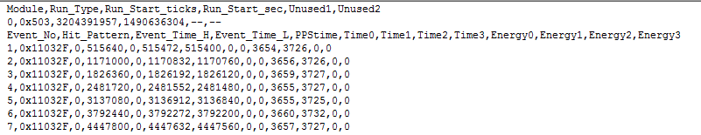lists in line 2 the module number, run type, and run start time in ns (FPGA) and s (Linux). Line 4 and beyond show the event number, hit pattern, upper and lower time stamp of the event, and local time stamp (24 bit) and energy for each channel. (See above for definition of these values). It also reports a PPStime, which is the local time latched by an external trigger signal. The local time stamp is captured at the rising edge of the pulse in that channel, the event time stamp is latched when the data is recorded in all channels.

Binary list mode files with waveforms (Run Type 0x400)
Run type 0x400 creates single-channel event records in binary format, LMdata.b00. This format is compatible with the Pixie-4e. XIA provides a utility to convert this data format to the upcoming IEC63047 list mode standard. The file starts with a file header of 32 words. The 32 words (16 bit unsigned integer, low byte first) are:

Word # | Variable | Description
0 | BlkSize | Block size (16-bit words)
1 | ModNum | Module number
2 | RunFormat | Format descriptor = Run Type
3 | ChanHeadLen | Channel Header Length
4 | CoincPat | Coincidence pattern
5 | CoincWin | Coincidence window in 8ns clock ticks
6 | MaxCombEventLen | Maximum length of traces plus headers from all 4 channels (in blocks)
7 | BoardVersion | Module type and revision
8 | EventLength0 | Length of traces from channel 0 plus header (in blocks)
9 | EventLength1 | Length of traces from channel 1 (in blocks)
10 | EventLength2 | Length of traces from channel 2 (in blocks)
11 | EventLength3 | Length of traces from channel 3 (in blocks)
12 | SerialNumber | Serial number of that module
13--31 | unused | Reserved
Table 7-2: File header data format, total 32 words (16bit).

Following the file header, the single channel event records are stored in sequential order. Each event starts out with a channel header of 32 words. The 32 words (16 bit) are:

Word # | Variable | Description
0 | EvtPattern | Hit pattern.
1 | EvtInfo | Event status flags.
2 | NumTraceBlks | Number of blocks of Trace data to follow the header
3 | NumTraceBlksPrev | Number of blocks of Trace data in previous record (for parsing back)
4 | TrigTimeLO | Trigger time, low word (in units of 1 ns)
5 | TrigTimeMI | Trigger time, middle word (in units of 2^16 x 1 ns)
6 | TrigTimeHI | Trigger time, high word (in units of 2^32 x 1 ns)
7 | TrigTimeX | Trigger time, extra 8 bits (in units of 2^48 x 1 ns)
8 | Energy | Pulse Height
9 | ChanNo | Channel number
10--15 | PSA Values
16--31 | reserved
Table 7-3: Channel header for Run Type 0x400, total 32 words (16bit).
The hit pattern is a bit mask, which tells which channels were recorded detected within the specified coincidence window plus some additional status information, as listed in table 7.1. The channel header may be followed by waveform data. An offline analysis program can recognize this by reading the number of waveform blocks from the NumTraceBlks word. The block size is defined in the file header.

Binary coincidence list mode files with waveforms (Run Type 0x402)
Run type 0x404 creates 4-channel event records in binary format, LMdata.b00. This format is compatible with the Pixie-4e. The file starts with a file header of 32 words, same as Run Type 0x400.
Following the file header, the 4-channel event records are stored in sequential order. Each event starts out with a channel header of 32 words. The 32 words (16 bit) are

Word # |  | Variable | Description
0 | EvtPattern |  | Hit pattern.
1 | EvtInfo |  | Event status flags.
2 | NumTraceBlks |  | Number of blocks of Trace data to follow the header (all channels)
3 | NumTraceBlksPrev |  | Number of blocks of Trace data in previous record (for parsing back)
4 | TrigTimeHI |  | Event trigger time, high word
5 | TrigTimeX |  | Event trigger time, extra 8 bits
6 | Energy_sum |  | Sum of channel energies
7 | NumUserDataBlks |  | Number of blocks of user header data to follow
8 | LocalTimeLO_0 |  | Local trigger time, low word (ch. 0)
9 | LocalTimeMI_0 |  | Local trigger time, middle word (ch. 0)
10 | Energy_0 |  | Pulse Height (ch. 0)
11 | NumTraceBlks_0 |  | Number of blocks of Trace data to follow the header (ch. 0)
12 | LocalTimeLO _1 |  | Local trigger time, low word (ch. 1)
13 | LocalTimeMI _1 |  | Local trigger time, middle word (ch. 1)
14 | Energy_1 |  | Pulse Height (ch. 1)
15 | NumTraceBlks_1 |  | Number of blocks of Trace data to follow the header (ch. 1)
16 | LocalTimeLO _2 |  | Local trigger time, low word (ch. 2)
17 | LocalTimeMI _2 |  | Local trigger time, middle word (ch. 2)
18 | Energy_2 |  | Pulse Height (ch. 2)
19 | NumTraceBlks_2 |  | Number of blocks of Trace data to follow the header (ch. 2)
20 | LocalTimeLO _3 |  | Local trigger time, low word (ch. 3)
21 | LocalTimeMI _3 |  | Local trigger time, middle word (ch. 3)
22 | Energy_3 |  | Pulse Height (ch. 3)
23 | NumTraceBlks_3 |  | Number of blocks of Trace data to follow the header (ch. 3)
24 | reserved |  | reserved
25 | reserved |  | reserved
26 | TrigTimeLO |  | Event trigger time, low word
27 | TrigTimeMI |  | Event trigger time, middle word
28--31 | reserved |  | reserved
Table 7-4: Channel header for Run Type 0x402, total 32 words (16bit).

Run Statistics Files
Run Statistics files contain comma separated values. The first row lists the column headers. The columns are
ParameterM Name of module parameter
Module Value of module parameter
ParameterC Name of channel parameter
Channel# Value of channel parameter for channel #
The units of the reported values are generally in seconds, nanoseconds, or counts per seconds. For full definition and explanation of the values, please see sections 8.3 and 9.3.
For example, the line
TOTAL_TIME,5.78441,INPUT_COUNT_RATE,1231.04,1231.04,0,0
reports an acquisition TOTAL TIME of 5.78441s and an input rate of 1231.04 counts/s for channel 0 and channel 1.

MCA Files
MCA files contain comma separated values. The first row lists the column headers (bin number and channel number). The following rows contain the values. For example,
bin,MCAch0,MCAch1,MCAch2,MCAch3
0,575,563,0,0
1,55,54,0,0
2,48,62,0,0
3,59,53,0,0
4,56,66,0,0
5,69,51,0,0

PSA Files

PSA files, generated in Run Type 0x502, contain comma separated values. The first row lists the column headers, i.e. PSA value bin numbers – 100 bins per channel numbered from 0 to 99. The first column lists the energy bin number – 100 bins numbered from 0 to 99.
,0,1,2,3,4,5,6,7,8,9,10,11,12,13,14,15 …
0,0,0,0,0,0,0,0,0,0,0,0,0,0,0,0,0,0,0
1,0,927,5030,4657,4735,5798,6045,6773
2,0,4801,3505,4590,4712,5995,6901,769
3,0,1993,1978,2165,2370,2984,3618,425
4,0,496,577,642,795,1084,1318,1474,15
5,0,208,234,255,356,509,626,692,716,7
6,0,138,137,199,250,337,435,512,528,5
7,0,78,98,140,205,258,336,402,479,545
8,0,49,69,110,155,240,303,403,467,506
9,0,42,51,77,143,206,309,349,437,514,
…

Module Registers Visible to Linux
The FPGA (PL) registers described below are used to apply settings to the pulse processing firmware and read back event data. This is generally handled by XIA’s API functions and users do not need to go in depth to understand this functionality. The primary way to set registers is by specifying parameters in the .ini file and call XIA’s API function progfippi to convert and apply as appropriate. XIA may change register addresses and bits in future code revision, but will try to keep the settings file format constant.
FPGA (PL) I/O registers are organized into 4 blocks. All registers are 32bit wide. All writeable registers are in block 0. To read registers, the output block number has to be written to address 0x003; this sets the upper digit of the read addresses. For example, writing 2 to the OUTBLOCK register (0x003) selects read address range 0x200-0x2FF.

Input Registers
Address range is 0x000 – 0x00F. Can be read back to verify I/O
Use these to specify parameters that control the data acquisition
Register | Address | R/W | Description
CSRIN | 0x000 | R/W | Run Control Register bits  0 RunEnable (set to start DAQ run)  9 nLive (set to 1 to pause DAQ run)
COINCPATTERN | 0x001 | R/W | Allowed coincidence pattern and other control bits  0..15 CoincPattern  16 LMRUN402 (coincidence mode)  17 MCARUN (no trace out mode)  18 CWGROUP (only 1 record per CW)
I2C | 0x002 | R/W | Control the SDA and SCL lines  0 SDA  1 SCL  2 SDA ENA (SDA output enable)
OUTBLOCK | 0x003 | R/W | Specifies address range for reads  If 0: 0x000-0x04F  If 1: 0x100-0x14F  If 2: 0x200-0x29F  If 3: 0x300-0x303
HV_DAC | 0x004 | R/W | HV DAC value (16 bit)
SERIAL_IO | 0x005 | R/W | Value for offboard serial IO (16 bit)
AUX_CTRL | 0x006 | R/W | Aux Control bits for HW  0 pulser enable  1 LED red on/off (NYI)  2 reserved  3 synchronize to PTP triggers
ADC_CTRL | 0x007 | R/W | Controls certain aspects of ADC operation  0 swap channel 0/1 data streams  1 swap channel 2/3 data streams
DSP_CLR | 0x008 | W | Writing to this register issues a dspclr pulse (processing init)
COUNTER_CLR | 0x009 | W | Writing to this register issues a pulse to clear runstats counters
RTC_CLR | 0x00A | W | Writing to this register issues a pulse to clear RTC time counter
 | 0x00C-0x00F | R/W | Reserved

Event Registers
Address range is 0x100 – 0x10F. Read only
Use these during the run to get info of the current status
Register | Address | R/W | Description
CSROUT | 0x100 | R | Run Status info bits  0 RunEnable (set to start DAQ run)  2 SDA readback  4 zdtfull  5 PTPenable required  7 PTPenabled  9 nLive  10 PSA licensed  11 VetoIn  13 ACTIVE (=RunEnable)  15..31 debug
EVSTATS | 0x101 | R | EVSTATS (Event status information)  0 DataReadyA (if 1, there is data in channel’s ZDT buffer)  1 DataReadyB  2 DataReadyC  3 DataReadyD
reserved | 0x102 | R
PPSTIME | 0x103 | R | Current PPStime (local time latched with external trigger)
reserved | 0x104 | R
EVTIME_L | 0x105 | R | Event time stamp M, L (mode 0x402, 503)
EVTIME_H | 0x106 | R | Event time stamp X, H (mode 0x402, 503)
EVPPS | 0x107 | R | Event PPS time (mode 0x402, 503)
reserved | 0x108-F | R

Run Statistics Registers
Address range is 0x200 – 0x21F. Read only
Used for run statistics and other output values. Sometimes two 16bit words per address
Unit “ticks” means 2ns clock ticks
Index in runstats para-meter list | PL address | units | Parameter name | Description
0 | 0x200 | Bits | L CSROUT  H CSROUT | See above, addr 0x100
1 | 0x201 | ns | L SYSTIME_L  H SYSTIME_M | Time since last STC reset (lower 32 bit)
2 | 0x202 | ns | L RUNTIME_L  H RUNTIME_M | RunTime for current/last run  (lower 32 bit)
3 | 0x203 | ns | L RUNTIME_H  H RUNTIME_X | RunTime for current/last run  (upper 32 bit)
4 | 0x204 | ns | L TOTALTIME_L  H TOTALTIME _M | TotalTime for current/last run  (lower 32 bit)
5 | 0x205 | ns | L TOTALTIME _H  H TOTALTIME _X | TotalTime for current/last run  (upper 32 bit)
6 | 0x206 |  | L NUMEVENTS_L  H NUMEVENTS _M | Number of events in current/last run (lower 32 bit)
7 | 0x207 |  | L NUMEVENTS _H  H NUMEVENTS _X | Number of events in current/last run (upper 32 bit)
8 | 0x208 |  | L EHL  H BHL | Event Header Length  Buffer Header Length
9 | 0x209 |  | L FIFOLENGTH  H CHL | Length of waveform capture FIFO  Channel Header Length
10 | 0x20A |  | L FIPREVISION  H SYSREVISION | FW Revision numbers
11 | 0x20B |  | L SERIAL_NUMBER  H -- | Serial number of the module
12-31 | 0x20C – 0x21F |  | reserved
The full value of e.g. RUNTIME is computed as
RUNTIME = RUNTIME _L +
RUNTIME _M *2^16 +
RUNTIME _H *2^32 +
RUNTIME _X *2^48
Times are in units of 1ns.

Output values derived from the run statistics parameters are
- EVENT_RATE = NUMEVENTS / RUNTIME

Channel Registers Visible to Linux
The FPGA (PL) registers described below are used to apply settings to the pulse processing firmware and read back event data. This is generally handled by XIA’s API functions and users do not need to go in depth to understand this functionality. The primary way to set registers is by specifying parameters in the .ini file and call XIA’s API function progfippi to convert and apply as appropriate. XIA may change register addresses and bits in future code revision, but will try to keep the settings file format constant.
Channel I/O registers are organized into 4 blocks. All registers are 32bit wide. All writeable registers are in block 0. To read registers, the output block number has to be written to address 0x003; this sets the upper digit of the read addresses. For example, writing 2 to the OUTBLOCK register (0x003) selects read address range 0x200-0x2FF.

Input Registers
Address range is 0x0N0 – 0x0NF, N=1..4. Can be read back to verify I/O
Use these to specify parameters that control the data acquisition
Register | Address | R/W | Description
0 | 0x0N0 | R/W | CCSRA, CCSRC:  0 GROUPTRIG (local or dist. trigger)  1 reserved  2 GOOD (enables triggers)  3 reserved  4 TRIGENA (trigger enabled)  5 INVERT (ADC input polarity)  6 VETOENA (GFLT required)  7 reserved  8 reserved  9 NEGE (NYI)  10 CFD TIME (NYI)  11 reserved  12 GATE_ENA (enable GATE rejection)  13 LOCALTIME (channel time stamp source)  14 ESTIMEATE_E (NYI)  15 reserved  16 VETO_INV (invert GFLT/Veto)  17 GATE_INV (polarity for TrigCtrl)  18 VETO2GATE (use GFLT/Veto for Gate)  19 PILEUP_DISABLE  20 RBAD_DISABLE (disable Rangebad)  21 PILEUP INVERT  22 PILEUP_PAUSE  23 GATE_EDGEINV (select r/f edge for GATE)  24 GATE_STATS (gate statistics, NYI)  25 GDT_ALLOW (ignored)  26 GATE_NOPULSE (use input directly, no edge)  27 reserved  28 GateIsBit0  29 GATE_OUT (to FP after invert/repulse etc)
1 | 0x0N1 | R/W | 0-6 SL (Slow Length)  8-14 SLSG (Slow length + gap)  16-22 SG (slow filter gap for BL pileup)  24-30 RDEL2-8 (delay for clearing Rangebad, bits 0,1=0)
2 | 0x0N2 | R/W | 0-5 FL (Fast Length)  8-13 FLFG (Fast length + gap)  16-25 THRE (trigger threshold)  26-29 DEC (filter decimation)  31 HALT (stop filters)
3 | 0x0N3 | R/W | 0-6 PEAKSAM (sample slow filter for E sum)  13-25 PEAKSEP (pileup inspection period)  26+ GAIN
4 | 0x0N4 | R/W | 0-15 DAC value
5 | 0x0N5 | R/W | 0-8 User Delay/4 (pretrigger trace)  29 NONZERO_TRACE
6 | 0x0N6 | R/W | 0-9 TRACELENGTH/4  16-23 coincwindow  24-31: PSATH (PSA threshold/4)
7 | 0x0N7 | R/W | 0-7 GATEWINDOW (stretch length of GATE pulse)  8-14 GATEDELAY (input delay for GATE)
8 | 0x0N8 |  | Reserved for ADC programming
9 | 0x0N9 | R/W | 0-7 CoincDelay
10 | 0x0NA | R/W | 0-4 QDC0length (length)  5 QDCDIV0  6-7 QDCshift (shift within a group of 4 samples)  8-14 QDC0delay (length+delay)  15 QDC0correct (correct for 4 sample coarseness)  16-20 QDC1length  21 QDCDIV1  24-30 QDC1delay  31 QDC1correct
11-15 | 0x0NB- 0x0NF | R/W | Reserved

Event Registers
Address range is 0x1N0 – 0x1NF, and 0x30N, N=1..4. Read only
Use these during the run to read event data
Register | Address | R/W | Description
EVDATAA | 0x1N0 | R | Hitpattern
EVDATAB | 0x1N1 | R | Event or local time stamp M, L  Time units: ns  (Exception in run task 0x402, 0x503: local TS contains lower 24 bits * 256)
EVDATAC | 0x1N2 | R | Event time stamp X, H  Time units: ns
PSAA | 0x1N3 | R | PSA value
PSAB | 0x1N4 | R | PSA value or gate pulse counter
CFDA | 0x1N5 | R | CFD values
CFDB | 0x1N6 | R | CFD values
EVDATAD | 0x1N7 | R | Lsum
EVDATAE | 0x1N8 | R | Tsum
EVDATAF | 0x1N9 | R | Gsum, read advances event buffers and increments NOUT
REJECT | 0x1NA | R | Read advances event buffers without incrementing NOUT
BLDATAL | 0x1NB | R | Lsum for BL avg
BLDATAT | 0x1NC | R | Tsum for BL avg
BLDATAG | 0x1ND | R | Gsum for BL avg
 | 0x1NE | R | reserved
ADC | 0x1NF | R | ADCvalue

Register | Address | R/W | Description
WF0 | 0x300 | R | Waveform FIFO channel 0
WF1 | 0x301 | R | Waveform FIFO channel 1
WF2 | 0x302 | R | Waveform FIFO channel 2
WF3 | 0x303 | R | Waveform FIFO channel 3

Run Statistics Registers
Address range is 0x2[2N]0 – 0x2[2N+1]F, N=1..4. Read only
Used for run statistics and other output values.
Index in runstats parameter list | PL address | Units | Parameter name | Description
0 | 0x2[2N]0 |  | L OOR | Out of range fraction
1 | 0x2[2N]1 |  | L ICR | Input count rate
2 | 0x2[2N]2 | ns | L COUNTTIME_L  H COUNTTIME _M | Count Time
3 | 0x2[2N]3 | ns | L COUNTTIME_H  H COUNTTIME_X
4 | 0x2[2N]4 |  | L NTRIG_L  H NTRIG_M | Number of triggers (P4e: FastPeaks)
5 | 0x2[2N]5 |  | L NTRIG_H  H NTRIG_X
6 | 0x2[2N]6 | ns | L FTDT_L  H FTDT_M | Fast trigger dead time
7 | 0x2[2N]7 | ns | L FTDT_H  H FTDT_X
8 | 0x2[2N]8 | ns | L SFDT_L  H SFDT_M | Slow filter dead time*
9 | 0x2[2N]9 | ns | L SFDT_H  H SFDT_X
10 | 0x2[2N]A |  | L GCOUNT_L  H GCOUNT_M | Number of gate pulses*
11 | 0x2[2N]B |  | L GCOUNT_H  H GCOUNT_X
12 | 0x2[2N]C |  | L NOUT_L  H NOUT_M | Number of output counts
13 | 0x2[2N]D |  | L NOUT_H  H NOUT_X
14 | 0x2[2N]E | ns | L GDT_L  H GDT_M | Gate dead time*
15 | 0x2[2N]F | ns | L GDT_H  H GDT_X
16 | 0x2[2N+1]0 |  | L NPPI_L  H NPPI_M | Number of counts passing pileup inspection*
17 | 0x2[2N+1]1 |  | L NPPI_H  H NPPI_X
18-31 | 0x2[2N+1]2-0x2[2N+1]F |  | Reserved
Properties marked with * are omitted in the PSA version of the firmware
The full value of e.g. COUNTTIME is computed as
COUNTTIME = COUNTTIME_L +
COUNTTIME _M *2^16 +
COUNTTIME_H *2^32 +
COUNTTIME_X *2^48
Times are in units of 1ns.

Output values derived from the run statistics parameters are
- OUTPUT_COUNT_RATE = NOUT / COUNTTIME
- INPUT_COUNT_RATE = NTRIG / (COUNTTIME-FTDT)
- PASS_PILEUP_RATE = NPPI / COUNTTIME
- GATE_RATE = GCOUNT / COUNTTIME

Linux Configuration

Licensing Information
The Pixie-Net software includes several components that are licensed with the GNU general public license (GPL). For most of them, the software is unchanged, and the source code is provided on the Pixie-Net SD card with the corresponding GPL license files. A small portion of the software is modified by XIA and the modified source code is provided both on the SD card and on XIA’s website. The source code for the Linux kernel built by XIA for the Pixie-Net and for the full collection of Ubuntu Linux programs is too large for the SD card or to host by XIA, but we can provide it upon request. XIA strives to keep those programs up to date and our own code compatible with the latest version, however, the best source of the programs may be their official repository.
List of key GPL programs:
- LinuxPTP source code on SD card or
at http://linuxptp.sourceforge.net/
- ptp-mii-tool source code on SD card or
at https://github.com/giftnuss/net-tools (original mii-tool) or
at http://support.xia.com/default.asp?W772 (XIA modification)
- Linux kernel source code per request or
at https://github.com/Xilinx/linux-xlnx
- Ubuntu files source code and configuration files on SD or
at https://releases.linaro.org/ubuntu/images/
developer/latest/linaro-vivid-developer-20151215-714.tar.gz
or per request
includes
  - Lighttpd
  - Samba
  - g++
  - i2c-tools

Software Information

The Pixie-Net Linux system prior to SW version 1.20 was based on Xillinux (1.3), which is based on Ubuntu LTS 12.04. The initial distribution can be downloaded from the Xillinux website (http://xillybus.com/xillinux). In what is distributed by XIA, the initial setup steps as described in the Xillinux documentation have been applied, including copying the Linux OS image on an SD card and increasing the “disk space” to 16GB. (http://xillybus.com/downloads/doc/xillybus_getting_started_zynq.pdf)
Starting from SW version 2.0, Ubuntu 15 with kernel version 4 is used. This has no major effect on the Pixie-Net operation, but more apps from the Linux universe are available.
The SD card contains mainly the Linux OS (not visible to Windows) and 4 boot files (visible) in a small FAT partition. FPGA configuration updates have to be copied to that partition.
Notes for the particular configuration of Xillinux or Ubuntu 15 for Pixie-Net:
- Xillybus demo source files are in /root/xillybus
- By default, Xillinux knows only about “main & restricted” Linux apps. Therefore we modified /etc/apt/sources.list and uncommented the “universe” entry to get more apps
- Installed Lighttpd web server
The default webpage is in /var/www. Need to modify /etc/lighttpd/lighttpd.conf as follows: add mod_cgi under server.modules and
$HTTP["url"] =~ "/cgi-bin/" {
cgi.assign = ( "" => "" )
}
cgi.assign = (
".cgi" => ""
)
Further modify for authentication of the webops section: see below
- sudo apt-get install g++
- sude apt-get install i2c-tools
- install boost libraries 1.61 in /usr/local and compiled all binaries (Xillinux) or installed boost version 1.55 from Ubuntu
- Installed Samba
Following Ubuntu help:” How to Create a Network Share Via Samba …”
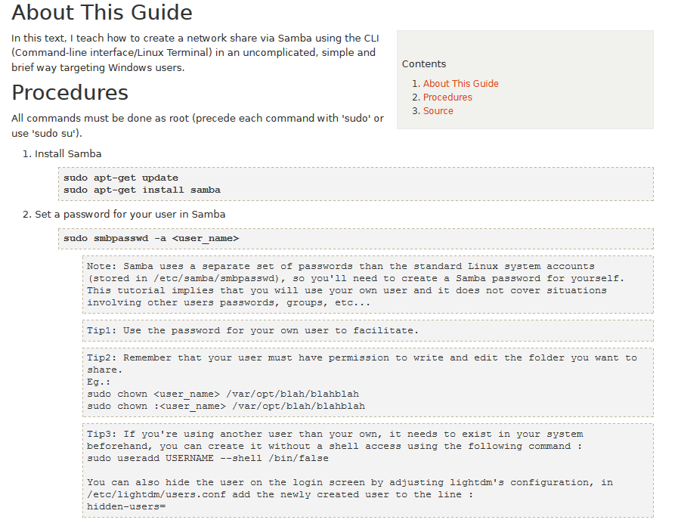
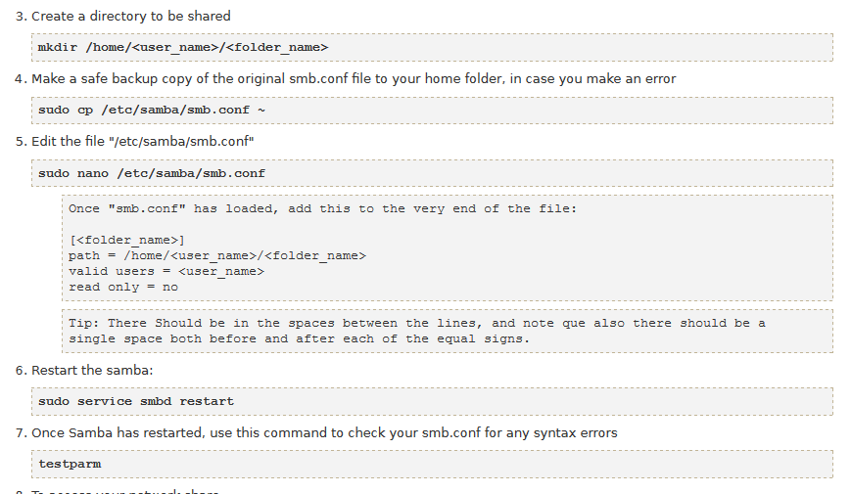
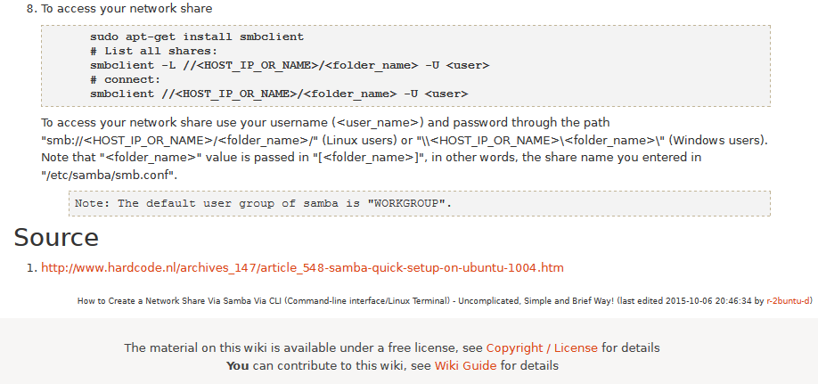
- Set up lighttpd for authentication for web ops
- Modify /etc/lighttpd/lighttpd.conf file
server.modules += ( "mod_auth" )
auth.debug = 2
auth.backend = "plain"
auth.backend.plain.userfile = "/var/www/webopspasswords"
auth.require = ( "/webops/" =>
(
"method" => "basic",
"realm" => "Password protected area",
"require" => "user=webops"
)
)
- Create "/var/www/webopspasswords
webops:xia17pxn
This file should be modified to change the password. For sensitive environments, change to encrypted passwords.
- Create folder /var/www/webops
change owner to wwww-data (=lightttpd)
in webops, make links to ini, jpg, js, html files from /var/www:
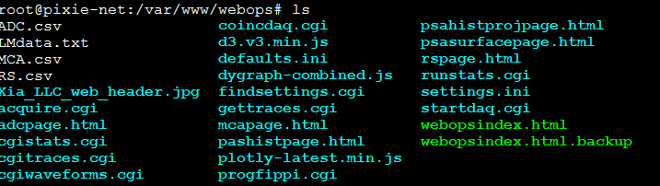
(white: data files created by webops, blue: links, green: webop specific html page)

- Zync temperature
For kernel 2.x (Xillinux), temperature in Celsius can be read from file /sys/devices/amba.0/f8007100.ps7-xadc/temp
For kernel 4.x, raw files are /sys/devices/soc0/amba/f8007100.adc/iio:device0,
which is difficult to open/read from a program because of the colon.
So we made a symbolic link :
ln -s /sys/devices/soc0/amba/f8007100.adc/iio\:device0/in_temp0_raw temp0_raw
to access it from PixieNetCommon.c and compute T in Celsius.
The temperature readings in the second method are typically ~5 degrees higher.
- To automatically give permission to all users to /dev/uio0 (avoiding the initial chmod command):
insert the following line in the file /etc/udev/rules.d/10-local.rules:
KERNEL==”uio0″, MODE=”666″

Theory of Operation

Digital Filters for γ-ray Detectors
Energy dispersive detectors, which include such solid state detectors as Si(Li), HPGe, HgI2, CdTe and CZT detectors, are generally operated with charge sensitive preamplifiers as shown in Figure 6.1 (a). Here the detector D is biased by voltage source V and connected to the input of preamplifier A which has feedback capacitor C_{f} and feedback resistor R_{f}.
The output of the preamplifier following the absorption of an γ-ray of energy E_{x} in detector D is shown in Figure 6.1 (b) as a step of amplitude V_{x} (on a longer time scale, the step will decay exponentially back to the baseline, see section 6.3). When the γ-ray is absorbed in the detector material it releases an electric charge Q_{x} = E_{x}/ε, where ε is a material constant. Q_{x} is integrated onto C_{f}, to produce the voltage V_{x} = Q_{x}/C_{f} = E_{x}/(εC_{f}). Measuring the energy E_{x} of the γ-ray therefore requires a measurement of the voltage step Vx in the presence of the amplifier noise σ, as indicated in Figure 11-1 (b). Scintillator detectors read out with a photomultiplier tube generate pulses in a different mechanism, but for the most part they can still be described as fast rise followed by exponential decay, so the processing described below equally applies.
Figure 11-1: (a) Charge sensitive preamplifier with RC feedback; (b) Output on absorption of a -ray.
Reducing noise in an electrical measurement is accomplished by filtering. Traditional analog filters use combinations of a differentiation stage and multiple integration stages to convert the preamp output steps, such as shown in Figure 11-1 (b), into either triangular or semi-Gaussian pulses whose amplitudes (with respect to their baselines) are then proportional to Vx and thus to the γ-ray’s energy.
Digital filtering proceeds from a slightly different perspective. Here the signal has been digitized and is no longer continuous. Instead it is a string of discrete values as shown in Figure 11-2. Figure 11-2 is actually just a subset of Figure 11-1 (b), in which the signal was digitized by a Tektronix 544 TDS digital oscilloscope at 10 MSPS (mega samples per second). Given this data set, and some kind of arithmetic processor, the obvious approach to determining V_{x} is to take some sort of average over the points before the step and subtract it from the value of the average over the points after the step. That is, as shown in Figure 11-2, averages are computed over the two regions marked “Length” (the “Gap” region is omitted because the signal is changing rapidly here), and their difference taken as a measure of V_{x}. Thus the value V_{x} may be found from the equation:
(1)
where the values of the weighting constants W_{i} determine the type of average being computed. The sums of the values of the two sets of weights must be individually normalized.
Figure 11-2: Digitized version of the data of Figure 6.1 (b) in the step region.
The primary differences between different digital signal processors lie in two areas: what set of weights W_{i} is used and how the regions are selected for the computation of Eqn. 1. Thus, for example, when larger weighting values are used for the region close to the step while smaller values are used for the data away from the step, Eqn. 1 produces “cusp-like” filters. When the weighting values are constant, one obtains triangular (if the gap is zero) or trapezoidal filters. The concept behind cusp-like filters is that, since the points nearest the step carry the most information about its height, they should be most strongly weighted in the averaging process. How one chooses the filter lengths results in time variant (the lengths vary from pulse to pulse) or time invariant (the lengths are the same for all pulses) filters. Traditional analog filters are time invariant. The concept behind time variant filters is that, since the γ-rays arrive randomly and the lengths between them vary accordingly, one can make maximum use of the available information by setting the length to the interpulse spacing.
In principle, the very best filtering is accomplished by using cusp-like weights and time variant filter length selection. There are serious costs associated with this approach however, both in terms of computational power required to evaluate the sums in real time and in the complexity of the electronics required to generate (usually from stored coefficients) normalized W_{i} sets on a pulse by pulse basis.
The Pixie-Net takes a different approach because it was optimized for high speed operation. It implements a fixed length filter with all W_{i} values equal to unity and in fact computes this sum afresh for each new signal value k. Thus the equation implemented is:
(2)
where the filter length is L and the gap is G. The factor L multiplying V_{x,k} arises because the sum of the weights here is not normalized. Accommodating this factor is trivial.
While this relationship is very simple, it is still very effective. In the first place, this is the digital equivalent of triangular (or trapezoidal if G ≠ 0) filtering which is the analog industry’s standard for high rate processing. In the second place, one can show theoretically that if the noise in the signal is white (i.e. Gaussian distributed) above and below the step, which is typically the case for the short shaping times used for high signal rate processing, then the average in Eqn. 2 actually gives the best estimate of Vx in the least squares sense. This, of course, is why triangular filtering has been preferred at high rates. Triangular filtering with time variant filter lengths can, in principle, achieve both somewhat superior resolution and higher throughputs but comes at the cost of a significantly more complex circuit and a rate dependent resolution, which is unacceptable for many types of precise analysis. In practice, XIA’s design has been found to duplicate the energy resolution of the best analog shapers while approximately doubling their throughput, providing experimental confirmation of the validity of the approach.

Trapezoidal Filtering in a Pixie Module
From this point onward, we will only consider trapezoidal filtering as it is implemented in a Pixie module according to Eqn. 6.2. The result of applying such a filter with Length L=1μs and Gap G=0.4μs to a γ-ray event is shown in Figure 6.3. The filter output is clearly trapezoidal in shape and has a rise time equal to L, a flattop equal to G, and a symmetrical fall time equal to L. The basewidth, which is a first-order measure of the filter’s noise reduction properties, is thus 2L+G.
This raises several important points in comparing the noise performance of the Pixie module to analog filtering amplifiers. First, semi-Gaussian filters are usually specified by a shaping time. Their rise time is typically twice this and their pulses are not symmetric so that the basewidth is about 5.6 times the shaping time or 2.8 times their rise time. Thus a semi-Gaussian filter typically has a slightly better energy resolution than a triangular filter of the same rise time because it has a longer filtering time. This is typically accommodated in amplifiers offering both triangular and semi-Gaussian filtering by stretching the triangular rise time a bit, so that the true triangular rise time is typically 1.2 times the selected semi-Gaussian rise time. This also leads to an apparent advantage for the analog system when its energy resolution is compared to a digital system with the same nominal rise time.
One important characteristic of a digitally shaped trapezoidal pulse is its extremely sharp termination on completion of the basewidth 2L+G. This may be compared to analog filtered pulses whose tails may persist up to 40% of the rise time, a phenomenon due to the finite bandwidth of the analog filter. As we shall see below, this sharp termination gives the digital filter a definite rate advantage in pileup free throughput.
Figure 11-3: Trapezoidal filtering of a preamplifier step with L=1µs and G=0.4µs.

Baselines and Preamplifier Decay Times
Figure 11-4 shows an event over a longer time interval and how the filter treats the preamplifier noise in regions when no γ-ray pulses are present. As may be seen the effect of the filter is both to reduce the amplitude of the fluctuations and reduce their high frequency content. This region is called the baseline because it establishes the reference level from which the γ-ray peak amplitude V_{x} is to be measured. The fluctuations in the baseline have a standard deviation σ_{e} which is referred to as the electronic noise of the system, a number which depends on the rise time of the filter used. Riding on top of this noise, the γ-ray peaks contribute an additional noise term, the Fano noise, which arises from statistical fluctuations in the amount of charge Q_{x} produced when the γ-ray is absorbed in the detector. This Fano noise σ_{f} adds in quadrature with the electronic noise, so that the total noise σ_{t} in measuring V_{x} is found from
σ_{t} = sqrt( σ_{f}² + σ_{e}²) (3)
The Fano noise is only a property of the detector material. The electronic noise, on the other hand, may have contributions from both the preamplifier and the amplifier. When the preamplifier and amplifier are both well designed and well matched, however, the amplifier’s noise contribution should be essentially negligible. Achieving this in the mixed analog-digital environment of a digital pulse processor is a non-trivial task, however.
With a RC-type preamplifier, the slope of the preamplifier is rarely zero. Every step decays exponentially back to the DC level of the preamplifier. During such a decay, the baselines are obviously not zero. This can be seen in Figure 11-4, where the filter output during the exponential decay after the pulse is below the initial level. Note also that the flat top region is sloped downwards.
Using the decay constant τ, the baselines can be mapped back to the DC level. This allows precise determination of γ-ray energies, even if the pulse sits on the falling slope of a previous pulse. The value of τ, being a characteristic of the preamplifier, has to be determined by the user and host software and downloaded to the module.

Figure 11-4: A γ-ray event displayed over a longer time period to show baseline noise and the effect of preamplifier decay time.

Thresholds and Pile-up Inspection
As noted above, we wish to capture a value of V_{x} for each γ-ray detected and use these values to construct a spectrum. This process is also significantly different between digital and analog systems. In the analog system the peak value must be “captured” into an analog storage device, usually a capacitor, and “held” until it is digitized. Then the digital value is used to update a memory location to build the desired spectrum. During this analog to digital conversion process the system is dead to other events, which can severely reduce system throughput. Even single channel analyzer systems introduce significant dead time at this stage since they must wait some period (typically a few microseconds) to determine whether or not the window condition is satisfied.
Digital systems are much more efficient in this regard, since the values output by the filter are already digital values. All that is required is to take the filter sums, reconstruct the energy V_{x}, and add it to the spectrum. In the Pixie-Net, the filter sums are continuously updated in the FPGA and are captured into event buffers. Reconstructing the energy and incrementing the spectrum is done by the ARM processor, so that the FPGA is ready to take new data immediately (unless the buffers are full). This is a significant source of the enhanced throughput found in digital systems.
The peak detection and sampling in a Pixie module is handled as indicated in Figure 11-5. Two trapezoidal filters are implemented, a fast filter and a slow filter. The fast filter is used to detect the arrival of γ-rays, the slow filter is used for the measurement of V_{x}, with reduced noise at longer filter rise times. The fast filter has a filter length L_{f} = 0.1μs and a gap G_{f} =0.1μs. The slow filter has L_{s} = 1.2μs and G_{s} = 0.35μs.
The arrival of the γ-ray step (in the preamplifier output) is detected by digitally comparing the fast filter output to THRESHOLD, a digital constant set by the user. Crossing the threshold starts a delay line to wait PEAKSAMP clock cycles to arrive at the appropriate time to sample the value of the slow filter. Because the digital filtering processes are deterministic, PEAKSAMP depends only on the values of the fast and slow filter constants. The slow filter value captured following PEAKSAMP is then the slow digital filter’s estimate of V_{x}. Using a delay line allows to stage sampling of multiple pulses even within a PEAKSAMP interval (though the filter values themselves are then not correct representations of a single pulse’s height).

Figure 11-5: Peak detection and sampling in a Pixie module.
Figure 11-6: A sequence of 3 γ-ray pulses separated by various intervals to show the origin of pileup and demonstrate how it is detected by the Pixie module.
The value V_{x} captured will only be a valid measure of the associated γ-ray’s energy provided that the filtered pulse is sufficiently well separated in time from its preceding and succeeding neighbor pulses so that their peak amplitudes are not distorted by the action of the trapezoidal filter. That is, if the pulse is not piled up. The relevant issues may be understood by reference to Figure 11-6, which shows 3 γ-rays arriving separated by various intervals. The fast filter has a filter length L_{f} = 0.1μs and a gap G_{f} =0.1μs. The slow filter has L_{s} = 1.2μs and G_{s} = 0.35μs.
Because the trapezoidal filter is a linear filter, its output for a series of pulses is the linear sum of its outputs for the individual members in the series. Pileup occurs when the rising edge of one pulse lies under the peak (specifically the sampling point) of its neighbor. Thus, in Figure 6.6, peaks 1 and 2 are sufficiently well separated so that the leading edge of peak 2 falls after the peak of pulse 1. Because the trapezoidal filter function is symmetrical, this also means that pulse 1’s trailing edge also does not fall under the peak of pulse 2. For this to be true, the two pulses must be separated by at least an interval of L + G. Peaks 2 and 3, which are separated by less than 1.0 μs, are thus seen to pileup in the present example with a 1.2 μs rise time.
This leads to an important point: whether pulses suffer slow pileup depends critically on the rise time of the filter being used. The amount of pileup which occurs at a given average signal rate will increase with longer rise times.
Because the fast filter rise time is only 0.1 μs, these γ-ray pulses do not pileup in the fast filter channel. The Pixie module can therefore test for slow channel pileup by measuring the fast filter for the interval PEAKSEP after a pulse arrival time. If no second pulse occurs in this interval, then there is no trailing edge pileup and the pulse is validated for acquisition. PEAKSEP is usually set to a value close to L + G + 1. Pulse 1 passes this test, as shown in Figure 6.6. Pulse 2, however, fails the PEAKSEP test because pulse 3 follows less than 1.0 μs. Notice, by the symmetry of the trapezoidal filter, if pulse 2 is rejected because of pulse 3, then pulse 3 is similarly rejected because of pulse 2.

Filter Range
To accommodate a wide range of energy filter rise times from tens of nanoseconds to tens of microseconds, the filters are implemented in the FPGA with different clock decimations (filter ranges). The ADC sampling rate is always 8ns (2ns or 4ns in 500 MSPS or 250 MSPS variants), but in higher clock decimations, several ADC samples are averaged before entering the energy filtering logic. In filter range 1, 2¹ samples are averaged, 2² samples in filter range 2, and so on. Since the sum of rise time and flat top is limited to 127 decimated clock cycles, filter time granularity and filter time are limited to the values listed in Table 6.1.

Data Capture Process
The data capture in the Pixie-Net is based on the principle that for every detected rising edge, one record is assembled from the continuously running processes for waveform capture and energy filters. As some of the processes are not finished by the time of the rising edge, input data or capture signals are delayed appropriately. For example, incoming ADC data is delayed for the waveform capture by the user specified pre-trigger delay. The signal to capture energy filter sums is sent through a delay line of length (energy filter rise time plus energy filter flat top) to capture the output after filtering.
Consequently, for every rising edge, the following information is latched into front end buffers:
- 56 bit time stamp of latch signal
- 32 bit time stamp of last rising edge in this channel
- Energy filter sums for last rising edge in this channel
- Pileup inspection flags
- Coincidence flags
- Starting address of waveform memory
and the (delayed) waveform data begins to flow into the waveform memory, for the user specified length of trace. The front end buffers hold 500 such records and the waveform memory holds 8Ki samples.
When the front end buffers are not empty, a flag is raised for the ARM processor. On this flag, the ARM processor reads one record and checks if it is to be recorded per the user defined pileup and coincidence conditions. If so, the ARM processor computes final energies, increments the MCA histogram, and reads and writes the list mode data to file. If the event is piled up or otherwise rejected, it is cleared from the front end buffer without recording.
Closely following rising edges still capture one record per edge, with the limitation of one record per 1/8 of a decimated clock cycle in filter range 3 and higher. If such events are piled up, the energy will be not a valid measure of the pulse height and waveforms may overlap from pulse to pulse, but some of the information in the record may still be useful for offline re-analysis.

Dead Time and Run Statistics

Definitions
Dead time in the Pixie-Net data acquisition can occur at several processing stages. For the purpose of this document, we distinguish three types of dead time (described below), each with a number of contributions from different processes.
Please note: There is a conceptual difference between momentary dead time (associated with a pulse) and cumulative dead time (sum of dead time contributions during an acquisition). Their relation is not trivial.
Live time is often used to describe the portion of the overall time during which the system was not dead. However, since dead time can occur on several levels, this term is prone to misunderstandings and not used here.

Dead time associated with each pulse
1. Filter dead time
At the most fundamental level, the energy filter implemented in the FPGA requires a certain amount of pulse waveform (the “filter time”) to measure the energy. Once a rising edge of a pulse is detected at time T0, the FPGA computes three filter sums using the waveform data from T- (a energy filter rise time before T0) to T1 (a flat top time plus filter rise time after T0), see section 11.4 and figure 11-7. If a second pulse occurs during this time, the energy measurement will be incorrect. Therefore, processing in the FPGA includes pileup rejection which enforces a minimum distance between pulses and validates a pulse for recording only if no more than one pulse occurred from T0 to T1. Consequently, each pulse creates a dead time Td = (T1 – T0) equal to the filter time. This dead time, simply given by the time to measure the pulse height, is unavoidable unless pulse height measurements are allowed to overlap (which would produce false results).
Assuming randomly occurring pulses, the effect of dead time on the output count rate is governed by Poisson statistics for paralyzable systems with pileup rejection. This means the output count rate OCR (valid pulses) is a function of filter dead time Td and input count rate ICR given by
OCR = ICR * exp(-ICR* 2 * Td), (4)
which reaches a maximum OCR_{max} = ICR_{max}/e at ICR_{max} = 1/(2*Td). Simply speaking, the factor 2 for Td comes from the fact that not only is an event E2 invalid when it falls into the dead time of a previous event E1, but E1 is rejected as piled up as well. This filter dead time is accumulated in the SFDT counter in each processing channel.
Figure 11-7: Filter dead time. A pulse arriving at T0 will incur slow filter dead time (for energy measurement) until T1. At T1, the pileup status is latched – for a single pulse, it is logic low and the event is accepted. A second pulse arriving at T0' will extend the dead time and cause the pileup status to be logic high. Unless pileup rejection is disabled, both events are rejected.
2. Fast trigger dead time (FTDT)
A second type of dead time only affects the trigger filter. Triggers are issued when the trigger filter output goes above the trigger threshold set by the user. However, the trigger filter output will remain above threshold for a finite amount of time, depending on the length of the trigger filter and the rise time of the input signal. During this time, no second trigger can be issued. Therefore triggers are not counted during this time, and when computing the input count rate, the time lost has to be taken into account. FTDT is thus purely a correction for the computation of the input count rate.

Figure 11-8: Fast Trigger Dead Time (FTDT). A second pulse is not detected if the trigger filter output is still above threshold.
3. Other
In the Pixie-Net, up to 500 events (and/or total 8Ki waveform samples) are buffered in the FPGA. Thus new events are accepted while captured ones are read out and processed further. If the buffers fill up, the channel pauses acquisition and stops the count time counter.

Dead time associated with external conditions
There are three dead time effects that originate from outside the trigger/filter FPGA. The first two have the effect of stopping the Pixie-4 Express count time counter, the last is counted separately.
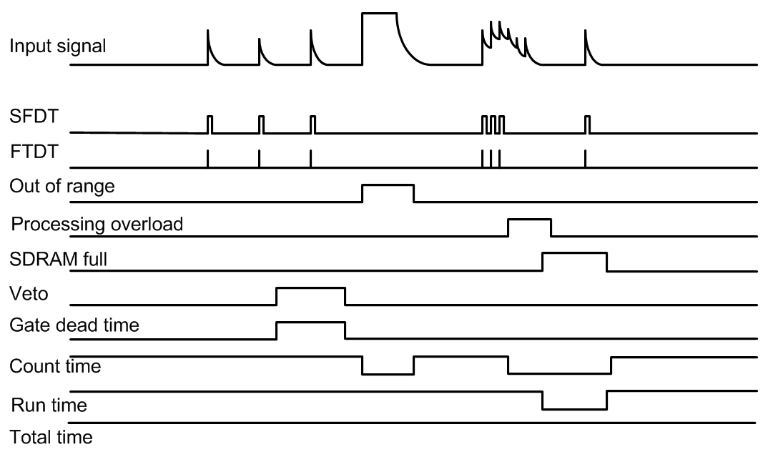
Figure 11-9: The count time counter is stopped when the signal is out of range and when events are rejected because of a processing backlog (e.g. local buffer memory full or file write process busy). SFDT and FTDT are only counted when the count time is on. The gate dead time is counted in a separate counter, but also only when the count time is on. Run time and total time are always on unless the run is stopped (see below).
1. Signal out of range
When detector gains or offsets drift, or an unusual large pulse is generated in the detector, the analog input of the ADC may go out of range. In this condition, the FPGA can not accumulate meaningful filter sums and thus is considered dead. This condition persists during the actual out-of-range time and several filter times afterwards until the bad ADC samples are purged from filter memory. The count time counter is stopped during the out-of-range condition because no triggers can be issued and no pulses are counted.
2. On-board pulse processing limit
The on-board pulse processing by the ARM processor computes the pulse height (energy) from raw energy filter sums, which is then stored in list mode memory and/or binned into spectrum memory. In the Pixie-Net, the computation itself takes only a few cycles, but there is significant readout and other overhead .In List mode with nonzero waveforms, the limit is strongly dependent on the length of the captured waveform. Bursts of pulses may still exceed the processing rate momentarily, fill the buffers, and so prevent the channel from acquiring more data. Thus the count time counter is stopped during such buffer full (processing overload) conditions.
3. Gate or Veto
If an external signal prohibits acquisition using the Gate or Veto signals, the channel is also dead (disabled on purpose). The appropriate way to count Gate or Veto dead time may depend on the experiment. The Pixie-Net counts both gate time and number of gate pulses. Please contact XIA for details.

Count time and dead time counters
The Pixie-Net firmware has been optimized to reduce the dead time as much as possible, and a number of counters measure the remaining dead times as well as the number of counts to provide information for dead time correction. The result of these counters is stored in the following output variables:
TOTAL TIME
The TOTAL TIME is an attempt to measure the real laboratory time during which the Pixie module was requested to take data. It essentially counts the time from the command to start a data acquisition to the command to end it. The TOTAL TIME includes the time spent for run start initialization and host readout. However, since it is based on the Zynq internal clock and only updated periodically, it may not be as precise as a “laboratory wall clock” over long time spans.
RUN TIME
The RUN TIME variable tracks the time during which the Pixie-Net was “switched on” for data acquisition. It’s currently identical to the TOTAL TIME
COUNT TIME
The COUNT TIME is counted in the FPGA independently for each channel and measures the time the channel is ready for acquisition. The COUNT TIME counter starts when the ARM processor finished all setup routines at the beginning of a run, omits the times the ADC signal is out of range, each channel's local 500-event buffer is full, and ends when the ARM encounters an end run condition. Internally, the “counter on” signal is called LCE. It is thus the time during which triggers are counted and can cause recording (or pile up) of data, the best available measurement of the time the channel was active. The difference between COUNT TIME and TOTAL TIME can be used to determine how long the local 500-event buffers were full and waiting for readout or other events prevented the channel from data taking (e.g. out of range).
FTDT (fast trigger dead time)
The fast trigger dead time counts the time the trigger filter is unable to issue triggers because the trigger filter output is already above threshold (and can not recognize a second pulse). It does not include the time triggers have been “paused” for a short time after a first trigger (an advanced user option to suppress double triggering), because the concept is that all triggers occurring during the pause are counted as only one trigger. When computing the input count rate, one should divide the number of triggers counted (FASTPEAKS) by the difference (COUNT TIME – FTDT) since triggers are not counted during FTDT.
SFDT (slow filter dead time)
The slow filter dead time counts the time new triggers will not lead to the recording of new data. This is the time the pileup inspection is taking place and the summation of energy filter sums is in progress (section 11.7.1.1). In case pileup inspection is inverted or disabled, there is no contribution to SFDT.
GDT (GATE dead time)
The dead time from Veto /GFLT is counted separately from SFDT for each channel. As mentioned above, the use of these signals may depend on the application.
In the current firmware, the time during which GDT is counted depends on several user options on signal source and polarity. The source options result in a signal GCE to be counted, the polarity selects whether to count while GCE is high or low, as listed in the following table.
Use Veto | Gate Mode | GCE | Count @ Fall | GDT incremented
0 | 0 | (Veto OR Gate*) AND LCE | 0 | GCE high
1 | 0 | Gate* AND LCE | 0 | GCE high
0 | 1 | (Veto OR Gate*) | 0 | GCE high
1 | 1 | Gate* | 0 | GCE high
0 | 0 | (Veto OR Gate*) AND LCE | 1 | GCE low
1 | 0 | Gate* AND LCE | 1 | GCE low
0 | 1 | (Veto OR Gate*) | 1 | GCE low
1 | 1 | Gate* | 1 | GCE low
* possibly shaped and delayed
For the case that the Veto input is used for a GFLT-type validation pulse, it may be more useful to work with the number of pulses issued. They can be counted by using the Veto input as the source for GATE PULSEs, which are counted in the variable GCOUNT.

Count Rates
Besides the count time and dead times, the Pixie-Net counts the numbers of triggers in each channel, NTRIG, the number of valid single channel events, NUMEVENTS, and the number of valid pulses stored for each channel, NOUT. To accommodate dead time correction for pileup even in cases where events are not recorded for other reasons (e.g. not matching coincidence or veto requirements), a counter NPPI counts the number of locally triggered events passing pileup inspection. In addition, it counts the number of gate pulses for each channel, GCOUNT. FASTPEAKS and GCOUNT are inhibited when the COUNT TIME counter is not incrementing. NUMEVENTS and NOUT by nature only count events captured when the COUNT TIME counter is incrementing.
Count rates are then computed as follows:
Input count rate ICR = NTRIG / (COUNT TIME – FTDT)
Event rate ER = NUMEVENTS / RUN TIME
Channel output count rate OCR = NOUT / COUNT TIME
Channel Pass Pileup Rate PPR = NPPI / COUNT TIME
Gate count rate GCR = GCOUNT / COUNT TIME
Users are free to use the reported values to compute rates and time better matching their preferred definitions.

Notes:
- Output pulse counters are updated whenever an event has been processed; input, gate and all time counters are updated every ~7ms. Therefore reading rates at random times, e.g. clicking Update in the Pixie Viewer, might return slight inconsistencies between input rates and output rates. At the end of the run, all rates are updated and these effects should disappear.
- NOUT is counted for each event a channel is processed no matter if the channel had a valid hit or not. Thus a channel that is processed in “group trigger” mode may have an output count rate even though its input count rate is zero.
- Since COUNT TIME counters are paused local 500-event buffers are full, the input and output count rates should be considered as “rates while active” as opposed to actual rates per elapsed lab time. For input count rates, this is the more intuitive case, since the detector will not stop generating pulses when the channel becomes inactive due to a full buffer and the input count rate should closely correspond to the detector's rate. For output count rates, it is a matter of perspective – should it mean the total number of counts per acquisition lab time or the number of counts processed while the Pixie module is taking date? The former would produce unreasonably low count rates when e.g. the signal goes out of range periodically, since it will not account for the duty cycle of the signal source. The latter would produce unreasonably high rates if the system is near its processing limit and often paused full buffers, though it will better reflect the pileup rejection statistics. The choices made in the current firmware select the latter case, but by multiplying the output count rate with COUNT TIME / TOTAL TIME, the former can be recovered.

Dead time correction in the Pixie-Net
Historically, dead time correction in analog systems relied on the system dead time measurements taken directly from the acquisition system and the recorded output count rate. For example, a peak sensing ADC module might output a “dead time” signal during the several microseconds it would require to capture the peak value. Thus reconstruction of true count rate required the knowledge of dead times associated with various stages of acquisition and the subsequent mathematical modeling to tie this quantity to the input rate. The classic paralyzable and non-paralyzable models of pulse acquisition do exactly that. For example, the dead time from a non-paralyzable ADC conversion process simply “takes away” active counting time (Td for each output count) and so one can use the classical model of OCR = ICR/(1+Td*ICR), derive OCR/ICR = (real time – dead time)/(real time), and solve for ICR as a function of measured OCR, real time and dead time.
In the Pixie-Net, the input count rate is measured directly with the trigger filter, and so the system dead time bears only theoretical or diagnostic value. For any measurements where accurate determination of true (source) counts are required (activity measurements), the empirical ratio ICR/OCR is the only really unbiased quantity for dead time correction. No matter what the actual dead time the acquisition process incurs on the system, the ICR/OCR ratio applied to any region of interest in the energy spectrum correctly reconstructs the true counts in this region, assuming a random source so that pulses are lost with equal probability in each region or in time. For cases where events are added by group trigger or removed by coincidence or veto requirements, PPR should be used instead of OCR.
In the Pixie-Net firmware design, the counter SFDT attempts to independently account for the system dead time. SFDT counts the time during which the pileup rejection will reject this and any subsequent pulse that are too close in time. Essentially it measures – cumulative for all pulses – the time from the first trigger until a new trigger is again allowed, extended by any trigger during the interval. This is a paralyzable dead time with pileup rejection, closely matching the classical model. SFDT correctly measures the time during which pulses are not recorded, but unless simplified to the assumptions in the classical model, it is not trivial to compute from that the number of pulses lost. The detailed mathematical treatment is beyond the scope of this writing.
Please also see a related application note: XIA Pixie-4e Dead Time Correction

Hardware and Firmware Variants
This sections describe hardware and firmware variants of the Pixie-Net. Typically, they are purchased separately as a licensed add-on to the standard hardware, firmware, and software. Please contact XIA for details.

Pulse Shape Analysis and Constant Fraction Timing
A variety of radiation detectors have the ability to discern between different types of radiation, such as neutrons and gamma rays, by creating different pulse shapes for different types of interactions. In addition, phoswich detectors, consisting of multiple layers of different scintillators, produce different pulse shapes depending on which layer absorbs the radiation. A suitable pulse shape analysis (PSA) can detect such differences, which then can be used for particle identification. The Pixie-Net firmware includes such PSA functions (enabled for specifically licensed units).

Overview
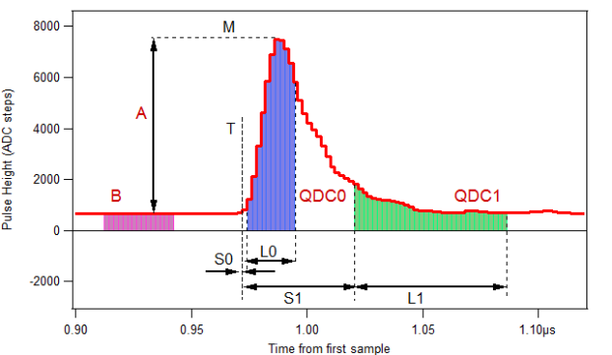
Figure 12-1: The PSA quantities and input parameters
The approach used by the Pixie-Net is a digital version of the Charge Comparison Method, where two sums over characteristic regions of the pulse are accumulated and a suitable ratio expresses the difference in pulse shape. This is an established method used in a variety of applications, well suited for online processing due to its simplicity. In this case, the functions compute baseline average sum B, amplitude A, and two sums QDC0 and QDC1 over characteristic areas of the pulse, as shown in Fig.1. The first 8 samples of the waveform are summed and normalized to obtain B. The maximum sample M in the waveform is located, then subtracted by B to obtain A. Four input parameters (L0, L1, S0, S1), specified prior to the data acquisition, define the length and delay of the sums QDC0 and QDC1 relative to the trigger T, as shown in Fig, 1. The sums QDC0 and QDC1 are baseline subtracted by B (scaled according to L0 and L1, respectively). Another return value, or PSA ratio R = QDC1/QDC0 is computed as the final result to differentiate pulse types. (Other ratios or combinations can be implemented on request). These data, plus the timestamp TrigTime and overall pulse height E computed with a trapezoidal filter, are written into the list mode data stream, followed by optional storage of the full waveform for each event.

An additional function of the PSA firmware is to compute a constant fraction timing value for the rising edge. This is illustrated in Figure 12-2. Having found the maximum of the pulse, the firmware logic computes the CFD level as 50% of the amplitude, and finds the two closest points to that level, cfdlow and cfdhigh. The CFD time of arrival x is then computed by the DSP through interpolation between cfdhigh and cfdlow:
x /1 = (cfdhigh – cfdlow) / (CFD level – cfdlow)
In the Pixie-Net, time stamps are latched by local or distributed triggers issued at the rising edge of a pulse. To accommodate delayed pulses in coincidence systems, the CFD time is captured at the end of the user specified coincidence window (1/2 of the “COINCIDENCE_WINDOW” specified in the settings file). The reported CFD time value is the time from the interpolated CFD level crossing to the end of the coincidence window. Therefore one can compute [in units of 1ns sampling intervals] the fractional (subsampling) time of arrival x from cfdlow
x = 1 – frac((CFD time)/256)
and the absolute time of the CFD crossing is
CFD crossing = TrigTime – (CFD time)/256+ ½ window width
For example, for a user specified coincidence window 400ns, the Pixie module may report an event with a TrigTime of 1234 and a CFD time of 12832. Then one can compute
x = 1-frac(50.125) = 0.875 (or 0.875ns)
and
CFD crossing = 1234 [x 1ns] – (12832/256) [x 1ns]+ ½ x 400ns
= 1484.125 ns after last reset of the time stamp counter

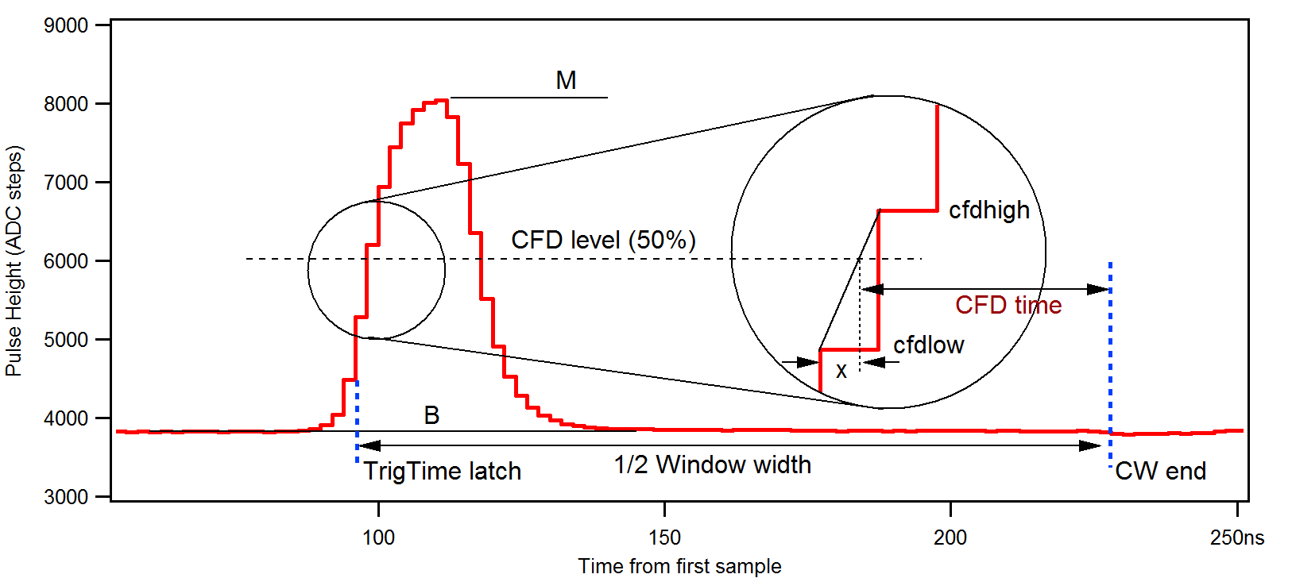
Figure 12-2: CFD timing definitions

Restrictions for the CFD:
- The CFD level is fixed to 50%
- The rising edge, from 50% level to maximum, must be less than 12 samples (48ns)
- If more than one pulse occurs within the coincidence window, results are invalid
- To measure time-of-arrival differences between channels, all channels must be in group trigger mode so data is captured on the same trigger.
- As CFD time has a maximum value of 512 ns, the coincidence window width must be less than 1024ns
- As the value is captured at the end of the coincidence window, the coincidence window width must be at least 2 times the pulse rise time. This ensures that the maximum is included in the CFD analysis.

PSA Input Parameters
PSA input parameters are specified in the settings file. For each channel, the parameter QDC0_LENGTH corresponds to L0, QDC1_LENGTH corresponds to L1, QDC0_DELAY corresponds to S0, and QDC1_DELAY corresponds to S1. In addition, the Boolean QDC_DIV8 can be set to 1 for long sums, where the result of QDC0 or QDC1 may overflow its 16-bit output variable. The parameter PSA_TESHOLD is used to detect the rising edge of a pulse. The threshold applies to both sums and is also used for the CFD maximum detection.
The sum lengths and delays can be set individually, with the following limitations:
- QDC1 must finish last (i.e. S1+L1 > S0+L0)
- L0, L1 must be between 2 and 60, and a multiple of 2
- L0+S0, L1+S1 must be between 0 and 250
- The difference of S0 and S1 must be a multiple of 2 (e.g S0 = 1, S1 = 17)
Two additional input parameters are used by the ARM C code, which accumulates a 2D histogram of the PSA data. This histogram plots PSA value R vs energy E. both R and E are 16 bit numbers which can range from 0 to 65536. The histogram has 100 bins in each direction. Therefore R and E must be divided by a scaling factor to map the value to a bin. These factors are
- MCA2D_SCALEX, i.e. bin x = E / MCA2D_SCALEX
- MCA2D_SCALEY, i.e. bin y = R / MCA2D_SCALEY
To see the full range, MCA2D_SCALEX/Y should be 655. In practice, a smaller value is often useful to “zoom in” to a particular range.

PSA Return Values
The ARM processor writes the PSA return values to the list mode data stream. The PSA values are placed into words 10-15 of the channel header in run type 0x400 as described above. Table 11-1 lists the mapping of the values to the channel header locations. To accommodate fractions for the ratio R, the number recorded in the file is 1000*R. To accommodate fractional samples for the CFD time, the number recorded in the file is 256* CFD time (1 LSB = 3.91ps). Divide the reported value by 256 to match units with the Trigger time (1ns).
For text output in Run Type 0x500 and 0x502, see sections 7.1.1 and 7.1.3

Word # | Variable | Description
0 | EvtPattern | Hit pattern.
1 | EvtInfo | Event status flags.
2 | NumTraceBlks | Number of blocks of Trace data to follow the header
3 | NumTraceBlksPrev | Number of blocks of Trace data in previous record (for parsing back)
4 | TrigTimeLO | Trigger time, low word
5 | TrigTimeMI | Trigger time, middle word
6 | TrigTimeHI | Trigger time, high word
7 | TrigTimeX | Trigger time, extra 8 bits
8 | Energy | Pulse Height
9 | ChanNo | Channel number
10 | PSA Values | Amplitude A
11 | PSA Values | CFD time *4*256 (divide by 256 for dt in ns)
12 | PSA Values | Base B
13 | PSA Values | QDC0
14 | PSA Values | QDC1
15 | PSA Values | Ratio R *1000
16--32 | reserved
Table 11-1: Channel header data format for PSA data acquisition in Run Type 0x400.

Reduced General Purpose Functionality
Due to resource limitations in the PL, the following output parameters are not computed in the PSA variant of the firmware:
- No gate pulse count in the event record
- No GDT counters in the channel run statistics
- No NPPI or PPR counters in the channel run statistics
- No SFDT counters in the channel run statistics
- No GCOUNT or GATE_RATE counters in the channel run statistics
- No CSFDT and CCT counters in the module run statistics

and the following functions are simplified or removed
- No delay and window for external gates
- No offboard serial I/O
- No coincidence mode acquisition (0x503, 0x402) with PSA and vice versa

These parameters and functions can be reinstated as necessary if other trade-offs are made.

IEEE 1588 Precision Timing Protocol
While traditionally detector data acquisition electronics use dedicated clock and trigger connections to synchronize multiple units, the Pixie-Net has the option to instead use the IEEE 1588 Precision Timing Protocol (PTP) to synchronize modules. Each Pixie-Net operates from its local clock, but clock frequencies and timestamps are adjusted by software that uses special PTP messages exchanged through the data network. With suitable network configurations, this can achieve sub-nanosecond precision.

Overview
The Zynq SoC used as the Pixie-Net’s processor has a number of PTP functions built into its standard Ethernet controller. With suitable Linux kernel options and PTP stack software (see below), the Zynq PTP clock can be synchronized to other PTP nodes in the network with a precision of ~1500 ns. However, as there are no useful connections between the Zynq PTP clock controller and FPGA fabric, this is of limited use for the detector pulse processing.
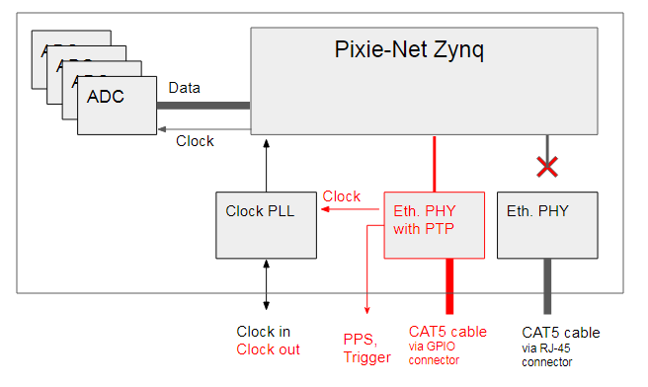
Figure 12-3: Block diagram of the clocking of the Pixie-Net (Revision B), with PTP features shown in red. The output from the clock PLL is only available in the PTP variant, but the connector can be used as a clock input in any variant.

Therefore, a special PTP variant of the Pixie-Net Revision B hardware implements the following alternate PTP functions:
- Redirect Ethernet data to a secondary Ethernet PHY.
- Perform PTP time stamping in the secondary Ethernet PHY.
- Generate a programmable PTP clock that can be used to clock the FPGA pulse processing, the ADCs, and external devices.
- Generate programmable PTP triggers for internal and external use, e.g. a pulse per second signal or an enable signal that allows data acquisition to begin at a specific time.
- Connect PTP PHY to CAT-5 cable through the GPIO connector (with adapters).
These hardware features require a number of (open source) control software for operation, as described in the following sections. Timing resolutions between 300 ns and 200 ps have been achieved with this technique, depending strongly on the network capabilities.

PTP Stack Software: LinuxPTP
The PTP stack software manages the clock adjustments based on PTP messages exchanged between the PTP nodes. The PTP PHY is supported by the open source software LinuxPTP, which is installed in the Pixie-Net’s Ubuntu 15 operating system. To work with the PTP PHY, LinuxPTP needs specific kernel drivers and firmware, which is part of the boot files provided for the PTP variant. (The standard boot files will let LinuxPTP communicate only with the built-in Zynq PTP functions).
To start LinuxPTP in the foreground with status messages, type
ptp4l -i eth0 -m –q
in the Pixie-Net terminal session. If another PTP node is present in the network, the Pixie-Net will try to link with it. The master clock node is determined automatically; for a defined setup we recommend start ptp4l in one Pixie-Net as shown above and wait until it assigns itself as the clock master, then start ptp4l in the second/third Pixie-Net with the added –s option to force it to clock slave mode.
It is often more convenient to start LinuxPTP as a service, or a background task and the Pixie-Net data acquisition as a foreground task. Please see the LinuxPTP documentation for the various options. As long as LinuxPTP is running, the clock generated by the PTP PHY is synchronized to the network’s PTP master. The Linux system clock can be additionally synchronized to the PTP clock with a second LinuxPTP utility, phx2sys.

PTP PHY Control Software: ptp-mii-tool
The secondary Ethernet PHY with PTP function has a number of registers that specify additional functions, such as the frequency of the generated PTP clock and the timing of GPO triggers. To program these registers, XIA adapted the mii-tool Linux utility to specifically communicate with the PTP PHY. The adapted program, ptp-mii-tool, is invoked by typing:
- ptp-mii-tool print basic status information, including PTP time
- ptp-mii-tool –v print more status information
- ptp-mii-tool –v -v print even more status information
- ptp-mii-tool –s toggle on/off synchronous Ethernet mode (PTP clock
derived from upstream Ethernet device)
- ptp-mii-tool –p turn on the pulse per second (PPS) signal on the
Pixie-Net’s PPS output 3 seconds from “now”
- ptp-mii-tool –t print current PTP and system time
- ptp-mii-tool –-enable=TON –-duration=DUR
create PTP triggers at PTP time TON and TON+DUR
which are used by the Pixie-Net to enable data
acquisition starting at TON and ending at TON+DUR.
The Pixie-Net time stamp counter is reset to 0 at TON.
The functions provided by ptp-mii-tool are useful but optional for the PTP synchronization and data acquisition process, and more functions will be added as necessary.

PTP Clock PLL Control Software: clockprog
By default, the Pixie-Net’s input clock PLL buffers the PTP clock generated by the PTP PHY (25 MHz) for the FPGA and optionally also for the “CLK” output on the Pixie-Net rear panel. However, this chip is very flexible and can be programmed to divide or multiply the input clock frequencies to generate frequencies other than 25 MHz for the “CLK” output. Such changes can be applied with the clockprog utility. A few standard modes are hardcoded in the program; expert users can modify the register settings with the help of the PLL’s data sheet (CDCD813-Q1) and TI’s ClockPro utility. The program is invoked by typing
./clockprog m
where m stands for one of the following mode numbers:

Mode | progclock function
0 | Report the register values
1 | Program the current register values into the PLL’s EEPROM to make them the new power-up defaults.
2  (default) | Enable the clock output for the FPGA (25 MHz), assuming a 25 MHz input signal from the PTP PHY.
3 | Enable the clock output for the FPGA (25 MHz) and the rear panel connector (25 MHz), assuming a 25 MHz input signal from the PTP PHY.

The clock PLL can also be used to clock the FPGA from an external clock source. This is not accomplished by programming, but by setting internal jumpers to use the rear panel CLK connector as an input to the PLL (instead of the PTP PHY). This option is available even for standard Rev. B hardware. We recommend a 2.5V, 25 MHz clock signal; otherwise the PLL has to be programmed to work with the alternate input clock frequency.
The functions provided by clockprog are optional for the PTP synchronization and data acquisition process, and more modes will be added as necessary.

PTP parameter settings
The following parameters are important for PTP data acquisitions:
- AUX_CTRL bit 3
If bit 3 is set, the Pixie-Net data acquisition is enabled by a first PTP trigger and disabled again when a second PTP trigger is received. This is similar to applying an external VETO signal to the Pixie-Net, except that the PTP triggers are generated at user specified date/time as programmed by the ptp-mi-tool utility.
If bit 3 is set, the first PTP trigger also clears the Pixie-Net’s time stamp counter, thus correlating the user specified trigger time (a UTC related date/time) with list mode data time stamps.
For non-PTP operation, the bit has to be set to zero, else data acquisition will wait (forever) for the PTP triggers to enable data taking.

Linux Shell Scripts for PTP operation
A number of Linux shell scripts have been written by XIA to make the PTP-synchronized operation of multiple Pixie-Net modules easier to use. The scripts are currently written to run on a Linux host PC connected via the network to 3 Pixie-Net units, but can be easily modified by interested users.
It is recommended to ensure settings and connections are correct by executing single-unit data acquisition with terminal login, i.e. before executing the ptpdaq script, log in and execute ./acquire to make sure data files are created correctly.
All scripts rely on ssh communication between the various Linux systems. To avoid being prompted for passwords at every step, it is recommended to set up public key login. For example, to set up a key on a Pixie-Net at 192.168.1.71, execute the following on the Linux host PC running the scripts:
ssh-keygen -t rsa // create a key
ssh-copy-id -o ControlPath=none root@192.168.1.71 // copy key to Pixie-Net
ssh-add // this is a bug fix of some sort
Say yes to defaults and/or type <enter> to all prompts. Enter the Pixie-Net password when requested. Usually there is no need to specify a password for the key (just hit <enter>).

- ptpsetup_3x.sh
The setup script has the following key steps after defining the Pixie-Nets’ IP numbers in variable IP1-3:
a) Execute the standard initial Linux commands to apply settings and find offsets. In addition, program the PTP clock PLL to generate a 25 MHz output to the Zynq processor:
ssh root@$IP1 'cd /var/www; ./clockprog 2; ./progfippi; ./findsettings'
ssh root@$IP2 'cd /var/www; ./clockprog 2; ./progfippi; ./findsettings'
ssh root@$IP3 'cd /var/www; ./clockprog 2; ./progfippi; ./findsettings'
b) kill any previous instances of LinuxPTP:
ssh root@$IP1 'pkill ptp4l'
ssh root@$IP2 'pkill ptp4l'
ssh root@$IP3 'pkill ptp4l'
c) Start LinuxPTP in the background as the clock master in Pixie-Net 1, and as clock slaves in Pixie-Net 2 and 3:
ssh root@$IP1 "sh -c 'nohup ptp4l -i eth2 > /dev/null 2>&1 &'"
ssh root@$IP2 "sh -c 'nohup ptp4l -i eth2 -s > /dev/null 2>&1 &'"
ssh root@$IP3 "sh -c 'nohup ptp4l -i eth2 -s > /dev/null 2>&1 &'"
- ptpdaq_3x.sh sss
The acquisition script has the following key steps after defining the Pixie-Nets’ IP numbers in variable IP1-3:
a) prompt for requested run time (DUR), and update the settings files on the Pixie-Nets. Additional 10s are added to accommodate overheads.
echo "PTP enabled run time in s?"
read DUR
RRT=$((DUR + 10))
CMD="sed -i '/REQ_RUNTIME/c REQ_RUNTIME $RRT ' /var/www/settings.ini"
ssh root@$IP1 "$CMD"
ssh root@$IP2 "$CMD"
ssh root@$IP3 "$CMD"
b) get the current PTP and System time from Pixie-Net 1. Compute the start time of the acquisition (TON) in PTP time units as EXTRATIME seconds from current PTP time (empirically EXTRATIME is set to 8s to accommodate overheads).
TIME1=`ssh root@$IP1 '/var/www/ptp-mii-tool/ptp-mii-tool -t'`
PTPTIME=$(echo $TIME1 | cut -c 21-32)
TON=`expr "$PTPTIME" + "$EXTRATIME"`
c) set up the PTP triggers for time TON and TON+DUR on all Pixie-Nets
CMD="$/var/www/ptp-mii-tool/ptp-mii-tool --enable=$TON --duration=$DUR"
ssh root@$IP1 "$CMD"
ssh root@$IP2 "$CMD"
ssh root@$IP3 "$CMD"
d) Start the acquire function in the background on all Pixie-Nets. The script will then end, but each Pixie-Net will continue the acquisition for DUR+10s. The PTP triggers will create a time window of DUR during which the acquisition is enabled, synchronous in all Pixie-Nets.
ssh root@$IP1 "sh -c 'cd /var/www; nohup ./acquire > daq.log 2>&1 < /dev/null &'"
ssh root@$IP2 "sh -c 'cd /var/www; nohup ./acquire > daq.log 2>&1 < /dev/null &'"
ssh root@$IP3 "sh -c 'cd /var/www; nohup ./acquire > daq.log 2>&1 < /dev/null &'"
- ptpcollect_3x.sh
The data file collection script, after defining the Pixie-Nets’ IP numbers in variable IP1-3, copies MCA.csv, RS.csv, LMdata.b00 from each Pixie-Net to the host PC:
scp root@$IP1:/var/www/LMdata.b00 LMData_$IP1.b00
scp root@$IP1:/var/www/RS.csv RS_$IP1.csv
scp root@$IP1:/var/www/MCA.csv MCA_$IP1.csv
and equivalent for Pixie-Net 2 and 3
- ptphalt_3x.sh
The shutdown script, after defining the Pixie-Nets’ IP numbers in variable IP1-3, issues the halt command to all modules. This should be done before turning off power.
ssh root@$IP1 'halt'
ssh root@$IP2 'halt'
ssh root@$IP3 'halt'

List Mode Data Analysis
Each Pixie-Net records its data into a local file LMdata.xxx. The time stamps in different files are synchronized to a common starting time (all time stamp counters are reset to zero at the first PTP trigger), and increment at the same rate (clock frequencies are synchronized via the PTP mechanism). The precision of this synchronization depends on the network infrastructure. In the setup described above, with one Pixie-Net being the PTP clock master and communicating with the others through a standard Ethernet network, we observed relative time stamp uncertainties of about 300 ns. In a network where all nodes conform to the PTP standard, uncertainties can be as low as 10ns, or even sub-nanosecond when synchronous Ethernet is used.
The data from the different list mode files can be assembled into a common file (or a spreadsheet), for example to extract coincidences across modules in offline processing. For real detector systems with random pulses, there will be events in one detector but not the other, and therefore in most cases only one channel of one Pixie-Net will record an event. While the events are ordered in increasing order for each channel in each file, the event records will not be a straightforward matched list; instead, time matching of the recorded events is required. For example, for each channel ch there are likely a random number of singles events NS(ch) between two coincident events captured in multiple channels at the same time. To match those coincidences in a spreadsheet, one would insert blank cells between the coincidences, based on time stamp differences, to bring the total cells between the coincidences to sum(NS(ch)). This is illustrated in the table below. No function is provided at this time by XIA; this kind of data processing is application dependent and beyond the scope of this manual.
Event No. in file | Event time stamps,  PN1, Ch.1 | Event time stamps,  PN2, Ch.2 |  | Overall Event No. | Event time stamps,  PN1, Ch.1 | Event time stamps,  PN2, Ch.2
1 | 5005 | 6004 |  | 1 | 5005
2 | 8006 | 7003 |  | 2 |  | 6004
3 | 9006 | 12002 |  | 3 |  | 7003
4 | 12008 | 15007 |  | 4 | 8006
5 | 18002 | … |  | 5 | 9006
6 | … | … |  | 6 | 12008 | 12002
7 | … | … |  | 7 |  | 15007
8 | … | … |  | 8 | 18002
Table 12-4: Illustration of data ordering in multiple list mode files. Coincident events (red) will usually not appear at the same event number in the files and not match exactly (e.g. due to cable delays). By looking at time stamp differences and inserting cells, coincidences can be matched. (Only one channel shown per Pixie-Net for clarity)
Note: For high rates and/or long waveforms, the Pixie-Net acquire function may not keep up with incoming data. When buffers fill up, acquisition [in that module] is paused, leading to time periods with no data. Such gaps will occur randomly in different Pixie-Nets, leading to partially active systems.

Reduced General Purpose Functionality
Due to resource limitations in the Zynq, the following features are not available in the PTP variant of the hardware and firmware:
- Gigabit Ethernet
The secondary Ethernet PHY operates only at 10/100 Ethernet.

Hardware Information

Jumpers

Revision A Modules
Pixie-Net Revision A has no internal jumpers

Revision B Modules
Pixie-Net Revision B has the following internal jumpers
- JP400, JP401
When a shunt is connecting pin 1 and pin 2 in each jumper (position “=”), the rear panel PMOD pinout is identical to the MicroZed PMOD
When a shunt is connecting both pin 1 and another shunt is connection both pin 2 (position “||”), the rear panel PMOD pinout has pins 2 and 3 swapped. This is useful for some UART PMOD devices, e.g. the Digilent GPS module.
- JP600, JP601
When a shunt is placed on JP600 (“PTP”), the output of the PTP PHY ptpclock signal is connected to the input of the clock PLL, which in turn generates clocks for the FPGA and/or the MMCX connector “CLK”.
When a shunt is placed on the on JP601 (“EXT”), the output of the clock PLL is connected to the MMCX connector “CLK”.
When a shunt connects the neighboring pins of JP600 and JP601, the MMCX connector “CLK” is connected to the input of the clock PLL, which in turn generates a clock for the FPGA
To access the internal jumpers first remove the screw at the bottom of the unit. Then remove the 4 hex screws on the front panel (with the analog inputs). Slide the board assembly out of the box and locate the jumpers at the bottom side of the (green) ADC board. Reverse steps for re-assembly.

Connector Pinout
The GPIO connector on the Pixie-Net rear panel is a micro HDMI connector. (It does not carry a video signal). In the standard hardware variant, the HDMI pins are buffered with input/output buffers to FPGA pins. In the PTP hardware variant, the differential pairs in the HDMI connector are connected to the Ethernet differential pairs as listed below:

PHY HDMI HDMI CAT-5 CAT-5 CAT-5 CAT-5
Signal wire color receptacle plug pin color
NC CLK+ blue/white: white NC NC 8 brown
NC CLK- blue/white: blue NC NC 7 brown/white
NC Data1+ green/white: green NC NC 5 blue/white
NC Data1- green/white: white NC NC 4 blue
TD- Data0- brown/white: brown TD- RX+ 3 orange/white
TD+ Dat0+ brown/white: white TD+ RX- 6 orange
RD- Data2- red/white: red RD- TX+ 1 green/white
RD+ Data2+ red/white: white RD+ TX- 2 green

It is quite difficult to find or make a CAT-5 cable with micro HDMI connector, but one can make use of commercial Ethernet to HDMI extenders:
- Plug a male micro HDMI to female HDMI adapter cable into the Pixie-Net’s GPIO port
- Plug the “MOTONG 30M HDMI To Dual Port RJ45 Network Cable Extender Over by Cat 5e / 6 1080p up to Extender Repeater for PS3 HDTV HDPC STB”, ASIN B01AQO57VQ, item # LYSB01AQO57VQ-CMPTRACCS from Amazon into the adapter cable (1)
This is a passive, direct wire adapter. Do not use active drivers.
- Make a custom CAT-5 cable with the following pinout on one end
1, 2, 3, 4, 5, 6, 7, 8
Orange, Orange/White, Brown/White,Blue/White, Blue, Brown, Green/White, Green
- Plug the custom end of the CAT-5 cable into port (2) of the MOTONG adapter.
- Plug the standard end of the CAT-5 cable in a standard network outlet.

This is done automatically in the Ubuntu 15 OS from software release 2.00 and higher.
This is done automatically in the Ubuntu 15 OS from software release 2.00 and higher.
As event records are for a single channel at a time, only one bit in [0..3] is set. If there was a coincident pulse in any other channel, the corresponding hits in [8..11] are set. However, recording of those other channels follows those channels' rules. For example, if a channel is piled up it will only be recorded if pileup rejection is turned off. Event records thus may show coincidence patterns with more channels than actually being recorded.
https://help.ubuntu.com/community/How%20to%20Create%20a%20Network%20Share%20Via%20Samba%20Via%20CLI%20%28Command-line%20interface/Linux%20Terminal%29%20-%20Uncomplicated,%20Simple%20and%20Brief%20Way!
https://www.cyberciti.biz/tips/lighttpd-setup-a-password-protected-directory-directories.html
G. Knoll, Radiation and Measurement, J Wiley & Sons, Inc, 2000, chapters 4 and 17.
The MAXWIDTH parameter can be used to define a maximum acceptable time over threshold and thus to reject events piled up “on the rising edge”.
OCR(1+Td*ICR) = ICR can be written as OCR = ICR(1-OCR*Td). The measured cumulative dead time DT is DT = OCR*Td*RT. Therefore OCR/ICR = RT-DT/RT.
The 2D histogram can be recreated offline from list mode data with arbitrary number of bins. 100 was chosen for online binning to keep processor load and website rendering speed within reason. The number is a compile parameter and can be modified by experienced users if necessary.
http://linuxptp.sourceforge.net/
https://help.ubuntu.com/community/SSH/OpenSSH/Keys
XIA is working on a project to do that in real time during the acquisition, please inquire

