2018.2.2

1 DMA的DB个数（DBNumber）？每个DB的大小(DBSize)？每个DB的成员(DBContent)？每个DB对应的数据空间大小(DB_DataSize)？

1. DB的个数，取决于DB总的空间大小和DB的大小。
2. DB对应的数据空间大小，取决于MAX_PKT_LEN，由用户设置。
3. DB的大小为0x40 bytes。
4. DB的成员 XAxiDma_BdRing。

2 DMA传输的数据大小？

DBNumber * DB_DataSize (注：防止溢出)

2018.2.6

1 BD空间分配有限制，不同的大小运行结果截然不同。

|  |
| --- |
| <工作正常>  //StructSteelPolarPotential  **#define** VPVN_RX_BD_SPACE_BASE (MEM_BASE_ADDR)  **#define** VPVN_RX_BD_SPACE_HIGH (VPVN_RX_BD_SPACE_BASE + 0xFF)  **#define** VPVN_RX_BUFFER_BASE (VPVN_RX_BD_SPACE_HIGH + 1)  **#define** VPVN_RX_BUFFER_HIGH (VPVN_RX_BUFFER_BASE + 0xFFF)  //RunningRailVoltage  **#define** AD1_RX_BD_SPACE_BASE (VPVN_RX_BUFFER_HIGH + 1)  **#define** AD1_RX_BD_SPACE_HIGH (AD1_RX_BD_SPACE_BASE + 0x00001FFF)  **#define** AD1_RX_BUFFER_BASE (AD1_RX_BD_SPACE_HIGH + 1)  **#define** AD1_RX_BUFFER_HIGH (AD1_RX_BUFFER_BASE + 0x001FFFFF) |
| <AD1路无法进入中断>：调试发现其当前描述符指针与尾指针相等  //StructSteelPolarPotential  **#define** VPVN_RX_BD_SPACE_BASE (MEM_BASE_ADDR)  **#define** VPVN_RX_BD_SPACE_HIGH (VPVN_RX_BD_SPACE_BASE + 0xFF)  **#define** VPVN_RX_BUFFER_BASE (VPVN_RX_BD_SPACE_HIGH + 1)  **#define** VPVN_RX_BUFFER_HIGH (VPVN_RX_BUFFER_BASE + 0xFFF)  //RunningRailVoltage  **#define** AD1_RX_BD_SPACE_BASE (VPVN_RX_BUFFER_HIGH + 1)  **#define** AD1_RX_BD_SPACE_HIGH (AD1_RX_BD_SPACE_BASE + 0x0000FF)  **#define** AD1_RX_BUFFER_BASE (AD1_RX_BD_SPACE_HIGH + 1)  **#define** AD1_RX_BUFFER_HIGH (AD1_RX_BUFFER_BASE + 0x001FFFFF) |

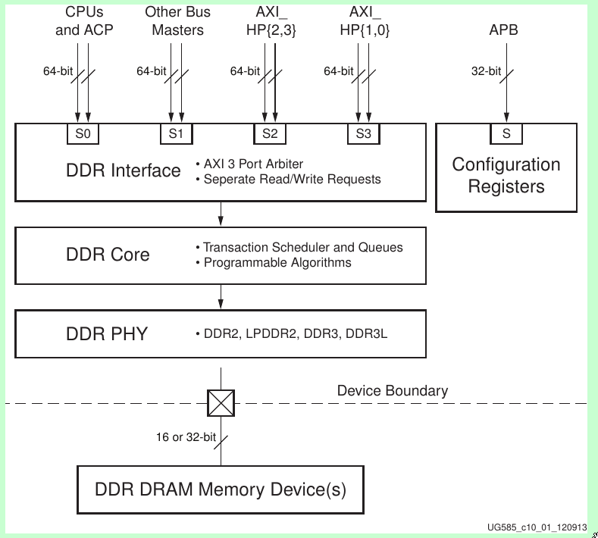

2018.2.28

问题1：FIR Compiler的输入采样频率设置1MHz和0.5MHz进行三倍的抽取，结果都正确。

