**Instructions: CYOA Event Segmentation**

This story has been written in a “Choose Your Own Adventure” style, where you can make choices and follow different storylines depending on your choices. You will each follow along with just one of the three main storylines. Your main task is to mark boundaries between different events in the story.

Because of the nature of CYOA stories, the structure is a little bit more complicated. Not only do you see the story text, you will also see the choices that would be presented, and some of the small branches of story. To help you picture what the structure is like, here’s a flowchart:

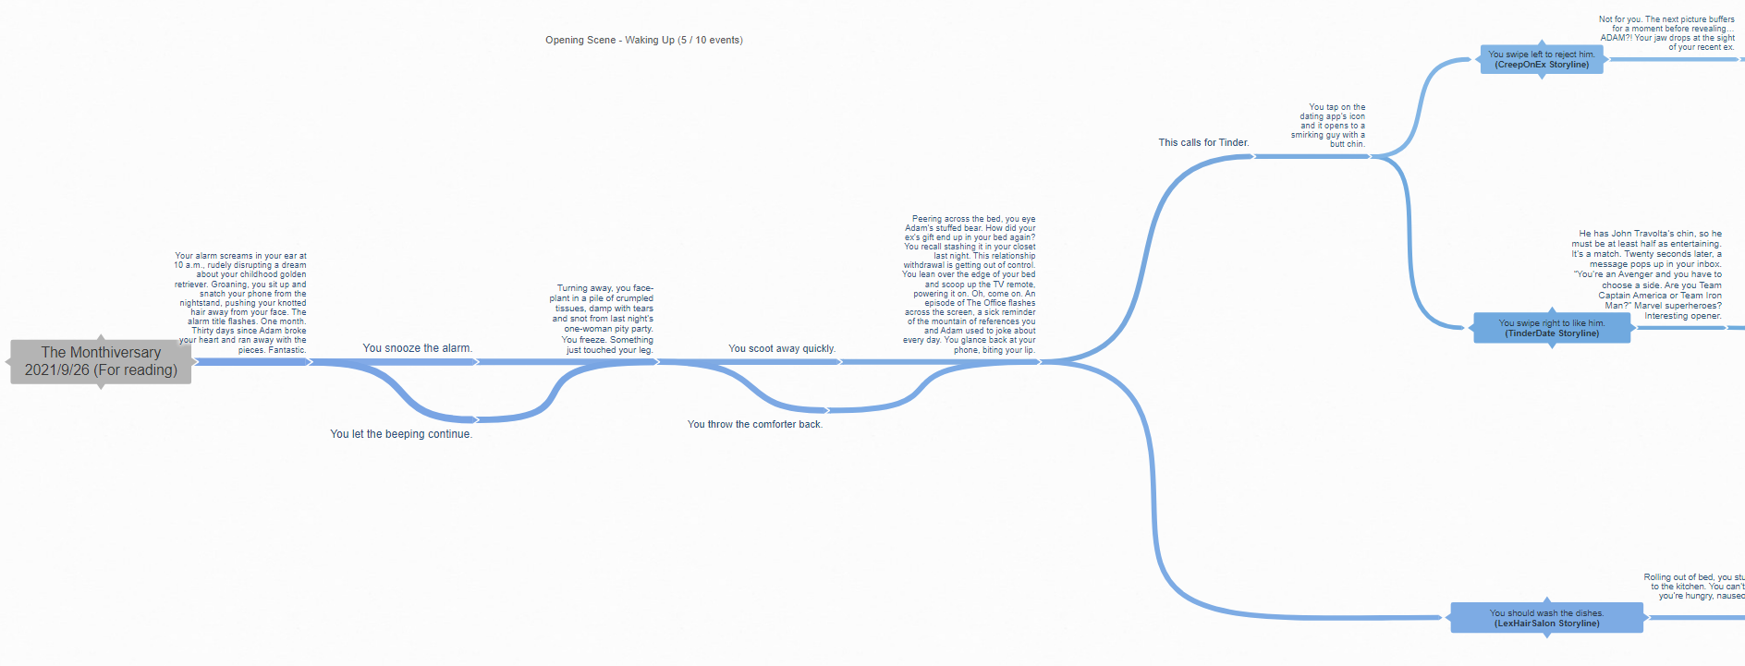

At the beginning, there are two choices, but they lead to the same outcome. Then later on, there are three main branches (the three storylines) and they stay diverged for longer, and have unique parts of the story, before they reconverge later.

**1. Place boundaries**

Your task is to identify time points in the movie at which there are breaks in the flow: these can be scene changes, shifts of topic, location, time, action, emotion, or other factors which make you feel that an event has ended and a new event is starting. We call these "event boundaries". Use your best judgment to choose time points where you feel there are event boundaries.

Use the @ symbol to mark the boundaries between events.

This is the example that I’m using to demonstrate how we’d like you to mark the boundaries between events. This example needs to be longer so here are some more words. **@** The next part of the instructions will talk more about the story.

You do not need to mark the choices as boundaries, just the parts with the story.

This folder has the three storylines you’ll be looking at. In each document, the indentation of the text indicates if any of the story is nested under one of the choices. You should mark boundaries for the main story text as well as text under one of the choices (the sections in bold).

**This paragraph is the story.**

Choice 1

Choice 2

**More story**

Choice 1

**Text you see only if you picked Choice 1**

Choice 2

**Back to the story**

**3. Submit your files**