- CIC-Darknet2020
  - ROEN_Fast_Transformer
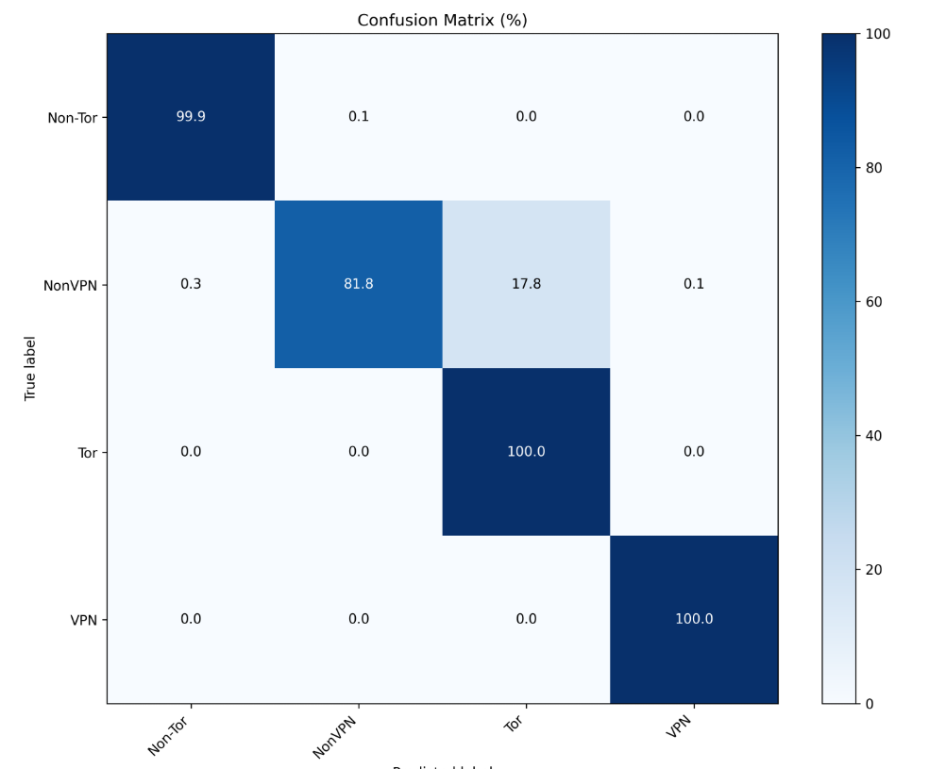
ACC: 0.9685, PREC: 0.9909, F1: 0.9760, Rec: 0.9685, FAR: 0.0378, AUC: 0.9974, ASA: 1.0000

2.ROEN_Final
超参数组合
SEQ_LEN = 10
BATCH_SIZE = 16
hidden=64
heads=8
NUM_EPOCHS = 100
LR = 0.001

2.1 CIC-NUSW-NB15
Thresh 0.5:Test -> ACC: 0.9713, Prec: 0.9823, Rec: 0.9713, F1: 0.9754, FAR: 0.0213, AUC: 0.9966, ASA: 0.7934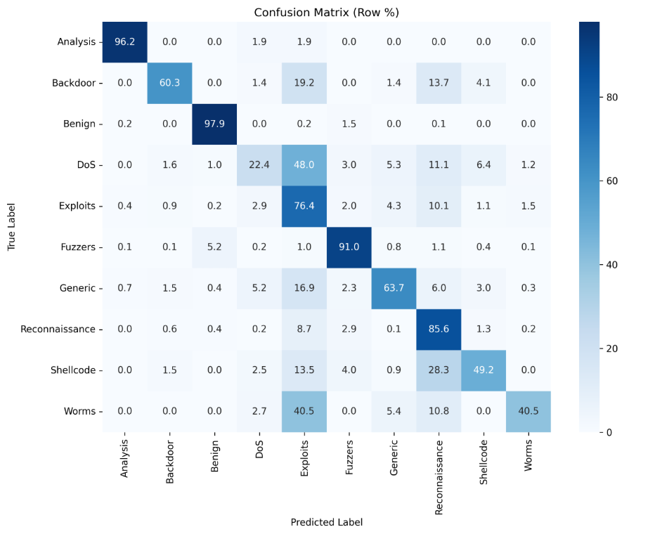
Thresh 0.4:Test -> ACC: 0.9710, Prec: 0.9826, Rec: 0.9710, F1: 0.9752, FAR: 0.0220, AUC: 0.9966, ASA: 0.8036