Supplementary Materials

#### Results of validation of *Yeast* gene expression data with size 10 and 100(DREAM3)

To describe the efficiency of DC-based methods, we compare our methods with MI-based methods in datasets with different size.

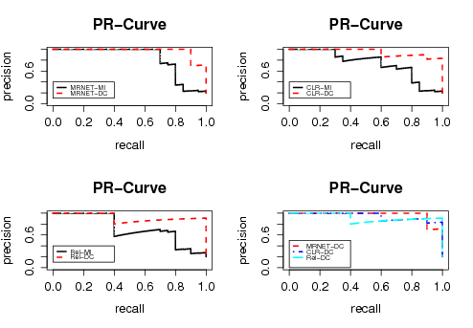

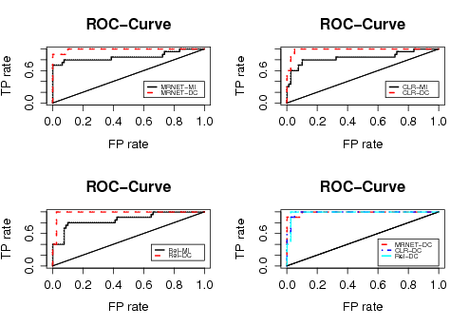

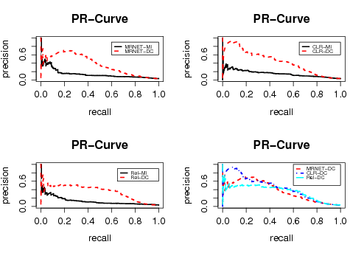

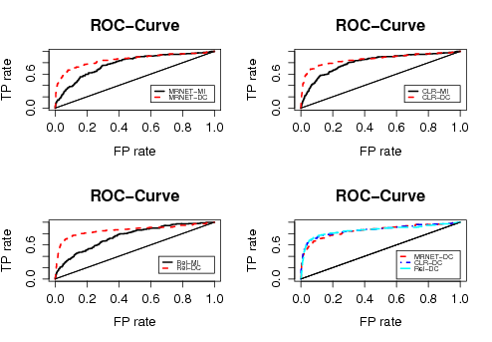

#### Performance comparison of different methods in noisy data

To access the performance of DC-based methods in noisy data, we compare REL-DC with REL-MI, DC-MRNET with MI-MRNET and DC-CLR with MI-CLR in datasets with different levels of noise. Those networks which contained 200 nodes and corresponding datasets were generated by SynTReN []. Moreover we compare the performance of different DC-based methods.

From these figures, we got that DC-based methods performed similarly to MI-based methods, however, they obtained better results which is more obvious in datasets with higher noise.

Yet, the performance of both DC-based methods and MI-based methods got worse significantly. However, as we can draw from Table 3, the difference between the performance of DC-based methods and MI-based methods remained nearly constant, which indicate that DC-based methods is robust in a sense.

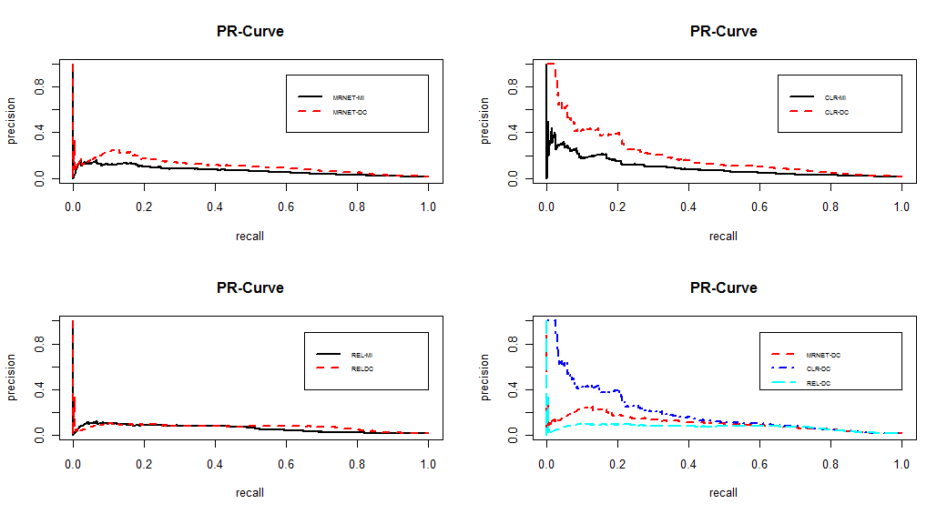

**Fig.S1** PR curves of different methods in data with 0.1 noise

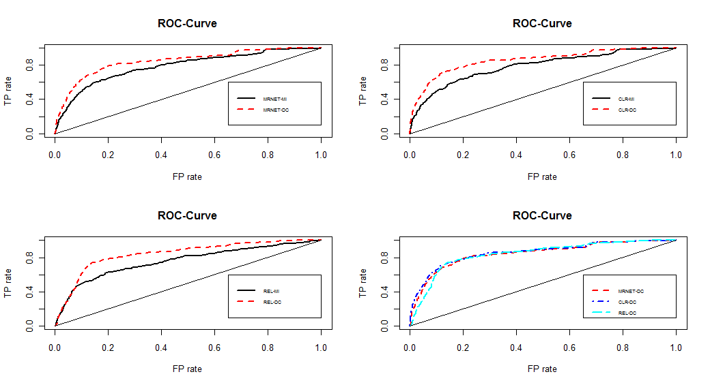

**Fig.S2** ROC curves of different methods in data with 0.1 noise

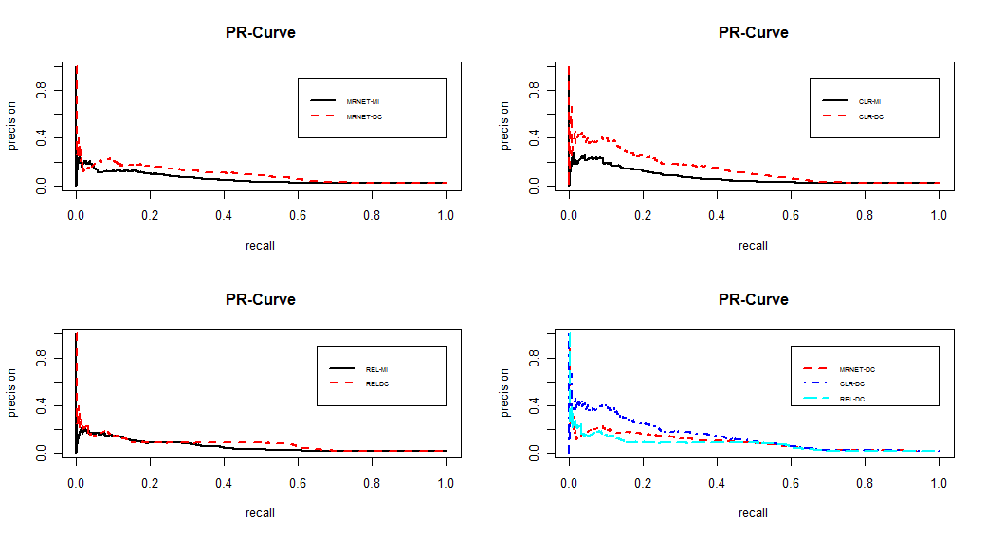

**Fig.S3** PR curves of different methods in data with 0.2 noise

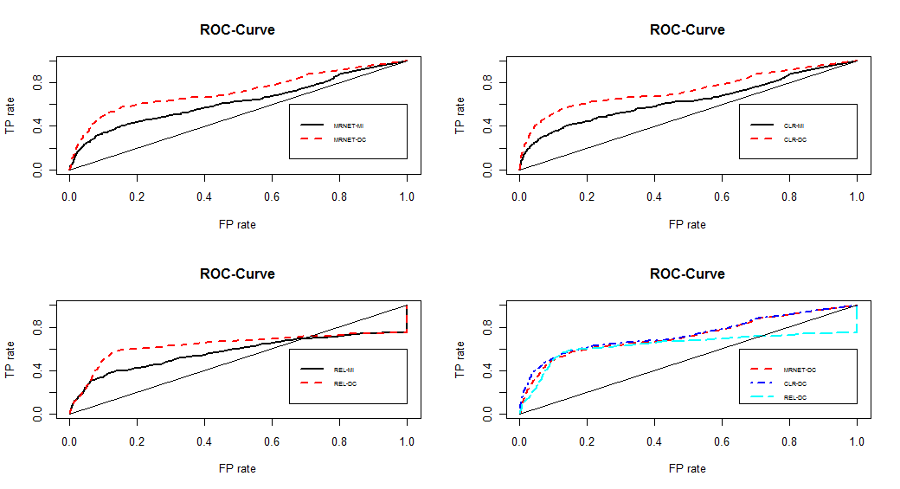

**Fig.S4** ROC curves of different methods in data with 0.2 noise

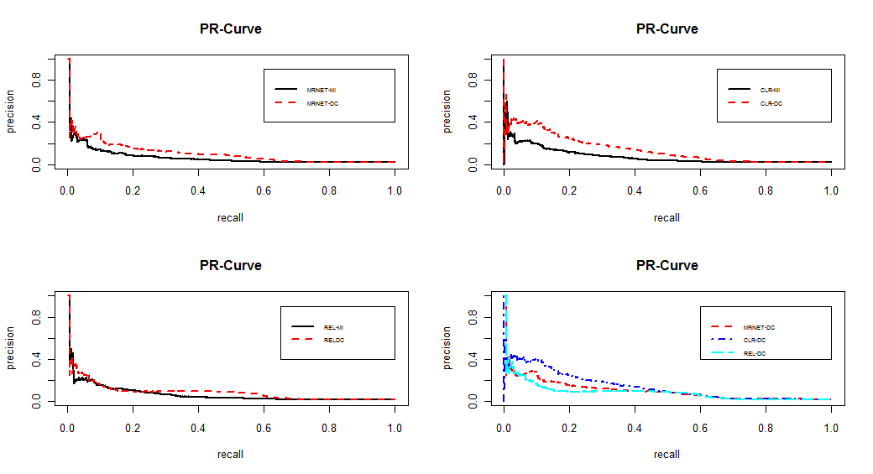

**Fig.S5** PR curves of different methods in data with 0.3 noise

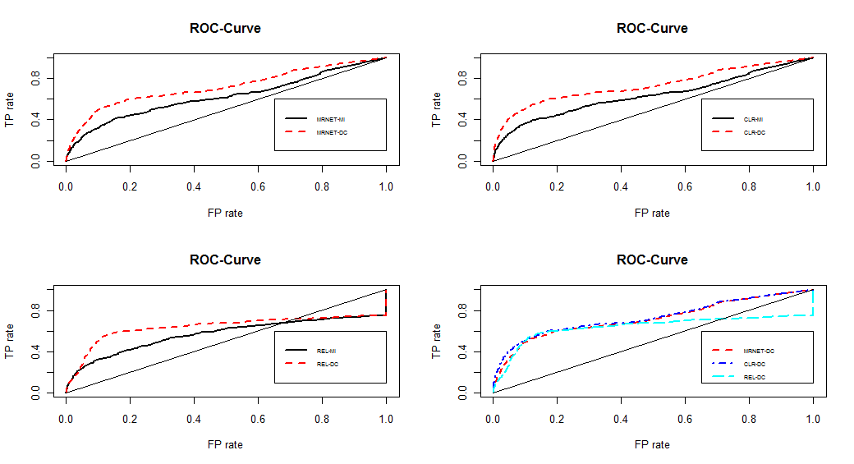

**Fig.S6** ROC curves of different methods in data with 0.3 noise