Project Description

1. **Project Overview**

The car market in China is huge. With the generation 1980s and 1990s, who are more open for “advanced consumption”, gradually becoming the main purchasers for cars, a growing demand for car loan is seen. However, most consumers know little about car loan or how it works. Therefore, our team decided to build a comprehensive car loan platform-"sweet mushroom easy loan". Our functions include a loan calculator, a car loan information search engine and an online transaction platform. Our app also includes a comment section, providing the chance for clients to share their experience or journey in both purchasing a car and choosing the right loan to the public, enabling lenders to adjust their loan policies based on all those ideas and thoughts.

Meanwhile, we would also provide map location services, allowing users to quickly find relevant outlets (both for purchasing and for financing). With the use of artificial intelligence, our service is more consumer-friendly and intelligent.

1. **Market analysis and positioning**

Nowadays, the development of online car loan information platform is still in its infancy, and the app that collects all the major loan means as well as detailed information has not yet appeared. Therefore, we have positioned the “Luxury Mushroom Loan” product as “a comprehensive information service platform focused on the car loan business”, and spotlight on showing detailed information for users about different ways of buying a car with the help of auto finance, so as to stand out from the crowd.

1. **Product introduction**

**“Luxury Mushrooms”** is a comprehensive information service platform that satisfies both the need from the car purchasers and the financial agencies.

On the one hand, this product is a software that provides relevant loan information inquiry, as well as the calculation of the amount to a specific type of car loan for car buyers. The core is to provide users with a fast and efficient way to get to know some detailed information of the available car loan choices at present. Our app “Luxury Mushrooms” contains all sorts of information, from the detailed information as well as terms & conditions of products provided by banks and loan companies, the required taxes, and the location of the nearest loan provider. At the same time, a car loan comment system is equipped to allow users to share their loan experience, and enable users to communicate with each other through this platform.

On the other hand, this product is a platform for lending business to various commercial banks and loan platforms (such as auto finance companies). Each state-approved commercial bank and platform can display relevant information to users through this platform, and obtain direct contact with individual users to realize the lending business.

1. **Business model**

(1) The app is free for downloading

(2) Merchant assistance and advertising implantation

(3) A small commission is charged for the loan transaction

(4) Potential data value: Analyze the data searched by users and analyze the user's preference for different car loan models.

1. **Development strategy**

The development strategy of this product is similar to that of the Meituan group.

In the initial stage, we will collect loan information from major banks and common large auto finance companies through data capture or field research (for display purposes only), and the platform will function as an information inquiry method.

At the same time, we would actively seek cooperation with small and medium-sized loan platforms. The platform which reached a partnership with us can directly connect with our users while displaying relevant information on the app to realize the lending business. At this stage, users can connect with the loan providers via our platform to reach a deal.

Later, with the expansion of our scale, we would use our own database and user resources, to attract commercial banks and large platforms to cooperate with us, so as to develop our app into a platform that covers whatever information on the market and whichever loan providers available.

1. **Marketing strategy**

We will combine the strategy of “push marketing” and “pull marketing”, and comprehensively adopt a variety of means including on-site visits, social media operations, and media advertising, to promote our platform to different customer groups. At the same time, we not only seek for the opportunity to cooperate with banks and loan platforms, but also actively attracts them to take the initiative to join us.

1. **Financial analysis**

After financial analysis (see Chapter 7 of the plan), we assume that the cost of “sweet mushrooms” is controllable. And based on the objective needs of the market, it is a high-quality project with broad profit margins and development prospects.

8. **Team introduction**

The name of our team is “Xiangqi Chicken”, which is taken from the three essences of human beings. The name shows that our team is developed based on analyzing the trend of current events, clarifying the needs of the masses, and the core spirit of building quality products that serve the society. Our team is mainly engaged in the operation of an app for auto loans and car information, and is determined to provide complete car loan information for the majority of car buyers. Our team's philosophy is to "create a more convenient world" and strive to create a "temperature-friendly" design with a good user experience.

**Chapter 1 Project Overview**

* 1. **Project Background**

Car loans are one of the largest and most extensive businesses in the financial business. Since the policies of various banks and loan platforms are very different, it takes a lot of time and effort for users to understand that of each way of acquiring loan. Therefore, when users choose a car loan, the phenomenon of information asymmetry arise.

Based on this phenomenon, the team decided to build a comprehensive information service platform based on car loan information to provide comprehensive and effective vehicle loan information for every car buyer.

* 1. **Products and services**

Our team developed a mobile app called “Luxury Mushroom Loan”, which includes functions such as car loan inquiry, information docking, car loan calculation, car loan information, and a sharing platform. Users are divided into two categories according to their identities, namely individual users and loan platforms (including banks and other loan platforms). Loan platforms can register to the app after providing some necessary information relevant and licenses to launch a car loan lending business on our platform. Individual users can scan the information, evaluation, contact information, etc. of each loan platform on the app, and can connect with customer service of the registered platform, ask about relevant information, and then carry out the loan procedure through the respective processes of each lending platform.

In addition, we also provide inquiries for various models of cars and the latest car news articles in the car information module. Users can not only query the relevant information of various loan platforms in the app, but also learn about the latest car purchase policies and view the latest and most popular car related information in this platform.

* 1. **Product Functional Objectives**

As a comprehensive information service platform focusing on car loans, “Luxury Mushrooms Loan” is determined to solve the problem of information asymmetry in car loans and create more convenient information services, providing more comprehensive and accurate information for car buyers. And we heartedly promoted inclusive finance, as a respond to the nation-wide trend, enabling more people to enjoy financial services easily and conveniently.

* 1. **Product Positioning**

“Luxury Mushrooms” is a comprehensive information service platform that focuses on the car loan business and connects bank and platform with users. Our market positioning is to be the platform for all car buyers and car loan service providers.

* 1. **Overview of Business Models**

This product connects car buyers and car loan service providers and is completely free to use. Individuals could inquire information and raise comments in the app once they have logged in. After the certification and qualification assessment, the car loan service providers could publishes loan information in the app.

When car loan service providers have promotions to make public, they can pay for the chance to get the recommended ad slot on the homepage, as advertising fee. It is necessary to ensure that the promotions are true and effective, to ensure the safety of users' property, and to comply with relevant national laws and regulations.

**Chapter II Product Overview**

**2.1 Mushrooms easy to lend**

**2.1.1 Product Design and Frame**

The "Lush Mushroom Easy Loan" app is divided into 4 modules: Home, Loan, Consulting, Me.

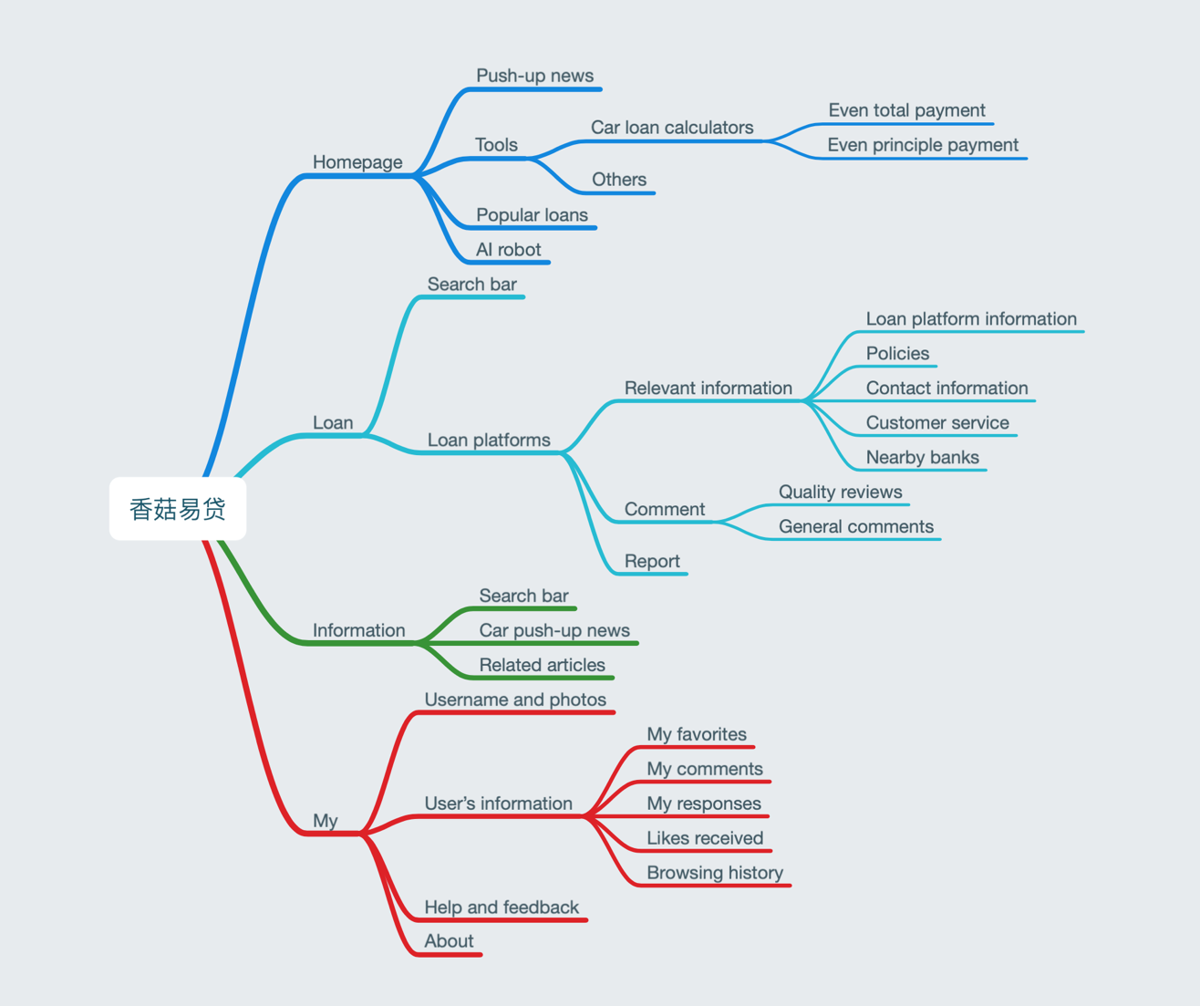

"Home" is divided into 3 modules: push-up news, tools, and popular loans. It comes with an artificial intelligence robot.

“Loan” consists of a search bar and a selection of available loan platforms. Click on the platform, then users could enter the details page.

"Information" includes a search bar, car information, and related articles.

"Me" includes the user's avatar and username, my favorites, my comments, my replies, my likes, browsing history, help and feedback, and about mushrooms.

2.1.2 Product display

The “home page” is in the structure of upper middle and lower, which are: push-up news, tools, and popular loans.

(screenshot of the homepage)

In the toolbar, we have an advanced loan calculator, which can calculate the interest and monthly repayment amount of both the method of even total payments and the even principal payments, and can also calculate the amount of purchase tax, vehicle and vessel tax, and CLIVTA.

(screenshot of the calculation interface)

The AI robot (supporting voice control) is set in the lower right corner of the interface. Users can communicate with it to learn about the usage of the app. It can help users to go to the page they want, and recommend some car loans according to the users’ needs.

(Close-up screenshot of the robot in the screenshot of the homepage,)

(Chat screenshot)

“Loan” consists of a search bar and a selection of loan platforms.

(loan interface screenshot)

Click on the loan platform to go to the “platform details” interface, to view loan platform information, policies and services, contact information, quality reviews and general comments. Commenting, collecting, etc. can also be performed here (login required).

(Picture of the platform details interface, circle the "Report" button, etc.)

In addition, with the reporting function, we will deal with false information and non-compliant platforms objected by users seriously, according to national laws and regulations, and report it to relevant state departments for filing.

(Reporting interface screenshot (may not))

The “information” section also has an upper middle and lower structure, with the search bar at the top, the car push-up news at the middle, and the related articles at the bottom.

(Screenshot of the information interface, circle the "View More" button, etc.)

Among them, a button for car browsing is in the lower right corner, users could click in the car information page, to browse various brands, models and prices.

(Car interface screenshot (similar to Baidu image interface))

If users don't click the button mentioned above, they can continue to slide down to see other related articles, including the latest car purchase information and national policies.

(Article screen screenshot (similar to qq point of view interface))

The "My" page is a top-and-bottom structure with the user's photo and username on the top, and my favorites, my comments, my responses, likes received, browsing history, help and feedback, about mushrooms at the bottom.

(My interface screenshot)

**2.1.3 Technology implementation**

Use app development technology and aesthetic design technology to build our app and related interfaces; use big data and cloud computing technology to recommend articles and loans specialized for every user; use AI and ASR technology to train our robot; use LBS technology to provide the information of nearby banks and suggested routes.

**2.1.4 Innovation points**

(1) “Luxury mushroom loan” connects lenders and borrowers, and is an open platform for both parties.

(2) With the comment section, users can share their experiences in banks or other platforms

(3) Combining the information section, our app is a one-stop information service platform that combines car browsing, inquiry, calculation and loan.

(4) Equipped with AI, positioning & navigation functions and other cutting-edge technologies, we provide users with a better experience.

**2.2 Product development**

**2.2.1 Basic process of product developmen**



Our team started working as soon as we registered for the competition, and we collected and read many cutting-edge information and papers of Fintech. Through discussions online and offline, we decided on our theme. Then, our team extensively referred to various types of apps on the market, using design aesthetics, and then design our interfaces and functional modules. After that, we use Java to create prototypes, and then improve and add various functions to it through receiving feedbacks and repeated modifications.

**2.2.2 Product development direction**

(1) Introduce more gadgets in the “Tools” column of the homepage, improve product features;

(2) Develop IOS and computer version

(3) Continue to strengthen the outlook of our product, improve our server, and enhance user experience;

(4) Continuously improve our management system, ensure that the loan platforms cooperated have relevant licenses, conform to national laws and regulations, and the loan information provided is authentic and effective;

(5) Continue to improve our specialized recommendation function, to ensure what we recommend is what our users need;

(6) Consider the follow-up of mortgage and other loan business information query functions

**Chapter Ⅲ Macro Environment Analysis**

**3.1 Political Environment Analysis**

The support of national policies for auto loans has promoted the development of the auto loan industry. In 2017, the People's Bank of China and the China Banking Regulatory Commission promulgated *the Notice on Relevant Policies on Adjusting Automobile Loans*. In order to implement the State Council's policy of adjusting the economic structure, release the diversified consumption potential, and improve the quality of the supply of the automobile consumer credit market, it is recommended to increase the maximum proportion of auto loans. Comparing the contents of the old and new laws, we can see that the biggest highlight of this revision is the preferential adjustment of the loan ratio of new energy vehicles and second-hand vehicles. This is an encouragement for the automotive consumer credit market.

Comparison between the old and new laws:

|  |  |  |
| --- | --- | --- |
| Comparison | The old law | The newest law |
| Legal execution time | October 1, 2014 | January 1, 2018 |
| Loan term | It shall not exceed 5 years. The loan term (including the extension period) of the used car loan shall not exceed 3 years, and the loan period of the dealer's car loan shall not exceed 1 year. | As before. |
| The first new addition |  | Identify the ‘new energy vehicle’ category |
| The second new addition | Set the maximum loan disbursement rate. | Clarify the ’requirement system for the maximum issuance of loans for the implementation of loan disbursement’, and the People’s Bank of China and China Banking Regulatory Commission will separately make provisions based on the actual situation of macroeconomics and industry development. |
| Loan ceiling | Self-use car: no more than 80% of the car price  Commercial vehicles: no more than 70% of the price of the car  Used car: no more than 50% of the price | Self-use traditional power car: the highest proportion of 80%  Commercial traditional power car: the highest proportion of 70%  Self-use energy vehicles: the highest proportion of 85%  Commercial new energy vehicles: up to 75%  Used car: the highest proportion of 70% |

As early as October 2015, the People's Bank of China decided to cut the benchmark interest rate for financial institutions' RMB loans and deposits. This adjustment also contributed to the increase in auto loans. The following bank information is the latest bank deposit benchmark interest rate table (updated on January 1, 2019) implemented since October 2015:

|  |  |
| --- | --- |
| **Various deposit interest rates** | **Interest rate** |
| Demand deposit | 0.35 |
| **Time deposit** | **Interest rate** |
| 3 months | 1.10 |
| Half a year | 1.30 |
| 1 year | 1.50 |
| 2 years | 2.10 |
| 3 years | 2.75 |
| **Various loans** | **Interest rate** |
| More than 1 year (including 1 year) | 4.35 |
| 1 to 5 years (including 5 years) | 4.75 |
| More than 5 years | 4.90 |
| **Provident fund loan** | **Interest rate** |
| Less than 5 years (including 5 years) | 2.75 |
| More than 5 years | 3.25 |

**3.2 Economic Environment**

With the development of national income and living standards, people’s spending in the field of transportation and communications has increased year by year, which cause private car ownership growing rapidly.

Map of Residents' Income and Expenditure and Transportation Expenditure in 2014-2018

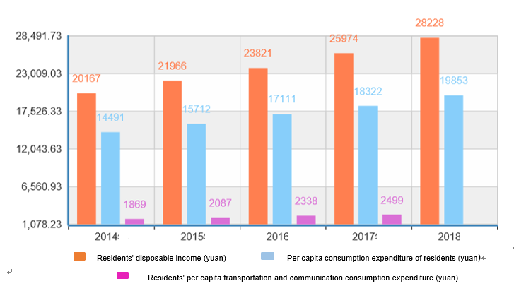

Chart of private car ownership in China in 2014-2018

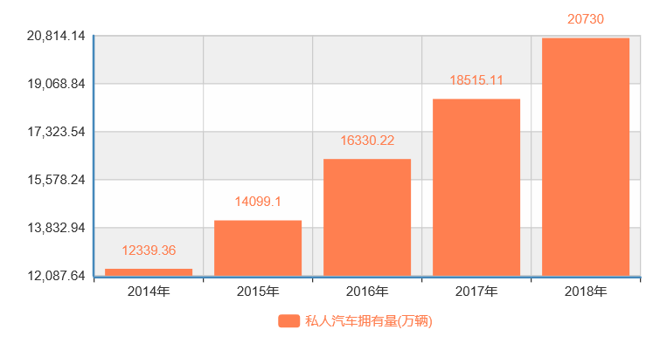

Car ownership (10,000)

It can be seen from the charts that while the income of residents in China is enhancing, the demand for automobiles is increasing, and the demand for car and car loan information is also raising. The emergence of the car loan information platform is a positive response to market demand.

**3.3 Social-cultural influence**

First, the car is not only a means of transportation, but also a symbol of status. Having cars has become an important indicator for people in the modern era.

Second, people's awareness of advanced consumption has increased. According to the data of the People's Bank of China, China's personal consumption loans have experienced explosive growth since 2015. From the latest data in 2018 and 2019, personal loans are still rising. According to the data of the survey on the distribution of “car purchase age” in South China in 2016, the owner’s age group is the most concentrated in “25-29 years old”, accounting for 23.3%. Followed by “30-34 years old”, about 19.2%. And these two groups have occupied more than 40%. The generation after 80s and 90s gradually became the main consumer of the automobile market. Advancing the future money to realize the immediate consumption desire, whose essence is the immediate satisfaction of psychological needs. People after the 80s and 90s grew up in an era of social stability and material abundance. Unlike their parents who suffered from material scarcity. What is more, their parents are now the backbone of society and have better economic strength which leads to young people have no strong sense of crisis of losing their wealth. In addition, the only generation in the family gathers thousands of loves at home, parents often have responsiveness or even oversupply for their material needs, and children do not need to work hard and endure to easily get what they want. With the rapid development of Internet finance and the increasing convenience of credit lending channels, credit consumption has become the preferred payment method for young people. Awareness of advanced consumption in gradually increasing.

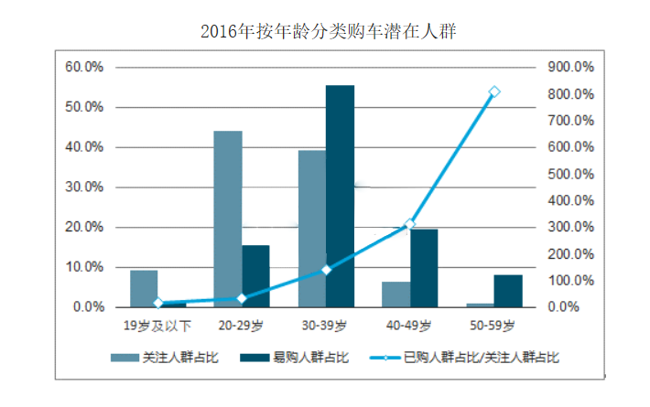

The portion of population who focus on easy to buy bought/focus

Potential crowds of car buyers

Under 19

**3.4 Technical Environment Analysis**

3.4.1 The connection of the Internet of Things will become a product development trend.

In the current era of continuous development of financial technology, from a global perspective, the connection of the Internet of Things has become a trend of product development. Whether it is the rise of the online shopping industry or the emergence of platforms such as online banking, it is inseparable from the combination of finance and technology.

3.4.2The online loan platform is developing rapidly, and the comprehensive auto loan inquiry platform is still a blue ocean.

With the advent of the Internet era, online loans have emerged. The diversification of car lending channels makes consumers feel overwhelmed when they choose. The extremely fast-changing loan data also makes it difficult for bank auto loans to be launched online. The lack of relevant auto loan information consultation platform provides us with a great opportunity, but it is also a challenge.

**Chapter IV Microenvironment**

**4.1 Market situation and prospects**

**4.1.1 Current situation**

**4.1.1.1 Big firms become bigger, making it hard for small platform to emerge**

The development of the auto finance market has finally reached a stage of steadiness after an explosive growth and the development of a staged low. In 2018, the total volume of China's auto finance industry exceeded one trillion Yuan, becoming a "cash cow" which everyone chases for.

But at this stage, most of the market share of China's auto financing market still belongs to the relatively conservative commercial banks. As veterans endorsed by the car companies, the traditional auto financing companies has a solid foundation in the non-bank market, and is firmly in the forefront of the market with more stable low-cost funds and a multi-year iteration of their risk control systems. As for flexible and convenient online loan platforms, what they have been trying to in the past few years were to catch up with the traditional platforms and to acquire more customers.

Unlike those traditional auto finance companies which are operating stably, the competition between online platforms is fierce. According to the data from *Online Loan Home*, in the year of 2018 alone, 206 car loan platforms faced the dilemma of stopping operations or transformation due to the pressure from big companies in the industry.

Online platforms must break through the traditional way of acquiring customers and making loans, and differentiate their way of operating the company if they want to survive in this jungle. For traditional institutions, only by actively embracing Fintech in the Internet era can they maintain their leading positions

**4.1.1.2 Since the majority of consumers become younger, a significant increase in car financing acceptance is seen**

In 2018, China's automobile sales ranked first in the world for the tenth consecutive year. Among purchasers, 1990s accounted for 26%. Growing in the electronic generation, they are more open for “advanced consumption” compared to the older generations. As digitalization, people have more chances to be exposed to new ideas, therefore an increase in the proportion of consumers who turn to car loans when buying a new car, reaching 30%.

**4.1.1.3 Though the diversity of car loan products is seen, integrated platforms for product comparison have not yet appeared**

In the trillion-dollar market, car buyers have a variety of choices when making loans. However, information about car loans is everywhere on the Interne. A car buyer may need to pay a lot of time and effort into getting accurate, authentic and suitable information. Therefore, what they tend to is to make loans directly through 4S stores, which results in challenges for non-brand affiliated financial companies to acquire their customers.

**4.1.2 Market trend**

**4.1.2.1 An increase in auto finance penetration rate**

Due to the large population base, China's 1,000-person car ownership has reached only 170 vehicles in 2018, far below the world average. Residents in China still possess a large potential demand for automobiles, and the market has broad prospects for development.

Compared with overseas mature markets, the penetration rate of China's auto finance is also significantly lower, see picture below:

With the development of the used car market and the rise of the new-energy car market, China's auto finance still has sufficient room for development. The report from *Roland Berger* predicts that by 2020, China's auto finance penetration rate is expected to reach 50%.

**4.1.2.2 Financial leasing emerged**

With the saturation of car market in the first- and second-tier cities, the third-to-fifth-tier cities have become the new playground for auto financial leasing business. Compared with the first- and second-tier cities where 4S shops are densely populated, consumers in the third-to-fifth tier cities rely more on the Internet when they are selecting and purchasing vehicles. At the same time, since the requirement for financial leasing are softer than traditional car loans, this product is also more suitable fo r promotion and sales using the Internet platform.

**4.2 Demand Analysis**

For car loan demanders, they need a more concise and efficient car loan information platform to meet their diverse and personalized loan needs.

For loan providers, they need a channel that is more directly accessible to effective customers, reducing the cost of intermediate links.

**4.3 Competitive Analysis**

We believe that the competitors of this product are divided into two categories: one is a loan service provider with data and technology advantages, and the other is an existing all-category loan integration platform. The following is a demonstration of two typical examples:

|  |  |  |
| --- | --- | --- |
| Name | Introduction | Advantage |
| *Credit Force*  (The parent company of a loan search platform “*Jiedianqian*”) | *Credit Force* is a credit service solution provider that provides an integration of precision marketing, big data risk control, SaaS and other services for more than 1000 financial institutions, including CITIC Bank. | 1. Have an official endorsement from Shanghai Social Credit Promotion Center  2. Holding a large amount of transaction data, which help them become more accurate when positioning customers  3. The platform has a high reputation which making them easy to earn the trust from institutiors. |
| *Rong 360* | Rong 360 enables users to search and compare loan products from various banks and lending agencies.  It went public on NYSE in 2017. | 1. The platform is matured after 8 years of development  2. Have continuous and stable fund channels since it has gone public  3. Offer more than 200,000 financial products of various kinds |

However, both platforms have seemingly neglected the auto finance market. Taking *Rong 360 Network* as an example, when users want to obtain information about car loans, they cannot directly obtain all product information from the online page. Instead, they need to leave personal contact information and wait for the loan officer's contact. This has greatly lengthened the process for applying for auto loans, causing inconvenience to consumers.

**4.4 SWOT model**

|  |  |
| --- | --- |
| Strength | Weakness |
| 1. A unique platform for car loans, reducing the time customers spend in searching for the right product with our search engine  2. Combine loan product recommendation, comment community, information and other diversified services to create a unique experience and increase user's stickiness to the platform.  3. Connect lenders and borrowers in no time  4. Moving down close to customers in need | 1. The platform is new, making it difficult to attract lenders to corporate with us  2. Car loan is not a demand for-all, so the customer base is rather small  3. Our own resources and technology are limited, so we need to rely on some data from a third-party agency  4. Limited funding sources for operations |
| Opportunity | Threat |
| 1. Auto finance has received strong support from national policies as a new leverage for financial services  2. 1990s, who are more open for “advanced consumption”, are gradually becoming the majority of consumers for cars  3. The call for inclusive finance  4. The increase in automobile financial penetration rate | 1. The early promotion of the platform requires a lot of human and material support.  2. The platform is highly reproducible, and it is easy to encounter other competitors with stronger technical strength in the market.  3. The protection of borrower information and the identification of the qualifications of platform assessed require a high level of risk management. |

**Chapter V Marketing Strategy**

**5.1 Target Market Strategy STP**

**5.1.1 Market Segmentation**

We divide the market into three categories according to loan type, object type and region, as shown in the following figure:

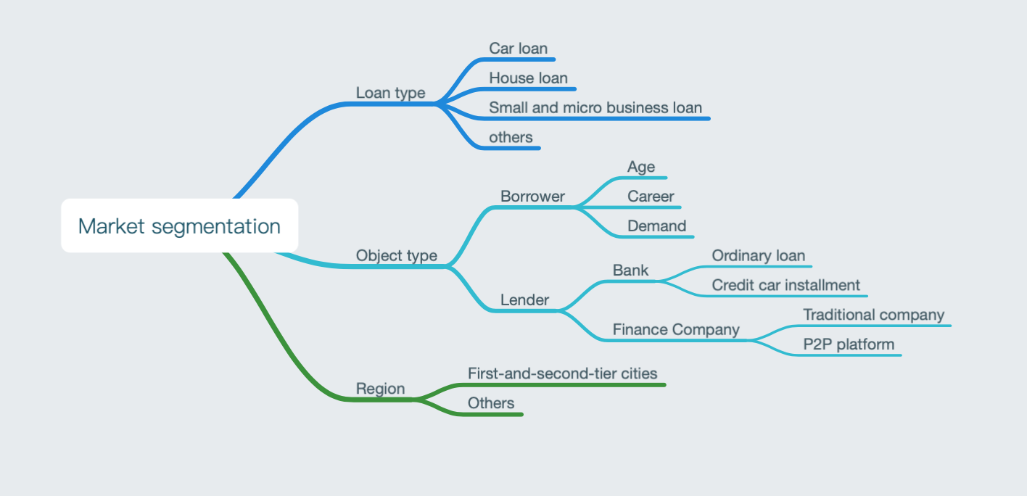

**5.1.2 Selecting the target market**

According to our study of the market, we have targeted our market as all lenders in China who want to purchase cars with the help of auto finance, as well as well-qualified lenders, and we would implement differentiated target market strategies.

**5.1.3 Market Positioning**

“Luxury Mushrooms” is a one-stop comprehensive information service platform focused on the car loan business, providing services to both borrowers and lenders.

For borrowers, “Luxury Mushrooms” is provides a one-stop loan solution for them, which goes as “personalized recommendation-selection-application-lending”. It saves the time required to search for information. The *loan review* feature also facilitates their choice of loans.

For lenders, “Luxury Mushrooms” is positioned to help them change the traditional way of acquiring customer via offline locations, to get rid of the shackles from the car dealers, and to provide them the opportunity to directly get in touch with their customers.

**5.2 Marketing plan**

|  |  |  |
| --- | --- | --- |
| Time | Goal | Strategy |
| Within six months of release | 1. Actively expand user base and increase users’ acceptance towards our app  2. Attract more financial companies to join us | 1. Post advertisements in bbs such as “Car Home”  2. Implement a system of giving rewards to encourage users to promote to friends around them.  3. Get recommendations from well-known bloggers or the media, advertise in the app store to increase our exposure  4. Allow financial companies to make transactions via our platform without commission in the previous period |
| Within a few years of release | 1. Develop into a leading platform that serves all users in all provinces  2. Maintain user loyalty and continuously improve our customer experience | 1. Set up offices in various provinces or regions to do target marketing and solve the problems locally  2. Implement word-of-mouth marketing strategy, actively take on social responsibility, and establish a positive corporate image |

**Chapter VI Team Management**

**6.1 Team Introduction**

Team name: Hong Cookie

Overview: the team takes the development of automobile loan information inquiry platform as its main business. The core of the business is to provide loans to buyers to provide loan information inquiry channels and to build bridges with customers for lending units. It is supplemented by other modules such as location service, sharing comments, and latest news. Determined to provide complete car loan information for the majority of car buyers. The team concept is “creating a more convenient world” and strives to create a “temperature-friendly” design with a good user experience.

**6.2 Organizational structure and management**

Based on the high requirements for comprehensive product performance, the initial core of our team is the students of two economics and trade colleges, one student majors in software , one academic of the mathematics college and one law school student.

We adopt a flat management **mode** and a rectangular organizational structure as a development framework to promote effective communication and achieve effective resource integration. The four functional departments serve as the horizontal axis of the organizational structure, while the vertical axis is the product line of the studio. Each specific project is carried out on the horizontal axis with the close cooperation of various departments.

**6.3 Function and Division of Labor**

**6.3.1 General manager**

The general manager's tasks include: grasping the direction of the team development, responsible for the normal operation of the entire team, team building, coordinating the work of various functional departments, organizing the company's monthly, quarterly and annual plans and indicators, and monitoring the operational development of each product line. Conduct performance evaluation on each product line, monitor the company's human resources status, financial income and expenditure status, and the overall status of the company's assets.

**6.3.2 Product Management Center**

With the cooperation of the market finance center, the product management center should understand the market, analyze the target user needs, and grasp the product direction and positioning through user expression. And it should make product plans according to product goals, provide product requirements documents and technology centers, assist and participate in product development. After the product goes on the market, pay close attention to the platform operation center, improve and improve user requirements in time, and promote product rapid and efficient iteration.

**6.3.3 Market management center**

The market management center should conduct research on the target users, master first-hand user data, analyze the target market, and provide market demand documents for the project management center. Before the product goes on the market, it needs to plan the corresponding marketing plan through the existing analysis of the target market: conduct reasonable financial analysis, estimate product cost and revenue, and coordinate the project management center to plan the product reasonably. After the product goes on the market, it must dock with the platform operation center to obtain real user feedback and adjust the marketing plan in time.

**6.3.4 Product and Technology R&D Center**

Under the guidance of the project management center, he should correctly understand the product requirements, and make the app interface as close as possible to the user's needs. After the product goes online, pay attention to the platform operation center and update the platform data and information in time with the cooperation of the project management center.

**6.3.5 Platform Operation, Maintenance and Feedback Center**

This center works closely with the marketing finance department to attract new users while enhancing user stickiness. It should correspond and record user feedback, provide feedback to other functional departments, make version updates user-centric, and achieve rapid and efficient iteration. In addition, it should severely crack down on illegal lending platforms, prohibit them from carrying out related activities in the platform in time and complain to relevant departments.

**6.4 Corporate Identity**

**6.4.1 Internet mind identity**

(1) Mission: Based on the analysis of current events, clarifying the needs of the public, and creating quality products that serve the society.  
(2) Business philosophy: Internet companies that follow loan-related policies and related products,  
(3) Service concept: Customer-oriented, market-oriented, technology-based, and experience-oriented.  
(4) Employee creed: highlighting individuality, realizing value, and serving customers wholeheartedly

**6.4.2 Behavior Identity**

Organizational system: Team management is carried out in a matrix structure. Each member belongs to each administrative department and is also a member of the product development cycle. From the product development, we can realize the core spirit of the team to analyze current events, clarify the needs of the masses, and create quality products that serve the society.  
Management norms: product development and enterprise management are divided into two parts. For each employee, the same stage two roles, as part of the product development chain, also grasp the analysis of the entire enterprise. Product and management are supervised by each other, there is no fixed relationship between superiors and subordinates, and they are encouraged to grow together.

Chapter VII Financial Analysis

**7.1 Basic financial assumptions**

In order to comprehensively and accurately analyze the financial status and operation status of the project, we establish the following financial assumptions:

1. Our platform relies on the company that has officially registered in the industrial and commercial administration department, and pay relevant taxes and fees according to law.
2. The unit of measurement is in RMB.
3. In the foreseeable future, the company will continue to operate at its current scale and status, will not cease business, and will not cut its business on a large scale, and its social, political and economic environment will remain relatively stable.
4. Accounting period: From January 1 to December 31.

**7.2 Financing plan**

Due to the need for our platform to be developed, we plan to apply for college students' entrepreneurial loan (interest-free) 100,000 yuan (four-year period), plus 80,000 yuan from every team member, and seek financing of 500,000 yuan, totaling 1 million yuan, as a start-up fund.

Later, we may seek for VC.

**7.3 Capital Operation Plan**

The upfront financing is mainly used to realize the transition from product ideas to executable applications, and is planned for the following parts:

**7.3.1 Technology R&D investment**

Mainly used for the rental of network servers, as well as the necessary expenses in the process of app development and online testing.

**7.3.2 Market expansion investment**

The focus of the platform promotion is to cover every consumer with car loan needs and all financial institutions with good qualifications. For this, a series of marketing activities including the app store homepage advertisement and the act of visiting financial enterprises are required. To save costs, everything would be done by the founding members.

After the stable development period of the platform (estimated for 2 years), and if we could acquire external capital, the use of our funds will shift from focusing on marketing to focusing on forming a more specialized operation team.

**7.4 Expenditure items**

Project Description

|  |  |
| --- | --- |
| Item | Introduction |
| App development | The cost in developing the app |
| Online testing of the app | Running stability test on the software before it was put on the market |
| Product promotion | 1. Visit financial enterprises 2. Advertisements and click farming activities 3. Other promotion ways |
| Employee salaries and benefits | Include employee salaries, bonuses, commissions, training fees, etc. |

**7.5 Income item**

|  |  |
| --- | --- |
| Item | Introduction |
| Commission | Expected to charge a 0.1% commission on each transaction made through the platform. |
| Advertising revenue | Homepage banner |
| Personalized push-up information |
| Data Sharing Revenue | After having accumulated a large amount of user data and enter a stable development period, we can use our own data advantages to build analysis models, and share it with our partners. |

**7.6 Summary**

After investigation and analysis, we suggest that the project cost of “Lush Mushroom Easy Loan” is controllable and it exist based on the objective needs of the market. It is a project with broad development prospects and profit margins.

**Chapter Ⅷ Risk Analysis and Control**

**8.1Risk Identification**

Due to the constant changes in political, economic and technological factors, the project brings great uncertainty and makes risks everywhere. Therefore, doing a comprehensive analysis of project risks and finding good countermeasures is the most effective way to avoid risks.

**8.2Risk Classification**

**8.3Risk Management**

**8.3.1 Macro environmental risk**

In recent years, the state has supported loans to purchase cars, and the state has also introduced relevant policies to encourage loans to purchase new energy vehicles. Although the restrictions imposed by some cities have affected the automobile market, from the statistics of recent years, the number of cars purchased is still large. Therefore, the probability of a national policy affecting the company is small, and it can be legally operated. At the same time, we should pay close attention to the state's incentive policies for the industry and make full use of policies to achieve the company's development. Connect the relevant industries, give play to the advantages of the group and strengthen the understanding of national policies.

**8.3.2Industry environmental risk management**

**8.3.2.1 Market risk**

1.Formulate long-term planning, develop market strategies step by step, achieve the established goals of the market, avoid market risks, and ensure the smooth development of the company.

2.Further improve the app‘s function, adhere to the service level, and protect the user experience.

3.Improve the comprehensive competitiveness of technical services to enhance the ability of service products to adapt to the changing needs of the market.

4.Establish a sound and complete market information network to capture the latest market trends and improve product services.

**8.3.2. Product risk**

1.Enhance service quality by improving technical content and strengthen scientific and technological research and development.

2.Establish a product supervision feedback mechanism and conduct customer research in a timely manner.

3.Timely handling of product failures to ensure smooth operation of the product.

4.Strengthen technical support for products.

5.When a resident merchant publishes false information, destroying market order and infringing on consumer rights. Let the merchant get off the shelf in time and report it to the relevant departments.

**8.3.2.3 Competitive risk**

When the market competition is not yet mature, we will increase our efforts to develop ourselves, strive to move closer to market leaders, seize market share, and enhance our competitiveness. Make the company achieve the position of market leader with strong technology, strong R&D and production strength, excellent product quality, good service attitude and great resource advantages.

When the market competition is close to maturity level, we will try our best to ensure the position of market leaders through adjusting plans to meet the market and developing technology, to maintain good competitiveness, and at the same time to establish a crisis planning.

**8.4 Internal Environmental Risk Management**

**8.4.1 Management risk**

(1) Strengthen management and control costs.  
(2) Take various measures such as internal training and external training to improve the overall quality of the team.  
(3) Advocate focus on hotspots, keep up with current events, and strive to innovate to adapt to the changing external environment.

**8.4.2 Technical risk**

(1)Take a variety of incentives, such as raising benefits, employee technology shares, etc., and retain talent as much as possible.  
(2) Strengthen the construction of technical R&D team, improve the overall R&D capability, and regularly conduct vocational skills training for the corresponding employees to improve the overall technical level of the company. Employing relevant experts to conduct business guidance for the company's research and development, making the company's technology research and development more smoothly.  
(3) Participate in the technical exchanges within the industry, provide a communication platform for the research and development of technical personnel, and inject fresh blood into the innovation and development of technology. Track new platforms that are emerging on the market.  
(4) Strictly crack down on infringement of intellectual property rights.

**8.4.3 Financial risk**

1) Follow the principle of income and risk balance, and avoid disadvantages  
(2) Establish and improve the financial risk management and control system: establish a company internal prevention system; strengthen financial auditing and supervision.  
(3) Establish and improve a financial risk early warning system  
(4) Establish a financial decision management system: strengthen corporate public relations, establish a good social network; establish a social financing network.

**8.4.4 Employee risk**

(1) Pay attention to the rationality of the talent structure and reasonably arrange the positions of employees.  
(2) Establish a sound internal control mechanism, clarify the responsibilities of each staff member, and strengthen supervision.  
(3) Establish a reasonable management system to resolve conflicts between employees  
(4) Strengthening the construction of corporate culture and enhancing employees' sense of belonging  
(5) Sign the labor contract to ensure the stability of the personnel.

**8.5 Risk Warning System**

Responding to dynamic risks is a key strategic issue. To this end, the company has established a risk early warning system. To a certain extent, the risk warning system can achieve pre-warning, in-process and post-event management of the company's risks, helping the company to prevent risks in advance and avoid risk factors, thus ensuring that the company's operations are not affected.  
The system widely collects internal and external negative information of the company, and judges the process of collecting, analyzing and sorting out the risk warning information through advanced electronic technology and expert risk factors judgment, and provides objective and targeted for the company to build a risk monitoring and early warning platform. Strong negative information for companies to analyze and prevent risks and make the company's business decisions more accurate and scientific.

Chapter IX Social Significance

“Luxury Mushrooms” is an app for car buyers and loan providers, making financial information more transparent, financial services more convenient, and financial services’ targets more comprehensive. Promoting inclusive finance according to the need for national development.

“Luxury Mushrooms” provides functions of reviewing and reporting the mis-leading loan providers, making our platform more transparent. And we would assist the national departments in defending counterfeiting behaviours according to national laws and regulations, making financial services more transparent and safe, and creating a good environment for the country and society.

“Luxury Mushrooms” provides a platform for car holders to communicate with each other and meet up to the needs our users, while building a better way of communication and sharing interest for the society.