# AlgoLabs Quant Developer Test

A key aspect of working on the quant desk is to be understand how to compute positions (how big the cumulative risk that has built up) and PnL (Profit And Loss - the realised and unrealised profits made from this risk) from underlying trade and price data. For this test we have provided a sample set of real client trades as well as market quote prices for the following FX pairs:

* + EURUSD
  + GBPUSD
  + USDCHF

## Explanation of Data:

The file ExampleTradesMar2016.csv contains client deals and has the following format:

|  |  |  |  |  |
| --- | --- | --- | --- | --- |
| time | sym | Side | Amount | ClientPrice |
| 2016-04-10T22:05:31.630274 | EURUSD | -1 | 5000 | 1.14025 |
| 2016-04-10T22:14:47.059968 | EURUSD | -1 | 500000 | 1.14123 |
| 2016-04-10T22:16:11.629639 | EURUSD | 1 | 500000 | 1.14106 |

* time is the timestamp down to the nearest millisecond in UTC
* sym is the instrument they traded
* Side is whether the trade was a buy or sell +1 and -1 respectively
* Amount is the traded amount in the base currency of the FX pair (XXXYYY where XXX is the base, YYY is the contra, eg. EURUSD base is EUR, GBPUSD base is GBP).
* ClientPrice is the price that the client traded at.

The file ExampleQuotesEURUSDMar2016.csv, ExampleQuotesEURGBPMar2016.csv and ExampleQuotesGBPUSDMar2016.csv contains the quote prices to use to compute the mark to market value of the risk built up. Each file has the following format:

|  |  |  |  |
| --- | --- | --- | --- |
| time | sym | bid | ask |
| 2016-04-10T21:00:17.007000 | EURUSD | 1.14133 | 1.14203 |
| 2016-04-10T21:00:18.336000 | EURUSD | 1.14158 | 1.14203 |
| 2016-04-10T21:00:45.707000 | EURUSD | 1.14128 | 1.14143 |

* time is the timestamp down to the nearest millisecond in UTC
* sym is the instrument being quoted
* bid the price we pay to sell in the market
* ask the price we pay to buy in the market

## Rough Idea of Calculation

The net open position is computed like so for each instrument (sym = EURUSD, GBPUSD, EURGBP):

$$Net Open Position=\sum{Trade.Side×Trade.Amount}$$

VWAP is the **V**olume **W**eighted **A**verage **P**rice:

${VWAP}_{Buy}=\frac{\sum^{Trade.Side=1}{\left(Trade.ClientPrice × Trade.Amount\right)}}{\sum^{Trade.Side=1}{Trade.Amount}}$

${VWAP}_{Sell}=\frac{\sum^{Trade.Side=-1}{\left(Trade.ClientPrice × Trade.Amount\right)}}{\sum^{Trade.Side=-1}{Trade.Amount}}$

Realised PnL (in contra) for each instrument (sym = EURUSD, GBPUSD, EURGBP):

$Realised PnL =\left\{\begin{aligned}\frac{\left({VWAP}_{Sell} -{VWAP}_{Buy}\right)}{{VWAP}_{Buy}}×\sum^{Trade.Side=1}{Trade.Amount} if Net Open Position>0 \\ \frac{\left({VWAP}_{Sell} -{VWAP}_{Buy}\right)}{{VWAP}_{Sell}}×\sum^{Trade.Side=-1}{Trade.Amount} if Net Open Position<0 \\ 0 otherwise\end{aligned}\right.$

Unrealised PnL (in contra) for each instrument (sym = EURUSD, GBPUSD, EURGBP):

$Unrealised PnL=\frac{\left(Quote.MidPrice-VWAP of All Trades\right)}{VWAP of All Trades} ×Net Open Position$

## Description of Tasks

### Task 1: Chart of PnL and Position

A key

The task is to take these source CSV data files and compute the net open position and realised/unrealised PnL in USD over the period of data (Mar 10th 2016 to Mar 16th 2016) and chart it like so:

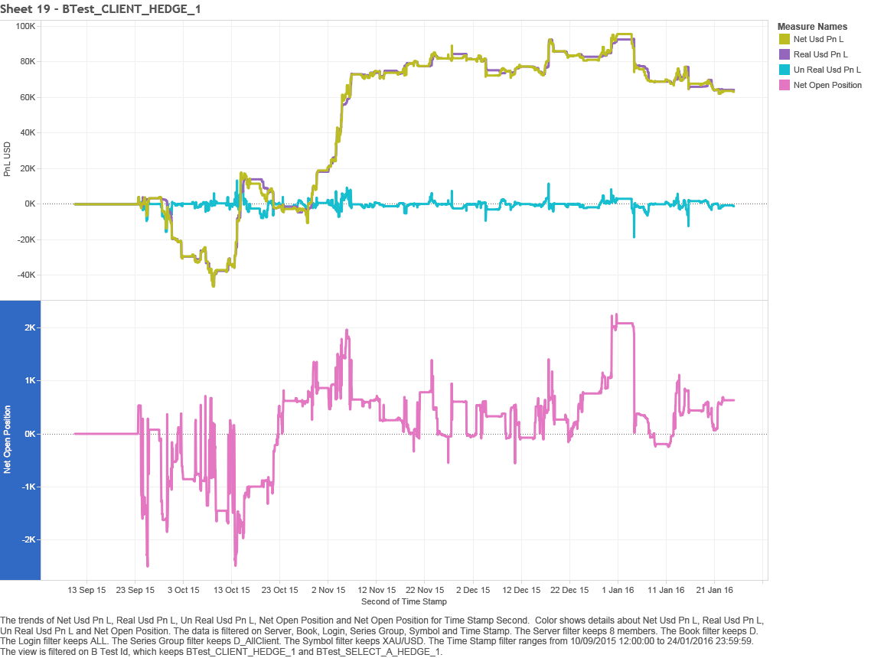

NOTE: this is just an illustrative chart, these are not the numbers for the data included for the test. We need time as the horizontal axis and the top chart to plot the Realised and Unrealised PnL computed in USD. Every change in the bottom position chart corresponds to when a client trade comes in, whereas the top PnL chart is with respect to both the position changes and price changes.

### Task 2: Chart of Trade Prices Vs Quote Prices

One key aspect to the business is to make sure the prices that the clients are paying are fair when compared to the market, charts like these give us the ability to easily visualise outliers.

The task is to take these source CSV data files (Mar 10th 2016 to Mar 16th 2016) and plot the Quote.bid and Quote.ask prices as a line chart and overlay the Trade.ClientPrice prices as points on the same chart. Trades should be coloured red as sell, green as buys and the size of the point should be proportional to the Trade.Amount, e.g. larger trades have larger circles as shown below:

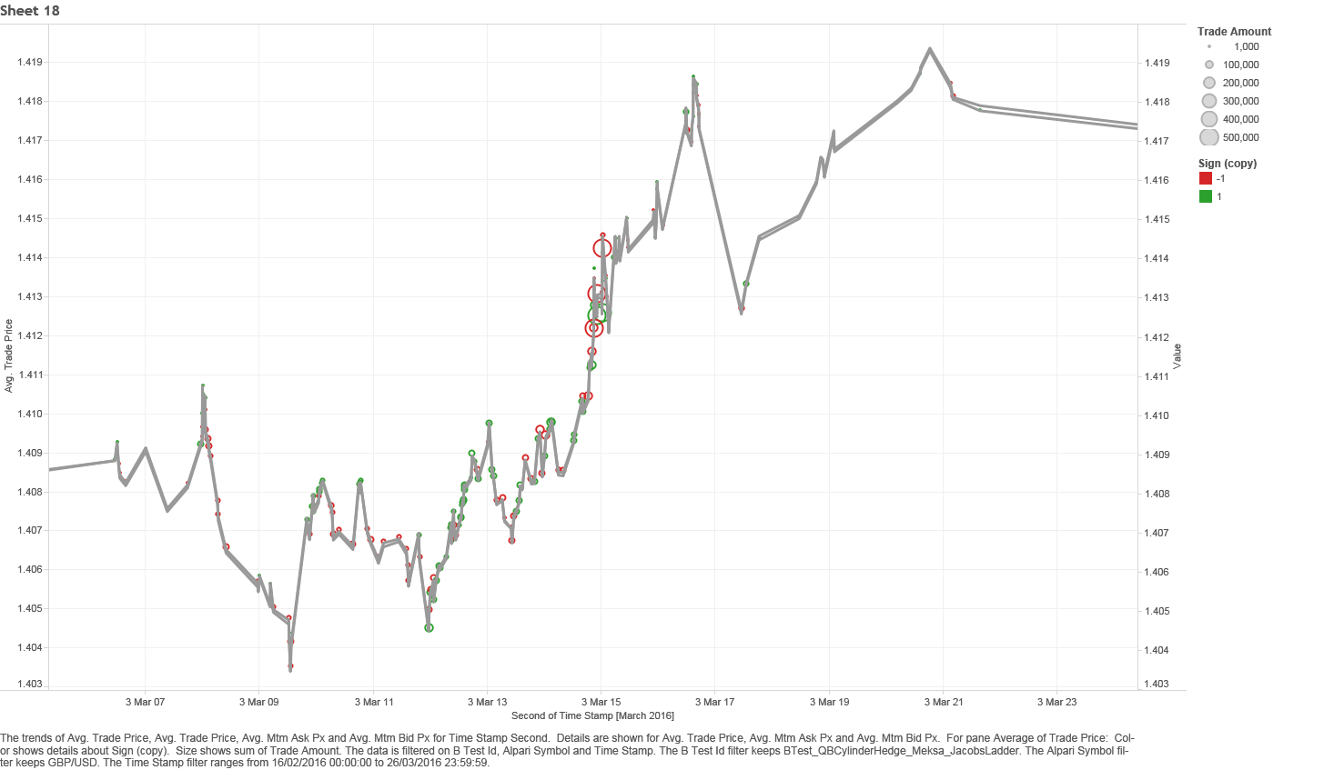

NOTE: this is just an illustrative chart, these are not the numbers for the data included for the test. We need time as the horizontal axis and price to be the vertical axis. We should be able to zoom on the chart.