yum install epel-release -y 下载yum源



yum install nginx -y 安装nginx

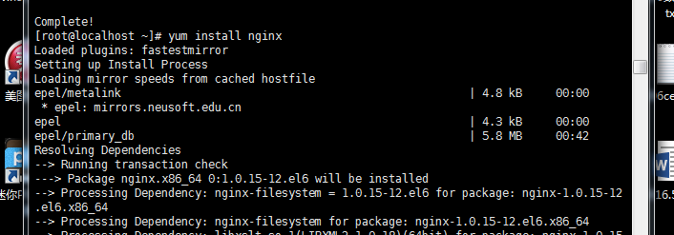

rpm -qa|grep nginx 查看是否安装成功



cd /usr/share/nginx/

rm -fr html/

vi thb/js/app/config.js

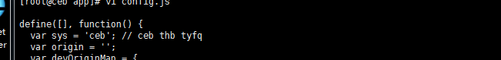

cd /usr/share/nginx

chown -R nginx:nginx thb

cd /etc/nginx/conf.d/

vi thb.conf

server {

listen 80;

server_name ec.taohuibang.com;

location / {

root /usr/share/nginx/thb;

index index.html;

}

#error_page 404 /404.html;

#error_page 500 502 503 504 /50x.html;

location /api/ {

proxy_pass http://127.0.0.1:8080/api/;

proxy_redirect off;

proxy_set_header X-Real-IP $remote_addr;

proxy_set_header X-Forwarded-For $proxy_add_x_forwarded_for;

}

}

service nginx start

chkconfig nginx on

/usr/sbin/nginx -s reload