IAPGUARD Unity SDK



A sample project for the Unity game engineI that contains fully working in-app purchase implementations including server-side receipt validation for the Apple App Store and Google Play. The IAPGUARD Service is a fully hosted
solutionI so you do not have to manage your own server or keep track of transactions and App Store API changes.
The platform offers a FREE plan to get started. Requirements:
You have created a free account on the IAPGUARD Platform You have created a new app in the IAPGUARD Dashboard
You should have set up your app and products on the App Store(s) already prior to running this project Table of Contents
1 . Project Setup
2. Installation
3. Usage
4. Testing
5. Integration
6. Missing Features
7. Support

Project Setup
Google Play: You should have created a Google Play Developer AccountI added an application and created in-app purchases for it.
Apple App Store: You should have enrolled in the Apple Developer ProgramI added an application and created in- app purchases for it.
. Verify that your project Is Package Name matches your App Store Is bundle identifier in Edit > Project Settings > Player > Other Settings > Identification > Package Name .
This project requires Unity IAP for billing. Import the latest Unity IAP package in your project via Window > Package Manager .

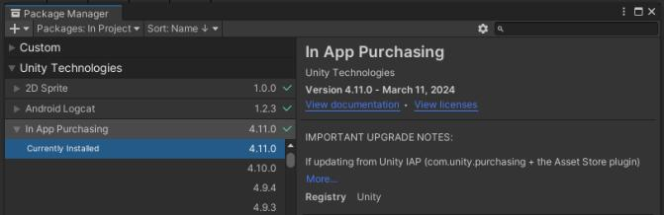

Because this project uses both local and server-side validation, follow the next steps for creating your secret files for local validation in Unity IAP.
. Open Edit > Project Settings > Services > In-App Purchasing
· Make sure that the toggle in the top-right corner is enabled (or enable it) . Scroll down to the Receipt Obfuscator section
o Google Play: find your Google Play Public Key in your Google Play Developer Console under Your App >
Monetise > Monetisation setup > Google Play Billing > Base64-encoded RSA public key o Apple App Store: no setup necessary
. Click the Obfuscate buttons to generate your Google Play and Apple Tangle files
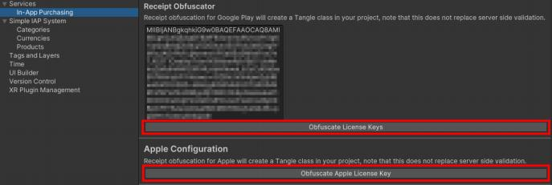
NOTE: You can now scroll back up and turn off the In App Purchases service again! This does not affect purchasing in any way, it just prevents sending analytics to Unity in case you do not intend to use that.

Installation
Get this plugin from the Unity Asset Store or from GitHub and import it into your project. Usage
The Demo scene provides buttons for buying each type of in-app product, along with a way to restore transactions. The logic for this is in the UIDemo script.

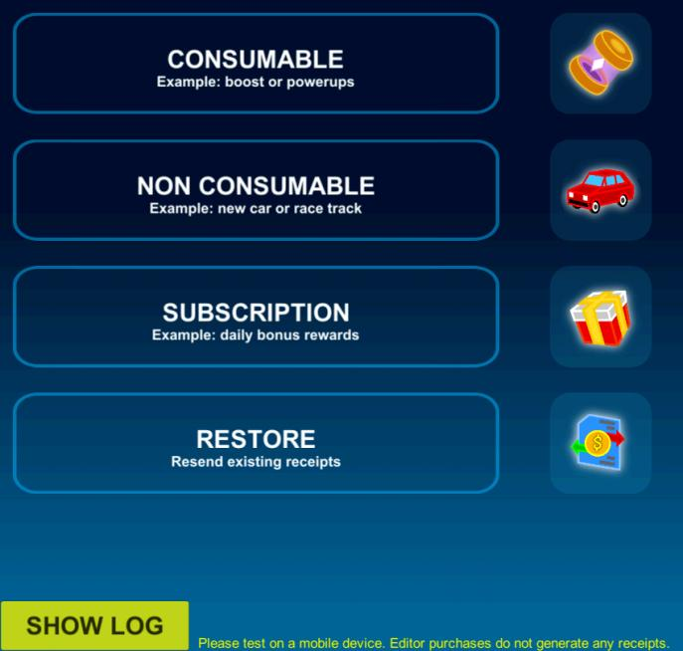

If you wish to use your own products in the Demo scene, select the IAPManager game object in the Hierarchy and modify the existing ones. The ID you enter here is the product identifier from the App Store.
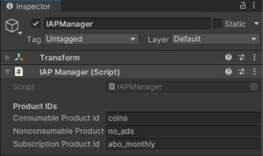

Likewise, select the IAPGuard game object and enter your own App ID from the IAPGUARD platform.

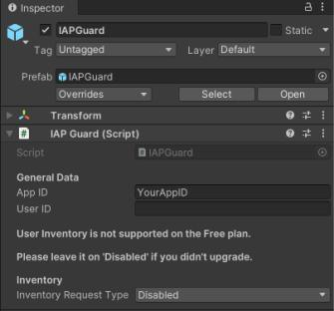

Testing
Since the Unity Editor does not have any connection to App Stores, you are not able to test purchases using it. In the Demo scene, a message is shown mentioning this too. You have to test on a real device that is actually able to receive valid receipts and transactions from the App Stores.
PLEASE NOTE: Guides on how to upload your application to the App Stores, or creating test users for
Sandbox purchasing is out of scope for this document. If you need help with that, please contact us (see Support).
When running on a real device you will be able to fully test all purchase validation workflows. Press the SHOW LOG button to display an informative console about web requests. In the following screenshot, a consumable and non- consumable product have been bought and validated. If you make use of IAPGUARD's User Inventory feature, the non-consumable product will be returned for that user in subsequent app launches as well.

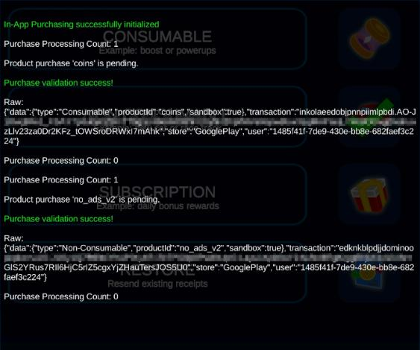

Integration
New Project
IAPManager: You can either rewrite the IAPManager script to fit into your game codingI or use it as-is. This script offers a purchaseCallback event that you would want to subscribe toI in order to define what happens when a
purchase event is received. Check that the success boolean is true before accessing the data JSONNode and
granting the corresponding product to the player. Note that the data JSONNode will return only the product IDI if the purchase was restoredI or if server validation was disabled or does not support the build platform.
It is recommended to save successful purchases in an encrypted file locallyI so you can access them at any time and players can also use them when playing offline.
IAPGuard: The IAPGuard script offers a purchaseCallback event for the web response as well - when using your own IAPManager I it should subscribe to this. AlsoI an inventoryCallback event that returns active purchases. If you are making use of IAPGUARD ls User Inventory featureI you would subscribe to this event after player
authentication and IAPGuard initializationI callIAPGuard.RequestInventory() and act on the products and status it returns. In this demoI if enabled (requires paid plan)I the UIDemo script checks User Inventory and sets the
purchase status of the products accordingly.

Existing Project
For an integration in an existing project that already implements Unity IAPI the following points need to be done:
1 . Instantiate the IAPGuard prefab
2. Initialize the IAPGuard component Initialize )
3. Extend the ProcessPurchase method with validation RequestPurchase )
4. Link IAPGuard ls purchaseCallback Action

5. (optional) Add User Inventory ( RequestInventory I GetInventory )
6. Add a way to let users restore their transactions RequestRestore )

1 . Place the Prefabs > IAPGuard prefab into the first scene of your application. It calls DontDestroyOnLoad on itself and therefore persists across scene changesI but is not initialized until you do so.
2. In your Unity IAP handler ls code:
o add the asset ls namespace at the top:
using FLOBUK.IAPGUARD;

o when you call ConfigurationBuilder.Instance to create a store moduleI save a reference to the
ConfigurationBuilder in a variable as we will need it in the next step. In the IAPManagerDemo scriptI this is done in Initialize().
o in your OnInitialized implementationI initialize the IAPGuard component by passing in the IStoreController and ConfigurationBuilder reference stored previously:
IAPGuard.Instance.Initialize(controller, builder);

3. In your ProcessPurchase implementationI pass the received product for validation to IAPGUARD and get its PurchaseState:

PurchaseState state = IAPGuard.Instance.RequestPurchase(product);

If the PurchaseState is Pending I it is important that you return PurchaseProcessingResult.Pending to keep the transaction open. If the transaction was processedI we will receive a callback from IAPGUARD in the next step. OtherwiseI the transaction was completed. You will then want to reward the user in case the
PurchaseState is Purchased (not in case it is Failed ) and return PurchaseProcessingResult.Complete .
4. In the previous stepI we already rewarded the user if the transaction was complete. HoweverI we only handled the Unity IAP partI in case IAPGUARD was not used. NowI we have to implement the IAPGUARD callback when finishing a transaction too. In OnInitialized I below the initialization call add:

IAPGuard.purchaseCallback += OnPurchaseResult;

To keep things simpleI in the IAPManager demo script we defined a separate OnPurchaseResult method that is also used in the ProcessPurchase implementation. This means that both interfaces call the same method to reward the user.
5. PAID PLAN ONLY: if you make use of user authentication and inventoryI a user ls purchases are stored in the backend. To retrieve themI on the IAPGuard prefab set the Inventory Request Type to a value other than Disabled and add the following line at the end of OnInitialized :

IAPGuard.Instance.RequestInventory();

You can either retrieve the inventory by subscribing to the IAPGuard.inventoryCallback action or by calling IAPGuard.Instance.GetInventory() manually later.
6. You will want to allow users to manually restore their purchases and re-sync them with the IAPGUARD
backendI in case they switch devicesI user IDs or lost their local storage in other ways. Add the below method

and let the user call it manually.

public void RestoreTransactions()
{
#if UNITY_IOS
extensions.GetExtension<IAppleExtensions>().RestoreTransactions(null);
#else
IAPGuard.Instance.RequestRestore();
#endif
}

Missing Features
The purpose of this SDK is to quickly get up and running within-app purchases and server-side receipt validation, while keeping it as simple as possible for you to extend and build upon.
A paid plugin for in-app purchases supporting:
. category, product and virtual currency management right in the Unity Editor · automatic handling of virtual product purchases (for virtual currency)
. product overrides for different App Store IDs . local storage of purchases for offline use
· several shop scenes for vertical or horizontal item alignment
in addition to built-in support for server-side receipt validation, is available on the Unity Asset Store. Support
This asset was specifically designed to be used in combination with IAPGUARD. For integration assistance or questions about the Service, please open a Support ticket within the IAPGUARD Dashboard.

