# **老师的代码**

<https://github.com/coderwhy/hy-react-web-music>

<https://4x.ant.design/docs/react/use-with-create-react-app-cn>

# **参考文档**

https://react.docschina.org/

# **安装node.js**

<https://nodejs.org/zh-cn>

默认安装后，就设置好了环境变量

# **设置阿里镜像**

npm config set registry <https://registry.npmmirror.com>

npm config get registry

创建react typescript项目

npm create vite@latest react-demo-app -- --template react-ts

# **创建react项目**

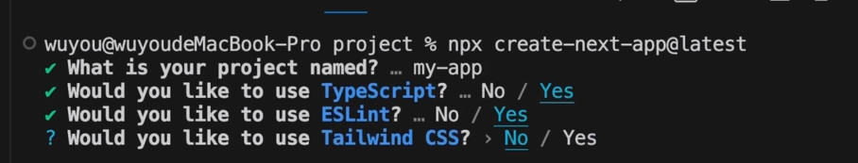

1先安装好脚手架

npm install -g create-react-app

2 创建项目

npx create-react-app my-react-app –template typescript

3安装craco

npm install @craco/craco@alpha -D

# **配置@目录**

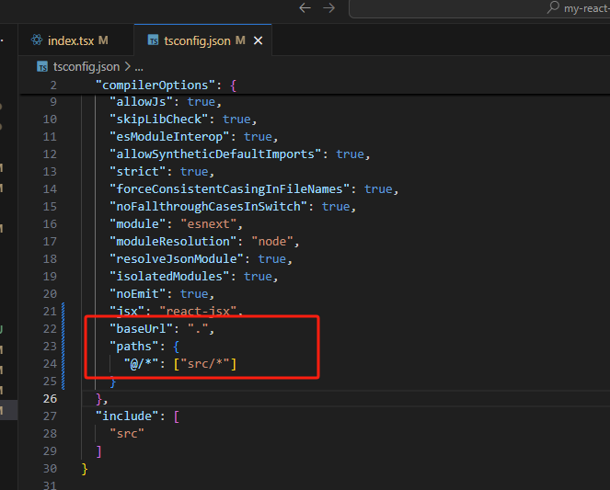

**新建.editconfig**

# .editorconfig file

# EditorConfig helps maintain consistent coding styles for multiple developers working on the same project.

root = true

[*]

indent_style = space

indent_size = 2

end_of_line = lf

charset = utf-8

trim_trailing_whitespace = true

insert_final_newline = true

[*.md]

trim_trailing_whitespace = false

**配置prettier**

npm install prettier -D

新建

.prettierrc

npm run prettier 会把所有文件格式化

建一个.pretieerignore, 问ai,会自动创建

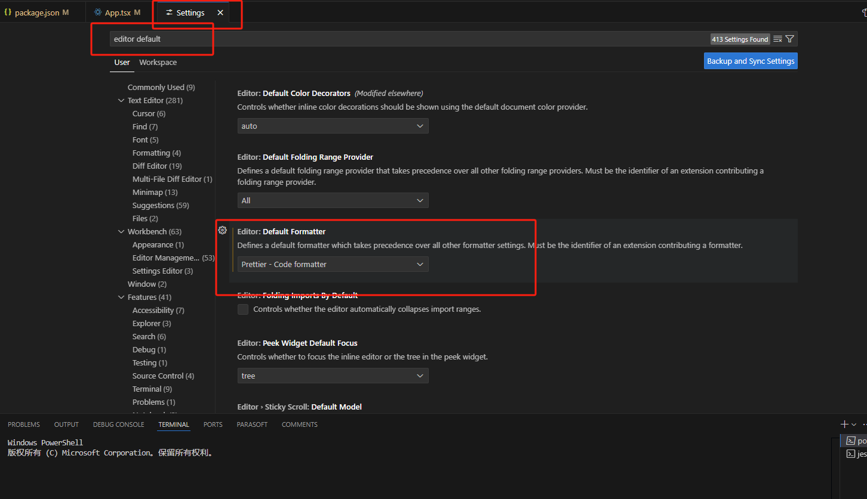

配置eslint

安装eslint

npm install eslint -D

npx eslint –init

生成C:\work\reacttest\01\my-react-app\eslint.config.mjs

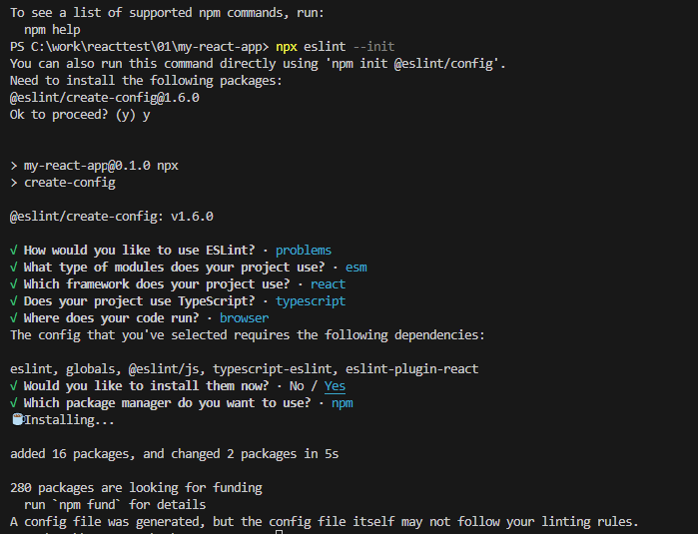

配置eslint

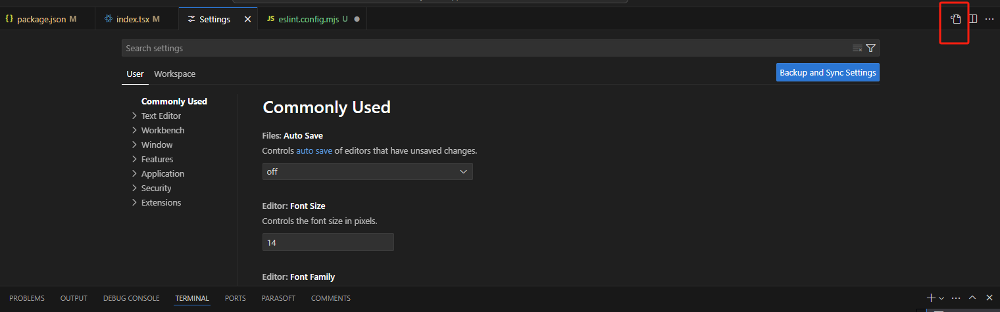

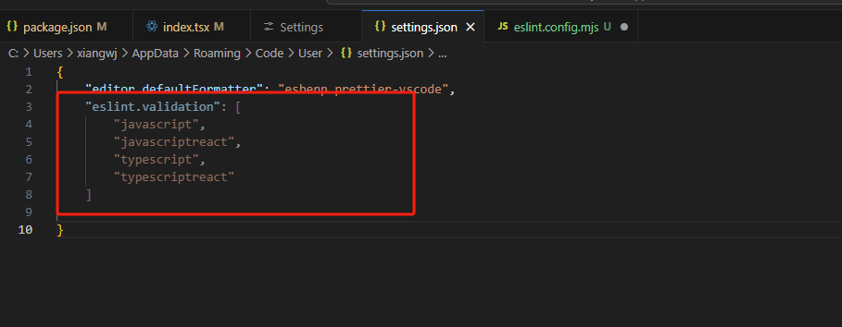

{

    "editor.defaultFormatter": "esbenp.prettier-vscode",

    "editor.formatOnSave": true,

    "eslint.validation": [

        "javascript",

        "javascriptreact",

        "typescript",

        "typescriptreact"

    ]

}

安装eslint-prettier-plugin

npm install eslint-plugin-prettier eslint-config-prettier -D

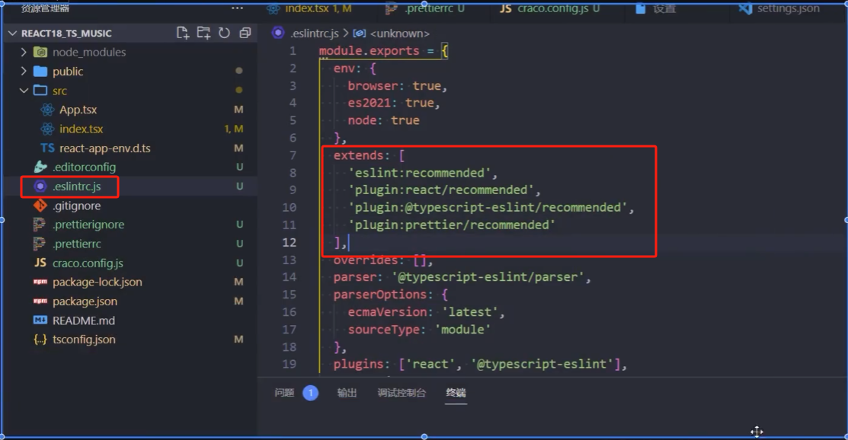

重置css

npm install normalize.css

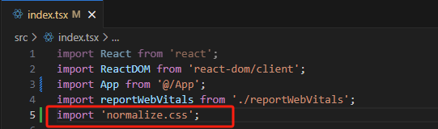

npm i craco-less

安装react-router-dom

npm install react-router-dom