[Template for Fortnightly eFolio submission]

Studio 1A

Name and Student Id: Xiangyu Fang - 33414610

Self-Evaluation {To be highlighted by Student only}: High Distinction

|  |  |  |  |  |  |
| --- | --- | --- | --- | --- | --- |
| Need Help | Work in Progress | Pass | Credit | Distinction | High Distinction |

Task 1A.1:

**Visual Studio Community Edition IDE IIS localhost screenshot**

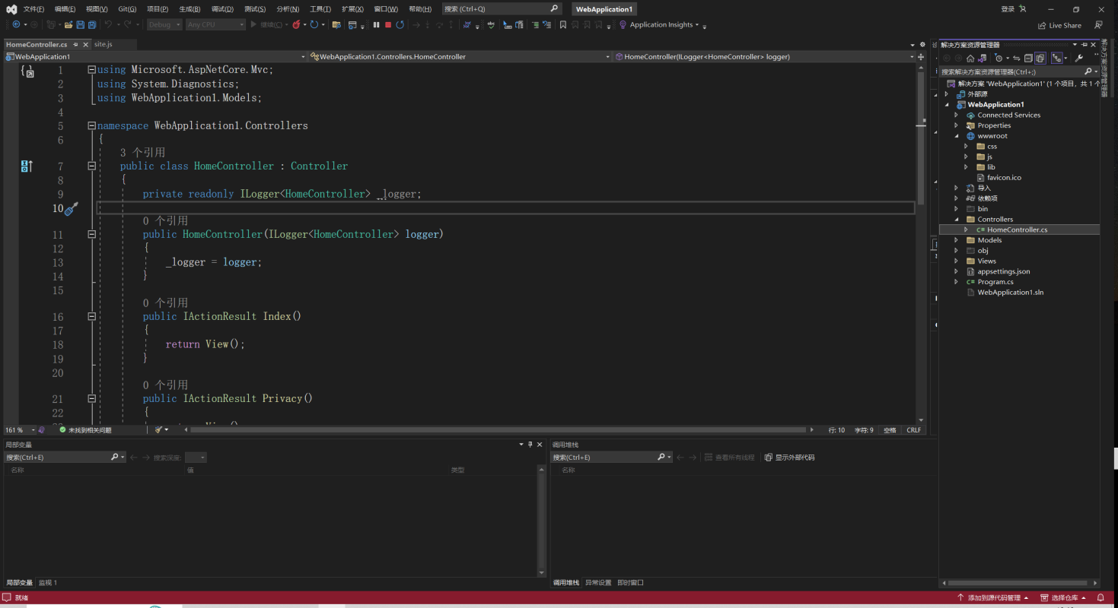

Task 1A.2:

1. **List five different IDEs currently used in the Agile software development industry**
   1. IntelliJ IDEA: IntelliJ IDEA is a powerful Java IDE that also supports other languages such as Kotlin and Scala.
   2. Eclipse: Eclipse is a popular open source IDE widely used in various programming languages, including Java, C++, Python, and more.
   3. Visual Studio: Visual Studio is a comprehensive IDE developed by Microsoft, primarily used for developing Windows applications and the. NET framework.
   4. Xcode: Xcode is an IDE developed by Apple for developing iOS and Mac applications.
   5. Android Studio: Android Studio is an IDE created specifically for developing Android applications.
2. **Briefly discuss five core features of Visual Studio Community Edition as an IDE** 
   1. Multi language support: Visual Studio Community Edition supports multiple programming languages, including C #, VB.NET, C++, Python, and more.

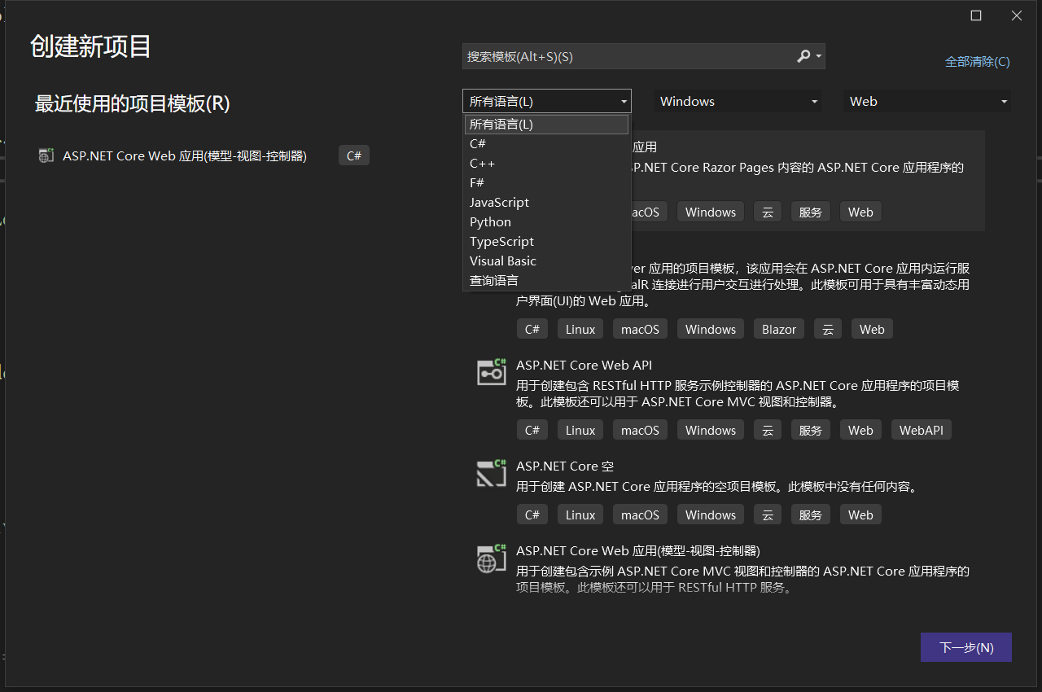

* 1. Powerful Debugger: Visual Studio Community Edition provides powerful Debugger that can help developers troubleshoot and debug code when applications are running.

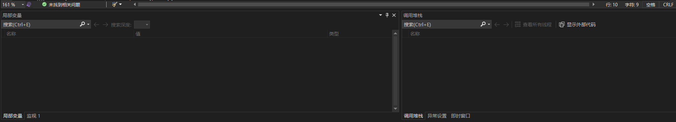

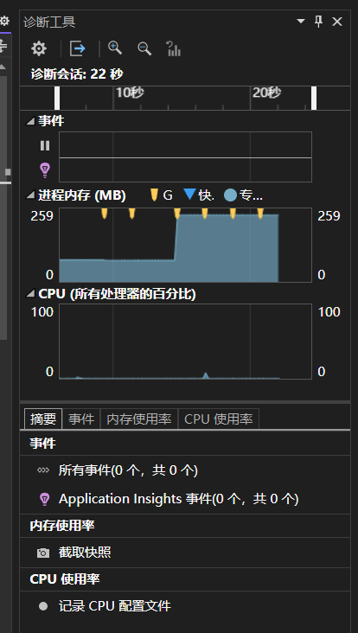

* 1. Extensibility and plugin support: Visual Studio Community Edition has rich extensibility, allowing developers to use plugins to extend and customize the functionality of the IDE.

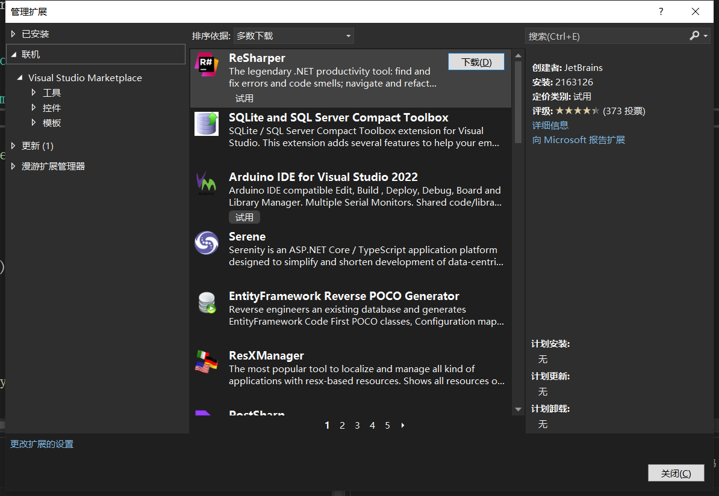

* 1. Integrated version control: Visual Studio Community Edition is tightly integrated with commonly used version control systems such as Git, providing developers with convenient team collaboration and version control capabilities.

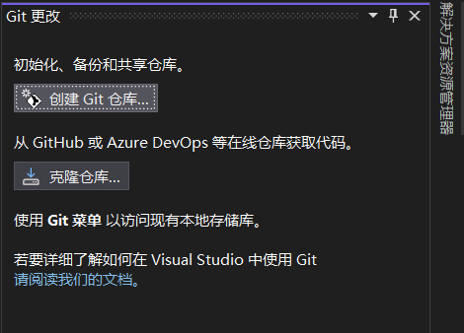

* 1. Built-in tools and templates: Visual Studio Community Edition provides a wealth of built-in tools and project templates to help developers create various applications more quickly.

