# 需求说明书

注意事项:

1.所需要显示的文字(中/EN) 都需要你们提供和确认.

2.你们选择几张有代表性的照片给我,已经你们想给客户看些什么?

3.这个文档需要保留,持续改善到项目上线.

**HOME/[首页](http://www.ultrablecell.com/Cn/Index/index.html)**

**ABOUT US/关于程通达**

OUR GUIDING VALUES/我们的指导价值

OUR MISSION/我们的使命

Industries We Serve/我们服务的行业

Shenzhen CTD Logistics Co.,Ltd (SZCTD) is a third party logistics (3PL) company headquartered in Shenzhen,China. SZCTD helps companies better manage freight by shipping

leveraging proprietary technologies, our carrier network and team of logistics professionals.Our solutions create efficiency in day to day logistics, freight savings and provide end-to-end visibility.

深圳市程通达国际物流有限公司（SZCTD）是总部位于中国深圳的第三方物流（3PL）公司。程通达通过利用专有技术，我们的运输网络和物流专业团队帮助企业更好地管理货物运输。我们的解决方案可提高日常物流效率，节省运费并提供起点到末端的可视性。

OUR GUIDING VALUES（内容如下）

At SZCTD Logistics, our company culture revolves around a set of guiding values that our team members live by every single day. SZCTD’s concept is “Technology innovates service; Professionalism creates efficiency”. We value knowledge creative & innovative and

combine latest information technology with the good experience from traditional logistics industry. We have a professional IT team with rich experience & excellent skills in our company.

在深圳市程通达物流有限公司，我们的公司文化围绕着我们团队成员的每一天生活。程通达以“科技创新服务、专业缔造高效”为理念，重视知识创新与变革，将高新信息科技与传统物流行业的优良经验相结合，创建了一支拥有丰富经验、技术能力过硬的专业信息技术服务团队。

Integrity: We do the right thing!

Determination: We are persistent and unshakable in overcoming obstacles.

Continuous Improvement: We aspire to reach our {untapped, full, greatest} potential.

Teamwork: We listen. We collaborate. We solve.

Fun: Fun lives here!

Excellence: We challenge the status quo.

诚信：我们做的事情！

决心：我们坚持不懈地克服障碍。

持续改进：我们渴望达到我们尚未开发的，充分的，最大的潜力。

团队合作：我们听。我们合作。我们解决。

乐趣：有趣的生活在这里！

卓越：我们挑战现状。

OUR MISSION（内容如下）

Excellence in freight transportation and logistics management

Attractive working environment and career opportunities for team members

Develop innovative technologies

Grow our carrier network

Build strategic partnerships

Be an active community partner

卓越的货运和物流管理

有吸引力的工作环境和团队成员的职业机会

开发创新技术

增加运营商网络

建立战略合作关系

成为一个积极的社区合作伙伴

INDUSTRIES WE SERVE（内容如下）

Chances are, if you’ve heard of it, we’ve arranged a shipment of it. Over time, our repeat experience in a wide variety of select industries has made us quite the expert when it comes to arranging shipment like you’ll see detailed below. This isn’t a complete list of all the industries we’ve served and commodities we’ve arranged, but it demonstrates several areas in which we have developed competitive advantages as a chosen provider for leading companies in each segment.

有机会，如果你听说过它，我们已经安排了一批货。随着时间的推移，我们在多个行业中的实践中已经使我们成为运输专家，就像您将在下面看到的那样。这并不是我们所服务的所有行业和我们已经安排的货物运输的完整列表，但它展示了我们在各领域发挥竞争优势的几个领域，作为各领域领先公司的选定供应商。

**（这里还有待补充内容）**

**SERVICES/程通达服务**

FBA/Amazon service/亚马逊FBA服务

Door-to-Door service/门到门服务

Transportation service of dangerous goods/危险货物运输服务

Air & Sea freight/空运&海运服务

Express service/快递服务

Railway service/铁路服务

Import to China service/进口到中国

**CUSTOMER CENTER/客户中心**

Why Work With SZCTD?/选择程通达的理由？

Frequently Asked Questions/常见问题

Documents and Downloads/文档下载

How to pay us?/怎么付款？

Why Work With SZCTD?/选择程通达的理由？

SZCTD has a well-established reputation in the world of transportation for treating our carriers right.Our company's main businesses are shipping services , shipping sensitive goods services , goods consolidation services and storage services . Shipping services include Express/Sea freight/Air freight , port to port and door to door . Shipping sensitive goods services include liquid , powder , large-scale equipments ,batteries copy brands and so on , Goods consolidation services include consolidate your goods from Taobao/Suppliers/Others channels , also can help you collect of money .

BEST SERVICE

Provide direct & fastest service.24 hours online feedback(Alibaba/Skype/Whatsapp/Wechat/

Email).Professional team with high quality service to you.

PROFESSIONAL

Over 10 years experience in freight forwarding.Ability to handle cargo from any city in China & consolidation service.Professional transportation of sensitive cargo.

SAFEST

Take responsible for all process of shipping.Help you coordinate with suppliers,customs,shipping line,trucking,inspection agent.

BEST PRICE

Cooperate with CARRIERS directly.Provide the most competitive price by checking with different carriers.

Customer service

We have a carrier relations department whose job is simply to serve you. Whether you have a question about getting set up, you’re wondering about a certain load, you’re curious about payment options, you’re wondering why you haven’t been paid yet, you’re in need of paperwork, or you have any other question or concern, our team is there to help you.

我们有一个承运人关系部门，其工作只是为您服务。无论您是否有关于设置的问题，您都想知道某个负载，您对付款方式感到好奇，您想知道为什么您还没有付款，您需要纸质工作，还是您有任何其他问题或关注，我们的团队在那里帮助你。

Frequently Asked Questions/常见问题

国内交仓地址网点如下：  
1，上海，宁波，深圳，厦门，天津，青岛，香港（海运LCL、海运FCL仓网点）；  
2，深圳，广州，香港，上海，厦门（空运仓网点）

**（这些还需要补充）**

Documents and Downloads/文档下载

Below, you’ll find a variety of documents and downloads you may require to do business with us.

在下面是与我们开展业务所需的各种文档和下载。

BOOKING

PACKLING LIST

Commercial Invoice

How to pay us?/怎么付款？

1. **OUR HK (USD) BANK ACCOUNT：**

**2.WESTERN UNION INFORMATION:**

**3.OUR RMB ACCOUNT：**

**4.微信和支付宝二维码**

**JOIN OUR TEAM/加入我们的团队**

Careers/招聘

Become our VIP customer/成为我们的VIP客户

Become a Carrier/成为承运人

Careers/招聘

Marketing Chief Operation Officer

job.png

1.take full responsibility of project kick-off , coordination and management  
2.Participating in the preparation of project implementation details, and responsible for the resolution and coordination of technical issues   
3.Organizing regular KPI meetings to and reporting to regularly  
4.Responsible for coordinating public relationship and the relationship between different departments  
5.Supplier management and internal operation supervision  
6.Other tasks assigned by line manager

requirements.png

 1.Bachelor degree or above with major in Marketing, logistics management or any other related major  
 2.At least 5 years’ experience in marketing and business management of logistic projects, transport industry background preferred  
 3.Excellent negotiation and public relation ability with strong business acumen; be able to develop business with integrity and flexibility good sense in marketing and able to expand the market actively, insisting of principle but flexible  
 4.Proficient in MS office softwares, good at data analysis  
 5.Frequent travels will be required

  Address：Room 402, building A11, longxiang garden, buji street, longgang district, shenzhen,China  
  Job vacancy: 1

职位：市场项目首席运营长

加入我们-上传图片01.jpg

1、领导项目衔接落地工作，协调内部各专业人员的关系，对项目运营结果承担全权责任；  
2、参与编制项目开发实施细则，负责技术问题的解决和协调；  
3、定期组织召开例会，研究各项指标进度情况，并定期向上级领导汇报进展情况;  
4、负责协调对外关系，协调项目各相关部门的关系；  
5、对项目开展过程中的供应商及内部运作进行管理和协调；  
6、完成上级领导交办的其他工作。

加入我们-上传图片02.jpg

1. 全日制本科以上市场营销、物流管理等相关专业；  
    2、3年以上物流运输市场营销和商务项目管理经验，有运输行业背景的优先；  
    3、性格开朗、有较强的市场敏感度，有很强的商务谈判能力和公关能力，具有积极的市场开拓精神，做事讲究原则，具有较强的灵活性;  
    4、熟练掌握各种办公软件，有较强的报表数据分析能力和数据运用能力.  
    5、可以根据项目要求需要出差。

  工作地点：深圳市龙岗区布吉街道龙翔花园A11栋402  
  需求人数：1人

Customs Declaration Operator

job.png

1.Assist customer service supervisor to handle daily operations and prepare relevant documents  
2.Responsible for the making, checking and organizing of relevant documents, communicating with on-site  
3.Dealing with all the problems about documents to meet customer’s requirements  
4.Responsible for filing and completeness of documents  
5.Other tasks assigned by line manager

requirements.png

1.College degree or above with major in international trade, logistics or other related major  
2.Familiar with the operation procedure customs and CIQ declaration  
3.Strong sense of responsibility,could work under pressure  
4.Detail-oriented, well organized, good communication skill

Address：Room 402, building A11, longxiang garden, buji street, longgang district, shenzhen,China  
 Job vacancy: 2

职位：报关操作员

加入我们-上传图片01.jpg

1、协助客服主管处理日常操作，制作相关单证；  
2、负责报关报检相关单证的制单、核对、整理等，与现场操作人员进行沟通及工作交接；  
3.、处理单证作业中各项问题，完成客户要求；  
4、 完成单证的存档和管理，保证完整性和全面性  
5、 完成交付的其他工作。

加入我们-上传图片02.jpg

  1、大专及以上学历，国际贸易、物流等专业相关背景；  
  2、熟悉报关报检单证工作流程及具体作业方式；  
  3、有较强的责任心，敢于承担压力，具执行力；  
  4、工作仔细严谨、认真、有条理，工作效率高，良好的沟通协调能力；

  工作地点：深圳市龙岗区布吉街道龙翔花园A11栋402  
  需求人数：2人

Excellent sales

job.png

1. 2.  
   3.  
   4.

requirements.png

 1.College degree or above with major in international trade, logistics or other related major.  
 2..Excellent negotiation and public relation ability with strong business acumen; be able to develop business with integrity and flexibility good sense in marketing and able to expand the market actively, insisting of principle but flexible  
 3.Strong sense of responsibility,could work under pressure  
4.Detail-oriented, well organized, good communication skill

  Address：Room 402, building A11, longxiang garden, buji street, longgang district, shenzhen,China  
  Job vacancy: 10

职位：业务精英

加入我们-上传图片01.jpg

1. 利用公司优越平台(国际阿里巴巴B2B平台)，与海外买家交谈，营销中国到全球国际物流服务。通过E-mail，Skype，whatsapp、电话、微信以及每年广交会等方式开发客户。  
   2、 对客户进行跟进与维护，回复客户的海运，空运询价；  
   3、 协调配合操作部与文件部等各部门安排订单；  
   4、货物出运后，及时收款。

加入我们-上传图片02.jpg

1. 大专及以上学历，国际贸易、物流等专业相关背景。英语4级以上，口语佳、有良好的业务开发能力者优先。
2. 性格开朗、有较强的市场敏感度，有很强的商务谈判能力和公关能力，具有积极的市场开拓精神，做事讲究原则，具有较强的灵活性;
3. 有较强的责任心，敢于承担压力，具执行力；
4. 工作仔细严谨、认真、有条理，工作效率高，良好的沟通协调能力；

  工作地点：深圳市龙岗区布吉街道龙翔花园A11栋402  
  需求人数：10人

Become our VIP customer/成为我们的VIP客户

这里需要的内容：

https://info.trinitylogistics.com/request-a-quote（按照这个页面，客户填信息之后，把客户的信息发送到我们指定的邮箱）

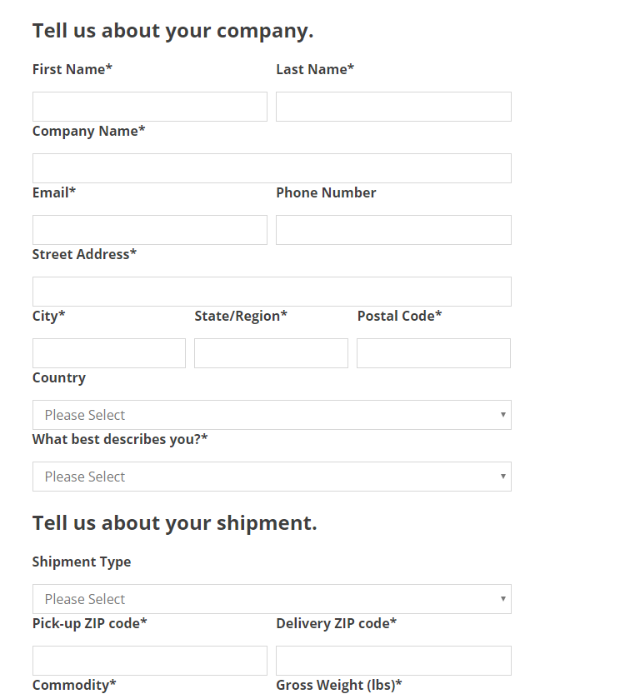

Become a Carrier/成为承运人

Submit a request if you are an asset-based carrier that is interested in becoming a part of the SZCTD Logistics family as a transportation partner.

**CONTACT US/联系程通达**

If you have any question about Shenzhen CTD Logistics Co.,Ltd (SZCTD) or how we can support your business, please contact us directly.

如果您对深圳市程通达国际物流有限公司（SZCTD）有任何疑问，或者我们如何支持您的业务，请直接与我们联系。

ADD：Room 402, building A11, longxiang garden, buji street, longgang district, shenzhen,China

TEL：:+86 13048828688

EMAIL： [Sky@szctdlogistics.com](mailto:Sky@szctdlogistics.com)

公司地址：深圳市龙岗区布吉街道龙翔花园A11栋402

联系电话：:+86 13048828688

邮        箱： [Sky@szctdlogistics.com](mailto:Sky@szctdlogistics.com)

在这里同时加入我们阿里巴巴的店铺的链接