**DPVR遇到仿真行到读flash后崩溃**

现象：USB端口无法正常使用，全部挂掉，以下是打印。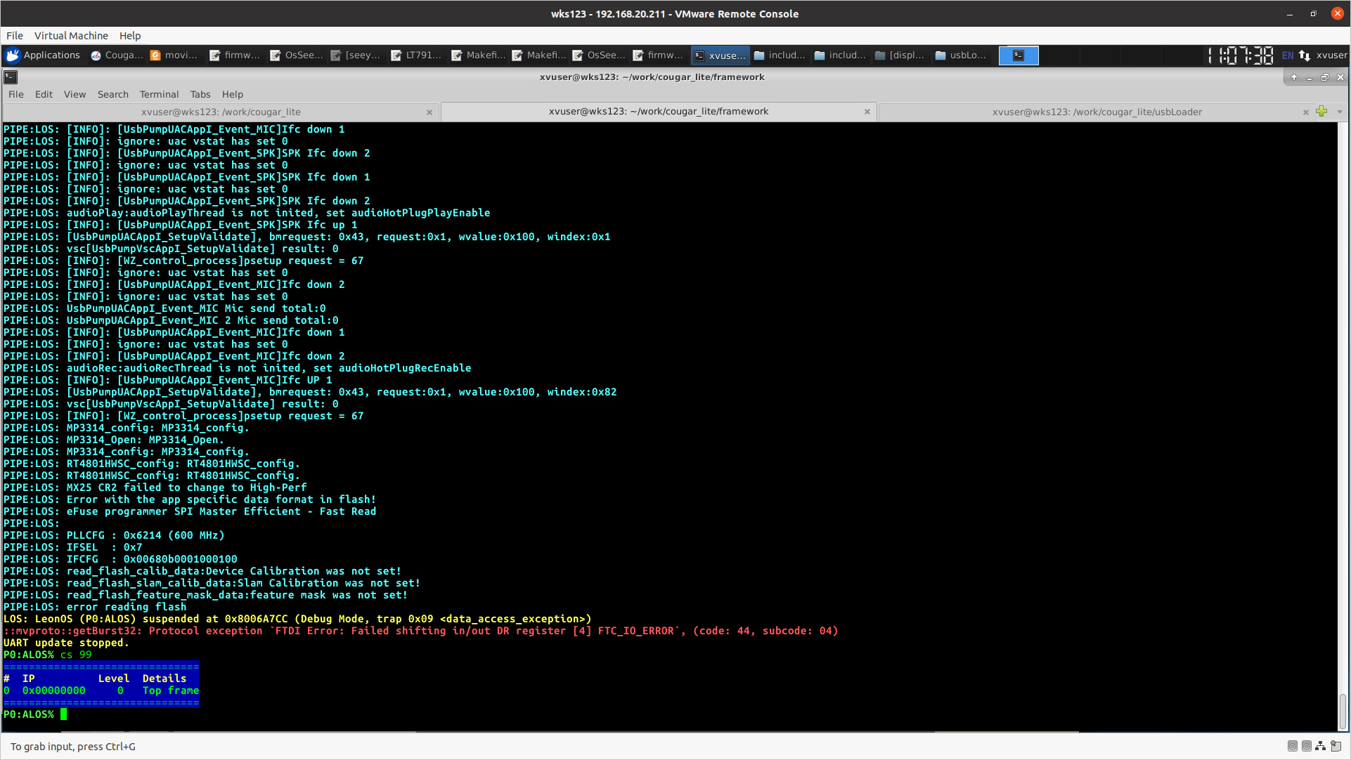

ubuntu dmesg 打印

[70035.321860] usb 4-4.2: new SuperSpeed USB device number 6 using xhci_hcd

[70035.342112] usb 4-4.2: Int endpoint with wBytesPerInterval of 1024 in config 1 interface 4 altsetting 0 ep 131: setting to 64

[70035.342434] usb 4-4.2: New USB device found, idVendor=2d49, idProduct=1011, bcdDevice= 1.10

[70035.342435] usb 4-4.2: New USB device strings: Mfr=1, Product=2, SerialNumber=3

[70035.342436] usb 4-4.2: Product: XVisio vSLAM

[70035.342437] usb 4-4.2: Manufacturer: XVisio Technology

[70035.342438] usb 4-4.2: SerialNumber: 0.0

[70035.354559] hid-generic 0003:2D49:1011.0042: hiddev0,hidraw3: USB HID v1.01 Device [XVisio Technology XVisio vSLAM] on usb-0000:00:14.0-4.2/input4

[70037.164193] retire_capture_urb: 26 callbacks suppressed

[70037.165120] xhci_hcd 0000:00:14.0: WARN Event TRB for slot 15 ep 1 with no TDs queued?

......

[70040.439124] xhci_hcd 0000:00:14.0: WARN Event TRB for slot 15 ep 1 with no TDs queued?

[70040.454562] usb 4-4.2: USB disconnect, device number 6

[70040.461348] usb 4-4.2: Disable of device-initiated U1 failed.

[70040.462202] usb 4-4.2: 3:0: usb_set_interface failed (-19)

重新上电，flash崩溃了，日志打印不一样了。

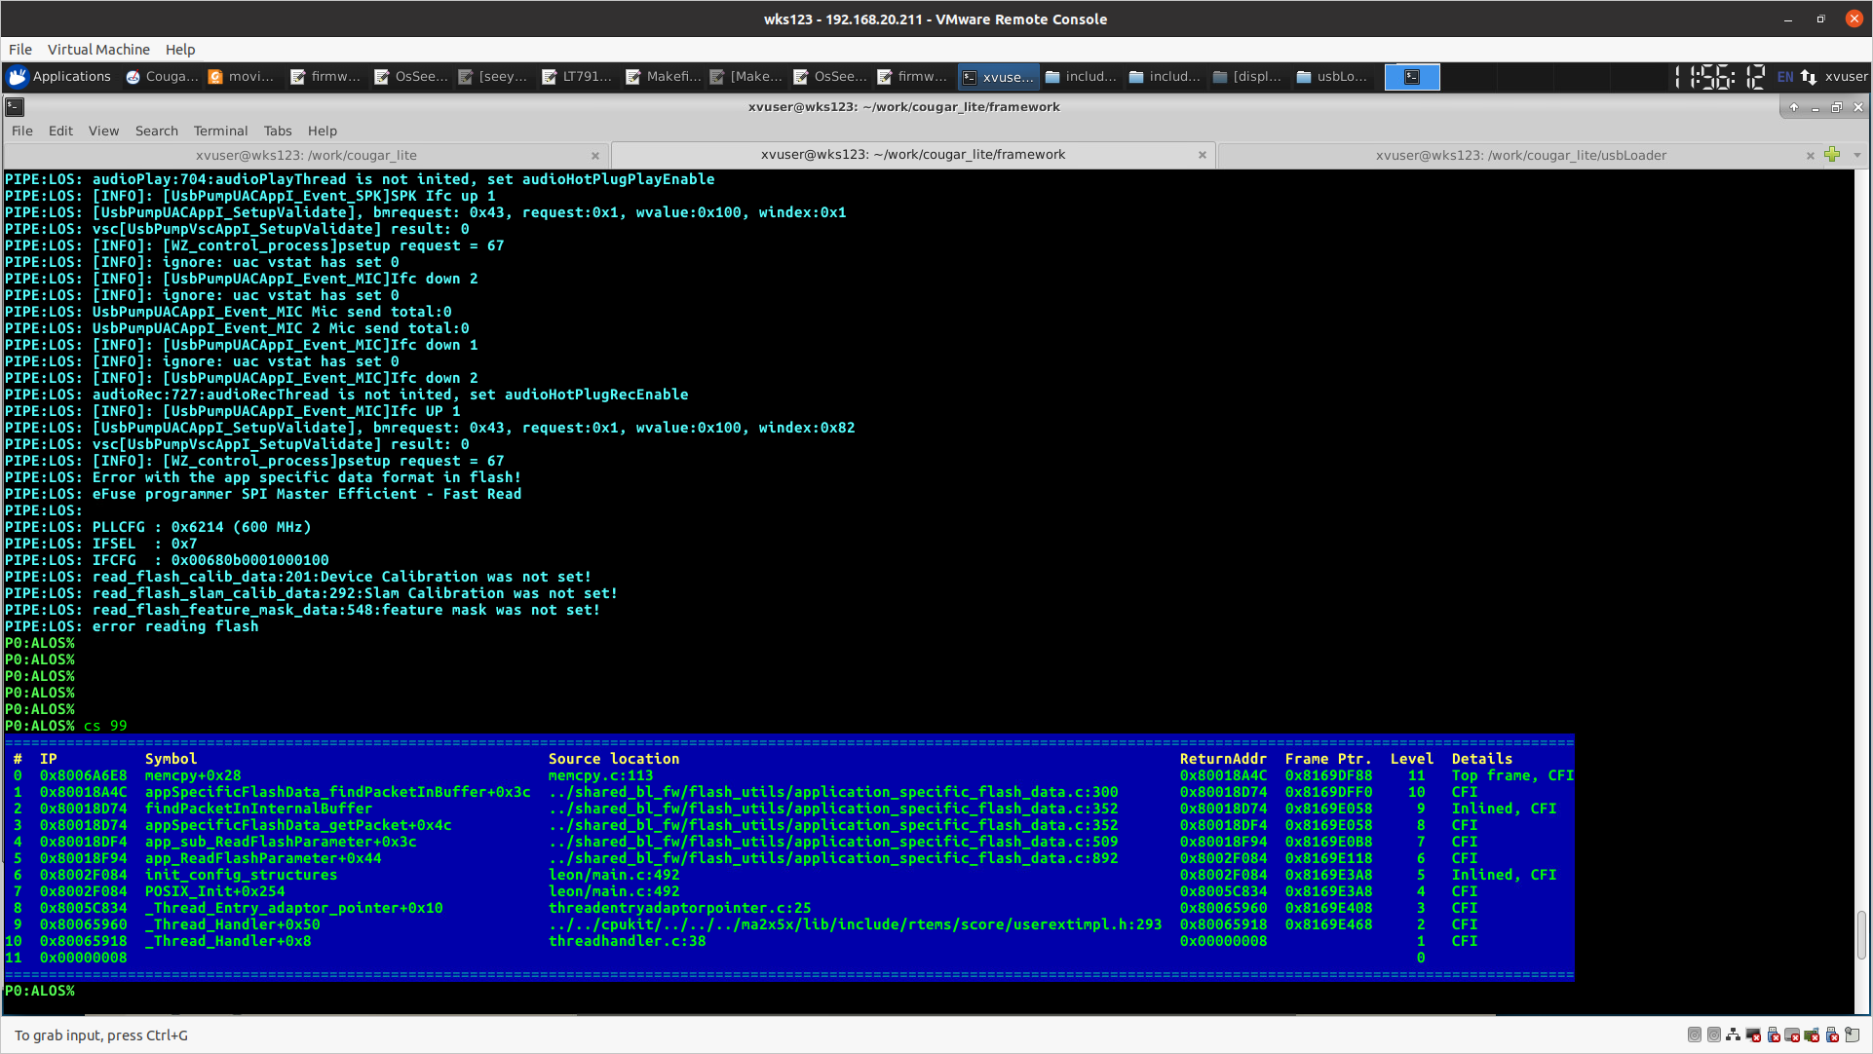

log:

memcpy.c 113

application_specific_flash_data.c 300 -- while(isValidPacketType)

application_specific_flash_data.c 352 -- uint8_t *pHeader = findPacketInIternalBuffer(type,&packeSize)

application_specific_flash_data.c 352

application_specific_flash_data.c 509 -- app_sub_ReadFlashParameter() <--- appSpecificFlashData_getPacket()

application_specific_flash_data.c 2022 -- app_sub_WriteFlashParameter(APP_SPECIFIC_TYPE_Reserved_1,_flashflashParamters.Reserved_1,flash_Reserved_length)

imu_common.c 451 -- app_ReadFlashParameter(),app_ReadParameter()

imu_common.c 642 -- init_bias<-- app_ReadFlashParameter()

imu_handler.c 1117

threadentryadaptorpointer.c:25

**解决办法**

**VPU的flash 存储区域app_specific (标定参数的地方，由于越界导致参数错误)。所以在读取时，导致程序崩溃。直接擦写flash，可以解决该问题，但是设备需要重新标定。**

make flash_erase BOARD=xxxx $YUNIP -j