**Programming Exercise 1: Tableau Public**

Student Name: Xianlin Feng

Student ID: 28847458

Tutor Name: Kadek Satriadi

Data: 16/03/2019

# Data Wrangling

## Correct the Wrong data

The latitude of “site02” is 18.937, which means the site is in Northern Hemisphere; it cannot be a site near the Great Barrier Reef. I believe it is missing the symbol “-”, so I add the “-” symbol in front of it. After modifying the latitude of site02, the data seems more reasonable on the map.

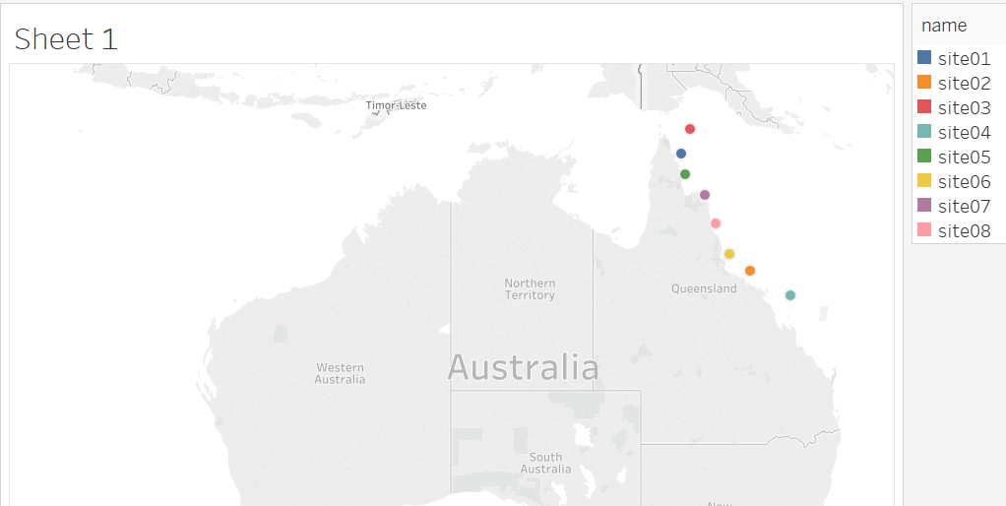

## Clear the Wrong data

When opening the dataset with excel and colouring the coral bleaching data by “Conditional Formatting” function. An abnormally high value can be found in the data record, which colour is bright red. It may be an outlier, because as coral bleaching cannot exceed 100%. As the correct value is not known, I decided to delete the value (leave it blank as a missing value).

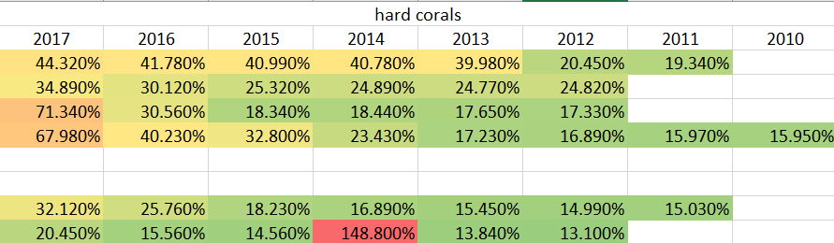

After double check the rest data in the data set, not the data value exceeds 100%.

## Reformat the dataset

When open the data with Microsoft Excel, it clearly shows that the first row is the name of the corals, and the second row is the main index of the rest rows, include the site names, longitude, latitude, and years, this data format will cause a bit problem when importing the data into Tableau. So, I reformat the dataset in the following steps:

1. Copy all the data in the sheet. Then paste it with paste option “transpose”. This option will transpose the row to a column, and the column to row.
2. Add “name” in the cell “A1”, Add Location in the cells “A2” and “A3”. Add corals name in the rest cells of column “A”.
3. Add “year” in the cell “B1“.
4. Save and close the excel sheet.

The picture below illustrates the result of the reformatting steps:

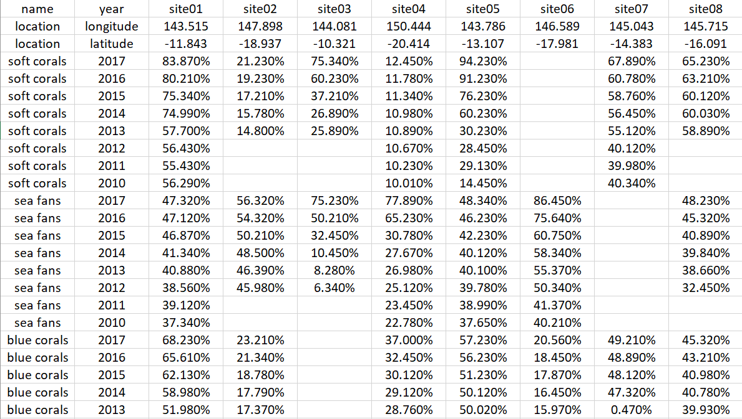

# Data exploration

After reformation the dataset, I read the data in Tableau public. Then try to explore the data in the following steps:

1. Add the data from the previous step, and check them. Make sure the blank cells show “null” the preview, and each column has the right data type.
2. In Dimensions of sheet1, drag the “Year” icon, then release it on the top of the “Name” icon to create Hierarchy. The result is shown below:

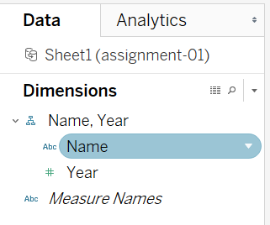

1. Drag the “Name, Year” icon in the field of Filters. Then select all items but not select “location”.
2. Drag the “Year” icon in the field of Filters, then select the year range from 2010 to 2017.
3. Drag the “Name, Year” Hierarchy and “Measure Names” into the field of “Columns”. Then drag “Measure Values” from “Measures” then drag into the field of “Row”.
4. In the field of “Columns”, right click on “Measure Values”, choose “Average” in the sub-menu of “Measure”.
5. Choose “Side-by-side bars” from “Show me” on the right side. I got a comparison chart for five corals in eight sites. The result is shown in the blow:

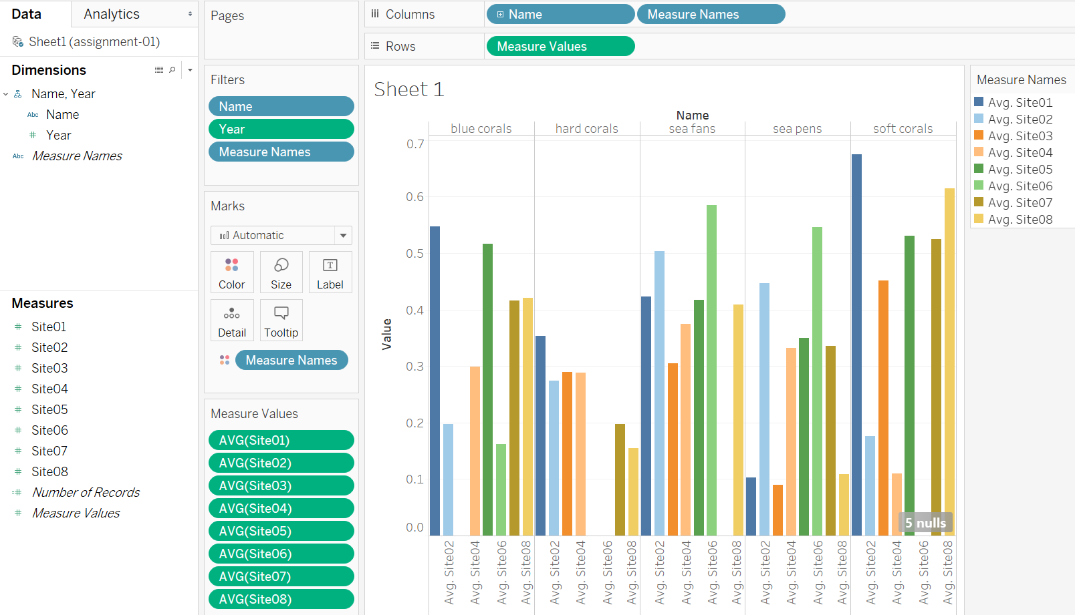

**As it shows in the bar chart above, the soft coral bleaching at site02 was the worst. The situation for see pens in site03 and site 01 ware the best. However, the chart illustrates the situations greatly varies in different sites.**

1. If we remove the “Measure Names” from “Columns”, I got a cumulative graph for five corals.

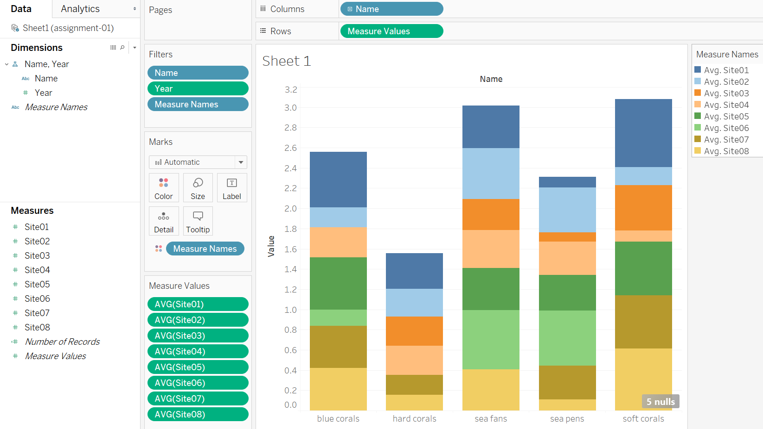

**From the chart above, we can see that the bleaching of hard corals was the best, soft corals was the worst, and the situation of see pens was a little better than soft corals.**

1. Change the order of “Name” and “Year” in Hierarchy of “Name, year”, drop them into the field of “Columns”, then drag “Measure Values” into the field of “Rows“, and select the measure of "average", choose “line” from “show me”. I got the figure of an average of five corals bleaching trend for eight sites.

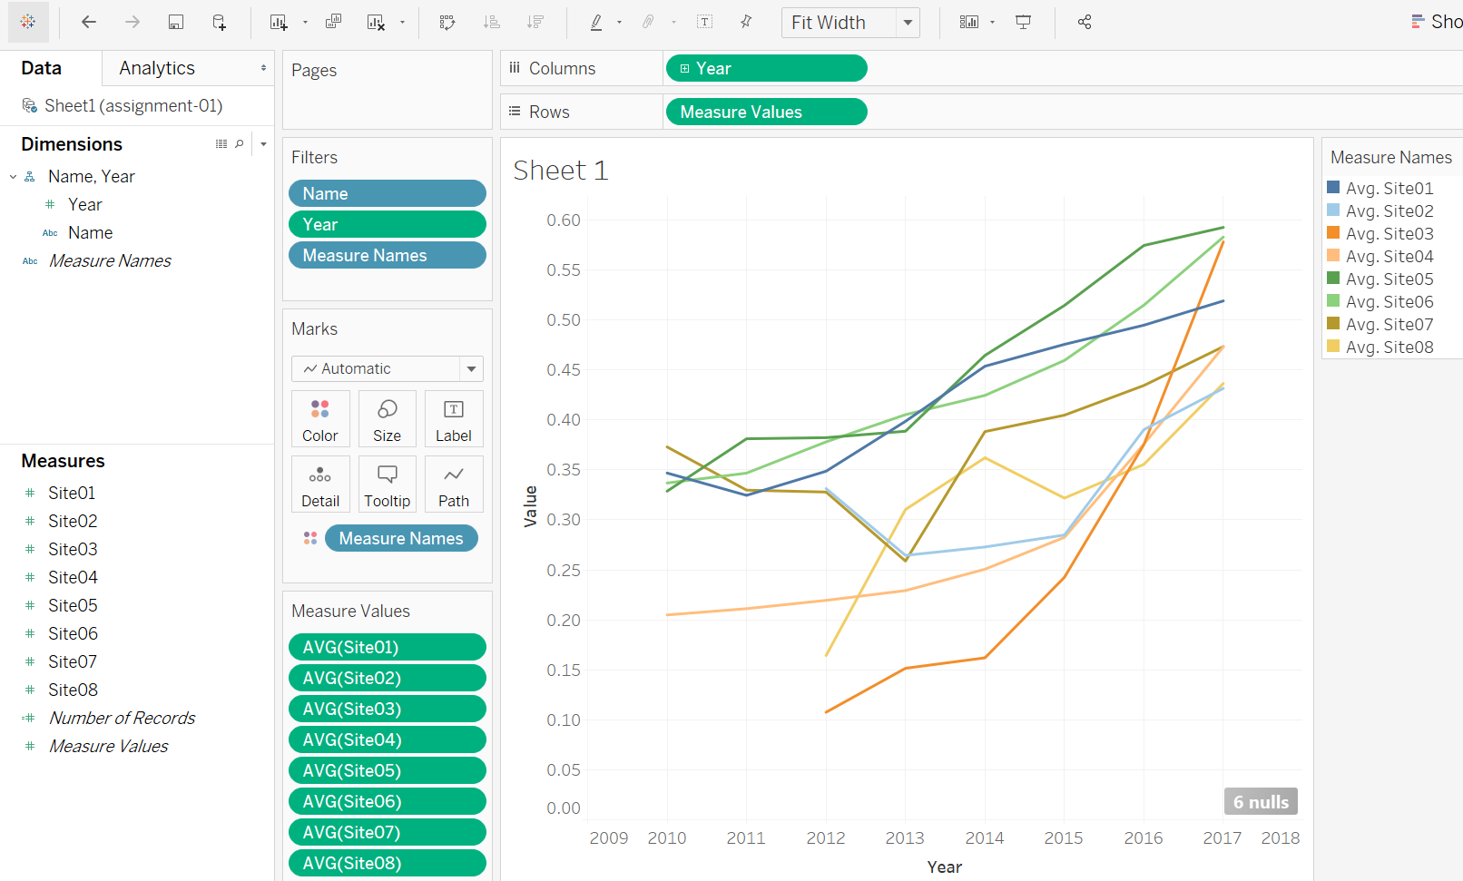

**The above picture shows the corals bleaching over time in different sites. It intuitively shows that the bleaching of all five corals became worse and worse in this period. Particularly for site05. In 7 years, it increased from 0.3287 to 0.5926, which means it increased by 80.28%.**

1. Another useful chart can be found if we put “Measure Names” into the field of “Columns”, and put “Measure Values” in the field of “Rows”, which shows the average coral bleaching of each site. The figure shows the coral bleaching situation in site05 was the worst. Site03 and site04 are the best.

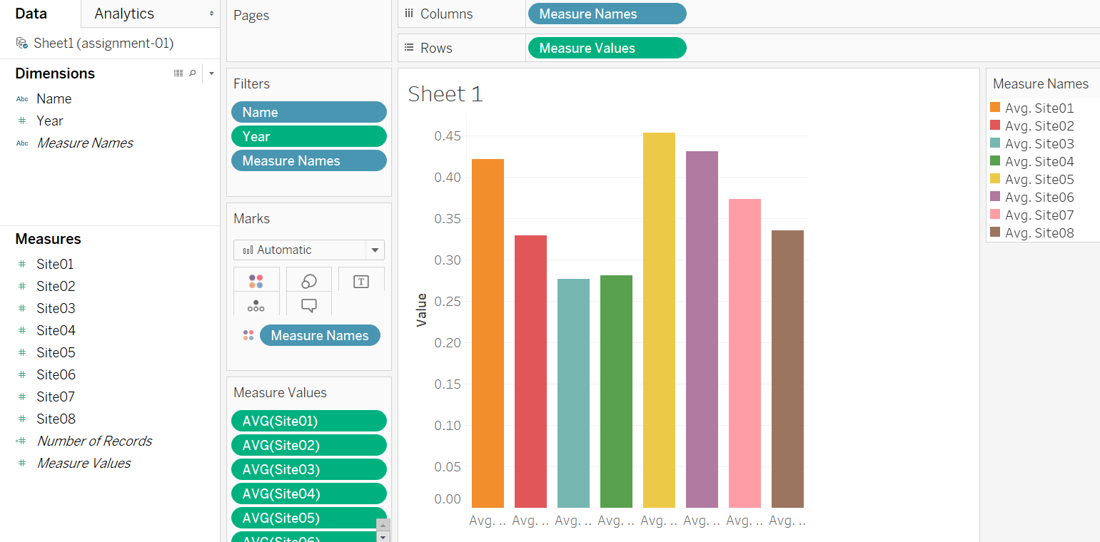

**From the first map in this report, we can see that the site03 is the northernmost site and the site04 is the southernmost site. Compared with the data from other sites, there is no obvious law. Therefore, it is speculated that coral bleaching has little to do with location. The focus of research can be on other aspects, such as ocean currents, human activities, monsoons, etc.**