

# Final Exam

**CS-GY 6083 - B, FALL-2023.**

**Principles of Database Systems.**

**16th Dec. 2023**

**FINAL EXAM [100 points with 20% weight]**

**Saturday, 12/16/2023 11:00 AM to 1:30 PM EST (2 ½ HRS.)**

**Please read the instructions carefully before writing the exam**

Write your name, student ID, and net ID below.

* **Last Name: First Name:**
* **Net ID: Student ID:**

**THIS IS AN ONLINE – OPEN BOOK EXAM. PLEASE LOG IN TO THE ZOOM MEETING USING YOUR NET ID (DO NOT LOG IN WITH YOUR PERSONAL EMAIL ACCOUNT). Find the Zoom meeting details under the ZOOM top bar menu of the course website with the title “Final Exam”. Join the Zoom meeting at least 15 minutes before the exam time.**

* **Write your answers under each question in this Word document and submit it on or before 1:30 pm to course site > assignments > Final Exam. Save and submit the exam submission document in format <your net id>_final_fall_2023_6083b.pdf. Unlimited submission is allowed before the deadline. The latest submission will be considered for grading. Please mute your microphone during the entire exam duration and keep video on since it is an online exam.**
* **This exam has 5 sections A, B, C, D, and E. There are no negative points for any wrong answers.**
* **If you have any questions during the exam, please send your question privately to the course assistant on zoom meeting chat window. Do not speak in the microphone.**
* **Please keep saving your exam document frequently.**
* **Please keep ready the practice schema (that we used for the SQL tutorial) with all tables with your initial.**

**GOOD LUCK!**

1. **Answer the following questions briefly [10 points]**
   1. **Explain the difference between Data, Metadata, and Information with an example of each.**
   2. **Explain the difference between Delete, Truncate, and Drop SQL statements.**

1. **For the HRD database in the relational model above, consider the following transaction and answer the question [10 points]**
2. CONNECT apatel/Fa1l2021@HRD
3. UPDATE AP_EMP SET COMM= COMM + SAL*0.12 WHERE DEPTNO=20;
4. DELETE * FROM AP_DEPT WEHRE DEPTNO=40;
5. ALTER TABLE AP_DEPT MODIFY (DNAME VARCHAR2 (40) );
6. ROLLBACK;
7. CREATE INDEX index_elname ON ap_emp(substr(elname,-2,2));
8. COMMIT;
9. ROLLBACK;
10. For the above set of database activities, list all transactions with transaction numbers e.g., TX1, TX2, etc., along with which activity number each transaction starts and when it ends. [5 points]

|  |  |  |
| --- | --- | --- |
| Transaction Name | Started at Activity Number | Ended at Activity Number |
| TX1 |  |  |
| TX2 |  |  |
| TX3 |  |  |
| TX4 |  |  |
| TX5 |  |  |

1. At the end of these transactions what changes will take place in the HRD database and why? [5 points]
2. **For the HRD database in the relational model above, correct each SQL [30 points]**

The following are incorrect SQLs.

For each of these SQL, identify and list all mistakes and then write. corrected SQL. State the purpose of the corrected query (what business question that query answers)

* 1. **ALTER TABLE AP_DEPT ADD CONSTRAINT ck_dept_loc**

CHECK (LOC = (‘NEW YORK’,’CHICAGO’,’BOSTON’))

WHERE DEPTNO=10 OR 20 OR 30 ;

* 1. **SELECT JOB, DNAME, AVG(SAL) ‘AVERGE SALARY’ FROM AP_EMP A JOIN AP_DEPT B A.DEPTNO=B.DEPTNO**

**WHERE DEPTNO<>50 AND AVG(SAL)>=2000**

ORDER BY 4;

* 1. **SELECT EMPNO, EFNAME, DEPTNO, SAL**

FROM AP_EMP WHERE SAL>=(SELECT DEPTNO, MIN(SAL) FROM AP_EMP GROUP BY DEPTNO);

* 1. **DELETE * FROM AP_PROEMP**

**WHERE PROJID=100, HOURS<30;**

* 1. **SELECT EMPNO, ENAME, DEPTNO, SAL FROM AP_EMP**

WHERE JOB= 'MANAGER' ORDER BY SAL INTERSECT

SELECT ENAME, EMPNO, DEPTNO, SAL FROM AP_EMP

WHERE DEPTNO=20 AND COMM=NULL;

1. **Consider the following scenario of transactions in the HRD database. [24 points]**

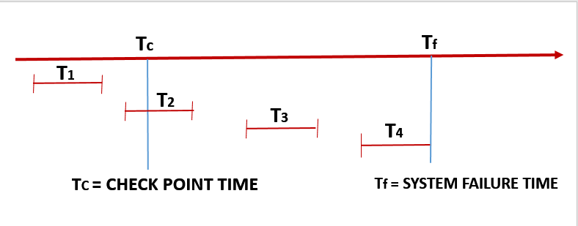

Tc is the time when database has checkpoint. Tf is the time when database has system failure T1, T2, T3, and T4 are database transactions.

Transactions T1, T2, T3, and T4 occurred in chronological order. The checkpoint in the database happened at a given time Tc and later on time at Tf, the system crashed due to power failure.

Assume that the employee MELVIN with employee ID 7799 is working in department number 20 with a monthly salary of $7000. MELVIN is currently not eligible to earn the commission.

The following are the details of the work done in each transaction.

T1:

CONNECT apatel/N3wY0rk23@HRD

SELECT deptno, sal, comm FROM ap_emp WHERE EMPNO=’7799’;

UPDATE ap_emp SET sal=sal+500, comm=sal*0.1 WHRE EMPNO=’7799’;

CREATE TABLE AP_EMP_TEST AS SELECT * FROM EMP WHERE “T1”=”TX 1”;

T2:

DELETE FROM ap_emp WHERE SAL BETWEEN 8000 and 9000;

ALTER TABLE EMP_TEST ADD CONSTRAINT

pk_emp_test PRIMARY KEY(EMPNO);

T3:

UPDATE ap_emp SET deptno=30 WHERE empno=’7799’;

UPDATE ap_emp SET sal=sal+sal*0.1 WHERE deptno=30;

COMMIT:

T4:

UPDATE ap_emp

SET comm=nvl(comm,0)+100 , sal=sal+300

WHERE empno=7799;

1. **Upon system recovery, which transaction(s) will undergo REDO operations, and which transactions will undergo UNDO operations and why? [ 8 points]**
2. **For transaction(s) that will undergo UNDO, what will be written out in the transaction log? [8 points]**
3. **What will the department number, salary, and commission of MELVIN be after the system is recovered? [8 points]**
4. **Consider the following dataset. [26 points]**

**This dataset is about employee churn (decision to leave the company) based on gender, age, and income criteria.**

1. **Draw bitmaps for the attributes GENDER, AGE, INCOME, and CHURN. Submit each bitmap. [8 points]**
2. **Using the bitmaps created in step a above, answer the following questions by resolving the bitmaps.**

**Total number of male employees of the age less than 50 and with salary less than 100Kwho left (CHURN) the company.**

1. **Submit intermediate and final bitmaps, and a total number of employees as per given criteria. [8 points]**

**Use the attached DDL and DML to create a table and data by replacing asp13 with your Net ID. Write a SQL query that finds the answer to the same question (Total number of male employees of the age less than 50 and with salary less than 100K who left (CHURN) the company).**

**Submit the SQL and screenshot of the result. [8 points]**

1. **Write DDL code to create bitmap indexes for each attribute.**

**Submit the DDL code. [2 points]**