

**28th Oct. 2023**

**Midterm Exam**

**CS-GY 6083 - B, Fall 2023 Principles of Database Systems**



**MIDTERM EXAM [100 points with 20% weight]**

**10/28/2023 11:00 AM to 1:00 PM EST: Time Limit: 2 Hours**

**Please read instructions carefully before writing exam**

**Write your name and net id below**

* **Last Name: First Name: Net ID:**

**This is an online exam. Please login to zoom meeting using your net id (mandatory, do not login with your personal email account). Login to Brightspace course website to join the zoom meeting.**

* **Join to zoom meeting no later than 10:45am. Please keep video on and mute microphone during exam.**
* **Write your answers under each question in this word document and submit it in single PDF file before the deadline to Brightspace course site. The file should be in Netiid_FA23_Midterm.PDF format**

**(e.g., asp13_FA23_Midterm.PDF). You may resubmit your assignment multiple times before the submission deadline. The latest submission will be considered for the grading.**

* **This exam has four sections A, B, C. All sections and questions have grading points. There are no negative points for any wrong answers.**
* **If you have any question during the exam, please send your question privately to professor/TA on zoom meeting chat window. Please do not speak in microphone.**
* **Plagiarism of any type will not be graded.**

**GOOD LUCK!**

1. **Answer following questions briefly [20 points]**
2. **Explain importance of referential integrity in OLTP database. Explain How to implement referential integrity with an example.**
3. **What is good quality data and its importance in business. Explain how to implement consistency in data with an example.**
4. **Draw ERD (Logical & Relational model) [50 points]**

**Acme Inc. is a national retail chain, specializing in consumer electronics products. Historically, the company has grown through acquisitions. This had led to a high level of heterogeneity in the IT systems at Acme. The business executives find it difficult to get timely, relevant, accurate information for better business decision making. Also, the information does not have uniform formats and integrity. To overcome this issue, the IT department has suggested creating a relational database that resolves the issues of data consistency and integrity.**

**The business team has provided a sample invoice to the database designer as a source to create a relational data model.**

**Business team of Acme has stated following requirements and rules:**

1. **There could be multiple customers residing on same address.**
2. **An order can have different address for billing and shipping.**
3. **Data model needs to have employee name, email address, and phone number.**
4. **Data model needs store address, and phone number.**
5. **Unit price in invoice is the sales price and not the MSRP (Maximum Sale Retail Price).**
6. **No separate entity is needed for promotion codes.**

**Create a normalized data model that represents all data items in the provided invoice. All table in your database model must have your initial as prefix, e.g., AP_EMP. Ignore blue arrow lines in invoice picture.**

**Submit: Screenshots of logical model and relational model, and any valid assumptions made other than stated.**

**NO NEED TO submit DDL code.**

1. **SQL DDL [30 points]**

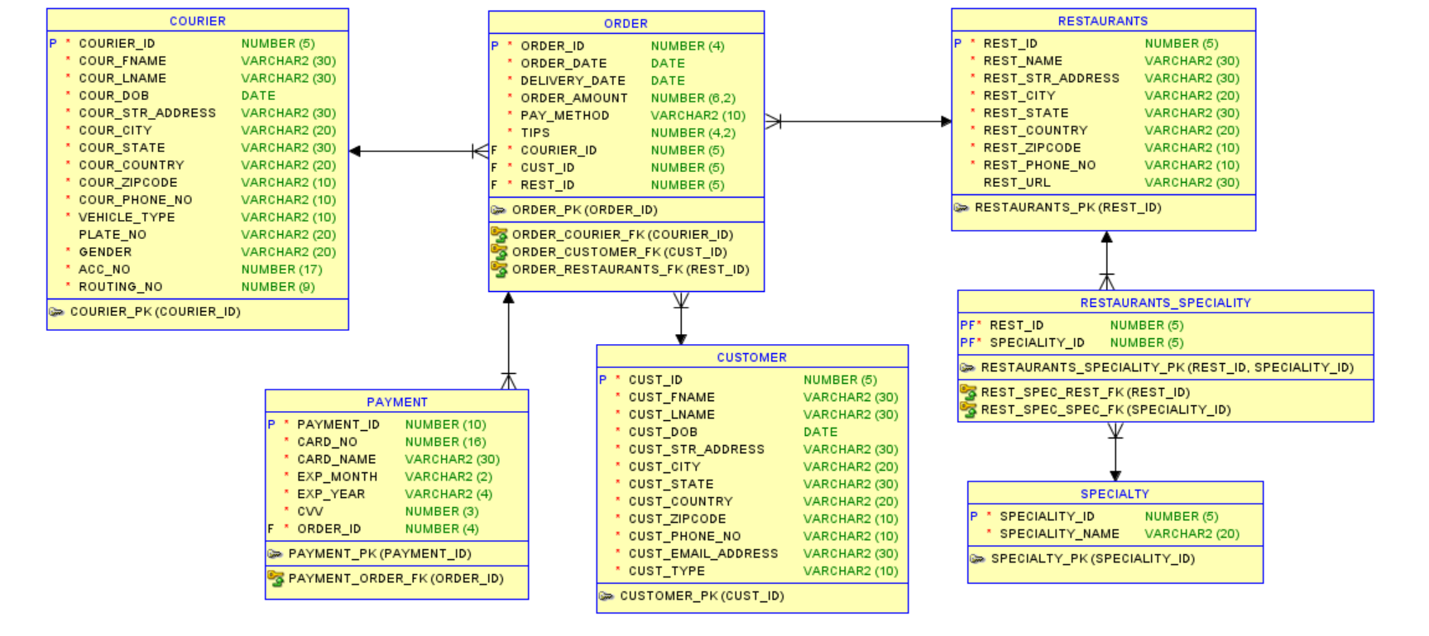

**Answer the following questions in terms of writing SQL DDL code.**

1. **Apply a business rule that CVV number in Payment table has minimum 3 digits.**
2. **Apply business rule that ORDER_DATE in ORDER table is not the past or future date.**
3. **Apply business rule that DOB of Courier is over 18 years of age.**
4. **Identify surrogate key in this relational model and explain reason to have it as surrogate key.**
5. **Explain how you can simplify this design. If any new entity needs to be added, what is it, and state relationships of that entity to other entities.**

**Submit: Answer to each of the questions. Please do not remove any questions, write your answers underneath each question.**

----------------------------------------------------End of Exam Paper ------------------------------------------------