1.

a.

$$I_{A}={10}^{5}Inst$$

$$I_{B}={2×10}^{5}Inst$$

$$I_{C}={5×10}^{5}Inst$$

$$I_{D}={2×10}^{5}Inst$$

$$ET_{1}=\frac{\left(CPI_{A_{1}}×I_{A}+CPI_{B_{1}}×I_{B}+CPI_{C_{1}}×I_{C}+CPI_{D_{1}}×I_{D}\right)}{F_{CLK1}}=\frac{{10}^{5}+4×{10}^{5}{+10}^{6}+2×{10}^{5}}{2×{10}^{9}}=0.58ms$$

$$ET_{2}=\frac{\left(CPI_{A_{2}}×I_{A}+CPI_{B_{2}}×I_{B}+CPI_{C_{2}}×I_{C}+CPI_{D_{2}}×I_{D}\right)}{F_{CLK2}}=\frac{{2×10}^{5}+6×{10}^{5}{+2×10}^{6}+8×{10}^{5}}{4×{10}^{9}}=0.9ms$$

$$ET_{1}<ET_{2}$$

So $P_{1}$ is faster.

b.

$$avg CPI_{1}=10\%CPI_{A_{1}}+20\%CPI_{B_{1}}+50\%CPI_{C_{1}}+20\%CPI_{D_{1}}=0.1+0.4+1+0.2=1.7$$

$$avg CPI_{2}=10\%CPI_{A_{2}}+20\%CPI_{B_{2}}+50CPI_{C_{2}}+20\%CPI_{D_{2}}=0.2+0.6+2+0.8=3.6$$

c.

$$Clock cycles_{1}=avgCPI_{1}×IC=1.7×{10}^{6}$$

$$Clock cycles_{2}=avg×IC=3.6×{10}^{6}$$

d.

$$IPS_{1}=\frac{F_{CLK1}}{avgCPI_{1}}=\frac{2GHz}{1.7}=1.18×{10}^{9}Inst/Sec$$

$$IPS_{2}=\frac{F_{CLK2}}{avgCPI_{2}}=\frac{4GHz}{3.6}=1.11×{10}^{9}Inst/Sec$$

$$IPS_{1}>IPS_{2}$$

Thus, $P_{1}$ has the highest throughout performance.

e.

$P_{1}$ is more energy efficient because it has lower CPI and $P_{2}$ needs more clock cycles in each instruction so it consumes more power to the same work.

2.

a.

50% of the total energy.

b.

$$\frac{E_{new}}{E_{old}}=\frac{\frac{1}{2}×C×V_{new}^{2}}{\frac{1}{2}×C×V_{old}^{2}}=\frac{1}{4}$$

So, 3/4 of the total energy can be saved.

3.

a.

$$P_{new_{1}}=90\%×\left(1-60\%\right){×P}_{max}=36\%P_{max}$$

$$P_{old}=90\%P_{max}$$

$$\frac{P_{old}-P_{new_{1}}}{P_{old}}=\frac{90\%-36\%}{90\%}=60\%$$

b.

$$P_{new_{2}}=90\%×P_{max}×\left(1-60\%\right)+20\%{×P}_{max}×60\%=48\%P_{max}$$

$$\frac{P_{old}-P_{new_{2}} }{P_{old}}=\frac{90\%-48\%}{90\%}=46.7\%$$

c.

$$1-\frac{P_{new_{3}}}{P_{old}}=1-\frac{C_{old}×{\left(0.8V_{old}\right)}^{2}×F_{old}×0.6}{C_{old}×V_{old}^{2}×F_{old}}=1-38.4\%=61.6\%$$

d.

$$1-\frac{P_{new_{4}} }{P_{old}}=1-\frac{90\%×P_{max}×\left(1-60\%\right)+20\%×P_{max}×30\% }{90\%}=1-\frac{42\%}{90\%}=53.3\%$$

4.

a.

MTTF for the system=35/3=11.7=12days

b.

If the MTTF is doubled, the running time for computers will increase, so we can save cost and time.

5.

a.

x=0, y=1

x=1, y=10

y=10/(10-9x)

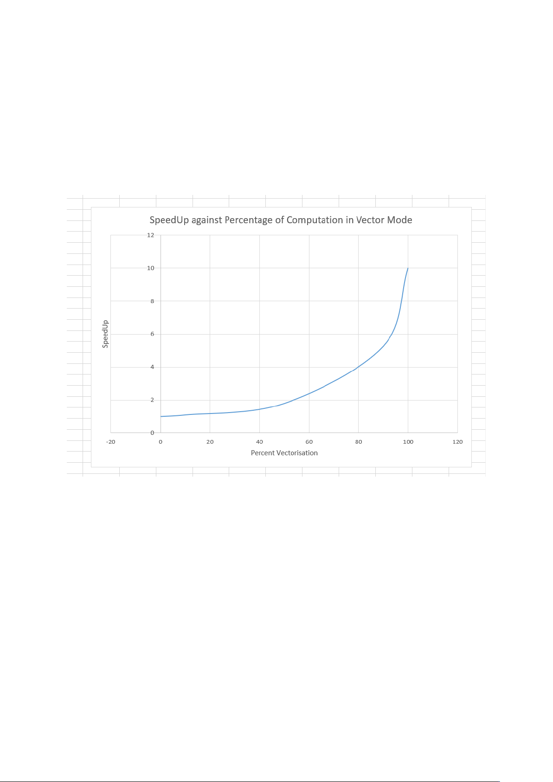

b.

$$\frac{10}{10-9x}=2$$

Then,

$$x=\frac{10}{18}=55.56\%$$

c.

If a speedup of 2 is achieved, then 55.6% of the code is vectorized.

Suppose the original code takes 100 seconds. Then 100-55.6 = 44.4 % of

the code will run unvectorized, which will take 44.4 seconds. We know,

since a speedup of 2 is achieved that the total run time is 50

seconds. Hence, 50-44.4=5.6 seconds are spent in vectorized code.

If a speedup of 2 is achieved, then 55.6% of the code is vectorized.

Suppose the original code takes 100 seconds. Then 100-55.6 = 44.4 % of

the code will run unvectorized, which will take 44.4 seconds. We know,

since a speedup of 2 is achieved that the total run time is 50

seconds. Hence, 50-44.4=5.6 seconds are spent in vectorized code.

If a speedup of 2 is achieved, then 55.6% of the code is vectorized.

Suppose the original code takes 100 seconds. Then 100-55.6 = 44.4 % of

the code will run unvectorized, which will take 44.4 seconds. We know,

since a speedup of 2 is achieved that the total run time is 50

seconds. Hence, 50-44.4=5.6 seconds are spent in vectorized code.

Assume the old execution time = 1.

$$Percentage=\frac{vector mode time}{new execution time}=\frac{55.56\%×0.1}{\frac{1}{2}}=11.112\%$$

d.

$$y=\frac{10}{2}=5=\frac{10}{10-9x}$$

$$x=\frac{40}{45}=88.89\%$$

e.

$$x=70\%$$

$$y=\frac{10}{10-9x}=2.70$$

$$y_{goal}=2.70×2=5.40=\frac{10}{10-9x}$$

$$x_{goal}=\frac{44}{48.6}=90.53\%$$

6.

a.

$$ET=\frac{I×\left(CPI_{1}+CPI_{2}+CPI_{3}\right)}{F_{CLK}}=\frac{150×{10}^{6}×\left(0.5×3+0.3×4+0.2×5\right)}{2.7×{10}^{9}}=205.6ms$$

b.

$$CPI_{new}=0.5×3+0.3×2+0.2×2=2.5$$

$$ET_{new}=\frac{I×CPI_{new}}{F_{CLKnew }}=\frac{150×{10}^{6}×2.5}{2.1×{10}^{9}}=178.6ms$$

$$Improvement=\frac{ET}{ET_{new}}-1=\frac{205.6}{178.6}=1.15-1=0.15$$

7.

a.

$$ET_{old}=\left(CPI_{1}×I_{1}+CPI_{2}×I_{2}+CPI_{3}×I_{3}\right)×Clock Cycle Time=\left(1×500+10×300+3×100\right)×{10}^{6}×Clock Cycle Time=3.8×{10}^{9}×Clock Cycle Time$$

$$ET_{new}=\left(1×500×75\%+10×300+3×100\right)×{10}^{6}×Clock Cycle Time×110\%=4.0426×{10}^{9}×Clock Cycle Time$$

Since $ET_{old}<ET_{new}$, it’s not a good design choice.

b.

If the performance is doubled, $CPI_{1}=0.5$.

$$ET_{new}=\left(0.5×500+10×300+3×100\right)×{10}^{6}×Clock Cycle Time=3.35×{10}^{9}×Clock Cycle Time$$

$$\frac{ET_{new}}{ET_{old}}=\frac{3.55}{3.8}=0.9342$$

$$Speedup=\frac{1}{0.9342}=1.07$$

If the performance is improved by 10 times, then $CPI_{1}=0.1$

$$ET_{new}=\left(0.1×500+10×300+3×100\right)×{10}^{6}×Clock Cycle Time=3.35×{10}^{9}×Clock Cycle Time$$

$$\frac{ET_{new}}{ET_{old}}=\frac{3.35}{3.8}=0.8815$$

$$Speedup=\frac{1}{0.8815}=1.13$$

8.

$$ET_{old}=\frac{CPI×I}{F_{CLK}}$$

$$ET_{new}=\frac{CPI×\left(1-30\%×\left(1-\frac{2}{3}\right)\right)I}{0.95F_{CLK}}$$

$$\frac{ET_{old}}{ET_{new}}=\frac{0.95}{0.9}=1.056$$

Since $ET_{old}>ET_{new}$, the optimized version is faster.

9.

a.

$$A_{operations}=0.7×throughput_{A}=9422.7$$

$$B_{operations}=0.3×throughput_{B}=10939.5$$

$$t_{TPU}=\frac{A_{operations}}{throughput_{A}}+\frac{B_{operations}}{throughput_{B}}=0.0419+0.0391=0.081$$

$$Speedup=\frac{t_{GPU}}{t_{TPU}}=12.35$$

b.

$$General:70\%×42\%+30\%×100\%=59.4\%$$

$$GPU:70\%×37\%+30\%×100\%=55.9\%$$

$$TPU:70\%×80\%+30\%×100\%=86\%$$

c.

$$P_{GPU}=\frac{55.9\%}{991W-357W}$$

$$P_{TPU}=\frac{86\%}{384W-290W}$$

$$\frac{P_{TPU}}{P_{GPU}}=10.3764$$

d.

General:

$$A=40\%×5482=2192.8$$

$$B=10\%×13194=1319.4$$

$$C=50\%×12000=6000$$

$$t_{GPU}=\frac{2192.8}{13461}+\frac{1319.4}{36465}+\frac{6000}{15000}=0.1629+0.0362+0.4=0.5991$$

$$Speedup_{GPU}=\frac{1}{0.5991}=1.6692$$

$$t_{TPU}=\frac{2192.8}{225000}+\frac{1319.4}{280000}+\frac{6000}{2000}=0.0097+0.0047+3=3.0144$$

$$Speedup_{TPU}=\frac{1}{3.0144}=0.3317$$

e.

$$Haswell: \frac{14kW}{504W}=27.78=27$$

$$NVIDIA: \frac{14kW}{1838W}=7.62=7$$

$$TPU: \frac{14kW}{861W}=16.26=16$$

f.

$$Haswell: \frac{200W×11}{504W}=4<27$$

$$NVIDIA: \frac{200W×11}{1838W}=1<7$$

$$TPU: \frac{200W×11}{861W}2<16$$

Thus, only 1 cooling door is required for each.

10.

a.

The projected growth rate in 2015 was 3.5% performance bump per year. Therefore, by this estimate the processors in 2025 should be 1.03510 times better than the processors of 2015.

b.

The SUN 4/290 processor, which was released in 1987, was 10 times faster than the VAX-11/780. Since the projected growth rate at the time was 52% increase per year, the performance of a 2025 processor, by 1977 estimates, would be (10 ·1.5238) times faster than the VAX-11/780

c.

Moore's Law was built upon Denard Scaling, which proposed that as transistors decreased in size, their power density remained consistent. This meant that power consumption remained proportional to chip area, resulting in reductions in both voltage and current. However, as transistors continued to shrink, it became apparent that lowering voltage and current indefinitely would jeopardize the integrity of integrated circuits. Factors such as leakage current and threshold voltage became increasingly influential when determining power consumption levels.

11.

a.

Failures in time (FIT) is traditionally reported as failure per billion (1 × 10^9) hours of operation. $MTTF =\frac{1}{\left(\frac{100}{{10}^{9}}\right)}=\frac{{10}^{9}}{100}= {10}^{7}hours$

b.

MTTR = 1 day = 24 hours

$$Availability of the system=\frac{MTTF}{\left(MTTF + MTTR\right)}=\frac{{10}^{7}}{{10}^{7}}+24 = 0.999 \sim 1 = 99.99\%$$

c.

$$FIT_{1000}=Number of processors × FIT per processor=1000 × 100 = {10}^{5}$$

$$MTTF_{1000}=\frac{1}{\frac{{10}^{5}}{{10}^{9}}}=\frac{{10}^{9}}{{10}^{5}}={10}^{4} hours$$