Organization of Digital Computers Lab EECS 112L

Lab 1: ALU and DFF

1/18/2021

**1 Objective**

In this lab, I finished 2 parts. Firstly, I fixed the code error of the ALU given by the prof, designed a testbench for it. Secondly, I designed a synchronous DFF and a asynchronous DFF, and added more cases in the testbench provided by the prof.

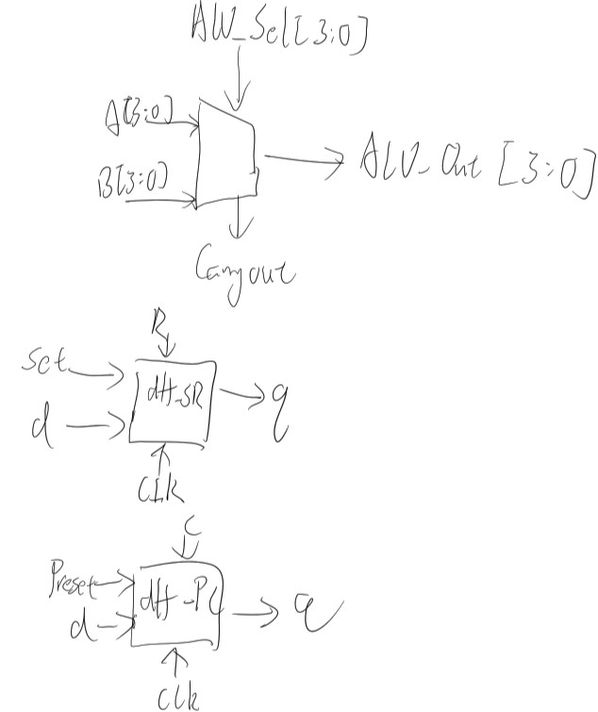

**2, Procedure**

Alu: The result of carryout varies in different ALU_Sel, so I designed the code for carryout under each case. Regarding the case selection I used if begin statement. DFF: I used always statement to achieve posedge, and if/else if/else to assign the value of Q based on different combination.

**3, Simulation result:**

ALU: the original error.

**1,** ADD operation: No error.

**2,** Multiplication: Error occurred.

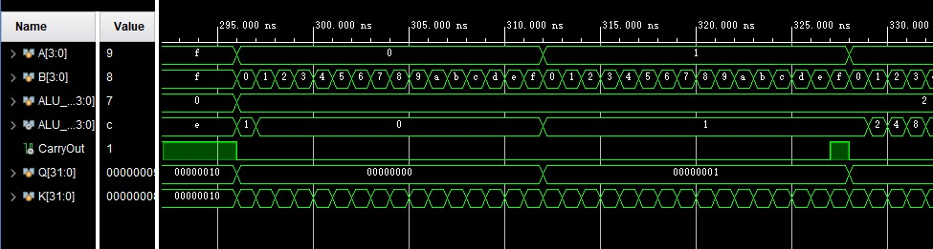

A ** B is not multiplication. For instance, 0 * 0 should be 0, but the waveform said 1.

**3,** logical shift left: Error occurred.

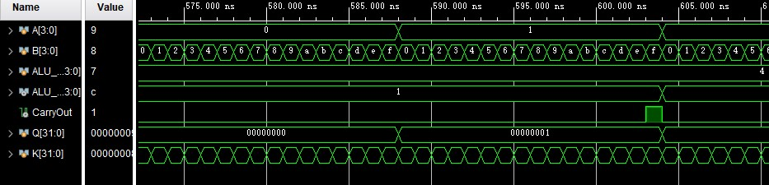

A <= 1 is not logical shift left. For instance, 1 << 1 is 2, but the waveform said 1. The correct expression should be <<.

**4,** Rotate right: Error occurred.

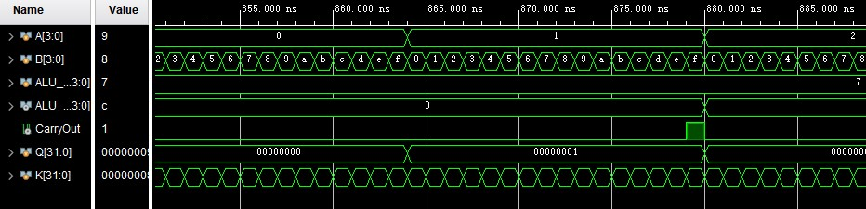

The expression for rotate right for ALU_Result should be ALU_Result = {A[0], A[3:1]} not ALU_Result

= {A[3] , A [3:1]}; .

**5,** Logical and: No Error .

**6,** Greater comparison: Error occurred.

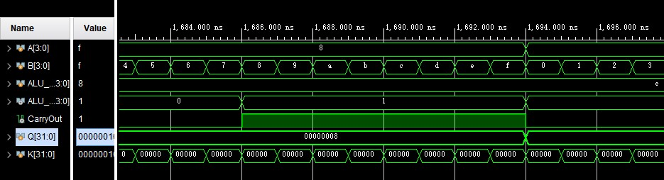When A > B, result should be 1, while the waveform is 0.

When A < B, result should be 0, while the waveform is 1.

The correct expression should be: (A>B)? 4'b1 :4'b0. **7,** CarryOut: Error occurred.

There are no carryouts except in addition, subtraction, multiplication, division, and shifted left operation. While there are carryouts in Rotate Right, Logical And, and greater comparison.

The way to fix this is to write code for carryout under each case.

**My simulation results:**

**ALU:**

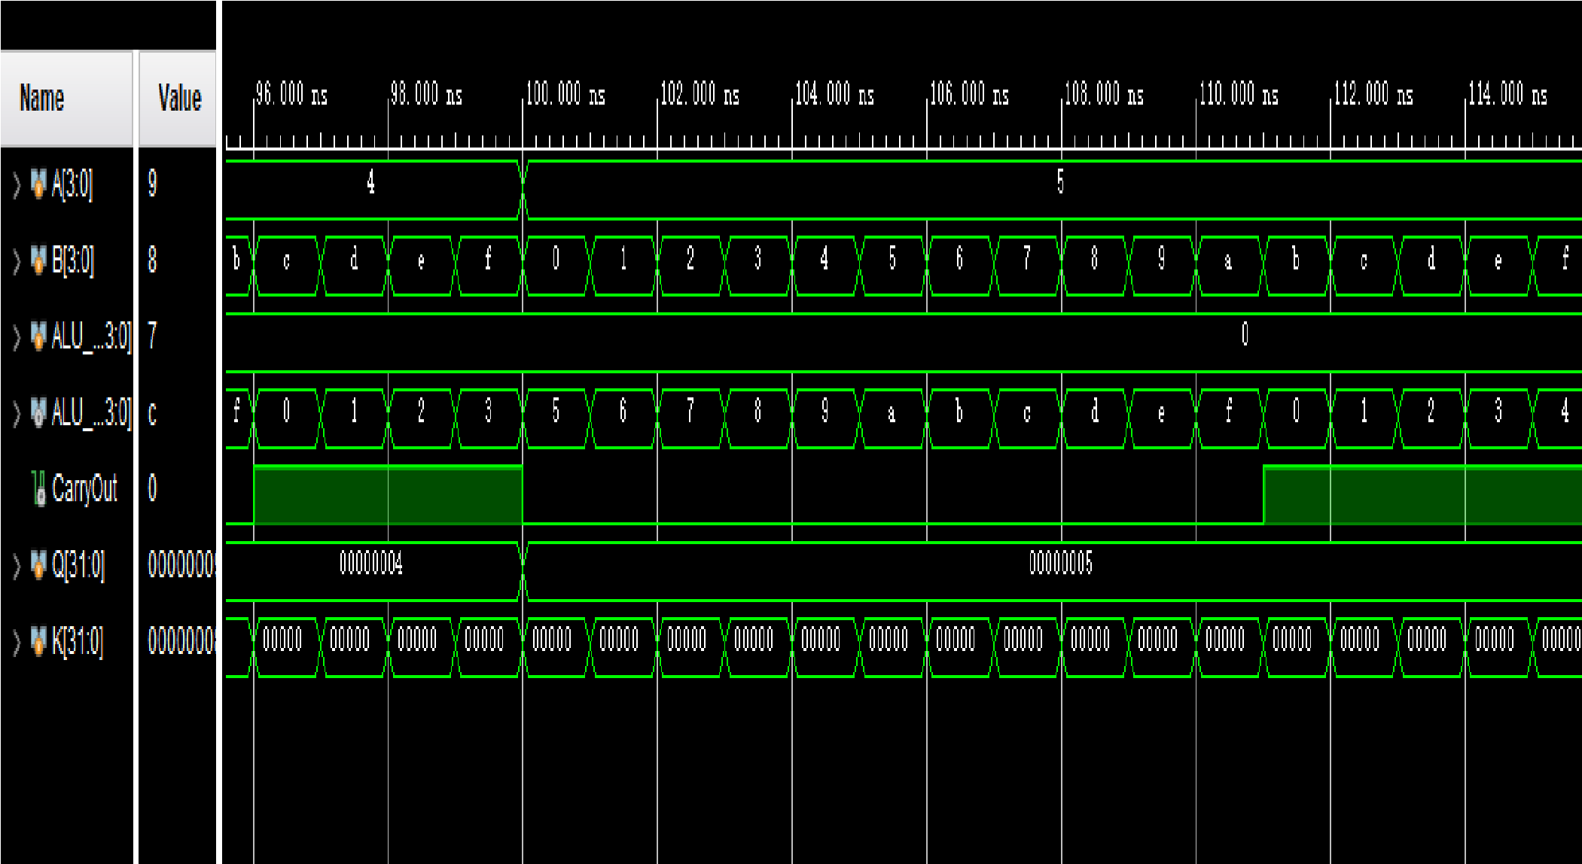**1,** Addition**:**

**2,** Multiplication:

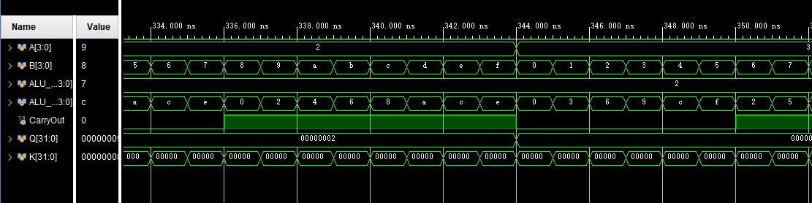

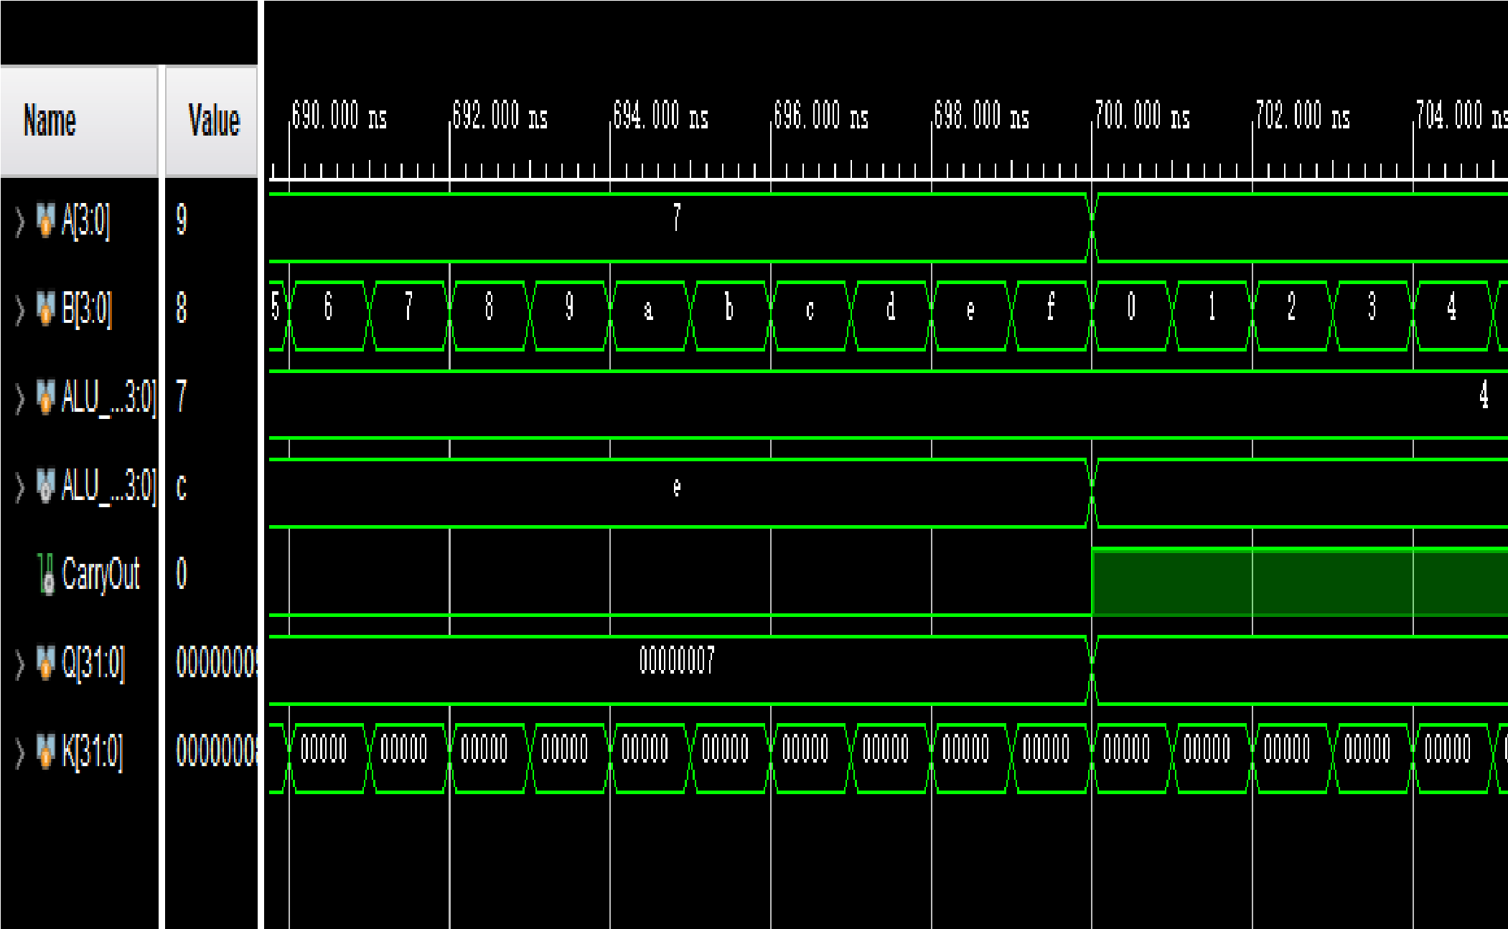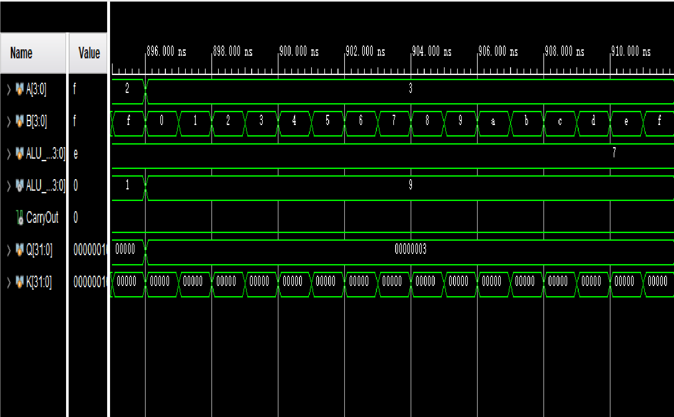**3,** logical shift left:

**4,** Rotate right:

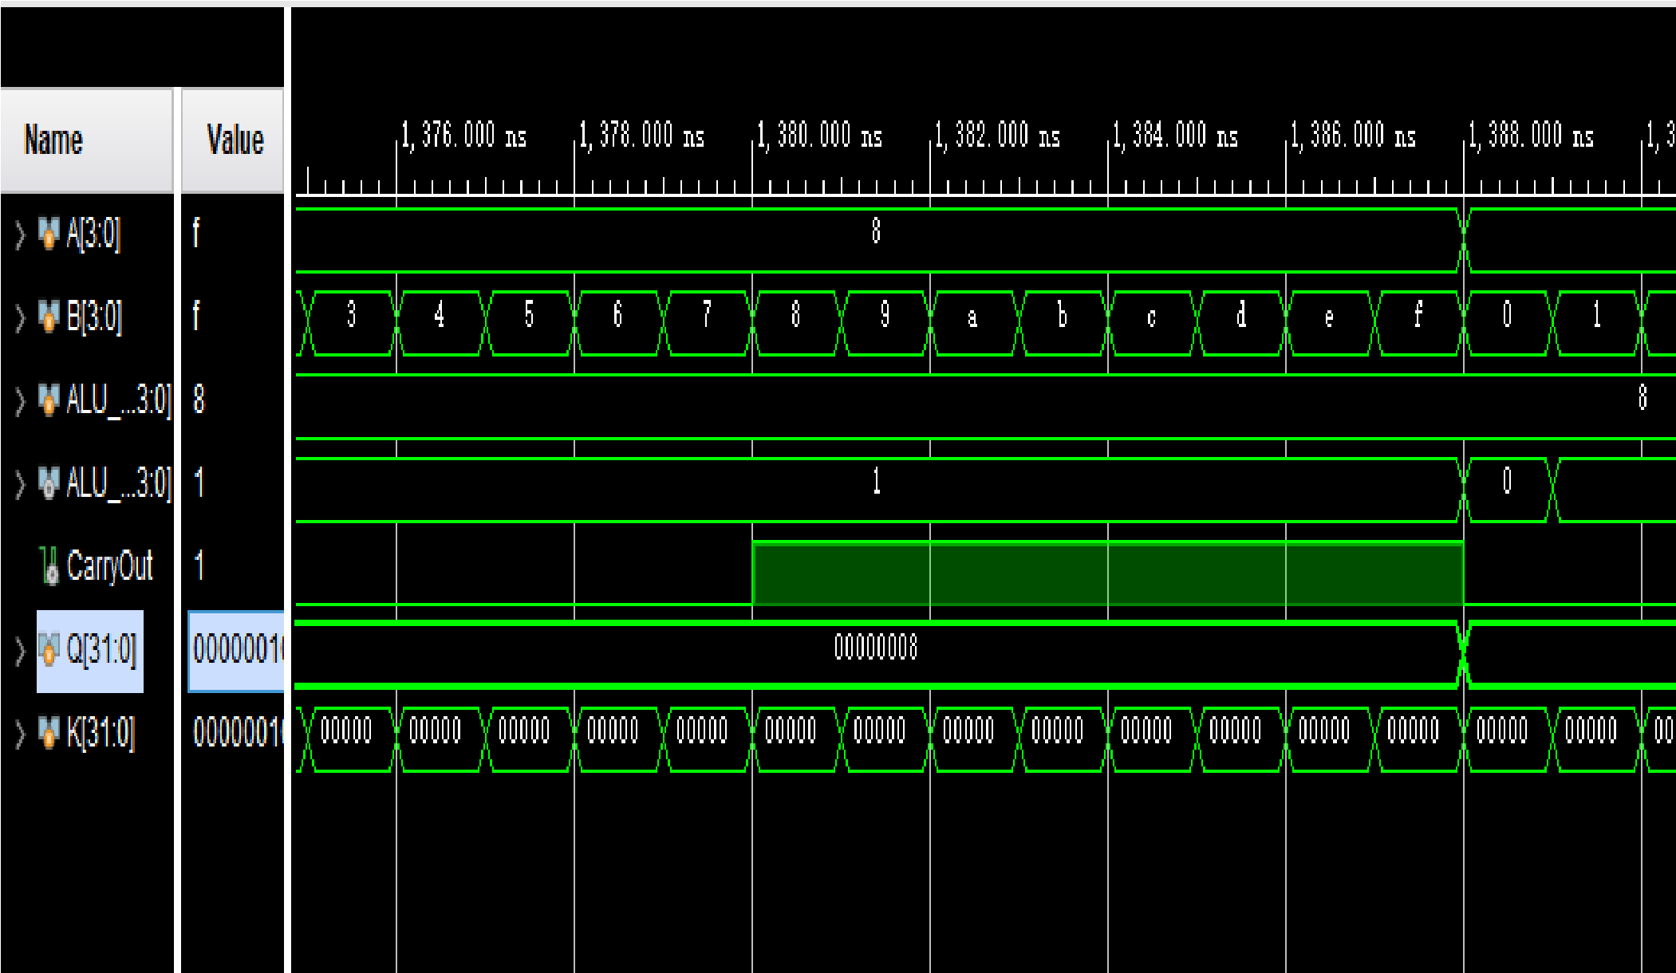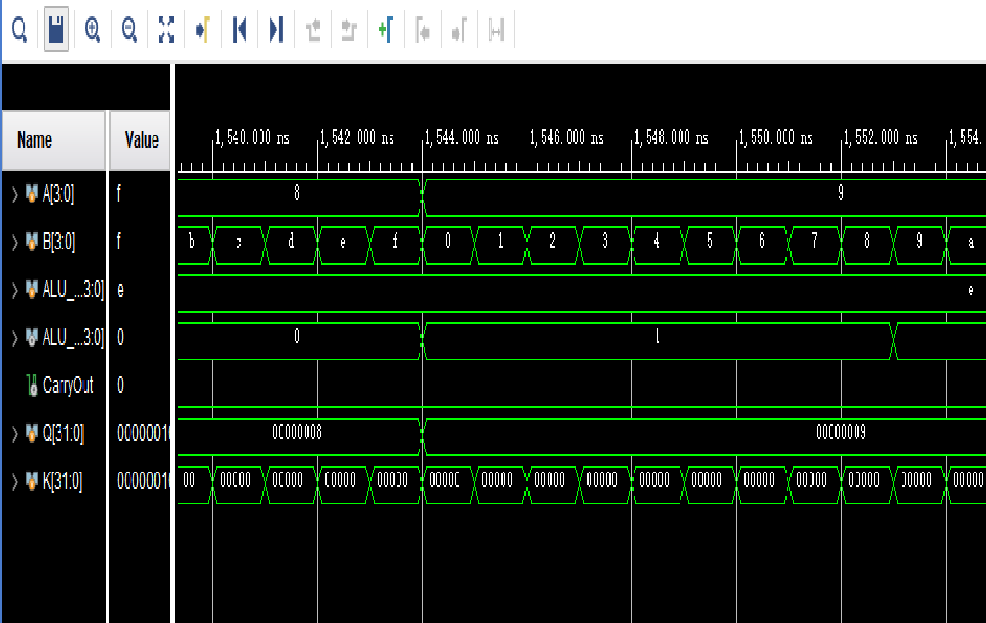**5,** Logical and:

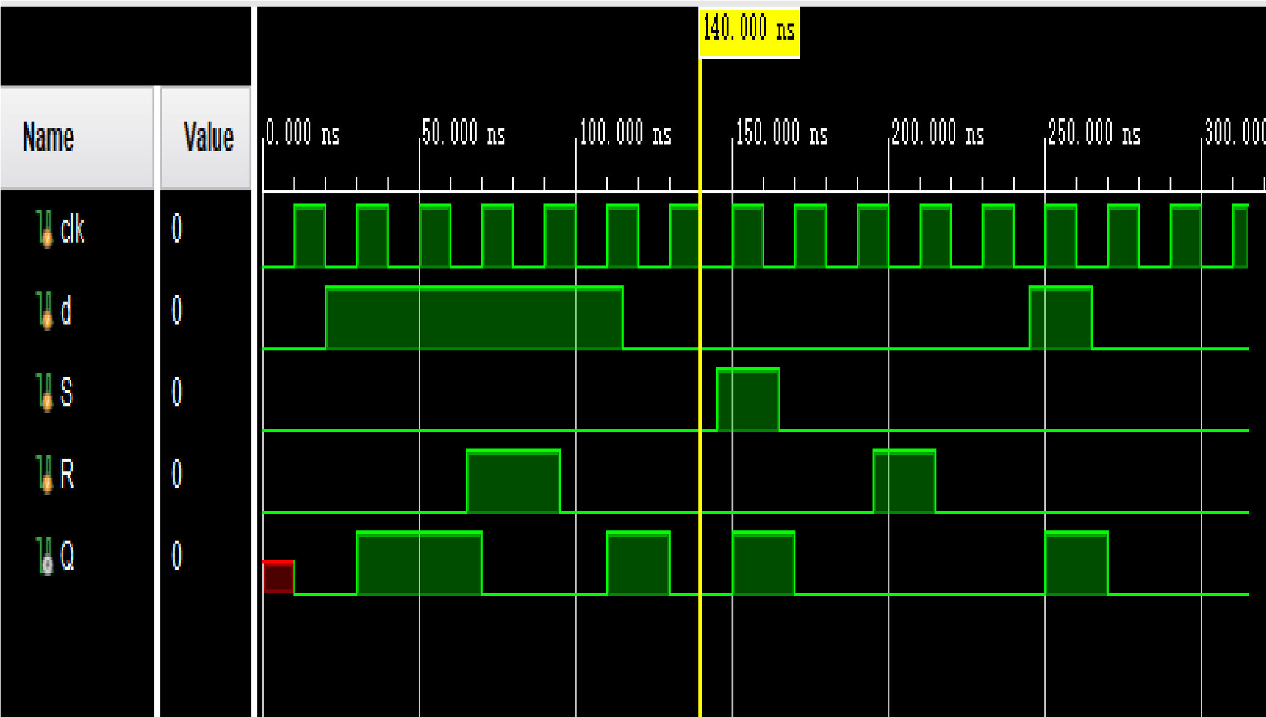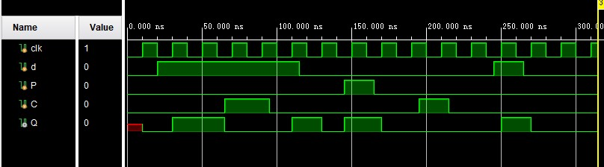**6,** Greater comparison **DFF_SR:**

**DFF_PC:**