**一、单项选择题**

**1-5：CAABC**

**6-10：DCACD**

**11-15：BADCA**

**二、程序阅读题（每题5分，共20分）**

1. **写出程序的输出结果（5分）**

**wang,19**

1. **写出程序的输出结果（5分）**

2,4,bc

1. **写出程序的输出结果（5分）**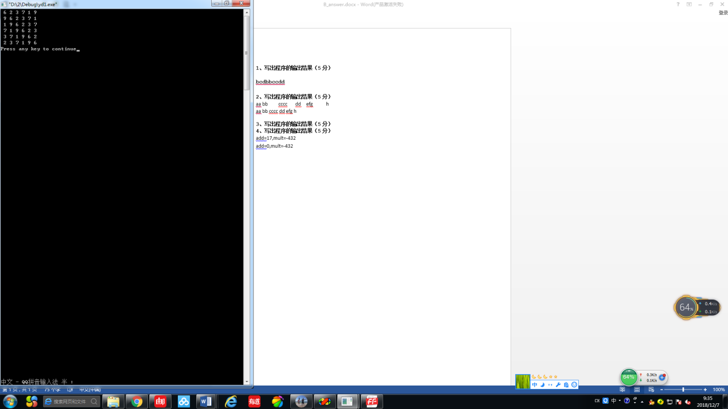
2. **写出程序的输出结果（5分）**

add=17,mult=-432

add=0,mult=0

**三、填空题(每空2分，10空，共20分)**

1. s=n/10%10;
2. n==g*g*g+b*b*b+s*s*s
3. flower(i)
4. a[i]
5. **strcpy(m,a[i]);**
6. m
7. a[i][i]
8. j<i
9. a[i-1][j-1]+a[i-1][j]
10. a[i][j]

**四、程序设计题(3题，共40分)**



#include <stdio.h>

int main()

{

int m[2][13]={{0,31,28,31,30,31,30,31,31,30,31,30,31},{0,31,29,31,30,31,30,31,31,30,31,30,31}};

int year,month,leap;

scanf("%d%d",&year,&month);

leap=year%400==0 || year%100!=0 && year%4==0;

printf("%d\n",m[leap][month]);

return 0;

}

2.

#include <stdio.h>

int hb(int a[],int n, int b[],int m,int c[])

{

int i,j,count=0;

for(i=0;i<n;i++)

{for(j=0;j<m;j++)

if (a[i]==b[j]) break;

if (j==m)

c[count++]=a[i];

}

for(i=0;i<m;i++)

{for(j=0;j<n;j++)

if (b[i]==a[j]) break;

if (j==n)

c[count++]=b[i];

}

return count;

}

main()

{

int i,a[4]={1,3,5,7},b[4]={2,4,3,5},c[20],num;

num=hb(a,4,b,4,c);

for(i=0;i<num;i++)

printf("%d ",c[i]);

}

3.

#include "stdio.h"

#include "stdlib.h"

#define N 100

#define M 3

struct Student{

char xh[10];

char name[20];

char sex //M or F

double score[M];

double total；

};

int read_data(struct Student* students，char* file_name)

{

FILE *fp,i=0;

fp=fopen(file_name,"r");

while(fp)

{

fscanf(fp,"%s%s%c%lf%lf%lf\n",(students+i)->xh,(students+i)->name,&(students+i)->sex,&(students+i)->score[0],&(students+i)->score[1],&(students+i)->score[2]);

(students+i)->total=(students+i)->score[0]+(students+i)->score[1]+(students+i)->score[2];

i++;

}

fclose(fp);

return i;

}

main()

{ int num;

struct Student a[N];

FILE fp1,fp2;

num=read_data(a,"student.txt");

fp1=fopen("M.txt","w");

fp2=fopen("F.txt","w");

for(i=0;i<num;i++)

if (a[i].sex=='M')

fprintf(fp1,"%s%s%c%lf%lf%lf%lf\n",a[i].xh,a[i].name,a[i].sex,a[i].score[0],a[i].score[1],a[i].score[2],a[i].total);

else

fprintf(fp2,"%s%s%c%lf%lf%lf%lf\n",a[i].xh,a[i].name,a[i].sex,a[i].score[0],a[i].score[1],a[i].score[2],a[i].total);

fclose(fp1);

fclose(fp2);

}