Hello

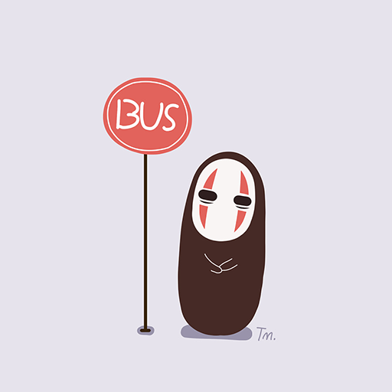

End.

|  |  |  |
| --- | --- | --- |
|  |  |  |
|  | let's img |  |

*Hi*

*1*

*2*

*3*

*4*