搜索接口：searchnew/?searchword=

真正的response（获取文件链接）：
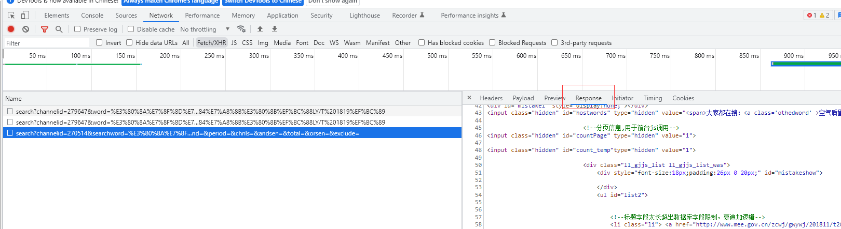

Wasurl
var wasurl="/was5/web/search?channelid=270514&searchword="+encodeURI(searchword)+"&page="+$("#nextPage").val()+"&orderby="+orderby+"&searchscope="+searchscope+"&timestart="+timestart+"&timeend="+timeend+
"&period="+period+"&chnls="+chnls+"&andsen="+encodeURI(andsen)+"&total="+encodeURI(total)+"&orsen="+encodeURI(orsen)+"&exclude="+encodeURI(exclude);

Channelid=27(月份与日期)

转链接
【怎么获取链接。。关于json怎么访问？】

获取文档：div class="neiright_JPZ_GK_CP"

