# Artificial intelligence - the application of Turing coin in life

Artificial Intelligence, an acronym for AI. Artificial intelligence is a branch of computer science. It attempts to understand the essence of intelligence, and can produce a new kind of response in the form of human intelligence similar intelligent machines, research in this field include robot, speech recognition, image recognition, natural language processing and expert system, etc.

In the next 10 years or more, artificial intelligence will be the breakthrough point for many intelligent industrial technologies and application development.

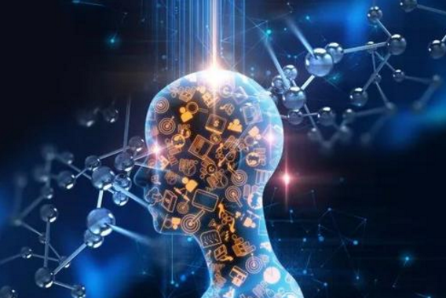

Turing currency team spirit True Knowledge to put forward the concept of the Turing machine for computability theory, provide a True development of intelligent block contract agreement, can be used to block chain of artificial intelligence authentication, data management, learning and application development, Project True will provide data for other artificial intelligence technology and application development platform, promote block chain with artificial intelligence. Ture is also an artificial intelligence technology and product, and Ture is a smart image (Avatar) that looks like you, speaks like you, and understands you more and more. Each TURE is generated, controlled, and managed by the original owner. Everyone is using their own Ture and contributing data and resources to the whole system, and thus making a profit. The Project Ture block chain protocol has three modules: authentication, intelligent network, data storage, and the development of a new digital currency, the Turing currency, based on the data on the block chain.



**Artificial intelligence helps to upgrade the blockchain.**

**What about the combination of blockchain and artificial intelligence? The Turing team found that not only artificial intelligence could solve the problem in the area of blockchain, but also the blockchain could solve the problem of artificial intelligence industry.**

**The first is the problem of the blockchain itself, which has been born without the ability of artificial intelligence. The first generation of blockchain is bitcoin, although the innovative creation of a distributed financial system, but the scripting language is simple, can only do simple transfer, payment; Second generation block chain etheric fang is optimized, such as platform, by trying to extend the script, the virtual machine and other ways to solve the development block the function of the chain, such as writing smart contracts, development DApp decentralized application and so on. But the etheric fang because run on chain, computing power, storage capacity and network capability is relatively weak, unable to run the semantic understanding of artificial intelligence, machine learning and multi-layer neural network.**

**Therefore, how to use artificial intelligence in the field of blockchain is a bottleneck in the current blockchain technology. What true COIN does is to solve this problem.**

**"So far this has not been done, first of all because it is a hard nut to crack. Secondly, there are some impetuous and froth in the industry, many people choose easy to do, easy to circle the money, do not want to touch this technical hard bone. And we are all people who are calm, we don't go to the trend, our vision is very simple, is to let the block chain use artificial intelligence."**

**As the saying goes, it takes a mouthful to eat. So their first step, first of all, is to use artificial intelligence. They hope to implement this plan by solving the problem of invoking AI services in smart contracts. Is similar to the etheric lane in the network intelligent "smart" in the contract is not real intelligence, and intelligence matrix by introducing AI, can make intelligent contracts and block chain system become a real "smart".**

**The Project Ture block chain protocol has an artificial intelligence network module of artificial intelligence learning. The distributed artificial intelligence algorithm is interwoven into the block chain architecture, which is the core module of the true block chain. Through data verification, artificial intelligence developers can prevent false files and data on the true network. Even if the user authorization on set developers to use their true deployment on other application, artificial intelligence, developers can still track their Project true activities to ensure that their true not malicious use. Also, developers and users are paid in an open and transparent manner. These behaviors are recorded into the block chain.**

**The innovation of these technologies has taken a big step in solving the blockchain problem: using artificial intelligence in the block chain.**

**The decentralization model of block chain helps the artificial intelligence industry to improve production efficiency.**

**In the field of artificial intelligence, Paul also found that although AI technology is advanced, its development mode is backward. "Is similar to the self-sufficient small-scale peasant economy mode" - things they need their production, they need the function of their research and development, "need food yourself, don't buy other people's food, also can't buy."**

**Once companies decided to start the layout of the artificial intelligence, is about to start constantly reinvent the "wheel", all others path to walk, no one is willing to share, and AI talent is original and less expensive, business efficiency is very low. They believe that these phenomena can be broken down into three problems:**

**1. How to share? In the AI field, sharing is essentially the sharing of algorithms and data models. What should you do if you all take it after sharing? Therefore, it is necessary to ensure the security of data and algorithms when sharing. It's like Coca-Cola developed a formula that sold customers a bottle of money, but couldn't sell the bottle and gave it to you.**

**2. How to share? It requires a certain pricing system because of the high cost, so it is not possible to share it for free.**

**3. How to use it after sharing? All major companies are independent, closed r&d, and have their own standards, which can't be used directly by other companies. There is a problem of standardization and compatibility of interfaces.**

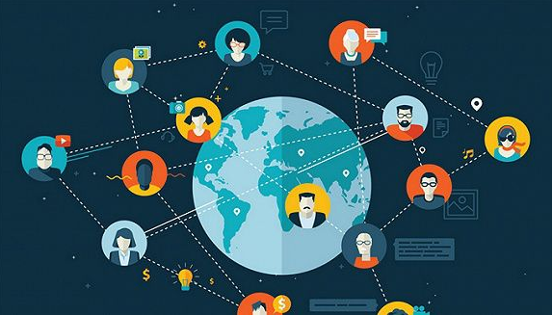

Using blockchain can solve these problems:

1. The problem of paid sharing: essentially, it is the valuation problem that can be priced and traded through the built-in "market" of the token system.

2. Standardization: using true, the AI will be invoked as a service API, and the enterprise will set the standard by itself, and what interface will be used for the interface to be used;

3. Share security issues: with API methods, data and code will not leak, and the blockchain itself can be registered and encrypted with data.

Thus, block chain can put up the world of artificial intelligence management, "our project makes the original mutual collaboration, closed, alone and not sharing, market-oriented industry, can be in the future market, sharing, collaboration,".