详细设计
—公司类网站

哈尔滨泰达天成

公司内部资料
仅供内部技术人员传阅

版本信息
序号 | 版本号 | 变更内容 | 日期
1 | V0.10 | 第4章之前整理完 | 10/15/2013
2 | V0.20 | 初稿完成 | 1/14/2014
3 | V0.30 | 删除附录部分 | 3/12/2016
4 | V0.31
5 | V0.32
6 | V0.33
7 | V0.34

目录

第一章 应用程序框架 6
前期准备 6
（一）、自动加载 7
（二）、移出演示 8
（三）、布局文件 8
（四）、前端框架 9
（五）、层次结构 17
一、Model 23
（一）、基类 23
（二）、功能类 27
二、Controller 29
（一）、基类 29
（二）、分管类 30
（三）、功能类 43
三、View 46
（一）、_layout_main 46
（二）、_layout_modal 49
（三）、组件页 51
四、Helper 54
（一）、按钮类 54
（二）、调试类 55
（三）、HTML类 56
第二章 Dashboard 61
一、用户登录 61
（一）、登录活动 61
（二）、登录框 64
（三）、登录管理 68
二、功能导引 70
（一）、视图 70
（二）、加载视图 79
第三章 后台部分 81
一、管理用户 82
（一）、User_M类 82
（二）、Views 84
（三）、User类 86
二、管理“公共模块” 91
（一）、语言 92
（二）、图像 97
三、管理“菜单项” 102
（一）、菜单维护 102
（二）、菜单顺序 108
四、管理“新闻中心” 116
（〇）、控制器 116
（一）、文章类型 121
（二）、文章内容 124
五、管理“产品” 132
（〇）、控制器 132
（一）、产品状态 141
（二）、产品参数 144
（三）、产品详细 147
六、管理“资质” 151
（一）、Qualification类 151
（二）、View 153
（三）、Qualification_M类 156
七、联系方式 157
（一）、Contact类 157
（二）、Views 159
（三）、Contact_M类 161
八、词汇对照 162
（一）、词汇维护 162
（二）、行业领域 167
第四章 前台部分 173
一、搭建前端架构 173
（〇）、路由设置 173
（一）、View 174
（二）、导航类 186
二、主页 187
三、产品页 188
四、新闻/公告页 189
（一）、分页 189
五、技术创新/资质页/公司概况 193
六、联系方式页 194
七、文章浏览 194
八、文章搜索 195

第一章 应用程序框架

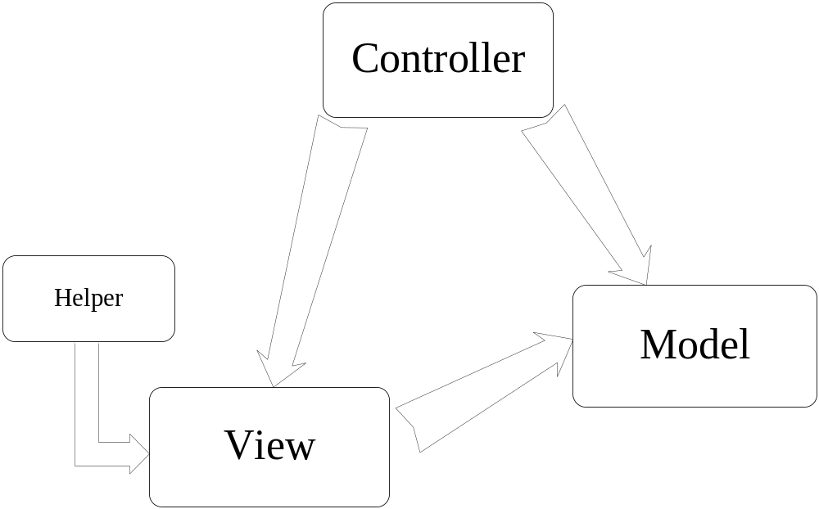MVC-H

关于Zend Studio使用“New->Class”的问题：
（在已生成的类代码中）
(1) 删除命名空间
(2) 删除类名的前缀

前期准备

（一）、自动加载
修改config/autoload.php

1. 加载db库

$autoload['libraries'] = array('database');

2. Helper

(1) url

增加对url helper的支持

$autoload['helper'] = array('url');

(2) form
对form helper的支持

$autoload['helper'] = array('url', 'form');

(3) html
对html helper的支持

$autoload['helper'] = array('url', 'html');

（二）、移出演示

1. 索引页
修改config/config.php中：
$config['index_page'] = '';

2. 控制器和视图
删除下列两个文件：
(1) controllers/welcome.php
(2) views/welcome_message.php

（三）、布局文件
新建以下两个布局文件，用于后台。

1. 主布局
views/admin/_layout_main.php

2. 登录布局
views/admin/_layout_modal.php

（四）、前端框架

1. Bootstrap

当前版本为V3.0

解压缩后，把3个子文件夹(css, fonts, js)拷贝到html中

Migrating from 2.x to 3.0
Folks looking to upgrade to v3 should use this section as a general upgrade guide. We've outlined some of the major changes and provided tables that highlight key changes. For an overview, read the announcement blog post.

Major class changes
Reference table for classes that have changed between v2.x and v3.0.
Bootstrap 2.x | Bootstrap 3.0
.container-fluid | .container
.row-fluid | .row
.span* | .col-md-*
.offset* | .col-md-offset-*
.brand | .navbar-brand
.nav-collapse | .navbar-collapse
.nav-toggle | .navbar-toggle
.btn-navbar | .navbar-btn
.hero-unit | .jumbotron
.icon-* | .glyphicon .glyphicon-*
.btn | .btn .btn-default
.btn-mini | .btn-xs
.btn-small | .btn-sm
.btn-large | .btn-lg
.visible-phone | .visible-sm
.visible-tablet | .visible-md
.visible-desktop | .visible-lg
.hidden-phone | .hidden-sm
.hidden-tablet | .hidden-md
.hidden-desktop | .hidden-lg
.input-small | .input-sm
.input-large | .input-lg
.checkbox.inline .radio.inline | .checkbox-inline .radio-inline
.input-prepend .input-append | .input-group
.add-on | .input-group-addon
.thumbnail | .img-thumbnail
ul.unstyled | .list-unstyled
ul.inline | .list-inline

What's new
We've added a few new elements and changed some existing ones. Here's their new or updated classes.
Element | Description
Panels | .panel .panel-default .panel-body .panel-title .panel-heading .panel-footer.panel-collapse
List groups | .list-group .list-group-item .list-group-item-text .list-group-item-heading
Glyphicons | .glyphicon
Jumbotron | .jumbotron
Tiny grid (<768 px) | .col-xs-*
Small grid (>768 px) | .col-sm-*
Medium grid (>992 px) | .col-md-*
Large grid (>1200 px) | .col-lg-*
Offsets | .col-sm-offset-* .col-md-offset-* .col-lg-offset-*
Push | .col-sm-push-* .col-md-push-* .col-lg-push-*
Pull | .col-sm-pull-* .col-md-pull-* .col-lg-pull-*
Input groups | .input-group .input-group-addon .input-group-btn
Form controls | .form-control .form-group
Button group sizes | .btn-group-xs .btn-group-sm .btn-group-lg
Navbar text | .navbar-text
Navbar header | .navbar-header
Justified tabs / pills | .nav-justified
Responsive images | .img-responsive
Contextual table rows | .success .danger .warning .active
Contextual panels | .panel-success .panel-danger .panel-warning .panel-info
Modal | .modal-dialog .modal-content
Thumbnail image | .img-thumbnail
Well sizes | .well-sm .well-lg
Alert links | .alert-link

What's removed
The following elements have been dropped or changed in v3.
Element | Removed from 2.x | 3.0 Equivalent
Form actions | .form-actions | N/A
Search form | .form-search | N/A
Fluid container | .container-fluid | .container (no more fixed grid)
Fluid row | .row-fluid | .row (no more fixed grid)
Navbar inner | .navbar-inner | N/A
Dropdown submenu | .dropdown-submenu | N/A
Tab alignments | .tabs-left .tabs-right .tabs-below | N/A

Additional notes
We've made many underlying changes in v3 that are not immediately apparent. Base classes, key styles, and behaviors have been adjusted for flexibility and our mobile first approach.
- Text-based form controls are now 100% wide. Wrap inputs inside <div class="col-*"></div> to control input widths.
- .badge no longer has contextual (-success,-primary,etc..) classes.
- .btn must also use .btn-default to get the "default" button.
- .container and .row are now fluid (percentage-based).
- Images are no longer responsive by default. Use .img-responsive for fluid <img> size.
- The icons, now .glyphicon, are now font based. They also require a base and icon class (e.g..glyphicon .glyphicon-asterisk).
- Typeahead has been dropped, in favor of using Twitter Typeahead.
- Modal markup has changed significantly. The .modal-header, .modal-body, and .modal-footer sections now get wrapped in .modal-content and .modal-dialog for improved mobile styling and behavior.
- JavaScript events are namespaced. For example, to handle the modal "show" event, use 'show.bs.modal'. For tabs "shown" use 'shown.bs.tab', etc..
For more information on upgrades and code snippets from the community check out Bootply.

2. JQuery

使用版本V1.x(当前版本为V1.10.2)

把jquery-1.10.2.js（开发用）和jquery-1.10.2.min.js（部署用）拷贝到html/js文件夹下

3. JQuery-UI

- 下载jquery-ui-1.x.custom.zip（当前版本V1.10.3）

钩选如下：

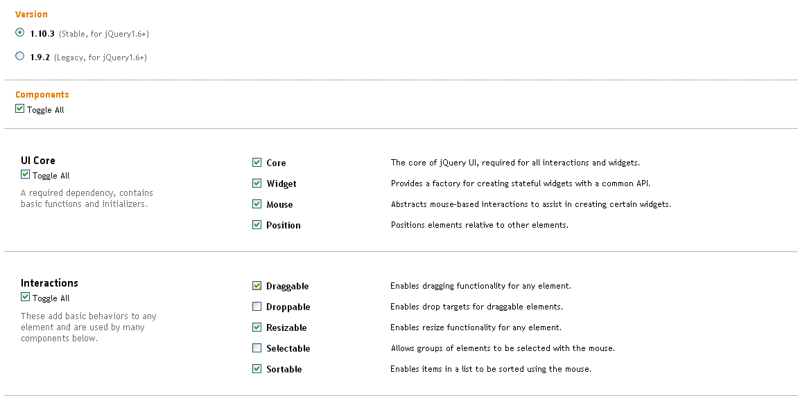

钩选“Dialog”之后，自动钩选上“Draggable”、“Resizable”和“Button”

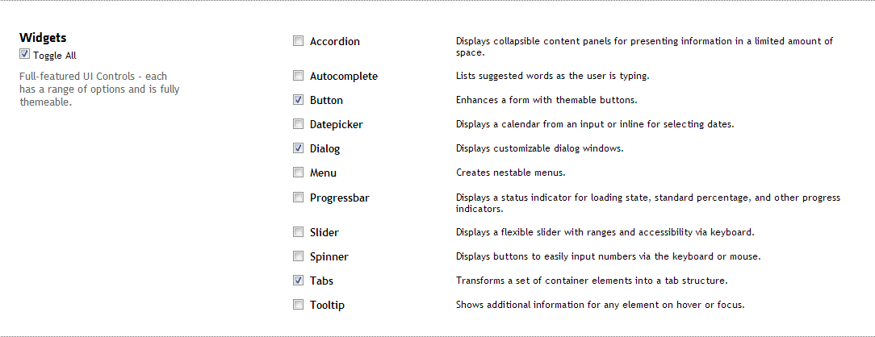

Theme：（默认）选择如下
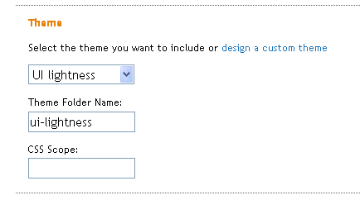

解压缩后，拷贝jquery-ui-1.10.3.custom下
- js文件夹到html（覆盖或替换）
- css文件夹到html（覆盖或替换）

（五）、层次结构

模型

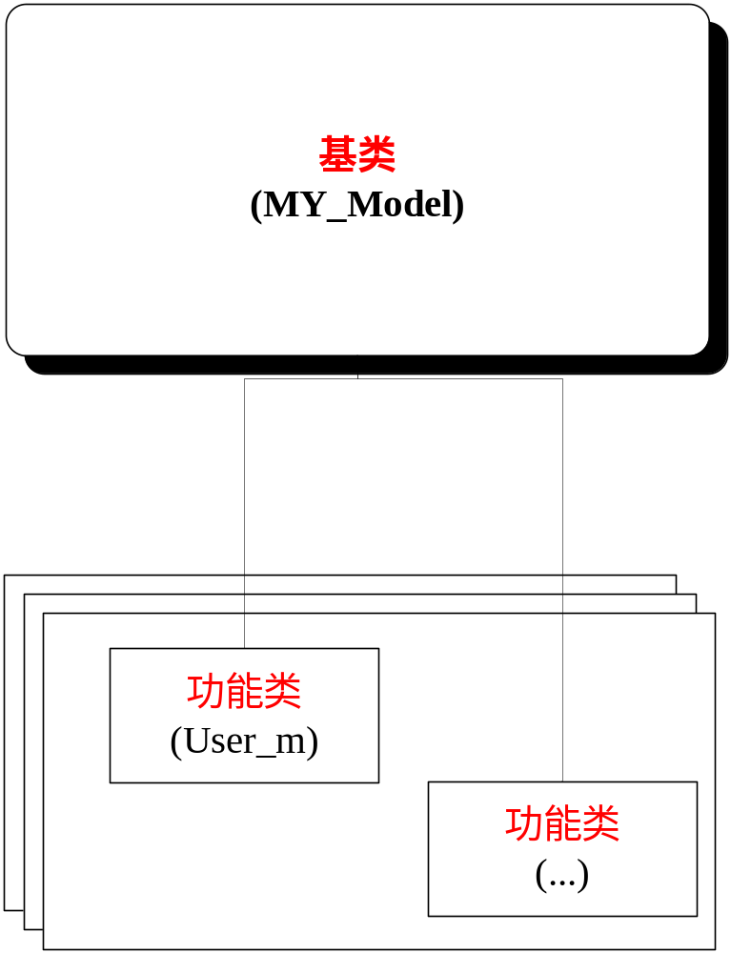

目录层次

core------基类
models---功能类

视图

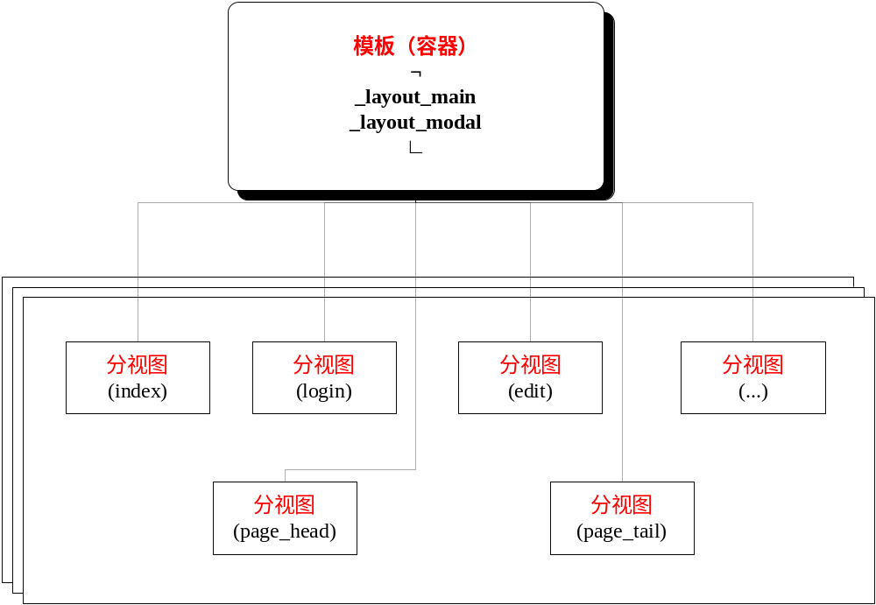

目录层次

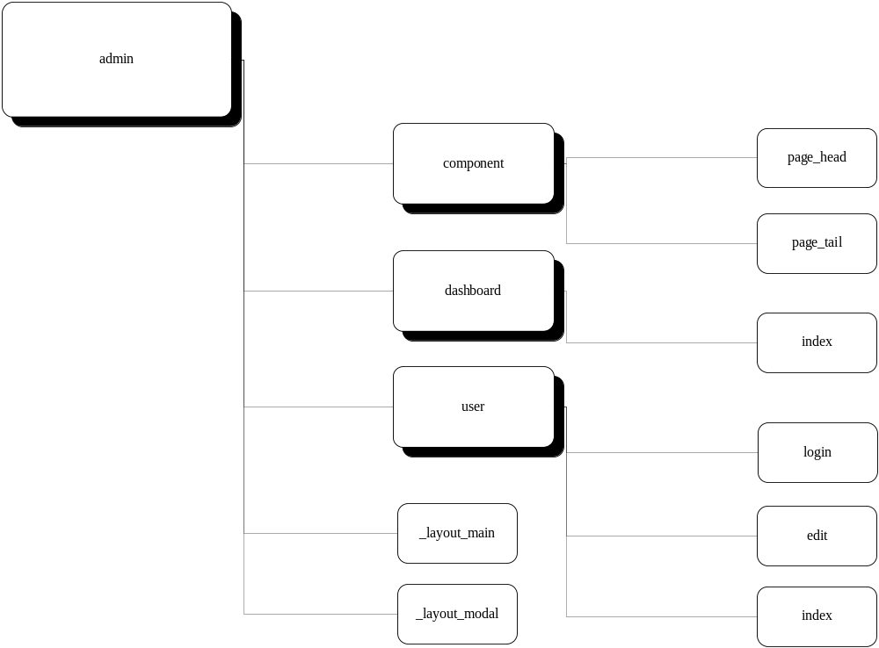

控制器
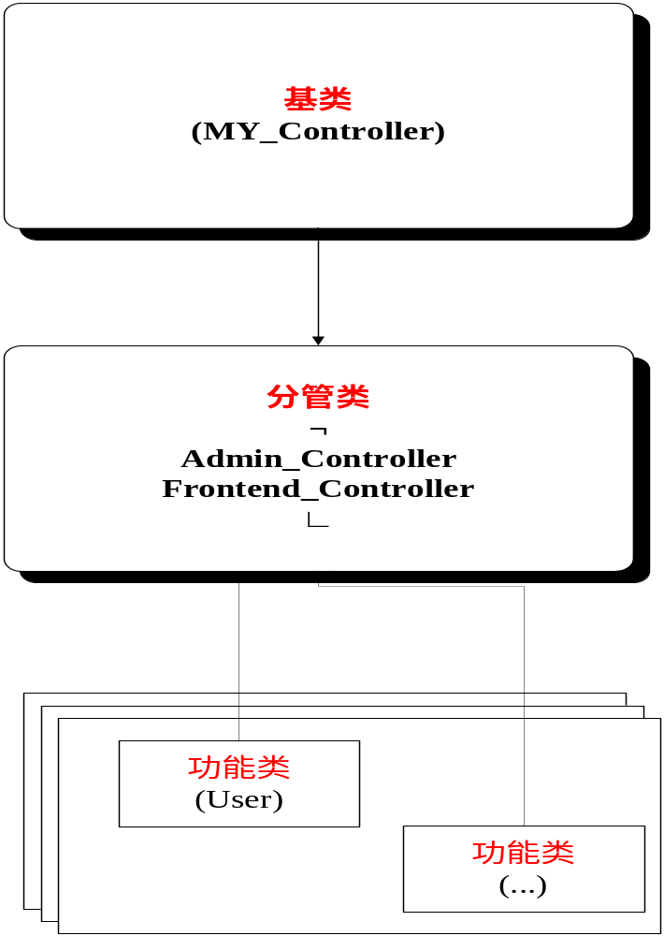

目录层次

core-----------基类
libraries------分管类
controllers---功能类

一、Model

（一）、基类
新建MY_Model类，其声明如下：

class MY_Model extends CI_Model {
public function __construct() {
parent::__construct ();
}
}

1. 保护变量
在变量名前加“$_”，黄色部分为公共变量。
protected $_table_name = '';
protected $_primary_key = 'id';
protected $_primary_filter = 'intval';
protected $_order_by = '';
protected $_timestamps = FALSE;

public $rules = array();

2. CRUD
在基类使用database类的Active Record模式中的get()、where()、insert()、update()、delete()来进行数据的查询、插入、修改、删除等的操作，并使用“Query Results”中的row()、result()等方法来返回结果集。

a. 查询
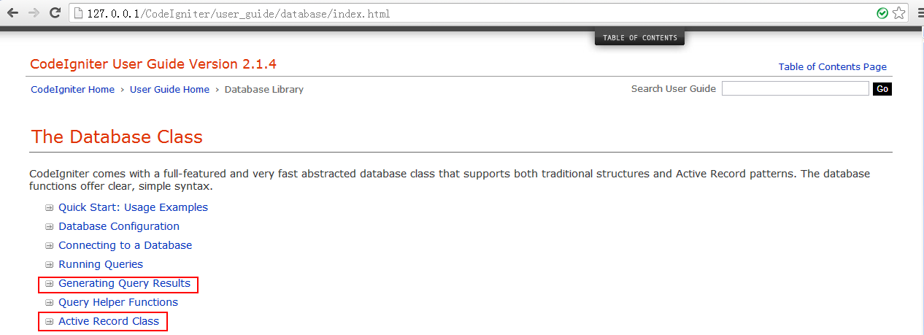

正常查询：
public function get($id = NULL, $single = FALSE) {
// Single row(), multiple rows with result();
if ($id != NULL) {

// $this->db->where('id=', $id);
$filter = $this->_primary_filter;
$id = $filter($id);
$this->db->where($this->_primary_key, $id);

$method = 'row';
}
elseif ($single == TRUE) {
$method = 'row';
}
else {
if (!count($this->db->ar_orderby)) {
$this->db->order_by($this->_order_by, 'asc');
}

$method = 'result';
}

return $this->db->get($this->_table_name)->$method();
}

条件查询：

public function get_by($where, $single = FALSE){
$this->db->where($where);
return $this->get(NULL, $single);
}

b. 插入和修改
$this->db->insert_id()：返回insert的ID
Isset见(php官网)
public function save($data, $id = NULL) {
// set timestamp
if ($this->_timestamps == TRUE) {
$now = date('Y-m-d H:i:s');

$id || $data['created'] = $now;
$data['modified'] = $now;
}

// insert
if ($id === NULL) {
!isset($data[$this->_primary_key]) || $data[$this->_primary_key] = NULL;
$this->db->set($data);
$this->db->insert($this->_table_name);
$id = $this->db->insert_id();
}
// update
else {
$filter = $this->_primary_filter;
$id = $filter($id);

$this->db->set($data);
$this->db->where($this->_primary_key, $id);
$this->db->update($this->_table_name);
}

return $id;
}

c. 删除
public function delete($id) {
$filter = $this->_primary_filter;
$id = $filter($id);

if (!$id) {
return FALSE;
}

$this->db->where($this->_primary_key, $id);
$this->db->limit(1);
$this->db->delete($this->_table_name);
}

3. 辅助函数

(1) 数组形式提交
/**
* <p> Array form post </p>
*
* @access public
* @param array $fields
* @return array
*/
public function array_form_post($fields) {
$data = array();

foreach ($fields as $field) {
$data[$field] = $this->input->post($field);
}

return $data;
}

(2) 数组成员变量为空

/**
* <p> Sets the member variable in the array is empty </p>
*
* @access public
* @param array $data_mul
*/
public function set_spaces($data_mul) {
$obj = new stdClass();

foreach ($data_mul as $data_single) {
$obj->$data_single = '';
}
return $obj;
}

（二）、功能类

为用户程序操作的数据表建立具体类。

其主要职能为基类的变量进行赋值。
例如，User_M类的赋值情况：
/**
* @filesource user_m.php
*
* @author xiaobin
* @version 1.0
* <br> date: 2013.10.08 </br>
* @license Apache License Version 2.0
*
* @tutorial users table.
*/

class User_M extends MY_Model {
/* The variables of the base class */
protected $_table_name = 'users';
protected $_order_by = 'name';

public $rules = array(
'email' => array(
'field' => 'email',
'label' => 'Email',
'rules' => 'trim|required|valid_email|xss_clean'
),
'password' => array(
'field' => 'password',
'label' => 'Password',
'rules' => 'trim|required'
)
);

public function __construct() {
parent::__construct ();
}
}

二、Controller

（一）、基类
新建MY_Controller类，
其声明如下：

class MY_Controller extends CI_Controller {
public $data = array();

public function __construct() {
parent::__construct ();

$this->data['errors'] = '';

// zh-cn or en-us
$this->data['lang_zh'] = config_item('lang_zh');
$this->data['lang_en'] = config_item('lang_en');

$this->data['flag_zh'] = FALSE;
if (stristr($_SERVER['SCRIPT_NAME'], $this->data['lang_zh'])) {
$this->data['flag_zh'] = TRUE;
}
}

1. 公用数组
public $data = array();

2. 成员变量
在构造器中设置公用数组的errors和中英文识别成员变量
$this->data['errors'] = array();

// zh-cn or en-us
$this->data['lang_zh'] = config_item('lang_zh');
$this->data['lang_en'] = config_item('lang_en');

$this->data['flag_zh'] = FALSE;
if (stristr($_SERVER['SCRIPT_NAME'], $this->data['lang_zh'])) {
$this->data['flag_zh'] = TRUE;
}

（二）、分管类

前台：展示
后台：编辑

1. Admin_Controller

(1). 加载库

a. Session
修改Admin_Controller.php
$this->load-library(‘session’);

b. form validtion

在Admin_Controller增加支持代码
$this->load->library('form_validation');

c. User library

$this->load->model('User_M');
$this->load->model('Language_M');
$this->load->model('Image_M');
$this->load->model('Type_M');
$this->load->model('Sector_M');

(2). 程序控制

在Admin_Controller类中的构造器中增加如下代码：

a. title

$this->data['meta_title'] = 'Admin Edit';

b. languages

添加语言列表

// Program controller
$this->data['sreach_zh'] = $this->Language_M->get_by('name = "' . $this->data['lang_zh'] . '"', TRUE);
$this->data['sreach_en'] = $this->Language_M->get_by('name = "' . $this->data['lang_en'] . '"', TRUE);

$this->data['lang_list'] = array(
$this->data['sreach_zh']->id => $this->data['sreach_zh']->description,
$this->data['sreach_en']->id => $this->data['sreach_en']->description
);

选取特定的数据表的数据项，用于下拉列表。

私有方法 _get_dropDown_list($model, $key, $value)

/**
* <p> Get key-value pairs from a data table, </p>
* <p> and add it to the array. </p>
*
* @param string $model
* @param string $key
* @param string $value
* @return array
*/
private function _get_dropDown_list($model, $key, $value) {
$array = $this->$model->get();
$result = array();
foreach ($array as $row) {
$result[$row->$key] = $row->$value;
}
return $result;
}

添加文章类型列表

$this->data['type_list'] = $this->_get_dropDown_list('Type_M', 'id', 'description');

添加图像列表

$this->data['img_list'] = $this->_get_dropDown_list ('Image_M', 'id', 'name');

添加文章类型列表

$this->data['type_list'] = $this->_get_dropDown_list('Type_M', 'id', 'description');

添加行业领域列表

$this->data['sector_list'] = $this->_get_dropDown_list('Sector_M', 'id', 'name');

x. 非法跳转

为防止非法跳转，在Admin_Controller.php增加如下代码：
// Login check
$exception_uris = array(
'admin/user/login',
'admin/user/logout');
if (in_array(uri_string(), $exception_uris) == FALSE) {
// if ($this->User_M->loggedin() == FALSE) {
// redirect('admin/user/login');
// }
}

代码中黄色部分为之后添加的代码。

2. Frontend_Controller

(1). 加载Model

// Load stuff
$this->load->model('Navigation_M');
$this->load->model('Language_M');
$this->load->model('Article_M');
$this->load->model('Type_M');
$this->load->model('Glossary_M');

(2). 程序控制

a. title

$companyName = $this->Glossary_M->get_word('VEIC', $this->data['lang_id']);
$webSite = $this->Glossary_M->get_word('web site', $this->data['lang_id']);
$this->data['meta_title'] = $companyName . ' - ' . $webSite;

b. language id

$langName = $this->data['lang_en'];
if ($this->data['flag_zh']) {
$langName = $this->data['lang_zh'];
}

$this->data['lang_id'] = $this->_get_langID($langName);

/**
* <p> Get the languages table ID </p>
*
* @param string $langName
* @return string Languages's ID
*/
private function _get_langID($langName) {
$sqlCond = 'name = "' . $langName . '"';
return $this->Language_M->get_by($sqlCond, TRUE)->id;
}

c. breadcrumbs

// Breadcrumbs
$this->data['body'] = $this->Glossary_M->get_word('body', $this->data['lang_id']);
$this->data['home'] = $this->Glossary_M->get_word('home', $this->data['lang_id']);
$this->data['isSearch'] = FALSE;

d. foreign key

获得外键ID值

/**
* <p> Gets the specified data table's foreign key values </p>
*
* @param string $model
* @param array $where
* @param string $foreignKey
* @return string
*/
private function _get_foreignKey($model, $where, $foreignKey) {
return $this->$model->get_by($where, TRUE)->$foreignKey;
}

e. menus

// Fetch navigation
$this->data['menu'] = $this->Navigation_M->get_nested($this->data['lang_id']);
$this->data['menu_prefix'] = 'page/invoke/';
$this->data['menu_href'] = stristr($_SERVER['SCRIPT_NAME'], 'index.php', TRUE);

f. convert special signs

转换“%20”为空格。

/**
* <p> Convert special characters to spaces </p>
*
* @param string $string
* @return string
*/
protected function get_space($string) {
if (strpos($string, '%20'))
$result = strtr($string, array('%20' => ' '));
else
$result = $string;

return $result;
}

g. view article

（无分页）
/**
* <p> According to the article type language ID and article ID to locate the article, </p>
* <p> return to the $this->data[$result] </p>
*
* @param string $templateName
* @param string $typeName
* @param array $result
* @param boolean $single Returning more than one row
*/
protected function get_article_view($templateName, $typeName, $result, $single = TRUE) {
$templatePath = 'templates/' . $templateName;

$typeID = $this->Type_M->get_by(array('name' => $typeName), TRUE)->id;

$where = array('type_id' => $typeID, 'lang_id' => $this->data['lang_id']);

$this->data[$result] = $this->Article_M->get_by($where, $single);

$this->data['menu_prefix'] = NULL;
$this->data['subview'] = $templatePath;
$this->load->view('_main_layout', $this->data);

$this->data['body'] = $this->Glossary_M->get_word('body', $this->data['lang_id']);
}

（分页）

文章存在于类型表中：
/**
* <p> According to the article type language ID and article ID to locate the article, </p>
* <p> return to the $this->data[$result] </p>
*
* @param string $templateName
* @param string $typeName
* @param array $result
* @param boolean $single Returning more than one row
*/
protected function get_article_view($templateName, $typeName, $result, $single = TRUE) {
$templatePath = 'templates/' . $templateName;

$typeID = $this->Type_M->get_by(array('name' => $typeName), TRUE)->id;

$where = array('lang_id' => $this->data['lang_id'], 'type_id' => $typeID);

// pagination begin
$counts = $this->_get_count('articles', $where);

$perpage = 13;
if ($counts > $perpage) {
// load library(system - libraries - pagination.php)
$this->load->library('pagination');

$offset = $this->uri->segment(4);

$this->data['pagination'] = $this->_get_pagination($counts, $perpage);
}
else {
$this->data ['pagination'] = '';
$offset = 0;
}

$this->db->limit($perpage, $offset);
// pagination end

$this->data[$result] = $this->Article_M->get_by($where, $single);

$this->data['menu_prefix'] = $this->data['menu_href'] . 'page/invoke/';
$this->data['subview'] = $templatePath;
$this->load->view('_main_layout', $this->data);

$this->data['body'] = $this->Glossary_M->get_word('body', $this->data['lang_id']);

}

全体文章：

/**
* <p> First, determine whether the article type; </p>
* <p> Then, to find articles based on article type and language ID; </p>
* <p> Otherwise, under the "search words" and language ID to locate the article. </p>
* <p> Finally, you call the "_article_list_view" shows a list of articles. </p>
* <p> return to the $this->data[$result] </p>
*
* @param string $templateName
* @param string $typeName
* @param array $result
* @param boolean $isType
*/
protected function get_article_view($templateName, $typeName, $result, $isType = TRUE) {
$templatePath = 'templates/' . $templateName;

if ($isType) {
$typeID = $this->Type_M->get_by(array('name' => $typeName), TRUE)->id;
$where = array('lang_id' => $this->data['lang_id'], 'type_id' => $typeID);
}
else {
$name = urldecode($typeName);
$where = '`lang_id` = ' . $this->data['lang_id'] .
' AND ' . ' `body` LIKE "%' . $name . '%"';
}

$this->_article_list_view($templatePath, $where, $result);
}

/**
* <p> Find articles and page displays based on conditions. </p>
*
* @param string $templatePath
* @param array or string $where
* @param array $result
*/
private function _article_list_view($templatePath, $where, $result) {
// pagination begin
$counts = $this->_get_count('articles', $where);

$perpage = 13;
if ($counts > $perpage) {
// load library(system - libraries - pagination.php)
$this->load->library('pagination');

$offset = $this->uri->segment(4);

$this->data['pagination'] = $this->_get_pagination($counts, $perpage);
}
else {
$this->data['pagination'] = '';
$offset = 0;
}

$this->db->limit($perpage, $offset);
// pagination end

$this->data[$result] = $this->Article_M->get_by($where, FALSE);

$this->data['menu_prefix'] = $this->data['menu_href'] . 'page/invoke/';
$this->data['subview'] = $templatePath;
$this->load->view('_main_layout', $this->data);

$this->data['body'] = $this->Glossary_M->get_word('body', $this->data['lang_id']);
}

h. generate breadcrumbs data

/**
* <p> Navigation instructions </p>
* <p> For example: News > Company news </P>
*
* @param string $linkAddr
* @return string
*/
protected function get_navInstr($linkAddr, $langID) {
$result = array();
$homeWord = $this->Glossary_M->get_word('home', $langID);
$home = array('name'=>$homeWord, 'linkAddr' => '#');

$where = array('linkAddr' => $linkAddr, 'lang_id' => $langID);
$curNavRow = $this->Navigation_M->get_by($where, TRUE);
$suffixName = $curNavRow->name;

$parentID = $curNavRow->parent_id;
$whereParent = 'id = ' . $parentID;
$parentNavRow = $this->Navigation_M->get_by($whereParent, TRUE);
$prefixName = $parentNavRow->name;

$prefixArray = array('name' => $prefixName, 'linkAddr' => $parentNavRow->linkAddr);

$suffixArray = array('name' => $suffixName, 'linkAddr' => $linkAddr);

$result[0] = $home;
$result[1] = $prefixArray;
$result[2] = $suffixArray;

return $result;
}

i. get navigation name

protected function get_nav_addr($id) {
$row = $this->Article_M->get($id);
$typeID = $row->type_id;
$langID = $row->lang_id;
$link_suffix = $this->Type_M->get($typeID);
$link_name = $link_suffix->name;
$percent = '%';
$sqlCond = "SELECT * " . " FROM " . " (`navigations`) ";
$sqlCond .= " WHERE " . " `linkAddr` " . " LIKE '" . $percent . $link_name . "'";
$sqlCond .= " AND " . " `lang_id` = " . $langID;

$linkAddr = $this->Navigation_M->get_like($sqlCond, 'linkAddr');
return $linkAddr;
}

（三）、功能类

管理User功能：
class User extends Admin_Controller {
public function __construct() {
parent::__construct ();
}

public function index() {
var_dump('test controllers');
}
}

1. 加载类
如果不加载我们的Controller运行时会出错，如下图。
解决方法：自动加载对象。

2. 测试公用函数

此测试，均在user.php中执行

首先，在Admin_Controller的构造器中增加：
// Load model
$this->load->model('User_M');

a. 查询

127.0.0.1/testCI3/public_html/admin/user

public function index() {
var_dump($this->User_M->get(1));
}

b. 插入和修改

127.0.0.1/testCI3/public_html/admin/user/save

插入：
public function save() {
//insert
$data = array(
'email' => 'test4@163.com',
'password' => '11ec5f2e24ddd092ee99aa1aba7746e1faddee248e3dd7ca2b79e92340bbd41b8a0e94c35803e5b3acadeb179a9a4d383d39905a2cf0ebd695fd80d65f6828bf',
'name' => 'test4',
);

$id = $this->User_M->save($data); // insert
var_dump($id);
}

修改：
public function save() {
// update
$data = array(
'name' => 'test44',
);

$id = $this->User_M->save($data, 4); // update
var_dump($id);
}

c. 删除

127.0.0.1/testCI3/public_html/admin/user/delete

public function delete() {
$cond = $this->User_M->delete(4);
var_dump($cond);
}

三、View

小技巧：
可以使用<pre></pre>标签来调试
<?php echo '<pre>'. print_r($this->session->userdata, TRUE) .'</pre>'?>

（一）、_layout_main
把bootstrap中的html模板代码拷贝到_layout_main.php中
模板文件如下：

<!DOCTYPE html>
<html>
<head>
<title>Bootstrap 101 Template</title>
<meta name="viewport" content="width=device-width, initial-scale=1.0">
<!-- Bootstrap -->
<link href="css/bootstrap.min.css" rel="stylesheet" media="screen">
</head>
<body>
<h1>Hello, world!</h1>
<script src="http://code.jquery.com/jquery.js"></script>
<script src="js/bootstrap.min.js"></script>
</body>
</html>

1. 使用site_url()

a. href="css/bootstrap.min.css"
->
href="<?php echo site_url('css/bootstrap.min.css'); ?>"

b. src=" http://code.jquery.com/jquery.js "
->
src="<?php echo site_url('js/jquery-1.9.1.js'); ?>"

c. src="js/bootstrap.min.js"
->
src="<?php echo site_url('js/bootstrap.min.js'); ?>"

2. 导航条
把bootstrap中的NAVBAR模板代码拷贝到<body>下面
模板文件如下：

(1) V2.3.2
<div class="navbar">
<div class="navbar-inner">
<a class="brand" href="#">Title</a>
<ul class="nav">
<li class="active"><a href="#">Home</a></li>
<li><a href="#">Link</a></li>
<li><a href="#">Link</a></li>
</ul>
</div>
</div>

美化工作

修改导航条代码。
原：
<div class="navbar">
现：
<div class="navbar navbar-static-top navbar-inverse">

(2) V3.0

<nav class="navbar">
<div class="collapse navbar-collapse">
<a class="navbar-brand" href="#">Home</a>
<ul class="nav navbar-nav">
<li class="active"><a href="#">Home</a></li>
<li><a href="#">Link</a></li>
<li><a href="#">Link</a></li>
</ul>
</div>
</nav>

美化工作

修改导航条代码。
原：
<nav class="navbar">
现：
<nav class="navbar navbar-default navbar-inverse" role="navigation">

（二）、_layout_modal

1. V2.3.2:

<?php $this->load->view('admin/components/page_head'); ?>

<body style="background: #555;">

<div class="modal show" role="dialog">
<div class="modal-header">
<h3>Page tilte</h3>
</div>
<div class="modal-body"></div>
<div class="modal-footer">
&copy; <?php echo $meta_title; ?>
</div>
</div>

<?php $this->load->view('admin/components/page_tail'); ?>

2. V3.0:

<?php $this->load->view('admin/components/page_head'); ?>

<body style="background: #555;">

<div class="modal-dialog">
<div class="modal-content">
<?php $this->load->view($subview); ?>
<div class="modal-footer">
&copy; <?php echo $meta_title; ?>
</div>
</div>
</div>

<?php $this->load->view('admin/components/page_tail'); ?>

其中的page_head和page_tail请看下结。

（三）、组件页

在views/admin新建components文件夹，
然后再建立2个文件：page_head.php和page_tail.php

1. page_head

(1) 标准页

使用DW建立一个标准的“基本页”

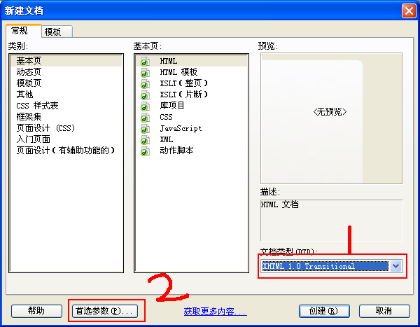

首先选择文档类型，然后点击“首选参数”进入下图

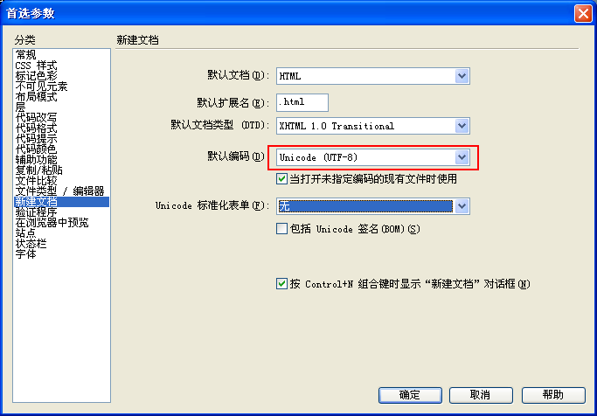
选择“默认编码”为“Unicode(UTF-8)”

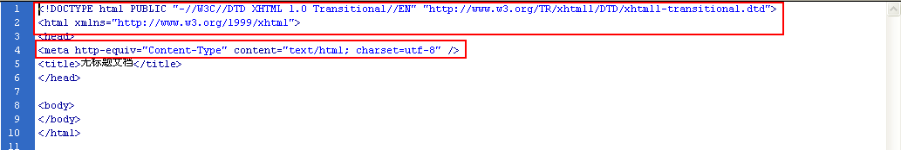
拷贝上图中方框中代码。

(2) 标题变量

把<title>Bootstrap 101 Template</title>
变更为
<title><?php echo $meta_title; ?></title>

最后的代码如下：

<!DOCTYPE html PUBLIC "-//W3C//DTD XHTML 1.0 Transitional//EN" "http://www.w3.org/TR/xhtml1/DTD/xhtml1-transitional.dtd">
<html xmlns="http://www.w3.org/1999/xhtml">
<head>
<title><?php echo $meta_title; ?></title>
<meta http-equiv="Content-Type" content="text/html; charset=utf-8 /">
<meta http-equiv="X-UA-Compatible" name="viewport" content="width=device-width, initial-scale=1.0" />
<!-- Bootstrap -->
<link href="<?php echo site_url('../html/css/bootstrap.min.css'); ?>" rel="stylesheet" media="screen">
</head>

2. page_tail

<script src="<?php echo site_url('js/jquery-1.9.1.js');?>"></script>
<script src="<?php echo site_url('js/bootstrap.min.js');?>"></script>
</body>
</html>

四、Helper
Helper主要是对页面操作。属于非数据类。也就是他们不操作数据的导向；而只进行html方面的操作。

新建”项目名_helper”（helpers/tdtc_helper.php）
更改config/autoload.php中如下内容：
$autoload['helper'] = array('url', 'form', 'html');
为
$autoload['helper'] = array('url', 'form', 'html', 'tdtc_helper');

（一）、按钮类

1. 编辑
/*
实现的功能等同于
anchor('admin/user/edit/' . $user->id, 图标);

*/
function btn_edit($uri) {
return anchor($uri, '<span class="glyphicon glyphicon-edit "></span>');
}

2. 删除

function btn_delete($uri) {
return anchor($uri, '<span class="glyphicon glyphicon -remove"></span>', array(
'onclick' => "return confirm('You are about to delete a record. This cannot be undone. Are you sure?');",
)
);
}

（二）、调试类

1. dump()

在tdtc_helper.php增加一个自定义的变量察看函数，此函数是var_dump（php系统自带）的升级版本。可以在https://gist.github.com/3838495中看到

/**
* Dump helper. Functions to dump variables to the screen, in a nicley formatted manner.
* @author Joost van Veen
* @version 1.0
*/
if (!function_exists('dump')) {
function dump ($var, $label = 'Dump', $echo = TRUE)
{
// Store dump in variable
ob_start();
var_dump($var);
$output = ob_get_clean();

// Add formatting
$output = preg_replace("/\]\=\>\n(\s+)/m", "] => ", $output);
$output = '<pre style="background: #FFFEEF; color: #000; border: 1px dotted #000; padding: 10px; margin: 10px 0; text-align: left;">' . $label . ' => ' . $output . '</pre>';

// Output
if ($echo == TRUE) {
echo $output;
}
else {
return $output;
}
}
}

if (!function_exists('dump_exit')) {
function dump_exit($var, $label = 'Dump', $echo = TRUE) {
dump ($var, $label, $echo);
exit;
}
}

（三）、HTML类

1. 有序列表
表现形式为：
<ol class="sortable">
<li><div>Some content</div></li>
<li>
<div>Some content</div>
<ol>
<li><div>Some sub-item content</div></li>
<li><div>Some sub-item content</div></li>
</ol>
</li>
<li><div>Some content</div></li>
</ol>

数据来源：
'0' ...
'id' => itemId
'1' ...
'id' => itemId
'children' ...
'0' ...
'id' => itemId
'1' ...
'id' => itemId
'2' ...
'id' => itemId

实现

function get_ol($array, $child = FALSE) {
$str = '';

if (count($array)) {
$str .= $child == FALSE ? '<ol class="sortable">' : '<ol>';

foreach ($array as $item) {
$str .= '<li id="list_' . $item['id'] . '">';
$str .= '<div>' . $item['name'] . '</div>';

if (isset($item['children']) && count($item['children'])) {
$str .= get_ol($item['children'], TRUE);
}

$str .= '</li>' . PHP_EOL;
}

$str .= '</ol>' .PHP_EOL;
}

return $str;
}

1.1 生成面包屑

表现形式为：

<ol class="breadcrumb">
<li><a href="#">Home</a></li> <li><a href="#">Library</a></li>
<li class="active">Data</li>
</ol>

页面代码：

<ol class="breadcrumb">
<?php echo get_breadcrumb($breadData, $menu_prefix); ?>
<li class="active"><?php echo empty($breadData) ? $this->Glossary_M->get_word('home', $this->data['lang_id']) : $body; ?></li>
</ol>

实现

function get_breadcrumb($array, $prefix = NULL) {
$str = '';

if (count($array)) {
foreach ($array as $item) {
if (strpos($item['linkAddr'], '#'))
$str .= '<li><a href="' . $item['linkAddr'] . '">' . e($item['name']) . '</a></li>' . PHP_EOL;
else
$str .= '<li><a href="' . $prefix . $item['linkAddr'] . '">' . e($item['name']) . '</a>' . '</li>' .PHP_EOL;
}
}
return $str;
}

2. 无序列表

表现形式为：

<ul class="nav navbar-nav">
<li><a href="#">Link</a></li>
<li class="dropdown">
<a href="#" class="dropdown-toggle" data-toggle="dropdown">Navigations<b class="caret"></b></a>
<ul class="dropdown-menu">
<li><a href="#">Link2</a></li>
</ul>
</li>
</ul>

页面代码：

<ul class="nav navbar-nav">
<?php echo get_menu($menu, $menu_prefix); ?>

</ul>

实现

function get_menu($array, $prefix = NULL) {
$str = '';

foreach ($array as $item) {

if (isset($item['children']) && count($item['children']) ) {
$str .= '<li class="dropdown">' . PHP_EOL;
$str .= '<a href=' . $item['linkAddr'];
$str .= ' class="dropdown-toggle" data-toggle="dropdown">' . e($item['name']);
$str .= '<b class="caret"></b></a>' . PHP_EOL;

$str .= '<ul class="dropdown-menu">'. PHP_EOL;
$str .= get_menu($item['children'], $prefix);
$str .= '</ul>' .PHP_EOL;
}
else {
$str .= '<li><a href="' . $prefix . $item['linkAddr'] . '">' . e($item['name']) . '</a>';
}

$str .= '</li>' .PHP_EOL;
}

return $str;
}

第二章 Dashboard

我们需要一个操作数据表的一个控制台，这就是dashboard!

在controllers/admin下新建Dashboard类
class Dashboard extends Admin_Controller

一、用户登录

（一）、登录活动

在models新建User_M类

user_m.php:
<?php

class User_M extends MY_Model {
protected $_table_name = 'users';
protected $_order_by = 'name';

public function __construct() {
parent::__construct ();
}
}

?>

1. 规则

详见Form Validation

public $rules = array(
'email' => array(
'field' => 'email',
'label' => 'Email',
'rules' => 'trim|required|vaild_email|xss_clean',
),
'password' => array(
'field' => 'password',
'label' => 'Password',
'rules' => 'trim|required',
),
);

2. 登录操作

主要是对Session进行操作

注意：
关于userdata与set_userdata
第一个是查找session里的数据项
第二个是插入session一个新的数据项

login()

设置session数据。

public function login() {
$user_form = array(
'email' => $this->input->post('email'),
'password' => $this->hash($this->input->post('password')), // encryption
);

$user = $this->get_by($user_form, True);

if (count($user)) {
$data = array(
'email' => $user->email,
'name' => $user->name,
'id' => $user->id,
'loggedin' => TRUE,
);
}

$this->session->set_userdata($data);
}

logout()

注销Session。

public function logout() {
$this->session->sess_destroy();
}

loggedin()

根均取得Session数据，来判断是否已经登录。

public function loggedin() {
return (bool) $this->session->userdata('loggedin');
}

hash()

包装标准hash()函数
使用我们的加密串。

public function hash($string) {
return hash('sha512', $string . config_item('encryption_key'));
}

（二）、登录框

1. 登录框模板

更改结构，以使它可以载入其他子页。

_layout_modal.php:

<?php $this->load->view('admin/components/page_head'); ?>

<body style="background: #555;">

<div class="modal show" role="dialog">
<div class="modal-header">
<h3>Page tilte</h3>
</div>
<div class="modal-body"></div>

<?php $this->load->view($subview); ?>

<div class="modal-footer">
&copy; <?php echo $meta_title; ?>
</div>
</div>

2. 登录框

新建views/admin/user/login.php
代码如下：

(1) V2.3.2:

<div class="modal-header">
<h3>Log in</h3>
<p>Please log in using your credentials</p>
</div>
<div class="modal-body">
<?php echo validation_errors(); ?>
<?php echo form_open();?>
<table class="table">
<tr>
<td>Email</td>
<td><?php echo form_input('email'); ?></td>
</tr>
<tr>
<td>Password</td>
<td><?php echo form_password('password'); ?></td>
</tr>
<tr>
<td></td>
<td><?php echo form_submit('submit', 'Log in', 'class="btn btn-primary"'); ?></td>
</tr>
</table>
<?php echo form_close(); ?>
</div>

(2) V3.0:

Button

Input

<div class="modal-header">
<h3>Log in</h3>
<p>Please log in using your credentials</p>
</div>
<div class="modal-body">
<?php echo validation_errors(); ?>
<?php echo form_open(); ?>
<?php $inputAttr = 'class="form-control" placeholder="'; ?>
<table class="table">
<tr>
<td>Email</td>
<td><?php echo form_input('email', '', $inputAttr . 'Please enter your password"'); ?></td>
</tr>
<tr>
<td>Password</td>
<td><?php echo form_password('password', '', $inputAttr . 'Please enter your password"'); ?></td>
</tr>
<tr>
<td></td>
<td><?php echo form_submit('submit', 'Log in', 'class="btn btn-primary btn-lg btn-block"'); ?></td>
</tr>
</table>
<?php echo form_close(); ?>
</div>

（三）、登录管理

controllers/admin/user.php:

<?php

class User extends Admin_Controller {
public function __construct() {
parent::__construct ();
}

}

?>

1. 登录

主要通过login函数实现。

(1). 设置规则

$rules = $this->User_M->rules;
$this->form_validation->set_rules($rules);

(2). 运行验证

if ($this->form_validation->run() == TRUE) {
// 空白处添加代码
}

(3). 载入登录框

$this->data['subview'] = 'admin/user/login';
$this->load->view('admin/_layout_modal', $this->data);

2. 登出

用户登出

public function logout() {
$this->User_M->logout();

redirect('admin/user/login');
}

3. 状态

放开非法跳转中注释的代码。

二、功能导引

（一）、视图

1. 索引页
在views/admin/dashboard新建index.php
内容如下：
<section>
<h2>Welcome</h2>
</section>

2. 主布局
网页的结构
原的为：
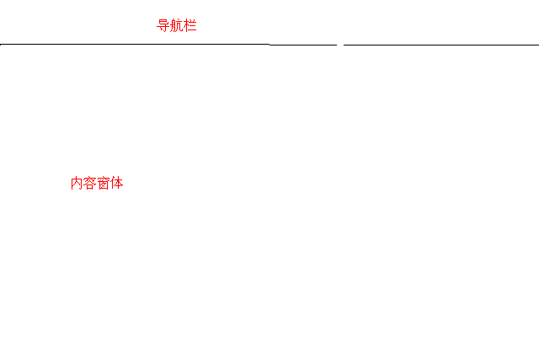

现在的
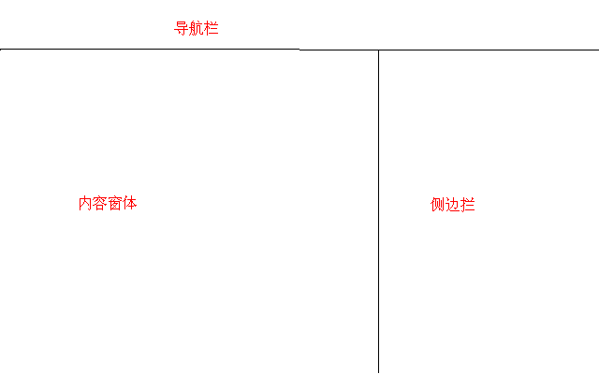

内容窗体代码，
由
<h1>Hello, world!</h1>
变更为

a. V2.3.2

<div class="container">
<div class="row">
<!-- Main column -->
<div class="span9">
<?php $this->load->view($subview); ?>
</div>
<!-- Sidebar -->
<div class="span3">
增加代码
</div>
</div>
</div>

b. V3.0

components/panel_main.php

<div class="container">
<div class="row">
<!-- Main column -->
<div class="col-md-9">
<?php $this->load->view($subview); ?>
</div>
<!-- Sidebar -->
<div class="col-md-3">
增加代码
</div>
</div>
</div>

(1). 侧边栏
在上面的“增加代码”处，添加Email和登出链接。
代码如下：

a) V2.3.2

图标

<section>
<?php echo mailto('tdtc_hrb@163.com', '<i class="icon-user"></i> tdtc_hrb@163.com'); ?></br>
<?php echo anchor('admin/user/logout', '<i class="icon-off"></i> logout'); ?>
</section>

b) V3.0

图标

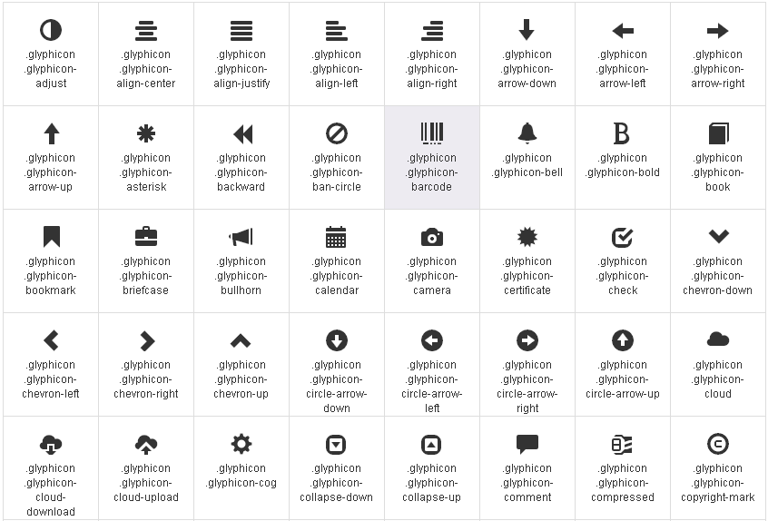

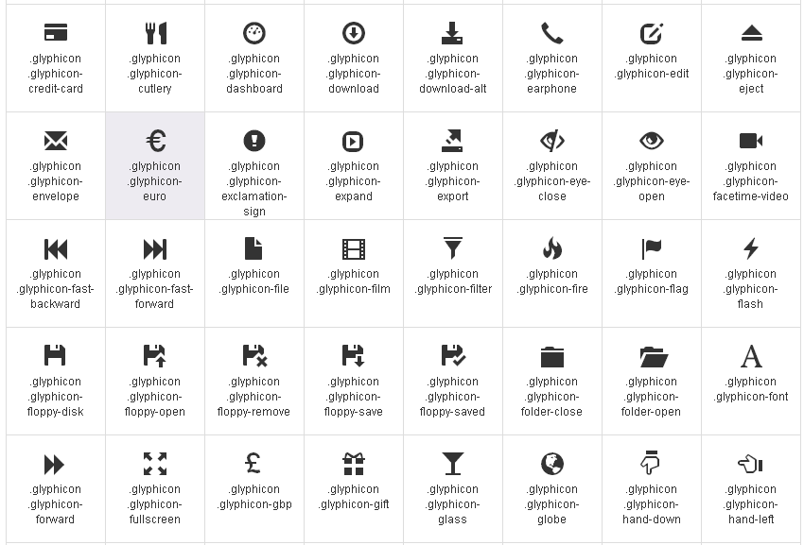

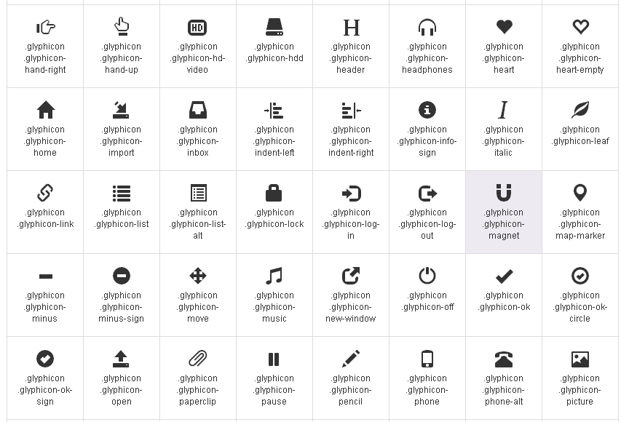

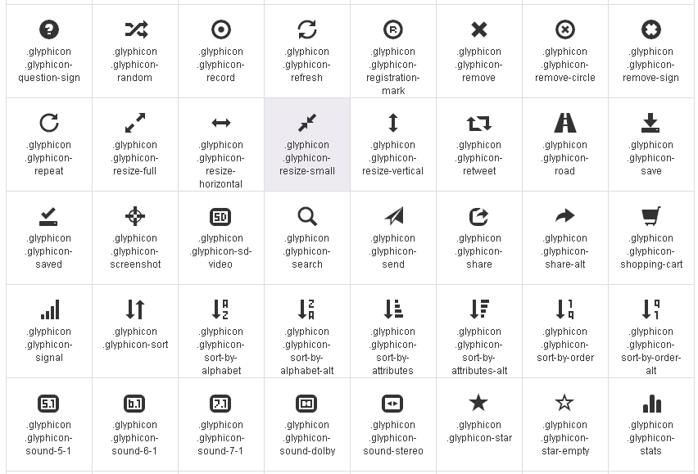

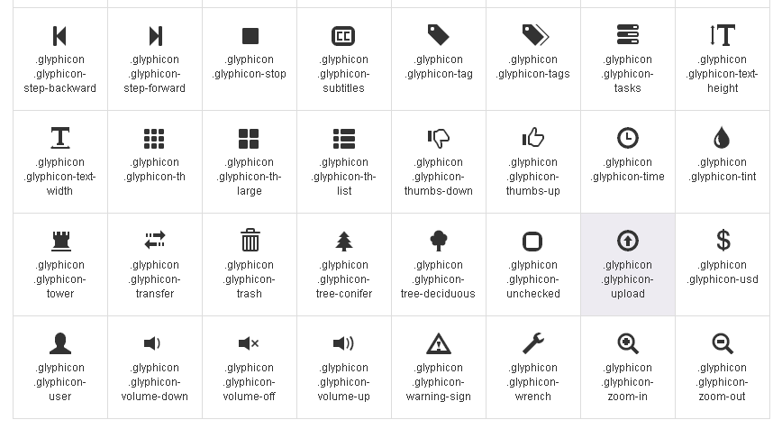

<section>
<?php echo mailto('tdtc_hrb@163.com', '<span class="glyphicon glyphicon-user"></span> tdtc_hrb@163.com'); ?></br>
<?php echo anchor('admin/user/logout', '<span class="glyphicon glyphicon-off"></span> logout'); ?>
</section>

(2). 导航条
添加导航条内容。
其中黄底为改动部分。

a) V2.3.2

<div class="navbar navbar-static-top navbar-inverse">
<div class="navbar-inner">
<a class="brand" href="<?php echo site_url('admin/dashboard'); ?>"><?php echo $meta_title; ?></a>
<ul class="nav">
<li class="active"><a href="<?php echo site_url('admin/dashboard'); ?>">Dashboard</a></li>
<li><?php echo anchor('admin/user', 'Users'); ?></li>
<li><a href="#">Link</a></li>
</ul>
</div>
</div>

b) V3.0

<nav class="navbar navbar-default navbar-inverse" role="navigation">
<div class="collapse navbar-collapse">
<a class="navbar-brand" href="<?php echo site_url('admin/dashboard'); ?>"><?php echo $meta_title; ?></a>
<ul class="nav navbar-nav">
<li class="active"><a href="<?php echo site_url('admin/dashboard'); ?>">Dashboard</a></li>
<li><?php echo anchor('admin/user', 'Users'); ?></li>
<li><a href="#">Link</a></li>
</ul>
</div>
</nav>

在Link处，增加导航项目：

a. 增加导航项目

<li class="active"><a href="<?php echo site_url('admin/dashboard'); ?>">Dashboard</a></li>
<li><?php echo anchor('admin/user', 'Users'); ?></li>
<li><?php echo anchor('admin/language', 'Languages'); ?></li>
<li><?php echo anchor('admin/image', 'Images'); ?></li>
<li class="dropdown">
<a href="#" class="dropdown-toggle" data-toggle="dropdown">Navigations<b class="caret"></b></a>
<ul class="dropdown-menu">
<li><?php echo anchor('admin/navigation', 'Navigation Maintenance'); ?></li>
<li class="divider"></li>
<li><?php echo anchor('admin/navigation/order', 'Navigation Order'); ?></li>
</ul>
</li>
<li class="dropdown">
<a href="#" class="dropdown-toggle" data-toggle="dropdown">Products<b class="caret"></b></a>
<ul class="dropdown-menu">
<li><?php echo anchor('admin/product/statu', 'Product Stauts'); ?></li>
<li><?php echo anchor('admin/product/parameter', 'Product Parameters'); ?></li>
<li class="divider"></li>
<li><?php echo anchor('admin/product/detail', 'Product Details'); ?></li>
</ul>
</li>

<li class="dropdown">
<a href="#" class="dropdown-toggle" data-toggle="dropdown">News Center<b class="caret"></b></a>
<ul class="dropdown-menu">
<li><?php echo anchor('admin/presscenter/types/lists', 'News Types'); ?></li>
<li class="divider"></li>
<li><?php echo anchor('admin/presscenter', 'News'); ?></li>
</ul>
</li>

<li><?php echo anchor('admin/qualification', 'Qualifications'); ?></li>
<li><?php echo anchor('admin/contact', 'Contact Way'); ?></li>
<li class="dropdown">
<a href="#" class="dropdown-toggle" data-toggle="dropdown">Glossaries<b class="caret"></b></a>
<ul class="dropdown-menu">
<li><?php echo anchor('admin/glossary', 'Glossary Maintenance'); ?></li>
<li class="divider"></li>
<li><?php echo anchor('admin/sector', 'Glossary Sector'); ?></li>
</ul>
</li>

（二）、加载视图

1. index()
在Dashboard类加载视图。

public function index() {
$this->data['subview'] = 'admin/dashboard/index';
$this->load->view('admin/_layout_main', $this->data);
}

2. 跳转Dashboard

在(2). 运行验证 中的“空白处添加代码”修改为：

第一种情况：如果没有登录或跳转到dashboard，继续执行其他代码。
$dashboard = 'admin/dashboard';

$this->User_M->loggedin() == FALSE || redirect($dashboard);

第二种情况：如果login验证通过，跳转到dashboard。
if ($this->User_M->login() == TRUE) {
redirect($dashboard);
}
else {
$this->session->set_flashdata('error', 'The email/password combination does not exist');
redirect('admin/user/login', 'refresh');
}

第三章 后台部分

注：以下所有View部分除非特殊申明，全部使用Bootstrap3.0。

一、管理用户
对用户的编辑、删除等数据操作

（一）、User_M类

1. 输入数据规则
新建rules_admin数组变量，给每个前端输入项定义规则。
public $rules_admin = array(
'name' => array(
'field' => 'name',
'label' => 'Name',
'rules' => 'trim|required|xss_clean'
),
'email' => array(
'field' => 'email',
'label' => 'Email',
'rules' => 'trim|required|valid_email|callback__unique_email|xss_clean'
),
'password' => array(
'field' => 'password',
'label' => 'Password',
'rules' => 'trim|matches[password_confirm]'
),
'password_confirm' => array(
'field' => 'password_confirm',
'label' => 'Confirm password',
'rules' => 'trim|matches[password]'
),
);

注意：密码和验证密码为互为匹配。

其中_unique_email函数是我们自定义的。

2. 设置空数据
我们在添加新数据时，需要所有输入数值是空的。
$user_fields = array(
'email',
'name',
'password'
);
$this->data['user'] = $this->User_M->set_spaces($user_fields);

3. 提交数据（数组）

我们希望一起提交整个数据。

public function array_form_post($fields) {
$data = array();
foreach ($fields as $field) {
var_dump('field: ' . $field);
$data[$field] = $this->input->post($field);
}
var_dump('data: ' . $data);
return $data;
}

（二）、Views

1. 索引页
在views/admin/user新建index.php
内容如下：
<section>
<h2>Users</h2>
<?php echo anchor('admin/user/edit', '<span class="glyphicon glyphicon-plus"></span> Add a user'); ?>
<table class="table table-striped">
<thead>
<tr>
<th>Email</th>
<th>Edit</th>
<th>Delete</th>
</tr>
</thead>
<tbody>
<?php if (count($users)): foreach ($users as $user): ?>
<tr>
<td><?php echo anchor('admin/user/edit/' . $user->id, $user->email); ?></td>
<td><?php echo btn_edit('admin/user/edit/' . $user->id); ?></td>
<td><?php echo btn_delete('admin/user/delete/' . $user->id); ?></td>
</tr>
<?php endforeach; ?>
<?php else: ?>
<tr>
<td colspan="3">We could not find any users.</td>
</tr>
<?php endif; ?>
</tbody>

</table>
</section>

其中编辑按钮和删除按钮需要我的helper文件来提供支持。

2. 编辑窗体

新建views/admin/user/edit.php

显示所有需要用户输入的数据项。

edit.php：

<section>
<h3><?php echo empty($user->id) ? 'Add a new user' : 'Edit user ' . $user->name; ?></h3>
<?php echo validation_errors(); ?>
<?php echo form_open(); ?>
<?php $inputAttr = 'class="form-control"'; ?>
<table class="table">
<tr>
<td>Email</td>
<td><?php echo form_input('email', set_value('email', $user->email), $inputAttr); ?></td>
</tr>
<tr>
<td>Name</td>
<td><?php echo form_input('name', set_value('name', $user->name), $inputAttr); ?></td>
</tr>
<tr>
<td>Password</td>
<td><?php echo form_password('password', '', $inputAttr); ?></td>
</tr>
<tr>
<td>Confirm password</td>
<td><?php echo form_password('password_confirm', '', $inputAttr); ?></td>
</tr>
<tr>
<td></td>
<td><?php echo form_submit('save', 'Save', 'class="btn btn-primary"'); ?></td>
</tr>
</table>
<?php echo form_close(); ?>
</section>

(1) 动态标题名
为了动态给标题命名：
由
<h3>Log in</h3>
<p>Please log in using your credentials</p>
变更为：
<h3><?php echo empty($user->id) ? 'Add a new user' : 'Edit user'; ?></h3>
如果id值为空，则标题为“增加新用户”；否则，为“编辑用户”

(2) 设置值

当我们编辑用户时，我们希望能读取用户的一些基本信息。

<tr>
<td>Email</td>
<td><?php echo form_input('email', set_value('email', $user->email)); ?></td>
</tr>
<tr>
<td>Name</td>
<td><?php echo form_input('name', set_value('name', $user->name)); ?></td>
</tr>

（三）、User类

1. 默认响应
列出除了超级用户之外所有的用户。
代码如下：
public function index() {
$this->data['users'] = $this->User_M->get_by('flag = 0');
$this->data['subview'] = 'admin/user/index';
$this->load->view('admin/_layout_main');
}

注意，运行上述代码会出现一个错误
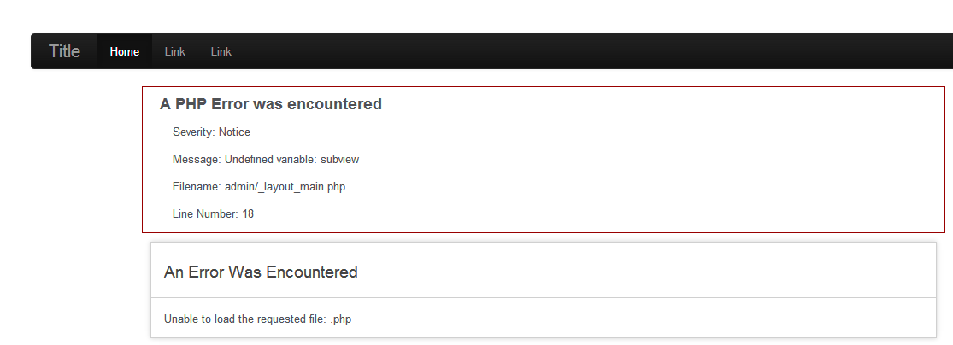
出错原因：我们在加载_layout_main时，没有给这个view内的各种变量带去数值造成的。
更改代码：
传入data数组。
$this->load->view('admin/_layout_main', $this->data);

2. Email的唯一性
增加函数_unique_email()
public function _unique_email($str) {
$id = $this->uri->segment(4);
$this->db->where('email', $this->input->post('email'));
!$id || $this->db->where('id != ', $id);
$user = $this->User_M->get();

if (count($user)) {
$this->form_validation->set_message('_unique_email', '%s should be unique');
return FALSE;
}

return TRUE;
}

3. 数据编辑

public function edit($id = NULL) {
$id == NULL || $this->data['user'] = $this->User_m->get($id);
// 增加校验
$this->data['subview'] = 'admin/user/edit';
$this->load->view('admin/_layout_main', $this->data);
}

(1) 新建or修改

$user_new = FALSE;
if ($id) {
$this->data['user'] = $this->User_M->get($id);
// 见下a
}
else {
$this->data['user'] = $this->User_M->get_new();
$user_new = TRUE;
}

a. 出错信息

count($this->data['user']) || $this->data['error'][] = 'User could not be found';

(2) 保存数据

// Set form
$rules = $this->User_M->rules_admin;
// 见下a
$this->form_validation->set_rules($rules);

// Process form
if ($this->form_validation->run() == TRUE) {
//见下b
//见下c
//见下d
//见下e
redirect('admin/user');
}

a. 强制请求输入密码

$id || $rules['password']['rules'] .= '|required';

b. 收集form数据

// Collection form data
$data_form = $this->User_M->array_form_post(array('name', 'email', 'password'));

c. 加密密码

// Encryption key
$data_form['password']=$this->User_M->hash($data_form['password']);

d. 增加提交时间

// Add data time
if ($user_new) $data_form['created'] = date('Y-m-d H:i:s');

e. 保存数据到数据库

// Save DB table
$this->User_M->save($data_form, $id);

4. 数据删除

public function delete($id) {
$this->User_M->delete($id);
redirect('admin/user');
}

二、管理“公共模块”

（一）、语言

1. Language_M类

protected $_table_name = 'languages';
protected $_order_by = 'id';

输入数据规则

public $rules_admin = array(
'code' => array(
'field' => 'code',
'label' => 'Code',
'rules' => 'trim|required|xss_clean'
),
'name' => array(
'field' => 'name',
'label' => 'Name',
'rules' => 'trim|required|xss_clean'
),
'description' => array(
'field' => 'description',
'label' => 'Description',
'rules' => 'trim|required|xss_clean'
),
);

2. Views

(1) 索引页

language/index.php

<section>
<h2>languages</h2>
<?php echo anchor('admin/language/edit', '<span class="glyphicon glyphicon-plus"></span> Add a language'); ?>
<table class="table table-striped">
<thead>
<tr>
<th>Name</th>
<th>Edit</th>
<th>Delete</th>
</tr>
</thead>
<tbody>
<?php if (count($languages)): foreach ($languages as $language): ?>
<tr>
<td><?php echo anchor('admin/language/edit/' . $language->id, $language->name); ?></td>
<td><?php echo btn_edit('admin/language/edit/' . $language->id); ?></td>
<td><?php echo btn_delete('admin/language/delete/' . $language->id); ?></td>
</tr>
<?php endforeach; ?>
<?php else: ?>
<tr>
<td colspan="3">We could not find any languages.</td>
</tr>
<?php endif; ?>
</tbody>

</table>
</section>

(2) 编辑页

language/edit.php

<section>
<h3><?php echo empty($language->id) ? 'Add a new language' : 'Edit language ' . $language->name; ?></h3>
<?php echo validation_errors(); ?>
<?php echo form_open(); ?>
<?php $inputAttr = 'class="form-control"'; ?>
<table class="table">
<tr>
<td>Code</td>
<td><?php echo form_input('code', set_value('code', $language->code), $inputAttr); ?></td>
</tr>
<tr>
<td>Name</td>
<td><?php echo form_input('name', set_value('name', $language->name), $inputAttr); ?></td>
</tr>
<tr>
<td>Description</td>
<td><?php echo form_input('description', set_value('description', $language->description), $inputAttr); ?></td>
</tr>
<tr>
<td></td>
<td><?php echo form_submit('save', 'Save', 'class="btn btn-primary"'); ?></td>
</tr>
</table>
<?php echo form_close(); ?>
</section>

3. Language类

在构造器中装载Language_M模型。

$this->load->model('Language_M');

(1) index()

public function index() {
$this->data['languages'] = $this->Language_M->get();
$this->data['subview'] = 'admin/language/index';
$this->load->view('admin/_layout_main', $this->data);
}

(2) edit()

public function edit($id = NULL) {
if ($id) {
$this->data['language'] = $this->Language_M->get($id);
count($this->data['language']) || $this->data['error'][] = 'language could not be found';
}
else {
$fields = array(
'code',
'name',
'description'
);
$this->data['language'] = $this->Language_M->set_spaces($fields);
}

// Set form
$rules = $this->Language_M->rules_admin;

$this->form_validation->set_rules($rules);

if ($this->form_validation->run() == TRUE) {
// Collection form data
$data_form = $this->Language_M->array_form_post(
array(
'code',
'name',
'description'
)
);
// Save DB table
$this->Language_M->save($data_form, $id);
redirect('admin/language');
}

$this->data['subview'] = 'admin/language/edit';
$this->load->view('admin/_layout_main', $this->data);
}

(3) delete()

public function delete($id) {
$this->Language_M->delete($id);
redirect('admin/language');
}

（二）、图像

1. Image_M类

protected $_table_name = 'images';
protected $_order_by = 'id';

输入数据规则

public $rules_admin = array(
'name' => array(
'field' => 'name',
'label' => 'Name',
'rules' => 'trim|required|xss_clean'
),
'description' => array(
'field' => 'description',
'label' => 'Description',
'rules' => 'trim|required|xss_clean'
),
);

2. Views

(1) 索引页

<section>
<h2>Images</h2>
<?php echo anchor('admin/image/edit', '<span class="glyphicon glyphicon-plus"></span> Add a image'); ?>
<table class="table table-striped">
<thead>
<tr>
<th>Name</th>
<th>Edit</th>
<th>Delete</th>
</tr>
</thead>
<tbody>
<?php if (count($images)): foreach ($images as $image): ?>
<tr>
<td><?php echo anchor('admin/image/edit/' . $image->id, $image->name); ?></td>
<td><?php echo btn_edit('admin/image/edit/' . $image->id); ?></td>
<td><?php echo btn_delete('admin/image/delete/' . $image->id); ?></td>
</tr>
<?php endforeach; ?>
<?php else: ?>
<tr>
<td colspan="3">We could not find any images.</td>
</tr>
<?php endif; ?>
</tbody>

</table>
</section>

(2) 编辑页

<section>
<h3><?php echo empty($image->id) ? 'Add a new image' : 'Edit image ' . $image->name; ?></h3>
<?php echo validation_errors(); ?>
<?php echo form_open(); ?>
<?php $inputAttr = 'class="form-control"'; ?>
<table class="table">
<tr>
<td>Name</td>
<td><?php echo form_input('name', set_value('name', $image->name), $inputAttr); ?></td>
</tr>
<tr>
<td>Description</td>
<td><?php echo form_input('description', set_value('description', $image->description), $inputAttr); ?></td>
</tr>
<tr>
<td></td>
<td><?php echo form_submit('save', 'Save', 'class="btn btn-primary"'); ?></td>
</tr>
</table>
<?php echo form_close(); ?>
</section>

3. Image类

在构造器中装载Image_M模型。

$this->load->model('Image_M');

(1) index()

public function index() {
$this->data['images'] = $this->Image_M->get();
$this->data['subview'] = 'admin/image/index';
$this->load->view('admin/_layout_main', $this->data);
}

(2) edit()

public function edit($id = NULL) {
$fields = array(
'name',
'description'
);

if ($id) {
$this->data['image'] = $this->Image_M->get($id);
count($this->data['image']) || $this->data['error'][] = 'image could not be found';
}
else {
$this->data['image'] = $this->Image_M->set_spaces($fields);
}

$rules = $this->Image_M->rules_admin;

$this->form_validation->set_rules($rules);

if ($this->form_validation->run() == TRUE) {
// Collection form data
$data_form = $this->Image_M->array_form_post($fields);
// Save DB table
$this->Image_M->save($data_form, $id);
redirect('admin/image');
}

$this->data['subview'] = 'admin/image/edit';
$this->load->view('admin/_layout_main', $this->data);
}

(3) delete()

public function delete($id) {
$this->Image_M->delete($id);
redirect('admin/image');
}

三、管理“菜单项”

前台导航栏

（一）、菜单维护

1. Navigation类

$this->load->model('Navigation_M');

(1) index()

public function index() {
$this->data['navigations'] = $this->Navigation_M->get();
$this->data['subview'] = 'admin/navigation/index';
$this->load->view('admin/_layout_main', $this->data);
}

(2) edit()

public function edit($id = NULL) {
if ($id) {
$this->data['navigation'] = $this->Navigation_M->get($id);
count($this->data['navigation']) || $this->data['error'][] = 'navigation could not be found';
}
else {
$fields = array(
'name',
'template',
'lang_id'
);

$this->data['navigation'] = $this->Navigation_M->set_spaces($fields);
}

$this->data['nav_lang'] = array(
$this->data['lang_zh']->id => $this->data['lang_zh']->description,
$this->data['lang_en']->id => $this->data['lang_en']->description
);

$rules = $this->Navigation_M->rules_admin;

$this->form_validation->set_rules($rules);

if ($this->form_validation->run() == TRUE) {
// Collection form data
$data_form = $this->Navigation_M->array_form_post(
array(
'name',
'template',
'lang_id'
)
);
// Save DB table
$this->Navigation_M->save($data_form, $id);
redirect('admin/navigation');
}

$this->data['subview'] = 'admin/navigation/edit';
$this->load->view('admin/_layout_main', $this->data);
}

(3) delete()

public function delete($id) {
$this->Navigation_M->delete($id);
redirect('admin/navigation');
}

2. Views

(1) 索引页

<section>
<h2>navigations</h2>
<?php echo anchor('admin/navigation/edit', '<span class="glyphicon glyphicon-plus"></span> Add a navigation'); ?>
<table class="table table-striped">
<thead>
<tr>
<th>Name</th>
<th>Edit</th>
<th>Delete</th>
</tr>
</thead>
<tbody>
<?php if (count($navigations)): foreach ($navigations as $navigation): ?>
<tr>
<td><?php echo anchor('admin/navigation/edit/' . $navigation->id, $navigation->name); ?></td>
<td><?php echo btn_edit('admin/navigation/edit/' . $navigation->id); ?></td>
<td><?php echo btn_delete('admin/navigation/delete/' . $navigation->id); ?></td>
</tr>
<?php endforeach; ?>
<?php else: ?>
<tr>
<td colspan="3">We could not find any navigations.</td>
</tr>
<?php endif; ?>
</tbody>

</table>
</section>

(2) 编辑页

<section>
<h3><?php echo empty($navigation->id) ? 'Add a new navigation' : 'Edit navigation ' . $navigation->name; ?></h3>
<?php echo validation_errors(); ?>
<?php echo form_open(); ?>
<?php $inputAttr = 'class="form-control"'; ?>
<table class="table">
<tr>
<td>Name</td>
<td><?php echo form_input('name', set_value('name', $navigation->name), $inputAttr); ?></td>
</tr>
<tr>
<td>Language</td>
<td><?php echo form_dropdown('lang_id', $nav_lang, $this->input->post('lang_id') ? $this->input->post('lang_id') : $navigation->lang_id); ?></td>
</tr>
<tr>
<td>Template</td>
<td><?php echo form_input('template', set_value('template', $navigation->template), $inputAttr); ?></td>
</tr>
<tr>
<td></td>
<td><?php echo form_submit('save', 'Save', 'class="btn btn-primary"'); ?></td>
</tr>
</table>
<?php echo form_close(); ?>
</section>

3. Navigation_M类

输入数据规则

public $rules_admin = array(
'name' => array(
'field' => 'name',
'label' => 'Name',
'rules' => 'trim|required|xss_clean'

),
'template' => array(
'field' => 'template',
'label' => 'Template',
'rules' => 'trim|required|xss_clean'
),
);

2. Views

（二）、菜单顺序

重载sess_update()

新建MY_Session（libraries/MY_Session.php）

重载sess_update()方法
function sess_update() {
// Listen to HTTP_X_REQUESTED_WITH
if (isset($_SERVER['HTTP_X_REQUESTED_WITH']) &&
$_SERVER['HTTP_X_REQUESTED_WITH'] !== 'XMLHttpRequest') {
parent::sess_update();
}
}

nestedSortable

nestedSortable是jQuery UI Sortable的扩展。

下载zip文件，如下图：
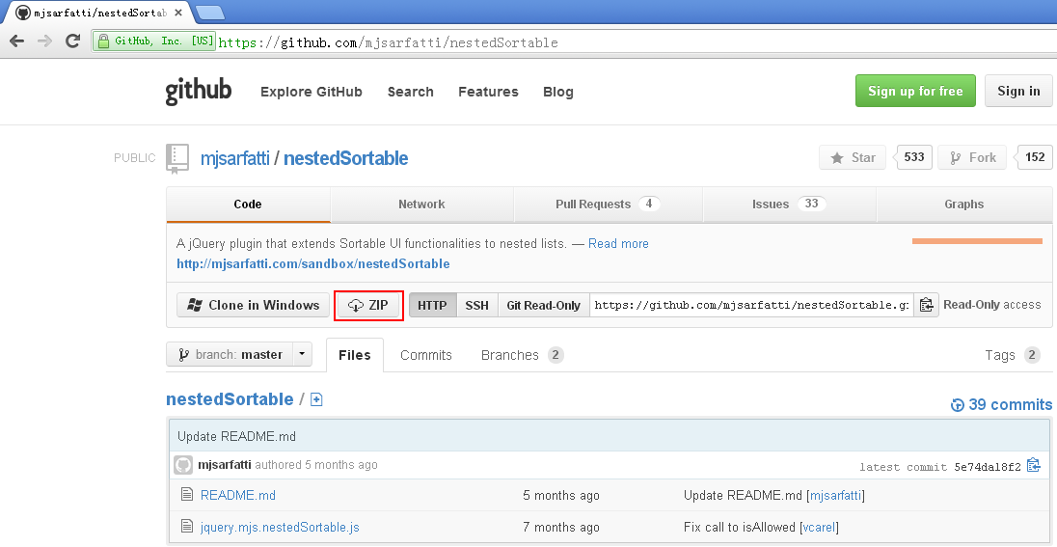

解压缩后，拷贝jquery.mjs.nestedSortable.js文件到html/js下

动态加载

<?php if (isset($sortable) && $sortable == TRUE): ?>
<script type="text/javascript" src="<?php echo site_url('../html/js/jquery-ui-1.10.3.custom.min.js'); ?>"></script>
<script type="text/javascript" src="<?php echo site_url('../html/js/jquery.mjs.nestedSortable.js'); ?>"></script>
<?php endif; ?>

面板式

地址: http://mjsarfatti.com/sandbox/nestedSortable/
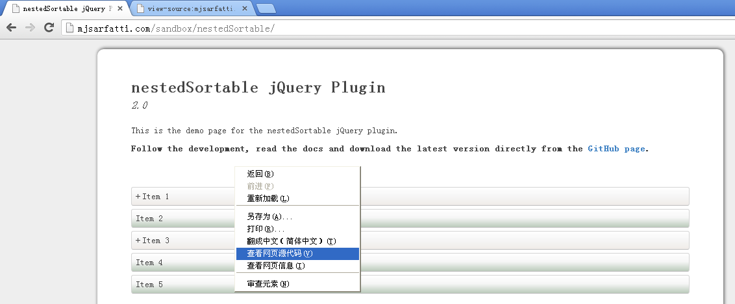

修剪其中的CSS代码，
保留.placeholder、.mjs-nestedSortable-error、ol、ol.sortable,ol.sortable ol、ol.sortable、ol.sortable、.sortable li、.sortable li div

保存为html/css/admin.css

加载它

<link href="<?php echo site_url('../html/css/admin.css'); ?>" rel="stylesheet" >

1. 数据源

生成2维数组。
在Model中生成如，数组1[变量][]形式的数组。

其中$lang_id为languages

public function get_nested($lang_id = NULL) {
if ($lang_id != NULL)
$this->db->where('lang_id', $lang_id);

$this->db->order_by($this->_order_by);
$navs = $this->db->get($this->_table_name)->result_array();

$array = array();

foreach ($navs as $nav) {
if ($nav['parent_id'] == 0) {
$array[$nav['id']] = $nav;
}
else {
$array[$nav['parent_id']]['children'][] = $nav;
}
}
return $array;
}

保存parent_id和order1数据项。

public function save_order($array) {
if (count($array)) {
foreach ($array as $order => $item) {
if ($item['item_id'] != '') {
$data = array(
'parent_id' => (int) $item['parent_id'],
'order1' => $order
);

$this->db->set($data)->where($this->_primary_key,
$item['item_id'])->update($this->_table_name);
echo '<pre>' . $this->db->last_query() . '</pre>';
}
}
}
}

2. 前端表现

分为框体和有序列表两部分。

(1) order

<section>
<h2>Order navigations</h2>
<p class="alert alert-info">Drog to order navigation and then click 'Save'</p>
<div id="orderResult"></div>
<input type="button" id="save" value="Save" class="btn btn-primary" />
</section>

保存提交

响应“save”按钮

功能代码部分：

$('#save').click(function() {
oSortable = $('.sortable').nestedSortable('toArray');

$('#orderResult').slideUp(function() {
$.post("<?php echo site_url('admin/navigation/order_ajax'); ?>",
{sortable : oSortable}, function(data) {
$('#orderResult').html(data);
}); // post - 2 end
$('#orderResult').slideDown();
}); // slide up end
}); // save click end

(2) order_ajax

<?php
echo get_ol($navigations);
?>

get_ol详见Helper中的有序列表。

使用nestedSortable

<script>
$(document).ready(function(){

$('.sortable').nestedSortable({
handle: 'div',
items: 'li',
toleranceElement: '> div',
maxLevels: 2
});

});
</script>

3. 调用

代码分布在navigation.php和order.php

(1) 显式调用

直接使用导航菜单调用（_layout_main.php），

<li><?php echo anchor('admin/navigation/order', 'Order Navigations'); ?></li>

实现代码（navigation.php）：

public function order() {
$this->data['sortable'] = TRUE;

// Load view
$this->data['subview'] = 'admin/navigation/order';
$this->load->view('admin/_layout_main', $this->data);
}

(2) 隐式调用

使用JQuery调用控制代码。

调用代码（order.php）：

<script>
$(function() {
$.post("<?php echo site_url('admin/navigation/order_ajax'); ?>", {}, function(data) {
$('#orderResult').html(data);
});
});
</script>

实现代码（navigation.php）：

public function order_ajax() {
// Save order from ajax call
if (isset($_POST['sortable'])) {
$this->Navigation_M->save_order($_POST['sortable']);
}

$this->data['navigations'] = $this->Navigation_M->get_nested();

$this->load->view('admin/navigation/order_ajax', $this->data);
}

四、管理“新闻中心”

根据不同类型来区分文章，是公司新闻、公司公告、公司概况还是技术创新等等。

（〇）、控制器

统一使用一个控制器：

class PressCenter extends Admin_Controller {
public function __construct() {
parent::__construct ();

$this->load->model('Type_M');
$this->load->model('Article_M');
}
… …
// 控制部分
}

1. 文章类型控制部分

根据参数来使用私有方法

public function types($param, $id = NULL) {

switch ($param) {
case 'list':
$this->_type_index();
break;
case 'add':
$this->_type_edit(NULL);
break;
case 'edit':
$this->_type_edit($id);
break;
case 'delete':
$this->_type_delete($id);
break;
default:
$this->_type_index();
break;
}
}

(1) index()

private function _type_index() {
$this->data['types'] = $this->Type_M->get();

$this->data['subview'] = 'admin/presscenter/type_index';
$this->load->view('admin/_layout_main', $this->data);
}

(2) edit()

private function _type_edit($id = NULL) {
if ($id) {
$this->data['type'] = $this->Type_M->get($id);
count($this->data['type']) || $this->data['error'][] = 'type could not be found';
}
else {
$fields = array(
'name',
'description'
);
$this->data['type'] = $this->Type_M->set_spaces($fields);
}

// Set form
$rules = $this->Type_M->rules_admin;

$this->form_validation->set_rules($rules);

if ($this->form_validation->run() == TRUE) {
// Collection form data
$data_form = $this->Type_M->array_form_post(
array(
'name',
'description'
)
);
// Save DB table
$this->Type_M->save($data_form, $id);
redirect('admin/presscenter/types/list');
}

$this->data['subview'] = 'admin/presscenter/type_edit';
$this->load->view('admin/_layout_main', $this->data);

}

(3) delete()

private function _type_delete($id) {
$this->Type_M->delete($id);
redirect('admin/presscenter/types/list');
}

1. 文章内容控制部分

(1) index()

public function index() {
$this->data['articles'] = $this->Article_M->get();

$this->data['subview'] = 'admin/presscenter/index';
$this->load->view('admin/_layout_main', $this->data);
}

(2) edit()

public function edit($id = NULL) {
$this->data['mceFlag'] = TRUE;
if ($id) {
$this->data['article'] = $this->Article_M->get($id);
count($this->data['article']) || $this->data['error'][] = 'article could not be found';
}
else {
$fields = array(
'type_id',
'lang_id',
'title',
'slug',
'body',
'pubdate',
'created',
'modified'
);
$this->data['article'] = $this->Article_M->set_spaces($fields);
}

// Set form
$rules = $this->Article_M->rules;

$this->form_validation->set_rules($rules);

if ($this->form_validation->run() == TRUE) {
// Collection form data
$data_form = $this->Article_M->array_form_post(
array(
'type_id',
'lang_id',
'title',
'slug',
'body',
'pubdate',
'created',
'modified'
)
);
// Save DB table
$this->Article_M->save($data_form, $id);
redirect('admin/presscenter');
}

$this->data['subview'] = 'admin/presscenter/edit';
$this->load->view('admin/_layout_main', $this->data);
}

(3) delete()

public function delete($id) {
$this->Article_M->delete($id);
redirect('admin/presscenter');
}

（一）、文章类型

1. Views

type_index.php和type_edit.php

(1) 索引页

<section>
<h2>types</h2>
<?php echo anchor('admin/presscenter/types/add', '<span class="glyphicon glyphicon-plus"></span> Add a type'); ?>
<table class="table table-striped">
<thead>
<tr>
<th>Name</th>
<th>Edit</th>
<th>Delete</th>
</tr>
</thead>
<tbody>
<?php if (count($types)): foreach ($types as $type): ?>
<tr>
<td><?php echo anchor('admin/presscenter/types/edit/' . $type->id, $type->name); ?></td>
<td><?php echo btn_edit('admin/presscenter/types/edit/' . $type->id); ?></td>
<td><?php echo btn_delete('admin/presscenter/types/delete/' . $type->id); ?></td>
</tr>
<?php endforeach; ?>
<?php else: ?>
<tr>
<td colspan="3">We could not find any types.</td>
</tr>
<?php endif; ?>
</tbody>

</table>
</section>

(2) 编辑页

<section>
<h3><?php echo empty($type->id) ? 'Add a new type' : 'Edit type ' . $type->name; ?></h3>
<?php echo validation_errors(); ?>
<?php echo form_open(); ?>
<?php $inputAttr = 'class="form-control"'; ?>
<table class="table">
<tr>
<td>Name</td>
<td><?php echo form_input('name', set_value('name', $type->name), $inputAttr); ?></td>
</tr>
<tr>
<td>Description</td>
<td><?php echo form_input('description', set_value('description', $type->description), $inputAttr); ?></td>
</tr>
<tr>
<td></td>
<td><?php echo form_submit('save', 'Save', 'class="btn btn-primary"'); ?></td>
</tr>
</table>
<?php echo form_close(); ?>
</section>

2. Type_M类

protected $_table_name = 'types';
protected $_order_by = 'id';

输入数据规则

public $rules_admin = array(
'name' => array(
'field' => 'name',
'label' => 'Name',
'rules' => 'trim|required|xss_clean'
),
'description' => array(
'field' => 'description',
'label' => 'Description',
'rules' => 'trim|required|xss_clean'
),
);

（二）、文章内容

TinyMCE
添加TinyMCE（当前版本V4.1.0）支持

解压缩后，剪切“tinymce_4.0.10\tinymce\js”中的tinymce文件夹到“html/js”中

其中(1)和(2)代码放在<head></head>之间。

(1) 引用
设置引用条件：
<?php if (isset($mceFlag) && $mceFlag == TRUE): ?>

<!-- TinyMCE -->
<script src="<?php echo site_url('../html/js/tinymce/tinymce.min.js'); ?>"></script>
<!-- /TinyMCE -->

<?php endif; ?>

(2) 初始化

使用高级模式初始化

<script type="text/javascript">
tinymce.init({
selector: "textarea",
theme: "modern",
plugins: [
"advlist autolink link image lists charmap print preview hr anchor pagebreak spellchecker",
"searchreplace wordcount visualblocks visualchars code fullscreen insertdatetime media nonbreaking",
"save table contextmenu directionality emoticons template paste textcolor"
],
toolbar: "insertfile undo redo | styleselect | bold italic | alignleft aligncenter alignright alignjustify | bullist numlist outdent indent | l ink image | print preview media fullpage | forecolor backcolor emoticons",
style_formats: [
{title: 'Bold text', inline: 'b'},
{title: 'Red text', inline: 'span', styles: {color: '#ff0000'}},
{title: 'Red header', block: 'h1', styles: {color: '#ff0000'}},
{title: 'Example 1', inline: 'span', classes: 'example1'},
{title: 'Example 2', inline: 'span', classes: 'example2'},
{title: 'Table styles'},
{title: 'Table row 1', selector: 'tr', classes: 'tablerow1'}
]
});
</script>

(3) 调用

在Textarea增加对tingmce的调用

<td><?php echo form_textarea('body', set_value('body', $article->body), 'class="tinymce"'); ?></td>

Datepicker

下载地址：http://www.eyecon.ro/bootstrap-datepicker/

拷贝datepicker/css/ datepicker.css到html/css中
拷贝datepicker/css/ bootstrap-datepicker.js到html/js中

(1) 引用

<link href="<?php echo site_url('../html/css/datepicker.css'); ?>" rel="stylesheet" />
<script src="<?php echo site_url('../html/js/bootstrap-datepicker.js'); ?>"></script>

(2) 使用

<tr>
<td><?php echo form_input('pubdate', set_value('pubdate', $article->pubdate), 'class="datepicker"'); ?></td>
</tr>

(3) 响应

在使用的页面使用如下JQuery代码，来进行Datepicker的响应。

<script type="text/javascript">
$(function() {
$('.datepicker').datepicker({format : 'yyyy-mm-dd'});
});
</script>

1. Views

(1) 索引页

<section>
<h2>articles</h2>
<?php echo anchor('admin/presscenter/edit', '<span class="glyphicon glyphicon-plus"></span> Add a articles'); ?>
<table class="table table-striped">
<thead>
<tr>
<th>Title</th>
<th>Edit</th>
<th>Delete</th>
</tr>
</thead>
<tbody>
<?php if (count($articles)): foreach ($articles as $article): ?>
<tr>
<td><?php echo anchor('admin/presscenter/edit/' . $article->id, $article->title); ?></td>
<td><?php echo btn_edit('admin/presscenter/edit/' . $article->id); ?></td>
<td><?php echo btn_delete('admin/presscenter/delete/' . $article->id); ?></td>
</tr>
<?php endforeach; ?>
<?php else: ?>
<tr>
<td colspan="3">We could not find any articles.</td>
</tr>
<?php endif; ?>
</tbody>

</table>
</section>

(2) 编辑页

<section>
<h3><?php echo empty($article->id) ? 'Add a new article' : 'Edit article ' . $article->title; ?></h3>
<?php echo validation_errors(); ?>
<?php echo form_open(); ?>
<?php $inputAttr = 'class="form-control"'; ?>
<table class="table">
<tr>
<td>Language</td>
<td><?php echo form_dropdown('lang_id', $lang_list, $this->input->post('lang_id') ? $this->input->post('lang_id') : $article->lang_id) ;?></td>
</tr>
<tr>
<td>Type</td>
<td><?php echo form_dropdown('type_id', $type_list, $this->input->post('type_id') ? $this->input->post('type_id') : $article->type_id) ;?></td>
</tr>
<tr>
<td>Publication Date</td>
<td><?php echo form_input('pubdate', set_value('pubdate', $article->pubdate), 'class="datepicker"'); ?></td>
</tr>
<tr>
<td>Title</td>
<td><?php echo form_input('title', set_value('tilte', $article->title), $inputAttr); ?></td>
</tr>
<tr>
<td>Slug</td>
<td><?php echo form_input('slug', set_value('slug', $article->slug), $inputAttr); ?></td>
</tr>
<tr>
<td>Body</td>
<td><?php echo form_textarea('body', set_value('body', $article->body), 'class="tinymce"'); ?></td>
</tr>
<tr>
<td></td>
<td><?php echo form_submit('save', 'Save', 'class="btn btn-primary"'); ?></td>
</tr>
</table>
<?php echo form_close(); ?>
</section>

<script type="text/javascript">
$(function() {
$('.datepicker').datepicker({format : 'yyyy-mm-dd'});
});
</script>

2. Article_M类

protected $_table_name = 'articles';
protected $_order_by = 'pubdate desc, id ';
protected $_timestamps = TRUE;

输入数据规则

public $rules = array (
'pubdate' => array (
'field' => 'pubdate',
'label' => 'Publication date',
'rules' => 'trim|required|excatlength[10]|xss_clean'
),
'title' => array (
'field' => 'title',
'label' => 'Title',
'rules' => 'trim|required|max_length[100]|xss_clean'
),
'slug' => array (
'field' => 'slug',
'label' => 'Slug',
'rules' => 'trim|required|max_length[100]|url_title|xss_clean'
),
'body' => array (
'field' => 'body',
'label' => 'Body',
'rules' => 'trim|required'
),
);

五、管理“产品”

（〇）、控制器

统一使用一个控制器：

class Product extends Admin_Controller {
public function __construct() {
parent::__construct ();

$this->load->model('Statu_M');
$this->load->model('Parameter_M');
}
… …
// 控制部分

}

1. 产品状态控制部分

根据参数来使用私有方法

public function status($param, $id = NULL) {
switch ($param) {
case 'list':
$this->_statu_index();
break;
case 'add':
$this->_statu_edit(NULL);
break;
case 'edit':
$this->_statu_edit($id);
break;
case 'delete':
$this->_statu_delete($id);
break;
default:
$this->_statu_index();
break;
}
}

(1) index()

private function _statu_index() {
$this->data['status'] = $this->Statu_M->get();

$this->data['subview'] = 'admin/product/statu_index';
$this->load->view('admin/_layout_main', $this->data);
}

(2) edit()

private function _statu_edit($id = NULL) {
if ($id) {
$this->data['statu'] = $this->Statu_M->get($id);
count($this->data['statu']) || $this->data['error'][] = 'statu could not be found';
}
else {
$fields = array(
'pubdate',
'name'
);
$this->data['statu'] = $this->Statu_M->set_spaces($fields);
}

// Set form
$rules = $this->Statu_M->rules_admin;

$this->form_validation->set_rules($rules);

if ($this->form_validation->run() == TRUE) {
// Collection form data
$data_form = $this->Statu_M->array_form_post(
array(
'pubdate',
'name'
)
);
// Save DB table
$this->Statu_M->save($data_form, $id);
redirect('admin/product/status/list');
}

$this->data['subview'] = 'admin/product/statu_edit';
$this->load->view('admin/_layout_main', $this->data);
}

(3) delete()

private function _statu_delete($id) {
$this->Statu_M->delete($id);
redirect('admin/product/status/list');
}

2. 产品参数控制部分

根据参数来使用私有方法

public function parameters($param, $id = NULL) {
switch ($param) {
case 'list':
$this->_parameter_index();
break;
case 'add':
$this->_parameter_edit(NULL);
break;
case 'edit':
$this->_parameter_edit($id);
break;
case 'delete':
$this->_parameter_delete($id);
break;
default:
$this->_sparameter_index();
break;
}
}

(1) index()

private function _parameter_index() {
$this->data['parameters'] = $this->Parameter_M->get();

$this->data['subview'] = 'admin/product/param_index';
$this->load->view('admin/_layout_main', $this->data);
}

(2) edit()

private function _parameter_edit($id = NULL) {
if ($id) {
$this->data['parameter'] = $this->Parameter_M->get($id);
count($this->data['parameter']) || $this->data['error'][] = 'parameter could not be found';
}
else {
$fields = array(
'lang_id',
'mtbf',
'voltage',
'electricity',
'ipxx',
'temperature'
);
$this->data['parameter'] = $this->Parameter_M->set_spaces($fields);
}

// Set form
$rules = $this->Parameter_M->rules_admin;

$this->form_validation->set_rules($rules);

if ($this->form_validation->run() == TRUE) {
// Collection form data
$data_form = $this->Parameter_M->array_form_post(
array(
'lang_id',
'mtbf',
'voltage',
'electricity',
'ipxx',
'temperature'
)
);
// Save DB table
$this->Parameter_M->save($data_form, $id);
redirect('admin/product/parameters/list');
}

$this->data['subview'] = 'admin/product/param_edit';
$this->load->view('admin/_layout_main', $this->data);
}

(3) delete()

private function _parameter_delete($id) {
$this->Parameter_M->delete($id);
redirect('admin/product/parameters/list');
}

3. 产品详细控制部分

(1) index()

public function index() {
$this->data['products'] = $this->Product_M->get();

$this->data['subview'] = 'admin/product/index';
$this->load->view('admin/_layout_main', $this->data);
}

(2) edit()

public function edit($id = NULL) {
if ($id) {
$this->data['product'] = $this->Product_M->get($id);
count($this->data['product']) || $this->data['error'][] = 'product could not be found';
}
else {
$fields = array(
'lang_id',
'param_id',
'statu_id',
'img_id',
'name',
'description'
);
$this->data['product'] = $this->Product_M->set_spaces($fields);
}

$this->data['param_list'] = $this->_get_param_list();
$this->data['statu_list'] = $this->_get_statu_list();

// Set form
$rules = $this->Product_M->rules_admin;

$this->form_validation->set_rules($rules);

if ($this->form_validation->run() == TRUE) {
// Collection form data
$data_form = $this->Product_M->array_form_post(
array(
'lang_id',
'param_id',
'statu_id',
'name',
'description'
)
);
// Save DB table
$this->Product_M->save($data_form, $id);
redirect('admin/product');
}

$this->data['subview'] = 'admin/product/edit';
$this->load->view('admin/_layout_main', $this->data);
}

a. 获得“产品参数”列表

private function _get_param_list() {
$array = $this->Parameter_M->get();
$result = array();
foreach ($array as $row) {
$result[$row->id] = $row->name;
}
return $result;
}

b. 获得“产品状态”列表

private function _get_statu_list() {
$array = $this->Statu_M->get();
$result = array();
foreach ($array as $row) {
$result[$row->id] = $row->name;
}
return $result;
}

(3) delete()

public function delete($id) {
$this->Product_M->delete($id);
redirect('admin/product');
}

（一）、产品状态

1. Views

statu_index.php和statu_edit.php

(1) 索引页

<section>
<h2>status</h2>
<?php echo anchor('admin/product/status/add', '<span class="glyphicon glyphicon-plus"></span> Add a statu'); ?>
<table class="table table-striped">
<thead>
<tr>
<th>Name</th>
<th>Edit</th>
<th>Delete</th>
</tr>
</thead>
<tbody>
<?php if (count($status)): foreach ($status as $statu): ?>
<tr>
<td><?php echo anchor('admin/product/status/edit/' . $statu->id, $statu->name); ?></td>
<td><?php echo btn_edit('admin/product/status/edit/' . $statu->id); ?></td>
<td><?php echo btn_delete('admin/product/status/delete/' . $statu->id); ?></td>
</tr>
<?php endforeach; ?>
<?php else: ?>
<tr>
<td colspan="3">We could not find any status.</td>
</tr>
<?php endif; ?>
</tbody>

</table>
</section>

(2) 编辑页

<section>
<h3><?php echo empty($statu->id) ? 'Add a new statu' : 'Edit statu ' . $statu->name; ?></h3>
<?php echo validation_errors(); ?>
<?php echo form_open(); ?>
<?php $inputAttr = 'class="form-control"'; ?>
<table class="table">
<tr>
<td>Publication Date</td>
<td><?php echo form_input('pubdate', set_value('pubdate', $statu->pubdate), 'class="datepicker"'); ?></td>
</tr>
<tr>
<td>Name</td>
<td><?php echo form_input('name', set_value('name', $statu->name), $inputAttr); ?></td>
</tr>
<tr>
<td></td>
<td><?php echo form_submit('save', 'Save', 'class="btn btn-primary"'); ?></td>
</tr>
</table>
<?php echo form_close(); ?>
</section>

<script type="text/javascript">
$(function() {
$('.datepicker').datepicker({format : 'yyyy-mm-dd'});
});
</script>

2. Statu_M类

输入数据规则

public $rules_admin = array(
'name' => array(
'field' => 'name',
'label' => 'Name',
'rules' => 'trim|required|xss_clean'
),
'pubdate' => array(
'field' => 'pubdate',
'label' => 'Pubdate',
'rules' => 'trim|required|xss_clean'
),
);

（二）、产品参数

1. Views

param_index.php和param_edit.php

(1) 索引页
<section>
<h2>parameters</h2>
<?php echo anchor('admin/product/parameters/add', '<span class="glyphicon glyphicon-plus"></span> Add a parameter'); ?>
<table class="table table-striped">
<thead>
<tr>
<th>MTBF(H)</th>
<th>Voltage(V)</th>
<th>Electricity(A)</th>
<th>IPxx</th>
<th>Temperature</th>
<th>Edit</th>
<th>Delete</th>
</tr>
</thead>
<tbody>
<?php if (count($parameters)): foreach ($parameters as $parameter): ?>
<tr>
<td><?php echo $parameter->mtbf; ?></td>
<td><?php echo $parameter->voltage; ?></td>
<td><?php echo $parameter->electricity; ?></td>
<td><?php echo $parameter->ipxx; ?></td>
<td><?php echo $parameter->temperature; ?></td>
<td><?php echo btn_edit('admin/product/parameters/edit/' . $parameter->id); ?></td>
<td><?php echo btn_delete('admin/product/parameters/delete/' . $parameter->id); ?></td>
</tr>
<?php endforeach; ?>
<?php else: ?>
<tr>
<td colspan="7">We could not find any parameters.</td>
</tr>
<?php endif; ?>
</tbody>

</table>
</section>

(2) 编辑页

<section>
<h3><?php echo empty($parameter->id) ? 'Add a new parameter' : 'Edit parameter'; ?></h3>
<?php echo validation_errors(); ?>
<?php echo form_open(); ?>
<?php $inputAttr = 'class="form-control"'; ?>
<table class="table">
<tr>
<td>Language</td>
<td><?php echo form_dropdown('lang_id', $lang_list, $this->input->post('lang_id') ? $this->input->post('lang_id') : $parameter->lang_id); ?></td>
</tr>
<tr>
<td>MTBF(H)</td>
<td><?php echo form_input('mtbf', set_value('mtbf', $parameter->mtbf), $inputAttr); ?></td>
</tr>
<tr>
<td>Voltage(V)</td>
<td><?php echo form_input('voltage', set_value('voltage', $parameter->voltage), $inputAttr); ?></td>
</tr>
<tr>
<td>Electricity(A)</td>
<td><?php echo form_input('electricity', set_value('electricity', $parameter->electricity), $inputAttr); ?></td>
</tr>
<tr>
<td>IPxx</td>
<td><?php echo form_input('ipxx', set_value('ipxx', $parameter->ipxx), $inputAttr); ?></td>
</tr>
<tr>
<td>Temperature</td>
<td><?php echo form_input('temperature', set_value('temperature', $parameter->temperature), $inputAttr); ?></td>
</tr>
<tr>
<td></td>
<td><?php echo form_submit('save', 'Save', 'class="btn btn-primary"'); ?></td>
</tr>
</table>
<?php echo form_close(); ?>
</section>

2. Parameter_M类

输入数据规则

public $rules_admin = array(
'mtbf' => array(
'field' => 'mtbf',
'label' => 'Mtbf',
'rules' => 'trim|required|xss_clean'
),
'voltage' => array(
'field' => 'voltage',
'label' => 'Voltage',
'rules' => 'trim|required|xss_clean'
),
);

（三）、产品详细

1. Views

(1) 索引页

<section>
<h2>products</h2>
<?php echo anchor('admin/product/edit', '<span class="glyphicon glyphicon-plus"></span> Add a product'); ?>
<table class="table table-striped">
<thead>
<tr>
<th>Name</th>
<th>Edit</th>
<th>Delete</th>
</tr>
</thead>
<tbody>
<?php if (count($products)): foreach ($products as $product): ?>
<tr>
<td><?php echo anchor('admin/product/edit/' . $product->id, $product->name); ?></td>
<td><?php echo btn_edit('admin/product/edit/' . $product->id); ?></td>
<td><?php echo btn_delete('admin/product/delete/' . $product->id); ?></td>
</tr>
<?php endforeach; ?>
<?php else: ?>
<tr>
<td colspan="3">We could not find any products.</td>
</tr>
<?php endif; ?>
</tbody>

</table>
</section>

(2) 编辑页

<section>
<h3><?php echo empty($product->id) ? 'Add a new product' : 'Edit product ' . $product->name; ?></h3>
<?php echo validation_errors(); ?>
<?php echo form_open(); ?>
<?php $inputAttr = 'class="form-control"'; ?>
<table class="table">
<tr>
<td>Name</td>
<td><?php echo form_input('name', set_value('name', $product->name), $inputAttr); ?></td>
</tr>
<tr>
<td>Language</td>
<td><?php echo form_dropdown('lang_id', $lang_list, $this->input->post('lang_id') ? $this->input->post('lang_id') : $product->lang_id) ;?></td>
</tr>
<tr>
<td>Image</td>
<td><?php echo form_dropdown('img_id', $img_list, $this->input->post('img_id') ? $this->input->post('img_id') : $product->img_id) ;?></td>
</tr>
<tr>
<td>Parameters List</td>
<td><?php echo form_dropdown('param_id', $param_list, $this->input->post('param_id') ? $this->input->post('param_id') : $product->param_id) ;?></td>
</tr>
<tr>
<td>Publication Status</td>
<td><?php echo form_dropdown('statu_id', $statu_list, $this->input->post('statu_id') ? $this->input->post('statu_id') : $product->statu_id) ;?></td>
</tr>
<tr>
<td>Description</td>
<td><?php echo form_textarea('description', set_value('description', $product->description), $inputAttr); ?></td>
</tr>
<tr>
<td></td>
<td><?php echo form_submit('save', 'Save', 'class="btn btn-primary"'); ?></td>
</tr>
</table>
<?php echo form_close(); ?>
</section>

2. Product_M类

输入数据规则

public $rules_admin = array(
'name' => array(
'field' => 'name',
'label' => 'Name',
'rules' => 'trim|required|xss_clean'
),
'description' => array(
'field' => 'description',
'label' => 'Description',
'rules' => 'trim|required|xss_clean'
),
);

六、管理“资质”

（一）、Qualification类

1. index()

public function index() {
$this->data['qualifications'] = $this->Qualification_M->get();

$this->data['subview'] = 'admin/qualification/index';
$this->load->view('admin/_layout_main', $this->data);
}

2. edit()

public function edit($id = NULL) {
$this->data['mceFlag'] = TRUE;

if ($id) {
$this->data['qualification'] = $this->Qualification_M->get($id);
count($this->data['qualification']) || $this->data['error'][] = 'qualification could not be found';
}
else {
$fields = array(
'lang_id',
'img_id',
'name',
'description'
);
$this->data['qualification'] = $this->Qualification_M->set_spaces($fields);
}

// Set form
$rules = $this->Qualification_M->rules_admin;

$this->form_validation->set_rules($rules);

if ($this->form_validation->run() == TRUE) {
// Collection form data
$data_form = $this->Qualification_M->array_form_post(
array(
'lang_id',
'name',
'description'
)
);
// Save DB table
$this->Qualification_M->save($data_form, $id);
redirect('admin/qualification');
}

$this->data['subview'] = 'admin/qualification/edit';
$this->load->view('admin/_layout_main', $this->data);
}

3. delete()

public function delete($id) {
$this->Qualification_M->delete($id);

redirect('admin/qualification');
}

（二）、View

1. 索引页

<section>
<h2>Qualifications</h2>
<?php echo anchor('admin/qualification/edit', '<span class="glyphicon glyphicon-plus"></span> Add a qualification'); ?>
<table class="table table-striped">
<thead>
<tr>
<th>Name</th>
<th>Edit</th>
<th>Delete</th>
</tr>
</thead>
<tbody>
<?php if (count($qualifications)): foreach ($qualifications as $qualification): ?>
<tr>
<td><?php echo anchor('admin/qualification/edit/' . $qualification->id, $qualification->name); ?></td>
<td><?php echo btn_edit('admin/qualification/edit/' . $qualification->id); ?></td>
<td><?php echo btn_delete('admin/qualification/delete/' . $qualification->id); ?></td>
</tr>
<?php endforeach; ?>
<?php else: ?>
<tr>
<td colspan="3">We could not find any qualifications.</td>
</tr>
<?php endif; ?>
</tbody>

</table>
</section>

2. 编辑页

<section>
<h3><?php echo empty($qualification->id) ? 'Add a new product' : 'Edit qualification ' . $qualification->name; ?></h3>
<?php echo validation_errors(); ?>
<?php echo form_open(); ?>
<?php $inputAttr = 'class="form-control"'; ?>
<table class="table">
<tr>
<td>Name</td>
<td><?php echo form_input('name', set_value('name', $qualification->name), $inputAttr); ?></td>
</tr>
<tr>
<td>Language</td>
<td><?php echo form_dropdown('lang_id', $lang_list, $this->input->post('lang_id') ? $this->input->post('lang_id') : $qualification->lang_id) ;?></td>
</tr>
<tr>
<td>Image</td>
<td><?php echo form_dropdown('img_id', $img_list, $this->input->post('img_id') ? $this->input->post('img_id') : $qualification->img_id) ;?></td>
</tr>
<tr>
<td>Description</td>
<td><?php echo form_textarea('description', set_value('description', $qualification->description), 'class="tinymce"'); ?></td>
</tr>
<tr>
<td></td>
<td><?php echo form_submit('save', 'Save', 'class="btn btn-primary"'); ?></td>
</tr>
</table>
<?php echo form_close(); ?>
</section>

（三）、Qualification_M类

输入数据规则

public $rules_admin = array(
'name' => array(
'field' => 'name',
'label' => 'Name',
'rules' => 'trim|required|xss_clean'
),
'description' => array(
'field' => 'description',
'label' => 'Description',
'rules' => 'trim|required|xss_clean'
),
);

七、联系方式

（一）、Contact类

在构造器中装载Language_M模型。

$this->load->model('Contact_M');

1. index()

public function index() {
$this->data['contacts'] = $this->Contact_M->get();
$this->data['subview'] = 'admin/contact/index';
$this->load->view('admin/_layout_main', $this->data);
}

2. edit()

public function edit($id = NULL) {
$fields = array(
'lang_id',
'name',
'displayName',
'tel',
'fax',
'email'
);

if ($id) {
$this->data['contact'] = $this->Contact_M->get($id);
count($this->data['contact']) || $this->data['error'][] = 'contact could not be found';
}
else {
$this->data['contact'] = $this->Contact_M->set_spaces($fields);
}

$rules = $this->Contact_M->rules_admin;

$this->form_validation->set_rules($rules);

if ($this->form_validation->run() == TRUE) {
// Collection form data
$data_form = $this->Contact_M->array_form_post($fields);
// Save DB table
$this->Contact_M->save($data_form, $id);
redirect('admin/contact');
}

$this->data['subview'] = 'admin/contact/edit';
$this->load->view('admin/_layout_main', $this->data);
}

3. delete()

public function delete($id) {
$this->Contact_M->delete($id);
redirect('admin/contact');
}

（二）、Views

1. 索引页

contact/index.php

<section>
<h2>contacts</h2>
<?php echo anchor('admin/contact/edit', '<span class="glyphicon glyphicon-plus"></span> Add a contact'); ?>
<table class="table table-striped">
<thead>
<tr>
<th>Display Name</th>
<th>Edit</th>
<th>Delete</th>
</tr>
</thead>
<tbody>
<?php if (count($contacts)): foreach ($contacts as $contact): ?>
<tr>
<td><?php echo anchor('admin/contact/edit/' . $contact->id, $contact->displayName); ?></td>
<td><?php echo btn_edit('admin/contact/edit/' . $contact->id); ?></td>
<td><?php echo btn_delete('admin/contact/delete/' . $contact->id); ?></td>
</tr>
<?php endforeach; ?>
<?php else: ?>
<tr>
<td colspan="3">We could not find any contacts.</td>
</tr>
<?php endif; ?>
</tbody>

</table>
</section>

2. 编辑页

contact/edit.php

<section>
<h3><?php echo empty($contact->id) ? 'Add a new contact' : 'Edit contact ' . $contact->name; ?></h3>
<?php echo validation_errors(); ?>
<?php echo form_open(); ?>
<?php $inputAttr = 'class="form-control"'; ?>
<table class="table">
<tr>
<td>Language</td>
<td><?php echo form_dropdown('lang_id', $lang_list, $this->input->post('lang_id') ? $this->input->post('lang_id') : $contact->lang_id); ?></td>
</tr>
<tr>
<td>Name</td>
<td><?php echo form_input('name', set_value('name', $contact->name), $inputAttr); ?></td>
</tr>
<tr>
<td>Display Name</td>
<td><?php echo form_input('displayName', set_value('displayName', $contact->displayName), $inputAttr); ?></td>
</tr>
<tr>
<td>Tel</td>
<td><?php echo form_input('tel', set_value('tel', $contact->tel), $inputAttr); ?></td>
</tr>
<tr>
<td>Fax</td>
<td><?php echo form_input('fax', set_value('fax', $contact->fax), $inputAttr); ?></td>
</tr>
<tr>
<td>Email</td>
<td><?php echo form_input('email', set_value('email', $contact->email), $inputAttr); ?></td>
</tr>
<tr>
<td></td>
<td><?php echo form_submit('save', 'Save', 'class="btn btn-primary"'); ?></td>
</tr>
</table>
<?php echo form_close(); ?>
</section>

（三）、Contact_M类

protected $_table_name = 'contacts';
protected $_order_by = 'id';

输入数据规则

public $rules_admin = array(
'name' => array(
'field' => 'name',
'label' => 'Name',
'rules' => 'trim|required|xss_clean'
),
'tel' => array(
'field' => 'tel',
'label' => 'Tel',
'rules' => 'trim|required|xss_clean'
),
'fax' => array(
'field' => 'fax',
'label' => 'Fax',
'rules' => 'trim|required|xss_clean'
),
'email' => array(
'field' => 'email',
'label' => 'Email',
'rules' => 'trim|required|valid_email|xss_clean'
),
);

八、词汇对照

（一）、词汇维护

1. Glossary_M

protected $_table_name = 'glossaries';
protected $_order_by = 'id';

输入数据规则

public $rules_admin = array(
'name' => array(
'field' => 'name',
'label' => 'Name',
'rules' => 'trim|required|xss_clean'
),
'description' => array(
'field' => 'description',
'label' => 'Description',
'rules' => 'trim|required|xss_clean'
),
);

2. Views

(1) 索引页

<section>
<h2>Glossaries</h2>
<?php echo anchor('admin/glossary/edit', '<span class="glyphicon glyphicon-plus"></span> Add a glossary'); ?>
<table class="table table-striped">
<thead>
<tr>
<th>Name</th>
<th>Edit</th>
<th>Delete</th>
</tr>
</thead>
<tbody>
<?php if (count($glossaries)): foreach ($glossaries as $glossary): ?>
<tr>
<td><?php echo anchor('admin/glossary/edit/' . $glossary->id, $glossary->description); ?></td>
<td><?php echo btn_edit('admin/glossary/edit/' . $glossary->id); ?></td>
<td><?php echo btn_delete('admin/glossary/delete/' . $glossary->id); ?></td>
</tr>
<?php endforeach; ?>
<?php else: ?>
<tr>
<td colspan="3">We could not find any glossaries.</td>
</tr>
<?php endif; ?>
</tbody>

</table>
</section>

(2) 编辑页

<section>
<h3><?php echo empty($glossary->id) ? 'Add a new glossary' : 'Edit glossary ' . $glossary->name; ?></h3>
<?php echo validation_errors(); ?>
<?php echo form_open(); ?>
<?php $inputAttr = 'class="form-control"'; ?>
<table class="table">
<tr>
<td>Name</td>
<td><?php echo form_input('name', set_value('name', $glossary->name), $inputAttr); ?></td>
</tr>
<tr>
<td>Language</td>
<td><?php echo form_dropdown('lang_id', $lang_list, $this->input->post('lang_id') ? $this->input->post('lang_id') : $glossary->lang_id); ?></td>
</tr>
<tr>
<td>Sector</td>
<td><?php echo form_dropdown('sector_id', $sector_list, $this->input->post('sector_id') ? $this->input->post('sector_id') : $glossary->sector_id); ?></td>
</tr>
<tr>
<td>Description</td>
<td><?php echo form_input('description', set_value('description', $glossary->description), $inputAttr); ?></td>
</tr>
<tr>
<td></td>
<td><?php echo form_submit('save', 'Save', 'class="btn btn-primary"'); ?></td>
</tr>
</table>
<?php echo form_close(); ?>
</section>

3. Glossary类

在构造器中装载Glossary_M模型。

$this->load->model('Glossary_M');

(1) index()

public function index() {
$this->data['glossaries'] = $this->Glossary_M->get();
$this->data['subview'] = 'admin/glossary/index';
$this->load->view('admin/_layout_main', $this->data);
}

(2) edit()

public function edit($id = NULL) {
$fields = array(
'lang_id',
'sector_id',
'name',
'description'
);

if ($id) {
$this->data['glossary'] = $this->Glossary_M->get($id);
count($this->data['glossary']) || $this->data['error'][] = 'glossary could not be found';
}
else {
$this->data['glossary'] = $this->Glossary_M->set_spaces($fields);
}

$rules = $this->Glossary_M->rules_admin;

$this->form_validation->set_rules($rules);

if ($this->form_validation->run() == TRUE) {
// Collection form data
$data_form = $this->Glossary_M->array_form_post($fields);
// Save DB table
$this->Glossary_M->save($data_form, $id);
redirect('admin/glossary');
}

$this->data['subview'] = 'admin/glossary/edit';
$this->load->view('admin/_layout_main', $this->data);
}

(3) delete()

public function delete($id) {
$this->Glossary_M->delete($id);
redirect('admin/glossary');
}

（二）、行业领域

1. Sector_M

protected $_table_name = 'sectors';
protected $_order_by = 'id';

输入数据规则

public $rules_admin = array(
'name' => array(
'field' => 'name',
'label' => 'Name',
'rules' => 'trim|required|xss_clean'
),
'description' => array(
'field' => 'description',
'label' => 'Description',
'rules' => 'trim|required|xss_clean'
),
);

2. Views

(1) 索引页

<section>
<h2>Sectors</h2>
<?php echo anchor('admin/sector/edit', '<span class="glyphicon glyphicon-plus"></span> Add a sector'); ?>
<table class="table table-striped">
<thead>
<tr>
<th>Name</th>
<th>Edit</th>
<th>Delete</th>
</tr>
</thead>
<tbody>
<?php if (count($sectors)): foreach ($sectors as $sector): ?>
<tr>
<td><?php echo anchor('admin/sector/edit/' . $sector->id, $sector->name); ?></td>
<td><?php echo btn_edit('admin/sector/edit/' . $sector->id); ?></td>
<td><?php echo btn_delete('admin/sector/delete/' . $sector->id); ?></td>
</tr>
<?php endforeach; ?>
<?php else: ?>
<tr>
<td colspan="3">We could not find any sectors.</td>
</tr>
<?php endif; ?>
</tbody>

</table>
</section>

(2) 编辑页

<section>
<h3><?php echo empty($sector->id) ? 'Add a new sector' : 'Edit sector ' . $sector->name; ?></h3>
<?php echo validation_errors(); ?>
<?php echo form_open(); ?>
<?php $inputAttr = 'class="form-control"'; ?>
<table class="table">
<tr>
<td>Name</td>
<td><?php echo form_input('name', set_value('name', $sector->name), $inputAttr); ?></td>
</tr>
<tr>
<td>Description</td>
<td><?php echo form_input('description', set_value('description', $sector->description), $inputAttr); ?></td>
</tr>
<tr>
<td></td>
<td><?php echo form_submit('save', 'Save', 'class="btn btn-primary"'); ?></td>
</tr>
</table>
<?php echo form_close(); ?>
</section>

3. Sector类

在构造器中装载Sector_M模型。

$this->load->model('Sector_M');

(1) index()

public function index() {
$this->data['sectors'] = $this->Sector_M->get();
$this->data['subview'] = 'admin/sector/index';
$this->load->view('admin/_layout_main', $this->data);
}

(2) edit()

public function edit($id = NULL) {
$fields = array(
'name',
'description'
);

if ($id) {
$this->data['sector'] = $this->Sector_M->get($id);
count($this->data['sector']) || $this->data['error'][] = 'sector could not be found';
}
else {
$this->data['sector'] = $this->Sector_M->set_spaces($fields);
}

$rules = $this->Sector_M->rules_admin;

$this->form_validation->set_rules($rules);

if ($this->form_validation->run() == TRUE) {
// Collection form data
$data_form = $this->Sector_M->array_form_post($fields);
// Save DB table
$this->Sector_M->save($data_form, $id);
redirect('admin/sector');
}

$this->data['subview'] = 'admin/sector/edit';
$this->load->view('admin/_layout_main', $this->data);
}

(3) delete()

public function delete($id) {
$this->sector_M->delete($id);
redirect('admin/sector');
}

第四章 前台部分

一、搭建前端架构

（〇）、路由设置

在config/routes.php中设置路由选项。

1. 默认控制器

$route['default_controller'] = "Page";

（一）、View

使用新的css，来规范前端页面。

styles.css

.navbar-default .navbar-nav > li > ul > li > a:hover {
color: #ffffff;
background-color: #0000FF;
}

h1 a {
display: inline-block;
/*
* bigtop2.jpg
* gifTop12.gif
* gifTop22.gif
* height: 70px;
* padding: 20px 0 0 940px;
*/
/*
* gifTop32.gif
* height: 140px
*/
background: url('../img/gifTop32.gif') no-repeat;
height: 140px;
padding: 20px 0 0 1140px;
color: black;
}

h1 a:hover {
text-decoration: none;
color: black;
}

h2 a {
color: black;
}

h1,h2,h3 {
font-family: georgia, serif;
}

p.pubdate {
font-style: italic;
font-size: 0.9em;
}

.sidebar h3 {
font-size: 1em;
line-height: 1.2em;
margin-bottom: 0;
}

.sidebar ul {
margin-left: 0;
list-style-type: none;
}

0. _main_layout

_main_layout.php

<?php $this->load->view('components/page_head'); ?>

<body>
<?php $this->load->view('components/navbar'); ?>

<?php $this->load->view('components/main_panel'); ?>

<?php $this->load->view('components/page_tail'); ?>

1. 组件

在Views新建components文件夹；
内建如下文件：
- page_head.php
- page_tail.php
- main_panel.php
- sidebar.php

(1) page_head.php

<!DOCTYPE html PUBLIC "-//W3C//DTD XHTML 1.0 Transitional//EN" "http://www.w3.org/TR/xhtml1/DTD/xhtml1-transitional.dtd">
<html xmlns="http://www.w3.org/1999/xhtml">
<head>
<title><?php echo $meta_title; ?></title>
<meta http-equiv="Content-Type" content="text/html; charset=utf-8 /">
<meta http-equiv="X-UA-Compatible" name="viewport" content="width=device-width, initial-scale=1.0" />
<!-- Bootstrap -->
<link href="<?php echo site_url('../html/css/bootstrap.min.css'); ?>" rel="stylesheet" media="screen">
<script src="<?php echo site_url('../html/js/jquery-1.10.2.js'); ?>"></script>
<script src="<?php echo site_url('../html/js/bootstrap.min.js'); ?>"></script>

<link href="<?php echo site_url('../html/css/styles.css'); ?>" rel="stylesheet" />

</head>

(2) page_tail.php

</body>
</html>

(3) main_panel.php

<div class="container">
<div class="row">
<!-- Main column -->
<div class="col-md-9">
<?php $this->load->view($subview); ?>
</div>
<!-- Sidebar -->
<div class="col-md-3">
<?php $this->load->view($sidebar); ?>
</div>
</div>
</div>

(4) sidebar.php

2. 导航菜单

<nav class="navbar navbar-default" role="navigation">
<div class="collapse navbar-collapse">
<a class="navbar-brand" href="<?php echo site_url(APPPATH . '..'); ?>"><?php echo $this->Glossary_M->get_word('home', $this->data['lang_id']); ?></a>
<ul class="nav navbar-nav">
<?php echo get_menu($menu, $menu_prefix); ?>

</ul>
</div>
</nav>

3. 模板

(0) 主页

<div class="laImg"><img id="largeImg" src="<?php echo site_url('../html/img/THDS_rail.jpg'); ?>" alt="Large image" /></div>
<div class="thumbs">
<a href="<?php echo site_url('../html/img/THDS_rail.jpg'); ?>" title="THDS"><img src="<?php echo site_url('../html/img/THDS_rail-thumb.jpg'); ?>" /></a>
<a href="<?php echo site_url('../html/img/AEI_antenna.jpg'); ?>" title="车号自动识别"><img src="<?php echo site_url('../html/img/AEI_antenna-thumb.jpg'); ?>" /></a>
<a href="<?php echo site_url('../html/img/TFDS_light.jpg'); ?>" title="TFDS"><img src="<?php echo site_url('../html/img/TFDS_light-thumb.jpg'); ?>" /></a>
<a href="<?php echo site_url('../html/img/TADS_car.jpg'); ?>" title="TADS"><img src="<?php echo site_url('../html/img/TADS_car-thumb.jpg'); ?>" /></a>
<a href="<?php echo site_url('../html/img/ATC_car.jpg'); ?>" title="列车自动清洗"><img src="<?php echo site_url('../html/img/ATC_car-thumb.jpg'); ?>" /></a>
<a href="<?php echo site_url('../html/img/HTK-M101.jpg'); ?>" title="HTK-M101"><img src="<?php echo site_url('../html/img/HTK-M101-thumb.jpg'); ?>" /></a>
<a href="<?php echo site_url('../html/img/HMIS_main.jpg'); ?>" title="HMIS"><img src="<?php echo site_url('../html/img/HMIS_main-thumb.jpg'); ?>" /></a>
</div>

<script type="text/javascript">
$(document).ready(function(){
$(".thumbs a").hover(function(){
var largePath = $(this).attr("href");
var largeAlt = $(this).attr("title");

$("#largeImg").attr({ src: largePath, alt: largeAlt });

return false;
});

});
</script>

(1) 新闻/公告

article.php

<section>
<h3><?php echo $article->title; ?></h3>
<h5><?php echo $article->pubdate; ?></h5>
<?php echo $article->body; ?>
</section>

(2) 新闻/公告列表

articles.php

<section>
<?php if(count($article_list)): ?>
<ul>
<?php foreach ($article_list as $article): ?>
<li><?php echo anchor('article/view/' . $article->id, $article->title . ' - ' . $article->pubdate); ?></li>
<?php endforeach; ?>
</ul>
<?php endif; ?>
</section>

<!-- pagination -->
<?php if($pagination): ?>
<?php echo $pagination; ?>
<?php endif; ?>

(3) 技术创新/企业资质

<section>
<?php if (count($certificates)) : ?>
<?php foreach ($certificates as $certificate) : ?>
<div>
<img src="<?php echo site_url('../html/img/' . $certificate->imgName); ?>"></img>
<p><?php echo $certificate->name; ?></p>
</div>
<?php endforeach; ?>
<?php endif; ?>
</section>

(4) 产品

中文：

<section>
<h2><?php echo $productName; ?></h2>
<h3><?php echo $productStatus; ?></h3>

<!-- JQuery Tabs -->
<script>
$(function() {
$( "#tabs" ).tabs();
});
</script>

<div id="tabs">
<ul>
<li><a href="#overView">概述</a></li>
<li><a href="#techParam">技术参数</a></li>
</ul>

<div id="overView">
<table class="table table-striped" border="0">
<tbody>
<td>
<img src="<?php echo site_url('../html/img/' . $imgName); ?>"></img>
</td>
<td>
<p><?php echo $productDesc; ?></p>
</td>
</tbody>
</table>
</div>

<div id="techParam">
<table class="table table-striped" border="1">
<thead>
<tr>
<th>参数名称</th>
<th>参数数值</th>
</tr>
</thead>
<tbody>
<tr>
<td>平均无故障时间（MTBF）</td>
<td><?php echo $param_list->mtbf; ?></td>
</tr>
<tr>
<td>额定电压（V）</td>
<td><?php echo $param_list->voltage; ?></td>
</tr>
<tr>
<td>额定输入电流（mA）</td>
<td><?php echo $param_list->electricity; ?></td>
</tr>
<tr>
<td>电气防护等级（IPxx）</td>
<td><?php echo $param_list->ipxx; ?></td>
</tr>
<tr>
<td>工作温度（摄氏度）</td>
<td><?php echo $param_list->temperature; ?></td>
</tr>
</tbody>

</table>
</div>

</div>

</section>

英文：

<section>
<h2><?php echo $productName; ?></h2>
<h5><?php echo $productStatus; ?></h5>

<!-- JQuery Tabs -->
<script>
$(function() {
$( "#tabs" ).tabs();
});
</script>

<div id="tabs">
<ul>
<li><a href="#overView">Overview</a></li>
<li><a href="#techParam">Technical Parameters</a></li>
</ul>

<div id="overView">
<table class="table table-striped" border="0">
<tbody>
<td>
<img src="<?php echo site_url('../html/img/' . $imgName); ?>"></img>
</td>
<td>
<p><?php echo $productDesc; ?></p>
</td>
</tbody>
</table>
</div>

<div id="techParam">
<table class="table table-striped" border="1">
<thead>
<tr>
<th>Parameter Name</th>
<th>Parameter Value</th>
</tr>
</thead>
<tbody>
<tr>
<td>MTBF</td>
<td><?php echo $param_list->mtbf; ?></td>
</tr>
<tr>
<td>Voltage</td>
<td><?php echo $param_list->voltage; ?></td>
</tr>
<tr>
<td>Electricity</td>
<td><?php echo $param_list->electricity; ?></td>
</tr>
<tr>
<td>International Portection</td>
<td><?php echo $param_list->ipxx; ?></td>
</tr>
<tr>
<td>Temperature</td>
<td><?php echo $param_list->temperature; ?></td>
</tr>
</tbody>

</table>
</div>

</div>

</section>

(5) 企业概况

<section>
<?php if (count($profile)): ?>
<?php foreach ($profile as $item) : ?>
<div>
<h4><?php echo $item->title; ?></h4>
<p><?php echo $item->body; ?></p>
</div>
<?php endforeach; ?>
<?php endif; ?>
</section>

(6) 联系方式

contact.php

<section>
<h4><?php echo $contact->displayName; ?></h4>
<p>TEL: <?php echo $contact->tel; ?></p>
<p>FAX: <?php echo $contact->fax; ?></p>
<p>E-Mail: <?php echo $contact->email; ?></p>
</section>

（二）、导航类

Page

class Page extends Frontend_Controller {
public function __construct() {
parent::__construct ();

$this->load->model('Product_M');
$this->load->model('Statu_M');
$this->load->model('Image_M');
$this->load->model('Parameter_M');
$this->load->model('Contact_M');
$this->load->model('Qualification_M');
}

public function invoke($param) {
$iCount = strpos($param, '-');
if ($iCount) {
$this->data['breadData'] = $this->get_navInstr($this->get_space($param), $this->data['lang_id']);

$strPrefix = substr($param, 0, $iCount);
$strName = substr(strrchr($param, '-'), 1);
switch ($strPrefix) {
case 'Product':
$this->_product_view($strName);
break;
case 'Company':
$this->_company_view($strName);
break;
case 'Contact':
$this->_contact_view($strName);
break;
case 'About':
if ($strName === 'profile')
$this->get_article_view($strName, $strName, $strName, FALSE);
else
$this->_about_view($strName);
break;
}
}
else {
echo $param . ' Found not links';
}

}
}

二、主页

public function index() {
$homepage = 'homepage';

$this->data['breadData'] = array();

$this->data['subview'] = 'templates/' . $homepage;
$this->data['sidebar'] = 'components/sidebar';
$this->load->view('_main_layout', $this->data);
}

三、产品页

private function _product_view($name) {
$this->data['productName'] = $name;
$where = array('name' => $name, 'lang_id' => $this->data['lang_id']);

// get status name
$statu_id = $this->get_foreignKey('Product_M', $where, 'statu_id');
$this->data['productStatus'] = $this->Statu_M->get($statu_id)->name;

if ($this->data['flag_zh']) {
$productTemplate = 'templates/production_cn';
}
else {
$productTemplate = 'templates/production';
}

// get image id
$img_id = $this->get_foreignKey('Product_M', $where, 'img_id');
// set image name
$this->data['imgName'] = $this->Image_M->get($img_id)->name;
// set product description
$this->data['productDesc'] = $this->Product_M->get_by($where, TRUE)->description;
// get parameter id
$param_id = $this->get_foreignKey('Product_M', $where, 'param_id');
// set Porduct parameter
$this->data['param_list'] = $this->Parameter_M->get($param_id);

$this->data['menu_prefix'] = NULL;
$this->data['subview'] = $productTemplate;
$this->load->view('_main_layout', $this->data);
}

四、新闻/公告页

private function _company_view($name) {
$this->get_article_view('articles', $name, 'article_list', FALSE);
}

（一）、分页

1. View

在articles.php下面增加：

<!-- pagination -->
<?php if($pagination): ?>
<?php echo $pagination; ?>
<?php endif; ?>

2. Config

在config目录下新建”pagination.php”

pagination.php

<?php

$config['full_tag_open'] = '<ul class="pagination">';
$config['full_tag_close'] = '</ul>';
$config['first_link'] = FALSE;
$config['last_link'] = FALSE;
$config['next_tag_open'] = '<li>';
$config['next_tag_close'] = '</li>';
$config['prev_tag_open'] = '<li>';
$config['prev_tag_close'] = '</li>';
$config['cur_tag_open'] = '<li><a href="#">';
$config['cur_tag_close'] = '</a></li>';
$config['num_tag_open'] = '<li>';
$config['num_tag_close'] = '</li>';

3. controll

在get_article_view()中增加：

// pagination begin
$counts = $this->_get_count('articles', $where);

$perpage = 13;
if ($counts > $perpage) {
// load library(system - libraries - pagination.php)
$this->load->library('pagination');

$offset = $this->uri->segment(4);
$this->data['pagination'] = $this->_get_pagination($counts, $perpage);
}
else {
$this->data ['pagination'] = '';
$offset = 0;
}

$this->db->limit($perpage, $offset);
// pagination end

(1) _get_count

/**
* <p> Read the specified conditions table data counts. </p>
*
* @param string $tableName
* @param array $lang_id & $type_id
* @return integer
*/
private function _get_count($tableName, $where) {
$this->db->where($where);
$this->db->from($tableName);
return $this->db->count_all_results();
}

(2) _get_pagination

生成如下数据：
'<ul class="pagination"><li><a href="#">1</a></li><li><a href="http://127.0.0.1/companySite/zh-cn/page/invoke/Company-notice/13">2</a></li><li><a href="http://127.0.0.1/companySite/zh-cn/page/invoke/Company-notice/26">3</a></li><li><a href="http://127.0.0.1/companySite/zh-cn/page/invoke/Company-notice/13">&gt;</a></li></ul>'

/**
* <p> Generate unordered lists, 'class="pagination"' </p>
* <p> http://getbootstrap.com/components/#pagination </p>
*
* @param integer $counts
* @param integer $perpage
* @return string
*/
private function _get_pagination($counts, $perpage) {
$result = '';

$strUrl = $this->uri->segment(1) . '/' . $this->uri->segment(2) . '/'. $this->uri->segment(3) . '/';

$config['base_url'] = site_url($strUrl);
$config['total_rows'] = $counts;
$config['per_page'] = $perpage;
$config['uri_segment'] = 4;

$this->pagination->initialize($config);
$result = $this->pagination->create_links();

return $result;
}

五、技术创新/资质页/公司概况

private function _about_view($name) {
$qualTemplate = 'templates/qualifications';
$strFlag = '2';
preg_match('/^qual\w+/i', $name, $matches);
if(count($matches))
$strFlag = '0'; // Aptitude - flag = 0
else
$strFlag = '1'; // Technique - flag = 1

// Qualifications table
$col = 'qualifications.*, img.name as imgName';
$where = array('qualifications.flag' => $strFlag, 'qualifications.lang_id' => $this->data['lang_id']);

$joinCond = 'qualifications.img_id = img.id';

$this->data['certificates'] = $this->Qualification_M->get_join_table($col, 'images img', $joinCond, $where);

$this->data['menu_prefix'] = NULL;
$this->data['subview'] = $qualTemplate;
$this->load->view('_main_layout', $this->data);
}

六、联系方式页

private function _contact_view($name) {
$contactTemplate = 'templates/contact';

$spaceName = $this->get_space($name);

$where = array('name' => $spaceName, 'lang_id' => $this->data['lang_id']);

$this->data['contact'] = $this->Contact_M->get_by($where, TRUE);

$this->data['menu_prefix'] = NULL;
$this->data['subview'] = $contactTemplate;
$this->load->view('_main_layout', $this->data);
}

七、文章浏览

class Article extends Frontend_Controller {
public function __construct() {
parent::__construct ();
}

public function view($id = NULL) {
if ($id) {
$this->data['article'] = $this->Article_M->get($id);

$linkAddr = $this->get_nav_addr($id);
$navInstr = $this->get_navInstr($linkAddr, $this->data['lang_id']);

$this->data['breadData'] = $navInstr;

count($this->data['article']) || $this->data['error'][] = 'article could not be found';
}
else {
redirect('errors/error_404');
}

$this->data['menu_prefix'] = $this->data['menu_href'] . 'page/invoke/';
$this->data['subview'] = 'templates/article';
$this->load->view('_main_layout', $this->data);
}
}

八、文章搜索

public function search($searchVal) {
$this->data['isSearch'] = TRUE;
$this->data['searchVal'] = $searchVal;
$this->get_article_view('articles', $searchVal, 'article_list', FALSE);

