参考博客：<https://www.cnblogs.com/EasonJim/p/6068002.html>

博客2：<https://www.jianshu.com/p/ec49f2985cb8>

1. 必要的插件：

Email Extension Plugin

1. 配置邮件告警

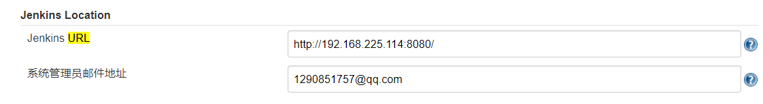

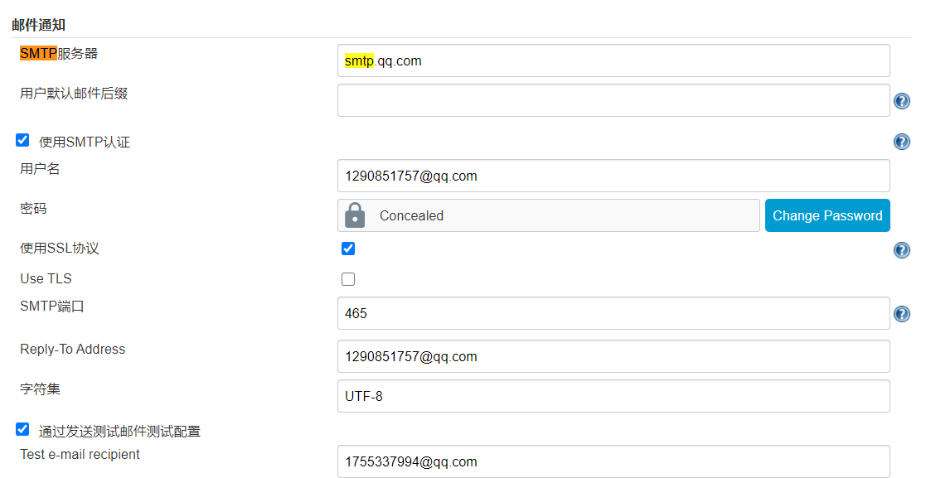

4，

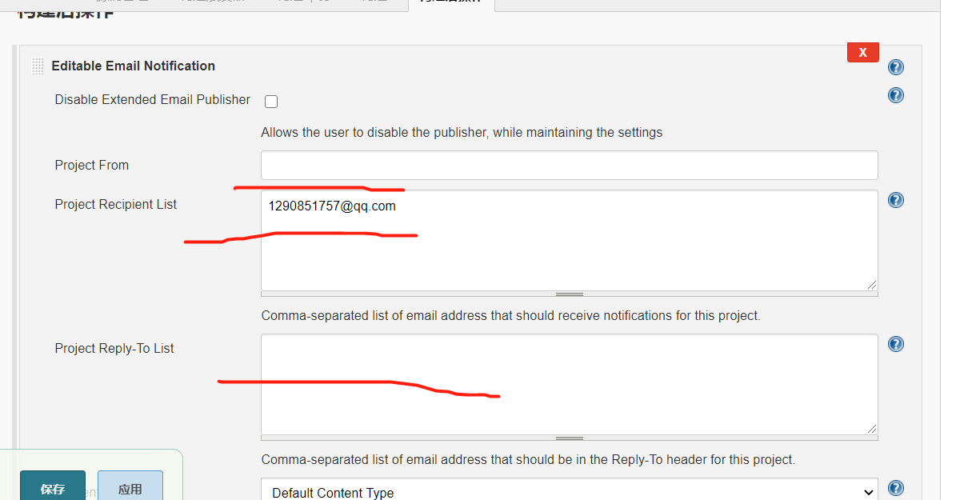

<!DOCTYPE html>

<html>

<head>

<meta charset="UTF-8">

<title>${ENV, var="JOB_NAME"}-第${BUILD_NUMBER}次构建日志</title>

</head>

<body leftmargin="8" marginwidth="0" topmargin="8" marginheight="4"

    offset="0">

    <table width="95%" cellpadding="0" cellspacing="0"

        style="font-size: 11pt; font-family: Tahoma, Arial, Helvetica, sans-serif">

        <tr>

            <td>(本邮件是程序自动下发的，请勿回复！)</td>

        </tr>

        <tr>

            <td><h2>

                    <font color="#0000FF">构建结果 - ${BUILD_STATUS}</font>

                </h2></td>

        </tr>

        <tr>

            <td><br />

            <b><font color="#0B610B">构建信息</font></b>

            <hr size="2" width="100%" align="center" /></td>

        </tr>

        <tr>

            <td>

                <ul>

                    <li>项目名称&nbsp;：&nbsp;${PROJECT_NAME}</li>

                    <li>构建编号&nbsp;：&nbsp;第${BUILD_NUMBER}次构建</li>

                    <li>SVN&nbsp;版本：&nbsp;${SVN_REVISION}</li>

                    <li>触发原因：&nbsp;${CAUSE}</li>

                    <li>构建日志：&nbsp;<a href="${BUILD_URL}console">${BUILD_URL}console</a></li>

                    <li>构建&nbsp;&nbsp;Url&nbsp;：&nbsp;<a href="${BUILD_URL}">${BUILD_URL}</a></li>

                    <li>工作目录&nbsp;：&nbsp;<a href="${PROJECT_URL}ws">${PROJECT_URL}ws</a></li>

                    <li>项目&nbsp;&nbsp;Url&nbsp;：&nbsp;<a href="${PROJECT_URL}">${PROJECT_URL}</a></li>

                </ul>

            </td>

        </tr>

        <tr>

            <td><b><font color="#0B610B">Changes Since Last

                        Successful Build:</font></b>

            <hr size="2" width="100%" align="center" /></td>

        </tr>

        <tr>

            <td>

                <ul>

                    <li>历史变更记录 : <a href="${PROJECT_URL}changes">${PROJECT_URL}changes</a></li>

                </ul> ${CHANGES_SINCE_LAST_SUCCESS,reverse=true, format="Changes for Build #%n:<br />%c<br />",showPaths=true,changesFormat="<pre>[%a]<br />%m</pre>",pathFormat="&nbsp;&nbsp;&nbsp;&nbsp;%p"}

            </td>

        </tr>

        <tr>

            <td><b>Failed Test Results</b>

            <hr size="2" width="100%" align="center" /></td>

        </tr>

        <tr>

            <td><pre

                    style="font-size: 11pt; font-family: Tahoma, Arial, Helvetica, sans-serif">$FAILED_TESTS</pre>

                <br /></td>

        </tr>

        <tr>

            <td><b><font color="#0B610B">构建日志 (最后 100行):</font></b>

            <hr size="2" width="100%" align="center" /></td>

        </tr>

        <!-- <tr>

            <td>Test Logs (if test has ran): <a

                href="${PROJECT_URL}ws/TestResult/archive_logs/Log-Build-${BUILD_NUMBER}.zip">${PROJECT_URL}/ws/TestResult/archive_logs/Log-Build-${BUILD_NUMBER}.zip</a>

                <br />

            <br />

            </td>

        </tr> -->

        <tr>

            <td><textarea cols="80" rows="30" readonly="readonly"

                    style="font-family: Courier New">${BUILD_LOG, maxLines=100}</textarea>

            </td>

        </tr>

    </table>

</body>

</html>