AliCloud 官方文档：https://www.terraform.io/docs/providers/alicloud/index.html

阿里云Terraform使用文档：https://www.alibabacloud.com/help/zh/doc-detail/95820.htm

ali模块下载：https://registry.terraform.io/browse/modules?provider=alicloud

阿里云练习地址：<https://shell.aliyun.com>

项目 ID：flask-283912

谷歌云产品：Compute Engine

谷歌Terraform创建虚拟机：

**<https://cloud.google.com/community/tutorials/getting-started-on-gcp-with-terraform>**

1. 创建项目

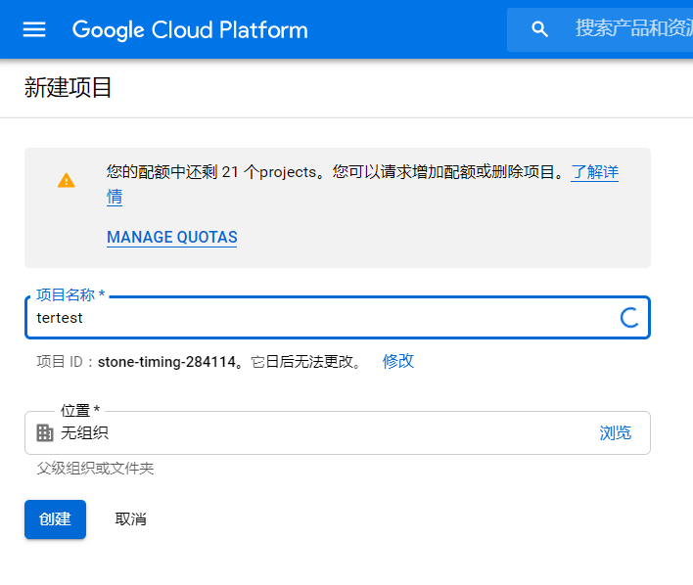

2，

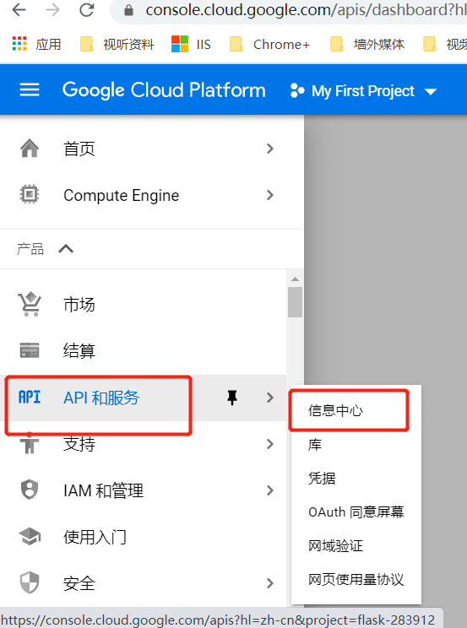

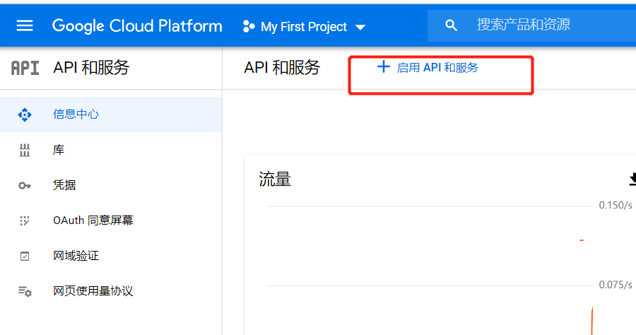

启用API

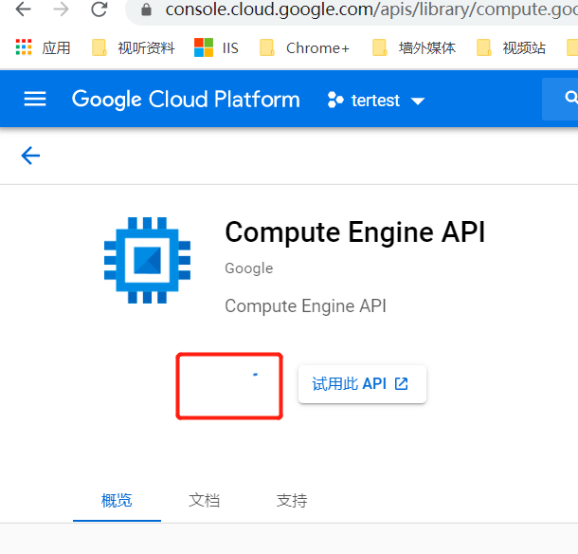

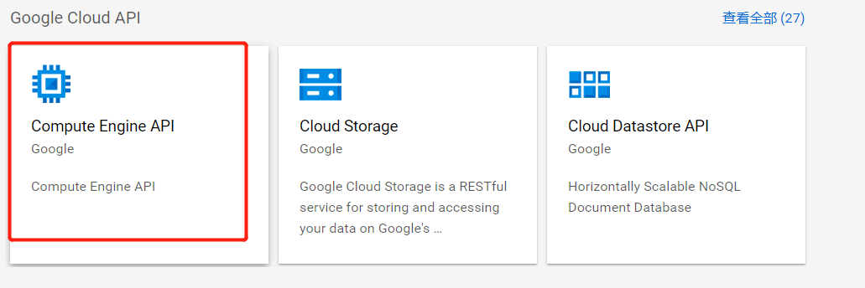

IAM账户需要以下权限：Access Context Manager Editor、Cloud Functions Admin、Compute Instance Admin（Beta 版）

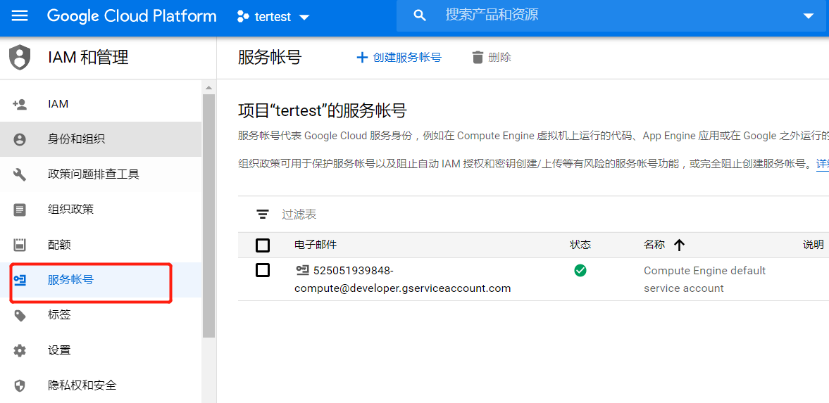

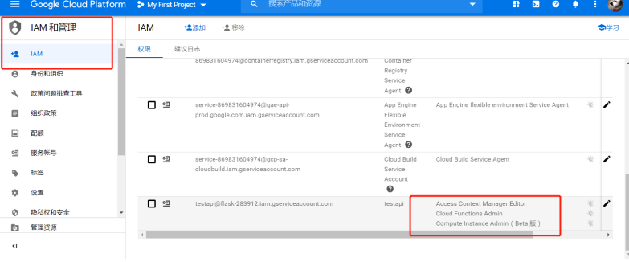

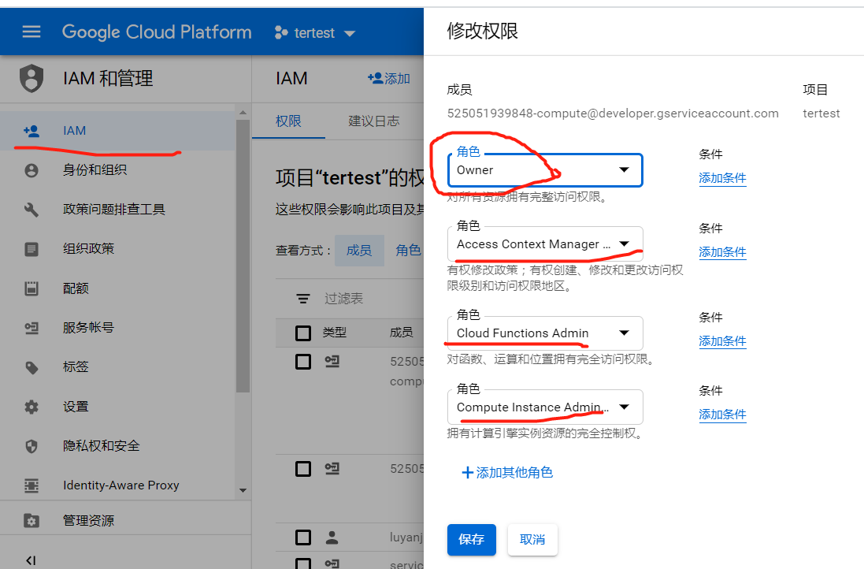

1. 准备凭证

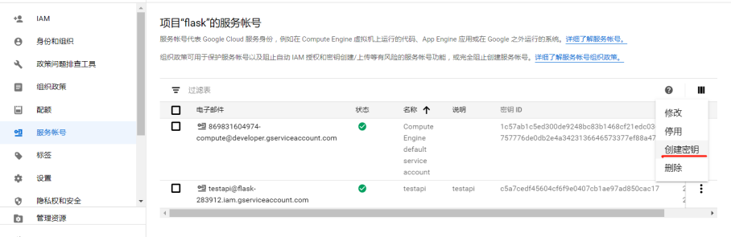

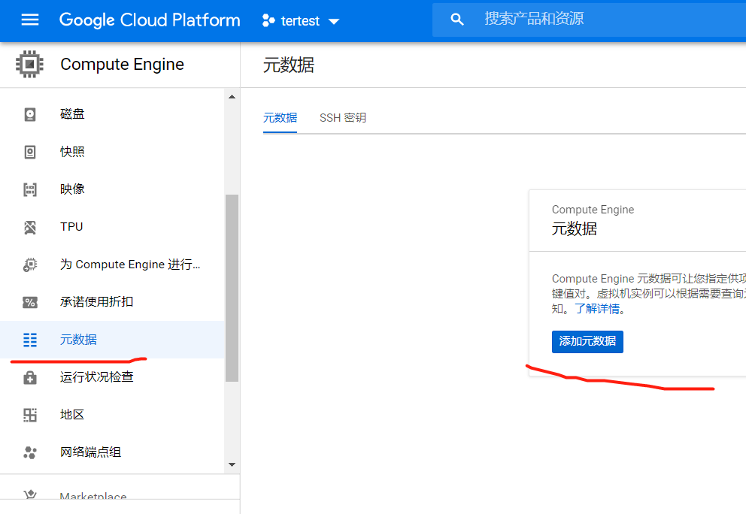

1. 新建 main.tf

provider "google" {

credentials = file("flask-283912-9fef590055c6.json")

project = "flask-283912"

region = "us-central1"

}

resource "random_id" "instance_id" {

byte_length = 8

}

resource "google_compute_instance" "default" {

name = "flask-vm-${random_id.instance_id.hex}"

machine_type = "f1-micro"

zone = "us-central1-a"

boot_disk {

initialize_params {

image = "centos-7-v20200714"

}

}

metadata_startup_script = "yum install -y build-essential python-pip; pip install flask"

network_interface {

network = "default"

access_config {

}

}

}

terraform init

terraform apply

2，

<https://github.com/GoogleCloudPlatform/cloud-foundation-toolkit/blob/master/docs/terraform.md>

官方文档：<https://www.terraform.io/docs/providers/google/index.html>

<https://cloud.google.com/docs/terraform>

<https://github.com/terraform-providers/terraform-provider-google/tree/master/examples/endpoints-on-compute-engine>

现成模块代码：

<https://github.com/GoogleCloudPlatform/cloud-foundation-toolkit/blob/master/docs/terraform.md>

现成模块说明：

<https://registry.terraform.io/modules/terraform-google-modules>

google代码构建：

<https://cloud.google.com/solutions/managing-infrastructure-as-code>