The fuzzy processed prior probability is a fuzzy possibility interval. To extract its eigenvalues, we defuzzify the fuzzy numbers using the area-mean method to obtain the specific likelihood value of event xi. As shown in Figure 3.

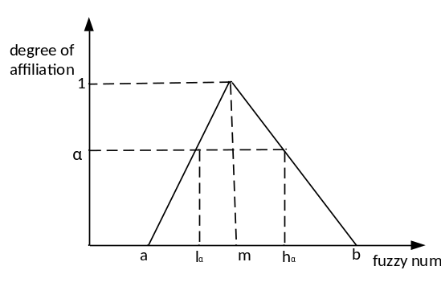
Fig. 3: The degree of affiliation of a triangular fuzzy function

For the affiliation problem shown in Figure 3, Equation 3 is a generalised formula for performing defuzzification.

（3） （4） （5） （6）
where 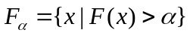denotes α- the intercept set of , Average（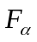） is the average of the α- intercept set, and 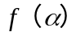 is the weighted valuation function. 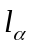 is the lower limit of the α- intercept. 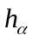 is the upper limit of the α- intercept set. Typically, 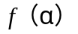 = 1 is set so that the probability value after defuzzification can be obtained by Equation 7. We use the calculated number of solution fuzzy as the prior probability of the root node for subsequent inference analysis.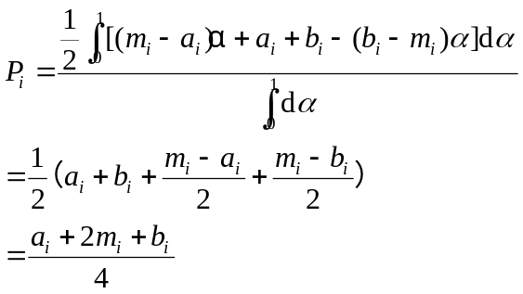 （7）

