Obtaining Conditional Probabilities Table(CPT)
The fault tree in Fig. 3 is transformed into a Bayesian network structure diagram to obtain Fig. 4, and the conditional probability table of leaf nodes and intermediate nodes in the Bayesian network can be obtained from the mapping of the logic gates of the fault tree. We input the node association strength into Algorithm 1 to obtain the conditional probability table of each node, and the results are presented in the form of a table.

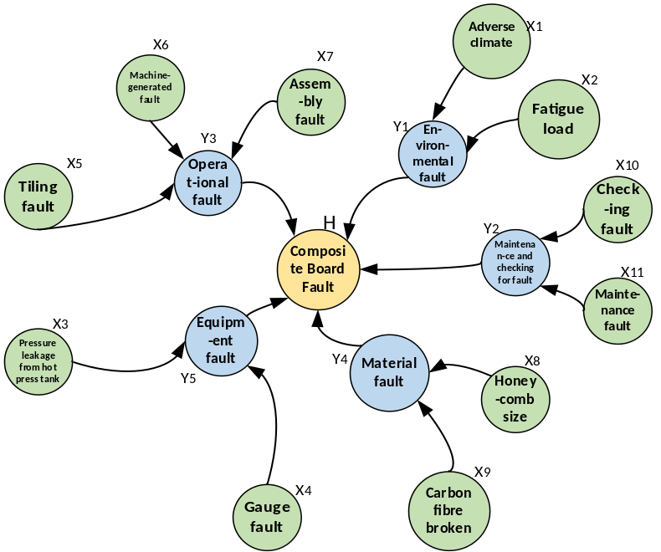
Fig 4

故障 | 故障类型 | 关联强度（条件概率）
adverse climate x1 | Environm-ental fault Y1 | P(Y1=1|X1=1,X2=1)=0.9817 P(Y1=0|X1=1,X2=1)=0.0183  P(Y1=1|X1=1,X2=0)=0.7850 P(Y1=0|X1=1,X2=0)=0.215  P(Y1=1|X1=0,X2=1)=0.915 P(Y1=0|X1=0,X2=1)=0.085  P(Y1=1|X1=0,X2=0)=0 P(Y1=0|X1=0,X2=0)=1
fatigue load  x2 | Environm-ental fault Y1
Pressure leakage from hot press tank  x3 | Equipment fault  Y5 | P(Y5=1|X3=1,X4=1)=0.97 P(Y5=0|X3=1,X4=1)=0.03  P(Y5=1|X3=1,X4=0)=0.88 P(Y5=0|X3=1,X4=0)=0.11  P(Y5=1|X3=0,X4=1)=0.75 P(Y5=0|X3=0,X4=1)=0.25  P(Y5=1|X3=0,X4=0)=0 P(Y5=0|X3=0,X4=0)=1
Gauge fault  x4 | Equipment fault  Y5
Tiling fault  x5 | Operat-ional fault Y3 | P(Y3=1|X5=1,X6=1,X7=1)=0.9932 P(Y3=0|X5=1,X6=1,X7=1)=0.0068  P(Y3=1|X5=1,X6=1,X7=0)=0.9776 P(Y3=0|X5=1,X6=1,X7=0)=0.0224  P(Y3=1|X5=1,X6=0,X7=1)=0.9573 P(Y3=0|X5=1,X6=0,X7=1)=0.0427 P(Y3=1|X5=1,X6=0,X7=0)=0.86 P(Y3=0|X5=1,X6=0,X7=0)=0.14  P(Y3=1|X5=0,X6=1,X7=1)=0.9512 P(Y3=0|X5=0,X6=1,X7=1)=0.0488  P(Y3=1|X5=0,X6=1,X7=0)=0.84 P(Y3=0|X5=0,X6=1,X7=0)=0.16  P(Y3=1|X5=0,X6=0,X7=1)=0.695 P(Y3=0|X5=0,X6=0,X7=1)=0.305  P(Y3=1|X5=0,X6=0,X7=0)=0 P(Y3=0|X5=0,X6=0,X7=0)=1
machine-generated fault  x6 | Operat-ional fault Y3
Assembly fault  x7 | Operat-ional fault Y3
Honeycomb size  x8 | Material fault Y4 | P(Y4=1|X8=1,X9=1)=0.9055 P(Y4=0|X8=1,X9=1)=0.0945  P(Y4=1|X8=1,X9=0)=0.825 P(Y4=0|X8=1,X9=0)=0.125  P(Y4=1|X8=0,X9=1)=0.46 P(Y4=0|X8=0,X9=1)=0.54  P(Y4=1|X8=0,X9=0)=0 P(Y4=0|X8=0,X9=0)=1
Carbon fibre broken x9 | Material fault Y4
Checking fault  x10 | Mainten-ance and checking for fault Y2 | P(Y2=1|X10=1,X11=1)=0.993 P(Y2=0|X10=1,X11=1)=0.00  P(Y2=1|X10=1,X11=0)=0.955 P(Y2=0|X10=1,X11=0)=0.045  P(Y2=1|X10=0,X11=1)=0.845 P(Y2=0|X10=0,X11=1)=0.155  P(Y2=1|X10=0,X11=0)=0 P(Y2=0|X10=0,X11=0)=1
Mainten-ance fault x11 | Mainten-ance and checking for fault Y2
Environm-ental fault Y1 | Composite material scrapping  H | P(H=1|Y1=1,Y2=1,Y3=1,Y4=1,Y5=1)=0.9999  P(H=1|Y1=1,Y2=1,Y3=1,Y4=1,Y5=0)=0.9996  P(H=1|Y1=1,Y2=1,Y3=1,Y4=0,Y5=1)=0.9978  P(H=1|Y1=1,Y2=1,Y3=1,Y4=0,Y5=0)=0.9906  P(H=1|Y1=1,Y2=1,Y3=0,Y4=1,Y5=1)=0.9994  P(H=1|Y1=1,Y2=1,Y3=0,Y4=1,Y5=0)=0.9973  P(H=1|Y1=1,Y2=1,Y3=0,Y4=0,Y5=1)=0.9861  P(H=1|Y1=1,Y2=1,Y3=0,Y4=0,Y5=0)=0.9395  P(H=1|Y1=1,Y2=0,Y3=1,Y4=1,Y5=1)=0.9997  P(H=1|Y1=1,Y2=0,Y3=1,Y4=1,Y5=0)=0.9986  P(H=1|Y1=1,Y2=0,Y3=1,Y4=0,Y5=1)=0.9930  P(H=1|Y1=1,Y2=0,Y3=1,Y4=0,Y5=0)=0.9998  P(H=1|Y1=1,Y2=0,Y3=0,Y4=0,Y5=1)=0.9980  P(H=1|Y1=1,Y2=0,Y3=0,Y4=1,Y5=0)=0.9912  P(H=1|Y1=1,Y2=0,Y3=0,Y4=0,Y5=1)=0.9552  P(H=1|Y1=1,Y2=0,Y3=0,Y4=0,Y5=0)=0.8050  P(H=1|Y1=0,Y2=1,Y3=1,Y4=1,Y5=1)=0.9995  P(H=1|Y1=0,Y2=1,Y3=1,Y4=1,Y5=0)=0.9978  P(H=1|Y1=0,Y2=1,Y3=1,Y4=0,Y5=1)=0.9889  P(H=1|Y1=0,Y2=1,Y3=1,Y4=0,Y5=0)=0.9519  P(H=1|Y1=0,Y2=1,Y3=0,Y4=1,Y5=1)=0.9968  P(H=1|Y1=0,Y2=1,Y3=0,Y4=1,Y5=0)=0.9860  P(H=1|Y1=0,Y2=1,Y3=0,Y4=0,Y5=1)=0.9287  P(H=1|Y1=0,Y2=1,Y3=0,Y4=0,Y5=0)=0.6900  P(H=1|Y1=0,Y2=0,Y3=1,Y4=1,Y5=1)=0.9984  P(H=1|Y1=0,Y2=0,Y3=1,Y4=1,Y5=0)=0.9930  P(H=1|Y1=0,Y2=0,Y3=1,Y4=0,Y5=1)=0.9644  P(H=1|Y1=0,Y2=0,Y3=1,Y4=0,Y5=0)=0.9450  P(H=1|Y1=0,Y2=0,Y3=0,Y4=1,Y5=1)=0.9897  P(H=1|Y1=0,Y2=0,Y3=0,Y4=1,Y5=0)=0.9550  P(H=1|Y1=0,Y2=0,Y3=0,Y4=0,Y5=1)=0.7700  P(H=1|Y1=0,Y2=0,Y3=0,Y4=0,Y5=0)=0
Mainten-ance and checking for fault Y2 | Composite material scrapping  H
Operat-ional fault Y3 | Composite material scrapping  H
Material fault  Y4 | Composite material scrapping  H
Equipment fault  Y5 | Composite material scrapping  H
Table 6

