According to the information, the real data of fault rate of composite wing panels of an airline company is shown in Figure1. Table of data comparing safety factor and true failure rateand the comparison results of the two are presented by Figure1. Since our method uses LLMs to predict and supplement the fault causes, some nodes do not find corresponding data in the information. The comparison results show that the true fault rate of the nodes is basically in inverse proportion to the safety factor, which just proves the reliability of the safety factor in this system.

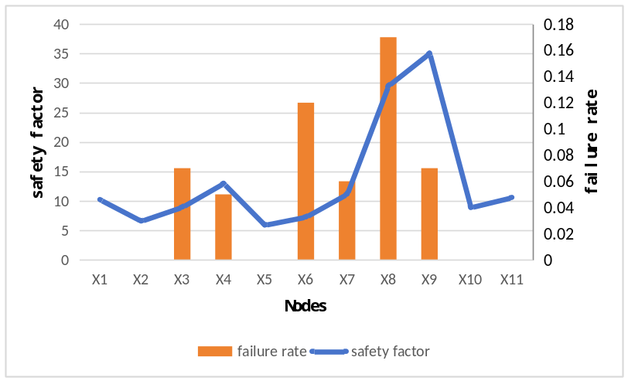
Figure 1

