Obtaining Faulty Nodes and Rating Evaluations Using Chatgpt
A. Get the cause and type of fault.According to the steps mentioned in section 4.1, the composite wing panel faults are taken as inputs to obtain five LLM feedback results, the LLM follows the prompts to generate the cause of the fault occurrence and the type of the fault, and then the obtained results are expressed in the form of a fault tree as shown in Fig. 3.

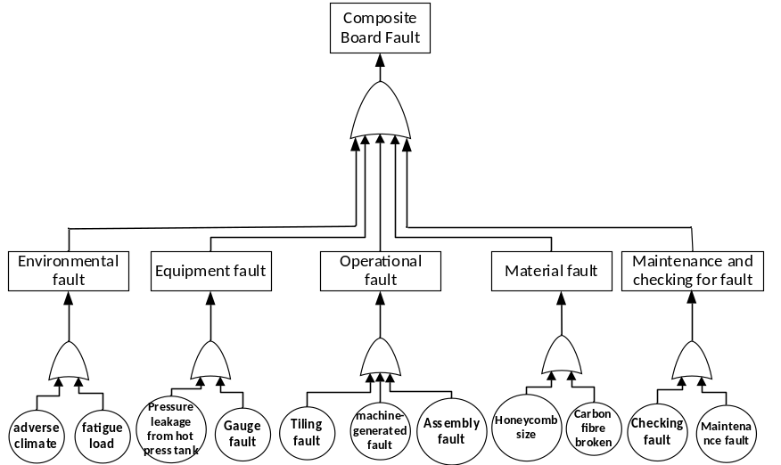
Fig 3

B.A priori probabilities were evaluated. The results derived above were used as hints and entered into chatgpt, gemini, Claude, Llama, and kimi, and the method of hinting used a combination of thought chain and character hints to get close to the real answer, Table 3 shows the evaluation results of the probability of occurrence of basic events given by LLMS.

Events | Chatgpt | Gemini | Claude | Llama | KIMI
adverse climate | Extremely Low | Medium | Moderately High | Moderately High | Moderately High
fatigue load | Moderately High | High | Extremely High | Moderately Low | High
Pressure leakage from hot press tank | High | High | High | Extremely Low | Medium
Gauge fault | Moderately High | Low | High | Medium | Moderately Low
Tiling fault | Extremely High | Moderately High | Extremely High | Moderately High | High
Machine generated fault | High | Moderately High | Moderately High | Moderately Low | Moderately High
Assembly fault | Moderately High | Medium | Medium | Medium | Medium
Honeycomb size | Moderately High | Moderately High | Moderately Low | Low | Extremely Low
Carbon fibre broken | Low | Moderately Low | Low | Moderately Low | Low
Checking fault | High | Moderately Low | Medium | Moderately High | Moderately High
Maintenance fault | High | Moderately Low | Low | Moderately High | High
Table 3
The strength of association between the nodes is evaluated. Similarly, the derived fault type of the cause of the fault occurrence is entered as a cue, alias into chatgpt, gemini, Claude, Llama, and kimi to get the assessment of the strength of association between each node and the results are shown in Table 4.

Events | Chatgpt | Gemini | Claude | Llama | KIMI
adverse climate | Medium | High | Moderately High | High | Extremely High
fatigue load | High | Extremely High | High | Extremely High | High
Pressure leakage from hot press tank | High | Extremely High | Extremely High | High | Moderately High
Gauge fault | Moderately High | High | Extremely High | Moderately High | Medium
Tiling fault | Extremely High | High | High | Moderately High | High
machine-generated fault | High | High | High | High | Moderately High
Assembly fault | Moderately High | High | Moderately High | Moderately High | Medium
Honeycomb size | High | Extremely High | High | Moderately High | Extremely High
Carbon fibre broken | Moderately Low | High | Moderately High | Moderately Low | Low
Checking fault | High | Extremely High | Extremely High | Extremely High | Moderately High
Maintenance fault | Moderately High | Moderately High | Extremely High | Extremely High | High
Environmental fault | High | High | Moderately High | Moderately High | High
Maintenance and checking for fault | Medium | High | High | Moderately Low | Medium
Operational fault | Extremely High | High | High | Moderately Low | Extremely High
Material fault | High | Extremely High | Extremely High | Extremely High | Extremely High
Equipment fault | Moderately High | High | Moderately High | High | Moderately High
Table 4

