In this paper, we simulate the fuzzy Bayesian network model for composite materials using GeNIe simulation software in the steps shown below. Input a priori probability and conditional probability table for FBN inference analysis.

A. Individual nodes of the FBN are represented using GeNIe and the a priori probabilities and CPTs are fed in to obtain the initial model as shown in Fig. 1.

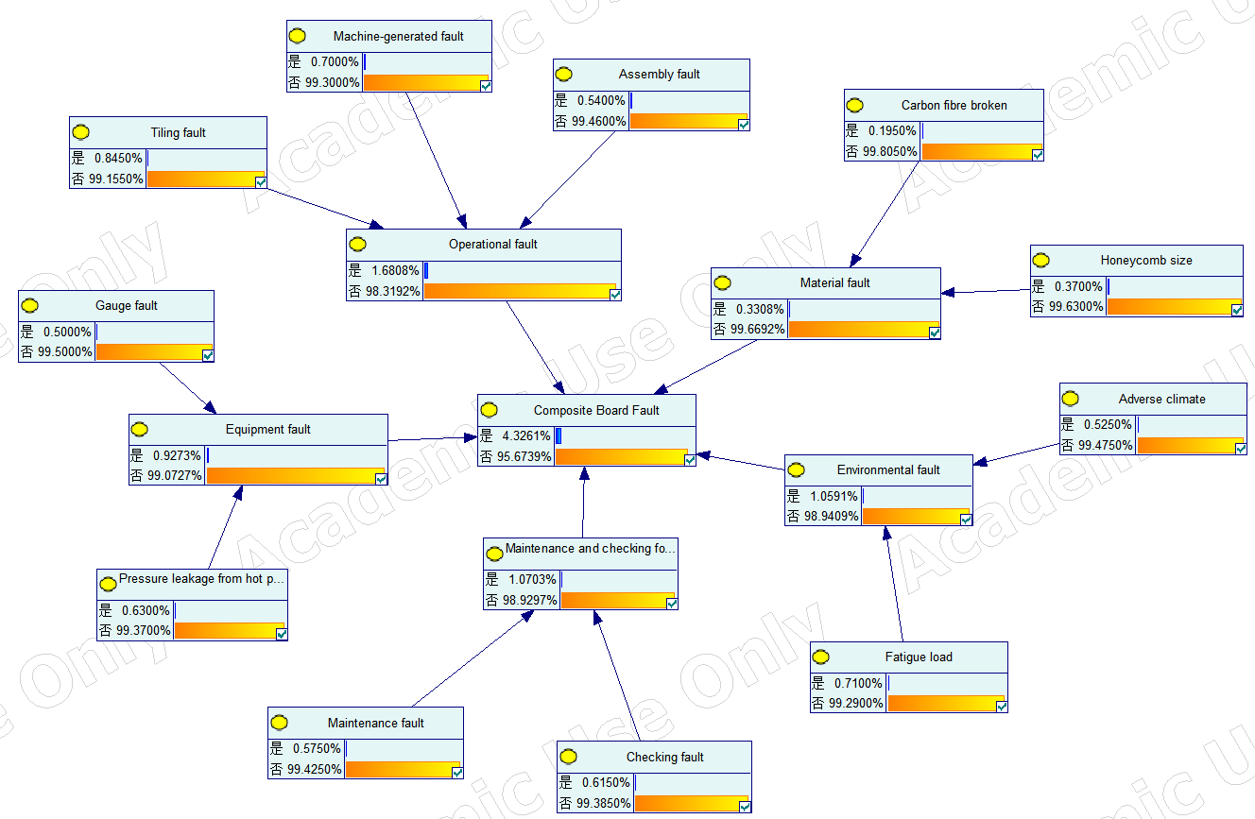
Fig 1

- Assuming that a composite wing panel failure has occurred, the state value of the leaf node composite scrap H is set to 100%, and the a posteriori probability of each root cause of the failure is obtained by using Bayesian reverse inference. The results are shown in Figure 2.

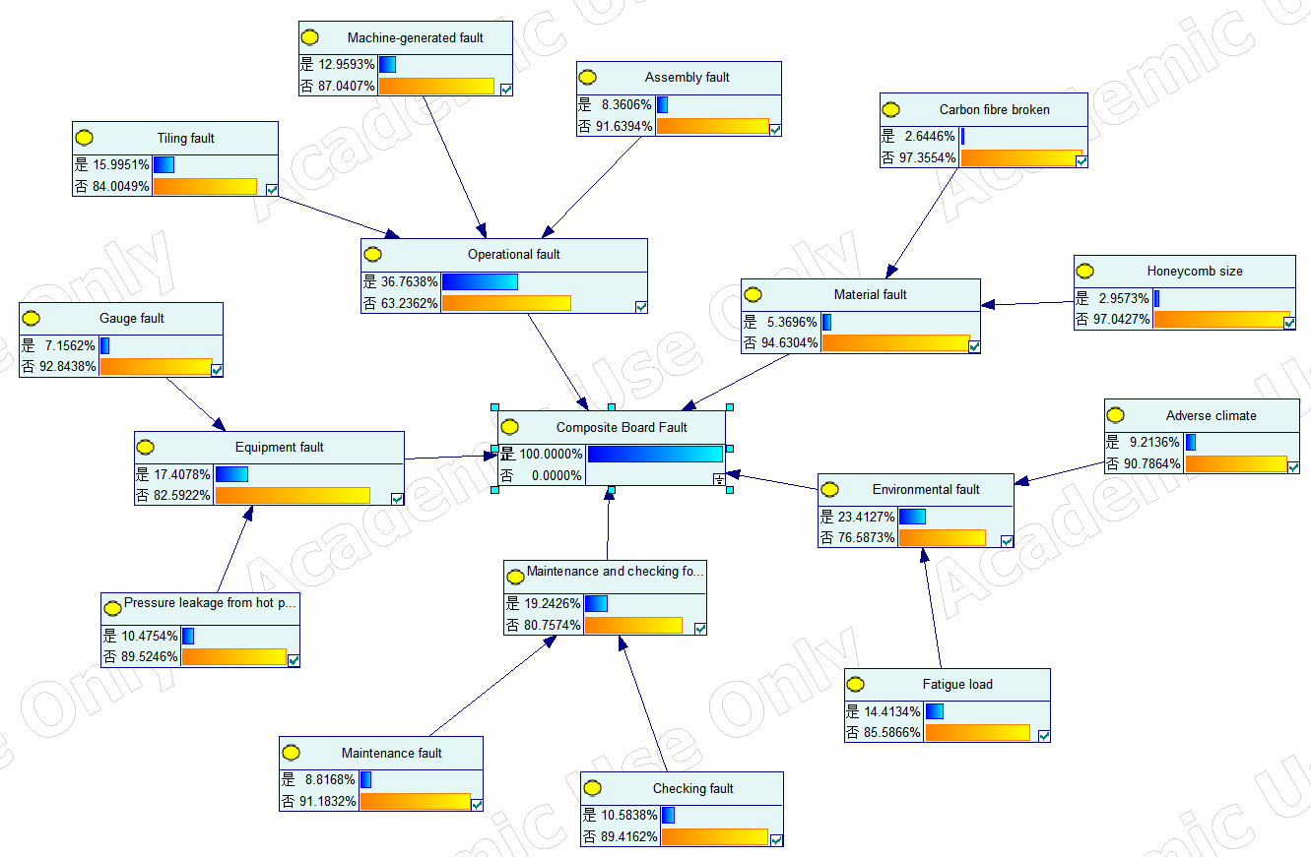
Fig 2

