Neural Network from Scratch for ODE Solving
  - Team 11 Course 35-380 Final Project Report
Student ID | Last Name | First Name | Group
D10774184 | Xia | Zimeng | 11
D10773951 | Chen | Botao | 11
D10773959 | Cui | Wenzhi | 11
D10774061 | Luo | Yiqin | 11
D10774076 | Yang | Miaomiao | 11
D10774175 | Wu | Han | 11

Submission deadline ______________________________

Abstract
We implement a feedforward neural network in Rust and train it to predict one-step increments of a damped pendulum. Dense layers, nonlinear activations, mean squared error, analytical backpropagation and mini-batch gradient descent are handwritten. ndarray supplies linear algebra only; no machine-learning framework or automatic differentiation system participates in training.
A seeded RK4 simulation produces 40,000 transitions from 80 initial conditions. Entire trajectories, rather than individual rows, define the training, validation and test partitions. We evaluate the frozen checkpoint on 6,000 held-out transitions and on autonomous ten-second rollouts, including a deliberately unfamiliar initial angle.
The main network reduces standardized one-step RMSE by 99.10% relative to persistence. Its pooled held-out rollout angle RMSE is 0.0349 rad, while the out-of-distribution example reaches 0.4989 rad. These results support a useful local surrogate, not a universally reliable ODE solver.
Measured quantity | Result
Main / small model parameters | 1,218 / 17
Main one-step angle RMSE | 0.000274 rad
Main one-step velocity RMSE | 0.000765 rad/s
50-epoch median training time | Rust 1.056 s / NumPy 2.469 s

The deliverable includes an offline Windows visualization, reusable Rust APIs, numerical tests, cross-language parity checks, raw experiment files and reproduction commands.

Physical System and Numerical Reference
Earlier neural differential-equation solvers train trial functions against equation residuals [2]. Neural ODEs learn continuous vector fields within a differential-equation solver [3]. Our project instead learns a supervised discrete transition map from numerical trajectories, which matches the assignment's next-state prediction objective.
The state x = [theta, omega] contains angle in radians and angular velocity in radians per second. The downward vertical is theta = 0. With unit mass, the nonlinear damped pendulum is an autonomous first-order system:
$$d theta / dt = omega$$
$$d omega / dt = -(g / L) sin(theta) - beta omega$$
Parameter | Value | Unit
Gravity g | 9.81 | m/s2
Length L | 1.0 | m
Damping beta | 0.1 | 1/s
Prediction interval dt | 0.02 | s
Reference substep h | 0.002 | s

For derivative f and a substep h, classical RK4 evaluates four slopes. Ten internal substeps produce each supervised transition. The numerical reference is a high-accuracy approximation, not an exact analytical solution.
$$k1 = f(x); k2 = f(x + h k1 / 2)$$
$$k3 = f(x + h k2 / 2); k4 = f(x + h k3)$$
$$x_next = x + (h / 6) (k1 + 2 k2 + 2 k3 + k4)$$
Numerical verification covers an unchanged equilibrium, agreement with the small-angle undamped analytical limit, fourth-order convergence and decreasing damped mechanical energy. The convergence test compares h = 0.04 and 0.02 over one second against h = 0.00025; it requires an error ratio above 14. The h = 0.002 state error must be below 1e-9 for that test case.
$$E / m = (L^2 omega^2) / 2 + g L (1 - cos(theta))$$
Euler and single-step RK4 at dt = 0.02 are evaluation baselines. Unlike the learned map, they retain knowledge of the physical equation during inference. This difference matters when interpreting their accuracy.

Training Dataset and Leakage Prevention
ChaCha8 with seed 42 selects independent initial angles uniformly in [-1.5, 1.5] rad and initial velocities uniformly in [-2, 2] rad/s. Each trajectory lasts ten seconds and contains 500 supervised transitions, corresponding to 501 states. Trajectory identifiers also determine disjoint split membership:
Partition | Trajectory IDs | Trajectories | Transitions
Training | 0 to 55 | 56 | 28,000
Validation | 56 to 67 | 12 | 6,000
Test | 68 to 79 | 12 | 6,000
Total | 0 to 79 | 80 | 40,000

A random row-level split would let almost adjacent states from the same pendulum motion appear in both training and evaluation. We prevent that leakage by assigning the whole trajectory before generating its rows. Test trajectories never enter the training routine or checkpoint selection.
$$delta_x = x(t + dt) - x(t)$$
$$x_standard = (x - mean_train_x) / std_train_x$$
$$delta_standard = (delta_x - mean_train_delta) / std_train_delta$$
Means and population standard deviations are fitted separately for state inputs and increment targets, using training rows only. A 1e-8 floor handles zero variance. Validation and test arrays reuse these saved statistics. Inference decodes the predicted increment before adding it to the current physical state.
The CSV contains trajectory ID, split, time, current angle and velocity, and the next reference angle and velocity. Its companion JSON stores the generation recipe and physical parameters. Loading validates row counts, trajectory ordering, split assignments, finite values and the time grid.
The initial-condition rectangle does not bound every later state: potential energy can become kinetic energy, so velocities along a valid training trajectory can exceed their initial range. The GUI therefore labels its warning specifically as an initial-state range warning rather than a calibrated uncertainty estimate.

Network Architecture and Activations
Samples occupy matrix rows. A dense layer computes Z = A W + b, with the bias broadcast over the batch, then applies an elementwise activation. The main architecture has two 32-neuron Tanh hidden layers and a two-coordinate linear output. The deliberately small baseline has three Sigmoid hidden neurons.
Main layer | Weight shape | Biases | Activation | Parameters
Hidden 1 | 2 x 32 | 32 | Tanh | 96
Hidden 2 | 32 x 32 | 32 | Tanh | 1,056
Output | 32 x 2 | 2 | Linear | 66
Total |  |  |  | 1,218

Activation | Function | Derivative
Sigmoid | 1 / (1 + exp(-z)) | a (1 - a)
ReLU | max(0, z) | 1 if z > 0 else 0
Tanh | tanh(z) | 1 - tanh(z)^2
Linear | z | 1

All four activations and their derivatives are handwritten and tested. The experiment uses Tanh for the larger model because the pendulum transition is smooth; this is a modeling choice, not evidence that Tanh is always better than ReLU or Sigmoid. ReLU is implemented and gradient-checked but is not a separately trained experimental condition.
Hidden weights use seeded Xavier uniform initialization, or He uniform when ReLU is selected. Biases start at zero. Sigmoid evaluates positive and negative arguments separately to avoid overflow. Training and inference use f64 throughout.
$$predicted_x_next = x + decode_delta(Network(encode_x(x)))$$
The residual connection preserves the meaning of the output as a learned state increment. The network receives neither reference next states nor a call to sin(theta) during prediction. There is no clipping, energy correction or periodic reset that could conceal autonomous prediction error.

Mathematical Derivation of Backpropagation
Let B be the mini-batch size, D = 2 the output width, A(0) the standardized inputs, and Y the standardized target increments. For layer l, weights W(l) have shape n(l-1) x n(l), while Z(l) and A(l) have shape B x n(l). The forward computation is:
$$Z(l) = A(l-1) W(l) + b(l); A(l) = phi_l(Z(l))$$
The loss averages over every scalar output, not just over the number of samples. Keeping the output-width factor is essential when matching gradients between implementations.
$$J = (1 / (B D)) sum_i sum_j (A(L)[i,j] - Y[i,j])^2$$
$$dJ / dA(L) = (2 / (B D)) (A(L) - Y)$$
Define delta(l) as dJ/dZ(l). Applying the chain rule at the output gives the following expression. The final activation is linear in this project, so its derivative is one.
$$delta(L) = (2 / (B D)) (A(L) - Y) .* phi'_L(Z(L))$$
A preceding activation contributes to every downstream preactivation through the weight matrix. Summing these paths is matrix multiplication by the transposed next-layer weights, followed by the local activation derivative:
$$delta(l) = [delta(l+1) W(l+1)^T] .* phi'_l(Z(l))$$
$$dJ / dW(l) = A(l-1)^T delta(l)$$
$$dJ / db(l) = sum_over_batch delta(l)$$
$$W(l) ← W(l) - eta dJ/dW(l); b(l) ← b(l) - eta dJ/db(l)$$
Here .* denotes elementwise multiplication. The implementation caches both activations and preactivations, traverses layers in reverse order, and computes all gradients before updating parameters. This avoids accidentally propagating a gradient through already-updated weights.
For each weight and bias of a 2-3-2 network, central differences with epsilon = 1e-6 must agree with the analytical gradient to absolute error below 1e-7. The test covers all four activations, away from ReLU's nondifferentiable point. Independent NumPy parity checks provide a second implementation-level check.

Training Protocol and Model Selection
Both architectures use 200 epochs, batch size 128 and learning rate 0.01. Epoch permutations come from a seeded generator. The last batch can contain fewer than 128 samples; MSE and its gradients always normalize by the actual batch size. No optimizer state, automatic differentiation, momentum or adaptive learning-rate algorithm is hidden in the implementation.
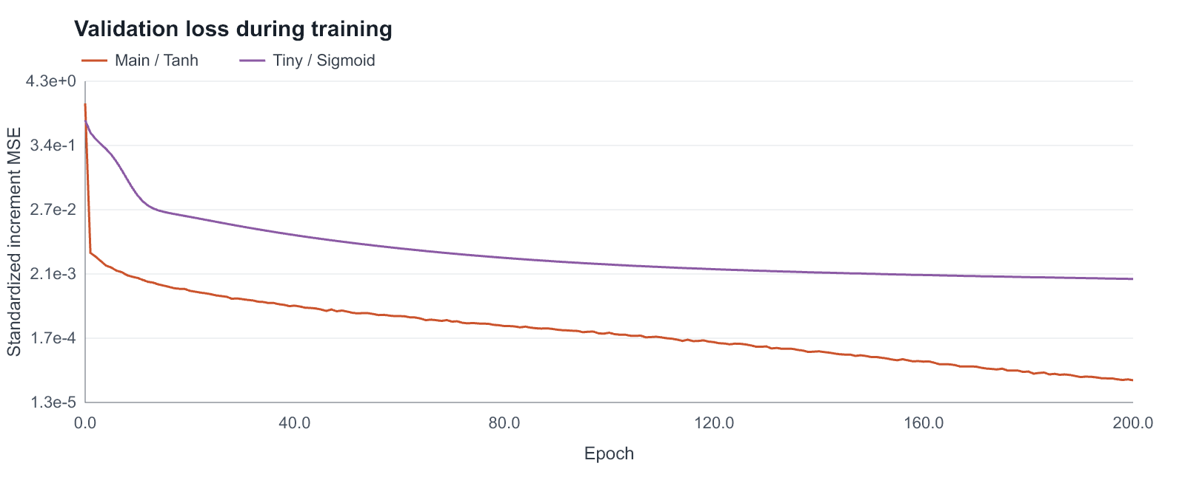
Figure 1 Validation MSE on standardized state increments for the two architectures. The vertical axis is logarithmic.
The main model selects epoch 200 with validation MSE 3.229722e-05; the small model selects epoch 200 with validation MSE 1.755639e-03. Checkpoint choice uses validation loss only. The default configuration passed acceptance, so the fallback learning-rate/epoch sweep was not used.
Recorded end-to-end training-loop times are 8.152 s for the main network and 0.729 s for the small network. These times include repeated full training/validation loss evaluation and history logging. They are different workloads from the optimizer-only benchmark later in this report.
Each model JSON stores a schema version, model kind, layer parameters, activations, physical constants, prediction interval, normalization statistics and training provenance. Loading rejects unsupported schemas, inconsistent dimensions, invalid physical parameters and non-finite parameters. The selected weights are embedded at build time for the offline GUI.

Held Out One Step Evaluation
One-step evaluation supplies the real current state and compares only the predicted next state. It measures local map accuracy but does not test whether errors amplify when the network feeds itself. We report angle and angular velocity RMSE separately because they have different physical units.
Method | Angle RMSE rad | Velocity RMSE rad/s | Standardized RMSE
Persistence | 2.947638e-02 | 8.717091e-02 | 9.228684e-01
Euler | 8.720061e-04 | 2.616401e-03 | 2.749991e-02
RK4 | 3.343947e-09 | 8.211050e-09 | 9.628035e-08
Tiny NN | 2.316487e-03 | 3.488872e-03 | 5.766122e-02
NN | 2.743729e-04 | 7.647934e-04 | 8.348774e-03

$$standardized_RMSE = sqrt(mean((prediction_error_j / std_train_delta_j)^2))$$
Relative improvement over persistence is 1 - RMSE_NN/RMSE_persistence = 99.10%. This exceeds the predeclared 50% acceptance threshold. Normalization makes this aggregate dimensionless; the physical-coordinate errors above remain available for interpretation.
Persistence predicts no motion. It is an important baseline because small time steps can make an untrained identity-like next-state predictor appear accurate. Euler uses the known pendulum derivative, and RK4 uses the known derivative four times at the prediction interval. The reference uses ten finer RK4 substeps.
The main network improves on Euler for this local test and is substantially more accurate than the three-neuron baseline. Single-step RK4 remains markedly more accurate than the network. This is expected for a low-dimensional system whose governing equation is known, and it prevents a misleading claim that the neural surrogate replaces a classical solver in every setting.
No test labels contribute to training, scaling or checkpoint selection. The result is conditional on the fixed seed, physical constants and sampled initial-condition distribution. It is not a multi-seed confidence interval or a guarantee for all pendulum motions.

Autonomous Ten Second Rollouts
For autonomous evaluation, both methods start at the same initial state. The numerical reference then advances itself, while the network repeatedly consumes its own previous prediction. Neither teacher forcing nor a periodic reference-state reset is allowed.
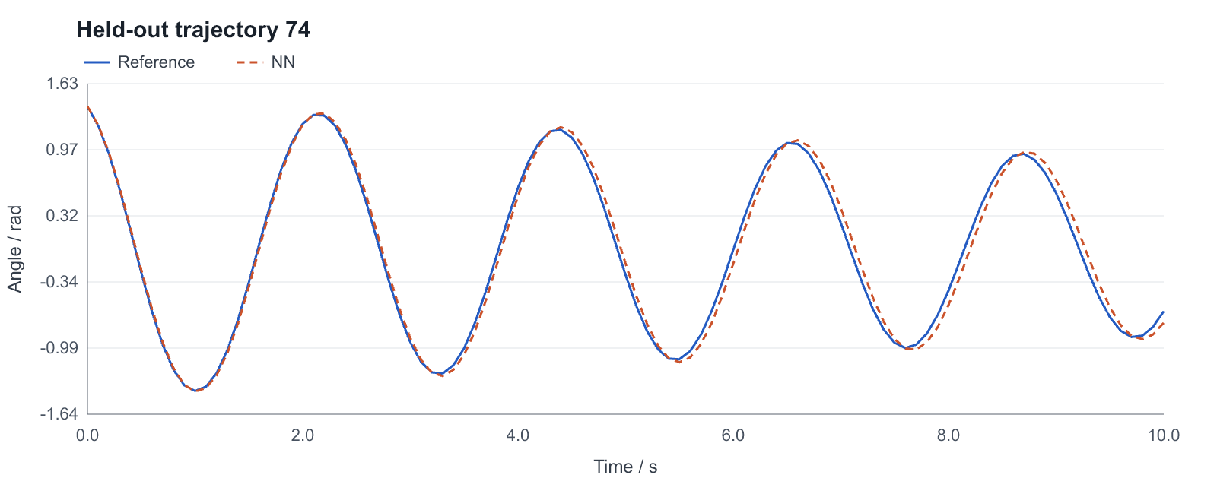
Figure 2 Held-out trajectory 74 is a more demanding large-amplitude case. The learned trajectory accumulates a visible phase error.
Method | Pooled angle RMSE rad | Pooled velocity RMSE rad/s
Persistence | 0.983225 | 1.748502
Euler | 0.579744 | 1.535943
RK4 | 0.000001 | 0.000002
Tiny NN | 0.334212 | 1.012039
NN | 0.034884 | 0.107939

Pooled RMSE is the square root of the mean per-trajectory squared RMSE across all twelve equal-length held-out trajectories, excluding the shared t = 0 state. It is not an average of only the visually best examples. Complete trajectories and per-initial-condition scores are retained in the raw CSV and JSON.
Small local errors perturb both oscillation phase and amplitude. Repeating the learned transition 500 times can therefore produce much larger state errors than the one-step table suggests. This distinction is central to evaluating a surrogate dynamical system.

Generalization Boundary and Failure Analysis
An additional initial state [2.5 rad, 0 rad/s] lies outside the specified training initial-condition rectangle. It is not part of the 80-trajectory dataset and does not affect model selection or the acceptance score.
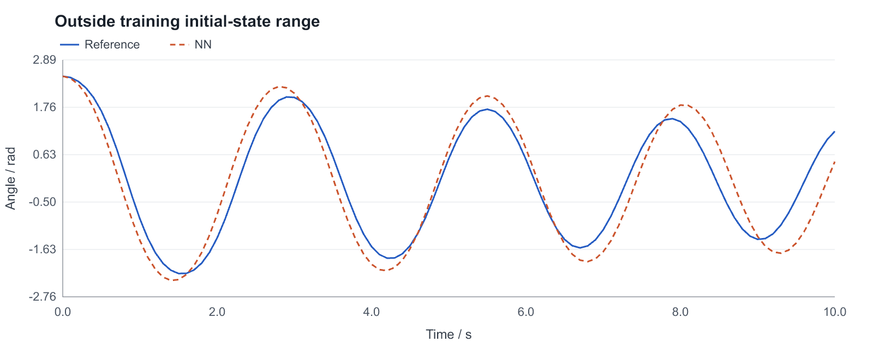
Figure 3 Out-of-distribution autonomous prediction. Larger phase and amplitude discrepancies remain visible rather than being corrected with reference physics.
OOD measure for main NN | Observed value
Ten-second angle RMSE | 0.498919 rad
Ten-second velocity RMSE | 1.346623 rad/s
Maximum absolute angle error | 1.220770 rad

The network has no encoded conservation law or monotonic-energy constraint. A low supervised loss does not enforce stability, preserve energy dissipation, or guarantee phase accuracy outside sampled trajectories. Its smooth hidden activations also do not solve the underlying distribution-shift problem.
The GUI exposes this case through an explicit preset and an initial-range warning. Non-finite predictions terminate the simulation with an error; the program never silently switches to RK4. Reasonable next experiments would expand state coverage, test additional seeds and investigate structure-preserving models. They are future work, not completed features.

Rust and Python Training Time Comparison
The benchmark compares independently implemented manual backpropagation in Rust/ndarray and Python/NumPy. A shared serialized fixture contains the same 28,000 standardized training samples, initial weights, batch size 128, learning rate 0.01 and every permutation for 50 epochs. Both implementations use float64.
Timed trial | Rust seconds | NumPy seconds
1 | 1.035058 | 2.609341
2 | 1.032679 | 2.681294
3 | 1.184062 | 2.212089
4 | 1.055673 | 2.469241
5 | 1.139549 | 2.164564
Median | 1.055673 | 2.469241

On this machine and workload, the NumPy-to-Rust median time ratio is 2.34. Rust uses ndarray's matrixmultiply backend without external BLAS or Rayon. NumPy uses scipy-openblas 0.3.34.106.0. Backend differences, allocation behavior and loop dispatch are included in the observed difference, so this is not a pure measurement of language overhead.
Each process performs one untimed warmup and five timed runs. Every run starts from a fresh copy of the same network. Timing includes batch gathering, forward propagation, analytical gradients and updates. It excludes interpreter/process startup, JSON loading, initial-network copying, validation, final-loss calculation and chart generation.
Backend thread variables are set to one before importing NumPy. Rust's chosen backend is single threaded. The run used Windows 11 AMD64, Python 3.12.10, NumPy 2.5.3 and Rust 1.99.0. CPU identifier: Intel64 Family 6 Model 198 Stepping 2, GenuineIntel. Raw trial files retain the measured values.
Numerical parity passes at tolerance 1e-10. The maximum forward discrepancy is 2.220e-16; the maximum analytical-gradient discrepancy is 2.220e-16. Both implementations also agree after one update and on the final training loss. The timings support this specific experiment only.
Trials ran sequentially, with Rust before NumPy. Background workload and processor thermal state were not isolated. Five repetitions and a warmup reduce some noise but do not establish a universal speed ratio or a statistical confidence interval.

Software Interfaces and Live Demonstration
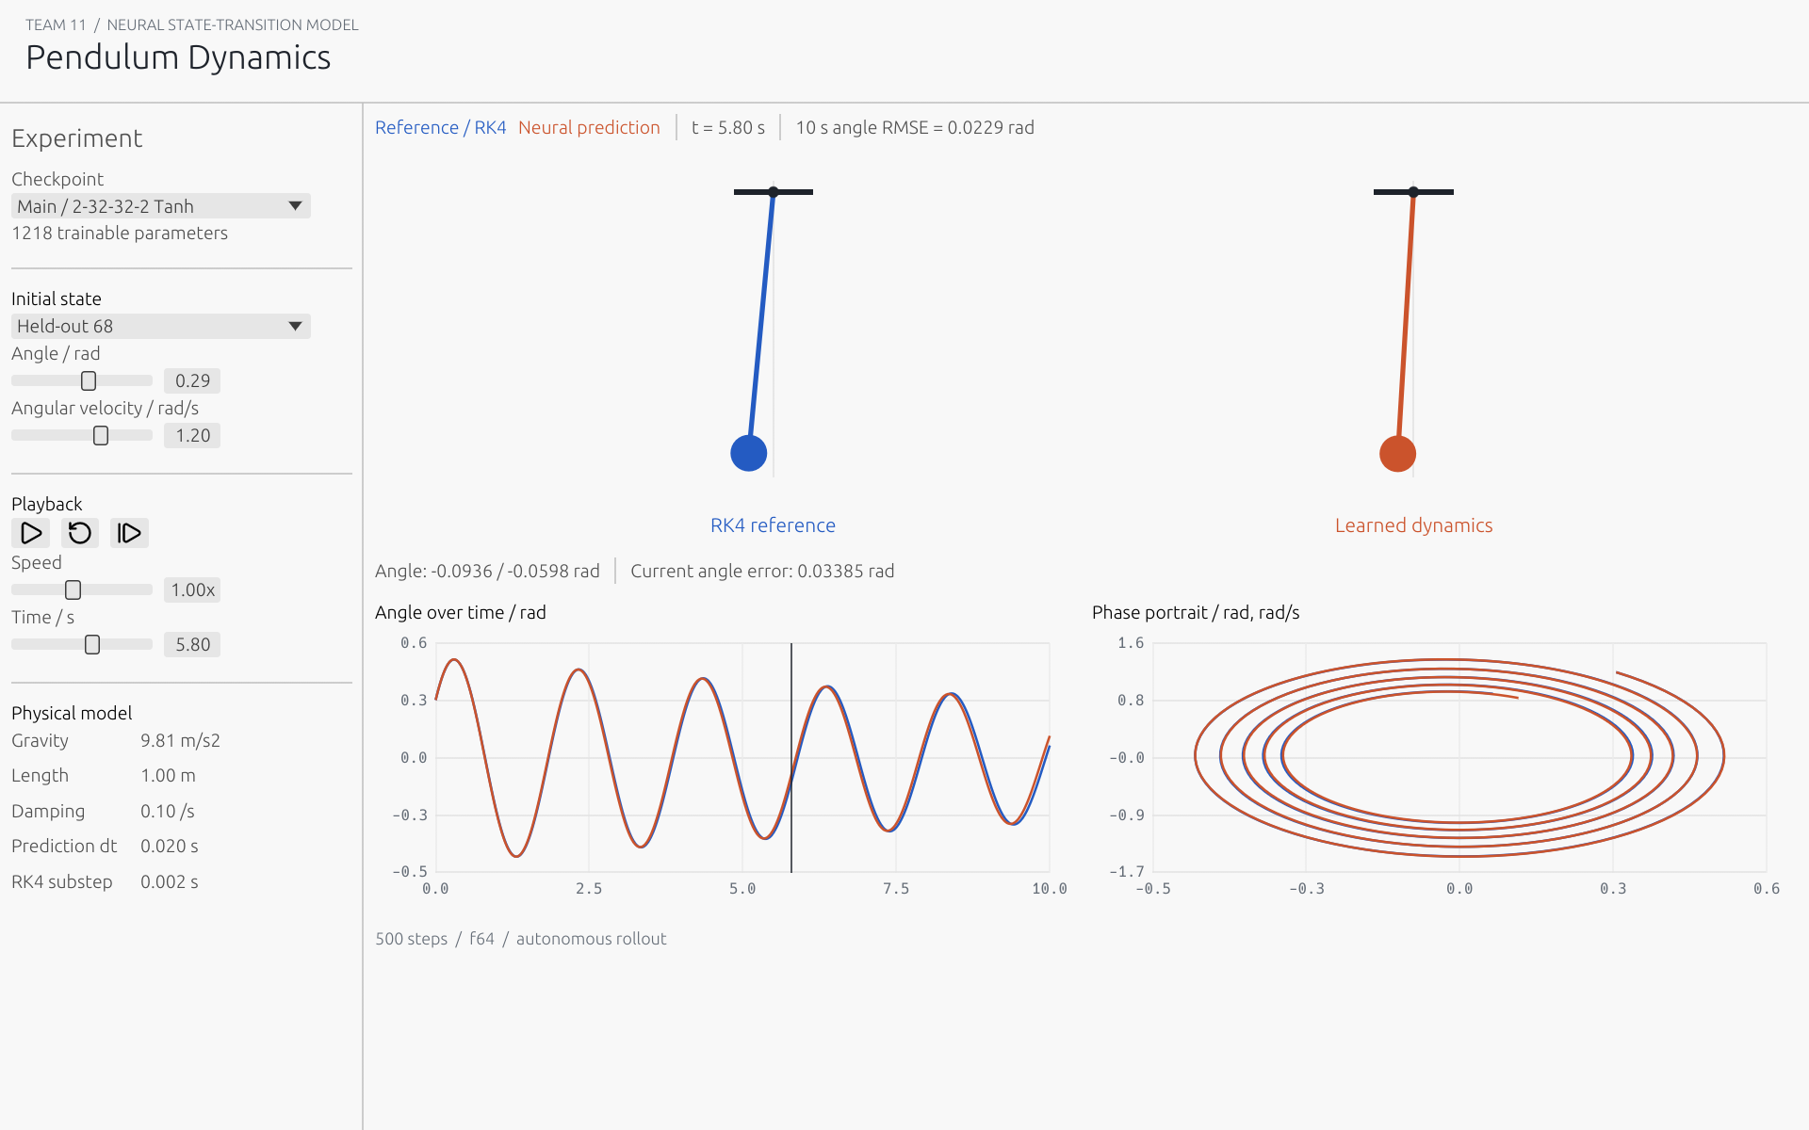
Figure 4 Actual native framebuffer capture at t = 5.80 s. The GUI uses embedded, validation-selected weights and a fully autonomous neural rollout.
The console-free pendulum-lab executable opens offline with no Rust, Python or model download required. Playback, pause, reset, single-step, speed, timeline, initial-state and model controls operate on precomputed fixed-step trajectories. Main and small-model checkpoints are available; custom checkpoint loading reports explicit errors.
cargo run --release --bin project11 -- reproduce --out experiment
cargo run --release --bin project11 -- benchmark --out experiment --epochs 50
python scripts/benchmark_numpy.py --root experiment
cargo run --release --bin project11 -- gui
Standalone commands generate, train and evaluate expose the same workflow in smaller steps. Python is needed only for the auxiliary comparison. The native GUI is separated behind a Cargo feature, so core tests and command-line workflows can run without windowing dependencies.
A three-minute demonstration first shows agreement on a held-out trajectory, then compares the small network, and finishes with the unfamiliar high-angle case. The presenter should distinguish local fit from accumulated rollout error and avoid promising unseen-state reliability.

Engineering Review and Conclusions

Verification and Project Management
Tests cover activation derivatives, all small-network weights and biases, numerical convergence, equilibrium, energy behavior, seeded generation, train-only normalization, checkpoint round trips, corrupted inputs, repeat training and file-level evaluation. Native screenshots verify multiple window sizes, both network sizes and the range-warning state. Windows CI checks formatting, tests, Clippy, Rustdoc, Release packaging and independent NumPy parity.
Development uses incremental Git commits for physics, neural-network mathematics, experiment workflows, benchmarks and the desktop lab. The remote initialization history is preserved.

Challenges and Limitations
The main mathematical risk was an incorrect MSE scaling or matrix orientation; finite differences and independent parity checks address it. The main experimental risk was trajectory leakage and visually hiding long-horizon drift. The desktop review also exposed passive slider rounding, which was removed so preset values remain unchanged. Localized operating-system messages were replaced by portable error-kind descriptions.
This is a learned discrete flow map at one fixed time step and one set of physical parameters. It is neither a physics-informed residual solver nor the continuous learned vector field of Neural ODEs [2, 3]. Current evidence uses one training seed and one OOD example. Classical RK4 remains more accurate here; no inference-speed advantage over RK4 was measured.

Conclusion
A manually differentiated Rust network can learn a useful local pendulum transition, achieving 99.10% lower one-step standardized RMSE than persistence. Autonomous errors and range failures remain material. The deliverable makes these limits inspectable through source, raw evidence, tests and the offline lab.

References
[1] Course Project for 35-380. General Instructions and Project 11 assignment brief supplied to Team 11.
[2] Lagaris, I. E., Likas, A. and Fotiadis, D. I. (1998). Artificial Neural Networks for Solving Ordinary and Partial Differential Equations. IEEE Transactions on Neural Networks 9(5), 987-1000. doi:10.1109/72.712178.
[3] Chen, R. T. Q., Rubanova, Y., Bettencourt, J. and Duvenaud, D. (2018). Neural Ordinary Differential Equations. NeurIPS 31. arXiv:1806.07366.
[4] ndarray 0.17.2 documentation. docs.rs/ndarray/0.17.2/ndarray. eframe 0.33.3 documentation. docs.rs/eframe/0.33.3/eframe.
[5] NumPy documentation. Global state and thread control. numpy.org/doc/stable/reference/global_state.html.
[6] Team 11 source and measured evidence. github.com/xiaobo121388/project11-neural-ode.

