HW3 Report

1. Result

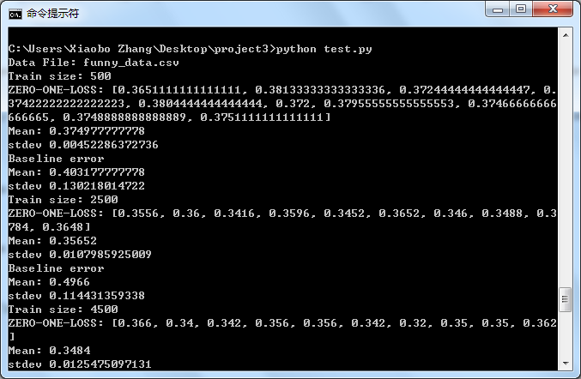

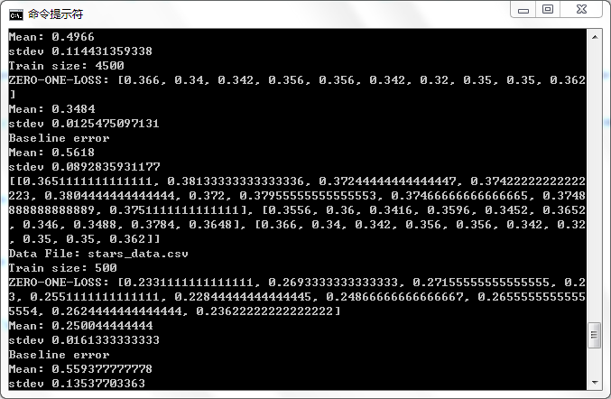

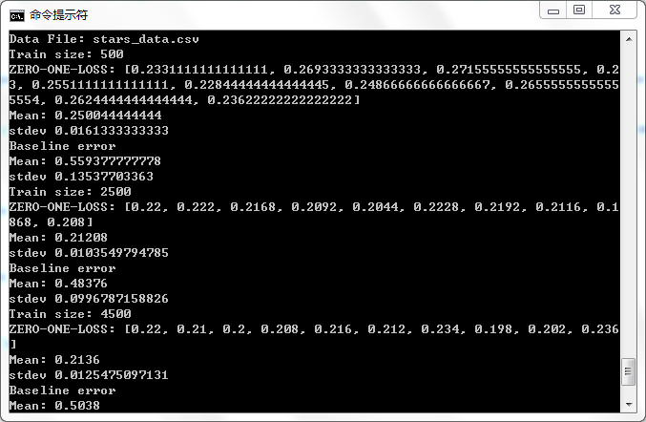

1. Chart

Funny data:

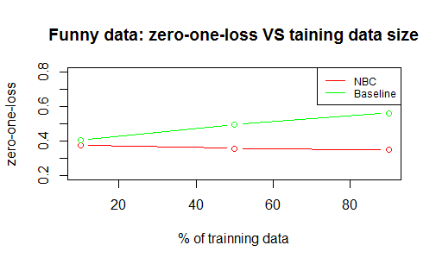

Stars data:

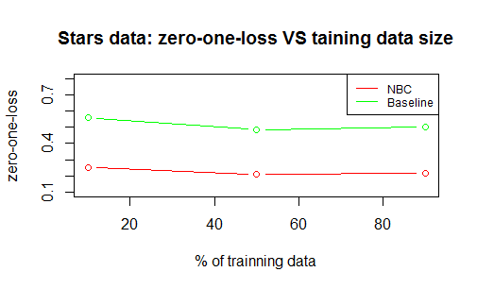

1. Analysis

According both charts, we can conclude that the NBC classifier has much lower zero-one-loss error than base line error. We can find out that when the data size larger, the error rate of NBC will become much slower. The zero-one-loss goes lower when data size from 10% to 50%, but the error doesn’t change a lot when the data size from 50% to 90% for NBC classifier.